Chapter 5 – Findings and Conclusions

Chapter 5.0 – Introduction

The overall aim of this research was to increase the understanding in to whether the current Public and Personal Safety Training Programme is suitable for modern day policing. The research objectives are: 1) Access the current elements of the police fitness test and explore whether it needs to be expanded. 2) Discuss the current First Aid Training received and explore whether further knowledge is required by a police officer. 3) Identify whether operational police officers need to be further trained to improve in the dealing with mental health calls. This chapter will also display data collated from the survey, whilst aiming to provide a conclusion around each objective.

Chapter 5.1 – Objective One – Access the current elements of the police fitness test and explore whether it needs to be expanded - Summary of findings

I have researched this area by sending out a survey to 25 police officers, asking for their feedback and thoughts, surrounding the projects research question – “Is the current Public and Personal Safety Training programme suitable for modern day policing?”. Within the survey, one question was asked:

“What fitness components do you feel you could improve on, which could help you perform your role?”. It was established that 68% of respondents stated they could improve on Strength, Flexibility, Agility, Stamina and Endurance. Additionally, Craig Williams was asked a question, which states:

“Do you believe more fitness elements (e. g Strength, Flexibility, Agility, Stamina) should be added to the current PPST Job Related Fitness Test?” To which Williams replied;

“100% yes. Officers need that level of fitness to be able to perform their job properly…”

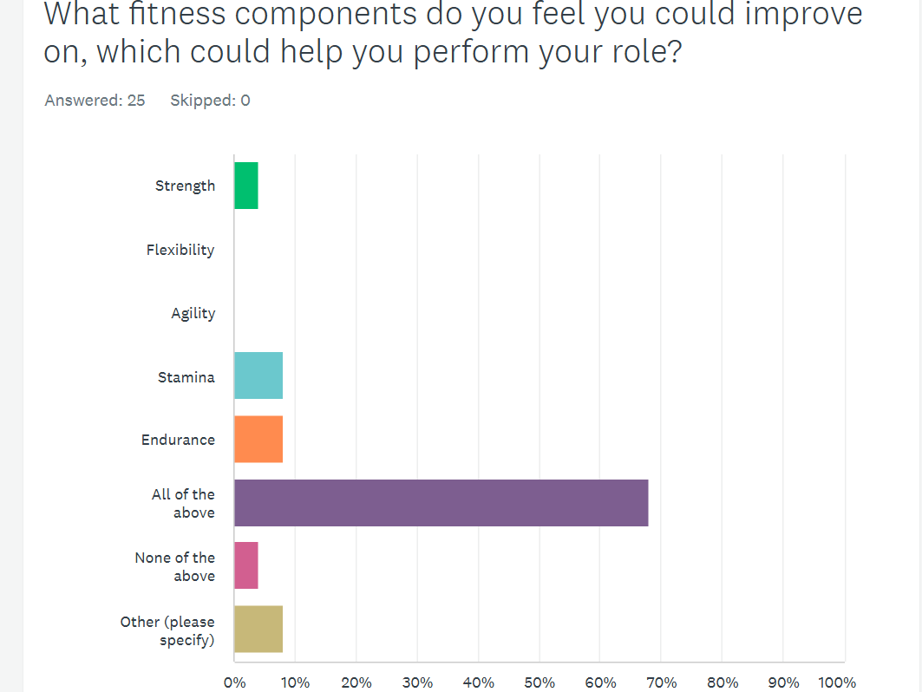

Regarding the literature review, (Santos et al, 2022, p. 1 – 18) conducted Twenty-nine studies to identify factors, aiming to understand the health-related physical fitness requirement according to job descriptions of a police officer. Previous studies suggest that improving health-related components of physical fitness including muscular strength, flexibility, cardiorespiratory fitness and endurance is necessary for improving policing skills. Additionally, low levels of physical endurance, muscle fitness and obesity have been shown to be vulnerabilities to a police officer`s health, with further studies showing an increase in body fat percentage is linked to a decrease in physical fitness and performance. These studies confirm that to perform operational tasks, physical fitness of a police officer is vitally important.

Chapter 5.2 - Conclusion

It strongly suggests, the fitness of a police officer is vitally important. Firstly, from the literature review, it suggests that overall fitness is necessary for to improve operational tasks. Additionally, it strongly suggests the data from the survey collaborates with this information established from the literature review, with officers stating in the survey they feel the need to improve on multiple elements of their fitness, to help them perform their role.

Chapter 5.3 – Objective 2 – Discuss the current first aid training received and explore whether further knowledge is required by a police officer – Summary of findings

I have researched this area by asking specific questions within the survey I submitted, where 25 police officers responded. One question asked stated;

“How confident are you in performing “First Aid” to an individual?”. It was established that 60% were “confident” with 24% saying they had “some confidence”. Additionally, I researched this area by interviewing Craig Williams. During the interview, Williams was asked;

“Do you feel the current First Aid content provides “Response police officers” with the confidence to administer first aid efficiently”? Williams replied;

“Yes I think it does. I think that everything we teach is more than likely what we come across on a daily basis. There are other police officers (e.g Firearms, police medics) that would have the sufficient training and knowledge to deal with more severe incidents…”

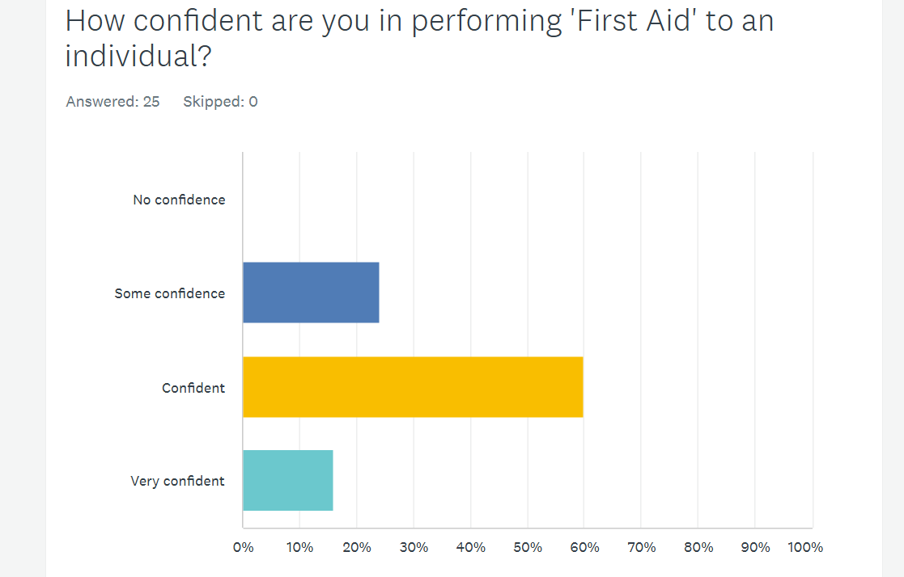

In regard to research discovered and documented in the literature review, (Mellor, 2022, p.1) states within the United Kingdom, police are not routinely dispatched to attend medical emergencies, however, can be first on scene at a medical emergency. Furthermore, when police officer`s arrive at scene, the officer`s level of confidence in delivering first aid effectively is a key barrier in essential treatment. Additionally, following a United Kingdom inquiry in 2018, it was established the police support during a medical response at a specific major incident was hindered, due to the police officers lack of confidence, in their first aid skills.

Chapter 5.4 – Conclusion

It suggests that from the data obtained, there is room for improvement in the confidence of police officers when administering first aid to individuals. From information discovered in the literature review, it also suggests that police support at a specific incident was hindered, due to the lack of confidence in their first aid skills, highlighting the importance of police officers needing the confidence to administer first aid effectively.

Chapter 5.5 – Objective Three – Identify whether operational police officers need to be further trained to identify in the dealing with mental health calls. Summary of findings

I have researched this area by asking specific questions within the survey submitted. One question asked within the survey stated;

“Do you feel you have received adequate training to deal with mental health calls and feel confident in identifying someone experiencing from a mental health episode?”.

One responder stated – “No. As mental health is such a large demand on the police, the level of training we have received is next to none. We are constantly let down by mental health professionals who put far too much onus on the police to deal with mental health” …

Additionally, during the interview with Craig Williams, a question was asked;

“If the PPST curriculum had a Mental Health Professional Input added to their training schedule, do you think this would benefit officers in identifying and responding to individuals experiencing mental health problems”? To which Williams replied;

“Any level would help. I think it would benefit persons. Anything additional would help…”

The question was also asked within the survey, to which 84% of officers agreed.

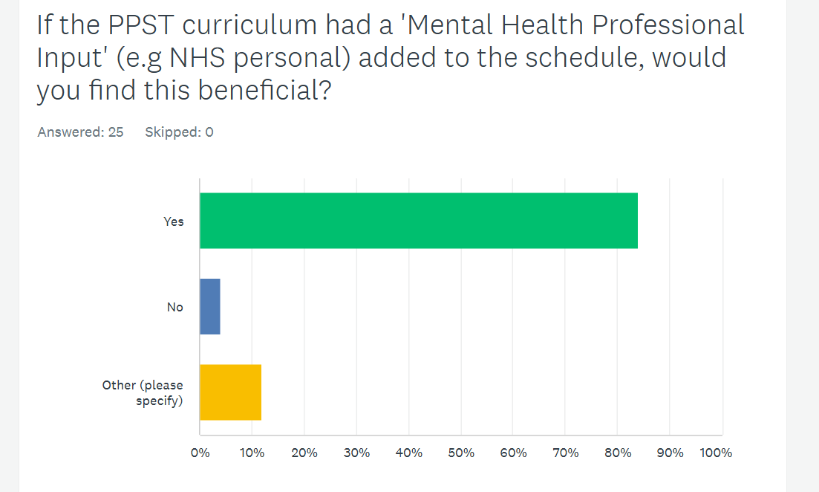

Regarding the research discovered in the literature review, (Scantlebury et al, 2017, p.1-17) states that approximately 15% - 20% of police time is spent on incidents linked to mental health in England and Wales, suggesting the police are heavily relied on. Further research was carried out, exploring whether following a mental health training package being delivered to police officers and establishing whether it was effective in responding to individuals experiencing mental health problems. 249 Police officers received a bespoke mental health training intervention, delivered by qualified and experienced `National Health Service` personnel. Training was aimed to increase an officer`s understanding and identifying mental vulnerability. The results established the training they received may have had a positive effect to individuals with mental health problems.

Chapter 5.6 – Conclusion

It suggests that the current PPST curriculum would strongly benefit from “mental health professional input training” which suggests would benefit police officers from dealing with individuals suffering from a mental health episode, due to the increased knowledge they may gain.

Word count - 1169

