Developing a new landscape for customer care

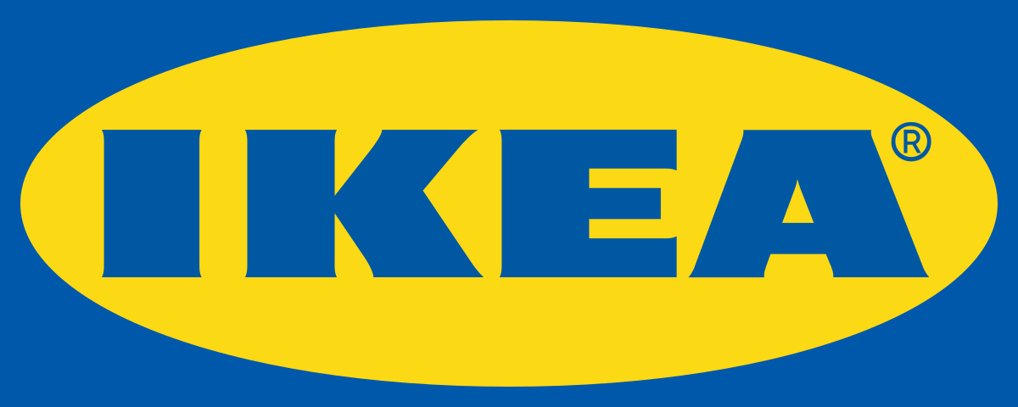

BMMB7013

Strategic management- Rebecca Reynolds (1701301)

Table of Contents
Executive summary 4
1.Introduction to IKEA Group 5
2. Strategic analysis 6
3. External analysis (Pestle analysis) 6
3.1. Political 6
3.2 Economic 7
3.3 Social 8
3.4 Technology 8
3.5 Environmental 9
4. Competitive environment 9
4.1 Porter’s five forces 9
4.1.1. Threat of new entrants 9
4.1.2. Bargaining power of buyers 10
4.1.3 Bargaining power of suppliers 10
4.1.4. Threat of substitute products or service 10
4.1.5. Competitive rivalry 11
5. Internal analysis (Value chain) 11
5.1. Primary activities 11
5.1.1 Inbound logistics 11
5.1.2 Operations 12
5.1.3 Outbound logistics 12
5.1.4. Marketing and sales 12
5.1.5 Product and services 14
5.2. Support activities 14
5.2.1. Infrastructure 14
5.2.2 Technological development 15
5.2.3. Human resource management 15
6. Internal analysis- strengths and weaknesses 16
6.1 Strengths 16
6.2 Weaknesses 16
7. TOWS 17
7.1. Opportunities 17
7.2 Threats 18
8. Strategic options for a more personalised care 19
9. Recommendations 20
10. Conclusion 21
11. References 22
12.1 Appendix 1- PESTLE 27
12.2. Appendix 2- SWOT 27
12.3 Appendix 3- Financial statement 2020 27

Table of figures

Figure 1. Design incorporated ………………………………………………….13
Figure 2. Franchises…………………………………………………………….15

Executive summary

The aim of this report was to creatively reshape IKEA’s strategic direction and to create a new way forward for delivering customer care. An external and internal analysis have been conducted. A PESTLE analysis was used to assess the external environment and a SWOT and Value chain to assess the internal factors impacting the organisation. The opportunities and threats have been identified whilst proving strategic recommendations to move froward. After conducting the research strategic options have been put forward for IKEA.

The findings have shown that the external factors have impacted the IKEA as the stores IKEA operate in have been adversely affected by the pandemic. The economy is in a recession in countries the organisation operates in which has affected sales. IKEA have used their own strategy to overcome problems such as striving on market change. The company focus efforts on sustainability with the aim by 2030 to be plastic free. The findings from the competitive environment show IKEA’s strong brand helps them retain the customers from their competitors. Opportunities moving forward have been identified is to continue expanding in foreign markets.

It is recommended that IKEA expand their omnichannel. Social media platforms will give consumers more information and will allow them to use messaging channels to get into contact with sale teams which reduces calls. This builds relationships with new customers and creates loyalty.

1.Introduction to IKEA Group

The organisation IKEA was formed in 1943 and founded by Ingvar Kamprad (Kristoffersson, 2014). The company started in a small Swedish village as a mail order catalogue business. It is currently a recognised globally as a home furnishing brand. It is one of the largest furnished retailers employing over one million people are employed showing how substantial the brand is (IKEA, 2020). According to Baxter and Landry (2017) the organisation has over 300 stores and franchises in over 40 countries across Europe, Asia, North America and Australia with 70% of stores located in Europe. The main product IKEA sell is furniture, mainly wood products. Most products are flat packed to reduce costs and damage and to make them assessable for consumers. Additionally, most IKEA franchises operate Swedish style restaurants in their stores (Panahi, 2016).

The mission of Ikea Group’s aims to provide high quality products at affordable prices for its consumers (IKEA, 2020). This is IKEA’s business strategy is the IKEA concept. The aim consists of building long term relationships with the company’s stakeholders, optimising its value chain and investing in production and creating significant amount of volume for its consumers (Panahi, 2016). According to IKEA (2020) the company’s vision is more than home furnishing, they want to make a positive impact on the world. IKEA’s (2020) simple vision is ‘’to create a better everyday life’’ which applies to many people. This is the core foundation which guides the business with an attitude to get it done. The organisation states to re-invest its profits in their stores and its product development in order to meet their vision. With IKEA’s business idea, the organisation also aims to inspire change to be more sustainable. IKEA (2020) is committed to making a positive impact on people and the planet. Their ambition is that by 2030, all plastic used in the company’s products will be based on renewable or recycled material.

With IKEA’s strategic direction focusing on the IKEA concept, a strategic analysis needs to be conducted in order to outline the external and internal environment to create a competitive advantage.

2. Strategic analysis

A strategy is important for organisation because it sets the direction. The term strategy can be seen as which organisation or individuals accomplish for their long-term goal and objectives (Grant, 2015). Alfred Chandler defines strategy as ‘the determination of the long-run goal and objectives of an enterprise and the adoption of courses of action and the allocation of resource necessary for carrying out these goals.’ (Johnson et al, 2017 p.g. 4). Alternatively, Richard Remelt defines strategy as a cohesive reaction to an important challenge (Grant, 2015). Alfred Chandler definition is clearer and more detailed in defining strategy.

According to Dess (2013) it is important to managers and employees to aim towards accepted goals and objectives. This enables the organisation to move forwards as if not individuals can be confused on what they are working towards. According to Lynch (2018), strategic management is identification of the purpose of the organisation and the plans and actions to achieve the purpose. This concerns the strategic goals of an organisations vision, mission and objectives.

A mission is important to an organisation as it provides clarity for employees and its stakeholders (Johnson et al, 2017). IKEA’s mission is to provide high quality furnishing at a low cost. The current position is accepted worldwide but faces current challenges and with new innovative strategies it can sustain a competitive advantage.

3. External analysis (Pestle analysis)

3.1. Political

With IKEA operating in more than 40 countries this means that the company is prone to different government attitudes and laws (Griffiths and Wall, 2011). In some countries the political environment is very stable providing good infrastructure. Although with over 70% of its franchises in Europe, with new laws under Brexit, there will be no taxes on goods on crossing the borders (Edgington 2020). The United Kingdom is free to negotiate trade deals with other countries across the world, this can benefit the furniture industry. Moreover, IKEA sees a positive shift moving into Asian markets due to the struggling European economy. With expanding businesses and rapid increase in sales this has impacted the organisation positively (Spinoglio,2020).

The government has supplied organisations with benefits of ten million pound a month and IKEA have qualified for business rates to reduce pressure on the organisation (BBC, 2020). A temporary reduced rate of (5%) will benefit this the café outlets (HRMC,2020). Tax rates can externally affect the organisation. In 2020, IKEA were charged 295 million euros. Comparing this to 2019, pre income tax was 17% and 2020 it was 15% (IKEA annual report, 2020). This was due to tax rate changes in the Netherlands. With European regulations and national laws, organisations need to be well organised stated by Griffiths and Wall (2011).

3.2 Economic

To achieve IKEA’s vision, economic conditions of countries need to be considered. With the first two quarters of 2020 seeing a negative impact on GDP, with the worst recession on record in the United Kingdom and other European countries. Although the third quarter showing the economy to grow again. The economy is 9.7 smaller than it was before the pandemic (BBC, 2020). Overall, the world economy will decrease by 4.4% will affect IKEA’s vision as consumers buyer habits will change. Currently businesses are facing a 45% decrease in turnover comparing to 2019 (Gov, 2020). Current exchange rates have generally stable despite a second wave of the virus and an election in the United States (Rogoff, 2020). There is uncertainty for this, but one reason can be interest rates have been kept in a lower bound. With exchange rate uncertainty, this can mean future fragilities. On a positive for IKEA, it is predicted that the Chinese economy will be 10% larger at the end of 2021 and therefore a reason for IKEA to expand in the Asia market (Rogoff, 2020).

The current inflation rate is extremely low at the moment which will impact the organisation (Inman, 2020). Plans to increase wages have been frozen and in some parts of the world even reduced meaning consumers are less likely to spend having a negative impact on businesses (Peat, 2020).

3.3 Social

Social and cultural factors are important for organisations to move forward. Concerning IKEA’s marketing strategy, the goal is to sell the same products in all markets. According to Burt et al (2011) IKEA is slow to adapt to foreign tastes (Bourny et al 2020). IKEA’s strategy is to strive on market change, so consumers have to adapt to the organisation’s products. If a product is in demand by the consumer, the market will need to offer this which has been highlighted by Sloman (2016). Moreover, consumer trends are constantly changing, and products will need adapted. With lockdowns and social distancing, the way in which consumers shop has changed to online. With an ageing population, technology can be difficult to use for some (national statistics,2017). This can be a challenge for organisations and needs to be addressed.

3.4 Technology

The future is becoming more digitalised and technological innovation is needed to be a competitive force. IKEA’s focus is shifting from traditional strategies to online strategies to embrace the transition (Haraldsson et al, 2020). In 2020, 75% of the organisation’s stores were shut down due to the lockdown. In 2020, IKEA’s annual report (2020) statistics show how e-commerce accounted for 16% of total sales comparing this to the 10% in 2019, this is showing the significance of technology in today’s society. To make it easier for consumers to access and purchase their products online. An example from IKEA innovation is the launch of a virtual reality application so consumers can see their products from their own home (IKEA, 2020). This has increased consumer satisfaction levels by utilising augmented reality.

3.5 Environmental

For any company, environmental factors should be focused on in order to sustain. IKEA have exerted their focus on efforts towards sustainability by ensuring their products are reducing the footprint (Cosmo and Yang, 2017). The organisation has invested in 1 billion in renewable energy. By 2030, IKEA products will only use recycled or renewable based plastic (IKEA, 2020). Consumers may be willing to pay a premium price for the products. However, with the size of the organisation, IKEA uses 1% of the total wood in the world according to Cosmo and Yang (2017). There is a large quantity of their wood not being sourced sustainable. Sustainability is an important factor for the organisation and their aim is to better the environment by limiting the organisations impact on the environment

4. Competitive environment

4.1 Porter’s five forces

4.1.1. Threat of new entrants

There is a low threat of new entrants in the furniture industry due to innovation and because of the high cost involved in making the products (Ayodele, 2018). There are obstacles in the way for new organisations due to multinational organisations producing large quantities to create cost advantage which makes it more expensive for new organisations. Furthermore, according to Ayodele (2018) to hire expertise with the right skills in the field is difficult. The marketing strategy at IKEA is successful at building a strong reputation at IKEA which helps the retain their customers so it is unlikely that consumers will want to change brands. These factors contribute to the low force of new entrants

4.1.2. Bargaining power of buyers
The bargaining industry is high because there are numerous furniture manufactures locally and internationally which sell their products successfully. Product differentiation is strong in the furniture industry, consumers are wanting different and innovative products making it difficult for new entrants. There is a strong emphasis on marketing products and to provide a high level of customer service and Porter (2008) highlights that organisations need to provide innovative products to attract to each target segment Buyers have enough competition and IKEA’s strategy is built upon competitive prices which loyalty can be seen as a factor in reduces customers to switch companies (WU, 2020). Therefore, consumers have options to buy from other companies according to Kermer (2019). Kermer (2019) adds that a lack of innovation in the industry has added strength of the power of buyers.

4.1.3 Bargaining power of suppliers
Porter (2008) states that organisations can switch suppliers because of lower costs if the prices are not suitable for the organisation. Suppliers have many options to sell their raw materials to in the furniture industry. IKEA have developed key relationships with their suppliers and put themselves in an effective position to have continuous access to supplies to make a significant positive impact on the market (Ivarsson and Alvstam, 2010). To help IKEA connect to their suppliers highlighted by Wu (2020), there is a code of conduct ‘’the IKEA way on purchasing home furnishing products’’ (IWAY). Therefore, it is seen as the bargaining power of suppliers as low.

4.1.4. Threat of substitute products or service

It will be challenging for organisations in the furniture industry due to it being competitive. With low price and high quality, it lowers the substitutes and other products can be seen as expensive. Types of designs have been changing overtime. IKEA have adapted to this and the organisation focuses on quality and low prices. This makes the threat of substitute low as people will always need furniture.

4.1.5. Competitive rivalry

Ikea is the leading furniture brand in the world (IKEA,2020). Although there are many organisations selling the same products which have strong roots in the market that has caused competition for IKEA. Organisations such as Walmart, Amazon and Wayfair are some competitors in the industry competing with affordable prices and their strong online presence. By August 2020, IKEA’s website reached 4 billion visits and online sales grew by 45% (IKEA annual report, 2020). With the presence of multinational companies, it has heightened the competition in the market which has decreased the profit margin. The competitive rivalry is high in the industry for IKEA.

5. Internal analysis (Value chain)

To develop an organisation’s sustainable competitive advantage, the concept of value can be added. Activities in an organisation can link to develop the value of the company. The activities combined can form a value chain. According to Lynch (2018) Michael Porter’s value chain is important because it identifies where the value can be added in a business and connects with the major functional segments of the business. The two types of activities that are included with in the model are primary activities and support.

5.1. Primary activities

5.1.1 Inbound logistics
In the supply chain, IKEA use a worldwide strategy and have close relationships with their suppliers. They manage every stage to reduce prices, with their transportation costs by using innovative designs (Kilinic and Akar 2019). For example, their products are all flat packed to improve their storage. IKEA try to use direct deliveries from suppliers to their stores (Alrubah, et al, 2020). This is to decrease the number of transports to reduce the environmental footprint. This has been throughout carefully by IKEA. To have efficient distribution system, logistics is an integral part of its business. Over 20% of their products are shipped from their suppliers to their stores. IKEA source from over 1800 suppliers in over 40 countries (IKEA,2020). A major aspect of achieving a low price is an effective distribution within the entire goods flow from supplier to customer and to reduce the environmental impact of transport.

5.1.2 Operations

IKEA operates in three divisions: franchise, finance and property (IKEA, 2020). The franchise system is the core of the company. This has helped them expand their brand internationally quickly. A decentralised business strategy is followed by the organisations as this gives regional mangers autonomy.

IKEA operates its stores in 30 countries worldwide under the franchise system. With 11 franchises in more than 50 markets. The formerly IKEA Group, Ingka Group is one of the largest franchises with stores on 20 markets. In 2020, the organisation reaches their customers through e-commerce in over 50 markets (IKEA, 2020).

5.1.3 Outbound logistics

From the increased use of online shopping customer distribution centres have been located closer to customers. To make it simpler for IKEA’s customers to retrieve their products, there is a plan to introduce central parcel units of shipping, internal and external pick up locations (Malmgren and Larsson, 2020). Additionally, customers can choose their products from warehouses which reduces costs and there are no free deliveries (Lu,2014). Logistic managers are placed in each of IKEA’s stores to ensure efficiency of the flow of goods, tracking supply and demand and deliveries. It can be a way forward for the organisation to use curb side pick-ups (McKinsey, 2020) to improve the customer experience.

5.1.4. Marketing and sales

Innovated marketing and a sales strategy are adopted by IKEA that uses modern techniques and mix of traditional channels. A sales and distribution network have been established which is manged by the company’s franchises. Stores are located strategically to reach customers to provide growth and drive sales. Promotion in-store offers a distinct shopping experience for its customers to grow IKEA’S s sales (Trendafilov, 2018).
The organisation uses digital channels to promote their products but also use traditional promotional channels as innovative methods. Their website and app as well as digital advertising, social media channels are used for customer engagement and to drive sales (Spinoglio, 2020). The strengths of the design of the app and website is its story telling platform to increase the value of their products. IKEA was one of the first furniture retailer to use augmented reality to help customers purchasing decisions. It used a catalogue that allows customers to try their wanted products in their own homes (IKEA, 2020). IKEA have an effective marketing strategy and figure three shows how design is incorporated as a personal experience for their consumers. To innovate their strategy, more information and the ability to use messenger for example robot chats can be away to reduce.

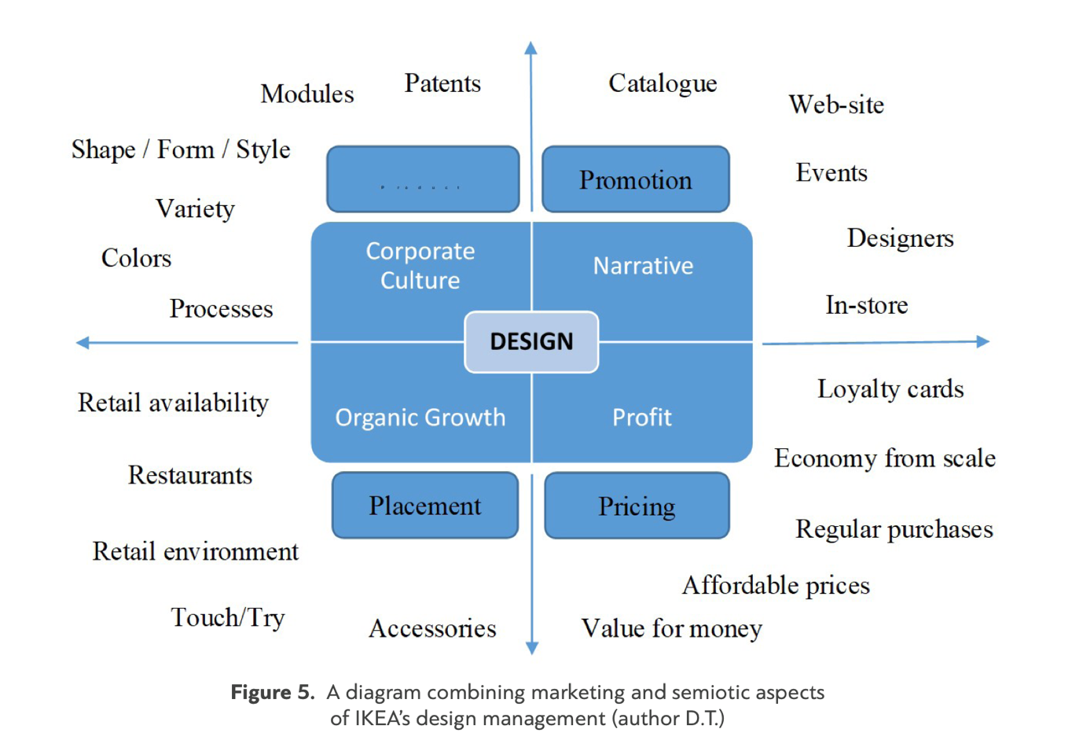

Figure one: Design incorporated (Trendafilov, 2018).

5.1.5 Product and services

One of IKEA’s (2020) primary activities in the value chain is producing quality customer service. This is addressed by online and telephone services, offers for refunds and exchanges and to give customers an option to provide feedback. According to Ikea’s (2020) website customers do not need to return to stores to exchange parts. It can be disagreed with some as products are explained through catalogues and displays. This method is to cut staff numbers which reduces sale representatives

IKEA sells a wide range of furnishing products. In IKEA’s stores, around 9,500 are stored each year and according to IKEA (2020) the team adds 2,000 new products to the catalogue. Key stakeholders which include suppliers, franchises, design team and engineers are all part of the production process and collaborate together to ensure production is cost effective. To add to this, IKEA products are flat packaged to improve operational effectiveness and to reduce transportation costs. IKEA maximising customer satisfaction by offering a large range of products and modern styles of furniture.

5.2. Support activities

5.2.1. Infrastructure

IKEA are divided into three main groups; franchises, range and suppliers (IKEA, 2020). Figure one shows how IKEA’s franchises are grouped. IKEA is a franchise business. The system enables the organisation to have continues growth For Inter IKEA Group the CEO is Tobjorn Loof and the management is overseen by a supervisory board. The CEO of IKEA Group B.V is Martin Van Dam IKEA is also managed on a regional basis and each of IKEA’s department for example head of human resource management as its own manager.
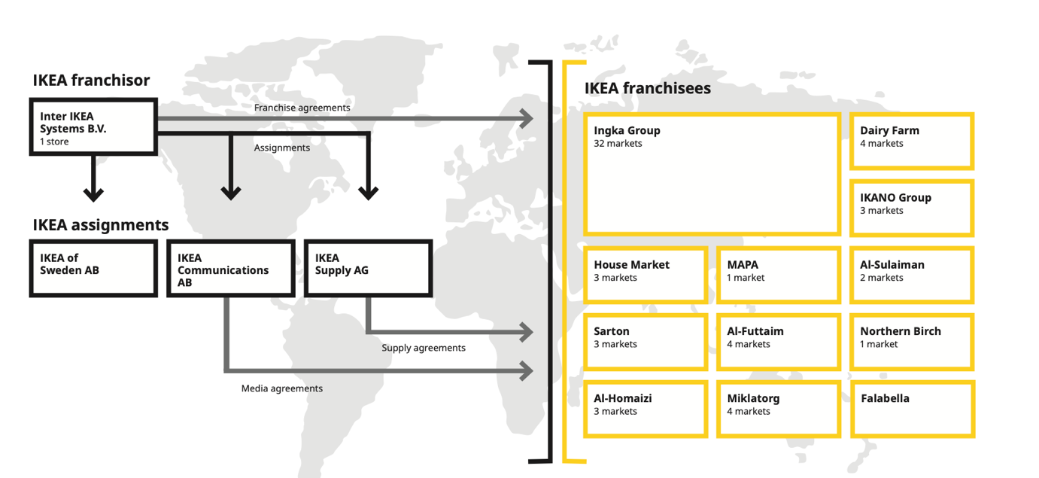

Figure two : Franchises (IKEA, 2020).

5.2.2 Technological development

Comparing it to their competitors, digital technology has played a crucial role for IKEA. To meet customer needs, IKEA invest heavily in digitalisation to improve manufacturing capabilities. Accelerated efforts have been made to automate production and to leverage the gains of data manufacturing.

5.2.3. Human resource management

IKEA’s leaders are committed to motivating employees and creating vision and energy for them. Direction is initially set for the future company plans. Bass and Burns (2006) state that a transformative leader give more incentives to employees and will be more attentive to the subordinates needs. IKEA not only does this but helps subordinates realise their self-worth by encouragement and creates career development by providing opportunities to their employees (Li, 2020). IKEA has been rated 72nd best 100 to be in employed in 2017 and 31st best employer according to Forbes (2020) and categorised in a group to be a great work environment By fulfilling employees needs it is more likely them they will be more motivated to achieve the company’s strategies, help with the design of products and market and sell the product (Gibb, 2011).

6. Internal analysis- strengths and weaknesses

6.1 Strengths

IKEA is the most recognisable brand in the furniture industry. In 2020, IKEA received 825 million store visits and 4 billion website visits (IKEA, 2020). This is a substantial amount. The quality of the IKEA products with modern affordable designs is a major factor for their success (Kumar and Kumar, 2010). IKEA’s strategy has always considered to develop products based on consumers’ interests, by keeping prices low and providing modern products. The inexpensiveness of the product is what retains the customers loyalty (Bourney et al., 2020). In 2020, the financial statements show that the group reached a revenue of 39.6 billion-euro sales. This was only slightly down from 2019. Despite a pandemic, this shows how the affordability of IKEA’s product is a driven point for their success.

In every stage, the organisation incorporate feasibility by working with key stakeholders (IKEA, 2020). Products are tested in labs which is why the products are quality and the products can be passed on to consumers at a low price. IKEA are able to bulk buy their products from their suppliers because of their long-lasting relationships they have made. This is cost effective for the organisation

With the strong brand, IKEA have a very strong culture on sustainability. Sustainability has been a drive IKEA’s strategy throughout its process. In 2012, it created its People and Planet Positive sustainability strategy. This approach achieves positive people and environmental impacts. This strengthens the organisations strategy to alter the value chain to reduce raw materials (Laurin, 2017).

6.2 Weaknesses

Due to the size of the organisation and the scale of its global business, this can be identified as a weakness. Some countries IKEA manufacture in have their own legalisation. This has resulted in improper working conditions (Li, 2020). This is evident from Křenková (2020) article as it has created a negative brand image and created bad press in numerous countries including Russia and Israel.

IKEA heavily rely on third- party manufacturers for its products. More than 50% is produced by third party (Bourney et al., 2020). This means that the organisation has less control and can be seen as a weakness each of cost of units might not be developed. Secondly when packages are delivered, they are not assembled which can be seen as unattractive to certain groups of customers.

7. TOWS

To analyse the internal and external strengths and weaknesses of the organisation IKEA, the TOWS matrix is seen as an effective tool. The TOWS matrix gives alternative strategies that a SWOT analysis does not. This is supported by Ravanavar and Poornima (2012) as the strengths can be capitalised by the opportunities to reverse the threats and the weaknesses can be reduced by opportunities and how threats can be averted.

7.1. Opportunities

An opportunity that can be identified with the strong global brand is the company expanding in the developing market. With increased globalisation, IKEA can create a strategy to expand in foreign markets to adapt to changing consumer markets (Roy, 2020). Sandybayev (2017) suggests that organisations can capitalise and concentrate on using their resources and opening new stores to expand revenue and income to stir away from the European economy. With rolling lockdowns due to the current pandemic this can be seen as a threat to expand in Europe and take the opportunity to expand and grow in new markets (BBC News, 2020). According to Rogoff (2020) with a prediction of the Chinese economy to boom by the end of 2021, it is a vital reason to expand in the Asian markets

With consumers more likely to buy products, IKEA can take the opportunity by marketing their sustainability with the products and capitalising on efficiency with their products (Yan and Shao, 2019) resulting in increased market share. An opportunity to reduce transportation costs can be another factor. To replace solid wood, particleboard can be used to reduce manufacturing and transport costs. Particleboard is lighter and 20% cheaper than solid wood. The barrier to sustainability is some countries differ their standards to sustainability. For example, IKEA may need to ship its materials from one country to another which can be seen as costly stated by Burger et al (2019).

IKEA need to recognise their weaknesses in order to help set objectives and develop new strategies. With the weakness of unassembled furniture being unattractive to a certain group of customers it can be an opportunity to give an option product being assembled at an extra cost. This can increase costs which is an advantage for IKEA to gain more revenue for each product. This opportunity will give the group of consumers the option and therefore encourage them to purchase products from IKEA thus increasing customer loyalty (McKinsey, 2020). Another opportunity identified from IKEA’s weaknesses is to expand their own factory manufacturing capacity in order to reduce third party manufactures. Third party manufactures can be an advantage for companies to reduce costs and less of a burden for companies but to increase customer service it can give customers a more efficient service being able to contact IKEA directly than having to contact third parties (Baxter, 2017).

7.2 Threats

With IKEAs low costing business model which is a strength for the organisation. Many other organisations have duplicated this which means that the company needs to be constantly innovating to have a competitive advantage (Roy,2020). With organisations such as Walmart and Amazon having affordable prices for its consumers, it can be seen as a threat. IKEA needs to be constantly innovating and keeping up with trends to gain a competitive advantage over their competitors. IKEA markets that it cares about its people which has advantage over its competitors (Spinoglio, 2020).

With the weakness of improper working conditions identified in the SWOT Analysis the threat of this is it can have an impact on people’s opinions about the organisation affecting employees and consumers interests. There is an opportunity here to improve corporate social responsibility. Corporate social responsibility can be defined as companies to be accountable for their actions and to consider stakeholder and public expectations (El Akremi et al, 2018). Therefore, companies can recognise the impact they are having on all aspects of society.

8. Strategic options for a more personalised care

The delivery of customer care IKEA have currently is that they value their customer experience. Consumers place higher on the value on IKEA’s products (IKEA, 2020). The brand offers ‘a better everyday life for the many people’, which in other words is perceived as the awareness of social factors of improving people’s lives. IKEA differentiates itself from its competitors by giving an experience in store that stimulates the five senses to improve the consumer journey (Rodrigues and Brandão, 2020). For their everyday product, showrooms are displayed to help the consumer in the decision-making process. Extra services are provided such as extended opening hours, in-store restaurants and some stores offer childcare (IKEA, 2020). This journey increases the overall value of the product and builds a relationship between the brand and the consumer.

As a result of the current strategy that has been analysed to ensure the organisation has a sustainable competitive advantage a strategic option for a more personalised care is more support the customers on IKEA’s social media platforms. Currently, the social media pages are not effective in providing information on the social media pages (Křenková, 2020). Additionally, to have representatives responding to customers concerns on the social media pages and this is currently lacking. These digital services should be made available to reduce calls. Methods that can be used are robotics such as chatbots, voice and speech recognition and artificial intelligence (PWC,2020). In addition to more support on social media platforms an updated app that allows self-service. Self-service is on a rise due to the current pandemic. A self-service will give consumers options (Mckinsey, 2020).

Launch a new delivery pickup. Safe delivery is important and curb side pickup can be an option. In the United States of America over 22 percent of consumers are using delivery methods more now than before the Covid crisis (Mckensy, 2020). Drive throughs can be an option for a more personalised care. Speed zones outside stores has been on the rise. By introducing popular items outside the zone can benefit third party sellers.

Building relationships with customers through a more personalised shopping experience. The organisation can use al-powered platforms with algorithms to get data collection (Pereira et al., 2017). An advantage of receiving data by using messages and profiles can allow staff members to consumers their preferred product in store. This enables successful guest service and increase sales without increasing footfall in store. Virtual selling can also be used to show customers the range of products that suits them (Mckensy, 2020).

9. Recommendations

The e-commerce market is rapidly growing, it is recommended that IKEA expand the omnichannel. By improving social media pages giving more information on the platforms and giving more options of being able to contact them on there can give customers a smoother online experience (McKinsey, 2020). To offer more promotions online rather than using stores to drive footfall.

To expand in more foreign markets that are doing well. Some countries are ahead with the pandemic and Sandybayev (2017) states that organisations can capitalise on using resources in new markets. Having more stores in China Is recommended.

Being more sustainable is a recommendation a suggestion of replacing wood and using particleboard instead. Throughout analysing the external and internal environment, strategic recommendations have been made throughout.

10. Conclusion

The current strategic position of IKEA despite the global pandemic, the organisations strategies are performing well. Distinguishing IKEA from their rivals, IKEA provide a low-cost position and excellent services for their customers (IKEA, 2020). IKEA is a well-known global brand and must keep assessing the external and internal environment to keep a competitive advantage.

The competitive environment analysis shows that IKEA are strategically moving in the right direction to gain a competitive advantage. IKEA’s combination of popular designs, low costing model and their responsibility for its people and environment means that the organisation retains a strong identity in the market (Roy, 2020).

The intention of becoming a leading example in the industry by continuing to be a sustainable organisation (IKEA, 2020). With the promise to create a better every day for its consumers shows the strategic direction the organisation is aiming for. With a more personalised care (McKinsey, 2020) the organisation will provide exceptional customer service.

11. References

Alrubah, S.A., Alsubaie, L.K., Quttainah, M.A., Pal, M., Pandey, R., Kee, D.M.H., Ling, L.K., Nadirah, N.A. and Aishan, N., (2020). Factors Affecting Environmental Performance: A Study of IKEA. International journal of Tourism and hospitality in Asia Pasific, 3(3), pp.79-89.

Ayodele, A., (2018) situational and strategic analysis of IKEA and the future. [online]. Available at: https://docs.google.com/viewer?a=v&pid=sites&srcid=ZGVmYXVsdGRvbWFpbnxyZXNlYXJjaHBhcGVyc2J5Ym9kZWF5b2RlbGV8Z3g6MzkxNGNhOGIzNThhZmExYg (Accessed. 4.1.2021)

Bass, B-M., and Burns., (2005). Transformational leadership. (2nd ed) Psychology press.

Baxter, M, & Landry, A., (2017). IKEA: Product, pricing, and pass-through. Research in Economics, 71(3), 507–520.

BBC News (2020) Covid- 19: Chinses trade grows as others struggle amid pandemic. [online]. Available at: https://www.bbc.co.uk/news/business-54522845 (Accessed: 15.12.2020)

Bourny, D., Mirza, D. and Turcu, C., (2020). The Culture-Promotion Effect of Multinationals on Trade: the IKEA case. Orleans Economics Laboratory/Laboratoire d'Economie d'Orleans (LEO), University of Orleans.

Burger, J.R., Brown, J.H., Day, J.W., Flanagan, T.P. and Roy, E.D., (2019). The central role of energy in the urban transition: Global challenges for sustainability. BioPhysical Economics and Resource Quality, 4(1), p.5.

Cosmo, D.E. and Yang, K., (2017). A Further Strategic Move to Sustainability—A Case Study on IKEA. Journal of Strategic Innovation and Sustainability, 12(2).

Dess, G. G., Eisner, A. B., & McNamara, G. (2014). Strategic management : text & cases (7th ed) McGraw-Hill Education.

Dess, G., (2013). Strategic management: Text and cases. (8th ed) McGraw-Hill Education.

Edgington, T. (2020) ‘Brexit: what trade deals has the UK done so far?’, BBC news, 25 november [online]. Available: https://www.bbc.co.uk/news/uk-47213842 (Accessed: 2020, Novemeber, 25).

El Akremi, A., Gond, J.P., Swaen, V., De Roeck, K. and Igalens, J., (2018). How do employees perceive corporate responsibility? Development and validation of a multidimensional corporate stakeholder responsibility scale. Journal of Management, 44(2), pp.619-657.
Forbes., (2020). IKEA. Forbes, [Online]. Available: at: https://www.forbes.com/companies/ikea/?sh=57521df42ad0 [Accessed 2, January 2021].
Garner, J., Stead, W., Stead, E., (2014), Sustainable Strategic Management 2nd edition, London: England: Greenleaf Pub.

Gibb, S. (2011) Human resource development: foundations, process, contexts, (3rd ed) Basingstoke: Palgrave Macmillan (Accessed:12.12.2020).

Grant, R.M., (2015). Contemporary strategy analysis Ninth. Chichester : Wiley 2015

Haraldsson, T., Johansson, D. and Lilja, M., (2020). Digital is the new normal:-The effects of Digitalization on the IKEA organization in Digitally Advanced Markets.

Hayes, J., (2014), The Theory and Practice of Change Management 4th edition, Palgrave.

HRMC (2020) Tax. [online].Available at: www.gov.uk (Accessed: 9.1.2021)

IKEA (2020) ‘IKEA’. [online]. Available at: www.Ikea.co.uk (Accessed: 18.11.2020)

IKEA Report (2020). Inter IKEA Group financial summary [online]. Available at: https://gbl-sc9u2-prd-cdn.azureedge.net/-/media/interikea/igi/financial-reports/inter-ikea-group-financial-summary-fy20- (Accessed: 7.1.2021).

Inman, P., (2020). The Gaurdian [online]. Available at: https://www.theguardian.com/business/2020/nov/18/why-uk-inflation-rate-appears-divorced-from-reality-but-could-change (Accessed:15.12.2020).

Ivarsson, I., and Alystam, C-G., (2010) Supplier upgrading in the home-furnishing value chain: an empirical study if IKEA’S sourcing in China and South East Asia. World development, 38(11),pp.1574-1580.

Johnson, G., Whittington, R., Scholes, K., Angwin, D., Regner, P., (2017), Exploring Strategy Text and Cases 11th edition Harlow: Pearson.

Kremer, K., (2019) Operation strategy: Literature review and case study ok IKEA. Vol 1. No.1 pp 1-870

Křenková, M., (2020). IKEA founder Ingvar Kamprad as one of the leading entrepreneurs of the 20th century.

Kristoffersson, S., (2014). Design by IKEA: a cultural history. Bloomsbury Publishing.

Laurin, F. and Fantazy, K., (2017). Sustainable supply chain management: a case study at IKEA. Transnational Corporations Review, 9(4), pp.309-318.

Li, Y., (2020) Business Insight: Leadership and Human Resource Management Analysis for IKEA.

LinkedIn (2020) IKEA [online]. Available at: www.LinkedIn/comapnyIkea.COM(Accessed: 6.1.2021)

Lynch, R.L., (2018). Strategic management (8th ed). Harlow, England : Pearson

Malmgren, K. and Mötsch Larsson, K., (2020). Reverse Logistics in the Transition Towards Circular Economy-A Case Study of Customer Returns at IKEA.

McKinsey (2020). The care of one- Hyper personalisation of customer care [online]. Available at: www.McKinsey.com (Accessed: 10.12.2020).

Panahi, O.P., (2016). IKEA Group on the International Stage. Asia Pacific University of Technology and Innovation. https://www.researchgate.net/profile/Omid_P_Panahi2/publication/306323896_IKEA_Group_on_the_International_Stage/links/57b8458e08aedfe0ec94a194/IKEA-Group-on-the-International-Stage.pdf

Peat, J (2020). https://www.thelondoneconomic.com/politics/national-living-wage-set-to-be-slashed-as-lowest-paid-bear-the-brunt-of-spending-cuts/24/11/

Pereira, G.C., Alves, R.C., Silva, F.L.D., Azevedo, R.M., Albertini, B.C. and Margi, C.B., (2017). Performance evaluation of cryptographic algorithms over IoT platforms and operating systems. Security and Communication Networks, 2017.

Ravanavar, G.M. and Charantimath, P.M., (2012). Strategic formulation using tows matrix–A Case Study. International Journal of Research and Development, 1(1), pp.87-90.

Rodrigues, C. and Brandão, A., (2020). Measuring the effects of retail brand experiences and brand love on word of mouth: a cross-country study of IKEA brand. The International Review of Retail, Distribution and Consumer Research, pp.1-28.

Rogoff, K (2020) Exchange rates covid crisis [online]. Available at: https://www.theguardian.com/business/2020/nov/16/exchange-rates-covid-crisis-pandemic-us-election (Accessed: 22.11.2020).

Roy, D., (2020). Impact of Consumer Market Preferences on Expansion Strategies: Strategies Used by IKEA in the International Market.

Sandybayev, A., (2017). Strategic Supply Chain Management Implementation: Case Study of IKEA. Noble International Journal of Business and Management Research ISSN, 1.

Spinoglio, M.A., (2020). Market Communication Strategy: A case study of IKEA.

Sloman, J. & Garratt, D. (2016) Essentials of economics (7th ed). Harlow: Pearson

Trendafilov, D., (2018). Design incorporated: IKEA as personal experience. Punctum. International Journal of Semiotics, 4(1), pp.165-178.

Wu, Y., (2020). The Marketing Strategies of IKEA in China Using Tools of PESTEL, Five Forces Model and SWOT Analysis. In International Academic Conference on Frontiers in Social Sciences and Management Innovation (IAFSM 2019) (pp. 348-355). Atlantis Press.

Yang, L. and Shao, N., 2019. Sustainability Strategies in IKEA with the focus on Production and Suppliers.

12. Appendices

12.1 Appendix 1- PESTLE

Political | Tax rates, , business rates, Laws and regualions, Brexit
Economic | Economic recession, inflation, interest rate GDP
social | Trends, ageing population, Belief and value, experience
technological | Technology advancements, social media, virtual reality
legal | Laws and obligations and health and safety
environmental | Sustainability

12.2. Appendix 2- SWOT

Strengths | Brand image, low costs, consumer experience
weaknesses | Bad press, competition
opportunities | New markets, market sustainable, social media
threats | Covid, Competition, more digitalised world.

12.3 Appendix 3- Financial statement 2020



