The Module Title: Foreign Languages & Cultural Awareness
The Module Code: BMIH5003
Lecturer’s name: Heidi Prosser
Student name: Fruzsina Valoczki
Student number:2223630
Word Count: 1081
Intercultural Competence Report
Assignment Title

Executive Summary
As the future Assistant General Manager of Inclusivity Hotel & Spa, a five-star hotel in London, the task was to assess and compare the differences between English and Spanish culture and the challenges of cross-cultural management in the hospitality industry. This report aims to provide an overview of these principal issues and make recommendations to hotel management for successful intercultural collaboration and leadership. The main findings and recommendations are summarised below.
Table of Contents
Executive Summary 1
Introduction 3
The key differences between England and Spain 3
Table I. Traditions in England and Spain 3
GLOBE Project: Comparing England and Spain 4
Similarities 4
Table II. GLOBE Project/ Cultural Practices in England & Spain 4
Table III. GLOBE Project/ Cultural Values in England & Spain 4
Differences 5
Leadership Styles 5
Table IV. Leadership Scores for Outstanding Leadership in England & Spain 5
Intercultural Leadership Challenges in the Hospitality Industry: Conflict Areas and Examples 6
Conclusion 6
Recommendations 6
References 8
Table’s References 9
Table 1: 9
Table 2 & Table 3 & Table 4 9

Introduction
The purpose of the visit to Spain between 5th of February and 15th of February 2024 was to gain experience before filling the position of Assistant General Manager of the Inclusivity Hotel & Spa in London. Understanding cultural differences is key to effective teamwork and integration (Kim et al., 2017). This report brings together the experiences gained during the visit, highlighting the cultural and customary differences between English and Spanish, comparing them with the research findings of the GLOBE Project, and critically examining the challenges of cultural leadership. It also makes three realistic recommendations for hotel management to successfully manage cultural differences. The aim of the report is to facilitate the effective integration of the London and Spanish staff joining in April 2024, thereby improving teamwork and performance.

The key differences between England and Spain
This section focuses on presenting the key cultural differences between England and Spain.
English people tend to consume fast food more frequently, partly due to their busier lifestyle and the wider availability of convenience foods (Ojo et al., 2023). In contrast, Spaniards place a greater emphasis on dining and spend more time on it (Randolph, 2018).
In Spain, Spanish is the official language, while English is the primary language in England. In England, foreigners and tourists speak a variety of languages, particularly in larger cities.
Working hours are different in both countries. English working hours usually start at 9am and end at 5pm, they keep the lunch break at noon, while Spanish working hours usually start around 10am, with long lunch breaks and late finish, often around 8pm or even later, until 8.30pm.
English people tend to be more direct and assertive in business communication (Evason, 2016), while Spaniard’s value relationship-building and informal conversations with business partners (Janicke, 2024). It is important to remember that there are several exceptions to these generalisations.

Table I. Traditions in England and Spain
[Source: (Attwooll, 2010; Farangiz, Kizi & Yakubov, 2022; Government Digital Service, 2016; Zhou, 2024)]

GLOBE Project: Comparing England and Spain
Based on the culture and leadership studies of the GLOBE Project, the cultural and leadership characteristics of England and Spain show various similarities and differences (Globe, 2020).

Similarities

Table II. GLOBE Project/ Cultural Practices in England & Spain
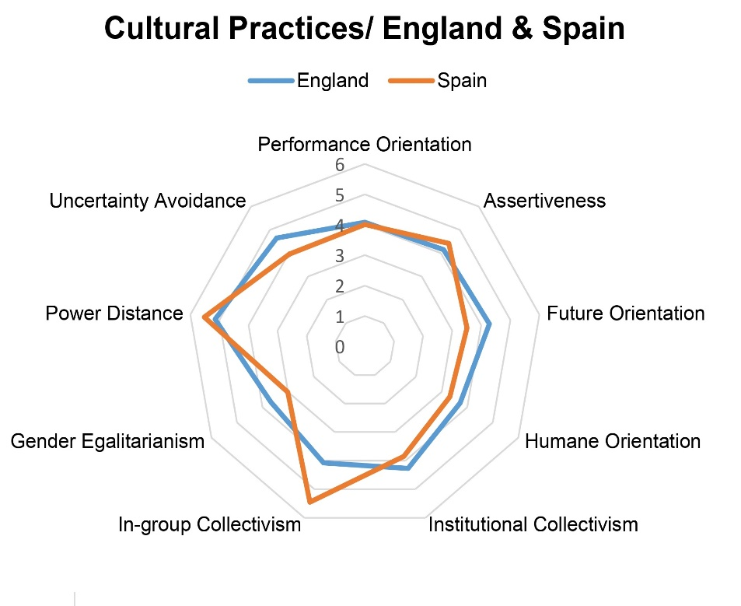
[Source: (GLOBE Project, 2020a; GLOBE Project, 2020b)]

Table III. GLOBE Project/ Cultural Values in England & Spain
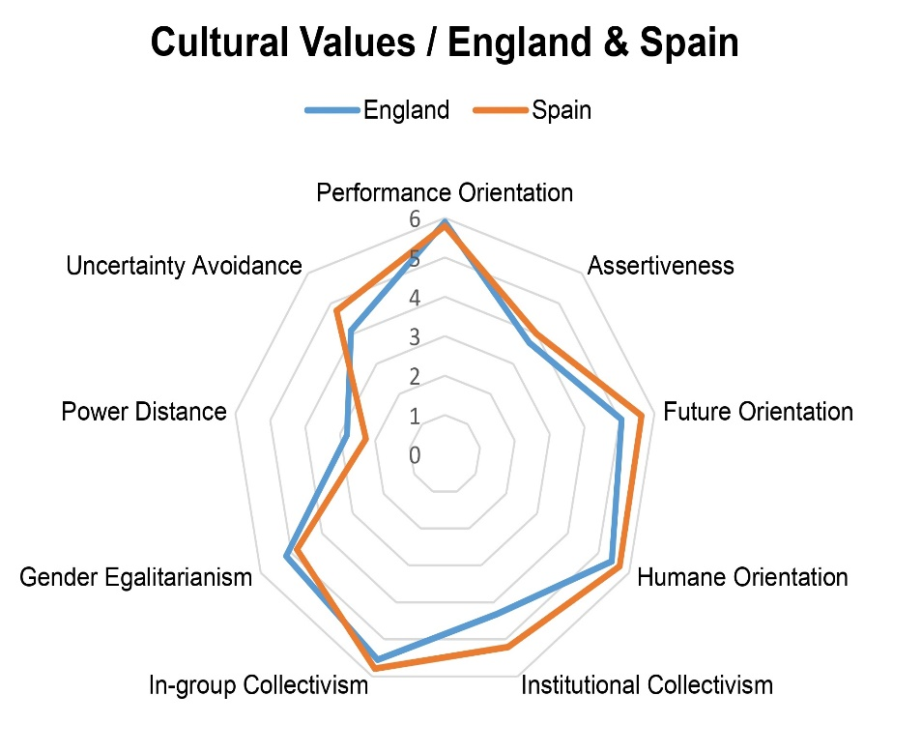
[Source: (GLOBE Project, 2020a; GLOBE Project, 2020b)]
- Both countries score high in performance orientation. Both cultures emphasise effective and competitive work.
- Both countries have high scores in assertiveness. This indicates that active communication and assertive behaviour are important in both cultures.
- Both countries exhibit strong group collectivism. In England and Spain, fitting into groups and strengthening group identity are seen as important.

Differences
- England has higher scores in future orientation in both practices and values compared to Spain, where these scores are lower. This indicates that England places more emphasis on long-term planning and development.
- England has higher scores in gender egalitarianism in both practices and values compared to Spain, where these scores are lower. This suggests that England places more emphasis on promoting gender equality.
- Spain has higher power distance in both practices and values than England. This indicates that in Spain, there is a greater distance between authority and subordination.

Leadership Styles
Based on the data, different leadership styles can be observed in both countries, but there are differences in the strengths and frequency of each style.

Table IV. Leadership Scores for Outstanding Leadership in England & Spain
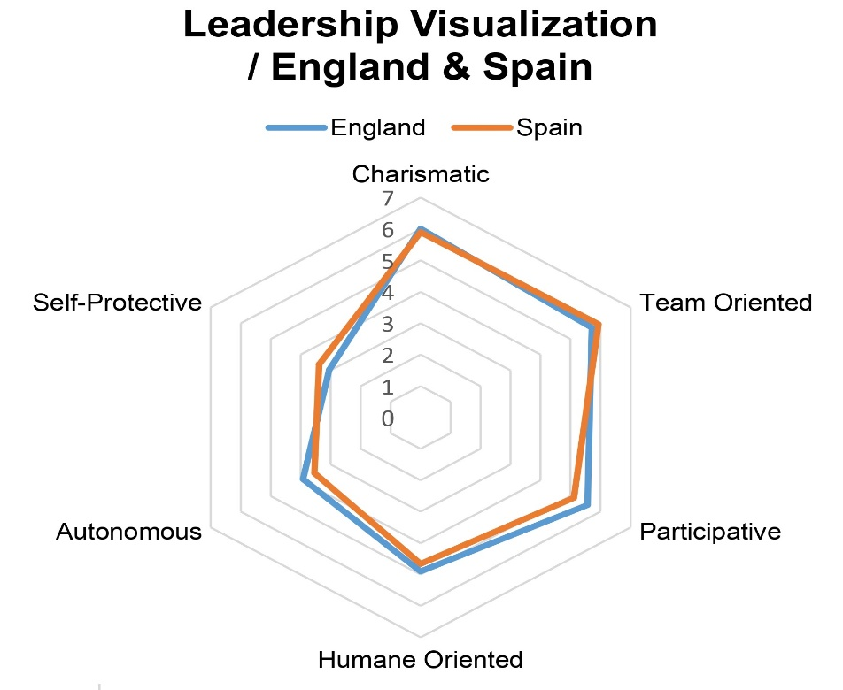
[Source: (GLOBE Project, 2020a; GLOBE Project, 2020b)]
Charismatic leadership is important in both countries, but Spain generally scores higher on this style. However, Spain scores lower in autonomous leadership style and defensive behaviour compared to England. This indicates that leadership culture and preferences may vary between countries based on the data from the Globe project.

Intercultural Leadership Challenges in the Hospitality Industry: Conflict Areas and Examples
Several causes for conflict which can affect the intercultural members have productivity and effectiveness can be found by closely analysing the difficulties of intercultural leadership in the hospitality sector (Yang, Cheung & Li, 2020).
First, the communication differences stand out clearly. For instance, there may be miscommunications and disputes due to the disparities in communication techniques between the cultures of Spanish and English. While the Spanish might prefer to be quieter and avoid conflict, the English are frequently more straightforward and detailed in their communication. This difference may cause conflict and lower team productivity (Jiang et al., 2016).
Second, problems with time and work management can play a significant role in conflicts. There can be significant differences between the English and Spanish work cultures in the attitude to time and the pace of work. The English tend to place more emphasis on meeting deadlines and being efficient, while the Spanish may tend to be more relaxed about time and focus more on interaction and relationships. This can lead to conflict situations when managing working hours and tasks (Mraovic, 2021).
Thirdly, differences between decision-making processes and hierarchical structures are also potential sources of conflict (Yirik, Yõldõrõm & Çetinkaya, 2015). In the English work environment, quick and efficient decision-making often prevails, while in the Spanish culture consultation and reaching consensus may be preferred. Because of this, English managers may have difficulty working with Spanish team members, which can lead to conflicts.
Finally, conflicts may also arise in the field of values and business ethics during intercultural management (Shonk, 2023). English and Spanish cultures have different values and business practices, which can cause tension and conflict in workplace practices and decision-making.

Conclusion
Mapping intercultural differences between England and Spain is a key step towards successful teamwork and integration. By analysing the cultural differences highlighted by this report and the dimensions revealed by the GLOBE Project, the analysis of similarities and differences will allow the development of effective management strategies. The challenges and management of intercultural leadership are essential for effective team building and motivation (Chaplik, 2020). The report's recommendations and understanding of cultural differences will enable hotel management to effectively address these challenges and promote harmonious collaboration and performance between London and Spanish teams.

Recommendations
As a first step, regular language and communication trainings should be organised for employees to improve their language skills and understand each other's communication styles (Ashton, 2017).
Secondly, cultural sensitivity and work ethics training should be organised to help employees respect one another's value systems and cultures (Saari and Korjala, 2013).
Finally, team-building activities should be regularly organised to strengthen team cohesion and motivate employees to work together (Jyoti and Dimple, 2021). In this way, tensions resulting from differences can be reduced and workplace atmosphere and performance can be improved.

References
- Ashton, A.S. (2017). How Human Resources Management Best Practice Influence Employee Satisfaction and Job Retention in the Thai Hotel Industry. Journal of Human Resources in Hospitality & Tourism, 17(2), pp.175–199. DOI: https://doi.org/10.1080/15332845.2017.1340759.
- Chaplik, K. (2020). Managing Intercultural Teams Bachelor Thesis for Obtaining the Degree BSc in International Management. [online] Available at: https://www.modul.ac.at/uploads/files/Theses/Bachelor/Undergrad_2020/BSC_2020/1721007_CHAPLIK_Kristina_Thesis_BSc.pdf [Accessed 10 Feb. 2024].
- Evason, N. (2016). British Culture - Communication. [online] Cultural Atlas. Available at: https://culturalatlas.sbs.com.au/british-culture/british-culture-communication [Accessed 6 Feb. 2024].
- Globe (2020). Results - GLOBE Project. [online] www.globeproject.com. Available at: https://globeproject.com/results%3Fpage_id=country.html#list [Accessed 12 Feb. 2024]. Reviewed England & Spain.
- Janicke, M. (2024). Business Culture in Spain. [online] Expat Guide to Spain | Expatica. Available at: https://www.expatica.com/es/working/employment-basics/business-culture-in-spain-102512/ [Accessed 8 Feb. 2024].
- Jiang, X., Flores, H.R., Leelawong, R. and Manz, C.C. (2016). The Effect of Team Empowerment on Team Performance. International Journal of Conflict Management, 27(1), pp.62–87. DOI: https://doi.org/10.1108/ijcma-07-2014-0048.
- Jyoti, J. and Dimple, D. (2021). Fun at Workplace and Intention to leave: Role of Work Engagement and Group Cohesion. International Journal of Contemporary Hospitality Management, [online] 34(2). DOI: https://doi.org/10.1108/ijchm-06-2021-0704.
- Kim, M., Choi, L., Knutson, B.J. and Borchgrevink, C.P. (2017). Hotel Employees’ Organizational Behaviors from cross-national Perspectives. International Journal of Contemporary Hospitality Management, 29(12), pp.3082–3100. DOI: https://doi.org/10.1108/ijchm-05-2016-0280.
- Mraovic, J. (2021). The Perception of Time in Different Cultures. [online] Clockify Blog. Available at: https://clockify.me/blog/managing-time/time-perception/ [Accessed 9 Feb. 2024].
- Ojo, A.S., Nnyanzi, L.A., Giles, E.L., Ells, L., Okeke, S.R., Ajayi, K.V. and Bolarinwa, O.A. (2023). I Am Not Really into the Government Telling Me What I Need to eat”: Exploring Dietary beliefs, knowledge, and Practices among Ethnically Diverse Communities in England. BMC Public Health, [online] 23(1). DOI: https://doi.org/10.1186/s12889-023-15689-6.
- Randolph, M. (2018). A Uniquely Spanish Part of the Meal. [online] www.bbc.com. Available at: https://www.bbc.com/travel/article/20180424-a-uniquely-spanish-part-of-the-meal [Accessed 7 Feb. 2024].
- Saari, S. and Korjala, V. (2013). Cultural Diversity in Hospitality Management– How to Improve Cultural Diversity Workforce. [online] Available at: https://www.theseus.fi/bitstream/handle/10024/55331/Korjala_Veera.pdf [Accessed 14 Feb. 2024].
- Shonk, K. (2023). How to Resolve Cultural Conflict: Overcoming Cultural Barriers at the Negotiation Table. [online] PON - Program on Negotiation at Harvard Law School. Available at: https://www.pon.harvard.edu/daily/conflict-resolution/a-cross-cultural-negotiation-example-how-to-overcome-cultural-barriers/ [Accessed 9 Feb. 2024].
- Yang, H., Cheung, C. and Li, W. (2020). Intercultural Communication Competency Practices in the Hotel Industry. Journal of China Tourism Research, 18(1), pp.1–23. DOI: https://doi.org/10.1080/19388160.2020.1807432.
- Yirik, E., Yõldõrõm, B. and Çetinkaya, N. (2015). A Study on Conflict Management and Conflict Resolution in Hospitality Organizations. [online] International Journal of Arts & Sciences. Available at: http://universitypublications.net/ijas/0808/pdf/F5N134.pdf

Table’s References

Table 1:
- Attwooll, J. (2010). Spain’s Weird and Wonderful Festivals. [online] The Telegraph. Available at: https://www.telegraph.co.uk/travel/festivalsandevents/8179397/Spains-weird-and-wonderful-festivals.html [Accessed 13 Feb. 2024].
- Farangiz, E., Kizi, O. and Yakubov, F. (2022). Holidays in USA and UK. [online] Available at: http://newjournal.org/index.php/new/article/download/987/840 [Accessed 13 Feb. 2024].
- Government Digital Service (2016). UK Bank Holidays. [online] GOV.UK. Available at: https://www.gov.uk/bank-holidays [Accessed 12 Feb. 2024].
- Zhou, R. (2024). Spain Public Holidays 2024- a Full List Is Here. [online] www.globalhighlights.com. Available at: https://www.globalhighlights.com/spain/festival-public-holiday [Accessed 12 Feb. 2024].

Table 2 & Table 3 & Table 4
- GLOBE Project (2020a). Results - England GLOBE Project. [online] Globeproject.com. Available at: https://globeproject.com/results/countries/GBR%3Fmenu=list.html#list [Accessed 13 Feb. 2024].
- GLOBE Project (2020b). Results - Spain GLOBE Project. [online] Globeproject.com. Available at: https://globeproject.com/results/countries/ESP%3Fmenu=list.html#list [Accessed 13 Feb. 2024].

