
Lecturer: Gasso Wilson Mwalueseke
Student Name: Varzari Cristina
Student ID: 2110951
Module code : LCBB5000
Module Title: Data Handling & Business Intelligence

Table of Contents
Introduction 3
Part 1: Hotel reservation Dataset 3
Pros and Cons of Excel Pre-Processing of Data 3
Pros and Cons of Data Analysis in Microsoft Excel 4
Pros and Cons of Visualization of Data in Microsoft Excel 5
IF Functions in Microsoft Excel 6
LOOKUP/VLOOKUP/XLOOKUP in Microsoft Excel 6
PIVOT Tables in Microsoft Excel 8
Part 2: Student Score Dataset 13
1. How many students are male and female? 13
2. How many students qualify and do not qualify for reduced/free lunch? 14
3. What are the mean and median of students who qualify and do not qualify for reduced/free lunch? 14
4. What are the mean and median differences between students' pre-test and post-test scores? 15
5. Using the dataset Student_Score.csv provided in conjunction with SPSS, give a specific example of Clustering (ex. K-Means Clustering). Show your workings with screenshots and clearly explain your results. 15
6. With real-world (practical) examples, explain a minimum of 5 most common data mining and text mining methods for each that can be used in contemporary business. 16
7. Discuss the advantages and disadvantages of using SPSS and Excel using relevant practical examples and present your discussions in a table. 17
Conclusion 20
References 21

Introduction
Data visualization is the process of representing data in a graphical or pictorial format to help understand and interpret patterns, trends, and relationships in the data. Effective data visualization can facilitate insights and help communicate complex information clearly and effectively. Excel has some popular data visualization tools used for data analysis and visualization. Microsoft Excel provides a range of data visualization options, including charts, graphs, and pivot tables. While it may not be as flexible or advanced as some other tools, it can be useful for basic data visualization tasks. “Overall, the choice of data visualization tool depends on the specific needs of the project and the user's level of expertise. Some tools may be better suited for certain types of data or visualizations”, while others may require more programming knowledge or provide more flexibility.

Part 1: Hotel reservation Dataset

Pros and Cons of Excel Pre-Processing of Data
The widely-used software, Microsoft Excel, serves as a spreadsheet program for data handling and examination. It is beneficial for preparing data for further analysis through its features such as data cleaning, formatting, and transformation. Nevertheless, there exist some possible restrictions and points to bear in mind while utilizing Excel for data pre-processing.
Pros:
- Data cleaning: Excel provides a variety of tools for cleaning and standardizing data, such as removing duplicates, correcting misspellings, and converting data types.
- Data transformation: Excel allows users to apply various mathematical and statistical functions to transform data, such as normalization, scaling, and aggregation.
- Data formatting: Excel provides a range of formatting options to improve the readability and presentation of data, such as adjusting font size, colour, and alignment.
- User-friendly interface: Excel has a user-friendly interface that makes it easy for non-technical users to perform basic data pre-processing tasks.

Cons:
- Limited scalability: Excel can be slow and inefficient when working with large datasets, which may limit its ability to handle complex data pre-processing tasks.
- Risk of errors: Excel is prone to errors, particularly when working with complex formulas or functions. These errors can lead to inaccurate data pre-processing results.
- Lack of reproducibility: Excel does not provide a reproducible workflow, which makes it difficult to reproduce data pre-processing steps and results.
- Security risks: Excel files can be easily shared and accessed by others, which may pose security risks if sensitive or confidential data is being processed.
Overall, Microsoft Excel can be a useful tool for basic data pre-processing tasks, particularly for small to medium-sized datasets (Haq et al., 2020). However, for more complex data pre-processing tasks or larger datasets, more advanced tools and programming languages may be required to ensure accuracy, scalability, and reproducibility.

Pros and Cons of Data Analysis in Microsoft Excel
Microsoft Excel is widely used for data analysis due to its versatility and ease of use. Here are some pros and cons of using Excel for data analysis:
Pros:
- Easy to use: Excel has a user-friendly interface that makes it easy for non-technical users to perform basic data analysis tasks.
- Wide range of functions and tools: Excel provides a wide range of functions and tools for data analysis, including statistical functions, pivot tables, and charts.
- Data visualization: Excel offers a variety of chart types and options for creating clear and informative visualizations of data.
- Integration with other tools: Excel can easily integrate with other tools and software, such as Microsoft Power BI, to enhance data analysis capabilities.

Cons:
- Limited scalability: Excel may not be the best option for analyzing very large datasets, as it can be slow and inefficient when working with large amounts of data.
- Risk of errors: Excel is prone to errors, particularly when working with complex formulas or functions. These errors can lead to inaccurate data analysis results.
- Lack of reproducibility: Excel does not provide a reproducible workflow, which makes it difficult to reproduce data analysis steps and results.
- Lack of flexibility: Excel has limited flexibility in terms of data processing and analysis compared to other programming languages and statistical software.
Overall, Microsoft Excel can be a useful tool for basic data analysis tasks, particularly for small to medium-sized datasets (Kowalska and Manning, 2021). However, for more complex analysis tasks or larger datasets, more advanced tools and programming languages may be required to ensure accuracy, scalability, and reproducibility.

Pros and Cons of Visualization of Data in Microsoft Excel
Microsoft Excel provides a variety of options for visualizing data, such as charts, graphs, and pivot tables. Here are some pros and cons of using Excel for data visualization:
Pros:
- User-friendly interface: Excel has a user-friendly interface that makes it easy for non-technical users to create basic visualizations.
- Wide range of chart types: Excel offers a wide range of chart types and options for creating clear and informative visualizations of data.
- Customization options: Excel provides a variety of customization options for visualizations, such as color schemes, font styles, and chart elements.
- Integration with other tools: Excel can easily integrate with other tools and software, such as Microsoft Power BI, to enhance data visualization capabilities.

Cons:
- Limited flexibility: Excel has limited flexibility in terms of creating advanced and complex visualizations compared to other tools and programming languages.
- Limited scalability: Excel may not be the best option for visualizing very large datasets, as it can be slow and inefficient when working with large amounts of data.
- Risk of errors: Excel is prone to errors, particularly when working with complex charts or data sets. These errors can lead to inaccurate data visualization results.
- Limited interactivity: Excel visualizations can be less interactive than other visualization tools, such as Tableau or D3.js.
Overall, Microsoft Excel can be a useful tool for basic data visualization tasks, particularly for small to medium-sized datasets (Ypusif and Zakaria, 2022). However, for more advanced or complex visualization tasks, other tools and programming languages may be required to ensure accuracy, scalability, and interactivity.

IF Functions in Microsoft Excel
Microsoft Excel's IF function is a logical function that permits you to examine a condition and produce a particular value if the condition is true, or an alternative value if it is false. The structure of the IF function can be represented as follows:
“=IF(logical_test, value_if_true, value_if_false)”
Each argument performs the following roles:
- “logical_test: This is the condition that you want to test. It can be a comparison, such as A1>B1, or a function that returns a logical value, such as ISBLANK(A1).
- value_if_true: This is the result that Excel will provide if the logical test is found to be true..
- value_if_false: This refers to the result that Excel will provide if the logical test is found to be false.

For example, let's say you have a column of sales data in column A and you want to calculate a bonus for any salesperson who has made more than $10,000 in sales. You could use the IF function with the following formula”:
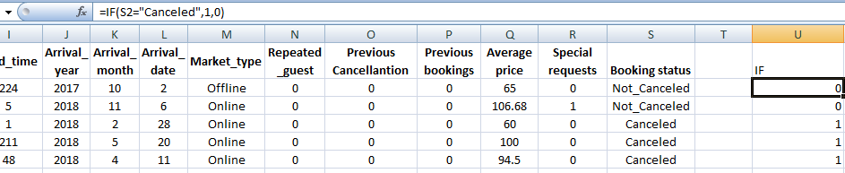
Figure 1: IF Functionality

The IF function in Microsoft Excel can be combined with other functions to create more intricate logical evaluations (Godino, 2022). The AND or OR functions can be utilized to test multiple conditions within the logical_test argument.
This feature enhances the versatility of the IF function. In general, the IF function is a potent tool in Microsoft Excel that can be applied to various tasks such as validating data, formatting data based on certain conditions, and executing calculations that depend on logical tests.

LOOKUP/VLOOKUP/XLOOKUP in Microsoft Excel
Microsoft Excel has three lookup functions that enable you to find a “value in a table and retrieve the corresponding value from a specified column. These functions are LOOKUP, VLOOKUP, and XLOOKUP.
LOOKUP: Although it is still available for backward compatibility, the LOOKUP function has been deprecated in newer versions of Excel. This function searches for a value within a singular row or column and retrieves a corresponding value from the same location in another row or column.
VLOOKUP: The VLOOKUP function searches for a value in the first column of a table and retrieves a value from a designated column in the same row. The syntax of the VLOOKUP function is as follows:
“=VLOOKUP(lookup_value, table_array, col_index_num, [range_lookup])”

- lookup_value: Referring to a table, this means the value that you are looking to locate specifically within the first column.
- table_array: The range of cells that makes up the table, including the first column that contains the lookup value and the column that contains the result you want to return.
- col_index_num: The column number of the table from which you want to return a value.
- range_lookup: Optional argument that specifies whether you want an exact match or an approximate match. If this argument is omitted, an exact match is assumed.
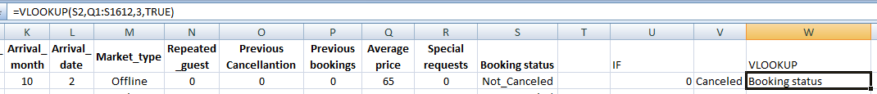
Figure 2: VLOOKUP Usage

XLOOKUP: function is a more recent addition to Microsoft Excel, which was introduced in Excel 365. It enables you to look up a value in any column of a table and retrieve a corresponding value from a specific column. Here is the syntax of the XLOOKUP function:
“=XLOOKUP(lookup_value, lookup_array, return_array, [if_not_found], [match_mode], [search_mode])”
- lookup_value: The value you want to find in the lookup_array.
- lookup_array: The range of cells that contains the values to search.
- return_array: This refers to the group of cells that holds the values which will be returned as a result.
- if_not_found: Optional argument that specifies what value to return if the lookup value is not found.
- match_mode: Optional argument that specifies the type of match to perform. If omitted, an exact match is performed.
- search_mode: Optional argument that specifies the direction of the search. If omitted, a search from top to bottom is performed”.
In Excel, the most popular lookup functions for fetching data from tables are VLOOKUP and XLOOKUP, while the use of LOOKUP is not encouraged anymore because of its limitations (Booker et al., 2022). XLOOKUP is regarded as a more potent and flexible option than VLOOKUP, but it requires a Microsoft 365 subscription.

PIVOT Tables in Microsoft Excel
Microsoft Excel provides a useful feature called pivot tables that can assist in analyzing and summarizing vast amounts of data in a compact and straightforward manner. By grouping or categorizing data, a pivot table can display various statistics, such as totals, averages, and counts.
Creating a pivot table in Excel involves the following steps:
- “Select the data that you want to use for the pivot table. This can be a range of cells, a table, or an external data source.
- Go to the "Insert" tab on the Excel ribbon, and click on the "PivotTable" button. This will open the "Create PivotTable" dialogue box.
- In the "Create PivotTable" dialogue box, make sure that the "Select a table or range" option is selected, and that the correct range of cells is displayed in the "Table/Range" field. Then, choose whether you want to place the pivot table in a new worksheet or in an existing worksheet.
- Click on the "OK" button to create the pivot table.
After creating the pivot table, you have the option to customize it by dragging and dropping fields into different areas such as "Rows," "Columns," and "Values." To illustrate, you can move a "Category" field into the "Rows" area, a "Date" field into the "Columns" area, and a "Sales" field into the "Values" area, resulting in the pivot table showing the total sales for each category and date”.
Additionally, the "Filter" field can be utilized to limit the displayed data in the pivot table. This allows you to filter by a specific category, date range, or other criteria.
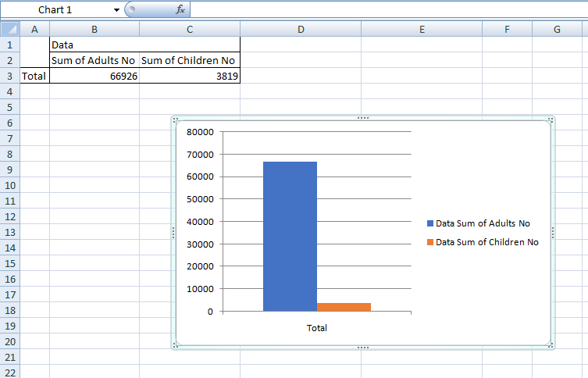
Figure 3: Pivot Table and chart generation

In Excel, pivot tables are a valuable resource that can aid in the quick and efficient summarization and analysis of large datasets. These tables are flexible and dynamic, making them an excellent tool for data analysis as they can be easily updated to reflect any changes in the data (Domino et al., 2021). Overall, using pivot tables can help to save considerable time and effort in data analysis tasks.
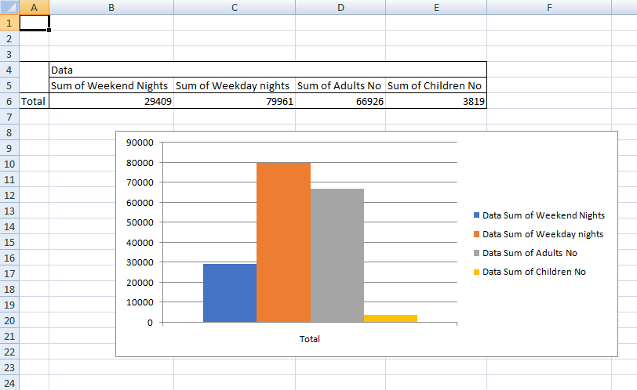
Figure 4: Segregation of pivot data

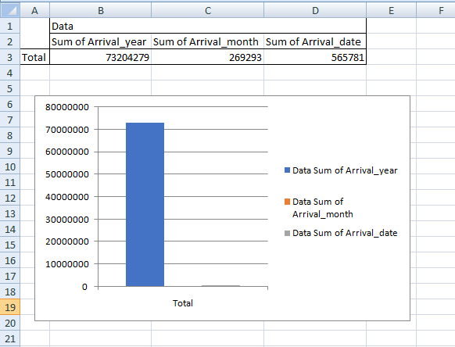
“Figure 5: Sum of the Arrival data

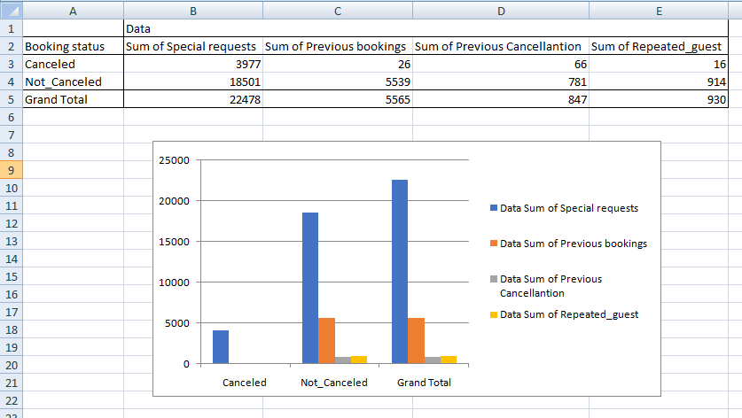
“Figure 6: Sum of the pivot table of different regret generation

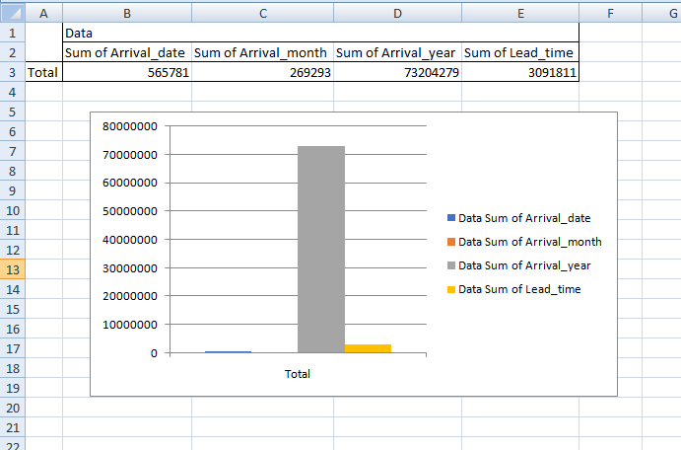
Figure 7: Pivot chart and data generation through Sum of Arrival and Lead time

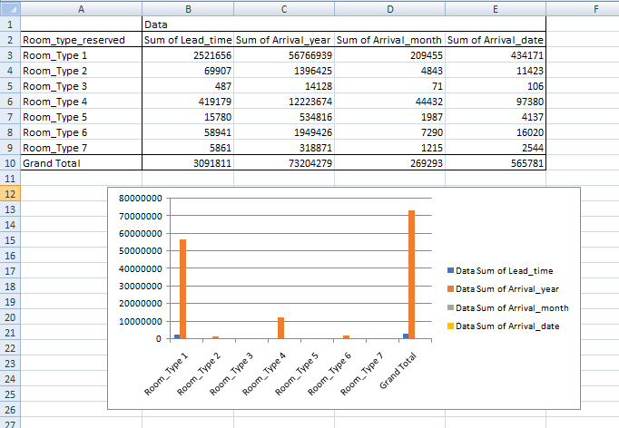
Figure 8: Pivot table of Lead time generation data

Part 2: Student Score Dataset

1. How many students are male and female?
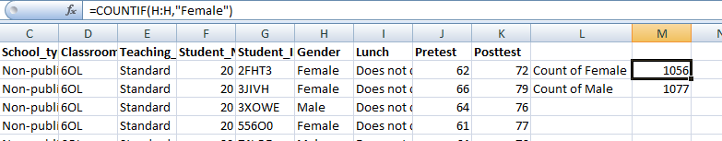
Figure 9: COUNTIF function of Female gender variation

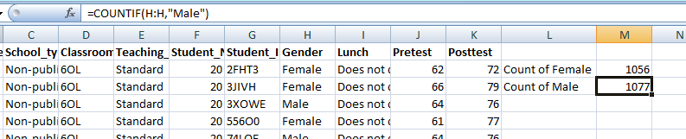
Figure 10: COUNTIF function of Male gender variation

Thus According to the scenario Male is 1077 and Female is 1056

2. How many students qualify and do not qualify for reduced/free lunch?
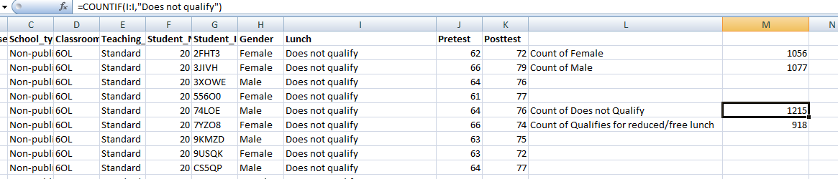
Figure 11: COUNTIF of Luch Data Variable

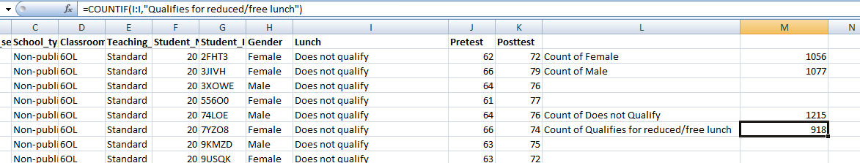
“Figure 12: COUNTIF of Luch Data Variable

Thus According to the Scenario Lunch is Count of Does not Qualify = 1215 and Count of Qualifies for reduced/free lunch = 918

3. What are the mean and median of students who qualify and do not qualify for reduced/free lunch?
 | Count of Does not Qualify | Count of Qualifies for reduced/free lunch | Total
 | 1215 | 918 | 2133
Mean | 1674 | 1525.5
Median | 1674 | 1215
Table 1: Mean Mode of Lunch

4. What are the mean and median differences between students' pre-test and post-test scores?
 | Pretest | Posttest
Mean | 54.95593061 | 67.10220347
Median | 56 | 68
Table 2: Pretest and Posttest scores generation

5. “Using the dataset Student_Score.csv provided in conjunction with SPSS, give a specific example of Clustering (ex. K-Means Clustering). Show your workings with screenshots and clearly explain your results”.
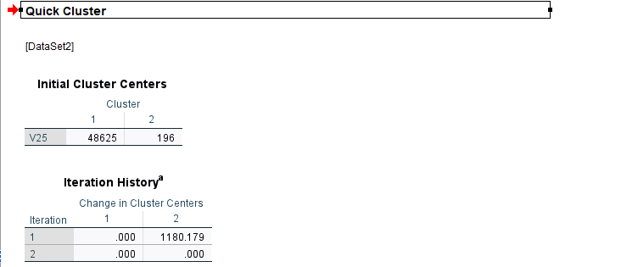
“Figure 13: K-Means Clustering

The convergence has been attained as the cluster centers have undergone little or no modification. The highest amount of absolute change in any center is only .000. The current stage of iteration is 2. The initial centers were separated by a minimum distance of 48429.000.”
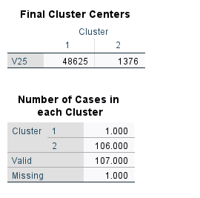
Figure 14: Final Clustering Data output in SPSS

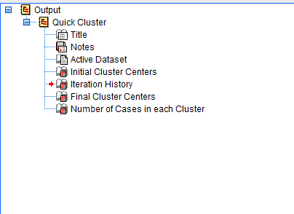
Figure 15: Output Generation technique

6. “With real-world (practical) examples, explain a minimum of 5 most common data mining and text mining methods for each that can be used in contemporary business.
The five common data mining and text mining methods used in contemporary business, along with practical examples of how they can be applied”:
- Classification: Classification is a technique used to predict the category or class of a data point by analyzing its associated features. This approach is widely utilized in various applications such as fraud detection, credit scoring, and spam filtering. For instance, a bank may employ classification to determine the probability of loan default for each application, based on different factors like employment history, credit score, and income.
- Clustering: In this method, data points that share similar characteristics are grouped together without any pre-defined categories. This approach is called clustering and is commonly used in various applications such as anomaly detection, recommendation systems, and customer segmentation. For instance, an e-commerce platform may apply clustering to group customers based on their purchase histories, and then suggest personalized products to each group.
- Association rule mining: Association rule mining is a technique used to discover interesting relationships or patterns between items in a dataset. Market basket analysis is a common application of this method, where retailers analyze customer purchases to identify which items are frequently purchased together. For instance, a grocery store may use association rule mining to determine which products are commonly purchased together and use this information to arrange their store layout and promotions for maximum sales.
- Sentiment analysis: Sentiment analysis is a process of utilizing natural language processing methods to examine text data and identify the expressed sentiment. This technique is commonly used in various applications such as brand monitoring, social media monitoring, and customer feedback analysis (Sarker, 2021). For instance, a company may apply sentiment analysis to evaluate customer reviews of their products or services, and use the results to make necessary improvements.
- Topic modelling: In this approach, the main objective is to identify the major themes or topics present in a collection of textual documents. This technique is beneficial for various tasks such as document clustering, content categorization, and trend analysis. For instance, a news website can utilize topic modeling to group articles together based on their underlying themes, and then suggest related articles to readers.

7. “Discuss the advantages and disadvantages of using SPSS and Excel using relevant practical examples and present your discussions in a table”.
 | Advantages | Disadvantages | Practical Example
SPSS | SPSS is a statistical analysis software that comes with numerous built-in functions and features to simplify and enhance data analysis. It provides advanced statistical analysis capabilities like regression analysis, ANOVA, and factor analysis, making it suitable for analyzing complex data sets. SPSS is proficient in managing large datasets, allowing for efficient analysis. Users can create charts and visualizations to explore data easily. The accuracy and reliability of SPSS make it popular in academic research. | The cost of purchase and maintenance of this software can be high, particularly for small businesses or individuals.<br>- Users who are not familiar with statistical analysis may find it challenging to learn.<br>- It has limited capabilities for non-statistical data analysis tasks.<br>- There are few options available for data cleaning and wrangling within the software. | SPSS can be used for a variety of research purposes. For instance, an academic researcher might use it to investigate the correlation between students' test scores and various demographic factors in a large dataset. Alternatively, a market research company might use SPSS to analyze survey data and determine customers' satisfaction levels with a new product.
Excel | It is widely accessible and user-friendly, and many people are already familiar with its interface and functions. It offers fundamental statistical analysis features like mean, median, and standard deviation. It has various data cleaning and data wrangling capabilities. It provides tools for creating charts and visualizations to facilitate data exploration. It is versatile and can be used for diverse data analysis tasks, beyond just statistical analysis. | Compared to dedicated statistical software like SPSS, Excel has limited statistical analysis capabilities. Excel is not optimized for handling large datasets, which can lead to performance issues when working with a significant amount of data. Excel can be prone to errors, particularly when dealing with complex formulas and data analysis tasks. Excel has limited options for advanced data exploration and visualization. | Excel can be utilized for various purposes. For example, an accountant might create a financial model in Excel to examine the profitability of a new product. Similarly, a marketing analyst might utilize Excel to analyze sales data and identify patterns and trends.
Table 3: Advantages, Disadvantages and Practical Example of SPSS and Excel

In general, both SPSS and Excel have their own strengths and limitations, and the choice between them largely depends on the specific data analysis task and the user's familiarity with the software. SPSS is better suited for complex statistical analysis tasks, particularly in academic research (Vigila et al., 2021). Meanwhile, Excel is more appropriate for basic data analysis tasks and is commonly used in business environments because it is readily available and commonly used by users.

Conclusion
To sum up, Microsoft Excel is a widely used tool for managing, analyzing, and visualizing data, with a user-friendly interface and a broad range of functions and tools that are useful for basic data analysis tasks and small to medium-sized datasets. However, it has some drawbacks, including limited scalability, potential errors, limited flexibility, and a lack of reproducibility, making it less suitable for complex analysis and larger datasets. Hence, more advanced tools and programming languages may be necessary to ensure accuracy, scalability, and reproducibility for complex data analysis and visualization tasks. Nevertheless, “the IF function is a powerful logical function in Microsoft Excel that can test a condition and return” different values based on that condition.

References
Booker, D., Pelzer, J. and Richardson, J.R., 2022. Integrating Data Analytics into the Auditing Curriculum: Insights and Perceptions from Early-Career Auditors. Available at SSRN 4362640.
Cronk, B.C., 2019. How to use SPSS®: A step-by-step guide to analysis and interpretation. Routledge.
Domino, M.A., Schrag, D., Webinger, M. and Troy, C., 2021. Linking data analytics to real-world business issues: The power of the pivot table. Journal of Accounting Education, 57, p.100744.
Godino, L., 2022. How to structure Microsoft Excel documents for systematic reviews. Nurse Researcher, 30(4).
Haq, H.B.U., Kayani, H.U.R., Toor, S.K., Zafar, S. and Khalid, I., 2020. The popular tools of data sciences: Benefits, challenges and applications. IJCSNS, 20(5), p.65.
Kad, N.M., 2019. Program to create Mean Squared displacement data from diffusion.
Kiesslich, T., Beyreis, M., Zimmermann, G. and Traweger, A., 2021. Citation inequality and the Journal Impact Factor: median, mean,(does it) matter?. Scientometrics, 126(2), pp.1249-1269.
Kowalska, A. and Manning, L., 2021. Using the rapid alert system for food and feed: Potential benefits and problems on data interpretation. Critical Reviews in Food Science and Nutrition, 61(6), pp.906-919.
Leech, N.L., Barrett, K.C. and Morgan, G.A., 2005. SPSS for intermediate statistics: Use and interpretation. Psychology press.
Luo, J., 2022, December. Application of K-means Method Based on SPSS in Graphic Design Score Analysis. In 2022 3rd International Conference on Big Data and Social Sciences (ICBDSS 2022) (pp. 453-459). Atlantis Press.
Rosenberg, J., Edwards, A. and Chen, B., 2020. Getting messy with data. The Science Teacher, 87(5), pp.30-35.
Sarker, I.H., 2021. Data science and analytics: an overview from data-driven smart computing, decision-making and applications perspective. SN Computer Science, 2(5), p.377.
Shanthi, R., 2019. Multivariate data analysis: using SPSS and AMOS. MJP Publisher.
Viglia, G., Zaefarian, G. and Ulqinaku, A., 2021. How to design good experiments in marketing: Types, examples, and methods. Industrial marketing management, 98, pp.193-206.
Watkins, M.W., 2021. A step-by-step guide to exploratory factor analysis with SPSS. Routledge.
Yousif, O.S. and Zakaria, R., 2022. Web-Based Big Data Integration Visualisation Solutions. In Sustainability Management Strategies and Impact in Developing Countries (Vol. 26, pp. 103-117). Emerald Publishing Limited.
Zhou, H. and Zhou, H., 2020. Excel and Data Mining. Learn Data Mining Through Excel: A Step-by-Step Approach for Understanding Machine Learning Methods, pp.1-19.

