



Topic: Factors that affecting online store image and the intention to buy in Hong Kong

Abstract
This study explores the elements influencing the image of an online store and the intention to purchase in Hong Kong, highlighting the significance of both traditional and novel elements in the online shopping context. Utilizing a robust methodological framework, the research developed a reliable instrument to measure these factors, leading to the identification of seven constructs associated with online store image. The findings reveal that Enjoyment and Trustworthiness emerged as critical predictors of purchase intention, contrasting with earlier studies that prioritized Usefulness and Ease of Use. Additionally, the study underscores the need for online retailers to enhance both the aesthetic appeal and the security features of their platforms to foster consumer trust and Enjoyment. Limitations regarding participant demographics, particularly the underrepresentation of younger consumers, suggest avenues for future research, including a more diverse age range and exploration of various online store categories. Overall, this research contributes to the understanding of online consumer behavior in Hong Kong, offering actionable insights for marketers in the online store sector.

Key Words: Online store image, Intention to buy, Usefulness, Enjoyment, Ease of Use, Trustworthiness, Style, Familiarity, and Settlement.

- Introduction

The aim and objective of this study is to explores the elements influencing the image of an online store and the intention to buy online in Hong Kong. Researchers like Liao and Shi (2009) revealed that factors such as website Usefulness and Ease of Use play a key role. However, his research had not covered the importance of overall image of online store. This study posits other factors such as Enjoyment, Trustworthiness, Style and Familiarity also influence the image of an online store in Hong Kong. In practical marketing research, various scholars had successfully connected a store's reputation with purchase intentions. It is reasonable to think that these connections would transfer to online settings.

The concept of store image had been extensively studied in relation to brick-and-mortar stores. In an online setting, the current measures of this concept seem insufficient. For instance, Van Der Heijden (2004) pointed out that they include improper things like cleanliness of the shop and how crowded the shop is. Furthermore, crucial components like privacy concerns and accurate delivery of purchased products are omitted from the list of important aspects in an e-commerce platform. Hence, in order to create a useful measurement tool for online store image, I must modify current store image measurement instruments.

The aim of this study is to develop a trustworthy and accurate instrument for assessing online store image, and to investigate how these factors impact the intention to buy online. This study focuses on identifying the conceptual components (dimensions) of online store image. Which objects can be utilized to quantify each of these abstract extents? Do the items provide reliable and valid measurements? Lastly, what are the relationship between the elements of store image and intention to buy online? The main emphasis of this paper is on e-commerce stores catering to consumers, selling physical, safe consumer goods, and solely using the Internet for distribution. The reason for this focus was the similarity between these online stores and brick-and-mortar stores, for which the current store image tools were initially created.

- Theoretical foundations

This study is developed based on research done by Houston and Nevin (1978) about traditional store image, referring to it as the store's personality and the various meanings and relationships as defined by customers. According to Martineau (1958) and Houston and Nevin (1981), store image can be described as how the shopper perceives a store, which is influenced by its functional and psychological qualities, as well as the consumer's views of its practical and emotional characteristics. Consumers view stores based on various aspects, often referred to as components or attributes, that together form the store's image. Kelly and Stephenson (1967) were among the pioneers in creating a method for measuring the image of retail stores. They suggested utilizing the semantic differential, which includes contrasting adjectives on both ends of the scale. According to Lindquist (1975), total of 51 items were designed according to the criteria of overall dimensions, physical characteristics, convenience, product quality, pricing, customer service, advertising, and recommendations from friends. He outlined nine elements in his influential study on the interpretation of pictures. Dickson and Albaum (1977) improved the measurements for retail store image by focusing on store layout and facilities, prices, products, promotion, service and personnel, and other aspects. A tool consisting of 29 components was created and assessed for reliability and validity. Since that time, the retail image had become more popular as a predictor for various factors, such as the appeal of a shopping area and the intention to make a purchase. It is unsurprising that store image serves as a crucial dependent variable. Factors like store atmospherics and store name had been examined in research by Baker, et al (1994) and research by Grewal, et al (1998). The consumer behaviour literature had thoroughly examined the connections between store image components and purchase intentions. Several research including Dodds, et al (1991) and Sweeney, et al (1999) had established a connection between certain store image elements like store name perception, price perception, and value for money to intention to buy. Nevin and Houston (1980) examined how the store image affects the desire to shop in a specific location. Strong relationships were not discovered; the proximity of the consumer to the shop was determined to be a more significant predictor. Some may suggest that distance is less significant in an online environment, therefore these discoveries may not easily apply to an e-commerce setting. Baker, et al (1994) examined how store image affects intentions. Their specific practical situation included bicycles and shops that sell bicycles. Their findings showed that there were strong connections between the image of the store and the intention to make a purchase. Although the correlation between store image and intention to buy was weak, the correlation between perceived value and intention to buy was stronger. There are those who would claim that perceived value is also a feature of store image, as this element is discussed in many store image studies. Combined, the variables explained 41% of the variation in purchase intentions. Bell (1999) conducted a study to examine how the perception of a retail store's image affects the likelihood of making a purchase at that store. A study using exploratory factor analysis found five factors: visual appeal, variety and quality of offerings, pricing equity, and convenience. Combined, they accounted for 29% of the variability in attitude towards buying. The attitude concept accounted for 30% of the variability in the willingness to purchase.

The desire to buy online is a concept that closely resembles the desire to utilize a website. Davis (1989) had investigated the origins of this concept by using input variables from the popular Technology Acceptance Model construct within the framework of the World Wide Web. Lederer, et al (2000) identified that support information, management, R&D, primary activities, and information quality are factors leading to Usefulness. Van Der Heijden investigated how the concept of perceived attractiveness contributes to the experience of Enjoyment. A distinct attitude framework is frequently represented as an intermediary between assessments of the system and the intentions of using it. A significant amount of research had concentrated on the factors that come before and after website usability, or, in terms of the Technology Acceptance Model, the perception of Ease of Use. This holds significance within the scope of this paper since the human-computer interaction is expected to impact the perception of the online store. For instance, Huizingh (2000) analyzed the differences in the layout and information of 150 websites that are accessible to the public. Liu and Arnett (2000) examined the factors that influence the quality of website design. It is clear from this and other studies that how easy a website is to use greatly influences peoples' attitudes and intentions towards visiting it. Some writers had proposed that this impact is not immediate, but rather indirect through utility and pleasure. The potential for applying these results to understand the desire to visit a website for online shopping presents an interesting opportunity to connect research on the Technology Acceptance Model with studies in online consumer marketing.

Van Der Heijden (2004) pointed out that factors affecting online store image and the intention to buy on online store include online store Usefulness, online store Enjoyment, online store Ease of Use, online store Trustworthiness, online store Style, online store Familiarity, and online store Settlement:

- Usefulness of online store is evident when it is quick and easy to use, surpassing manual shopping systems, and also enhances user performance. This aligns with the research done by Davis (1989), who affirmed the importance of Usefulness is essential in influencing intention to buy online, as well as the research done by Singh (2016), Nguyen (2020), and Ha & Stoel (2009) who acknowledged that the positive impact of Usefulness on online shopping intention.

- Enjoyment is how a consumer finds pleasure in the process or activities of shopping according to Beatty & Ferrell (1998) and Mohan, et al (2013). Donovan, et al (1994), Bellenger & Korgaonkar (1980) and Shannon & Mandhachitara (2008) determined that shoppers who like shopping spend a longer amount of time per visit, leading to increased spending, and are often less traditional, more inventive, and more engaged in seeking information..

- Ease of use refers to buyers’ perceptions that online shopping will require minimal effort according to Davis (1989). Ease of use refers to the lack of difficulty experienced by consumers when using online shopping sites, as they do not need to exert much effort. Hence, consumer's online shopping decision can be influenced by how easily they understand information, the functionality of the application, and the quality of service. This statement aligns with the research carried out by Singh, et al (2016), Trinh, et al (2020), and Nguyen, et al (2020) which stated Ease of Use impacts one's choice to buy online.

- Trustworthiness means secure transmission and protection of data privacy according to Doney & Cannon (1997), Gruman (1999), and Hoffman, et al (1999). Users feel secure when conducting transactions on the website. The users rely on the website to protect his personal information. Users have faith that the administrators of the website will not abuse their personal data. Trustworthiness has an positive influence on online shopping decisions.

- Online store Style depicts the organization of the content on the website as stated by Ranganathan and Grandon (2002). The website Style quality is crucial for drawing in customers to any online store. In their research, Cho and Park (2001) discovered a link between the quality of website Style and customer satisfaction in e-commerce. Additionally, Ranganathan and Ganapathy (2002) have presented scientific proof demonstrating that the online store Style positively influences the intention to buy.

- Familiarity stems from positive interactions between consumers and producers through product assessment, reflecting a strong relationship according to Luhmann (2001). Familiarity is a personal sensation stemming from past experiences, education, and interactions regarding past actions according to Zhang, Ghorbani & Cohen (2007). Herrera & Blanco (2011) show that having a level of familiarity can moderate the connection between trust, satisfaction, and intentions to repurchase.

- Settlement refers to the selection of delivery options, delivery accuracy, and delivery speed for products and services provided by the online store. Exceptional Settlement performance demonstrates an online store's capacity to fulfill its responsibilities for each transaction according to Culnan & Armstrong (1999). In line with Spence (1973), Image of an online store, whether positive or negative, can serve as heuristic cues to assess Settlement performance.

- Method

This study utilized the established method of instrument creation proposed by Churchill (1979). Table-1 shows the procedures employed in this procedure.

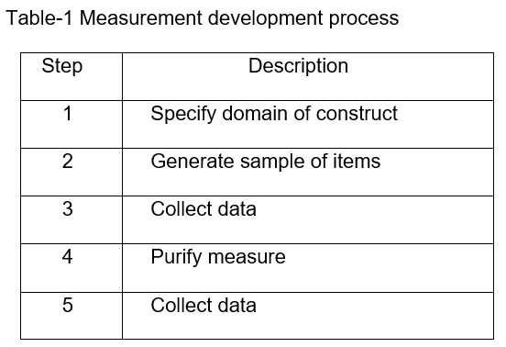
In Step One, I took the retail image construct from Dickson and Albaum (1977) and split it into 7 constructs including online store Usefulness, online store Enjoyment, online store Ease of Use, online store Trustworthiness, online store Style, online store Familiarity, and online store Settlement.

In Step Two, a focus group with a sample of 5 individuals was chosen from my circle of friends who have experience with online shopping. Two of the participants were electronic commerce practitioners. During the focus groups, the participants were requested to give feedback on how relevant the Dickson and Albaum (1977) items are in an electronic commerce setting, and to propose additional items for the intention to buy online. This led to the creation of the Pilot Test Questionnaire which include 7 factors with 32 items: online store Usefulness (6 items), online store Enjoyment (3 items), online store Ease of Use (5 items), online store Trustworthiness (4 items), online store Style (5 items), online store Familiarity (4 items), and online store Settlement (5 items). In order to measure scales for the intention to buy online, this study borrowed the intention scales from Van Der Heijden, et al (2003), which were originally based on the scales from Jarvenpaa, et al (2000) with some modifications following a study on online purchase intention. Target participants are required to fill the intention to buy online (4 items) at the end of the Pilot Test Questionnaire.

In Step Three, this study conducted a pilot test of the instrument involved 10 respondents selected through convenience sampling. Participants were instructed to study the website of HKTVmall (1137.hk) online store and complete the Pilot Test Questionnaire.

In Step Four, by utilizing information from the convenience sample in the Pilot Test, this study examined the reliability of the measurement scales in order to refine the measures. To demonstrate the predictive accuracy of the constructs, the total scores of each component of the online store were analysed against the intention to make a purchase from the online store. This study calculated Cronbach alphas for each measurement. According to George & Mallery (2003), 6 items with alpha coefficients below 0.70 were dropped to improve the reliability. Table-2 shows items revisions from Pilot Test Questionnaire.

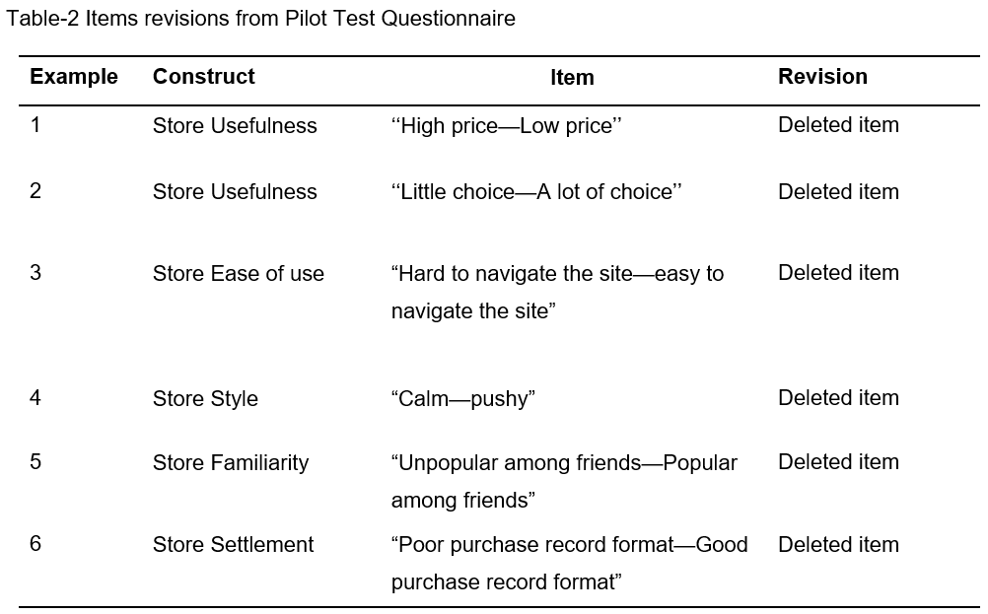

This led to the creation of the Final Experiment Questionnaire which include 7 factors with 26 items: online store Usefulness (4 items), online store Enjoyment (3 items), online store Ease of Use (4 items), online store Trustworthiness (4 items), online store Style (4 items), online store Familiarity (3 items), and online store Settlement (4 items). In order to measure scales for the intention to buy online, target participants are required to fill the intention to buy online (4 items) at the end of the Final Experiment Questionnaire. Please refer to Appendix A for the translated instrument.

In Step Five, this study conducted the Final Experiment involving a sample of professionals which included 30 CEOs or CFOs employed at publicly traded or privately owned companies in Hong Kong. Each professional was required to study the website of HKTVmall (1137.hk) online store and fill out the survey which included the 7 factors with 27 items and fill the intention to buy online (4 items) at the end of the survey.

- Results

There are 30 Participants in Final Experience of this study which include 15 males and 15 females. Most of them are experienced online store buyers who bought online weekly. No age group was divided in the Final Experience due to difficulties in finding different age group. Table-3 shows important descriptors of the sample of the Final Experient in this study.

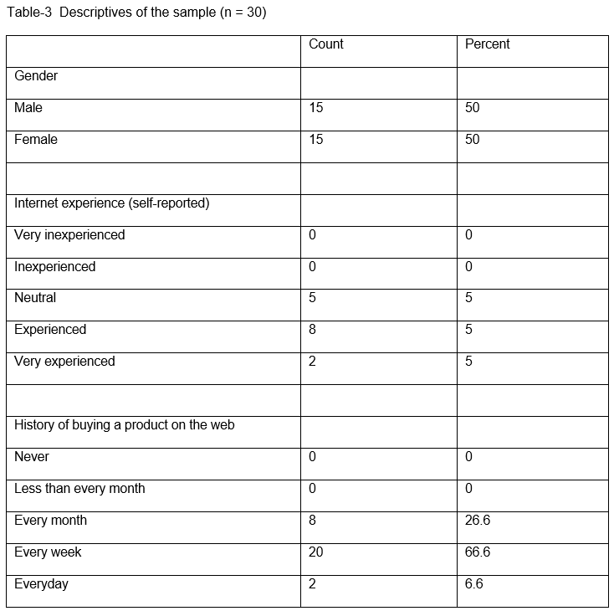

Data received in Final Experiment indicated that the mean, standard deviation, range, minimum, and maximum of score of every items in this study. With higher and the standard deviation is lower compared with the studis done by Van Der Heijden (2003) and Chen & Ching (2013), it implicated that our study is more consistent with the results of other researchers and even more convincing. Table-4 shows the Items Statistics.

Table-4 Items Statistics
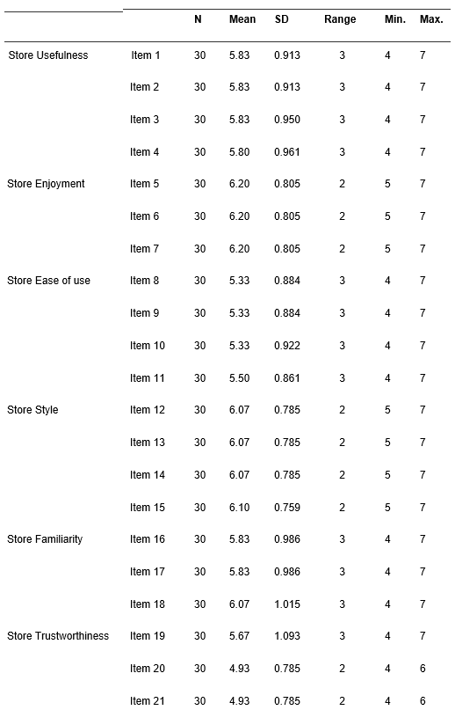
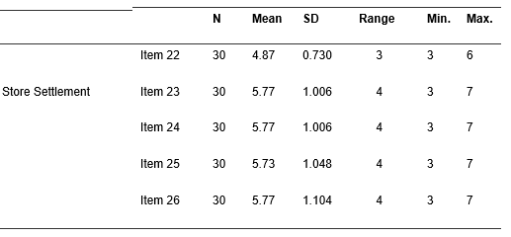
As all of Cronbach alphas in the Final Experiment exceeded the 0.70 threshold for exploratory research, this study determined that the seven-factor structure is a dependable and trustworthy foundation for assessing factors that affect the intention to buy online in Hong Kong. Enjoyment and Trustworthiness are with the highest Cronbach alphas coefficients. This result is different from Ziqi Liao and Xinping Shi (2009) which indicated website Usefulness and Ease of Use played the most important role. Table-5 presents the Cronbach alphas for the data.

Table-5 Cronbach alphas for 7 Factors
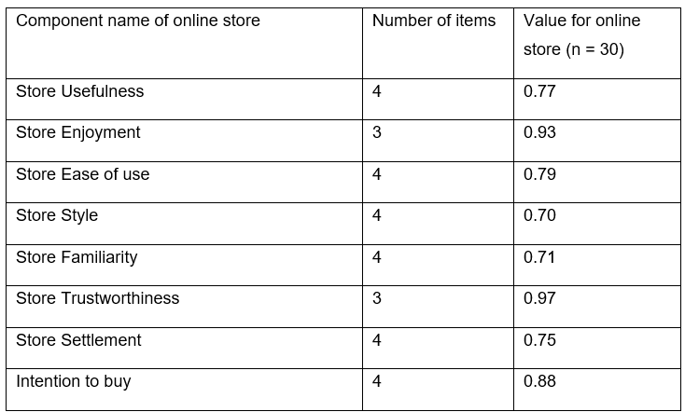
A hypothesis (H0) was tested with an independent samples t-test to determine if there is a correlation between an online shopper's perception of 7 factors and their purchase intention. When the score of the intention to buy from this study is 6.1, 95% confidence interval of the Enjoyment (p=0.298) and Trustworthiness (p=0.811) contain 6.1. H₀ will be accepted and we are 95% confident that an shopper will experience higher intention to buy online as his/her perception of the Enjoyment or/and the Trustworthiness becomes more positive. Table-6 shows the T-Test result for the 7 Factors.

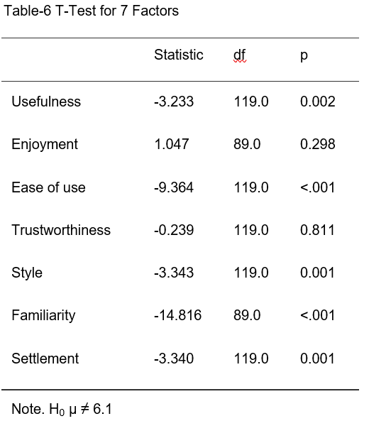

This study also checked the differences in scores between the two groups: females and males. First, we see the statistics for the two groups in table-7. We see that the mean score is higher for females than males which implicated that the male have less intention to buy than the female. Second, table-8 shows a paired t-test between the score of male and female. As the significance value is 0.755, this study conclude that there is no significant difference between the two groups although the female have higher intention to buy.

Table-7 Statistics of Male and Female
 | N | Mean | SD | Variance | Range | Minimum | Maximum
Male | 15 | 6.00 | 0.845 | 0.714 | 2 | 5 | 7
Female | 15 | 6.20 | 0.862 | 0.743 | 2 | 5 | 7

Table-8 Paired Samples T-Test of Male and Female
 |  |  | statistic | df | p
Male | Female | Student's t | -0.318 | 14.0 | 0.755

- Discussion and limitation

This study had added several contributions to the current research on image of online shopping in Hong Kong. Initially, this study created assessments for seven important concepts associated with image of online store. The measures had undergone standard reliability tests and consist of various items. This study had presented findings that connect each of these factors to the inclination for image of online shopping. Enjoyment and Trustworthiness are with the highest Cronbach alphas coefficients. Although the findings of this study is different from Ziqi Liao and Xinping Shi (2009) which indicated website Usefulness and Ease of Use played the most important role, it enhance and broaden comparable empirical studies in this field.

However, the limitation in this study is the age of participants. Younger generations were not willing to respond in this study although great effort tried. Most participants found are above 30 years old while many younger generations were not included in this study. Here is the suggestion that future research can divide participants into different age groups. Future research can also focus on different types of online store e.g. book, clothes, food, electronics…etc. Therefore, readers or investors will locate where the investment or advertising should be focused for different target online buyers.

- Conclusions and recommendations

This study had concentrated on the image of online store. In terms of ideas, this study analysed the literature regarding online store image. By utilizing this method, along with a Trial Run with focus group, a preliminary measuring tool was created. This was later utilized in my Pilot Test. By analysing the data from Pilot Test, this study improved the tools until 7 constructs with 26 items of online store perception were identified.

This study yields at least three conclusions. First, our findings show that all 7 factors related to images can account for a significant part of the intention to buy online as all alpha coefficients are above 0.70. These outcomes are promising for the online store. Second, our findings show that there is a limited correlation between image of online store and Usefulness and Ease of Use which is different from the result of previous researchers. Third, this study not only reaffirm the findings of Van Der Heijden (2004) that Trustworthiness is a key factor of the image of online store but also implicated the significance of the Enjoyment in driving buying intentions. This study implies that investing in enhancing store recognition and appearance is unlikely to greatly affect the image of online store. It is beneficial for online stores to enhance the Trustworthiness and Enjoyment of their websites, while also improving their Usefulness and Ease of Use. This study does offer backing for defining clear priorities in the marketing budget.

Verhagen and Dolen (2009) showed that how consumers perceive offline and online stores directly affects their intention to make purchases online. Moreover, they verified that offline store impressions served as points of reference for their online counterparts. Nevertheless, this study only examines the structural connections between online store image, neglecting to address potential interactions between online and offline store image factors. In reality, a lot of retail stores have both brick-and-mortar shops and online platforms. Hence, future research should explore in more detail the connections between various aspects of online store image and offline store image.

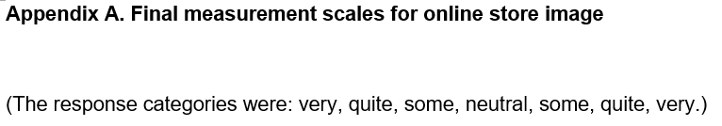
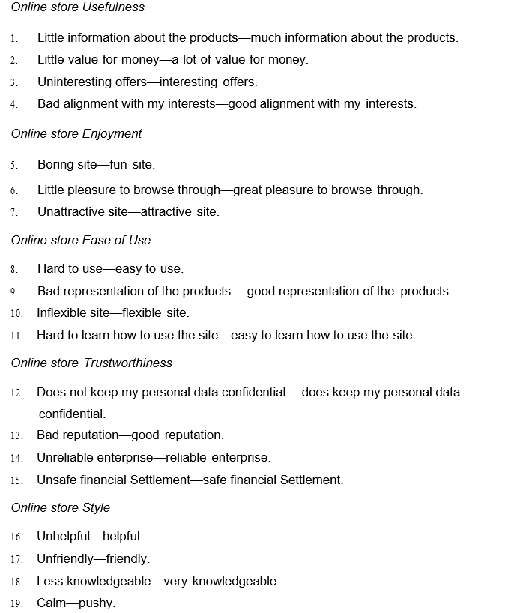

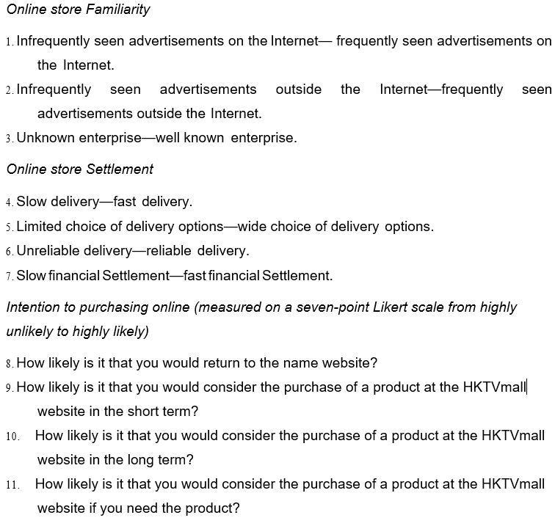

References

A.L. Lederer, et al (2000), The technology acceptance model and the World Wide Web, Decision Support Systems 29, pp. 269–282.

Beatty, S. E., & Ferrell, M. E. (1998), Impulse buying: Modeling its precursors, Journal of retailing, 74, pp. 169–191.

Bellenger, D. N., & Korgaonkar, P. (1980), Profiling the recreational shopper, Journal of Retailing, 56, pp. 77–92.

Cho, N. and Park, S. (2001), Development of electronic commerce user – consumer satisfaction index (ECUSI) for internet shopping, Industrial Management and Data Systems, 101(8), pp.400–405.

C. Liu and K.P. Arnett (2000), Exploring the factors associated with website success in the context of electronic commerce, Information & Management 38, pp. 23–33.

Culnan, M. J., & Armstrong, P. K. (1999), Information privacy concerns, procedural fairness and impersonal trust: an empirical investigation, Organization Science, 10(1), pp. 105–116.

Davis, F. D. (1989), Perceived Usefulness, perceived Ease of Use, and user acceptance of information technology, MIS Quarterly, 13(3), pp. 319-340.

D. Grewal, et al (1998), The effect of store name, Journal of Retailing 74 (3), pp. 331–352.

Donovan, R. J., Rossiter, J. R., Marcoolyn, G., & Nesdale, A. (1994), Store atmosphere and purchasing behaviour, Journal of Retailing, 70, pp. 283–294.

E.K.R.E. Huizingh (2000), The content and design of web sites: an empirical study, Information and Management 37, pp. 123–134.

F.D. Davis (1989), Perceived Usefulness, perceived Ease of Use, and user acceptance of information technology, MIS Quarterly (September), pp.319–340.

G. Churchill (1979), A paradigm for developing better measures of marketing constructs, Journal of Marketing Research 16, pp. 64–73.

George, D. & Mallery, P. (2003), SPSS for windows step by step: a simple guide and reference, 4th ed. Boston: Allyn & Bacon.

Ha, S., & Stoel, L. (2009), Consumer e-shopping acceptance: Antecedents in a technology acceptance model, Journal of business research, 62(5), pp. 565-571

Herrera, C. F. & Blanco, C. F (2011), Consequences of consumer trust in PDO food products: The role of Familiarity, Journal of Product and Brand Management, 20(4), pp. 282–296.

H. Van Der Heijden (2003), Factors influencing the usage of websites: the case of a generic portal in The Netherlands, Information & Management 40 (6), pp. 541–549.

H. Van Der Heijden (2003), T. Verhagen, M. Creemers, Under- standing online purchase intentions: contributions from technology and trust perspectives, European Journal of Information Systems (12 March), pp. 41–48.

H. Van Der Heijden (2004), Online store image: conceptual foundations and empirical measurement, Information & Management 41 (2004), pp. 609–617.

J. Baker, et al (1994), The influence of store environment on quality inferences and store image, Journal of the Academy of Marketing Science 22 (4), pp. 328– 339.

J.C. Sweeney, et al (1999), The role of perceived risk in the quality-value relationship: a study in a retail environment, Journal of Retailing 75 (1), pp. 77– 105.

J. Dickson and G. Albaum (1977), A method for developing tailormade semantic differentials for specific marketing content areas, Journal of Marketing Research 14 (2), pp. 87–91.
J.D. Lindquist (1975), Meaning of image: a survey of empirical and hypothetical evidence, Journal of Retailing 50 (4), pp. 29–38.

J.R. Nevin and M.J. Houston (1980), Image as a component of attraction to intraurban shopping areas, Journal of Retailing 56 (1), 1980, pp. 77–93.

Le, H. B. H., Ngo, C. T., Trinh, T. T. H., & Nguyen, T. T. P. (2020), Factor Affecting Customers’ Decision to Use Mobile Banking Service: A Case of Thanh Hoa Province, Vietnam, Journal of Asian Finance, Economics and Business, 7(2), pp. 205-212.

Luhmann, N (2001), Familiarity, confidence, trust: Problems and alternatives, pp. 15–35.

Ming-Yi Chen and Ching-I Teng (2013), A comprehensive model of the effects of online store image on purchase intention in an e-commerce environment, Electronic Commerce Research. 13. 10.1007/s10660-013-9104-5.

M.J. Houston and J.R. Nevin (1978), Retail shopping area image: structure and congruency between downtown areas and shopping centers, Advances in Consumer Research 8, pp. 677–681.

Mohan, G., Sivakumaran, B., & Sharma, P. (2013), Impact of store environment on impulse buying behavior, European Journal of Marketing, 47, pp. 1711–1732.

Nguyen, O. T. (2020), Factors Affecting the Intention to Use Digital Banking in Vietnam, The Journal of Asian Finance, Economics, and Business, 7(3), pp. 303-310.

P. Martineau (1958), The personality of the retail store, Harvard Business Review 36 (1), pp. 47–55.

P.Y.K. Chau, et al (2000), Impact of information presentation modes on online shopping: an empirical evaluation of a broadband interactive shopping service, Journal of Organisational Computing and Electronic Commerce 10 (1), pp. 1–22.

Ranganathan, C. and Grandon, E. (2002), An exploratory examination of factors affecting online sales, Journal of Computer Information Systems, 42(3), pp.87–93.

R.F. Kelly and R. Stephenson (1967), The semantic differential: an information source for designing retail patronage appeals, Journal of Marketing (31 October), pp.43–47.

Shannon, R., & Mandhachitara, R. (2008), Causal path modeling of grocery shopping in hypermarkets, Journal of Product & Brand Management, 17, pp. 327–340.

Singh, P., et al (2016), A Study of Adoption Behavior for Online Shopping: An Extension of Tam Model. International Journal Advances in Social Science and Humanities, 4(7), pp.11-22.

Singh, P., Keswani, S., Singh, S., & Sharma, S. (2016), A Study of Adoption Behavior for Online Shopping: An Extension of Tam Model, International Journal Advances in Social Science and Humanities. 4(7), pp. 11-22.

S.J. Bell (1999), Image and consumer attraction to intraurban retail areas: an environmental psychology approach, Journal of Retailing and Consumer Services 6, pp. 67–78.

S.L. Jarvenpaa, et al (2000), Consumer trust in an internet store, Information Technology and Management 1 (1), pp. 45–71.

Spence, M. (1973), Job market signalling, Quarterly Journal of Economics, 87(3), pp. 355–374

Verhagen, T., & van Dolen, W. (2009), Online purchase intentions: a multi-channel store image perspective, Information & Management, 46(2), pp. 77–82

W.B. Dodds, et al (1991), The effect of price, brand, and store information on buyers’ products evaluations, Journal of Marketing Research 28, pp. 307–319.

Zhang, J., Ghorbani, A. & Cohen, R (2007), A Familiarity-based Trust Model for Effective Selection of Sellers in Multiagent E-commerce Systems, International Journal of Information Security, 6(5), pp. 333-344.

Ziqi Liao and Xinping Shi (2009), Consumer perceptions of internet‐based e‐retailing: an empirical research in Hong Kong, Journal of Services Marketing, 23(1), pp. 24-30.

