

Module Code: LCMB7023
Module Name: Human Capital Management
Assessment component 1: Individual report
The Influence of National and International Labour Markets on HRM and IHRM Strategies
Student Name: Shivam Vijaykumar Patel
Student ID: 2439811
Lecturer Name: Hoang Dang Nguyen
Executive Summary
This study looks at how ‘Human Resource Management (HRM)’ and 'International HRM (IHRM)’ strategies are affected by ‘demographic changes’, ‘technological improvements’ and ‘geopolitical considerations’. It examines how migration, automation and artificial intelligence affect international labour markets and offers solutions for workforce shortages and skill gaps. Organisations that integrated AI into their HR processes increased their efficiency, reduced hiring discrimination, and improved staff retention. It understands that active listening should be perfected and communication patterns based should be adjusted towards favouring the requirements of foreign employees.
Table of Contents
Introduction 4
Technological Advancements and Their Impact on Labor Markets and HRM and IHRM Strategies 4
Demographic and Geopolitical Factors Influencing Employment Markets 6
Addressing Skills Gaps and Talent Shortages 8
Self-Reflection on International Work Preparedness 11
Overall Conclusive statements 13
References 15

Introduction
The world labour market is experiencing constant change which has been necessitated by technological advancements, demographic changes and geopolitical changes. These forces have a huge impact on the strategic modalities of the Human Resource Management (HRM) as well as International Human Resource Management (IHRM) by forcing organisations to tune down their managerial practice. This report provides a critical overview of the ways emerging technologies, changing demographic trends and geopolitical contingencies impact HRM, and IHRM, as well as how those working in HR can offset skills scarcity and talent gaps in key areas and evaluation of readiness of individuals to work in a culturally diverse and technologically advanced work environment.

Technological Advancements and Their Impact on Labour Markets and HRM and IHRM Strategies
Claim:
The active transformation of the world labour markets by technological advances, particularly, the spread of ‘artificial intelligence (AI)’, ‘automation’ and the ‘digital platforms’ is defining new occupational profiles, requires new HRM and IHRM strategic positions (Sposato and Rumens, 2021; Bader et al., 2021). There is a decline in demand for the low-skilled occupations due to the automation of the routine jobs, but the significance of the high-elevation occupations increases (Jooss et al., 2024; Aldossari and Chaudhry, 2024). These changes provide both challenges and opportunities simultaneously to both HRM and IHRM to perfect approaches concerning the development of its employees, recruitment and management of a global workforce.
Evidence:
The widespread adoption of artificial intelligence and automation has created significant upheavals in the traditional working fields. It was estimated by the World Economic Forum (2025) that the fastest-growing employment responsibilities by 2030, expressed as a percentage, are likely to be driven by technical improvements like robots and artificial intelligence, as well as more digital access. Jobs like Big Data Specialists, FinTech Engineers, AI and Machine Learning Specialists, and Software and Applications Developers are among those with the strongest growth rates (Tran et al., 2024; Khassawneh and Abaker, 2022; Chung and Sparrow, 2024). As a result, the labour market has become increasingly technologically skilled, and the organisations are more concerned with individuals who can demonstrate their skills in such areas as programming, cybersecurity, and AI.
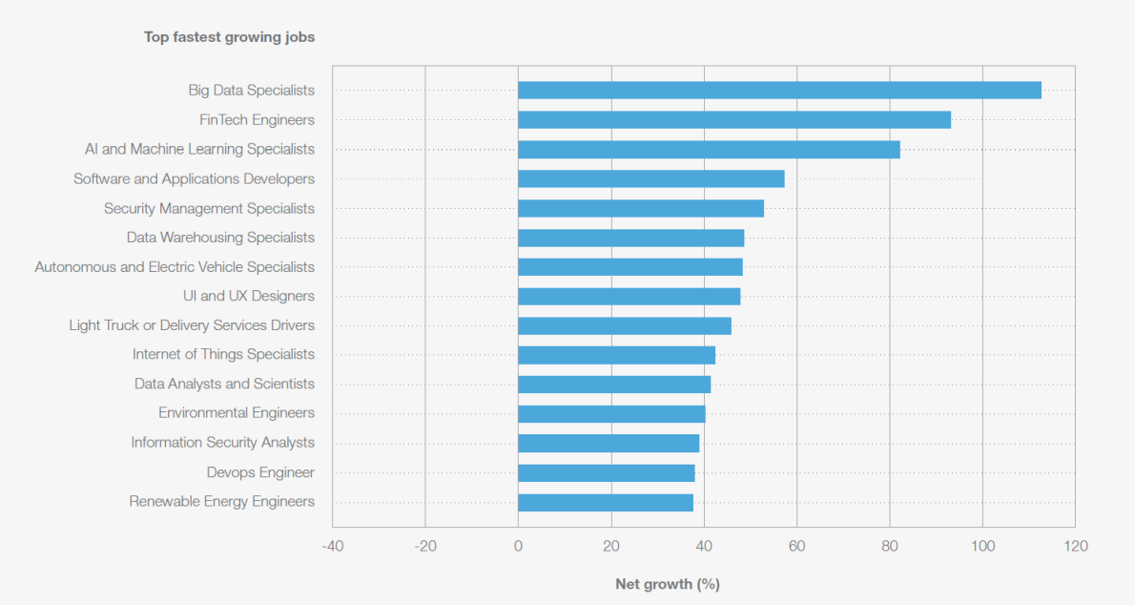
FIGURE 1: Fastest-growing and fastest-declining jobs, 2025-2030
(Source: World Economic Forum)
Many organisations have been adopting online systems to streamline the recruitment and staff management in the HRM field. Applications that use AI are used in the screening of candidates, performance reviews and analytics used in employee engagement. According to Accenture (2025), the degree to which businesses have mastered AI-related competencies in the proper mix to achieve excellent outcomes for consumers, shareholders, and staff is measured by AI maturity.
In the context of IHRM, the development of technology has expanded the scope of remote working; cloud-based collaboration platforms, such as ‘Microsoft teams’, ‘zoom’ and ‘slack’, are now inseparable in supporting synchronistic teamwork amid geographically separated employees. The ability to work at different times and locations has created a more differentiated work force, both in culture and geography, creating new managerial challenges to IHRM, namely on how to manage cross-cultural work teams and how to ensure effective communicative process. A report by PwC (2021) pointed out just 37% of businesses that do not currently use them think that they would increase productivity—down from 63% in our prior poll.
Interpretations:
The rapid technological development presents opportunities and challenges both to HRM and IHRM. The efficiency of the operation, triggers the process of innovation and widens the scope of the availability of worldwide talent pools, maintaining the organisational competitiveness (Fora and Perkasa, 2025). In its turn, job displacement as a result of automation exacerbates the necessity of the HR professionals to facilitate the transition of the workforce and foster the acquisition of the necessary skills of success in the digital economy (Li and Pilz, 2023).
The strategies used by the HRM entities should anticipate reskilling and upskilling initiatives that will help staff prepare for the changing labour environment. New job opportunities in the field of data science, AI, and cybersecurity are on the rise (Fora and Perkasa, 2025). Research has shown a strong correlation between business success and HR policies including performance-based remuneration, intensive training, and selective recruiting (Ayanponle et al., 2024). HR should ensure that the labour force is ready to shift to the new role and consider deploying technology into fundamental operations rather than just operations performance (Presbitero et al., 2023). This will enhance employee experience, more individualised learning journeys, and provide tailored career advancement.
In the case of IHRM, the growing reliance on digital tools to manage remote workforce presents both opportunities and challenges at the same time. Although technology can help organisations recruit employees around the world and provide virtual teams with effective control (Farndale et al., 2025; Cooke et al., 2025). Further, remote working is a global practice, and this means that close attention should be paid to legal and regulatory aspects in various jurisdictions, as far as labour law, data privacy and cybersecurity compliance are concerned.

Demographic and Geopolitical Factors Influencing Employment Markets
Claim:
Two major drivers to change in the global labour markets are demographic changes and geopolitics. Labour markets are increasingly being affected as populations grow old, as they migrate and register variable rates of fertility (Duch-Brown et al. 2022; Szymczak, and Wolszczak-Derlacz, 2022; Lippens et al. 2022). In combination with geopolitical forces, these population shifts create new obstacles to HRM practitioners in the form of migration policy changes, political unrest, and trade tensions (Menzies et al., 2024; Li and Pilz, 2023; Cooke et al., 2025). These variables cannot be fully understood without the knowledge of an HR professional in order to skilfully organize the workforce and forecast the future needs of human capital.
Evidence:
The ageing of the population in many developed countries is one of the biggest demographic changes to exert pressure on the modern labour markets. The United Nations (2022) has estimated that in 2050 one out of every six persons will be above 65 years. This is more so in Japan, Germany, and Italy, whereby the shrinking workforces are due to the retirement of the older workforces. The situation is being further worsened by the fact that the Baby Boomer working generation (Qi et al. 2022). The aging workforce thus becomes a twofold challenge to the human-resource practitioners since they will not only be expected to handle the rising number of retirees but also to overcome the skills gap that will be occurring due to the loss of the experienced employees (Farr-Wharton et al. 2023: Boehm et al. 2021).
The increase in migration due to economic opportunities, political instability and climatic change is another salient demographic factor. According to the International Organization for Migration (2024), there were nearly 281 million foreign migrants worldwide in 2020, or 3.6% of the world's total population. The influx result is a more diverse and multicultural labour market, and at the same time, it poses challenges on the part of HR professionals to manage multicultural workforces and policy adaptation to accommodate multicultural workers.
The geopolitical factors such as trade policies, political instability, and armed conflicts are also extremely important in the formation of the labour market. As an example, the geopolitical rivalry between the US and China has highlighted both traditional and high-tech manufacturing capabilities (Cohen and Rogers, 2021; Zhang, 2025). As a result, importers are being forced to think about modifying their supply chains in order to preserve profitability and customer relationships. The unstable political situation in other parts of the world like the Middle East and Africa means that many people have been forced to move and created a refugee crisis in the countries that the refugees have flooded.
Interpretations:
The ageing demographics of an ageing population and the rising trends of migration are a complicated mix of problems affecting HR experts. An aging population requires strategic workforce planning which involves the adoption of succession plans and maintenance of older workers by offering them flexible working schedules and knowledge- transfer programs (Wissemannet al. 2022). The organizations need to provide proper training and equipment to the next generations as the old and experienced workforce retires leaving important positions to be filled in by them.
Within, further, the increased migration the world over poses both opportunities and challenges. It opens access to a wider range of talent as well as the inclusion and culturally competent HR practices. The HR departments would need to invest in diversity and inclusion programs, offer cross-cultural training and create policies that befit the diverse national and cultural background of the workers (Al-Tarawneh, and Al-Badawi, 2025).
There is a further complexity of geopolitical factors. Trade conflicts, political instability and economic embargo can trigger the problem of labour shortage or surplus, because companies can find it hard to continue operating in those areas. Using adaptive control in conjunction with pre-emptive and mitigating actions before disruptions can successfully reduce the effects in the aftermath (Boonluaet al., 2023). The HR professionals should thus continue to be agile and flexible with regard to geopolitical changes and strategizing contingency plans to get through disruptions in the labour-markets.

Addressing Skills Gaps and Talent Shortages
Claim:
The existence of skills gaps and shortage of talents are becoming rather widespread in most sectors, especially in technological, medical, and manufacturing ones. Such deficits are a significant challenge to Human Resource Management (HRM) where entities struggle to acquire candidates with the necessary skills to handle specific positions (Ochieng, 2023). In order to remain competitive, HR professionals need to use strategic solutions such as reskilling and upskilling, new approaches to recruitment, and collaborations with institutions of learning so that these shortages of talents.
Evidence:
The growing gap between the demands and supply of the workforce is being experienced in a variety of industries. According to the data provided by World Economic Forum (2025), By 2030, companies expect that 19 out of 100 employees will need training, be retrained, and be redeployed inside their company. Computer and information technology jobs will expand by 13 per cent between 2020 and 2030, compared to the average growth in other careers of 5.4 per cent.
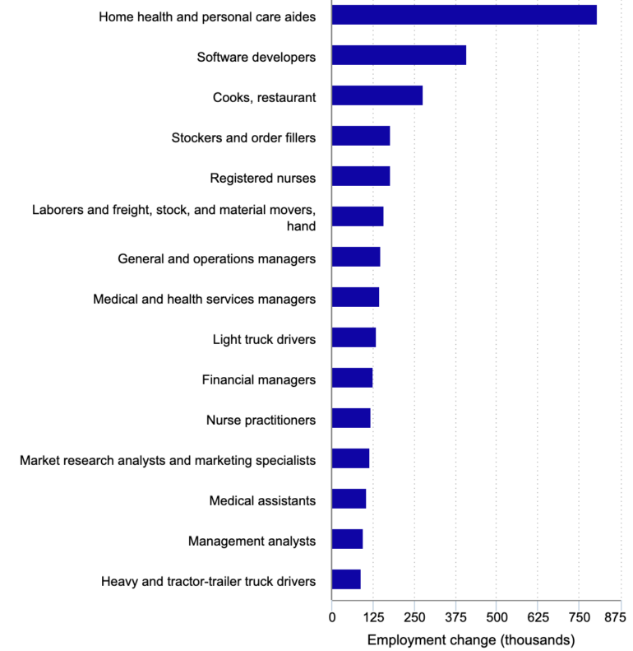
Figure 2: Fifteen fastest growing occupations, percent change, projected 2023‒33
(Source: U.S. BUREAU OF LABOR STATISTICS)
The same is quite alarming in the case of healthcare. The COVID-19 pandemic has helped to increase the shortage of healthcare workers, especially nurses and physicians. New manufacturing is in a precarious situation also with numerous companies having a hard time finding skilled tradesmen like welders, machinists, or electricians to work in new areas of manufacturing like solar energy and high-tech manufacturing.
Interpretations:
The facts on the ground indicate clearly that the skills gaps and talent shortages are an expanding issue that has necessitated the HR to use strategic workforce planning. Reskilling and upskilling programs, including introduction of special training programs and introduction of certifications in areas of great demand and placement of employees in transitional opportunities in the organization should therefore be top priority of HRM.
Additionally, companies need to understand how critical it is to keep their current employees. HR specialists can guarantee those workers stay engaged and motivated, lowering attrition and lessening the consequences of talent shortages, by providing possibilities for professional growth, flexible work schedules, and a culture of ongoing learning.

Self-Reflection on International Work Preparedness
Description
In the modern realm of growing globalization of the workplace, the ability to adjust to the more varied cultures and leverage the emerging technologies has become a more and more prevalent prerequisite of career growth. During past few months, subjects have been engaged in a sequence of learning activities aimed at promoting readiness to international professional involvement (Bendowska and Baum, 2023; Mystakidis et al., 2021; Christian et al., 2021). Virtual team assignment, seminars assess cross-cultural communication and the discussions about the influence of technology in the world of work.
Feelings
First, the subject felt excited but had a feeling of being overwhelmed with the intricacies of being in an international environment. Potential of working with people with different cultural and professional experience aroused curiosity, while also brought feelings of insecurity (Birenbaum et al., 2024; Alarcón‐Orozco et al., 2025; Clughen, 2024). There was a high wish to use the chance to form skills, yet, it turned out to be more challenging than expected to find the way in the complexities of cross-cultural communication and understand global leadership styles.
Frustration was also experienced during team-based activities due to the difference in cultural orientation resulting in misunderstanding or divergence in work profiles. Another issue that was reported by the subject was the difficulty in effectively communicating with team members with different degrees of language fluency. The importance of differences of opinion was appreciated and their role of contributing to problem-solving and creativity in the global context acknowledged.
Evaluation
Considering those experiences, the subject recognizes all those positive and negative aspects. On the positive side, the individual was able to significantly enhance his capability of working with a team that was of a multi-cultural nature. It helped to better understand how to navigate across different cultural values and therefore become more open-minded and tolerant to differences.
On the other side, the areas that require improvements have been pointed out. At some points, communication, especially in the context of cross-cultural one, became difficult (Aririguzoh, 2022). There is also a need to improve leadership skills in dealing with teams in the world of global teams.
Regarding the technology, the topic is well versed in typical digital tools and understands the necessity to keep up with the newest changes and technologies, including AI-based project management systems and more sophisticated communication tools, to maintain competitiveness.
Analysis
The reflection analysis reveals the significant relevance of lifelong learning in communication, leadership, and technological flexibility to achieve success in cross-cultural and global work settings. Awareness of cultural diversity and ability to adapt communication strategy are keys towards establishing cooperation and reducing conflicts (Guo et al., 2025; Chukwu et al., 2023). Global teams require leaders who are managerial, encouraging, and orienting to the objectives of a team, especially in virtual teams, and therefore require reputable skills in managing tasks as well as motivating and directing team members towards a single goal.
Action Plan
Objectives | Measures to be Taken | Evaluation/Monitoring | Time-Scale
To enhance cross-cultural communication | Engage in cultural exchange, practice in multicultural teams | Review discussions, feedback from team members, self-reflection | 3 months
To develop leadership in global teams | Lead virtual/in-person meetings, seek mentorship, practice decision-making | Record meetings, gather feedback, track leadership progress | 3 months
Table 1: Action Plan
(Source: Self-Adopted)
Conclusion
In conclusion, I have made this reflective study self-directed learning. I've demonstrated my ability to assess my own skill level, spot weaknesses, and put improvement plans into action. I am dedicated to continuing to engage in foreign opportunities, whether in employment situations, educational settings, or other collaboration possibilities, since an active approach towards education and personal progression is essential in the dynamic world workforce. These encounters will improve my capacity to function well in international settings.

Overall Conclusive statements
Finally, the topic has come far in the preparation of doing international work, although there are points of further development. Through the refinements, the subject will be in a better position to cope with the dynamics in the global work environment and be a contributor in the international team. This contemplation has helped define essential competencies and offered practical ways forward information to personal and professional development in the future. Subsequent emphasis on personal development, especially in the areas of communication, leadership, and digital literacy, will help the subject overcome the complexity of the global workplaces and become a productive member of the international workforce in the future.

References
Accenture, (2025) The art of AI maturity. Available at: https://www.accenture.com/in-en/insights/artificial-intelligence/ai-maturity-and-transformation
Alarcón‐Orozco, M.M., Franco‐Mariscal, A.J., Oliva, J.M. and Blanco‐López, Á., (2025). ‘Emotions Experienced by Preservice Early Childhood Teachers During a Training Program in Inquiry‐Based Science Education’. Journal of Research in Science Teaching. Available at: https://doi.org/10.1002/tea.70007
Aldossari, M. and Chaudhry, S., (2024). Gendered precarity in Saudi Arabia: Examining the state policies and patriarchal culture in the labour market. Gender, Work & Organization, 31(6), pp.2698-2716. Available at: https://doi.org/10.1111/gwao.13119
Al-Tarawneh, A. and Al-Badawi, M., (2025). ‘Cross-Cultural Training for HR Professionals in Multilingual Corporates’. In from Machine Learning to Artificial Intelligence: The Modern Machine Intelligence Approach for Financial and Economic Inclusion (pp. 817-828). Cham: Springer Nature Switzerland. Available at: https://doi.org/10.1007/978-3-031-76011-2_58
Aririguzoh, S., (2022). ‘Communication competencies, culture and SDGs: effective processes to cross-cultural communication’. Humanities and Social Sciences Communications, 9(1), pp.1-11. Available at: https://doi.org/10.1057/s41599-022-01109-
Ayanponle, L.O., Awonuga, K.F., Asuzu, O.F., Daraojimba, R.E., Elufioye, O.A. and Daraojimba, O.D.,(2024).‘A review of innovative HR strategies in enhancing workforce efficiency in the US’. International Journal of Science and Research Archive, 11(1), pp.817-827. Available at: https://doi.org/10.30574/ijsra.2024.11.1.0152
Bader, A.K., Bader, B., Froese, F.J. and Sekiguchi, T., (2021). One way or another? An international comparison of expatriate performance management in multinational companies. Human Resource Management, 60(5), pp.737-752. Available at: https://doi.org/10.1002/hrm.22065
Bendowska, A. and Baum, E., (2023). ‘The significance of cooperation in interdisciplinary health care teams as perceived by polish medical students’. International journal of environmental research and public health, 20(2), p.954. Available at: https://doi.org/10.3390/ijerph20020954
Birenbaum, M., Nasser-Abu Alhija, F., Shilton, H., Kimron, H., Shahor, N. and Rosanski, R., (2024). ‘Characteristics of Curious Minds: Evidence from Interviews with Renowned Experts in Five Curiosity-Dominant Fields’. Education Sciences, 14(10), p.1111. Available at: https://doi.org/10.3390/educsci14101111
Boehm, S.A., Schröder, H. and Bal, M., (2021). ‘Age-related human resource management policies and practices: Antecedents, outcomes, and conceptualizations’. Work, Aging and Retirement, 7(4), pp.257-272. Available at: https://doi.org/10.1093/workar/waab024
Boonlua, S., Supachaiwat, J., Thongchua, K., Mohamad, B. (2023). Linking Supply Chain Resilience Strategies for Surviving Major Disruptions. International Journal of Construction Supply Chain Management, Vol. 13, No. 1 (pp. 154-172). Available at: https://doi.org/10.14424/ijcscm2023130109
Christian, K.B., Kelly, A.M. and Bugallo, M.F., (2021). ‘NGSS-based teacher professional development to implement engineering practices in STEM instruction’. International Journal of STEM Education, 8(1), p.21. Available at: https://doi.org/10.1186/s40594-021-00284-1
Chukwu, E., Adu-Baah, A., Niaz, M., Nwagwu, U. and Chukwu, M.U., (2023). ‘Navigating ethical supply chains: the intersection of diplomatic management and theological ethics’. International Journal of Multidisciplinary Sciences and Arts, 2(3), pp.127-139. Available at: https://doi.org/10.47709/ijmdsa.vxix.xxxx
Chung, C. and Sparrow, P., (2024). Exploring the configuration of international HRM strategies for global integration and local responsiveness in MNEs. The InTernaTIonal Journal of human resource managemenT, 35(11), pp.1943-1969. Available at: https://doi.org/10.1080/09585192.2024.2320768
Clughen, L., (2024). ‘‘Embodiment is the future’: What is embodiment and is it the future paradigm for learning and teaching in higher education?’. Innovations in education and teaching international, 61(4), pp.735-747. Available at: https://doi.org/10.1080/14703297.2023.2215226
Cohen, M.A. and Rogers, P.C. (2021) ‘When Sino-American Struggle Disrupts the Supply Chain: Licensing Intellectual Property in a Changing Trade Environment’, World Trade Review, 20(2), pp. 238–257. Available at: https://doi.org/10.1017/S1474745620000531
Cooke, F.L., Sanders, K., De Cieri, H. and Bhoir, K.B., (2025). Women's authorship in international human resource management research: Implications for responsible management education and emerging scholars. Human Resource Management Review, 35(3), p.101087. Available at: https://doi.org/10.1016/j.hrmr.2025.101087
Duch-Brown, N., Gomez-Herrera, E., Mueller-Langer, F. and Tolan, S., (2022). ‘Market power and artificial intelligence work on online labour markets’. Research Policy, 51(3), p.104446. Available at: https://doi.org/10.1016/j.respol.2021.104446
Farndale, E., Horak, S., Piyanontalee, R., Puffer, S.M. and Vidović, M., (2025). Looking back to look forward: Disruption, innovation and future trends in international human resource management. International Business Review, 34(1), p.102362. Available at: https://doi.org/10.1016/j.ibusrev.2024.102362
Farr-Wharton, B., Bentley, T., Onnis, L.A., Caponecchia, C., Neto, A.D.A., O’Neill, S. and Andrew, C., (2023). ‘Older worker-orientated human resource practices, wellbeing and leave intentions: A conservation of resources approach for ageing workforces’. International Journal of Environmental Research and Public Health, 20(3), p.2725. Available at: https://doi.org/10.3390/ijerph20032725
Fora, Y. and Perkasa, D.H., (2025). INTERNATIONAL HUMAN RESOURCE MANAGEMENT IN CONTEXT INTERNATIONAL INDUSTRIAL RELATIONS: SYSTEMATIC LITERATURE REVIEW. Multidisciplinary Indonesian Center Journal (MICJO), 2(2), pp.2275-2292. Available at: https://doi.org/10.62567/micjo.v2i2.902
Guo, W., (2025). ‘Conflict resolution in intercultural communication: strategies for managing cultural conflicts’. Humanities and Social Sciences Communications, 12(1), pp.1-10. Available at: https://doi.org/10.1057/s41599-025-04391-0
International Organization for Migration., (2024). ‘World Migration Report 2024’. Available at: https://worldmigrationreport.iom.int/msite/wmr-2024-interactive/
Jooss, S., Collings, D.G., McMackin, J. and Dickmann, M., (2024). A skills‐matching perspective on talent management: Developing strategic agility. Human Resource Management, 63(1), pp.141-157. Available at: https://doi.org/10.1002/hrm.22192
Khassawneh, O. and Abaker, M.O.S.M., (2022). Human resource management in the United Arab Emirates: Towards a better understanding. In HRM in the Global South: A critical perspective (pp. 103-128). Cham: Springer International Publishing. Available at: https://doi.org/10.1007/978-3-030-98309-3_5
Li, J. and Pilz, M., (2023). International transfer of vocational education and training: A literature review. Journal of Vocational Education & Training, 75(2), pp.185-218. Available at: https://doi.org/10.1080/13636820.2020.1847566
Lippens, L., Baert, S., Ghekiere, A., Verhaeghe, P.P. and Derous, E., (2022). ‘Is labour market discrimination against ethnic minorities better explained by taste or statistics? A systematic review of the empirical evidence’. Journal of Ethnic and Migration Studies, 48(17), pp.4243-4276. Available at: https://doi.org/10.1080/1369183X.2022.2050191
Menzies, J., Sabert, B., Hassan, R. and Mensah, P.K., (2024). Artificial intelligence for international business: Its use, challenges, and suggestions for future research and practice. Thunderbird International Business Review, 66(2), pp.185-200. Available at: https://doi.org/10.1002/tie.22370
Mystakidis, S., Fragkaki, M. and Filippousis, G., (2021). ‘Ready teacher one: Virtual and augmented reality online professional development for K-12 school teachers’. Computers, 10(10), p.134. Available at: https://doi.org/10.3390/computers10100134
Ochieng, E.M., (2023). ‘A Study of the History Functions Roles and Challenges of Human Resources Management’. Journal of Enterprise and Business Intelligence, 3(1), pp.054-064. Available at: https://doi.org/10.53759/5181/JEBI202303006
Presbitero, A., Froese, F.J., Peltokorpi, V., Pudelko, M. and Tenzer, H., (2023). Language in international human resource management: current state of research and future research directions. The InTernaTIonal Journal of human resource managemenT, 34(21), pp.4027-4045. Available at: https://doi.org/10.1080/09585192.2023.2274659
PwC., (2021) Productivity 2021 and beyond.Available at: https://www.pwc.com/gx/en/industries/financial-services/publications/productivity-agenda.html
Qi, J., Chatterjee, S. and Liu, Y., (2022). ‘Retirement preparedness of generation X compared to other cohorts in the United States’. International Journal of Financial Studies, 10(2), p.45. Available at:https://doi.org/10.3390/ijfs10020045
Sposato, M. and Rumens, N., (2021). Advancing international human resource management scholarship on paternalistic leadership and gender: the contribution of postcolonial feminism. The International Journal of Human Resource Management, 32(6), pp.1201-1221. Available at: https://doi.org/10.1080/09585192.2018.1521862
Szymczak, S. and Wolszczak-Derlacz, J., (2022). ‘Global value chains and labour markets–simultaneous analysis of wages and employment’. Economic Systems Research, 34(1), pp.69-96. Available at: https://doi.org/10.1080/09535314.2021.1982678
Tran, T.T., Muenjohn, N. and Montague, A., (2024). Negotiating entry to the professional labour market among Vietnamese skilled migrants in Australia: The impact of cultural distance. International Journal of Intercultural Relations, 100, p.101977. Available at: https://doi.org/10.1016/j.ijintrel.2024.101977
United Nations., (2025). ‘Ageing’. Available at: https://www.un.org/en/global-issues/ageing
Wissemann, A.K., Pit, S.W., Serafin, P. and Gebhardt, H., (2022). ‘Strategic guidance and technological solutions for human resources management to sustain an aging workforce: review of international standards, research, and use cases’. JMIR Human Factors, 9(3), p.e27250. Available at: https://doi.org/10.2196/27250
World Economic Forum, (2025) Future of Jobs Report 2025. Available at: https://reports.weforum.org/docs/WEF_Future_of_Jobs_Report_2025.pdf
Zhang, M.Y., (2025). ‘From Dependence to Decoupling: China’s Semiconductor Self-Sufficiency amid Geopolitical Pressures’. In Technology Rivalry Between the USA and China (pp. 93-130). Cham: Springer Nature Switzerland. Available at: https://doi.org/10.1007/978-3-031-76169-0_4

