Free market environmentalism, Big Business and Global Politics
(Assignment 2) - Essay

Does responsibility for action on the climate and biodiversity crisis rest with individuals or with collectives (such as states and corporations), or both?

The question of who is responsible to take action against the ever-growing climate crisis is unfortunately subjective. Some may take the stance that individuals can make the biggest impact and therefore they hold the majority of responsibility. Whilst others argue that individuals need no part in stopping the climate crisis and that all of it could be solved by collectives. Both of these, to some extent, are true. However, this blame-game that the two sides are playing is perhaps one of many reasons as to why not enough action is being taken. This essay shall show that both individuals and collectives hold responsibility but that there is a more pressing need for collectives to act upon it.

Firstly, what does responsibility mean? Furthermore, is there, or should there be, a difference in how we understand responsibility as it applies to individuals and collectives. By establishing an understanding of what is meant by responsibility it will allow for a clearer understanding of which group holds more. The definitions shall be kept brief as to not get off topic.

There are many different forms of responsibility, for individuals, this is largely seen as moral responsibility. The responsibility to act within the societal and or self regulated moral code, within this there is formal and informal action that can be taken in regards to somebody that breaks this code. These are not exclusive to one another, for example, if a person murdered another person, the formal response to this is to punish the murderer by sending them to prison, this is a formal and legislative (governed by law) response. Concurrently, this person will be shunned from society and others shall dislike this person, this being an informal response. It is one's responsibility to feel this way to enforce the notion that murdering is wrong and is by extension their responsibility to uphold these rules themselves. In the case of, what shall be referred to as, environmental moral responsibility there are virtually no formal responses, or legislation, for a breach on an individual level, in the UK. As well as very few people who enforce informal responses. This does not mean however that individuals do not hold environmental moral responsibility.
Collective responsibility in the words of (Smiley, 2022) “The notion of collective responsibility, like that of personal responsibility and shared responsibility, refers in most contexts to both the causal responsibility of moral agents for harm in the world and the blameworthiness that we ascribe to them for having caused such harm.”. As one can assume from the name, collective responsibility does not find such ‘causal responsibility’ or ‘blameworthiness’ from individuals but rather “the source of moral responsibility in the collective actions taken by these groups” (Smiley, 2022).

As stated by (Smiley, 2022) both personal and collective responsibility have a specific and key quality, that responsibility and harm are linked. It is on this basis that shall be the deciding factor in this paper, which group, either individuals or collectives, produces the most harm and/or has the power to alleviate the most harm.

For a long time companies and governments have blamed individuals for climate change. Perhaps the biggest and most effective ruse, in regards to blaming individuals for climate change, comes from BP (British Petroleum) when they coined the term “carbon footprint”. Mark Kaufman wrote:

“British Petroleum, the second largest non-state owned oil company in the world, with 18,700 gas and service stations worldwide, hired the public relations professionals Ogilvy & Mather to promote the slant that climate change is not the fault of an oil giant, but that of individuals. It’s here that British Petroleum, or BP, first promoted and soon successfully popularized the term “carbon footprint” in the early aughts. The company unveiled its “carbon footprint calculator” in 2004 so one could assess how their normal daily life – going to work, buying food, and (gasp) travelling – is largely responsible for heating the globe.”
(Kaufman, 2021, cited by Solnit, 2021)

In a BBC article by (Timperley, 2020) she refers to the climate journalist Amy Westervelt’s podcast “Drilling” stating ““It was the most brilliant example of ‘It’s your fault, not ours,’” says Westervelt. “It's a framework that serves them really well because they can just say ‘Oh well, if you really care then why are you driving an SUV?’”” This makes clear the kind of propaganda that big business uses to shift responsibility to individuals. This cannot be so successfully done without there being merit to the claims. So how can individuals make a difference and by extension what responsibility do they hold?

The methods of action for individuals working to help prevent the climate and biodiversity crisis come in a variety of forms. The first being emission reduction or reducing one's own carbon footprint.

Personal and direct carbon cutting is what BP encouraged individuals to do back in the early aughts and is still the most common way to take action today. An article published by the BBC reported on the ‘Top options for reducing your carbon footprint’ from evidence gathered through numerous papers published by The Centre for Research into Energy Demand Solutions. See Image below.

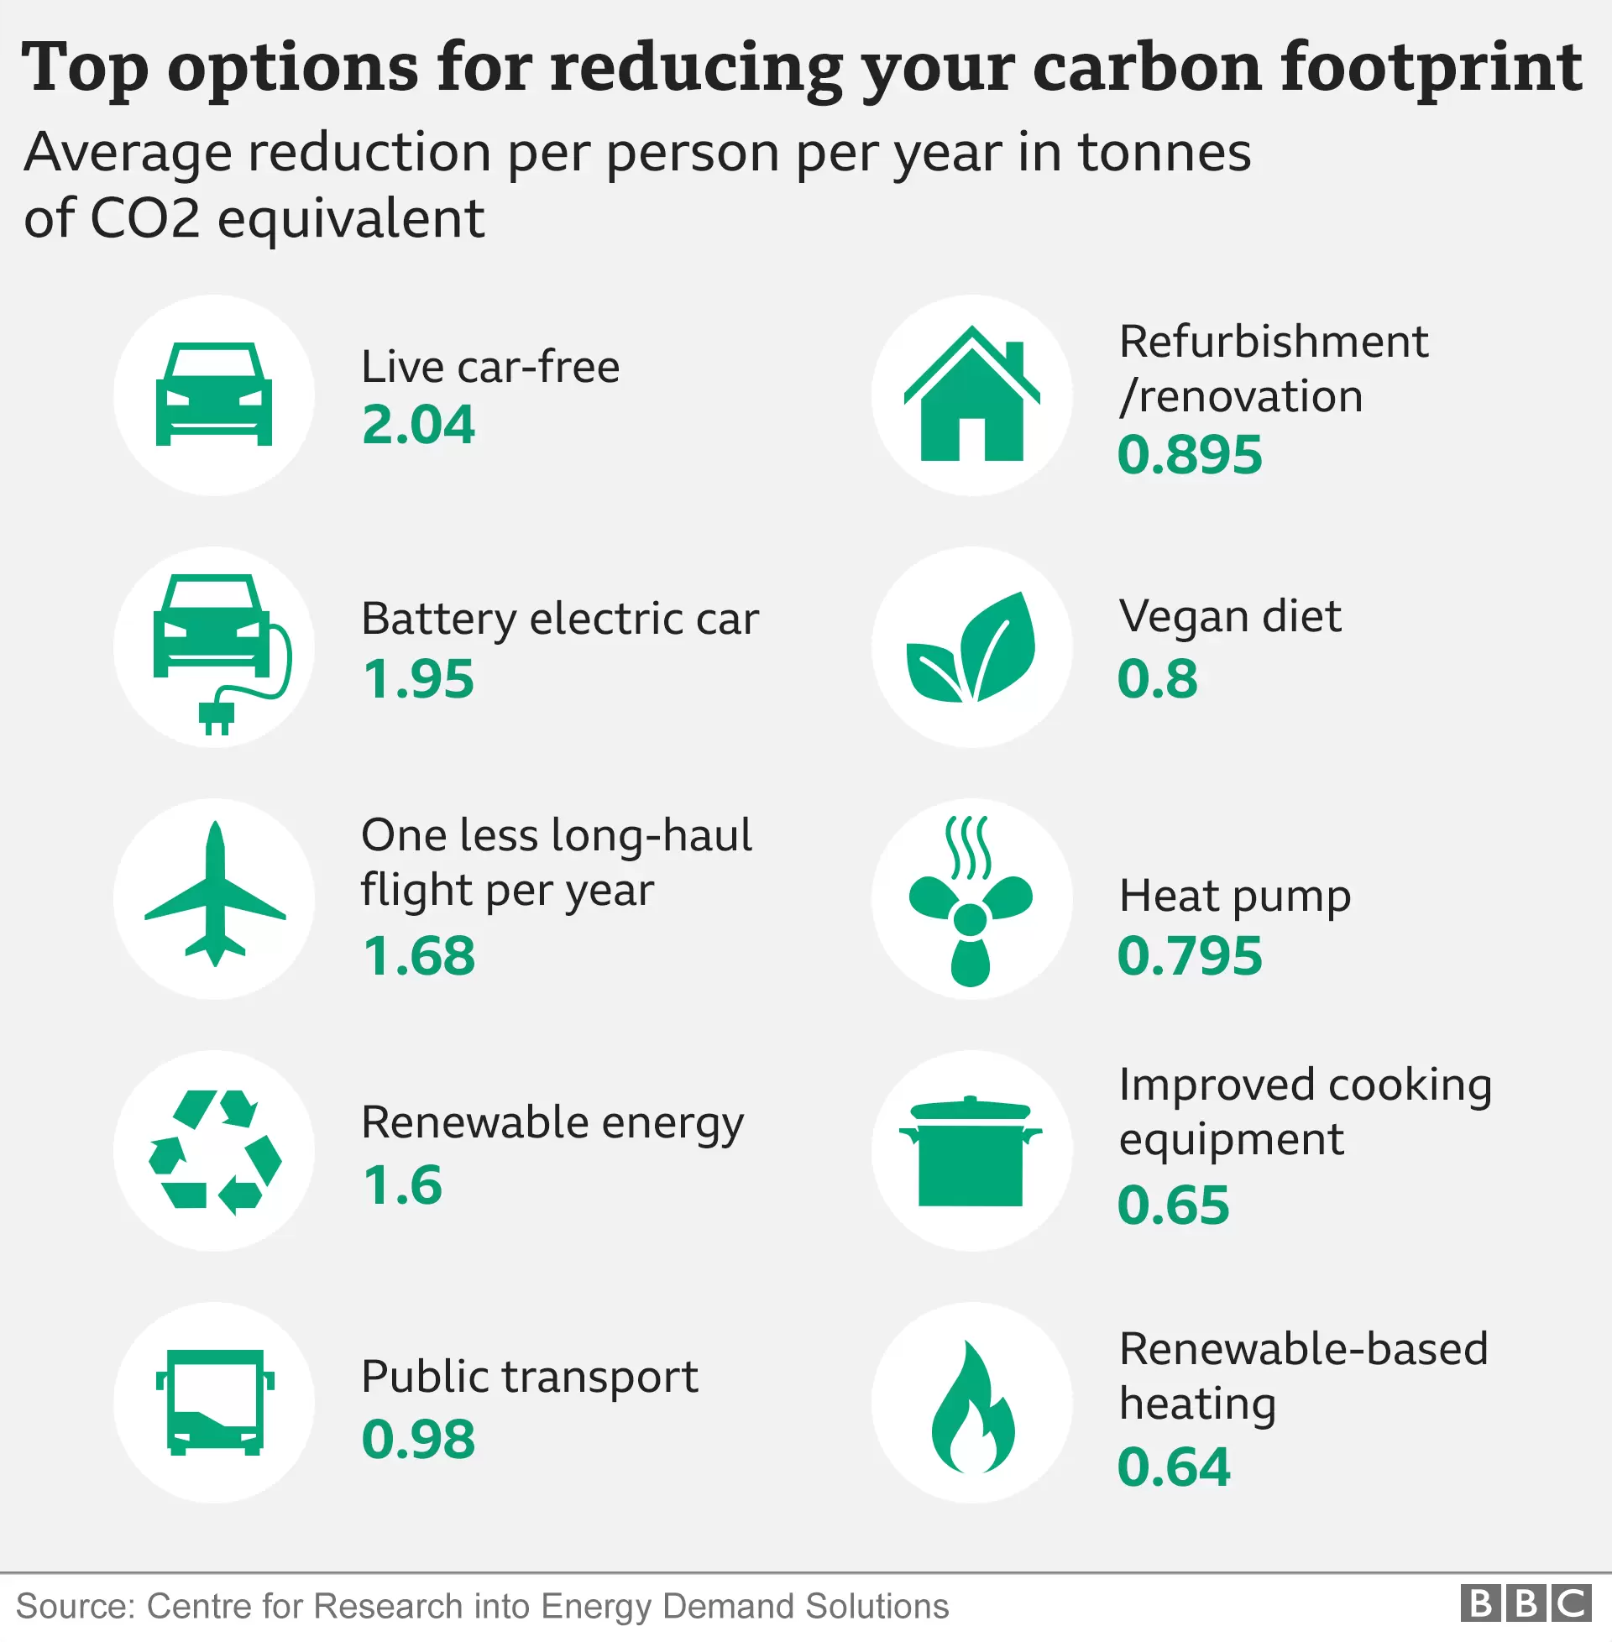
(Harrabin, 2020)

The evidence suggests that living car free is the biggest change that an individual can make to reduce their emissions, saving on average 2.04 tonnes of CO2/ CO2 equivalent emissions per year. Pair this with taking one less long-haul flight (1.68 tonnes), having modern insulation (0.895 tonnes), living off renewable energy (1.6 tonnes), using energy efficient cooking equipment (0.65 tonnes), using a ground source heat pump (0.795 tonnes) and subscribing to a vegan diet (0.8 tonnes). Making all of these lifestyle changes and home improvements could save 8.46 tonnes of CO2/ CO2 equivalent emissions per individual per year. This number is impressive, however this is completely unachievable. This is with zero travel other than walking or cycling. Therefore it would be unreasonable to assume that any large number of people could even attempt this. Individuals therefore do not have a responsibility to reach this, in fact it would be irresponsible to expect people to change so much. Instead, individuals have a responsibility to be considerate and eco-minded and do their best to adopt some of these carbon cutting techniques. As it is their responsibility to give the environment due consideration, and it is their duty to society to act upon this.

The second form of action is influential action. Individuals make up society, every teacher, every doctor, every role model is an individual within the larger network of society and it is this that gives individuals the power to make real change, and thus makes individuals responsible.

Greta Thunberg - King Charles - Jane Goohall - Al Gore

Finally the third and last form of action, this essay will address, is what shall be referred to as selective spending. Selective spending is the process of spending money in targeted areas to show demand for certain products. In my opinion, it is the best course of action for the common individual. The world is, whether good or not, fueled by money and money, therefore, is a better way to enact change than a ballot. GDP measurements every year show the will of the people, and money in the hands of those that share the same cause will only be beneficial to that cause. Not only that but it will force other large businesses to change what they’re doing to suit the current market.
Political lobbyists and the impact they have and the impact that we can have on them.

Argument for why people must take action and therefore give credence to the argument of responsibility.

No matter what philosophical view you hold, whether it be anthropocentric, sentientist, biocentric or ecocentric. The argument is largely the same. As long as you value some form of life, environmental action is inherent. If you view human life as the only intrinsically valuable form of life you have a need to protect the environment in order for humans to live.

Collectives working for climate action:

There are two ways that collective action can be viewed, one is individuals in a community coming together and all working individually to accomplish a common goal.This is what I would refer to as the ideal individual action. Or there is the collective action of organisations and governments coming together to act collectively. This is what this essay means by collective action.

It is far easier to see how collectives are responsible for climate change. This is because of their impact on the environment, their control over society and capabilities to resolve these issues are vastly greater and are easier to enact. According to the findings of (Franta, 2018) companies like ExxonMobil and Shell have known for over forty years the impact they were having on the environment and decided to continue anyway. These two companies are two of the top 10 greenhouse gas (GHG) emitting companies according to (Taylor and Watts, 2019). Together producing an estimated 75.92bn tonnes of CO2 equivalent between 1965 and 2017 and are currently in the process of being sued by The City of New York for greenwashing among other charges. This is direct proof that society and judicial systems hold collectives largely responsible for climate change.

Conclusion:

In conclusion I maintain my thesis in the introduction that the responsibility is subjective. What is objective however, is that collectives have a far greater capacity for easy change. Where we demarcate between collectives and individuals however, I think is the real importance in discussing responsibility. Furthermore, it is of paramount importance that, collectives such as governments help make environmental action easier for the individual, and try to reduce their conscious responsibility as much as possible, for example through legislation and law.

References

Berger C (2022) Meet Fortune 500’s most senior CEOs. Available at: https://fortune.com/2022/05/24/most-senior-ceos-fortune-500/ (accessed 28 July 2023).

Franta B (2018) Shell and Exxon’s secret 1980s climate change warnings. The Guardian, 19 September. The Guardian. Available at: https://www.theguardian.com/environment/climate-consensus-97-per-cent/2018/sep/19/shell-and-exxons-secret-1980s-climate-change-warnings (accessed 28 July 2023).

Friedrich J, Ge M, Pickens A, et al. (2023) This Interactive Chart Shows Changes in the World’s Top 10 Emitters. Available at: https://www.wri.org/insights/interactive-chart-shows-changes-worlds-top-10-emitters (accessed 28 July 2023).

Geys B (2020) Growing older makes you care less about climate protection. Available at: https://www.bi.edu/research/business-review/articles/2020/09/growing-older-makes-you-care-less-about-climate-protection/ (accessed 28 July 2023).

Harrabin R (2020) Climate change: Top 10 tips to reduce carbon footprint revealed. BBC, 20 May. Available at: https://www.bbc.co.uk/news/science-environment-52719662 (accessed 28 July 2023).

Smiley M (2023) Collective Responsibility. The Stanford Encyclopedia of Philosophy Zalta EN and Nodelman U (eds). Fall 2023. Metaphysics Research Lab, Stanford University. Available at: https://plato.stanford.edu/archives/fall2023/entries/collective-responsibility/.

Solnit R (2021) Big oil coined ‘carbon footprints’ to blame us for their greed. Keep them on the hook. The Guardian, 23 August. The Guardian. Available at: https://www.theguardian.com/commentisfree/2021/aug/23/big-oil-coined-carbon-footprints-to-blame-us-for-their-greed-keep-them-on-the-hook (accessed 28 July 2023).

Taylor M and Watts J (2019) Revealed: the 20 firms behind a third of all carbon emissions. The Guardian, 9 October. The Guardian. Available at: https://www.theguardian.com/environment/2019/oct/09/revealed-20-firms-third-carbon-emissions (accessed 28 July 2023).

Timperley J (2020) Who is really to blame for climate change? BBC, 19 June. BBC. Available at: https://www.bbc.com/future/article/20200618-climate-change-who-is-to-blame-and-why-does-it-matter (accessed 28 July 2023).

This could be because the people that run the UK, and the rest of the world, are of an older demographic. (Geys, 2020) suggests that once “beyond the age of 45 growing older makes people put less emphasis on protecting the environment”. This could be a contributing factor as to why big business isn’t making more of an effort towards climate change, because the individuals who run big business are older. In America, the second largest CO2 producing country (Friedrich, Ge and Pickens, 2020), a list of the five hundred largest industrial corporations are documented in the Fortune 500 list. As of May 2022 “the average age of a Fortune 500 CEO is 57” (Berger, 2022), this could be seen as a reason for the lack of environmental protection that these companies show. However, even though age may influence people’s motivation, it should not influence the responsibility they hold, especially if they have a greater influence.
It is worth noting now that this number alone is insignificant; it is only through wide-spread individual action that any significant changes can be made.
Hiding or otherwise lying about the amount of harm they are causing the planet.

