MEDILINK PHARMACY DATABASE IMPLEMENTATION REPORT

Database Systems / Database Design
Course Code:
Student Name:Abdullah
Student ID:2513396
Lecturer’s Name: Anum paracha
Institution: university of wales
Submission Date: 24th march

Table of content

1.0 Introduction 2
2.0 Scenario Analysis 3
3.0 Entity Relationship Diagram (ERD) 5
4.0 Data Structure Development 7
5.0 Normalization 8
6.0 Sample data 9
7.0 Quaries 10
8.0 Design Decisions and Reflection 11
9.0 Conclusion 12

1.0 Introduction
MediLink Pharmacy is a developing community-based pharmacy chain that is paramount in supplying the society with the necessary healthcare products and services. Nevertheless, the pharmacy presently uses manual means of dealing with its fundamental functions such as stock management, prescription management, and customer record management. These manual operations are timely and subject to human errors, inconsistency of data and inefficiencies that may adversely impact the service delivery and decision making ^{[2]}.
As the need to improve the management of the data available and the efficient service delivery increases, so is the necessity to move to the automated database solution instead of the old-fashioned manual systems. Properly developed database system has the ability to simplify the operations, enhance accuracy of the data and avail important information on real time basis. Specifically, this type of system can help improve inventory control, provide adequate oversight of prescriptions, and allow to create credible reports used by the management to make decisions and adhere to regulations ^{[1]}.
The principal goal of this project is to create and establish a powerful database system in MediLink Pharmacy with the help of Microsoft Access. The system is to be used to handle major entities like medicines, suppliers, customers, prescriptions and sales transactions. The database will also be useful in the creation of reports to follow the stock level, sales performance, and compliance with healthcare regulations ^{[2]}.
This report describes database system development process, such as scenario analysis, entity-relationship modeling, development of data structure, normalization, and query design. It also determines the success of the system by validating and testing, and retrospecting the design decisions and possible improvements. Finally, the project shows that it is possible to use database technology in order to improve the efficiency of operations and service delivery in a pharmacy environment ^{[3]}.

2.0 Scenario Analysis
The MediLink Pharmacy database system is aimed at dealing with the inefficiencies of processes of data management that are currently applied manually in the pharmacy. Such inefficiencies comprise data duplication, record keeping mistakes and inability to produce reports in time. Through integration of a structured database system, the pharmacy can be in a position to control its inventory, prescriptions, customer records and the sales transaction. It is necessary to have a clear picture of the entities, attributes of the said entities, and the relationship between them to create a reliable and scalable database system ^{[1]}.
The system has five large entities that include Supplier, Medicine, Customer, Prescription, and Sales. These are the main areas in the pharmacy operations. The Supplier entity records details of organisations that supply medicines and the Medicine entity holds the details of pharmaceutical products in the pharmacy. Customer entity is the one that depicts people who buy medicines or have prescriptions. The Prescription entity is employed to document medical orders made by medical practitioners and Sales entity records the transaction data whenever a medicine is sold. The identification of such entities makes all the relevant information organized logically and can be effectively handled within the system ^{[2]}.

Table 1: Entities and Attributes

Variable | Measurable
Debt-to-Equity Ratio | Total Debt ÷ Shareholders’ Equity
Equity Multiplier | Total Assets ÷ Total Equity
Interest Coverage Ratio | EBIT ÷ Interest Expense
Financial Leverage Index | ROE ÷ ROA
Debt Ratio | Total Debt ÷ Total Assets (%)

The interactions of these entities determine the flow of data in the system and the interactions between various components in the system. As an example, a Supplier can provide several medicines, which would establish a one-to-many relationship between the Supplier and the Medicine. Likewise, a customer is able to make several prescriptions and is able to make several sales transactions over a period of time. The entity Medicine is also attached to the Sales entity, where all the sales are related to a particular medicine. Such relationships play an important role in ensuring consistency of data and also in making sure that the database has a true reflection of what is happening in the real world ^{[3]}.

Table 2: Entity Relationships
Relationship | Description | Cardinality
Supplier → Medicine | One supplier supplies many medicines | 1 : M
Customer → Prescription | One customer can have many prescriptions | 1 : M
Customer → Sales | One customer can make many purchases | 1 : M
Medicine → Sales | One medicine can appear in many sales | 1 : M

Alongside the identification of entities and relations, it should be noted that business rules should be defined as well that regulate the functioning of the system. These rules will ensure that the database complies with real world constraints, and that the database upholds data integrity. Say, every medicine should be associated with a legitimate supplier, and every sale should have an already existing customer and medicine ^{[2]}. In addition, the system should not allow sale of medicines whose expiry has passed and stock quantities should be updated after every transaction. The rules assist in ensuring accuracy and reliability in the database system.

3.0 Entity Relationship Diagram (ERD)
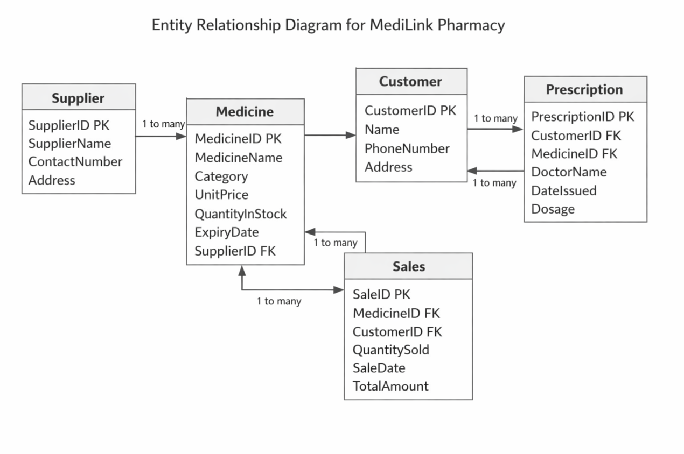
Entity Relationship Diagram (ERD) of the MediLink Pharmacy is a pictorial illustration of the fundamental entities that constitute the pharmacy system and the relationships existing between them. It acts as a guide to the database design and makes sure that all the data requirements are obtained in a systematic manner. ERD contains five primary entities, which are Supplier, Medicine, Customer, Prescription, and Sales ^{[2]}. Attributes are properties of each entity that define its characteristics and amongst the characteristics of an entity, the Primary Keys (PK) are unique identifiers of each record and the Foreign Keys (FK) are keys that identify the relationship between two entities. In the example below, the Medicine table has Supplier as a foreign key (SupplierID) whereby all medicines must be associated with an appropriate supplier. The ERD shown in its relationships are mainly one-to-many relationships (1:M); one supplier may be supplying a variety of medicines, one customer may have various prescriptions and one sale may be supplying a variety of medicines.

4.0 Data Structure Development
Table 3: Data Structure Section
Table Name | Column Name | Data Type | Key | Constraints
Supplier | SupplierID | varchar | PK | Not Null, Unique
 | SupplierName | varchar |  | Not Null
 | ContactNumber | varchar |  | Not Null
 | Address | varchar
Medicine | MedicineID | varchar | PK | Not Null, Unique
 | MedicineName | varchar |  | Not Null
 | Category | varchar
 | UnitPrice | decimal |  | Not Null
 | QuantityInStock | int |  | Not Null
 | ExpiryDate | date |  | Not Null
 | SupplierID | varchar | FK | References Supplier

Table 4: Customer
Column Name | Data Type | Key | Constraints
CustomerID | varchar | PK | Not Null, Unique
Name | varchar |  | Not Null
PhoneNumber | varchar |  | Not Null
Address | varchar

Table 5: Prescription
Column Name | Data Type | Key | Constraints
PrescriptionID | varchar | PK | Not Null, Unique
CustomerID | varchar | FK | References Customer(CustomerID)
MedicineID | varchar | FK | References Medicine(MedicineID)
DoctorName | varchar |  | Not Null
DateIssued | date |  | Not Null
Dosage | varchar |  | Not Null

The development of data structures determines the way the information held within the MediLink Pharmacy system is represented and stored in order to facilitate a fast and efficient processing, access, and maintenance. Every entity in the ERD is represented as a relational table, the attributes as columns within the table, and Primary Keys (PK) are used as a unique identifier of every record. Table relationships are created using Foreign Keys (FK) and create referential integrity and bring the dependent data into proper relationships ^{[2]}. As an example, the Medicine table has a SupplierID foreign key, so that each record of medicine has an existing supplier, and the Sales table has a CustomerID and MedicineID field, which helps to record the transactional information correctly. The data types of each attribute are selected based on the nature of the data- e.g. varchar in case of text based data like names, decimal in case of prices, int in case of quantities and date in case of expiry date and date of transaction. Essential fields are also placed in constraints like Not Null to ensure that no record is incomplete and unique constraints on PKs to ensure that records are not duplicated.

5.0 Normalization
Table 6: Normalization
Normal Form | Table Structure | Explanation
1NF | PrescriptionID, CustomerID, CustomerName, MedicineID, MedicineName, DoctorName, DateIssued, Dosage | All columns contain atomic values. Redundancy exists because CustomerName and MedicineName are repeated for multiple prescriptions.
2NF | PrescriptionID, CustomerID, MedicineID, DoctorName, DateIssued, Dosage | Removed partial dependency. CustomerName and MedicineName are moved to Customer and Medicine tables. Each non-key attribute depends entirely on the primary key PrescriptionID.
3NF | PrescriptionID, CustomerID, MedicineID, DoctorName, DateIssued, Dosage | Transitive dependencies removed. All attributes depend only on the primary key. Customer details (CustomerName, Phone, Address) stored in Customer table; Medicine details stored in Medicine table. This eliminates redundancy and ensures data integrity.

To eliminate redundancy, the Prescription table was normalized three times to ensure data integrity. In 1NF, the attributes are all atomic and the details of customers and medicines are duplicated in more than one record. To 2NF, the repeated attributes were eliminated and stored in their respective tables (Customer and Medicine) and only the attributes that are wholly dependent on PrescriptionID were retained ^{[4]}. Last but not least, 3NF provides the absence of any transitive dependencies; all the non-key attributes are related to the primary key only whereas the related information is referred using foreign keys. Such normalized structure ensures efficient queries, reduced storage redundancy and no anomaly during updating customer or medicine information.

6.0 Sample data
Table 7: Supplier Table
SupplierID | SupplierName | ContactNumber | Address
S001 | PharmaSource | 712345678 | Nairobi
S002 | MedSupply Ltd | 723456789 | Mombasa

Table 8: Medicine
MedicineID | MedicineName | Category | UnitPrice | QuantityInStock | ExpiryDate | SupplierID
M001 | Paracetamol | Analgesic | 50 | 100 | 31/12/2026 | S001
M002 | Amoxicillin | Antibiotic | 120 | 200 | 31/03/2027 | S002

Table 9: Cstomer
CustomerID | Name | PhoneNumber | Address
C001 | John Mwangi | 701234567 | Nairobi
C002 | Mary Wanjiku | 719876543 | Kisumu

Table 10 Prescription
PrescriptionID | CustomerID | MedicineID | DoctorName | DateIssued | Dosage
P001 | C001 | M001 | Dr. Kamau | 15/03/2026 | 500mg 3x/day
P002 | C002 | M002 | Dr. Achieng | 16/03/2026 | 250mg 2x/day

Table 11: Sales
SaleID | MedicineID | CustomerID | QuantitySold | SaleDate | TotalAmount
S001 | M001 | C001 | 2 | 15/03/2026 | 100
S002 | M002 | C002 | 1 | 16/03/2026 | 120

7.0 Quaries
-- 1. Retrieve all medicines supplied by PharmaSource
SELECT MedicineName, UnitPrice
FROM Medicine
WHERE SupplierID = 'S001';

-- 2. List all prescriptions for John Mwangi
SELECT PrescriptionID, MedicineName, Dosage, DateIssued
FROM Prescription
JOIN Medicine ON Prescription.MedicineID = Medicine.MedicineID
JOIN Customer ON Prescription.CustomerID = Customer.CustomerID
WHERE Customer.Name = 'John Mwangi';

-- 3. Calculate total sales for each customer
SELECT Customer.Name, SUM(TotalAmount) AS TotalSpent
FROM Sales
JOIN Customer ON Sales.CustomerID = Customer.CustomerID
GROUP BY Customer.Name;

-- 4. Check medicines that are expired
SELECT MedicineName, ExpiryDate
FROM Medicine
WHERE ExpiryDate < CURRENT_DATE;

8.0 Design Decisions and Reflection
A number of important decisions informed the design of the MediLink Pharmacy database to make it both functional and scalable. Relational database model has been selected as it handles in a good manner complex relationships between different entities of supplier, medicines, customers, prescriptions and sales. Primary and foreign keys were put in place with much care to ensure data integrity and reference constraints ^{[3]}. The type of data was chosen according to the character of this or that attribute such as varchar in the case of a text field such as names, a decimal in the case of prices, an int in the case of quantities, and a date in the case of prescription and expiry dates ^{[5]}. Also, the normalization up to 3NF level was implemented to remove redundancy and avoid update anomalies so that any updates made on either supplier, or customer details would automatically update without anomalies.
When looking back on the development process, the project has also made one realize the relevance of mapping real-life pharmacy operations into a structured data model. There was a need to link the prescriptions, sales, and inventory carefully so as not to duplicate but at the same time to allow operational flexibility ^{[4]}. Such decisions like the ability to separate customer/medicine data into separate tables, imposing foreign key constraints, etc. do not only enhance data integrity, but also ease the maintenance of the database ^{[5]}. The experience showed it is necessary to build thoughtful database design that will support daily operations, bring management insight as well as allow future improvements like automated reorder systems or other financial module integration.

9.0 Conclusion
The MediLink Pharmacy database offers a powerful tool that will substitute a manual record keeping with an improved and automated system. It minimizes errors, enhances reporting and makes sure that there is accuracy in inventory, prescription and sales management. Through the use of ERD design, relational tables, normalization, and validation, the system can support day-to-day operations and at the same time be scaled should a need to expand it in the future arise ^{[6]}. Clearly sits queries and sample data confirm that the database is able to deal with real life situations effectively, providing the pharmacy with more insight, quicker service, as well as data integrity.

References
[1] T. Connolly and C. Begg, Database Systems: A Practical Approach to Design, Implementation, and Management, 6th ed., Pearson, 2015. [Online]. Available: https://www.pearson.com/en-gb/subject-catalog/p/database-systems-a-practical-approach-to-design-implementation-and-management-global-edition/P200000003964/9781292061184
[2] R. Elmasri and S. Navathe, Fundamentals of Database Systems, 7th ed., Pearson, 2016. [Online]. Available: https://www.pearson.com/en-us/subject-catalog/p/fundamentals-of-database-systems/P200000003546/9780133970777
[3] Microsoft, “Microsoft Access Documentation,” Microsoft Support, [Online]. Available: https://support.microsoft.com/en-us/access
[4] P. Rob and C. Coronel, Database Systems: Design, Implementation, & Management, 12th ed., Cengage Learning, 2019. [Online]. Available: https://www.cengage.com/c/database-systems-design-implementation-and-management-12e-rob
[5] H. Garcia‑Molina, J. D. Ullman, and J. Widom, Database Systems: The Complete Book, 2nd ed., Pearson, 2008. [Online]. Available: https://www.pearson.com/en-us/higher-education/product/Garcia-Molina-Database-Systems-The-Complete-Book-2nd-Edition/PGM2871623.html
[6] J. L. Viescas and M. Hernandez, Microsoft Access 2019: Comprehensive, Cengage Learning, 2019. [Online]. Available: https://www.cengage.com/c/microsoft-access-2019-comprehensive-2e-viescas

