

A Comparative Analysis of Marketing Strategies: Zara UK vs Zara India

Programme Name: Master of Business Administration
Module Name: Internatio nal Marketing: Principles and Practices
Module code: LCMB7026
Lecturer’s Name: Dr Mustakkima Afrin
Student Name : Md Sohidul Islam
Student ID : 2504070
Group : 03 ,Term 2
Word Count : 5500
Submission Date :

Table of Contents
Introduction 4
Company Background: Zara 4
PESTLE Analysis: UK vs India 5
Political Factors 5
Economic Factors 6
Social and Cultural Factors 6
Cultural Analysis Using Hofstede’s Model 7
Technological Factors 8
Environmental Factors 8
Legal Factors 8
Comparative PESTLE Summary 9
Segmentation, Targeting and Positioning (STP) 9
Market Segmentation 9
Targeting Strategy 11
Positioning Strategy 11
Perceptual Mapping 12
Critical Evaluation of STP 12
Marketing Mix Analysis (7Ps): UK vs India 13
Product 13
Place 14
Market Entry Method 14
Promotion 14
People 15
Comparison Summary of the 7Ps 15
Critical Evaluation of the Marketing Mix 16
Directional Development Strategy (India) 16
Ethical Issues in Zara’s Marketing Mix (India-focused) 17
Recommendations 18
United Kingdom 18
India 19
Conclusion 22
Reference 24
Appendix 27

Introduction
Zara is a global fast fashion retailer that relies on being fast, being trendy and controlling the supply chain. Its international marketing strategy, therefore, is critical to keeping its competitiveness in various markets (Inditex, 2025). This report is a study of Zara's approach in two countries - the United Kingdom and India - which were chosen to represent different conditions. The UK is a mature, regulated, sustainability-minded market, whereas India is an emerging, high-growth market and is influenced by cultural diversity and price sensitivity. By analysing both contexts, we will be able to assess the workings of international marketing theory in different institutional and consumer contexts (Inditex Group, 2025). The analysis is based on the standardisation-adaptation debate and discusses the compromise that Zara makes between global efficiency and local legitimacy. It examines cultural, ethical and operational pressures experienced by global fashion brands, such as scrutiny of sustainability and labour governance (Riaño, 2025). Using PESTLE, STP, the 7Ps and strategic direction frameworks, the report has a critical application of theory to reveal tensions, trade-offs and evidence based strategic responses for supporting resilient international growth.

Company Background: Zara
Zara is part of the Inditex group, and it is based on the fast fashion philosophy (speed rather than scale) (Inditex, 2025). Its model shortens the design, production and retail cycles in order to be able to act quickly in response to demand signals. This creates a competitive advantage but leaves the brand vulnerable to volatility, ethical scrutiny and risk to forecasting at the same time. Zara has a vertically integrated supply chain, allowing nearly real-time variations to assortments (Riaño, 2025). Centralised control helps in improving efficiency and also results in higher dependency on the correct data and labour-intensive processes. Current debates make a point of how speed-based models are facing rising costs of legitimacy that come with sustainability and worker welfare.
Zara was able to grow globally on the basis of a semi-standardised format. Core processes are kept centralised, but the retail execution is locally adapted (Simpson, 2025). This constitutes a paradigm shift away from pure efficiency logic towards a strategy of contingency in international relations in which legitimacy is just as important as cost leadership (Inditex, 2025). Zara's mission is focused on being customer-centric in fashion, operational excellence and responsible growth. These values increasingly become mechanisms of governance and less symbolic statements determining the sourcing, transparency and communication choices in the face of pressure from stakeholders. In the United Kingdom, Zara encountered a mature market with a sensitivity to trends and expectations of sustainability. Strategy focused on efficiency, omnichannel integration and brand consistency (Inditex Group, 2025). In India, there was more adaptation to entry. Cultural norms, climate, and income dispersion forced the act of design innovation, the logic of pricing, and store experience. Zara's evolution is one from efficiency-dominated expansion to legitimacy-dominated competition (Simpson, 2025). The important strategic issue is the balance between the response to demand and ethics and cultural fit. This tension is suggested to characterise long-term competitiveness.

PESTLE Analysis: UK vs India
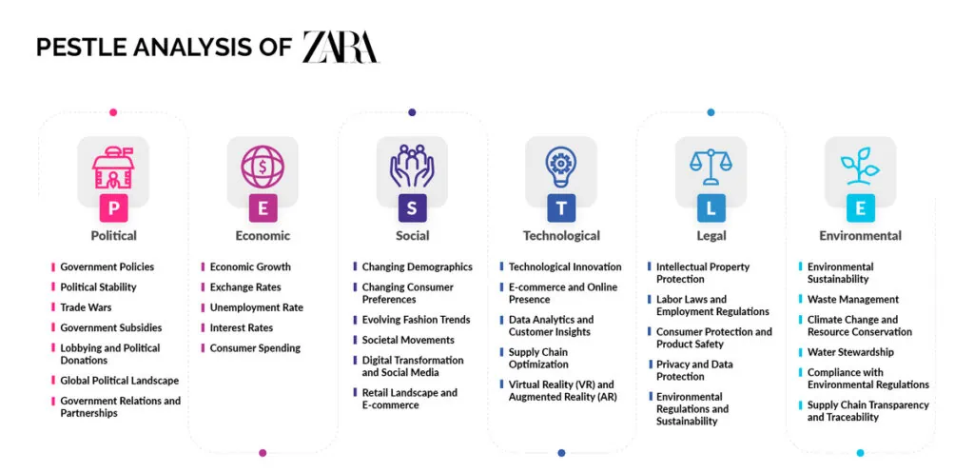
Figure 1: PESTLE Analysis of Zara
Source: (PEREIRA, 2024)

Political Factors
United Kingdom: The UK is politically favourable to Zara, as the regulation is stable and the enforcement is predictable. That helps leasing, the sourcing of contracts and store planning. The major issue is post-Brexit trade friction. Customs declarations, rules of origin checks and border controls can slow down the movement of imported goods and incur higher administrative costs (Zhu, 2023). For a fast fashion company, delays of any length despoil the speed advantage. Zara should therefore continue dual sourcing and near sourcing for time-sensitive lines.
India: India is partly favourable. Single-brand retail policy is open to foreign investment, but compliance is more patchy on a state-by-state basis. That leads to an approval risk and coordination cost (Rees, 2026). The Market is Attractive for Expansion, But Not Easy to standardise. Zara needs to use phased city-by-city growth with the support of the law.

Economic Factors
United Kingdom: The UK is economically favourable as the purchasing power of the consumers is high. World Bank's figures predict that the UK GDP per capita will exceed $50,000 in 2024. Yet inflation continues to strain retail prices and the sensitivity of consumers to price. UK CPI has been 3.0% for January 2026 (Rees, 2026). This means Zara can maintain premium prices, but this can only be done if the value is protected through assortment discipline.

India: India is good for Growth, but less good for margin. GDP growth is still high, around 7% in the World Bank outlook; however, GDP per capita was only around $2,695 in 2024 (Zhu, 2023). That gap matters. Zara should use a selective entry-price architecture for India without compromising its prestigious position.

Social and Cultural Factors
United Kingdom: The UK is socially conducive to trend-led retail. Fashion consumption is more individualistic, consumers are fast to react to newness, and awareness of sustainability is leading brands to justify their choices (Aleem, 2026). This does help in Zara's design velocity, but increases reputational exposure as well
India: India is a place that is socially favourable for the long-term demand, but more complex. Collectivist norms, modesty expectations and some occasion buying may restrain direct transfer of Western assortments. At the same time, urban consumers are more and more drawn to aspirational Western fashion (Zhu, 2023). Zara benefits from the localising of visible design elements, such as sleeve length, festive capsules, etc. Part of that is that the global aesthetic gets preserved. One strategic problem is heterogeneity of demand.

Cultural Analysis Using Hofstede’s Model
Dimension | UK | India
Power Distance | 35 | 77
Individualism | 89 | 48
Masculinity | 66 | 56
Uncertainty Avoidance | 35 | 40
Long-Term Orientation | 51 | 61
Indulgence | 69 | 26
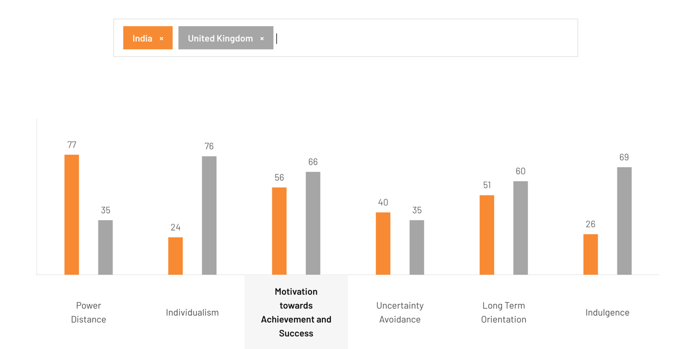
Figure 2: Cultural Analysis Using Hofstede’s Model
Source: (Hofstede Insights, 2025)
The UK is culturally favourable to self-service stores, personalised promotion and expressive styling. India is favourable for relationship-led retail but not so much favourable for complete standardisation. Greater power distance is supportive of greater service guidance (Hofstede Insights, 2025). Lower indulgence implies promotion should be more aspirational, social acceptability rather than hedonism. Hofstede is all very well for making broad comparisons, but less so for urban India, where class, city and digital exposure result in micro-cultures within one market (Hofstede Insights, 2025). Zara should therefore combine cultural theory with information from stores and knowledge of local ethnography.

Technological Factors
United Kingdom: The UK is very favourable as omnichannel retail is mature. Zara can integrate the low-friction reading of apps, storing and picking up at stores and inventory visibility (Zhu, 2023).
India: India is, too, favourable, but unevenly so. Bain puts a $60 billion or so e-retail market in 2024 and over 270 million online shoppers. However, the access and quality of service vary from city to city (Rees, 2026). Zara should use hybrid online and offline travel journeys in India rather than assume one seamless national market for granted.

Environmental Factors
United Kingdom: The UK is unfavourable in terms of environment for the short-term as fast fashion has a high scrutiny on wastage, emissions and greenwashing (Aleem, 2026). Yet it is favourable in terms of strategy as strong pressure can force innovation and building of trust.
India: India is mixed. Enforcement is weaker, and hence, short-term pressure for compliance is also less. That would appear to be favourable; however, it is more likely to create long-term reputational risk as the harms that are not so visible now can come back to haunt you later (Zhu, 2023). Zara should regard environmental governance as a pre-emptive investment in both countries.

Legal Factors
United Kingdom: The UK is legally favourable, but the cost is unfavourable for trusts. Strong labour law, advertising standards and consumer protection minimise ambiguity but increases cost of compliance (Aleem, 2026).
India: India is good for flexibility and growth, but not so good for consistency of governance. Labour and retail rules may differ in how they are put in place, and so the low formal cost may hide high monitoring risk (Zhu, 2023). Zara must have been having more internal auditing in India than is required by law.

Comparative PESTLE Summary
Similarities: Both countries are favourable as they provide fashion demand, digital consumer engagement and room for Zara's model. In both, speed and data matter (Zhu, 2023). In both, Zara is lucky to keep the core identity and supply chain intact.
Differences: The rewards of efficiency, transparency and reliability are reaped by the UK. India is the boon of selective accommodation, cultural credibility, and patient growth (Aleem, 2026). The UK is easier to rule than to defend its ethics. India is easier to grow in and harder to coordinate. The asymmetric solution for Zara is thus standardisation of the backbone and localisation of market face.

Segmentation, Targeting and Positioning (STP)

Market Segmentation
Demographic Segmentation
United Kingdom: In the UK, the target consumer groups of Zara are aged between 20 and 40. These are urban professionals and students who are moderate to high disposable income earners. They are focussed in the trend relevance and convenience (Lee and Kim, 2023). Demographic research suggests that this group is spending a lot of money on fast fashion in order to maintain social identity through clothing.
India: The market for fashion in India is younger. Nearly 65% of the people in the country are below 35 years of age. Zara, therefore, is focused on youth from the urban middle class. This group is aspirational and is connected digitally (Kou and Xu, 2022). However, levels of income remain below the UK average. Demographic segmentation must therefore be a combination of aspiration and affordability.
Geographic Segmentation
United Kingdom: In the UK, Zara stores can be found in concentrations in big cities such as London, Manchester and Birmingham. Urban locations attract high fashion turnover and induce tourism. Less intensity of trends is evident in the suburban areas (Kou and Xu, 2022). Geographic segmentation, therefore, affects store size, inventory rotation and omnichannel logistics.
India: India is a better geographical variation. Metro cities like Mumbai, Delhi, and Bangalore are the driving force of consuming fashion. Tier-1 & Tier-2 cities are showing increasing demand with high price sensitivity. Regional climate and cultural diversity also contribute to the choice of clothing preferences (Lee and Kim, 2023). Zara must therefore develop geometric flexible assortments between geographic clusters.
Psychography Segmentation (VALS)
United Kingdom: In the UK, Zara has a primary application to Experiencers and Achievers. Experiencers are all about novelty and trend experimentation. Achievers are also interested in efficiency and professional appearance (Kou and Xu, 2022). Both groups acknowledge fashion as a tool for the organisation of identity formation. This is in line with Zara's fast trend cycle and minimalistic branding.
India: In India, Zara is focused on Aspirers and Strivers. Aspirers are the followers of modern lifestyles and fashion symbols from all over the world. Strivers need to be defined as status through visible consumption (Kasem, Hamada and Taj-Eddin, 2024). Zara's international brand identity is a means of reinforcing aspired value. However, cultural sensitivity is still required to enforce legitimacy.
Behavioural Segmentation
United Kingdom: UK consumers exhibit behaviour that is driven by trend cycles and via digital engagement. A lot of shoppers are inclined to buy frequently but in smaller quantities. Sustainability awareness is also a factor when making purchasing decisions (Kasem, Hamada and Taj-Eddin, 2024). Behavioural segmentation, therefore, helps Zara to manage the inventory and change the rotation of products.
India: Indian patterns of behaviour are not the same. Purchases frequently occur during festivals and weddings, or social occasions. Group shopping is common (Lee and Kim, 2023). Consumers also tend to be very responsive to promotions. Zara must therefore use the brand exclusivity in conjunction with selective promotional strategies.

Targeting Strategy
United Kingdom: Zara has differentiated targeting. The brand is more targeted to the urban fashion consumer with their demand for fast-paced updates of trends. These consumers are also very active with online platforms (Kasem, Hamada and Taj-Eddin, 2024). The major strategic risk in the UK is market saturation. Growth is less about opening new stores and more about retention of customers and omnichannel experience.
India: In India, Zara targets urban youth and aspirant middle-class consumers. These groups are the fastest-growing segment of fashion (Lee and Kim, 2023). However, the hazard of operation consistency is a major factor. Poor quality of service or cultural insensitivity can easily destroy new market trust.

Positioning Strategy
United Kingdom: In the UK, Zara brands themselves as a high-end fast fashion brand. The focus is on trend leadership, speed and design sophistication (Kou and Xu, 2022). This positioning makes Zara stand out from the low-cost retailers and yet is accessible.
India: In India, Zara is a brand that portrays itself as modern and aspirational. The brand is a representation of fashion access throughout the world and still abides by the cultural expectations (Kasem, Hamada and Taj-Eddin, 2024). Product design as well as store experience are used to reinforce this balance.

Perceptual Mapping
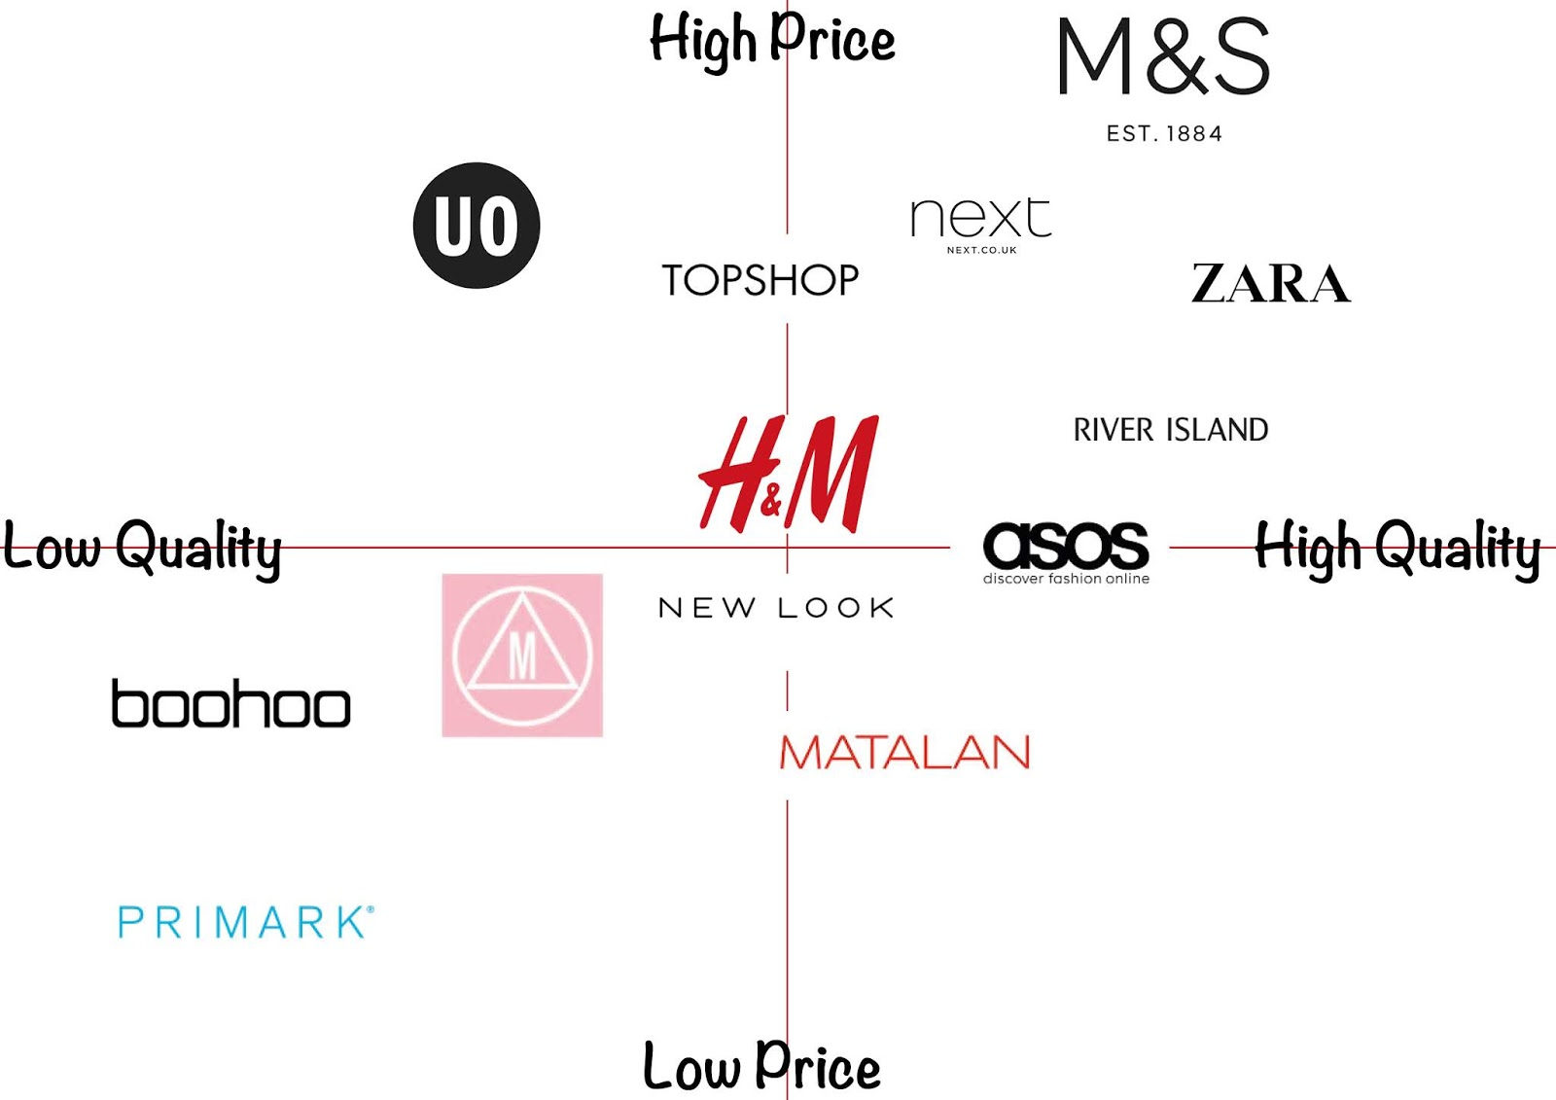
Figure 3: Perceptual Mapping of Zara
Source: (O’Brien, 2019)
Perceptual mapping compares Zara with competitors like H&M and Uniqlo. The horizontal axis is cultural fit VS. trend intensity (Kou and Xu, 2022). The vertical axis is a measure of price and quality as perceived. In the UK, Zara shows quite a high trendiness but medium price competitiveness. In India, the approaches of localisation bring Zara nearer to the high cultural fit quadrant.

Critical Evaluation of STP
Similarities: The bulk of Zara's STP logic is based on psychographic and behaviour segmentation of both markets (Kou and Xu, 2022). This will enable fast product rotation and data-driven inventory planning.
Differences: However, other strategic drivers are different. In the UK, segmentation is lifestyle and convenience-based. In India, it is cultural mores and income that prevail in segmentation logic (Kasem, Hamada and Taj-Eddin, 2024). Zara must therefore balance between global identity and local interpretation of the market in order to maintain a competitive advantage.

Marketing Mix Analysis (7Ps): UK vs India

Product
United Kingdom: Zara's product strategy in the UK is focused on having a strong brand identity and fast turnover of trends. The brand has around 20,000 new designs released each year, which helps them to refresh the products all the time (Raj, Vimal and Shini,2025). UK collections are a combination of traditional silhouettes and seasonal trends. So, innovation is not radical, but selective. This is to help protect brand consistency as well as operational efficiency. However, there is a change in consumer expectations. OTHMAN (2024) found that over 60% of UK consumers consider sustainability when making a purchase in fashion. Zara must, therefore, operate using recycled fabrics and circular design principles in order to preserve legitimacy.
India: In India, Zara is choosy in its portfolio of products. Designs are altered according to local climate and cultural norms. Longer silhouettes, restrained cuts and lighter fabrics help in increasing the acceptance of culture. The strategy of global branding vs cultural legitimacy is grounded on a balance (OTHMAN, 2024). However, too much localisation would deplete the strength of global brand identity. Zara should thus have core designs, and only visible elements like fabric and colour changed.
Price
United Kingdom: Zara is employing the premium fast fashion pricing in the UK. Average prices of products are between £30 and £120, depending on the category (OTHMAN, 2024). The UK's GDP per capita is about $46,000, and supportable for discretionary fashion spending. Premium pricing consolidates brand prestige but suffers from inflationary pressure (Raj, Vimal and Shini,2025). Zara must ensure the integrity of pricing by controlling discounts and effective distribution channels.
India: The reason for the cost in India is the import duty and low purchasing power. Many products of Zara cost ₹3,000-₹10,000, making the brand very ultra-premium compared with domestic retailers. India's GDP per capita is about $2,700, which is limited (Praveena et al., 2025). Zara, therefore, conveys exclusivity over mass affordability. This strategy has the advantage of safeguarding brand prestige but suffers from the disadvantage of limited market penetration.

Place
United Kingdom: Zara has over 100 stores in the UK, and these are in high footfall urban centres, such as London and Manchester (OTHMAN, 2024). Distribution is a mixture of flagship stores with an excellent e-commerce platform. Zara has a direct distribution model through the controlled Inditex logistics centres.
India: India has approximately 25 Zara stores, most of which are present in premium shopping malls. Distribution is more discriminatory. Zara works through the partnership with the Tata Group that handles the retail operations (Raj, Vimal and Shini,2025. This hybrid structure is a combination of direct control by the brand and local market expertise.

Market Entry Method
United Kingdom: Zara made its entry into the UK through wholly owned subsidiaries. This approach provides great control of the brand experience & operations (Saidani, 2019). The advantage of doing so is strategic uniformity and profit retention. The drawback is high costs and the risk of regulation.
India: In India, Zara entered in the form of a joint venture with the Tata Group. The advantage here lies in the local knowledge and simpler regulation (Praveena et al., 2025). The disadvantage is shared decision-making, which can potentially slow down adapting the strategy.

Promotion
United Kingdom: Promotion within the UK is based on little storytelling and fashion media visibility. Zara has a very low spending on traditional advertising (Raj, Vimal and Shini,2025. Instead, having products in fashion magazines and on social media helps to generate brand desirability.
India: Promotion in India is more of a dream. Celebrity appearances, influence in fashion from weddings and visibility of luxury retailing reinforce status appeal. This strategy makes Zara congruent with aspirational lifestyle stories (Saidani, 2019).

People
United Kingdom: Sales associates are the ambassadors of the brand. Zara has approximately 5,000 employees in stores throughout the UK (Praveena et al., 2025). Service expectations are concerned with efficiency and product knowledge.
India: India has around 2000 employees from Zara retail (Raj, Vimal and Shini,2025). Culturalexpecting help more individually. Staff training is in the area of hospitality and cultural sensitivity.

Process
United Kingdom: Retail processes are very standardised. Automated inventory systems provide the ability to quickly restock. Consumer complaints are handled by centralised digital support (Saidani, 2019).
India: In India, processes of the service are constituted in terms of building trust. Customer complaints can be easily and frequently solved using in-store engagement. High-touch service is a brand credibility builder (Saidani, 2019).

Physical Evidence
United Kingdom: Zara stores are characterised by minimalistic designs of the buildings and neutral interior designs. Materials such as glass, steel and polished stone lend themselves to the symbolism of modern brands (Praveena et al., 2025). There are over 100 stores in the UK network.
India: Indian stores are a cross between world styles and warmer lighting and open spaces. Premium mall locations enhance exclusivity (Praveena et al., 2025). The number of Zara outlets in the country is about 25 at the moment.

Comparison Summary of the 7Ps
Similarities: Both markets have a high brand standardisation. Zara maintains the worldwide design language, store aesthetics and efficacy of supply chains (Praveena et al., 2025).
Differences: Localisation is viewed mainly in the area of pricing, promoting, and providing services. India is about aspiration and cultural fit, while the UK is about being efficient and responding to trends (OTHMAN, 2024).

Critical Evaluation of the Marketing Mix
Zara's UK operations have better per-store profitability. The UK fashion market is worth over £ 60 billion every year, so there are high sales volumes. Indian operations are aimed at growth and not immediate profit. Zara India's annual revenue is over ₹2,500 crore (OTHMAN, 2024). Customer reviews are on average 4.2 stars in the UK and 4.0 stars in India. Social media engagement is greater in India because of the young digital audience. However, fast-fashion criticism generates brand equity risks over the long term (Raj, Vimal and Shini,2025. Zara would need to strengthen the sustainability, transparency and governance over the supply chain to ensure trust is not broken.

Directional Development Strategy (India)
Strategic Framework: Ansoff Matrix
Ansoff's Matrix discusses ways that firms attempt to achieve their growth through four strategic directions: market penetration, market development, product development and diversification (Benjamin Zugay, 2023). For Zara in India, the strategic choices are to be made with regard to economic limitations, cultural diversity and operational risks. India is a high-growth fashion market; however, expansion has to balance between brand prestige and affordability pressures. Strategic decisions must therefore be on the basis of sustainable growth and not of rapid scale (Benjamin Zugay, 2023).
Market Penetration Limits
Market penetration is interested in selling more in existing markets. In India, Zara is already working in major metropolises such as Mumbai, Delhi and Bangalore. Such locations are the top purchasing power segments. However, penetrating has its structural limits. India's gross domestic product (GDP) per capita is still in the neighbourhood of $2,700, which limits the availability of mass markets (Hortega et al., 2025). High product prices reduce the frequency of purchase by middle-income consumers. Too much discounting could damage the premium positioning of Zara as a brand. Therefore, further penetration by forceful prices would create brand dilution risks.
Constraints for Market Development
Market development is the expansion of markets into new geographical markets. In India, expansion potential in Tier-2 and Tier-3 cities appears to be attractive due to population growth. However, these regions have a low buying power and weak retail infrastructure. Luxury malls and high-end retail spaces are still concentrated in metropolitan areas (Benjamin Zugay, 2023). Outside the major cities, the logistics cost has also increased significantly. Rapid geographic expansion could therefore contribute to the complexity of operations and lower profitability. Controlled expansion is essential to protect brand equity.
Product Development (Most Used by Brands)
Product development has the most balanced growth path. This strategy is concerned with the production of new products for existing markets. The demographic structure in India is in favour of this approach. Over 65% of the population is below 35 years of age, hence there is a high demand for fashion innovation (Hortega et al., 2025). However, because of cultural fragmentation, there is a wide variety in preferences for clothing in different regions and social groups (Benjamin Zugay, 2023). Zara should introduce culturally adapted designs like modest silhouettes, climatic fabrics and festival designs.
Strategic Justification
Product development helps in reducing the geographical risk and increasing the relevance of the market. Zara is capable of using consumer data, sales data analysis and limited-edition testing to fine-tune designs before starting large-scale production (Hortega et al., 2025). Such an approach is contingency theory in the field of international marketing. It recognises that strategy has to adapt to local institutional and cultural conditions, as well as retain core brand identity.

Ethical Issues in Zara’s Marketing Mix (India-focused)
Product. Fast fashion is the cause of frequent buying. This leads to the risks of overconsumption and normalises low garment life cycles. Price can make this worse if, through promotions, "newness can feel cheap" (Abzug, 2023). Place adds platform ethics. Heavy reliance on prestige from malls may be perpetuating consumption of exclusion and status (Baena, 2024). Promotion in India can put more pressure on aspirational influencers. This is sensitive in a market of great inequalities of income. People and Process are important as the service norms undertake high-touch selling (Abzug, 2023). This can become manipulative if there are targets that staff have to sell to too many. Physical evidence suggests that luxury and product may not reflect durability value
The underlying tension between speed and sustainability. High product churn creates waste and emissions. The textile waste systems in India are weaker than those of the UK, and hence the externalities are easier to externalise to society (Wang, 2024). The stories of recycling or "join life" which come from Zara are subject to more tests of credulity. India-linked supply chains are chronically vulnerable to wages, overtime and opacity of subcontractors. Unclear transparency implies a higher probability of hidden harm. This is a governance issue, and is not merely a CSR issue (Abzug, 2023). Strengths are increasing sustainability communication and selective eco-lines. Ethical tensions are ongoing in risk and unequal social effects: Greenwashing. Reputational risk is high given the velocity with which scandals spread online. A defensible solution is audited disclosure, supplier traceability and scarcity - led hype limits.

Recommendations

United Kingdom
Sustainable Fashion Leadership: Zara needs to re-focus its strategy in the UK as a sustainability leader. Consumer awareness of the impact on the environment is growing fast in this market. Research has shown that more than 50% of UK fashion consumers consider sustainability in making their purchase decisions (Zhou, 2025). Zara should therefore expand more circular fashion projects in terms of recycling programs, repair and resale platforms. These actions help to reduce textile waste and consolidate the long-term legitimacy of brands. Transparent sustainability reporting should accompany these initiatives to avoid accusations of greenwashing.
Data-Driven Personalisation: The UK retail space is highly digitalised. Zara already collects volumes of consumer data in the form of e-commerce platforms and mobile applications. Advanced analytics should be used for better demand forecasting and personalising product recommendations (Baena, 2024). Data-driven inventory management can help to reduce overproduction, which is one of the major criticisms of fast fashion. However, the use of consumer data should respect strict privacy rules like GDPR (Abzug, 2023). Clear consent systems and responsible data governance will not only help protect customer trust, but it will also support strategic insights.
Ethical Transparency: Ethical transparency should be an obvious part of Zara's marketing strategy within the UK. Consumers are demanding more and more on supply chains and labour practices (Baena, 2024). Zara should publish audited reports of sustainability, reporting the standards of suppliers. Independent verification will increase this credibility and reduce the reputational risk.

India
Disciplined Expansion: In India, Zara must concentrate on disciplined growth and not fast store growth. The retail infrastructure and purchasing power are extremely different in the different regions (Zhou, 2025). Expansion should be aimed at high-income urban markets where brand positioning can be maintained. Controlled growth to preserve brand prestige and operational efficiency.
Product Localisation: The cultural diversity in India creates the need for the adaptation of products. Zara should develop suitable climate fabrics and simple silhouettes as well as festive-oriented fabrics (Abzug, 2023). This strategy helps to increase the cultural relevance of a product while ensuring the global design identity.
Ethical Sourcing & Labour Governance: Strengthening supplier monitoring and transparency on labour is critical in India. Regular audits, fair wage policies, and sustainable sourcing practices will ensure that the reputational risks are minimised and that sustainable growth is ensured in the long run (Zhou, 2025).
10. Reflection (Gibbs Reflective Cycle)
Description: This assignment focused on the international marketing approach of Zara in the United Kingdom and India. The analysis has been carried out with the help of a few strategic frameworks like PESTLE analysis, STP, extended 7Ps marketing mix and Ansoff's Matrix. These frameworks helped to structure the evaluation of the way in which Zara adjusted its strategy in two very different markets. The process of research was based on academic literature, industry reports and statistical data (Dutta, He and C.W. Tsang, 2023). The aim was not only to describe the operation of Zara, but to analyse the strategic decisions and their consequences. The report also included ethical analysis, taking into consideration sustainability issues and labour governance in the fast-fashion industry (Praveena et al., 2025). Each framework was used to find strategic tensions between efficiency and legitimacy. The work, therefore, needed to combine the use of theoretical models with empirical evidence to develop an understanding of the operation of multinational fashion firms in complex environments.
Feelings: At the beginning of the assignment, the scope seems demanding. International marketing is multi-analytical. Each of the frameworks has different perspectives on the topic of strategy. This led to an initial worry about the way in which the frameworks could be integrated into a coherent argument. However, since the assignment was structured, this uncertainty was reduced. Once the analytical sequence was understood, the research process was easier to deal with (Praveena et al., 2025). The comparison between the UK and India also made the task intellectually stimulating. It demonstrated the differences in the ways the same global brand has to operate in different markets. This realisation made me more interested in this topic and motivated me more to produce a rigorous analysis.
Evaluation: A number of aspects of the research process were effective. The combination of the macro-environmental analysis and marketing strategy gave a very clear pathway for analysis. PESTLE analysis was employed to determine the external forces that the brand is facing. STP analysis explained the response of Zara towards the differences of consumers. The 7Ps framework provided a connection between the strategic intent and the operational execution. Another positive element was the use of statistical evidence (Praveena et al., 2025). Economic indicators, including GDP and demographic information, helped in understanding the difference in the consumer behaviour of the two countries. This made the analysis even more credible. Ethical evaluation also contributed to enhancing the depth of the assignment. Examining the practices of sustainability and labour revealed that there is no separation of international marketing strategy and corporate responsibility. However, there were still some limitations (Dutta, He and C.W. Tsang, 2023). Data availability was spotty for different markets. Information related to the UK fashion sector was more transparent than the corresponding information for India. This led to asymmetry in the analysis. Another challenge was getting the right balance between analysis depth and word quota. Some complex problems, such as circular fashion and transparency of the supply chain, had to be simplified.
Analysis: The assignment has helped me in understanding the theory of international marketing to a great extent. One important understanding was one of tension between standardisation and adaptation. There are traditional theories where these strategies are present as opposites. However, the combination of the two approaches was found to be successful for multinational brands, the analysis showed. Zara standardises basic operations such as supply chains and branding. At the same time, it adjusts the design of its products, pricing and promotion to local cultural conditions (Praveena et al., 2025). This observation fits into the contingency theory in international business. According to this perspective, there is no one strategy that can work in all markets. Instead, the firms are compelled to adapt their strategies to make sense of institutional, cultural and economic circumstances. The comparison between the UK and India brought out this principle very well.
The research process has also helped in enhancing my methodology skills. I have learned that strategic frameworks are analytical tools and not rigid forms (Praveena et al., 2025). Effective analysis requires the combination of multiple frameworks in order to capture complex realities. For example, PESTLE analysis is used to explain environmental pressures and STP analysis is used to explain consumer behaviour. The marketing mix then correlates these insights to operational decisions. There was also an increase in ethical awareness as a result of the research process. Fast fashion has all sorts of issues, both environmental and labour (Dutta, He and C.W. Tsang, 2023). These issues are not ignorable in the evaluation of the international marketing strategies. Sustainable business practices are, therefore, not only ethical requirements, but they are also strategic needs. Brands that fail to address these concerns risk losing the trust of consumers.
Conclusion: The key learning to be derived from this assignment is the need for disciplined strategic flexibility in international marketing. Global brands need to have a coherent identity and, at the same time, to be able to respond to local conditions. This balance is especially important in industries such as fashion, where the taste of consumers changes quickly. The analysis also confirmed the fact that sustainability and ethical governance are emerging as a central part of the competitive advantage (Praveena et al., 2025). Consumers increasingly are making judgment and voting decisions about brands based on environmental and social responsibility. Companies that ignore these expectations may make short-term profits, but are taking long-term risks in their reputation. Finally, the assignment demonstrated the importance of evidence-based decision-making. Strategic frameworks are of greatest use when they are derived from empirical data and critical evaluation. This combination is the strengthening of the quality of managerial judgement.
Action Plan: Future academic work will be based on analytical skills developed in this assignment. I plan to develop my ability to integrate qualitative understandings and quantitative information. This will help to improve the rigour of future research projects. From a professional point of view, the experience confirmed the importance of the adaptive strategy in global markets (Dutta, He and C.W. Tsang, 2023). I will apply this learning by ensuring data-driven decision-making and cultural sensitivity when it comes to strategic planning. Ethical evaluation will also be a permanent factor in my analytical approach. When considering business strategies, I will take into consideration not just financial consequences, but also other societal and environmental consequences. This integrated view can help to promote more sustainable and responsible business practices in the international markets.

Conclusion
The analysis proves that the marketing strategy of Zara internationally has a considerable variance in the UK and India. The UK is a maturing market for fashion where efficiency, expectations of sustainability, and digital engagement are the strategic priorities. India is a high-growth market that is characterised by cultural diversity and price sensitivity. These differences impact segmentation, product design, pricing and promotional approaches (Abzug, 2023). There is proof of worldwide uniformity of the Zara brand, but a deliberate adaptation of operational elements to local market conditions. The results show dependence of long-term competitiveness on disciplined adaptation and not pure standardisation. Zara has to defend its speed advantage in fast fashion against ethical pressures on matters of sustainability and labour administration. Product localisation, transparent supply chains and data-driven demand forecasting are some ways of mitigating reputational risk and improving market relevance (Zhou, 2025). The study supports the relevance of the standardisation-adaptation debate of the international marketing theory. Zara's strategy is a case study of contingency-based decision making, in that the strategic decisions are determined by institutional, cultural, and economic differences between markets.

Reference
Abzug, R. (2023) ‘Identifying Ethical Challenges in the Marketing Mix: Experiential Exercise Themes and Variations’, Journal of Business Ethics Education, 20, pp. 195–208. Available at: https://doi.org/10.5840/jbee20232011.
Aleem, A. (2026) ‘Strategic Resilience in Fast Fashion: A Critical Analysis of Zara’s Competitive Positioning’, Social Science Review Archives, 4(1), pp. 1002–1015. Available at: https://doi.org/10.70670/sra.v4i1.1619.
Baena, V. (2024) ‘The shift from fast fashion to socially and sustainable fast fashion: The pivotal role of ethical consideration of consumer intentions to purchase Zara’, Corporate social-responsibility and environmental management, 31(5). Available at: https://doi.org/10.1002/csr.2803.
Benjamin Zugay (2023) Ansoff Matrix. 2455 Teller Road, Thousand Oaks, California, 91320: SAGE Publications, Inc.
Dutta, S., He, M. and C.W. Tsang, D. (2023) 'Reflection and peer assessment to promote self-directed learning in higher education', Journal of Educational Research and Reviews, 11(3), pp. 35–46 Available at: https://doi.org/10.33495/jerr_v11i3.23.111.
Hofstede Insights (2025) Country Comparison Tool, Theculturefactor.com. Available at: https://www.theculturefactor.com/country-comparison-tool?countries=india%2Cunited+kingdom.
Hortega, A., Menezes, D., Serra, F.A.R., Ebrahimpour, M. and Kramer, B. (2025) ‘Revisiting the Intellectual Legacy of H. Igor Ansoff: A Critical Analysis of His Contributions and Their Impact on the Evolution of Strategic Management’, Strategic Change [Preprint]. Available at: https://doi.org/10.1002/jsc.70027.
Inditex (2025) INDITEX | History, Inditex.com. Available at: https://www.inditex.com/itxcomweb/es/en/group/history.
Inditex Group (2025) INDITEX GROUP ANNUAL REPORT 2024. Available at: https://www.annualreports.com/HostedData/AnnualReports/PDF/inditex_2024.pdf.
Kasem, M.S., Hamada, M. and Taj-Eddin, I. (2024) ‘Customer profiling, segmentation, and sales prediction using AI in direct marketing’, Neural Computing and Applications, 36(9). Available at: https://doi.org/10.1007/s00521-023-09339-6.
Kou, J. and Xu, X. (2022) ‘Does internet infrastructure improve or reduce carbon emission performance? --A dual perspective based on local government intervention and market segmentation’, Journal of Cleaner Production, 379, p. 134789. Available at: https://doi.org/10.1016/j.jclepro.2022.134789.
Lee, J. and Kim, J.-J. (2023) ‘A Study on Market Segmentation According to Wellness Tourism Motivation and Differences in Behavior between the Groups—Focusing on Satisfaction, Behavioral Intention, and Flow’, International Journal of Environmental Research and Public Health, 20(2), p. 1063. Available at: https://doi.org/10.3390/ijerph20021063.
OTHMAN, B. (2024) ‘Traditional marketing mix helps clothing store brands analyse service value and increase customer retention’, Industria Textila, 75(04), pp. 422–433. Available at: https://doi.org/10.35530/it.075.04.2023104.
Praveena, K.S., Juslin F, Patil, C.M. and Bhargavi K (2025) ‘Using Gibb’s Reflective Model Approach for Enhancing Project-Based Learning Among Students Through Reflective Assessment’, Journal of Engineering Education Transformations, 38(IS2), pp. 148–155. Available at: https://10.0.66.24/jeet/2025/v38is2/25018.
Raj, K., Vimal, S. and Shini, V. (2025) 'The Role of Marketing Mix Elements & Personalization on the Brand Equity of Online Fashion Retailers'ICT Systems and Sustainability Switzerland: Springer, pp. 202–222. Available at: https://doi.org/10.1007/978-3-032-06671-8_22
Rees, M. (2026) 'Analysing the External Environment for Fashion Ventures'Fashion Entrepreneurship. 1st edn. Routledge, pp. 51–72.
Riaño, P. (2025) Zara Turns 50: The Story Behind Inditex’s Fashion Revolution - Modaes Global, @. Modaes Global. Available at: https://www.modaes.com/global/companies/zara-turns-50-the-story-of-the-inditex-revolution.
Saidani, B. (2019) ‘Marketing Mix-7Ps: the Effect on Customer Satisfaction’, Jurnal Pendidikan Ekonomi Dan Bisnis (JPEB), 7(1), pp. 81–94. Available at: https://doi.org/10.21009/JPEB.007.1.7.
Simpson, E. (2025) ‘Zara: Inside the secretive world of the fashion brand’, BBC, 8 May. Available at: https://www.bbc.com/news/articles/c62j2dxe9zyo.
Wang, Z. (2024) 'Research on the marketing strategies of mainstream fast fashion and luxury clothing brands based on the 4P model: A case study of Zara and Prada', SHS web of conferences, 207, pp. 2002 Available at: https://doi.org10.1051/shsconf/202420702002.
Zhou, J. (2025) ‘Marketing Strategy for a Fast Fashion Brand Based on SWOT: The Case of ZARA’, Finance & Economics, 1(6). Available at: https://doi.org/10.61173/ka51b151.
Zhu, Y. (2023) 'Research on Fast Fashion Industry Under Sustainable Development Model: Based on ZARA’s SWOT Analysis'Proceedings of the 6th International Conference on Economic Management and Green Development Singapore: Springer Nature Singapore, pp. 935–942.
O’Brien, K. (2019) Brand Positioning Map, Blogspot.com. Blogger. Available at: http://fmckeiraobrien.blogspot.com/2019/02/brand-positioning-map.html (Accessed: 8 March 2026).
PEREIRA, D. (2024) Zara PESTLE Analysis (2026), Business Model Analyst. Available at: https://businessmodelanalyst.com/zara-pestle-analysis/?srsltid=AfmBOoqWp9w9OQH26m-mSezbcP2klTwdk741fedIendDZAdZ_iHxR07r (Accessed: 8 March 2026).

Appendix
Zara UK Website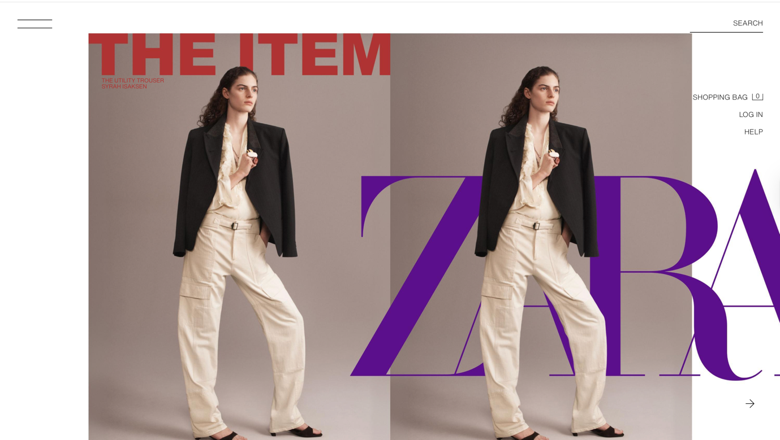
Website: https://www.zara.com/uk/

Zara UK Product
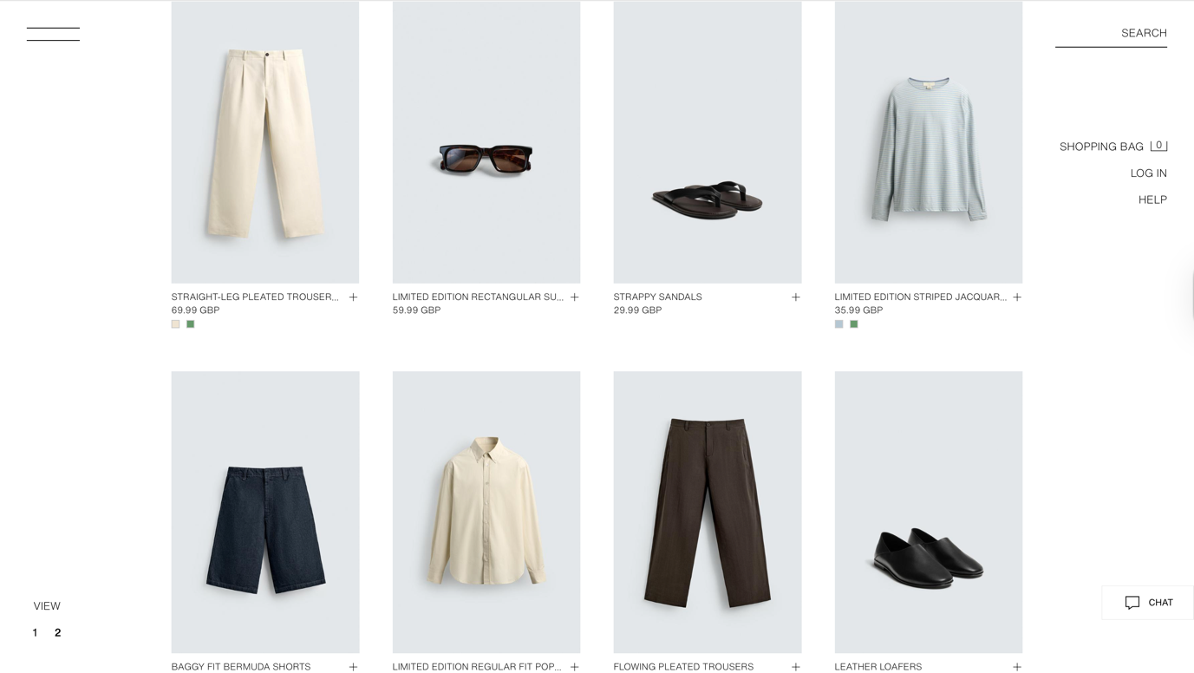
Website: https://www.zara.com/uk/en/man-new-in-l711.html?v1=2544454
Zara India Website

Website: https://www.zara.com/in/
Zara India Product
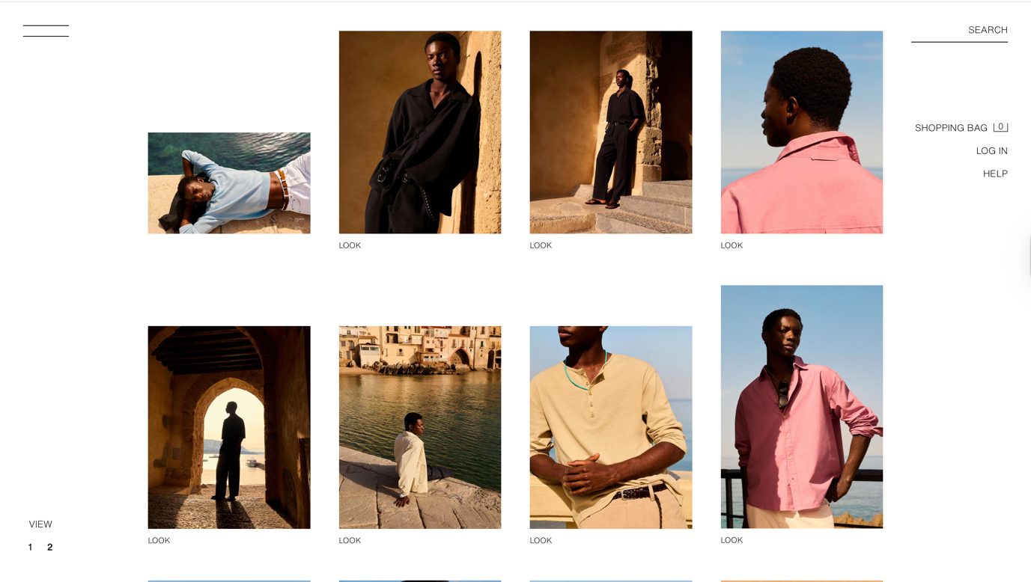
Website: https://www.zara.com/in/en/man-new-in-l711.html?v1=2544454

Zara UK Stores
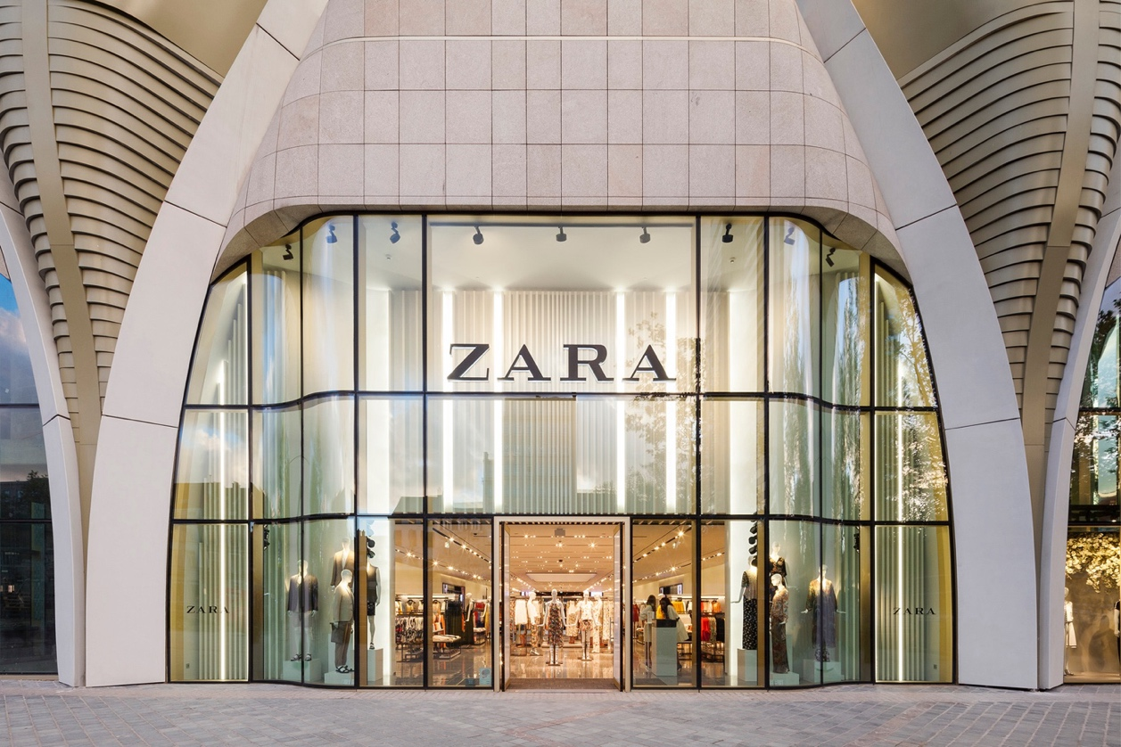
Website: https://www.theindustry.fashion/zara-launches-innovative-store-mode-technology-in-uk/
Zara India Stores
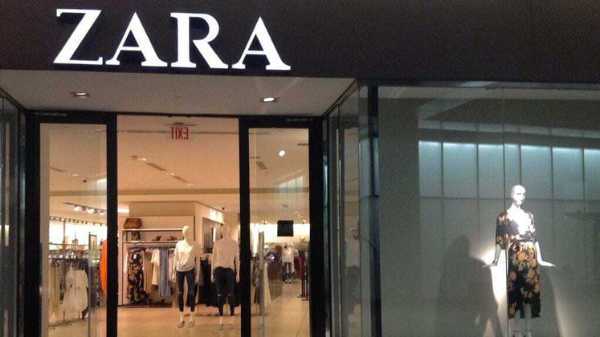
Website: https://apparelresources.com/business-news/retail/zara-indias-profit-78-per-cent/

Zara UK Employee

Website: https://www.fibre2fashion.com/news/textile-news/zara-home-opens-first-portuguese-for-from-store--292635-newsdetails.htm

Zara India Employee
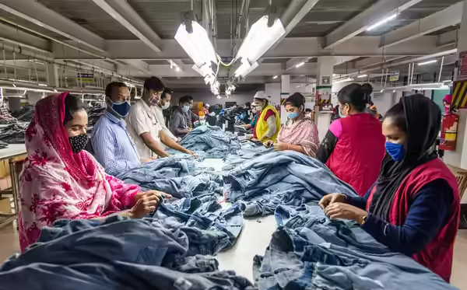
Website: https://economictimes.indiatimes.com/prime/economy-and-policy/as-zara-hm-swelter-over-bangladesh-turmoil-this-is-what-india-can-stitch-up/primearticleshow/112612016.cms?from=mdr

