
Community Policing: Partnerships, Policing and people
Community and Neighbourhood Policing

2007838
Chelsey poulton

CONTENTS
Introduction…………………………………………………………………………………………………………………..……..2
What is partnership working…………..…………………...…………………………………………………………………..3
Effective communication………………………….………………………………………………………………………….….4
Community and Neighbourhood policing……………………………………………………………………………………7
Modern Policing challenges and impacts ………….……………………………………………………………………….8
Conclusion………………..…………..………………………………………………………………………………………………9
Appendix……………………………………………………………………………………………………………………….……..10
Reference list…………………………………………………………………………………………………………………………11

Introduction

This report will breakdown and look at community policing: Partnerships, Policing and People. It will go on to focus on these four key aspects-
- Partnership working
- Effective communication
- Community and Neighbourhood Policing
- Modern Policing challenges and impacts
It is evident within this paper that police can not fight crime alone, and having partnerships and community support is key for having safer neighbourhoods. It is shown within this report that the community is a large part of modern day policing and this causes its own set of challenges for modern policing.

What is Partnership Working

Farrell (2020) simply states that partnership policing is when multiple agencies such as,
- Police
- Businesses
- Communities
- Government agencies
Come together and collaborate with the main aim of making communities safer. According to Rowe (2015) this only come into play because of the Crime and Disorder Act in 1998. Forrells (2020) words are backed up in an article written by Mazerolle (2024). Within this report Mazerolle states that partnerships in policing are common practice to reduce crime levels and anti-social behaviour across most parts of the world.
The most widely used partnership policing type is the Third-Party-Policing (TTP). (Mazerolle, et al, 2024). TTP is only achieved when police work cohesively with third party companies. Cooperation Between all parties is important to help minimize the risk of safeguarding issues slipping through the system. (collage of policing, 2015). Data protection was a concern that was raised with policing partnerships, so in 2016 the General Data Protection Regulation (GDPR) was introduced, this co insides with the Data Protection Act 2018. According to the collage of policing (2016) this act and the GDPR are a key part of the information sharing process with TTP, without these the TTP’s wouldn’t work. Comparing h work done by Florence et al (2011) and Aston et al (2021) it is evident that they have both come to the conclusion and argue that all shareable information enables that possibility of early intervention, preventing crime and permitting safeguarding and promoting welfare creating wider public protection. The safeguarding and welfare of the public is of the up most importance as this encourages trust and community engagement, as shown in the table 1 (APPENDIX 1) this table also shows the potential risks that non effective communication can cause.

Effective communication

Engagement is referred within policing as a key objective as pointed out by Bowen-Jones and Davies in a seminar in the University of Wales Trinity St Davids in 2024, as this will build the public’s confidence in the police and help build a level of trust and without these two things there could potentially be a breakdown of effective communication. The way police officers communicate with the public matters, but communication can differ in different types of situations. An officer would not communicate with a grieving family the same way they would communicate with a suspect. Although both have a level of respect as it is a person one would have a level of empathy leading to communicating in a different manner. Roggers (1995) describes communication as
“A process in which participants create and share information with on another in order to reach a mutual understanding”
The English language differs from place to place, pronunciation also differs from place to place, for example
Oxford english | Swansea english
House | OWSS
EAR | YUR
WHAT IS THAT | WASSAT
Although as shown in the table above that language and pronunciation differs from place to place, form all communication always stay the same. There are three main types of communication and they are,
- Verbal communication
- Written communication
- Non-verbal communication

Verbal communication:
Verbal communication is a form of oral communication that happens when the messenger also known as the person talking uses words or sounds that has pace, to communicate a message to a recipient also known as the person listening. (Johnson et al, 2024)

Written communication
Written communication has quickly become the everyday form of communication for young people. The most common form of written communication is non formal communication, this can vary from text email snapchat. There is also formal forms of written communication and this type of writing has structure and is a professional way of writing and follows a strict set of rules. (Heck et al, 2019)

Non-verbal communication
Non-verbal communication is something all humans do subconsciously multiple time a day. This type of communication involves eye contact, facial expressions, hand gestures and body language. (Sutiyatn, 2018)
Mehrabain (1971) conducts a study and concludes that,
- 7% of perception comes from what we say

- 38% comes from our tone and pace or the way we speak.

- And a large 55% comes from our body language and the non-verbal ways of communicating

In an article by Bsat in 2020, it is found that within 7-30 seconds of meeting someone, a first impression is made from someone’s body language and eye contact. This matches the evidence shown above found above by Mehrabain (1971) when it suggests that 55% comes from non-verbal communication.
Given all this information it is evident that effective communication is a key skill for officers to have for them of appropriately perform their policing duties. (Bottomley, et al 2020) advanced communication skills enables police officers to build trust and a good repot, encouraging individuals to open up more freely. To quote Weismann (2003)
“ Our ability to create and sustain our social world depends in large measure on how well we communicate”
In short a police officer is not able to build relationships or de-escalate situations or write reports without effective communication. Given that communication is a large part of the job, these forms of communication do contain some barriers. Smith (2019) suggests that some of these potential barriers are,
- Physical barriers
- Emotional barriers
- Language barriers

Physical barriers
Environment: Some of the environmental barriers can be physical challenges such as social distancing, remote work, or closed office doors.
Body language: Some of the physical barriers when it comes to body language is closed off body language such as, Poor posture, crossed arms, or fidgeting.

Emotional barriers
Emotions: people react with emotions and this creates a large barrier some of these emotions are, Fear, mistrust, anger, stress, or sadness
Self-esteem: Low self-esteem is a large barrier especially as people tend to get embarrassed making their job harder as they get shy and don’t communicate effectively.

Language Barriers
Language barriers occur when people speak different languages, and this makes it hard for people to understand each other. People do not have to talk a different language as shown in the table earlier in this report different places speak different English dialect making miscommunication possible.
Communication for officers can be hard enough in some circumstances to so adding barriers to the problem can make it a lot harder but s seen officers can work hard to get around these barriers leading to successful effective communication.

Community and neighbourhood policing

This chapter focuses on community and neighbourhood policing. It is common knowledge that the main objective of community and neighbourhood policing is to make the communities safer for all individuals, this is backed up by Wadley et al (2023) with Wadley et al also pointing out the underpinning ethical frameworks in neighbourhood Hot Spot policing strategies. Commonly called ‘Hot Spots’ by officers, this is where crimes are happening in a cluster of locations and the aim of community and neighbourhood police officers is to find these Hot Spots and make them safer. Rowe (2017) hives a similar description to Innes et al (2020) with both describing that community and neighbourhood policing is a critical path for all officers to gain the public’s trust, therefore possibly opening community links to find out more information hot crime Hot Spots.
The key aspects of Hot Spot policing are
- Identifying the Hot Spots
- Focusing resources
- Rotating officers
- Random patrols
Neighbourhood Policing is a strategy within the police force that is all about engaging with local communities. Innes et al (2017) suggests that the aim of engaging with the community is to reduce crime and possibly prevent it all together, leading to the improvement of neighbourhoods and communities.

Modern Policing challages and impacts

Although modern policing brings its benefits it also brings its fair share of challenges. Dame Diana Johnson MP (Parliament, 2023) who is the chair of the home affairs committee states
“The challenges facing police today are immense, due to evermore sophisticated online crime and unrelenting demand”
Just one of the challenges and probably one of the biggest challenges is

Publics trust
Due to the rise on criminal officers the publics dis trust is high. In 2023 the parliament made a report based on some quality research, finding out that in 2022 alone black individuals were searched at a rate of 4.8% higher than white individuals. (Brown and Hobbs 2023) this is leading to a high distrust amongst black communities when it comes to community officers.
Modern policing has been impacting officers and communities for many years now. The biggest impact is community relations and public trust. These issues can only be fixed if more objectives like the neighbourhood policing are adhered to, and by officers being more visible and accessible to the communities they are serving. It is also being seen in modern policing that police offers are being held accountable for their own actions this was written by James cleverly in a statement made in May 2024 (Parliament, 2024). This is leading to trust being reinstated within the communities between the police and the individuals withing the communities.

conclution

To conclude, it is evident withing this report that the police can only fight so much crime alone and TTP are a key part of any crime fighting initiative. As the college of policing (2015) point out cooperation between all parties involved creates a more effective line of communication, and without effective communication safeguarding cases can slip through the system and make officers jobs harder. Police officers have enough barriers in place without the communication with TTP being difficult to. So all this report has pointed out and the key thing it has brought to the surface is that police need the help of others to be successful and the most important help come from communities themselves.

Appendix

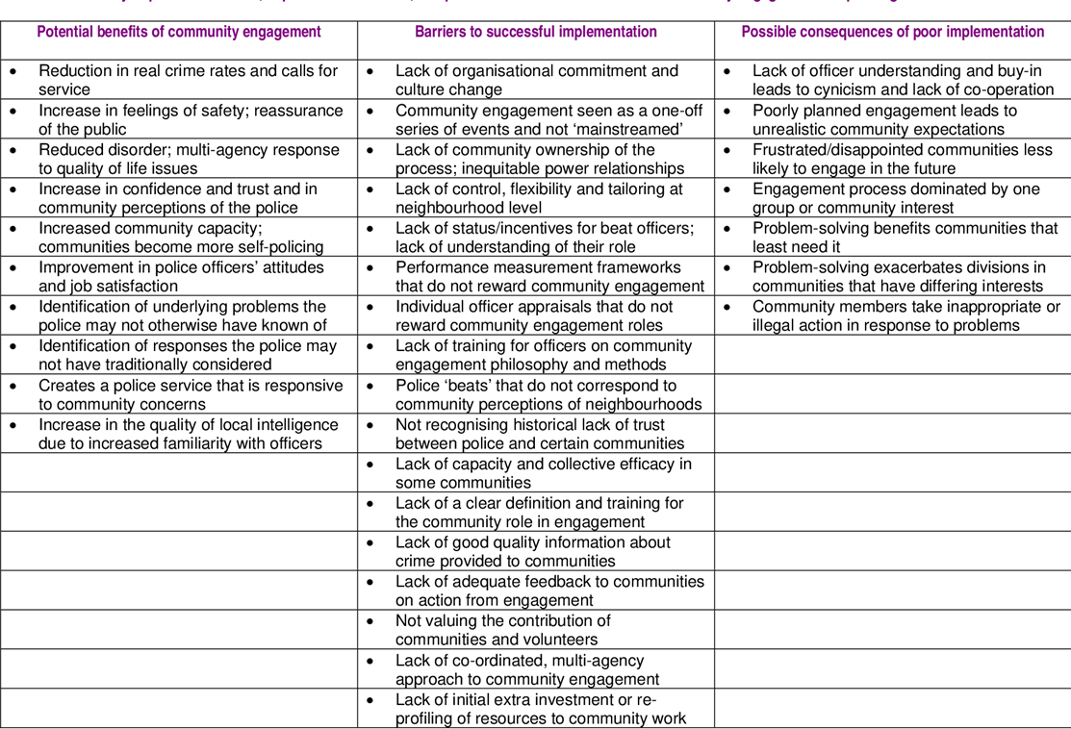
Appendix 1

Refrence list

Aston, E.V., O’Neill, M., Hail, Y. and Wooff, A. (2021). Information sharing in community policing in Europe: Building public confidence. European Journal of Criminology, 20(4), pp.1349–1368. doi:https://doi.org/10.1177/14773708211037902.
Bottomley, J., Wright, M. and Pryjmachuk, S. (2020). Communication Skills for your Policing Degree. Critical Publishing.
Bowen-Jones, L. and Davies, j (28AD). Communities, Partnership and Cohesion, Community and Neighbourhood Policing. University of Wales Trinity Saint David.
Brown, R. and Hobbs, A. (2023). Trust in the police Overview. [online] Available at: https://researchbriefings.files.parliament.uk/documents/POST-PN-0693/POST-PN-0693.pdf [Accessed 8 Jan. 2025].
Bsat, M. (2020). Neurolanguage Collective Magazine. [online] neuro heart collective. Available at: https://neuroheartcollective.com/the-impact-of-body-language-on-first-impressions/ [Accessed 1 Jan. 2025].
College of Policing (2015). Partnership working and multi-agency responses/mechanisms. [online] College of Policing. Available at: https://www.college.police.uk/app/major-investigation-and-public-protection/domestic-abuse/partnership-working-and-multi-agency-responsesmechanisms [Accessed 30 Dec. 2024].
College of Policing (2016). Information Sharing. [online] College of Policing. Available at: https://www.college.police.uk/app/information-management/information-sharing [Accessed 30 Dec. 2024].
College of policing (2020). Part 3 Part 3: Future challenges. [online] Available at: https://assets.college.police.uk/s3fs-public/2020-08/Future-Operating-Environment-2040-Part3-Challenges.pdf.
Farrell, C. (2022). Partnership Working – Why is this important. [online] Careers in Blue. Available at: https://careersinblue.co.uk/partnership-working-why-is-this-important/ [Accessed 30 Dec. 2024].
Florence, C., Shepherd, J., Brennan, I. and Simon, T. (2011). Effectiveness of anonymised information sharing and use in health service, police, and local government partnership for preventing violence related injury: experimental study and time series analysis. BMJ, [online] 342, pp.1405–1405. doi:https://doi.org/10.1136/bmj.d3313.
GDPR (2018). General data protection regulation (GDPR). [online] General Data Protection Regulation (GDPR). Available at: https://gdpr-info.eu/ [Accessed 30 Dec. 2024].
Heck, J.A. et al. (2019) Life skills for success. Communication skills. St. Paul, MN: JIST Career Solutions.
Innes, M., Roberts, C. and Lowe, T. (2017). Neighbourhood policing. The rise and fall of a policing model. Corby. England: Oxford University Press.
Johnston, S., Chute, A. and Pawliuk, B. (2024). 1.1 What is Communication: Types and Forms. jcu.pressbooks.pub. [online] Available at: https://jcu.pressbooks.pub/health-communication/chapter/1-1-communication-types-and-forms/ [Accessed 1 Jan. 2025].
legislation.gov.uk (1998). Crime and Disorder Act 1998. [online] Legislation.gov.uk. Available at: https://www.legislation.gov.uk/ukpga/1998/37/contents [Accessed 30 Dec. 2024].
Mayhill, A. (2012). Community engagement in policing Lessons from the literature. A typology of community engagement for policing . Available at: https://www.semanticscholar.org/paper/Community-engagement-in-policing-Lessons-from-the-Myhill/c50bfbd090fa899ef43ee9624f1fcb1ca8759dca [Accessed 30 Dec. 2024].
Mazerolle, L. (2014). The power of policing partnerships: sustaining the gains. Journal of Experimental Criminology, 10(3), pp.341–365. doi:https://doi.org/10.1007/s11292-014-9202-y.
Mazerolle, L. (2024). Partnership approaches in policing: An analysis of different types of partnerships and how they work to reduce crime and disorder . [online] Oxford Academic. Available at: https://doi.org/10.1093/police/paad075.
Mazerolle, L., Petersen, K., Sydes, M. and Ransley, J. (2024). Partnerships in Policing: How Third Parties Help Police to Reduce Crime and Disorder. [online] Elements in Criminology. Available at: https://www.cambridge.org/core/elements/partnerships-in-policing/0864BAD08D35451F0DCD3B558BC7A3BD [Accessed 30 Dec. 2024].
Mehrabian, A. (1971). Silent messages : Implicit communication of emotions and attitudes. Belmont, Calif.: Wadsworth Pub. Co.

Parliament.uk. (2023). Hard-hitting measures to eradicate toxic police culture must come before wider change possible, Home Affairs Committee warns - Committees - UK Parliament. [online] Available at: https://committees.parliament.uk/work/6865/policing-priorities/news/198334/hardhitting-measures-to-eradicate-toxic-police-culture-must-come-before-wider-change-possible-home-affairs-committee-warns/ [Accessed 8 Jan. 2025].
Parliament.uk. (2024). James Clervely Written Statements - Written questions, Answers and Statements - UK Parliament. [online] Available at: https://questions-statements.parliament.uk/written-statements/detail/2024-03-21/hcws369 [Accessed 10 Jan. 2025].
Rogers, E.M. (1995). Diffusion of innovations. 4th ed. New York: Free Press, p.35.
Rowe, M. (2002). Policing Diversity: Themes and Concerns from the Recent British Experience. Police Quarterly, 5(4), pp.424–446. doi:https://doi.org/10.1177/109861102237689.
Rowe, M. (2018). Introduction to policing. 3rd ed. Los Angeles Etc.: Sage.
Smith, D. (2019). 13 Barriers to Effective Communication & What is a Comm Barrier? [online] Making Business Matter. Available at: https://www.makingbusinessmatter.co.uk/barriers-to-effective-communication/ [Accessed 1 Jan. 2025].
Sutiyatno, S. (2018) ‘The Effect of Teacher’s Verbal Communication and Non-verbal Communication on Students’ English Achievement’, Journal of language teaching and research, 9(2), pp. 430–437. Available at: https://doi.org/10.17507/jltr.0902.28.
UK Government (2018). Data Protection Act 2018. [online] Legislation.gov.uk. Available at: https://www.legislation.gov.uk/ukpga/2018/12/contents [Accessed 30 Dec. 2024].
Wadley, S., Riley, L. and Murria, S. (2023). Police Problem Solving Models and Theories. 1st ed. St Albans, England: Critical Publishing.
Weissman, D.H., & Compton, R.J. (2003). Practice makes a hemisphere perfect: The advantage of interhemispheric recruitment is eliminated with practice. Laterality, 8, 361-375.

