
Contempory Challenges
Making a difference

acca4027
andrew davis
2220233

Contents
Page 1 Contents.
Page 2 Introduction to visions of the future.
Page 2 Definition of Automation and what it contains.
Page 2-3 The main causes of Automation.
Page 3-4 Consequences.
Page 4 Potential Solutions.
Page 4-5 Summary.
Page 5 Poster and link.
Page 5-8 References.
Page 8 Bibliography.

Introduction to visions of the future.
This report will discuss the effects of Automation, Robotics and AI on society and focus on the impact to future job opportunities. Defining what automation, robotics and AI are, discussing the reasons behind the advancement of automation, robotics and AI. The consequences of progression in automation, robotics and AI on society and employment. Concluding the report discussion will be potential solutions and theories to this issue. Finally, a short summary.
Definition of automation and what it contains.
Automation: - The method or technique used to operate machines or systems without human interaction by highly automatic processes [1].
Artificial Intelligence: - The theory and development of computer systems able to perform tasks normally requiring human intelligence, such as visual perception, speech recognition, decision-making, and translation between languages [2].
Robotics/Robot: -The process of designing and operating Robots (a machine that can perform a complicated series of tasks by itself) [3].
Internet of Things: - Objects with computing devices contained within that can connect to each other and exchange data using the Internet. [4]
Definitions have been detailed above of Automation, AI, and Robotics as automation includes each of these separate factors brought together and they will be mentioned regularly.
The main causes for automation
So, what’s the driving force pushing for the new era of automation, AI and robots to now take over the manual labour blue collar employee? Andy Puzder Former CEO of CKE Restaurants was very enthusiastic for digital devices over human workers “They’re always polite, they always upsell, they never take a vacation, they never show up late, there’s never a slip-and-fall, or an age, sex or race discrimination case.” Whilst it’s also mentioned by Eric Boehm writer for Watchdog.org ‘’You don’t need to pay a computer kiosk $15 an hour to take orders’’ [5].
Below figure 1 shows industrial installations by customer industry [1].
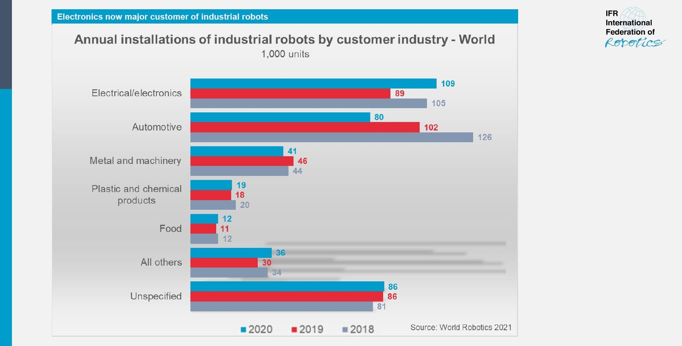

With the reduction in costs to implement an automated system and labour costs rising many CEOs think it is more viable to go fully automated, Wendy’s COO Bob Wright mentions “We’ve hit the point where labour-wage rates are now making automation of those tasks make a lot more sense’’ [6]. Amazon for example have developed Amazon Go an app that offers users a unique shopping experience. The GO store is fitted with ‘just walk-out’ technology such as cameras and senor’s that track items customer pick up. When done they just leave the store with no need to go through a checkout, their receipts emailed to them, and the bill charged to an amazon account [12]. Amazon also deploy over 50,000 Kiva robots, which they claim can cut labour cost of fulfilling online orders by up to a fifth [6]. Automating the whole process from purchasing and payments via an AI app to storage and retrieving goods with robots, the processing speed to which these machines and programs perform and interact with each other help streamline the whole experience.
The advancement of AI and Robotics the Internet of Things has exploded in the last 25 years with technology now capable of performing more than routine set tasks. Machines share data with each other at an increasing amount each day, now threatening more non-routine cognitive tasks such as driving or performing intricate operations like data mining [7].

Consequences?
Frey and Osborne state that up to 47% of all US jobs could be automated in the near future, causing serious fear and doubt about low skilled worker jobs due to the lack of capitalization effect [8].

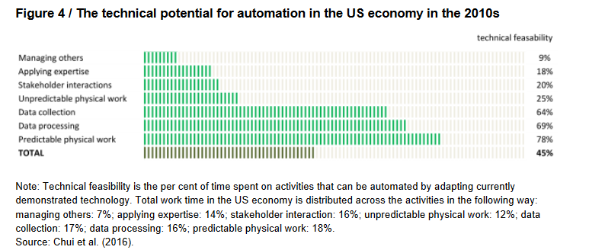
Above figure 2 shows technical feasibility of activities that could potentially be automated with current technology [2].
However, another report used a task-based rather than occupation-based research method into the automation of tasks within job roles and found that overall, less jobs would be fully automated and more individual tasks would be suggesting 9% of jobs to be automated [7]. With the introduction of new and innovative technology to replace tasks more training and education is required to ensure the technology can work effectively. As automation becomes increasingly more integrated within the workplace workers will need to be educated and retrained in the technology being used. This has been referred to as the ‘Race Against the Machine’ [9]. The loss of jobs is therefore no forgone conclusion, especially when experts tend to overestimate what technology could replace human workers compared to the practical implementation [10]. Historically labour rights have always been at the front of people’s attention when new technology is introduced, looking at the Luddites in the industrial revolution breaking machines which threatened mass-produced low-quality goods compared to the more expensive handmade textiles [11].
Solutions
More recent events which have had a huge impact on the workforce and how business was operating was the COVID pandemic. The use of technology like OneDrive and Microsoft Teams gave some people the option to work from home. This was a solution to a problem, using technology to help people interact whilst still being able to work during lockdown conditions. With automation only growing across all industries and more jobs becoming obsolete due to societal needs and wants, an evaluation of what constitutes work might be needed as the current definition is mainly formal work supplied as labour. If society re-evaluates what constitutes work to include other aspects of life, such as raising children, volunteering and other varying work, such as artistic/spiritual learning or cultural activities which promote self-advancement. This would require the economy to be for the benefit of its citizens and reforms to social and economic arrangements such as a universal basic income. Another alternative would be to slow down the implementation of technology until societal needs can be achieved alongside economic ones [6].
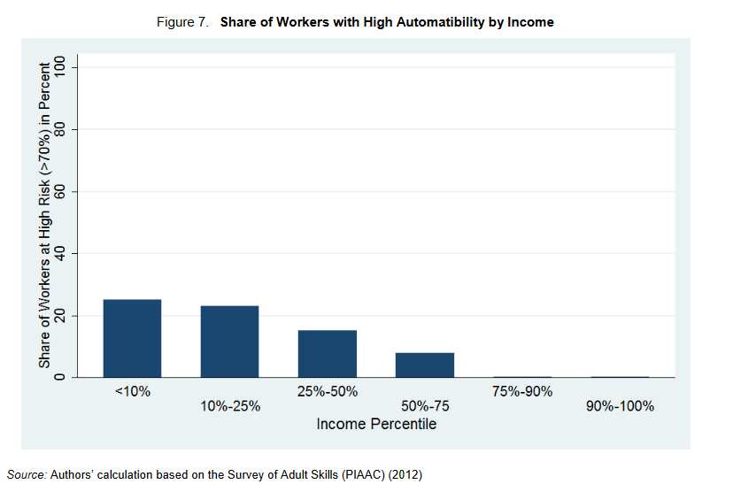
Above figure 3 shows risk of automation in relation to earned income [3]
Summary
Automation is the process of machine performed tasks using Artificial Intelligence and Robotics. This report discussed the causes and effects of automation on future job opportunities and what the consequences and solutions might be to them. Looking at evidence from a historical perspective of how innovation of technology impacted jobs in the industrial revolution to how the future projections of Automation in the digital era have been calculated. Finally, solutions to how society can advance with technology and what can be done to help this happen.
AI and the future of jobs Poster and link
https://www.behance.net/gallery/164937535/Automation-AI-and-Robotics-impact-on-future-jobs
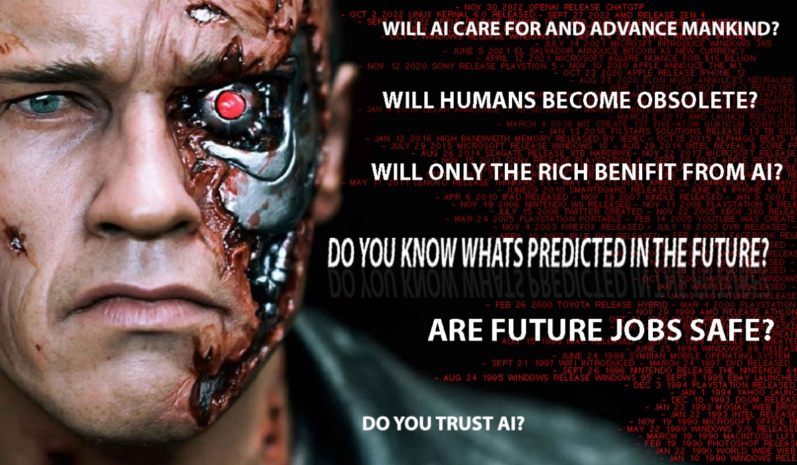
References
[1] “Automation definition & meaning,” Dictionary.com. [Online]. Available: https://www.dictionary.com/browse/automation. [Accessed: 11-Feb-2023].
[2] “Artificial Intelligence,” Oxford Reference. [Online]. Available: https://www.oxfordreference.com/display/10.1093/oi/authority.20110803095426960;jsessionid=FF2B03B8AF7B09D0D080933D51D27751. [Accessed: 11-Feb-2023].
[3] “Robotics,” robotics noun - Definition, pictures, pronunciation and usage notes | Oxford Advanced Learner's Dictionary at OxfordLearnersDictionaries.com. [Online]. Available: https://www.oxfordlearnersdictionaries.com/definition/english/robotics. [Accessed: 11-Feb-2023].
[4] “The internet of things,” Cambridge Dictionary. [Online]. Available: https://dictionary.cambridge.org/dictionary/english/internet-of-things. [Accessed: 20-Feb-2023].
[5] K. Taylor, “Fast-Food CEO says he's investing in machines because the government is making it difficult to afford employees,” Business Insider. [Online]. Available: https://www.businessinsider.com/carls-jr-wants-open-automated-location-2016-3?r=US&IR=T. [Accessed: 11-Feb-2023].
[6] D. M. West, The Future of Work: Robots, AI, and Automation. Washington, D.C.: Brookings Institution Press, 2019. Pg 3-6, 19-23, 43-45,
[7] M. Arntz, T. Gregory, and U. Zierahn, “The risk of automation for jobs in OECD countries,” OECD iLibrary, 14-May-2016. [Online]. Available: https://www.oecd-ilibrary.org/social-issues-migration-health/the-risk-of-automation-for-jobs-in-oecd-countries_5jlz9h56dvq7-en. [Accessed: 11-Feb-2023].
[8] Frey, C. B. and M.A. Osborne (2015), “Technology at Work: The Future of Innovation and Employment”,
Citi GPS: Global Perspectives & Solutions, February 2015.
[9] E. Brynjolfsson and A. McAfee, Race against the machine how the Digital Revolution is accelerating innovation, driving productivity, and irreversibly transforming employment and the economy. Erik Brynjolfsson and Andrew McAfee © 2011, 2012.
[10] D. Autor, “Economics.mit.edu.” [Online]. Available: https://economics.mit.edu/sites/default/files/publications/AI%20and%20Jobs%20-%20Evidence%20from%20Online%20Vacancies.pdf. [Accessed: 20-Feb-2023].
[11] “Wiiw monthly reports - THE LUDDITE REBELLION: PAST AND PRESENT,” wiiw.ac.at. [Online]. Available: https://wiiw.ac.at/publications-1-all-all-all-10-year-desc-0-.html. [Accessed: 20-Feb-2023].
[12] “Amazon go technology - the end of checkouts?,” Amazon Go Technology - the End of Checkouts? [Online]. Available: https://www.adcocksolutions.com/post/is-amazon-go-store-technology-the-end-of-supermarket-checkouts. [Accessed: 01-Mar-2023].
Image References
[1] IFR International Federation of Robotics, “IFR presents world robotics 2021 reports,” IFR International Federation of Robotics. [Online]. Available: https://ifr.org/ifr-press-releases/news/robot-sales-rise-again. [Accessed: 20-Feb-2023].
[2] “Wiiw monthly reports - THE LUDDITE REBELLION: PAST AND PRESENT,” wiiw.ac.at. [Online]. Available: https://wiiw.ac.at/publications-1-all-all-all-10-year-desc-0-.html. [Accessed: 20-Feb-2023].
[3] D. M. West, The Future of Work: Robots, AI, and Automation. Washington, D.C.: Brookings Institution Press, 2019. Pg 20.
Poster Image References
[1] R. Leston, uk.movies.yahoo.com, 2017.
Poster References
[1] “Research guides: How to create a research poster: Poster basics,” Poster Basics - How to Create a Research Poster - Research Guides at New York University. [Online]. Available: https://guides.nyu.edu/posters. [Accessed: 27-Feb-2023].
[2] Library, “Presentations: Posters,” Library, 14-Jul-2020. [Online]. Available: https://library.leeds.ac.uk/info/1401/academic_skills/196/presentations_posters. [Accessed: 27-Feb-2023].
[3] “How to make your scientific poster stand out,” How to make your scientific posters stand out. [Online]. Available: https://www.scientifica.uk.com/neurowire/how-to-make-your-scientific-posters-stand-out. [Accessed: 27-Feb-2023].
[4] “Making an impact with your poster - university of Liverpool.” [Online]. Available: https://www.liverpool.ac.uk/media/livacuk/computingservices/printing/making-an-impact-with-your-poster.pdf. [Accessed: 27-Feb-2023].
[5] “Tips for effective poster design,” University of Birmingham. [Online]. Available: https://www.birmingham.ac.uk/schools/metallurgy-materials/about/cases/tips-advice/poster.aspx#:~:text=Typically%2C%20a%20poster%20should%20contain,%2C%20results%2C%20discussion%20and%20conclusions. [Accessed: 27-Feb-2023].
[6] “1001freefonts.com,” Search fonts | Adobe Fonts. [Online]. Available: https://fonts.adobe.com/fonts?purpose=desktop&ref=tk.com&referrer=0189d50fcf. [Accessed: 27-Feb-2023].
[7] “Timeline of computing 2020–present,” Wikipedia, 23-Feb-2023. [Online]. Available: https://en.wikipedia.org/wiki/Timeline_of_computing_2020%E2%80%93present#2020. [Accessed: 28-Feb-2023].
[8] “Neuralink: Elon Musk unveils pig with chip in its brain,” BBC News, 29-Aug-2020. [Online]. Available: https://www.bbc.co.uk/news/world-us-canada-53956683. [Accessed: 28-Feb-2023].
[9] K. Webb, “From the internet to the iphone, here are the 20 most important inventions of the last 30 years,” Business Insider. [Online]. Available: https://www.businessinsider.com/most-important-inventions-of-last-30-years-internet-iphone-netflix-facebook-google-2019-5?r=US&IR=T#photoshop-1990-2. [Accessed: 01-Mar-2023].
[10] P. Ediomo-Abasi, “Tech timeline: 30 years and beyond (1987–2017) +,” Medium, 26-Apr-2018. [Online]. Available: https://medium.com/fbdevclagos/tech-timeline-30-years-and-beyond-1987-2017-8beef66255dc. [Accessed: 01-Mar-2023].
Bibliography
“The Rise of the Robot Worker,” ProQuest | Better Research, Better Learning, better insights. [Online]. Available: https://www.proquest.com/. [Accessed: 21-Feb-2023].
B. O. B. BATES, learning theories simplified: And how to apply them to teaching. S.l.: SAGE PUBLICATIONS, 2023.
“The future of AI: How Artificial Intelligence Will Change ... - built in.” [Online]. Available: https://builtin.com/artificial-intelligence/artificial-intelligence-future. [Accessed: 27-Feb-2023].
“1001freefonts.com,” Search fonts | Adobe Fonts. [Online]. Available: https://fonts.adobe.com/fonts?purpose=desktop&ref=tk.com&referrer=0189d50fcf. [Accessed: 27-Feb-2023].

