

WIRELESS NETWORK PENETRATION TESTING

by
SRAVANTHI SILVERU
(2228080)

Supervisor: Dr. Nitheesh Murugan Kaliyamurthy

Project submitted as part of the requirements for the award of MSc Cyber Security and Digital Forensics Analysis

JULY 2024

DECLARATION FORM

I, SRAVANTHI SILVERU declare that I am the sole author of this Project; that all references cited have been consulted; that I have conducted all work of which this is a record, and that the finished work lies within the prescribed word limits.
This work has not previously been accepted as part of any other degree submission.

Signed: Sravanthi Silveru
Date: 05 JULY 2024

FORM OF CONSENT

I SRAVANTHI SILVERU hereby consent that my Project, submitted in candidature for the M.Sc. Applied Computing degree, if successful, may be made available for inter-library loan or photocopying (subject to the law of copyright), and that the title and abstract may be made available to outside organisations.

Signed: Sravanthi Silveru
Date: 05 JULY 2024

ABSTRACT
In the current complex and expansive world of digital networks, wireless networks specifically require penetration testing to assess the vulnerability against possible attacks. This work centres on the vulnerability assessment of wireless networks through the use of especial tools and methods. The goal is primarily focused on testing the security of wireless infrastructures by probing supposed weaknesses of WPA and WPA2. Using Wireshark and Aircrack-ng, the project proceeds to capture and analyse traffic, employing various packets capturing and decryption techniques for vulnerabilities identification purposes.
With a wireless USB adapter, DIR-615 wireless N300 router, and the Kali Linux distribution, the project imitates real-life attack methods such as brute force, de authentication, and man in the middle. When it comes to the practical approach it is based on capturing handshake packets, finding vulnerabilities and then trying to penetrate the network without having proper access rights. Ethical conducts are followed in each phase of testing, which helps to retain the network’s integrity and offer valuable recommendations for enhancing its security.
The project also sought to outline the weaknesses of modern wire-less networks and ways to improve on existing security measures. These insights will help to enhance wireless network communication robustness and provide guidelines to the superintendents of such networks. The findings of this research thus come at a time when organizations should carry out security evaluation regularly to protect such information shared over wireless links.

Table of Contents
ABSTRACT 3
Table of Contents 4
LIST OF FIGURES 5
LIST OF TABLES 7
1. INTRODUCTION 7
1.1 Problem Statement 9
1.2 Aim & Objectives 9
2. LITERATURE REVIEW 10
2.1 Background 11
2.2 Networks and its Types 12
2.2 Wireless Networks 12
2.3. Standards 13
2.4 Wireless Network Security 14
2.5 Wireless Network Security Protocols 14
2.5.1 Wired Equivalent Privacy (WEP) 14
2.5.2 WiFi Protected Access (WPA) 15
2.5.3 Wi-Fi Protected Access 2 (WPA 2) 15
2.5.4 Wi-Fi Protected Access (WPA3) 15
2.6 Wireless Network Vulnerability 16
2.6.1 Vulnerability Assessment 17
2.7 Security Policies for Organizational Protection 18
2.8 Different Types of Attacks On WLAN 19
2.9 Security Challenges in Wireless Network 24
2.10 Penetration Testing 25
2.10.1 Types of Penetration Tests 25
2.10.2 Standard of the Penetration Testing 26
2.10.3 Penetration Testing Tools 26
2.11 Mitigations Wireless Network 27
2.12 Case Study 28
3 METHODOLOGY 30
3.1 Research on Onion Layers: 30
3.1.1 Layer 1: Research philosophy 31
3.1.2 Layer 2: Approaches 31
3.1.3 Layer 3: Approaches to theory development 32
3.1.4 Layer 4: Research strategy 33
3.1.5 Layer 5: Methodological choice 34
3.1.6 Layer 6: Time horizons 35
3.2. Specific Methods 35
3.3 Data collection 36
3.4 Experimental Approach 37
3.5 Reporting 38
3.7 Timeline of Project Approach 40
4. NETWORK DESIGN AND IMPLEMENTATION 42
4.1 Laboratory Experiment Setup and Requirements 42
4.2 Exploiting Vulnerabilities in IEEE 802.11 WEP Security Protocol 44
4.3 Exploiting Vulnerabilities in IEEE 802.11 WPA/WPA2 Encryption Protocol 54
5. RESULTS ANS ANALYSIS 61
5.1 Mitigations 62
5.2 Status Attacks 68
6. CONCLUSIONS 72
7. FUTURE WORK 72
REFLECTIONS 73
REFERNCES 75

LIST OF FIGURES
Figure 1: Wi-Fi Protected Access (WPA) 15
Figure 2: Vulnerability Assessment 17
Figure 3: WLAN 19
Figure 4: Man-in-the-Middle Attack 20
Figure 5: Chop Chop Attack 21
Figure 6: ARP Replay Attack 22
Figure 7: Brute Force Attack 23
Figure 8: Evil Twin Attack 23
Figure 9: Research Onion Layers 30
Figure 10: Gnatt Chart 41
Figure 11: Topology 41
Figure 12: airmon-ng start wlan0mon 44
Figure 13: airodump-ng wlan0mon 45
Figure 14: BSSID 45
Figure 15: airodump-ng bssid 84:1B:5E:88:BA:02 channel 11 write chopchop wlan0mon 46
Figure 16: Get BSSID 46
Figure 17: mac changer r wlan0mon 47
Figure 18: Create fake auth 47
Figure 19: Get Station Id 48
Figure 20 : Read the Packets 48
Figure 21 : chop chop attack 49
Figure 22 : Read the ARP packets 50
Figure 23 : Read the file Chopchop01.cap 50
Figure 24 : Aircrack-ng chopchop01.cap 50
Figure 25: Key found 51
Figure 26: arp request replay test 51
Figure 27: Perform a fake auth 52
Figure 28: Capture the Station 52
Figure 29: ARP request 52
Figure 30: Get the list of files 53
Figure 31: Key Found 53
Figure 32: Wireshark interface 54
Figure 33 : Link layer Header 55
Figure 34 : capture interface in the Wireshark program 55
Figure 35 : capturing in Monitor Mode. 56
Figure 36 : Capturing the Fourway Handshake 57
Figure 37 : save the captured traffic to a cap file 58
Figure 38: man aircrack-ng 58
Figure 39: Aircrack-ng 59
Figure 40 : Get the Encryption bssids 59
Figure 41: Key Found 60
Figure 42 : Server Manager 62
Figure 43 : Focus on name and password and give updates 62
Figure 44: Troubleshooting 63
Figure 45: GHz Wi-Fi settings 63
Figure 46: Create radius server 63
Figure 47: Open new RADIUS client 64
Figure 48: Give Ip add 64
Figure 49 : Add NAS port 64
Figure 50 : Create user ID 65
Figure 51: Created strong password 65
Figure 52: Create Group 66
Figure 53: Create Group Test 66
Figure 54: Wi-Fi status 67
Figure 55 : Chopchop attack Fails 68
Figure 56 : ARP Reply Attack Fails 69
Figure 57: Brute Force Attack Fails 70

LIST OF TABLES
Table 1: Appropriate layers for this project 35
Table 2: Project Timeline 40
Table 3: Success of attacks 70

INTRODUCTION
Wireless networks are gaining popularity in the communication technology industry due to their accessibility, mobility, and flexibility. They are used in various sectors like business, education, transportation, communication, and organizational settings. Wireless technology offers both secured and open connectivity options and is widely used in residential buildings. However, security issues remain due to the global demand for wireless access beyond current technology capabilities. Wireless networks offer the benefits of wired networks without physical limitations, making them essential in areas with insufficient telecommunications infrastructure and internet connectivity. IEEE sets "802.11b" as the industry standard for certified wireless networking products. Wi-Fi, developed in 1997, is widely used for wireless local area networking in residential and commercial settings.

Wireless technologies offer a more practical alternative to wired networking by eliminating the limitations associated with cables. The Institute of Electrical and Electronics Engineers (IEEE) has established "802.11b" as the industry standard for a class of approved wireless networking devices that meet this requirement. Wireless Fidelity, or Wi-Fi, technology was created in 1997 by the IEEE 802.11 and is currently extensively utilised for wireless local area networking in both residential and commercial settings because of its seamless connectivity and low cost. The concept of confidentiality involves limiting access to sensitive information to those who are authorised and protecting it from unauthorised users. Integrity preserves the legitimacy of data by guaranteeing its accuracy and protecting it against unintentional or intentional manipulation. When data is made available to verified users, it is said to be accessible. This guarantees that authorised users can easily obtain the data when they need it.
Since the 802.11 standard's creation, specific security protocols have been incorporated to guarantee safe peer-to-peer communication inside Wireless Local Area Networks (WLANs). At first, Wired Equivalent Protection (WEP) was put into place, but it was quickly found to be susceptible to different availability attacks and, more importantly, threats to the key's confidentiality, which compromised the communication's confidentiality overall. Later attempts, like WiFi Protected Access (WPA) and WPA2, showed improved resilience in terms of confidentiality. But their effectiveness is expected to decline with the spread of low-cost cluster computing and the increase of processing power. In the near future, it is anticipated that even brute force attacks will be able to compromise these mechanisms. However, cloud-based solutions such as Cloud Cracker have shown that they can test 300 million possible WPA passwords in just 20 minutes, illustrating how wireless network security issues are constantly changing[1].
Penetration testing mimics an assault to evaluate a system's or environment's security. Its goal is to identify flaws and vulnerabilities by closely examining how devices, networks, or systems behave under pressure. Tools for penetration testing can be as simple as system analysis or as complex as actively attacking a system to find vulnerabilities[2]. The test safely injects different exploits to assess the system's security. Permission is what distinguishes a penetration tester from a hacker. At the conclusion of the task, testers are required to submit a report and obtain permission from the owner of the resources under test. By assisting organisations in creating more dependable and secure systems, these tests improve security against possible attackers. This project's main goal is to evaluate a WiFi network's security using a TP-Link adapter. The project aims to find weaknesses in the network, take advantage of those weaknesses, and fortify the network's defences by employing specialised tools and targeted attack techniques. This test will be conducted using Kali Linux tools, its Aircrack-ng tools were used to perform penetration testing in WEP & exploited a 4-way handshake for WPA/WPA2. and the outcomes will be carefully examined[3].

1.1 Problem Statement
Attackers exploit vulnerabilities to intercept and decrypt sensitive data, compromising its integrity and confidentiality. Weak authentication methods, such as shared keys or MAC address filtering, are easily bypassed, leading to unauthorized access and potential data breaches. Rogue access points, intentional or accidental, enable cyberattacks like man-in-the-middle and data exfiltration. Inadequate network monitoring and logging exacerbate these risks by delaying incident detection and response.

Effectively addressing these problems requires a thorough wireless network security plan. This entails putting in place intrusion prevention and detection systems (IDS and IPS), conducting frequent security audits and penetration tests, using robust encryption protocols like WPA3 in conjunction with dependable authentication techniques like 802.1X, training employees on security best practices, and making sure that network hardware and software patches are applied on time. By implementing these measures, the risk of cyber threats is reduced, and network security is greatly improved.

1.2 Aim & Objectives
Aim:
The project aims to establish a secure, efficient wi-fi network for a small home or enterprise office by identifying and assessing vulnerabilities and threats, selecting appropriate tools, implementing mitigation strategies, and ensuring continuous monitoring and improvement. It provides actionable recommendations to protect against unauthorized access and data breaches.
Objective:
Identify vulnerabilities within the wireless network, this involves scanning for unsecured access points, strength of encryption protocols, and assessing network configurations to pinpoint any misconfigurations
1.Conduct comprehensive literature review on wireless network security, focusing on vulnerabilities, focusing on password weaknesses and mitigation strategies Analyse existing methodologies for ethical penetration testing to inform project methodology.
2.Deploy wireless network penetration testing tools and techniques, utilizing a Wi-Fi adapter to simulate real-world attack scenarios and identify vulnerabilities in target networks accurately.
3.Design and execute systematic testing methodology, including network reconnaissance, vulnerability scanning, and exploitation of identified weaknesses.
4.Collect and analyse data from penetration testing, identifying vulnerabilities and potential threats to wireless network security. Prioritize findings based on severity and potential impact on network integrity.
5. Recommendations for strengthening network defences and mitigation strategies based on the analysis findings to enhance the security posture of wireless networks, including strengthening password policies. Present findings and recommendations to stakeholders for implementation

LITERATURE REVIEW
Since its inception, IEEE 802.11 Wireless Local Area Network (WLAN) has evolved into a widely adopted and user-friendly network technology. Its popularity stems from the affordability and simplicity of deploying Local Area Networks (LANs), offering straightforward setup, installation, and configuration processes. The IEEE 802.11 standard provides a framework for WLAN communication, established in 1997 as a subset of the broader 802 standards [4]. The "11" suffix denotes WLAN within the IEEE framework, distinguishing it from other network types like Local and Metropolitan Area Networks (MANs). Governed by a set of protocols, 802.11 facilitates wireless signal propagation and communication throughout the network. It employs the Medium Access Control (MAC) protocol, incorporating Collision Avoidance (CA) and Carrier Sense Multiple Access (CSMA) mechanisms [5]. Variants such as 802.11a, 802.11b, 802.11g, 802.11n, and 802.11ac are distinguished by alphanumeric characters, with 802.11a, b, and g being the most widely utilized. This literature review emphasizes the importance of wi-fi adapters and explores key concepts, methodologies, and findings in wireless network penetration testing.

2.1 Background
Wireless networks are widespread in today's digital world because they are easy to use and offer connectivity. The security of wireless networks has become critical due to the growing reliance on them in both home and commercial settings. Due to their limited resources and expertise, small offices in particular frequently face challenges in maintaining strong security measures. There has never been a more pressing need for efficient penetration testing and security enhancement in wireless networks due to the ongoing evolution and sophistication of cyber threats.
The wireless local area networking are specified by the IEEE 802.11 family of standards, also known as Wi-Fi. (WLAN). Several encryption protocols, including WEP (Wired Equivalent Privacy), WPA (Wi-Fi Protected Access), WPA2, and the more recent WPA3, are included in these standards. Newer encryption protocols, like WPA3, have been introduced to address the vulnerabilities in older protocols, like WEP, that have been discovered to be susceptible to attacks over time. However, implementation, configuration, and other factors can affect how effective these protocols are in securing wireless networks.[6]
Choosing an authentication method significantly impacts security. WPA2Enterprise is suitable for high-security contexts like corporate networks but requires more setup due to enhanced features. WPA2PSK is simpler but less scalable and susceptible to passphrase hacking. Disabling Service Set Identifier (SSID) broadcast can improve security by making WLANs less apparent to casual users and requiring manual entry. Temporal Key Integrity Protocol (TKIP) was a better option but was mostly replaced by WPA2's AES (Advanced Encryption Standard). The more secure AESCCMP offers stronger protection against attacks compared to TKIP.

The project aims to identify vulnerabilities in a small office setting, evaluate their severity, and assess potential security risks using qualitative and quantitative research methods. It will involve IT staff and stakeholders to ensure recommendations are practical and useful. Wireless network penetration testing is crucial for assessing network security and replicating actual cyber threats. The project will assess IEEE 802.11 encryption protocols using Kali Linux hacking tools like Aircrack-ng and Wireshark to identify vulnerabilities and suggest security improvements.

2.2 Networks and its Types
Networks, consisting of interconnected computers, facilitate resource sharing, file exchange, and electronic communications. They exist in various types like social, mobile, and computer networks. Networking equipment connects computers in different configurations, and data packets are segmented and transmitted using wired or wireless media. [7] Computer networks are classified based on geographic area and data transfer rate.
- Personal Area Network: The lowest and most basic kind of network is called a personal area network (PAN). PANs link devices that are within a person's immediate vicinity and do not extend more than ten metres (m).
- Local Area Network: a system where computers and devices connect in one location, ranging from a few meters in a home to hundreds of meters in a large company office. LANs use both wired and wireless connectivity options, with wireless LAN (WLAN) surpassing wired LAN in popularity.
- Wide Area Network: A computer network architecture that links several local area networks (LANs) within a single network and extends beyond city boundaries is known as a wide area network, or WAN. [8]

Wireless Networks
A computer network that uses Radio Frequency (RF) links to transfer data between network nodes is called a wireless network. For residences, companies, and telecom networks, wireless networks are a common solution. Cell phone networks, satellite communication networks, wireless local area networks (WLANs), wireless sensor networks, and terrestrial microwave networks are a few types of wireless networks. [9]
- Wireless Local Area Network (WLAN): A group of linked gadgets in a permanent setting, like a house or office. A local area network (LAN) can range in size from an enterprise network in an office or school with tens of users and devices to a home network with just one user
- Wireless Wide Area Network (WWAN): It cover large regions like cities, states, or nations, enabling communication across great distances between localized networks. Examples include the Internet and cellular services, as they are not tied to a specific area.
- AdHoc Wireless Network: The method describes ad hoc nets or peer-to-peer systems where components form an unstructured organization, with no dominant relationship, used in untidy or impossible structures, proposing devolved connections in various situations.
Advantages of Wireless Networks:
- Mobility: Users can address network sources and the internet from any wireless reporting segment geographical area.
- Flexibility: It is more convenient to organize and distribute the load of wireless networks than wired ones, proving the existence of flexibility and mobility.
- Convenience: This reduces installation and preservation prices since no great cables are needed.

2.3. Standards
In the early 1990s, the need for networking standards grew across industries like business, education, health, communication, and transportation. Identifying wireless network values above establishes conditions and measures for device communication, ensuring it is compatible, interoperable, and uniformly presented across constructs and applications.[10]
Key Wireless Network Standards:
1. IEEE 802.11: This family of standards is IEEE 802. 11, accredited with IEEE, is in charge of wireless local area networks (WLANs), commonly called WiFi. For instance, it has 802 varieties. 11a, 802. 11b, 802. 11g, 802. 11n, 802. 11ac, and 802. 11ax, every necessary data tax, occurrence band, and variation process for wireless interconnection scenarios.
2. WiFi Alliance Certifications: This WiFi Alliance certification procedure ensures that the procedures correlate with IEEE 802. The Total ITSM mapping consists of 11 standards for interoperability and Implementation. Numbers and letters included in names like WiFi Certified 6 (802. 11ax), WiFi Certified 5 (802. 11ac), or previous WLAN standards like WiFi Certified 4 (802. 11n) show compliance with specific wireless networking standards.[11]
Importance of Standards:
Interoperability: This clearly shows that procedures built by diverse constructors can harmonize and carry out works effectively without compatibility issues.
Compatibility: This confirms compatibility and allows consumers to transition and join plans and organization mechanisms seamlessly.
Reliability: This verifies that there are separate preset suitable measures and circumstances to secure consistent implementation in wireless counterparts.

2.4 Wireless Network Security
Wireless securitization refers to the comprehensive security measures that ensure the reliability and ease of use of wireless communication systems. It includes four main categories: information security, network security, computer security, and wireless channel security. These categories are combined to create wireless network security, Wireless personal area networks (WPANs) have a 10 meter range, while wireless local area networks (WLANs) have a 100meter range and support data transfer speeds of up to 200 Mbps. [12]

2.5 Wireless Network Security Protocols
WLANs, utilizing radio wave media, are increasingly popular due to their cost effectiveness and efficiency, expanding into various markets and applications. However, securing WLANs is crucial due to inherent differences from wired LANs. WLANs extend fixed/wired LANs, operating in ad hoc and infrastructure modes. Security breaches in WLANs can compromise wired LAN security due to challenges in maintaining security within WLAN coverage, wired LANs offer more control and security[13].

2.5.1 Wired Equivalent Privacy (WEP)
In 1997, IEEE 802.11 introduced Wired Equivalent Privacy (WEP), a security technology based on the RC4 symmetric stream cypher.
WEP uses a short Initialization Vector (IV), typically 24 bits long, which is transmitted in clear text and reused frequently. The 40bit shared secret key is combined with the 24bit IV to form the WEP encryption key, also known as the RC4 key stream.

2.5.2 WiFi Protected Access (WPA)
To address the weaknesses and vulnerabilities in WEP, the WiFi Alliance developed WPA in 2003. WPA enhances data encryption through the Temporal Key Integrity Protocol (TKIP), a hashing algorithm that jumbles keys and adds an integrity check feature to prevent key manipulation. TKIP generates a unique 128bit key for each packet,
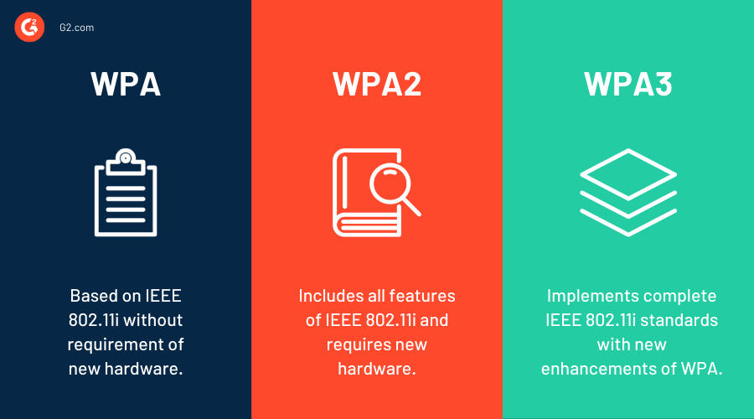
Figure 1: Wi-Fi Protected Access (WPA)

2.5.3 Wi-Fi Protected Access 2 (WPA 2)
The cryptographic algorithm's weakness threatens encryption fundamentals and initiates the development cycle of WEP, WPA, and WPA2. The weaknesses in prior protocols led to the development of WPA2, also known as IEEE 802.11i. Prior protocols made Layer 3 vulnerable in the Open System Interconnection Seven Layer Reference Model (OSI). The Wi-Fi alliance aims for interoperability, which WPA2 achieves. WPA2 is a new defensive protocol to protect encryption principles, following security vulnerabilities in WEP and WPA wireless protocols. This strengthens protocols with advanced encryption and authentication procedures, benefiting the network.[14]

2.5.4 Wi-Fi Protected Access (WPA3)
The newest security protocol created to improve Wi-Fi network security is called WPA3 (Wi-Fi Protected Access 3). Compared to WPA2, it offers a number of significant enhancements to handle changing security risks. Individualised data encryption is a crucial component that offers enhanced security for data transferred between networked devices. Below are the changes and enhancements of WPA3
WPA3 enhances public Wi-Fi security by improving data privacy and security for networks without passwords, such as cafes, airports, and public Wi-Fi connections. It also provides better protection against brute force attacks on weak passwords by ensuring better passwords are used and cannot be cracked through automated methods, thereby enhancing overall security.[15]

2.6 Wireless Network Vulnerability
Wireless network vulnerability refers to weaknesses or flaws in wireless networking systems that can be exploited by attackers to gain unauthorized access, disrupt services, or steal sensitive information. These vulnerabilities can arise from various factors, including weak encryption protocols, poor network configuration, and insecure authentication mechanisms. Understanding and identifying these vulnerabilities are crucial for maintaining robust wireless network security.
- Weak Encryption Protocols
Encryption protocols are essential for protecting data transmitted over wireless networks. However, some older protocols, such as WEP (Wired Equivalent Privacy), are known to be weak and easily exploitable. Even WPA (Wi-Fi Protected Access) has vulnerabilities, although it is more secure than WEP. WPA2, while widely used, also has known vulnerabilities, such as the KRACK (Key Reinstallation Attack). The latest standard, WPA3, addresses many of these issues but is not yet universally adopted. Using strong and up-to-date encryption protocols is critical to securing wireless communications and protecting sensitive information from interception and unauthorized access.[16]
- Poor Network Configuration
Misconfigured network devices and settings can create significant security risks. Common misconfigurations include using default SSID and passwords, leaving administrative interfaces accessible and unsecured, and having weak access controls. These issues can make it easier for attackers to guess access credentials, gain control of network devices, and access sensitive information. Ensuring proper network configuration by changing default settings, securing administrative access, and implementing strong access control measures is essential to maintaining a secure wireless network.
- Insecure Authentication Mechanisms
Authentication mechanisms are critical for verifying the identity of users accessing the network. Weak or insecure authentication methods can be exploited to gain unauthorized access. Common issues include weak password policies, such as using simple or easily guessable passwords, and the lack of multi-factor authentication (MFA). Relying solely on passwords without additional verification methods increases the risk of compromise. Implementing strong password policies and using MFA can significantly enhance the security of wireless networks by ensuring that only authorized users can access the network.
- Rogue Access Points
Rogue access points are unauthorized wireless access points installed within a network. These can be used by attackers to intercept network traffic, steal sensitive information, or launch further attacks. Detecting and mitigating rogue access points is essential for maintaining network security. Regularly scanning for and eliminating unauthorized access points can help prevent attackers from exploiting these vulnerabilities and ensure that the network remains secure.
- Eavesdropping
Eavesdropping involves intercepting and listening to wireless communications without authorization. Attackers can capture unencrypted data transmitted over the network, leading to the exposure of sensitive information such as passwords, personal data, and confidential communications. Encrypting sensitive data transmitted over the network is essential to prevent eavesdropping and protect the privacy and confidentiality of communications.[17]

2.6.1 Vulnerability Assessment
Network security refers to vulnerabilities in a network or system that attackers can exploit, such as DDoS, DNS spoofing, DHCP snooping, ARP poisoning, Man-in-the-Middle, Smurf attacks, buffer overflow, and SQL injection attacks.[18] These vulnerabilities can be caused by weak passwords, software bugs, non-patching of software, and script code injection spaces. Vulnerability Assessment (VA) is a process that scans systems or software to identify flaws and weaknesses, helping businesses determine their security posture and exposure to threats. Major network vulnerabilities include missing patches, weak passwords, misconfigured firewall rules, mobile devices, and USB flash drives.
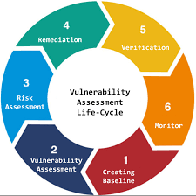
Figure 2: Vulnerability Assessment

2.7 Security Policies for Organizational Protection
Security policies are essential for an organization's information systems and networks, providing a framework for establishing and maintaining security. They guide the development, implementation, and enforcement of safeguard measures, covering physical, network, access control, incident response, and compliance with legal and regulatory requirements.[19] An outline of the main elements of wireless network security policies is provided below:
- Authentication policies verify user and device identities before network access, using robust methods like WPA3-Enterprise or 802.1X with RADIUS.
- Access control policies define network access permissions and user roles, enforcing least privilege principles to restrict access to sensitive resources under specific conditions.
- Encryption policies are protecting sensitive information on wireless networks, strong encryption protocols like WPA3 or AES must be used in accordance with encryption policies.
- Data loss prevention solutions, frequent backups, and stored data encryption are also essential steps outlined in data protection policies to prevent eavesdropping and ensure data security.
- Password policies outline the rules for generating and maintaining passwords for wireless networks, including length, complexity, and regular expiration.
- Network monitoring policies outline procedures for monitoring network traffic, detecting irregularities, and handling security issues.
- Intrusion detection and prevention systems (IDS) and IPS are deployed to detect suspicious behavior and respond to threats. Incident response policies outline procedures for security breaches, including detection, containment, eradication, recovery, and post-incident analysis.
- Physical Security Policies focus on protecting physical assets, hardware, and facilities. They comprise personnel access control measures, physical control of visitors, and monitoring and management of physical security incursions[20]
Frameworks for Developing Security Policies:
Security policies are generally based on previous, well-formulated frameworks and standards. Some of the most recognized frameworks include:

1. ISO/IEC 27001: This is the international standard for Information Security Management Systems. It provides a structured approach to the management of sensitive company information so that it remains secure. The framework contains a set of controls that organizations can implement to mitigate security risks of many types.
2. NIST CSF: The National Institute of Standards and Technology's framework provides a policy framework with computer security guidance on how the private sector in the U.S. can assess and subsequently enhance its capability to prevent, detect, and respond to cyber-attacks. The five core functions identified herein are Identify, Protect, Detect, Respond, and Recover.
3. COBIT: Control Objectives for Information and Related Technologies—This can be referred to as a framework that supports the organization in developing, implementing, monitoring, and improving IT governance and management practices. The framework comprises a thorough set of practices, analytical tools, and models to support any enterprise in effectively meeting its information security and governance requirements.
4. PCI DSS—Payment Card Industry Data Security Standard: This may be defined as a particular set of security standards ensuring that all companies that accept, process, store, or transmit credit card information maintain a secure environment. It provides requirements to secure credit card transactions.
5. GDPR—General Data Protection Regulation: Although this is more of a regulatory requirement in a sense, it also lays down detailed security measures and policies for the protection of the personal data of European Union citizens.

2.8 Different Types of Attacks On WLAN
WLANs, which rely on radio frequency infrared transmission technology for device connectivity, are vulnerable to attacks due to their vulnerability. The IEEE standard Wired Equivalent Privacy (WEP) was compromised, posing a major threat to the network's availability, secrecy, integrity, and essential data. On wireless networks, there are two kinds of attacks: passive attacks and active attacks.[21]
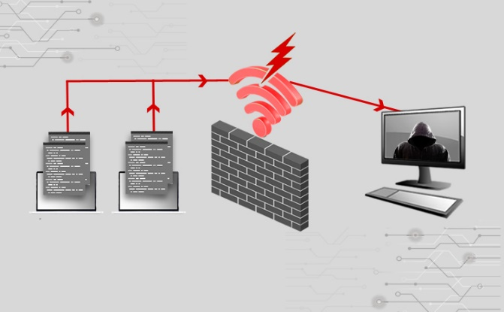
Figure 3: WLAN
Passive attacks don't change the resources. Attacks on network traffic, waiting for a client to connect to an Access Point or find the network Service Set Identifier (SSID), can compromise secrecy by listening in on network traffic and obtaining the SSID in cleartext. They can intercept data used for port scanning, packet sniffing, war-driving, and traffic analysis, making them difficult to detect as they don't alter the data or content.
Active attacks involve resource alteration. The aggressor node uses energy to execute an attack, modifying network data and introducing fraudulent packets. They can disrupt network operations using tactics like Denial of Service (DoS), Session Hijacking, Brute Force Attack, Reply Attack, and Man in the Middle (MITM) attack, gaining information and disrupting network operations.
- Man-in-the-Middle Attack

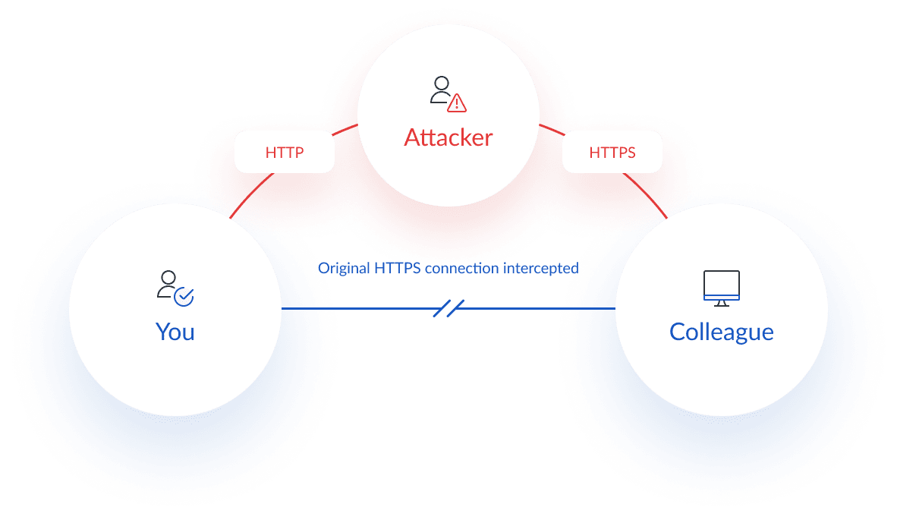
Figure 4: Man-in-the-Middle Attack
The man-in-the-middle (MTIM) attack is a valuable tool for possessing a network. In creating a MitM attack, the attacker positions his device between the two participants in a communication to forward all packets through the attacker’s computer. This unauthorized change to the network structure enables the attacker to eavesdrop, concentrate on decryption, and manipulate the content of transmitted communication data.[22] Their motivation is to control traffic and affect the attack secretly, which threatens the confidentiality and security of the network. After a successful MITM attack, the attacker can perform side attacks, including blocking the victim from accessing the internet and intercepting the victim’s emails, logins, and chat messages. This is well illustrated in the case of the Man in the Middle attack under Kali Linux.
- Chop Chop Attack
Korek also proposed the Chop Chop assault. Without knowing the Key, it enables an attacker to obtain the m last bytes of a packet's plaintext and keystream. This vulnerability stems from two things: (a) WEP uses CRC-32 incorrectly for message integrity; and (b) WEP has no safeguard against replaying previously delivered packets.
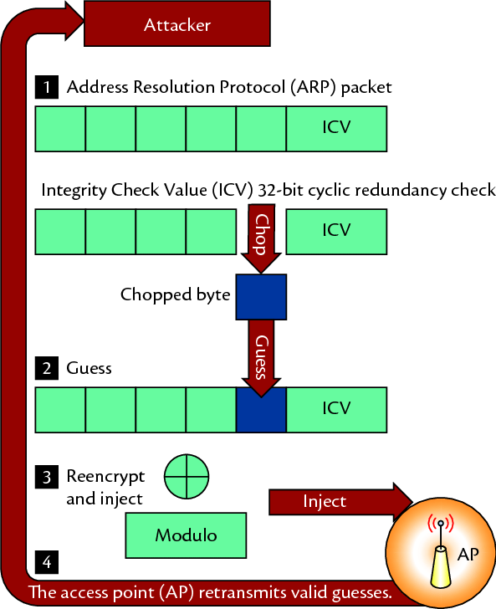
Figure 5: Chop Chop Attack
The attack involves a packet attacker chopping the final byte of a packet's encrypted section and determining its true ciphertext value. The frame's ICV is invalid in this shortened form due to the missing byte. The attacker XORs the shortened packet with a selected value to create a sequence suitable for the ICV. The attacker injects the altered packet into the network, knowing the ICV is invalid. The attacker uses the AP as an oracle, repeating the procedure for every possible byte value (256) if the ICV is invalid. Ultimately, the attacker gains access to both the keystream and plaintext of the shortened byte. Retrieving the final m bytes of a packet requires an average of 128 m guesses and a maximum of 256 m guesses. Large chunks of the keystream are typically extracted by the Chop Chop attack in practice. In a later step, this keystream will be utilised to inject and forge frames within a network. Partially decrypting packets using this attack is a less common scenario, particularly in cases where the attacker lacks knowledge of the WEP Key.[23]
- ARP Replay Attack
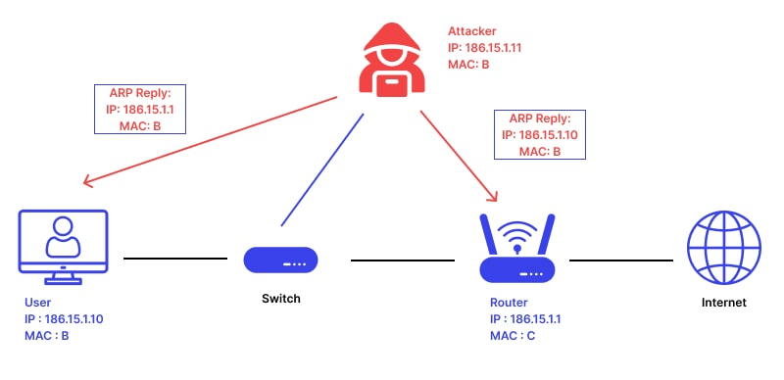
Figure 6: ARP Replay Attack
The packet injection method involves intercepting a packet and injecting it into the stream, forcing the AP to generate a new packet with a new IV. This attack aims to generate a continuous stream of new IVs, even without traffic. The attacker collects these IVs and feeds them to key cracking algorithms. Techniques to induce an ARP amplification effect result in two or three messages with different IVs for every injected frame.[24] Accurate client IP addresses and network topology knowledge are crucial. The attacker creates an ARP request, sends it over the network, and receives an initial IV. The ARP response is sent back to the client, resulting in a third IV.
- Dictionary Attack
An attacker can obtain unauthorised access to a wireless network by methodically inputting each word in a preset list, called a "dictionary," as a password attempt. This technique is known as a dictionary attack. Networks secured by password-based encryption protocols, such WPA/WPA2-PSK (Wi-Fi Protected Access Pre-Shared Key), are the main target of this approach. Dictionary assaults, which employ popular words, phrases, and passwords instead of trying every character combination found in a brute-force attack, are quicker and frequently more successful when used against weak passwords.[25]
An attacker records a device and wireless access point in a four-way handshake, exchanges encrypted keys, and attempts each word as a possible network password using software. The software hashes each word and compares it to the recorded handshake, breaking the password if a match is found. Dictionary attacks exploit people's preference for simple passwords, with the quality of the dictionary determining its effectiveness. Mitigation strategies include strong password regulations, WPA3, and user education on secure password usage.
- Brute Force Attack
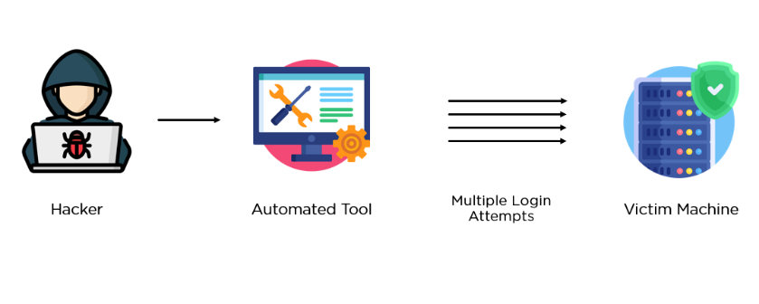
Figure 7: Brute Force Attack
Brute force attacks are dangerous cyber-attacks that use automated methods to generate password combinations, attempting to gain unauthorised access to wireless networks. They often target Wi-Fi Protected Access (WPA/WPA2) protocols, which encrypt wireless communication by requiring a pre-shared key (PSK). An attacker captures the initial handshake between a device and router, decoding it using different password guesses until the right one is found. Advanced brute force attacks can include dictionary attacks and hybrid attacks, which combine dictionary and brute force methods. To mitigate brute force attacks, use strong, complicated passwords, activate WPA3 features, and use network monitoring and intrusion detection systems.[26]
- Evil Twin Attack
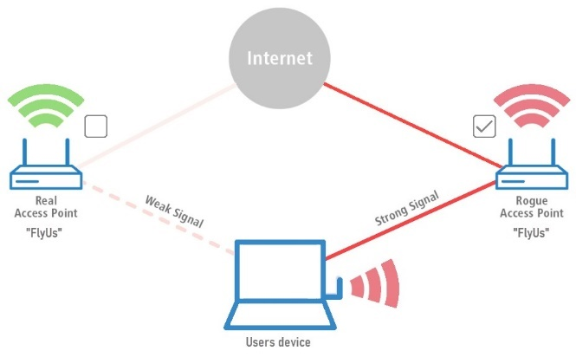
Figure 8: Evil Twin Attack
An Evil Twin is a type of honeypot that disguises as an active ESSID to trick users into connecting to a fictitious network instead of a legitimate one. This occurs because multiple APs with the same ESSID can coexist in the same space and clients often choose the strongest signal, ignoring the genuine AP's BSSID. The attacker displays a phoney AP with the same ESSID as a legitimate one, and the client connects to the fictitious network if the attacker's Network Interface Card (NIC) transmits with a stronger signal.[27]

2.9 Security Challenges in Wireless Network
Numerous security issues arise with wireless networks, particularly those that adhere to the IEEE 802.11 standard, necessitating a comprehensive solution. Among the most important security concerns are:
- Encryption Weakness:
WEP, a pioneering encryption algorithm for wireless networks, was criticized for its instability and vulnerability to hacking. WPA and WPA2, its enhanced version, were developed to address these issues. However, weak passwords can still expose them to attacks. WPA3, the latest standard, improves network security by adding better encryption algorithms and more reliable authentication mechanisms. It's crucial to upgrade encryption protocols to ensure wireless network security.[28]

- Authorization and Authentication:
Default Login credentials: Many wireless devices come with default login credentials that hackers can easily use if they are not changed. Attackers can readily get unauthorised access to the network because these default credentials are routinely made public and generally known. Users must change the default credentials to strong, one-of-a-kind passwords to reduce this risk. [29]
MAC Address Spoofing is a common issue in wireless networks where access is restricted based on a device's MAC address. Attackers can create forged MAC addresses to resemble permitted devices, allowing them to join the network without permission and perform dangerous actions. To prevent MAC address spoofing, robust encryption and authentication methods should be implemented.
- Eavesdropping and Packet Sniffing:
Wireless signals can be intercepted, leading to the unauthorised collection and analysis of personal data. Attackers can use specialist equipment to intercept data traffic, such as emails, passwords, and credit card numbers, without the sender or recipient's knowledge. This compromises the integrity and confidentiality of the information, potentially causing privacy violations and data breaches. Man-in-the-Middle (MitM) attacks involve inserting an attacker in the middle of communication to intercept and modify data, potentially obtaining private information or introducing malicious code.[30]
- DoS (denial-of-service) attacks:
DoS attacks on wireless networks cause network disruption by flooding it with traffic, slowing performance, and even outages. Botnets, networks of compromised devices, are commonly used by attackers for coordinated attacks. Deauthentication attacks on wireless networks use deauthentication frames to disconnect users, causing service interruption. Attackers demanding reauthentication impede network communication, making it difficult to pinpoint the attack's source.[31]

2.10 Penetration Testing

Penetration testing is a proactive technique that finds vulnerabilities in computer systems, apps, and networks that attackers can exploit. In the contemporary digital environment, it seeks to accomplish cyber security goals including integrity, availability, and confidentiality. This entails doing reconnaissance scans on a range of systems and devices, such as workstations, switches, routers, firewalls, perimeter defences, servers, and firewalls. The network can be secured thanks to penetration testing results that confirm the infrastructure's security measures. [32]
Network penetration testing is a simulated cyber-attack used to identify potential security vulnerabilities in IT infrastructure before an actual attack. It helps protect data and ensure overall security, particularly in managing important data. The test allows testers to access services and bypass authentications, aiming to compromise the entire server or data centre if a vulnerability exists.

2.10.1 Types of Penetration Tests
- Black box
Pen testers simulate attacks without having any prior knowledge of the network they are examining, which helps them better understand the infrastructure and the possible attacks of potential adversaries.
- White box
In white box testing, testers use all available information about the target system—including its IP address, operating system specifics, infrastructure, and passwords—to simulate an attack on an organisation and gain familiar with it.
- Gray box
They are provided with certain details about the system that will be tested during gray-box testing. Using this technique, a pen tester can determine the level of access that an authorised user can obtain.

2.10.2 Standard of the Penetration Testing
The absence of strong policies and standards means that cybercriminals always employ novel attack methods on their targets. As a result, they take advantage of the system and steal important data. Penetration testers employ certain standards to deter cyber intruders. Common standards are:
- Information Systems Security Assessment Framework (ISAAF)
- National Institute of Standards and Technology Special Publication 800-115 (NIST SP 800-115)
- Open-Source Security Testing Methodology Manual (OSSTMM)
- Penetration Testing Execution Standard (PTES)

2.10.3 Penetration Testing Tools
Penetration testing is a process that uses various tools to simulate various types of assaults in order to find weaknesses in the system.
- Aircrack-ng is a full set of tools for assessing WiFi network security, with an emphasis on several areas of WiFi security, including analysis tools for 802.11 wireless LANs, packet sniffing, WEP and WPA/WPA2-PSK cracking, and detection.
- Wireshark is an open source program that operates on UNIX, Windows and many other operating systems. It employs a graphical user interface and named network sniffer. It is a passive tool used for diagnosing network problems. It examines and collects packet data without being observed by other parties
- Nmap is a network mapper that is used as a penetration-testing tool to find vulnerabilities by scanning the network for hosts, ports, operating systems, and services. It is applied during penetration testing's initial stage. It is also suitable for scanning large and small networks. Nmap searches many type of protocols and existing system.
- Metasploit is an open-source penetration tool that builds a framework for penetration testing and is compatible with Linux, Apple Mac OS X, and Microsoft Windows. It tests vulnerabilities in operating systems and applications by executing a series of scripts on the test target.
- Kismet is possible to identify wireless networks with this tool. Its operation differs slightly from that of other network detectors in that it is passive, meaning that it may identify wireless access points and clients without sending any packets that can be logged in.[33]
- Netcat is a command-line tool that reads and writes data across network connections using the TCP or UDP protocols. It is one of the most potent tools in a network and system administrator's toolbox.

2.11 Mitigations Wireless Network
Improving network security requires mitigating the vulnerabilities found during wireless network penetration testing. The following are important measures for mitigating:
- Strengthen Password Policies
Creating complicated, one-of-a-kind passwords that incorporate special characters, digits, and letters is one way to strengthen password policies. It is imperative to establish policies requiring strong passwords and enforcing frequent password changes. Steer clear of default or readily guessed passwords, and make sure your passwords are long enough—usually 12–16 characters. By doing this, the possibility of brute-force attacks and unauthorised access is greatly decreased.[34]
- Upgrade Encryption Protocols
Network security depends on upgrading encryption methods to the newest standards, such WPA3. Older protocols that are susceptible to different types of attacks, such as WEP and WPA, ought to be updated. To prevent illegal access and eavesdropping on data transmissions, make sure all devices and access points support and are set up to use these better encryption methods.
- Configure Access Controls
Controlling the devices that can connect to the network by adopting techniques like MAC address filtering is known as configuring access restrictions. Strictly defining access control lists (ACLs) makes it possible to limit access to vital network resources and guarantee that only authorised people and devices have access to private data. By doing this, the attack surface is reduced and network security is improved overall.
- Deploy Intrusion Detection and Prevention Systems (IDS/IPS)
IDS/IPS deployment is essential for real-time network traffic monitoring and suspicious activity detection. By recognising and reacting to possible threats, these systems can lessen security incidents and stop unauthorised access.[35] Unusual patterns should also be tracked by network monitoring tools, which give another degree of protection by warning administrators about any security breaches.
- Implement Network Segmentation
By breaking the network up into smaller, more isolated areas, network segmentation can be implemented to restrict access and lessen the impact of any breaches. Sensitive data is better safeguarded when vital network parts are kept apart from less secure locations using VLANs (Virtual Local Area Networks). By containing risks, this strategy hinders an attacker's ability to move laterally within the network.

2.12 Case Study
- KRACK Attack (2017)
The Key Reinstallation Attack (KRACK), discovered in 2017 by researchers Mathy Vanhoef and Frank Piessens from KU Leuven, exploited a vulnerability in the WPA2 protocol. This attack allowed hackers to decrypt, replay, and forge packets by tricking the victim into reinstalling an already-in-use key. The KRACK attack affected almost all Wi-Fi devices, prompting companies like Apple, Google, and Microsoft to issue urgent security patches.[36] This incident highlighted significant flaws in WPA2 and accelerated the adoption of WPA3, which offers enhanced security features to mitigate such vulnerabilities.
Impact: This incident highlighted significant flaws in WPA2 and accelerated the adoption of WPA3, which offers enhanced security features to mitigate such vulnerabilities. It underscored the need for continuous security evaluation and updates to encryption standards.
- WEP Cracking (Early 2000s)
Wired Equivalent Privacy (WEP), the original encryption standard for Wi-Fi, was found to be highly insecure due to its use of static encryption keys and a short initialization vector (IV). Throughout the early 2000s, security researchers demonstrated how tools like Aircrack-ng could easily crack WEP keys within minutes by capturing sufficient data packets. This vulnerability showed the inadequacy of WEP in protecting wireless communications, leading to the development and widespread adoption of more secure protocols, such as WPA and WPA2.
Impact: This vulnerability showed the inadequacy of WEP in protecting wireless communications, leading to the development and widespread adoption of more secure protocols, such as WPA and WPA2. The deprecation of WEP was a significant step forward in improving wireless network security.
- Wi-Fi Pineapple (2008-Present)
The Wi-Fi Pineapple, a device produced by Hak5 since 2008, has been widely used for network penetration testing and ethical hacking. However, its powerful capabilities, such as creating rogue access points and performing man-in-the-middle attacks, have also been exploited by malicious actors. This device can intercept and manipulate data transmitted over the network, demonstrating how easily wireless networks can be compromised. The Wi-Fi Pineapple has become a critical tool for security professionals to test and secure their networks while highlighting the ongoing need for strong network security measures.
Impact: The Wi-Fi Pineapple has become a critical tool for security professionals to test and secure their networks while highlighting the ongoing need for strong network security measures. It demonstrated the ease with which wireless networks can be compromised, stressing the importance of regular security assessments and robust defenses.

In conclusion of literature review this project identified significant vulnerabilities in wireless networks using a TP-Link adapter and Kali Linux tools. By employing penetration testing tools like Aircrack-ng and Wireshark, we uncovered weaknesses in encryption protocols, authentication methods, and network configurations that could be exploited by malicious actors.
Our findings highlight the critical need for robust security measures, including strong encryption, proper network configuration, and regular security audits. These steps are essential for protecting sensitive data and ensuring network integrity against evolving cyber threats.

METHODOLOGY
The report uses hacking tools for Kali Linux to exploit remote organization security, focusing on IEEE 802.11 encryption conventions. The methods include network reconnaissance, vulnerability assessment, exploitation, post-exploitation analysis, and documentation. The report identifies potential security issues in the organization's encryption conventions and analyzes caught traffic to identify horizontal development and security breaches. It provides findings, exploits, vulnerabilities, and recommendations for improving network security.

3.1 Research on Onion Layers:
Methodology is a general research strategy which delineates the way how research should be undertaken. It includes a system of believes and philosophical assumptions which shape the understanding of the research questions and underpin the choice of research methods. Research methodology is an integral part of a dissertation or thesis which helps to ensure the consistency between chosen tools, techniques and underlying philosophy.
The research methodology construction method, based on the "research onion" concept by Saunders et al. (2016), involves defining the main philosophy, choosing approaches, methods, strategies, and defining time horizons. This process leads to the research design, which includes techniques and procedures for data collection and analysis.[37]

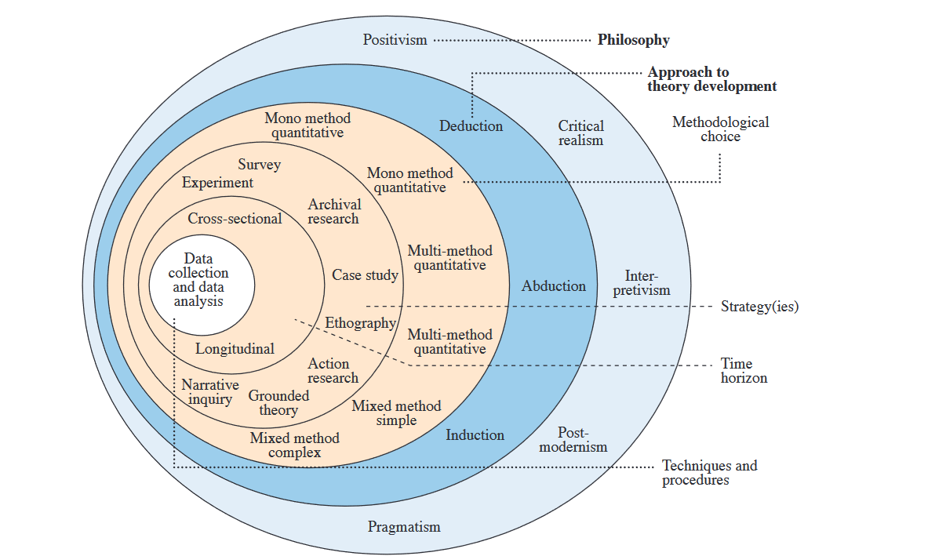
Figure 9: Research Onion Layers

3.1.1 Layer 1: Research philosophy
Positivism: It is a philosophical stance that emphasizes observable, empirical evidence and objective reality. It assumes that the world can be understood through scientific observation and measurement.
- Measurable Data: Collect and analyse quantitative data from penetration testing activities. Measure attack success rates against WEP, WPA, and WPA2. Record time to crack each encryption type. Assess signal strength's impact on attack effectiveness. Track error rates to evaluate the reliability of tools and methods used.
- Tools: Use tools like Wireshark, Aircrack-ng, and other penetration testing frameworks to gather data.
- Empirical Analysis: Perform statistical analysis on the collected data to identify patterns and draw conclusions about the vulnerabilities and robustness of different wireless security protocols.
Interpretivism: It is a philosophical stance that focuses on understanding the meaning and context of human behavior and social phenomena. It assumes that reality is socially constructed and subjective.
- Contextual Understanding: Study the context in which wireless security protocols are implemented and how they behave under attack scenarios. Observe network responses to penetration tests, including defensive measures. Analyze user interactions with the network and their impact on security. Investigate how different implementations of the same protocol, like WPA2, affect overall security.
- Qualitative Data: Collect qualitative data through observations, interviews, and case studies.
- Subjective Analysis: Analyze the qualitative data to understand the social and contextual factors that influence network security and the effectiveness of security measures.
Pragmatism: Based on assumption that within the research it is possible to adapt both positivist and interpretivist positions whichever works best for particular research question.
After going through first layer of onion it is consider that Positivism phase is suitable for this project.

3.1.2 Layer 2: Approaches
Quantitative Methods:
Quantitative methods involve the collection and analysis of numerical data to identify patterns, relationships, and trends. These methods emphasize objective measurements and statistical analysis.
1. In assessing attack success rates, various penetration tests were conducted to determine the effectiveness of dictionary and brute force attacks against WEP, WPA, and WPA2. Statistical tools like mean, median, and standard deviation were employed to analyze success rates across different security protocols.
2. Time to crack encryption protocols (WEP, WPA, WPA2) was measured using Aircrack-ng, focusing on the average time and distribution of cracking attempts. Statistical tests were applied to identify significant differences in cracking times between the protocols.
3. Signal strength's impact on attack success and speed was evaluated by measuring Wi-Fi signal at various distances and conducting penetration tests. Regression analysis was used to quantify the relationship between signal strength and attack outcomes.
Qualitative Methods:
Qualitative methods involve collecting nonnumerical data to understand concepts, experiences, or contexts. These methods focus on subjective interpretation and rich, detailed descriptions
1. During penetration tests, real-time observations of network behaviour are crucial to understanding responses. By monitoring changes in traffic patterns, disconnections, and security alerts, detailed logs with timestamps and specific network actions are maintained.
2. Evaluating the effectiveness of security measures involves testing configurations like complex passwords and MAC address filtering. Through penetration tests, outcomes are recorded to create detailed reports assessing each measure's success, considering contextual influences.
3. Identifying challenges in penetration testing requires maintaining a reflective logbook. Entries document encountered difficulties such as hardware limitations and unexpected network behaviours, enabling analysis to uncover common themes and recommend strategies for future tests.[38]

3.1.3 Layer 3: Approaches to theory development
Deductive Approach:
Deductive reasoning involves developing a hypothesis based on existing theory and then designing a research strategy to test the hypothesis. It moves from a general premise to a specific conclusion. The process of testing wireless security protocols involves a theoretical understanding of potential vulnerabilities, such as the susceptibility of WEP encryption to brute force attacks and the increased likelihood of successful penetration attacks. To test these hypotheses, controlled penetration tests are conducted using tools like Aircrackng and Wireshark. Data is collected using measures like attack success rates, time to crack, and signal strengths. Results are analyzed using statistical methods, such as t-tests, to compare different encryption protocols. The conclusions drawn from the data analysis can either confirm or refute the hypotheses, either strengthening the existing theory or potentially leading to new hypotheses.
Inductive Approach:
Inductive reasoning involves collecting data and developing a theory based on the analysis of the data. It moves from specific observations to broader generalizations. The process of collecting data for penetration testing, which involves conducting observations on networks, recording variables, and analyzing data using qualitative and quantitative methods. The process involves identifying patterns and trends, such as recurring themes or differences across networks and attack scenarios. Theoretical theories are then developed based on these observed patterns, such as the critical role of password strength in network security. As more data is collected, these theories are refined to better fit the observed data.
Abductive Approach:
Abductive reasoning is a method that involves forming hypotheses based on the best available information and testing them. It combines elements of both inductive and deductive reasoning and is often used when there is incomplete information. The process begins with initial observations, such as identifying clues from preliminary penetration tests. Hypotheses are then developed based on these observations, such as the unusual traffic patterns suggesting a potential vulnerability. Targeted tests are conducted to test these hypotheses, often focusing on networks with similar configurations. The iterative process of refining hypotheses as more data is collected continues until a satisfactory explanation is found.

3.1.4 Layer 4: Research strategy
The third layer of the onion comprises various strategies such as experimental research, action research, case study research, grounded theory, ethnography, and archive research.
Experiments: Used to establish cause and effect relationships in wireless network penetration testing (WNPT). Controlled penetration tests on wireless networks with different security protocols (WEP, WPA, WPA2) can help in recording success rates and time taken to crack each protocol. This strategy allows for detailed comparison of the effectiveness of various security measures under controlled conditions, providing empirical data that can be analyzed to determine the best security protocol.
Surveys: Used in WNPT to gather insights from cybersecurity experts and network administrators about common vulnerabilities and best practices in wireless network security. They involve collecting data through questionnaires or interviews, focusing on their experiences with different security protocols and common attack vectors, thereby providing valuable qualitative data.
Archival research: Method of analysing existing records and documents to gather data, especially useful for historical or non-primary research. In the context of Wireless Network Protection Techniques (WNPT), it can be applied to study historical data on wireless network security breaches, identifying patterns and trends.[39]

3.1.5 Layer 5: Methodological choice
Mono method approach is used for WNPT, focusing on one type of data collection and analysis. This involves conducting penetration tests on wireless networks, collecting numerical data like attack success rate, time taken to crack protocols, and signal strength variations. This data can be statistically analyzed to understand the effectiveness of different security protocols. A qualitative mono method involves documenting observations and interviews with network administrators and security experts, identifying common patterns and insights into user behaviour and security practices.

Mixed methods approach is used to study research problems, such as WNPT. This involves conducting quantitative methods like penetration tests on wireless networks, measuring variables like time to breach security protocols and attack success rates. Statistical analysis helps identify patterns and trends. Qualitative methods, such as interviews with network security professionals and observing network behaviour under attack, provide context and depth to the quantitative findings. This approach helps to understand the research problem better and provides a more comprehensive understanding of the problem.

A mono approach involves using only one data part, either qualitative or quantitative. A mixed-methods strategy uses both quantitative and qualitative data. A multi-method strategy uses a variety of methods beyond just one quantitative and one qualitative approach.

3.1.6 Layer 6: Time horizons
Short term time horizons: The adapter is used to address immediate security threats in wireless networks, including vulnerabilities in existing protocols. It also assesses technological advancements in wireless security protocols, evaluating the effectiveness of new patches. The goal is to optimize operational efficiency by streamlining testing procedures to quickly identify and mitigate security risks.
Medium term time horizons: It involve anticipating future security trends in wireless network security, monitoring policy and regulation changes, and developing scenario planning to simulate potential threats and vulnerabilities. This helps in preparing proactive security measures and response strategies, ensuring the protection of networks from potential attacks and vulnerabilities, especially in the face of technological advancements like IoT integration.
Long-term: strategies for wireless network security include strategic security planning, risk assessment and mitigation, and sustainability and scalability. Strategic planning involves envisioning future technological landscapes and adapting WNPT methodologies to address security challenges. Risk assessment involves modelling potential scenarios and their impact on network integrity and data confidentiality. Sustainability and scalability involve integrating predictive analytics and machine learning.

Philosophy | Positivism
Approach | Quantitative
Approaches to theory development | Inductive
Research Strategy | Experiment
Methodological Choice | Mixed
Time Horizon | Medium-Term
Table 1: Appropriate layers for this project

3.2. Specific Methods
When it comes to performing penetration testing, also known as pen testing, on wireless networks, a number of frameworks and methodologies offer organised ways to find weaknesses and evaluate security posture. OWASP (Open Web Application Security Project), EC-Councils, and SANS (Sysadmin, Audit, Network, Security) are a few notable approaches.
OWASP Method:
OWASP offers a comprehensive framework for online application security testing, focusing on common vulnerabilities like cross-site scripting, broken authentication, and injection issues.[40] Its ideas can be applied to more comprehensive assessments, such as wireless network penetration testing, and provides software security guidance, tools, and resources.

- Information Gathering: The objective is to gather preliminary data about the target web application, including its architecture, technologies, and potential vulnerabilities, using manual investigation methods and web application scanners.
- Testing Configuration Management involves examining server configurations, database designs, and web application security settings for potential vulnerabilities. Identity Management tests evaluate web application authentication and authorization mechanisms for flaws.
- Validation Testing: Evaluate the security of the confirmation components utilized by the web application. Test for weaknesses, such as beast force assaults, secret key splashing, and bypassing verification controls.
- Approval Testing: Assess the web application's approval controls to guarantee clients can access assets they are approved to get to. Test for honour heightening, shaky direct article references (IDOR), and other approval weaknesses.
- Meeting The executives Testing: Determine whether the web application's session tokens, cookies, and session expiration mechanisms are secure. Test for meeting obsession, meeting seizing, and uncertain transmission of meeting tokens.
- Testing of input validation: Distinguish and take advantage of weaknesses connected with ill-advised input approval in the web application. Look for SQL injection, command injection, cross-site scripting (XSS), and other vulnerabilities that allow injection.

3.3 Data collection
The data collection process will involve specialized tools to gather information about the target wireless network's structure, active devices, and encryption algorithms. Airodump-ng will be used for vulnerability evaluation and network reconnaissance, while Aircrack-ng will be used for vulnerability detection and exploitation. Wireshark will facilitate network traffic analysis. Network SSIDs, BSSIDs, MAC addresses, signal strengths, open ports, service versions, recorded handshakes, and decrypted packets will be gathered. This data will evaluate the wireless network's security posture and suggest enhancements.
Passive Data Collection:
Network Discovery: To find any active wireless networks nearby, use applications like Airodump-ng and Kismet to passively search the area.
Signal Strength and BSSID: Record the BSSID (Basic Service Set Identifier) and signal strength of the networks that have been discovered.
Device Identification: Provide a list of every device connected to the network, including its MAC address and signal strength.
Active Data Collection:
Network Scanning: Actively scan wireless networks to identify open ports, services, and potential vulnerabilities.
Packet Capture: Use Wireshark to record wireless network traffic to conduct a comprehensive analysis. Focus should be placed on data packets related to the encryption technologies. Authentication Testing: Use tools like Aircrack-ng to do authentication testing in order to evaluate the security of encryption protocols and identify any weaknesses.

3.4 Experimental Approach
One essential method that every firm needs to use is penetration testing. Penetration testing has become one of the most popular and recommended techniques for network security, especially in light of the rise in computer and cybercrimes in recent years. An organisation can be better protected from external and internal dangers with the help of a penetration test. [41] The penetration test can also help find weaknesses and possible dangers that an attacker might use against you.
The penetration testing can be separated into the following phases:
- The Pre-engagement Interactions stage establishes the parameters for each and every penetration testing task. This includes discussing the objectives, aims, policies, and any limitations. It also requires familiarising yourself with the organization's environment and systems to ensure a comprehensive and effective examination.
- Intelligence Gathering: All pertinent information regarding the target under test is acquired in this phase, both actively and passively, without establishing a link with the target.
- Threat modelling: In order to determine the areas with the highest level of risk, this step compares the data with the assets.
- Finding, recognising, and verifying known as well as unknown vulnerabilities is the process known as vulnerability analysis.
- We take advantage of the vulnerabilities found in previous phases during the exploitation phase. This entails using instruments and methods to take advantage of flaws in order to enter the network or system being tested without authorization.
- Post-exploitation: The actual actions taken in tandem with the target, include creating accounts, downloading files, and shutting down systems. This phrase encapsulates what you ought to do in the wake of exploitation.

3.5 Reporting
During the Reporting phase, which marks the culmination of the wireless network penetration testing, the results and findings are meticulously summarized. This involves detailing the vulnerabilities, weaknesses, and successful exploits encountered throughout the testing process. Additionally, the report provides actionable suggestions and recommendations to address the identified weaknesses effectively. The ultimate goal of this phase is to fortify the target network's defences and enhance its overall security posture. By providing comprehensive insights and guidance, the report aims to empower network administrators and stakeholders to implement necessary security measures and mitigate potential risks effectively.
3.6 Contingency Plan for Experiment
The well-being plan identifies potential risks to the testing framework, including software failure, data breaches, and regulatory issues. It includes preventive measures, immediate response, communication protocols, and escalation procedures. Documentation and post-occurrence surveys ensure successful and safe online protection testing.
1. Review and Analysis
Identify Causes of Failure: Conduct a thorough review to understand why the project failed. Identify key issues, whether they are technical, resource related, or due to other unforeseen challenges.
Documentation: Document all findings from the project, including what worked and what didn’t. This documentation can be valuable for future projects.
2. Adjust and Revise the Project Plan
Scope Adjustment: Reevaluate the project's scope to see if it was too ambitious. Adjust goals and timelines to make them more achievable.
Resource Allocation: Ensure that you have the right resources and expertise. This might involve training for the current team or bringing in external experts.
Methodology Change: Consider changing the approach or methodology. For example, if certain penetration testing tools or techniques didn’t work, research and adopt alternative methods.
3. Enhance Team Skills
Training and Workshops: Provide additional training for your team on the latest penetration testing techniques and wireless security measures.
Consult Experts: Bring in consultants or experts in the field of wireless network security to provide insights and guidance.
4. Pilot Testing
Smaller Scale Pilot: Implement a smaller scale pilot test of the revised project. This allows you to test new approaches without committing to the full-scale project.
Iterative Testing: Use an iterative approach, where you test small components of the project, analyse the results, and make necessary adjustments before moving on.
5. Backup Solutions
Alternative Technologies: Consider exploring alternative technologies or security protocols that might be more feasible or effective.
Third-party Solutions: Look into third-party solutions or software that might address the issues faced in your project.
6. Stakeholder Communication
Regular Updates: Keep all stakeholders informed about the challenges faced and the steps being taken to address them.
Feedback Mechanism: Establish a mechanism to receive feedback from stakeholders and incorporate their suggestions into your revised plan.
7. Risk Management
Risk Assessment: Perform a detailed risk assessment to identify potential risks early in the revised project plan.
Mitigation Strategies: Develop mitigation strategies for each identified risk to ensure they are managed effectively.
8. External Review
Peer Review: Have your project plan and findings reviewed by peers or industry experts to get an external perspective.
Benchmarking: Compare your project with similar successful projects to identify best practices and potential improvements.

3.7 Timeline of Project Approach
Using a TP-Link USB adapter, and router and Kali Linux for penetration testing, the following is a timeline of the project approach for your wireless network security project:

Table 2: Project Timeline
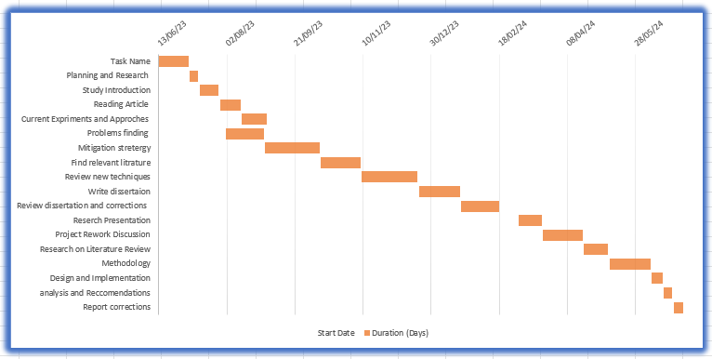
Figure 10: Gnatt Chart

4. NETWORK DESIGN AND IMPLEMENTATION
This WLAN infrastructure established the experimental network laboratory for the assessment and penetration testing process. The laboratory environment keeps the user and legal concerns safe so that no individual or organization will be negatively affected.

4.1 Laboratory Experiment Setup and Requirements
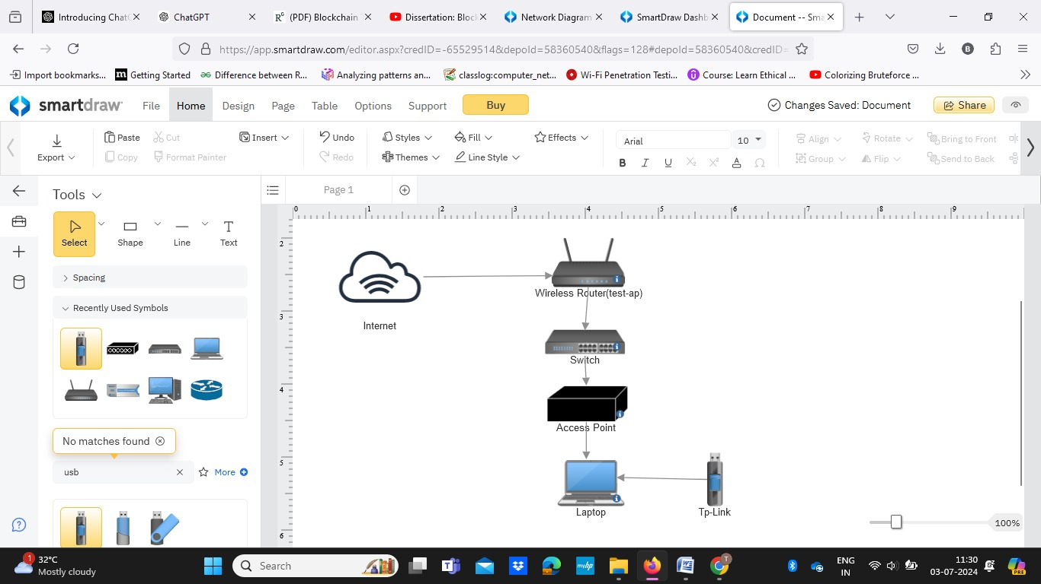
Figure 11: Topology
Internet:
The internet is a global network of interconnected computers, enabling data exchange, information access, and device connection. It operates on the Internet Protocol Suite (TCP/IP) and includes the World Wide Web, online services like search engines, social media, streaming media, and e-commerce platforms. Cloud computing provides on-demand access to computing resources, while the Internet of Things (IoT) refers to physical objects embedded with sensors and connectivity.
Access Point:
An access point (AP) is a device in a wireless local area network (WLAN) that connects wireless devices to a wired network using Wi-Fi. It acts as a bridge between wireless devices and a wired router, switch, or hub, providing a wireless connection within a specific range, enabling devices like laptops, smartphones, and tablets to access network resources and the internet.

Switch:
A switch is a networking device that operates at the data link layer of the OSI model, connecting devices within a local area network (LAN). It forwards data packets between devices on the same network segment, learning and storing the MAC addresses of connected devices. This intelligently transmits data only to the intended recipient, optimizing network performance.
Router:
A router is a networking device that forwards data packets between computer networks. It operates at the network layer (Layer 3) of the OSI model and is used to connect multiple networks together, such as a local area network (LAN) to the internet or to another LAN. For this network we have to connect a tp-link ac 1300 usb adaptor to the router(Test-ap). Tp-link provides a speed of the network to the pc. A router is a networking device that directs data packets between computer networks, typically forwarding data between a local area network (LAN) and the internet or another network, based on routing tables and protocols.
PC:
A Personal Computer (PC) is a versatile electronic device designed for individual use, consisting of a CPU, RAM, storage, input/output devices, and an operating system like Windows, macOS, or Linux. PCs can perform tasks like word processing, web browsing, gaming, multimedia playback, and software development, and are widely used in homes, offices, schools, and various industries for personal and professional computing needs.
Software Tools and Devices information:
- Tp-Link Archer T3U:
Specifications:
- USB Adapter Archer T3U
- IEEE 802.11b/g/n 2.4GHz, 802.11a/n/ac 5GHz
- Interface: USB 3.0
- Security: WEP, WPA/WPA2
- Router: Test ap
Specifications:
- Model: Test ap (Placeholder for a standard router model)
- Wireless Standards: IEEE 802.11a/b/g/n/ac/ax
- Frequency Bands: Dual band (2.4 GHz and 5 GHz)
- Data Transfer Rates: 2.4 GHz: Up to 600 Mbps, 5 GHz: Up to 2400 Mbps (depending on the router model)
- Security: WPA/WPA2/WPA3Personal, WPA/WPA2/WPA3Enterprise, Firewall (SPI and NAT)
- Kali Linux: A Linux distribution widely used for penetration testing and ethical hacking, known for its comprehensive suite of pre-installed tools.
- VirtualBox: Virtualization software used to run Kali Linux, enabling controlled testing of various security measures and hacking techniques.
- Airodump-ng: A tool for capturing and analyzing wireless packets to identify security vulnerabilities.
- Aircrack-ng: A suite of tools used for analyzing and cracking wireless network security, particularly within Kali Linux.
- Wireshark: A network traffic analysis tool used for troubleshooting and detecting security threats.

4.2 Exploiting Vulnerabilities in IEEE 802.11 WEP Security Protocol
- Chopchop Attack:
First and foremost, enable the monitoring mode on your TP Link AC1300 USB adapter if you conduct penetration testing. This feature allows the given adapter to capture all wireless network traffic in its surroundings, which is crucial in analysis and exploitation while conducting penetration testing against possible vulnerabilities. First, open a terminal and write the following: airmon-ng start, followed by the name of your adapter's interface—in this case, wlan0. By firing up this command, a new interface in monitor mode will show up, for example, something like wlan0mon. This interface will be used during penetration testing activities to sniff and capture packets. The airodump-ng command captures the wireless network traffic, detailing all the networks easily accessible from your location, including their respective BSSIDs, channels, signal strengths, and attached clients. Running airodump-ng on the wlan0mon interface—an interface made in monitor mode—gathers data for further analysis in the exploitation of vulnerabilities in wireless networks during penetration testing.[41]
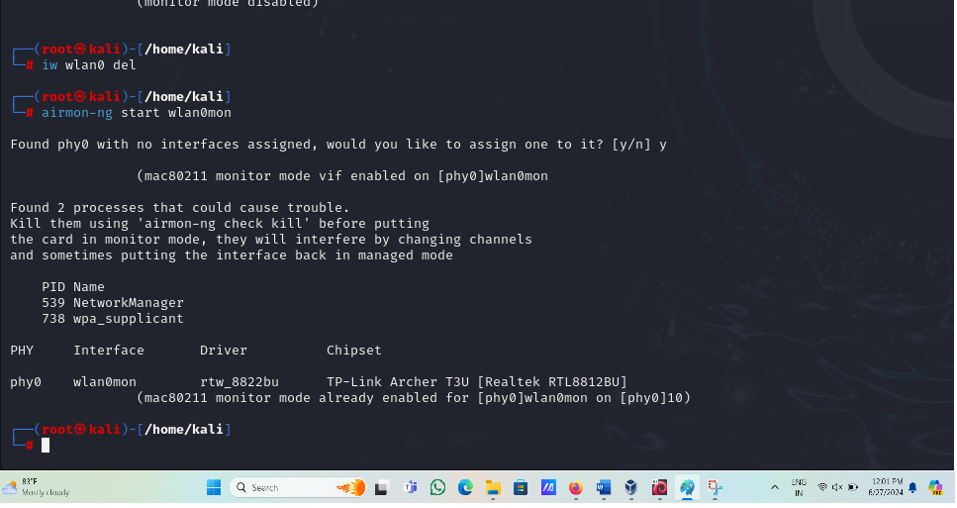
Figure 12: airmon-ng start wlan0mon
Assuming that you run the airodump-ng wlan0mon command and then identify a target network you want to penetrate, this should narrow attention to capturing packets from that particular network.
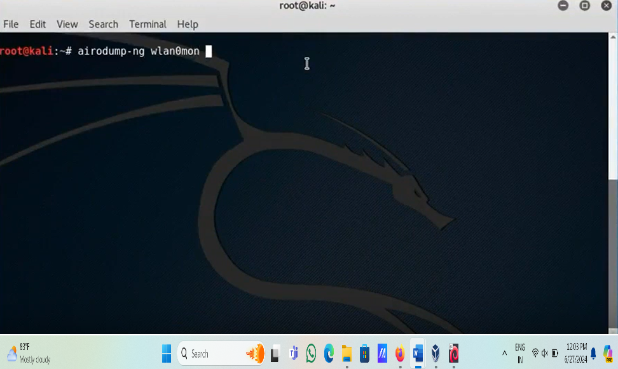
Figure 13: airodump-ng wlan0mon
This is done using the airodumpng command, adding other options such as bssid for the MAC address of the target network being attacked, c for its channel, and w to specify a file where all captured packets should be saved. For instance, the command sudo airodumpng bssid 84:18:5E:8B: BA:02 c 11 w capture_file wlan0mon captures all the packets from the network whose BSSID is 84:1B:5E:88: BA:02 on channel 11 and saves these in a file called capture_file. These captured focused packets provide exhaustive penetration testing methods —analysis and possible exploitation of vulnerabilities within the target network.
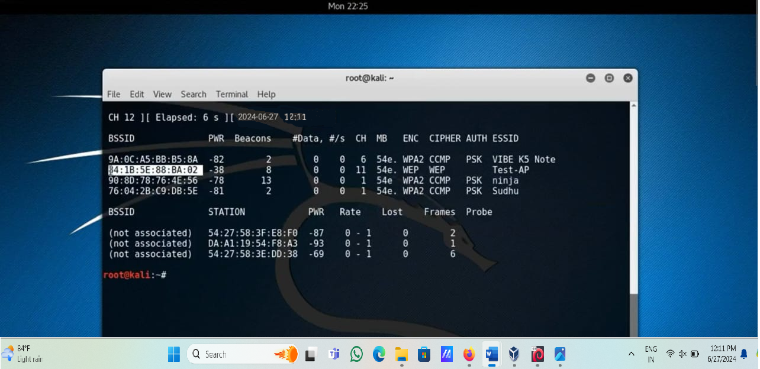
Figure 14: BSSID
Once the target network is determined, airodump-ng bssid <BSSID> c <channel> w <output_file> wlan0mon captures the packets for that network. At this stage, a special attack can be performed. Here, the command airodump-ng bssid 84:1B:5E:88:BA:02 channel 11 write chopchop wlan0mon runs the "ChopChop" attack against the network with BSSID 84:1B:5E:88:BA:02 on channel 11 and stores its results in a file called chopchop. Then, switch to another terminal and type the following. Changing a wireless network interface's MAC address using some tool such as Mac changer r wlan0mon is done mainly for security purposes in penetration testing, that is, hacking and ethical things now referred to as hacking.
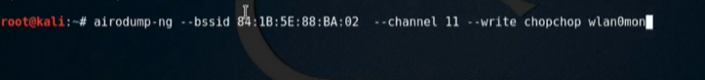
Figure 15: airodump-ng bssid 84:1B:5E:88:BA:02 channel 11 write chopchop wlan0mon
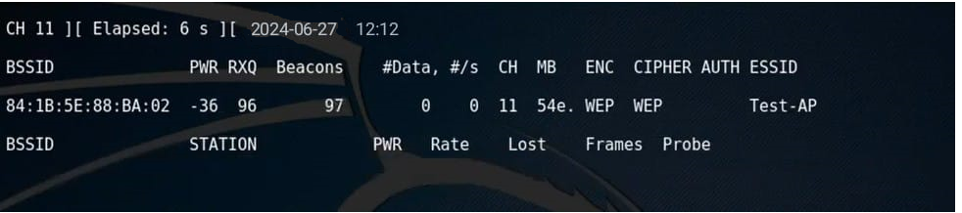
Figure 16: Get BSSID
This command to randomize the MAC address of the given interface—that would be wlan0mon, in this case—makes your device much more challenging to track or identify by network administrators or security tools. MAC address rotation can help you avoid getting blocked or detected while performing security assessment related activities. That way, testing will be more covert and influential. However, this should be used responsibly and within the bounds of the law by first obtaining appropriate authorization before penetration testing activities. Using the aireplay-ng fakeauth 0 a 84:1B:5E:88: BA:02 h f4:f2:6d:1d:77:d6 wlan0mon command is to fake an authentication process with a particular access point (a 84:1B:5E:88: BA:02) via a specified MAC address (h f4:f2:6d:1d:77:d6).
Command: macchanger -r wlan0mon
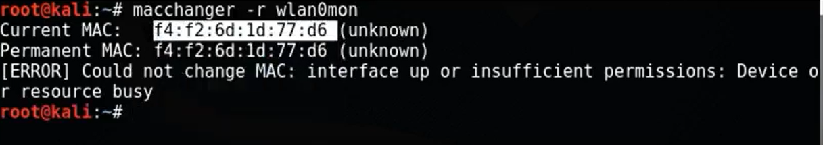
Figure 17: mac changer r wlan0mon
This attack aims to deceive the access point that the attacker's device is an accredited client to scale up, bypassing capabilities against security controls such as MAC address filtering implemented within. This –0 option shows that the attack must be run continuously until manually stopped. Testing for access control mechanisms with their strength and probably getting unauthorized access to the target network might be performed as a part of this technique during a Penetration test. Attacks like these without any explicit authorization are illegal and against ethics. Always check that you have obtained proper approval before any security testing activity.
Command: aireplay-ng –fakeauth 0 -a84:1B:5E:88:BA:02 -h f4:f2:6d:1d:77:d6 wlan0mon

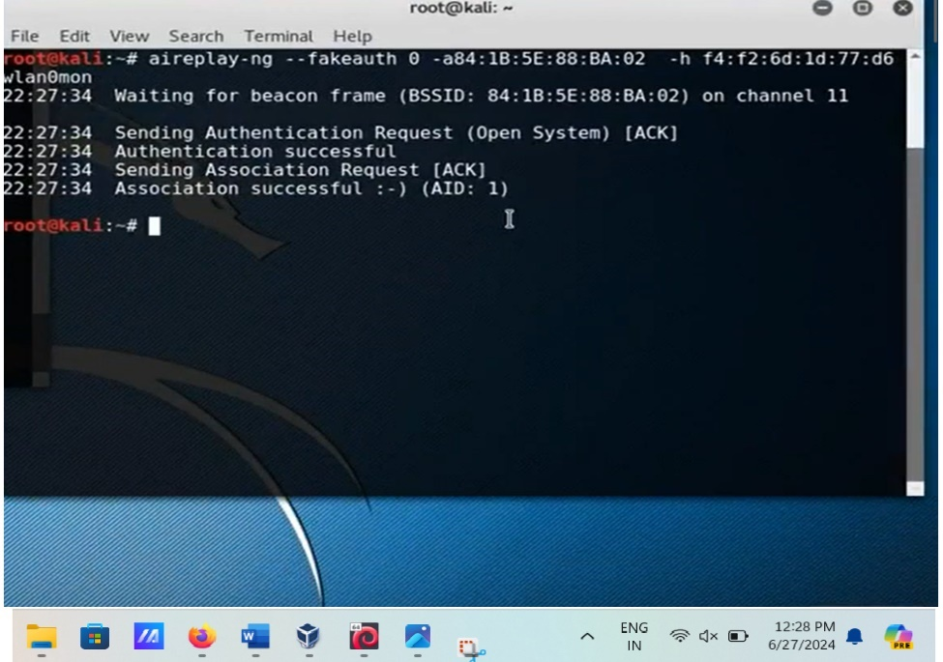
Figure 18: Create fake auth
After giving the above command, return to the existing terminal and note the STATION
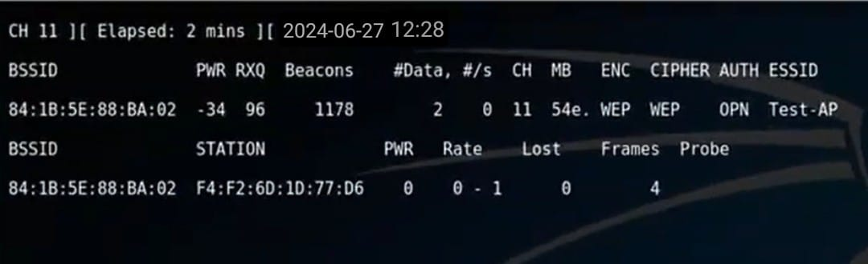
Figure 19: Get Station Id
Now, switch to another available terminal and use the following command. The command below is the airplay-ng fake auth 0 with additional options a, specifying the BSSID of a target network, and h, specifying the MAC address for conducting a "fake authentication" attack on the network interface in monitor mode. This is an attack where specially crafted authentication packets are sent to the access point, trying to authenticate as a client without having valid credentials. He tries to connect to the network in such a manner that once this simulated authentication is done, he will not be legitimately authorized, which turns useful for further analysis or exploitation of the network. Nevertheless, such attacks must be carried out ethically and legally by making sure there is appropriate authorization before the execution of any security testing activities.
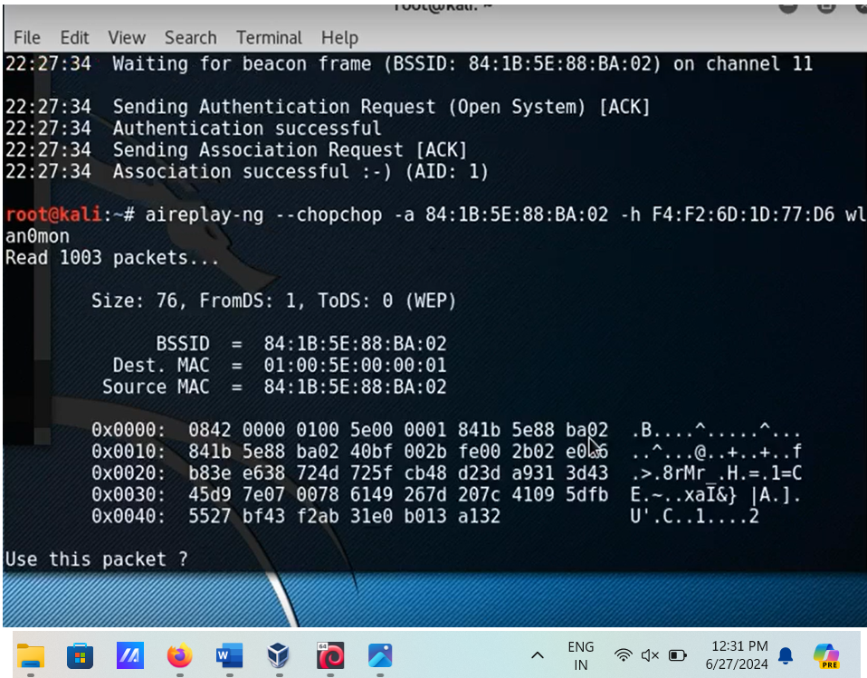
Figure 20 : Read the Packets
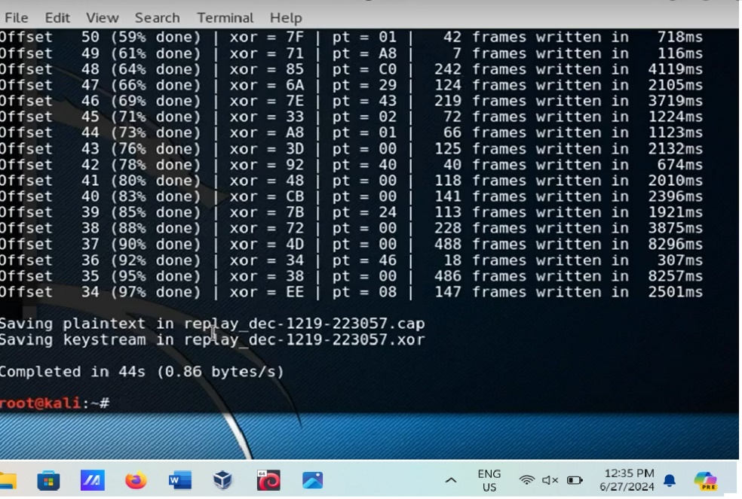
The next line, packetforgeng0 a 84:1B:5E:88:BA:02h F4:F2:6D:1D:77:D6 k 255.255.255.255 l 255.255.255.255 yreplay_dec1219223057.xor wchopchoppacket, crafts a specialized packet designed to attack the target. This command identifies the BSSID, with –a, and the MAC address, with –h, that belong to your target network and device, respectively.
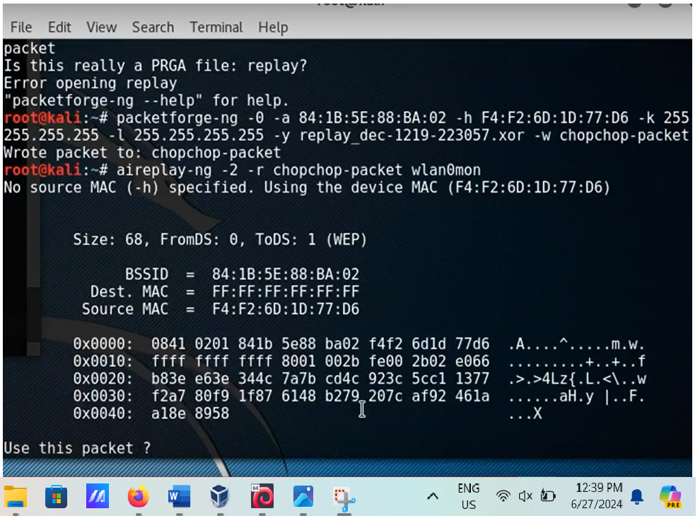
After giving the command airplayng 2 r chopchoppacket wlan0mon to run the data packets
Figure 21 : chop chop attack
Click on Yes, Go to the existing terminal, and check the Data packets.
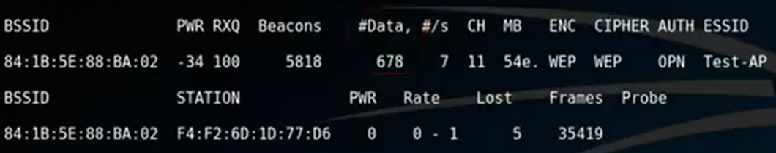
Figure 22 : Read the ARP packets
Next, give the “ls” command to see the list of files
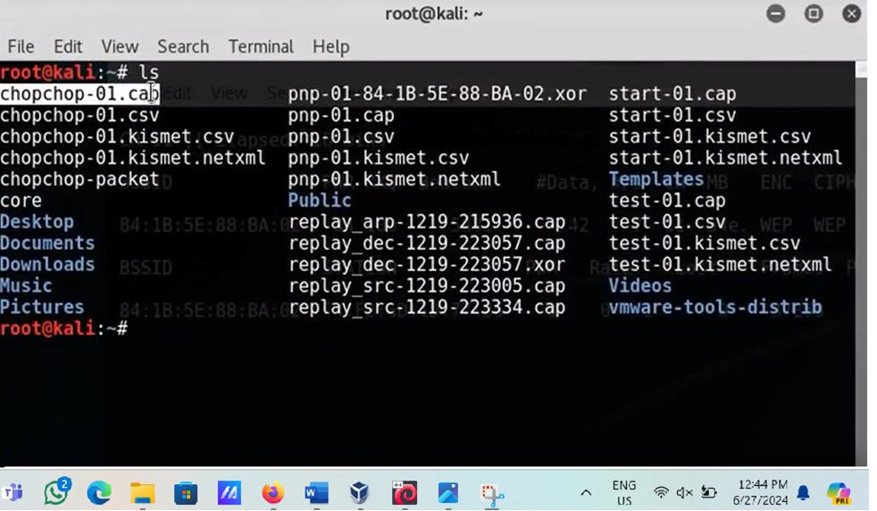
Figure 23 : Read the file Chopchop01.cap
Then run the data packets in the packets with the command aireplayng 2 r chopchoppacket wlan0mon. The aircrackng wlan0mon command starts cracking the keys against captured data from wireless networks. This utility is typically used after enough packets have been captured, usually by airodumpng, which uses sophisticated algorithms and techniques such as statistical analysis and bruteforce attacks to crack WEP, WPA, and WPA2 encryption keys.
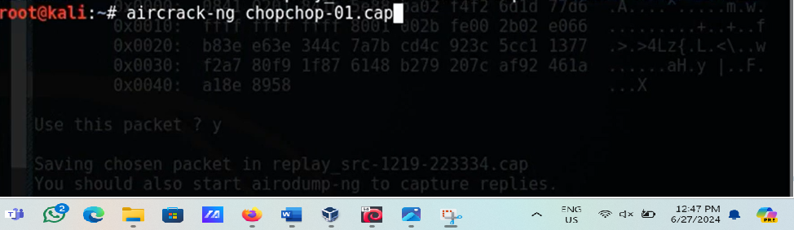
Figure 24 : Aircrack-ng chopchop01.cap
Aircrackng provides realtime progress feedback during the cracking process by indicating the number of keys tested and the estimated time remaining. Upon successful key cracking, aircrackng outputs the cracked key in plaintext; this approach, therefore, helps penetration testers analyze the network's security and possibly exploit vulnerabilities in it. All activities related to crucial cracking must be executed with due responsibility and proper authorization because unauthorized access or testing may have legal implications.
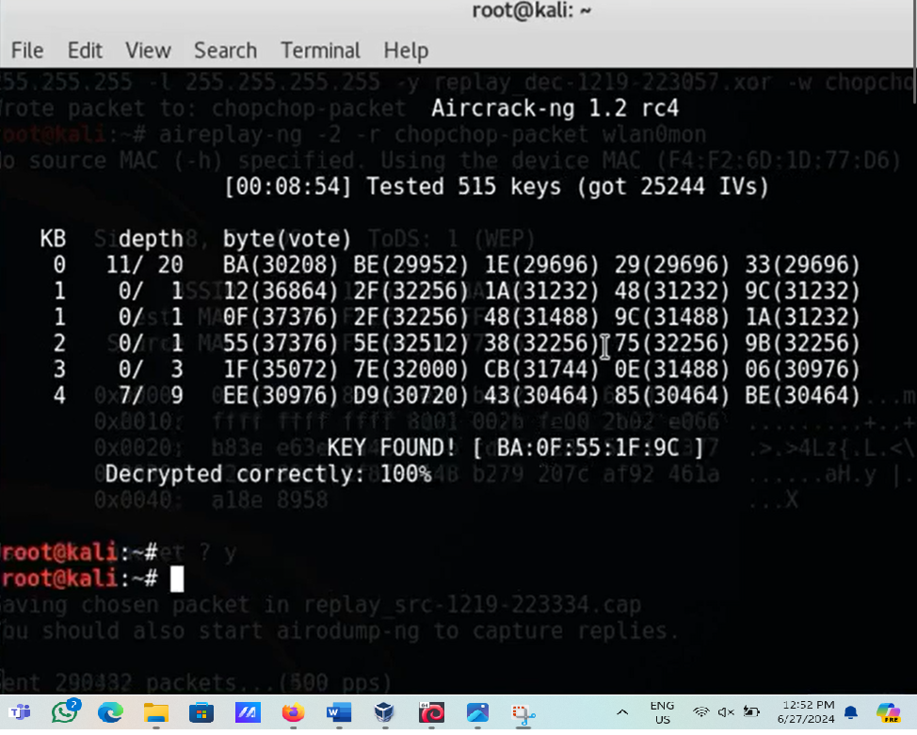
Figure 25: Key found
- ARP Replay attack:
Command: airodump-ng –bssid 00:10:18:90:2D:EE –channel 2 –write arp-request-reply-test mon0
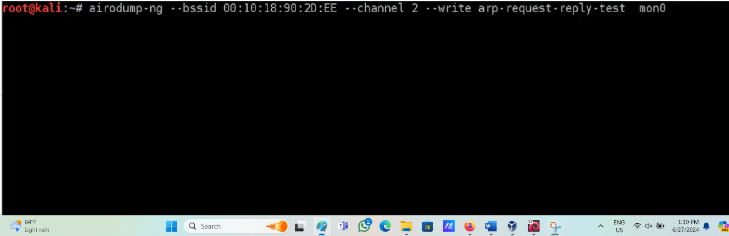
Figure 26: arp request replay test
Airodump-ng catching remote traffic on channel 2 for the BSSID 00:10:18:90:2D:EE. The organization, named "testap", utilizes WEP encryption. Beacons, data packets, signal strength, and other parameters necessary for network analysis are shown in the capture. Penetration testing and comprehending the wireless network's security posture can benefit from this output.
The utilization of aireplay-ng to play out a phony validation assault on a remote organization. The access point on channel 2 receives authentication and association requests from the command aireplay-ng fakeauth 0 a 00:10:18:90:2D:EE h 00:c0:ca:6c:ca:12 mon0. The attacking device can now appear to be a legitimate client to the target network because the output indicates that authentication and association were successful.
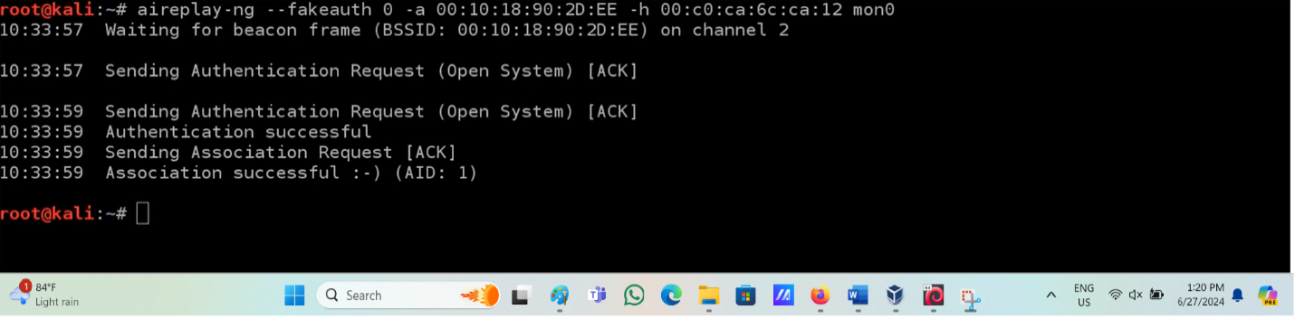
Figure 27: Perform a fake auth

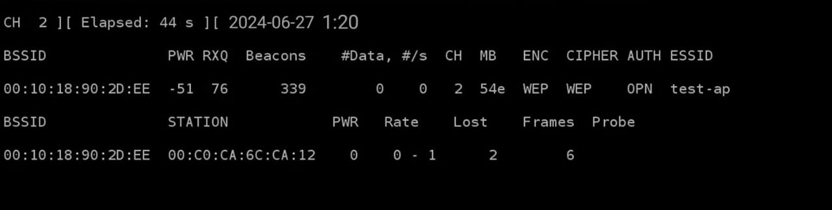
Figure 28: Capture the Station
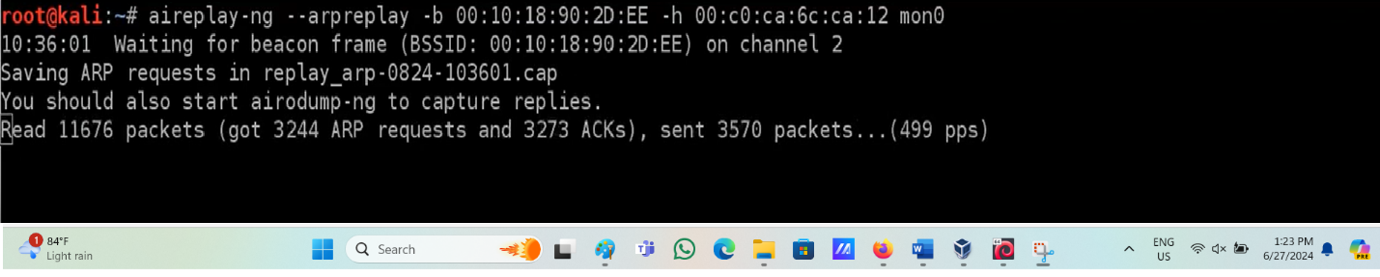
Figure 29: ARP request
Capture the list of files giving the command ls .cap
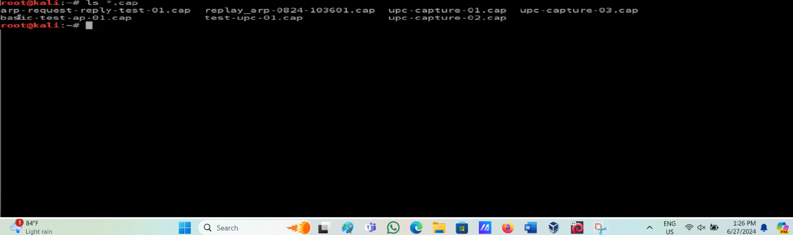
Figure 30: Get the list of files
Give the command to get the KEYaircrack-ng arprequestreplytest01.cap
It will tread the packets and decrypt the KEY.

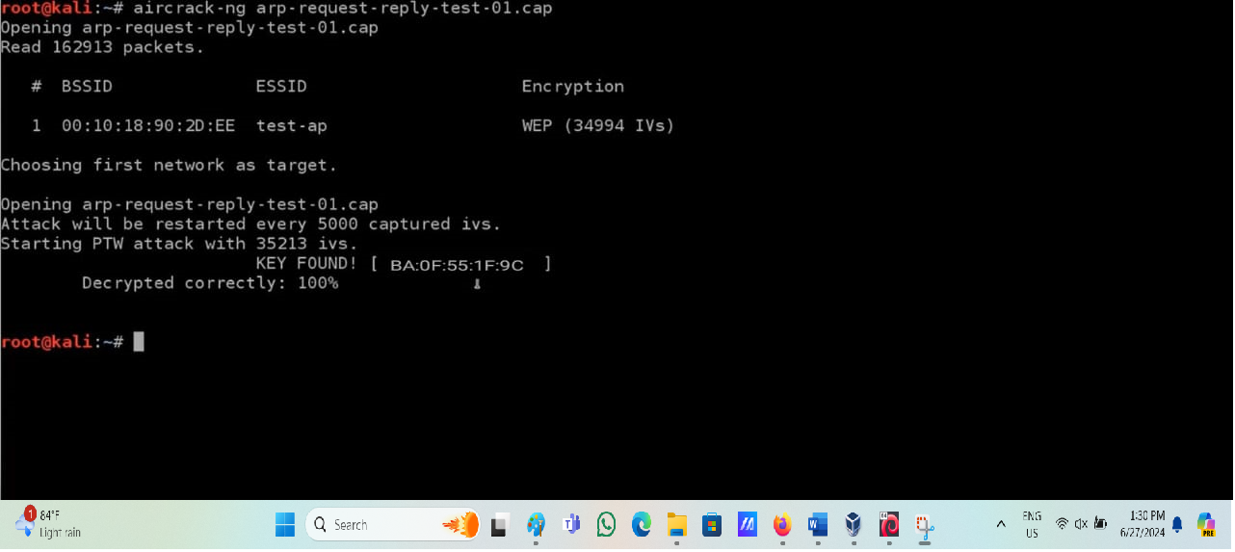
Figure 31: Key Found

4.3 Exploiting Vulnerabilities in IEEE 802.11 WPA/WPA2 Encryption Protocol
Step 1: Start the Wireshark program.
To sniff the packets, you may need to grant Wireshark root privilege by typing $ sudo wireshark in a terminal. Below is the screenshot of the Wireshark interface on my iMac desktop.
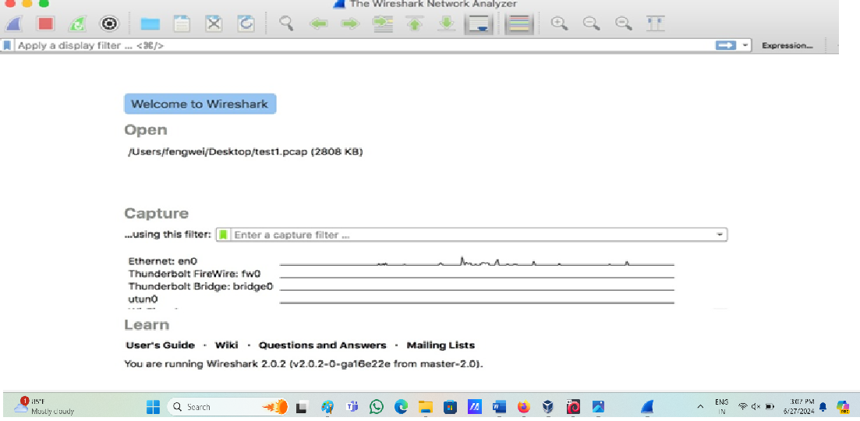
Figure 32: Wireshark interface
Step 2: Choose Wifi Interface
Click Capture > Options in the Wireshark program. In the WiFi interface, the name is typically wlan0, but it may be a different name, depending on your configuration. For instance, the preconfigured WiFi interface in my iMac is "WiFi:en1."
Step 3: Activate Monitoring Mode or Promiscuous Mode
It captures all packets within its distance range, meaning it captures packets from every SSID. Note that Monitor Mode is different from Promiscuous Mode. For this lab and what we want to do, we need all the traffic captured, meaning either monitor or promiscuous mode must be enabled.
The link below will show how I have the capture interface configured in the Wireshark program running on my monitor mode iMac. That means you have to enable Monitor mode first and then configure the 802.11
Link layer Header in Preferences, as seen below in the screenshot:
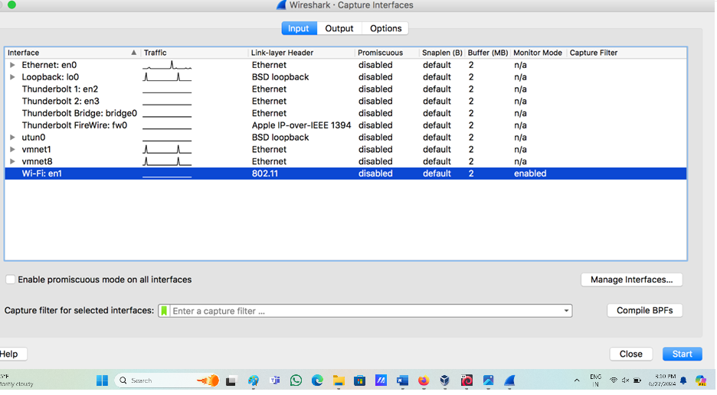
Figure 33 : Link layer Header
The screenshot below depicts the settings of the capture interface in the Wireshark program installed on my iMac, including enabling promiscuous mode. The promiscuous mode should be configured to support 'the link layer head per packet information.
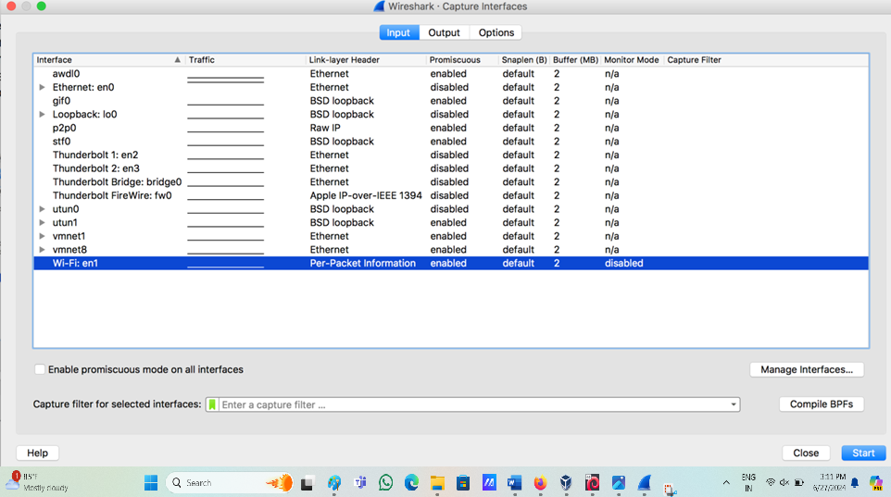
Figure 34 : capture interface in the Wireshark program
Step 4: Start Capturing
Click on start in the capture interfaces window and start the capture. The screenshot below shows the Wireshark program's interface while capturing in Monitor Mode.
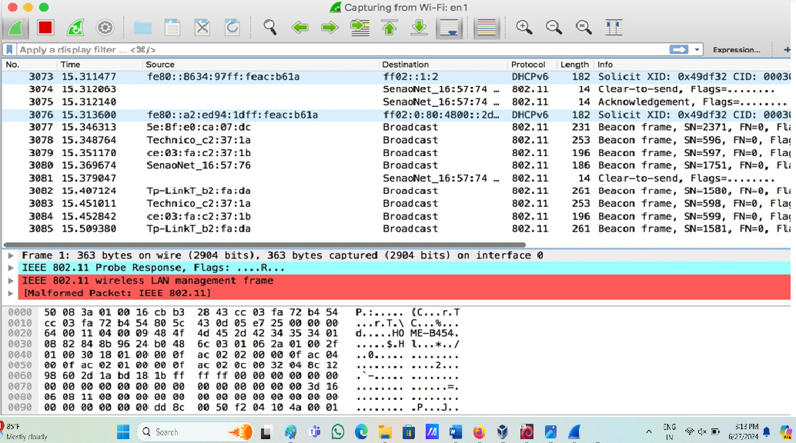
Figure 35 : capturing in Monitor Mode.
Step 1: Start capturing all the traffic
This is what we just did in our previous step. Just put the Wireshark program into Monitor Mode and run.
Step 2: Connect to the Access Point using your passphrase.
Connect your cell phone or laptop to the access point. Note that our classroom router SSID is "Hack3r" for this lab exercise.
Step 3: Stop the Wireshark application and look for the fourway handshake
Click on the stop button in Wireshark to stop capturing. The keyword "EAPOL" can then be typed into the filter to display only data containing the fourway handshake. This is shown in the screenshot below.
Capturing the Fourway Handshake
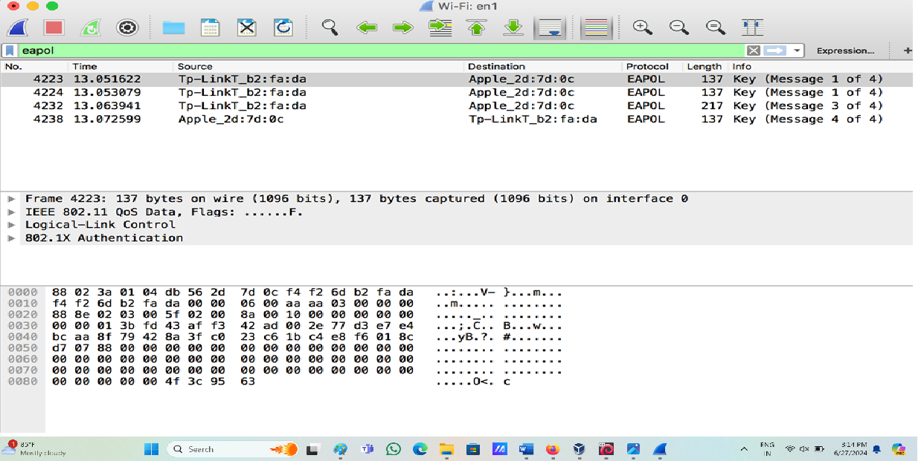
Figure 36 : Capturing the Fourway Handshake
Step 4: Save the captured traffic
Now click on File => Save as an option to save the captured traffic to a cap file. The screenshot below shows the example. The name of the pcap file saved is test.cap

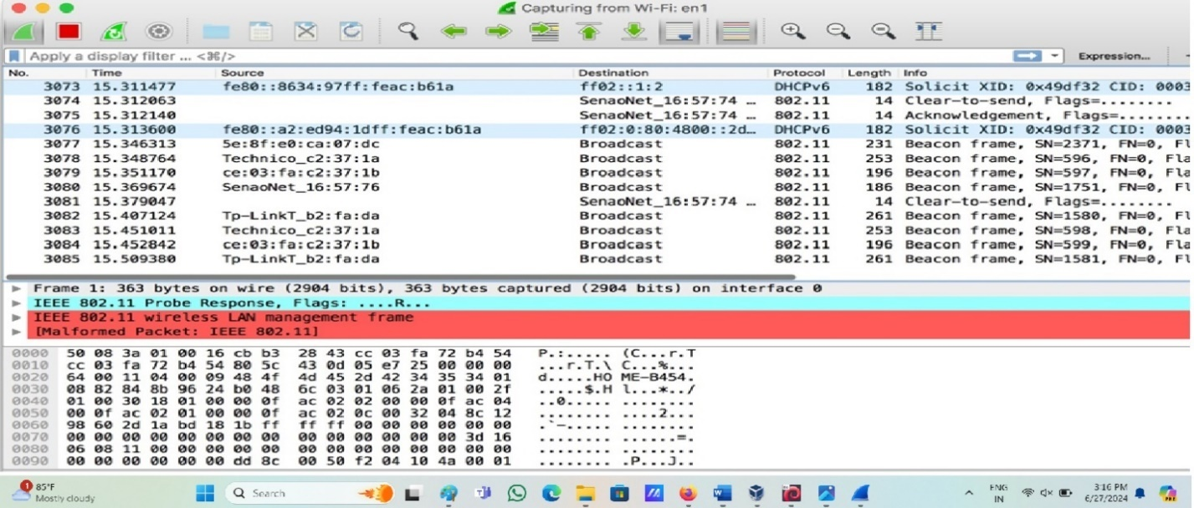
Figure 37 : save the captured traffic to a cap file

Cracking WPA2 WiFi Passphrase Using Kali Linux
Step 1: Copy the test.pcap file on to Kali Linux.
Our Kali Linux image contains copies of the following files: test instructor monitor. pcap and test instructor promiscuous. If you do not have your copy, you may use these also.
Step 2: Cracking the pass phrase
using aircrack-ng , is a network software suite—it's an allinone detector, packet sniffer, WEP, and WPA/WPA2PSK cracker, plus an analysis tool for 802.11 wireless LANs. It comes by default after installing Kali Linux.
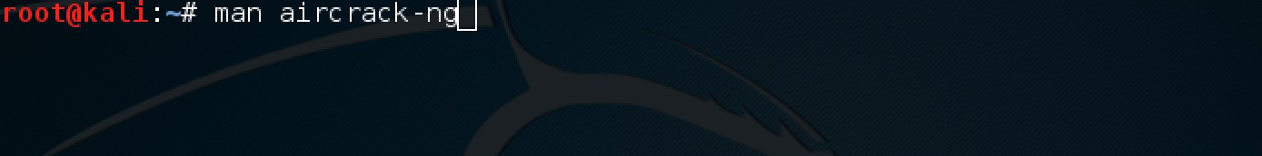
You can type $ man aircrack-ng to see the manual page of the tool.
Figure 38: man aircrack-ng

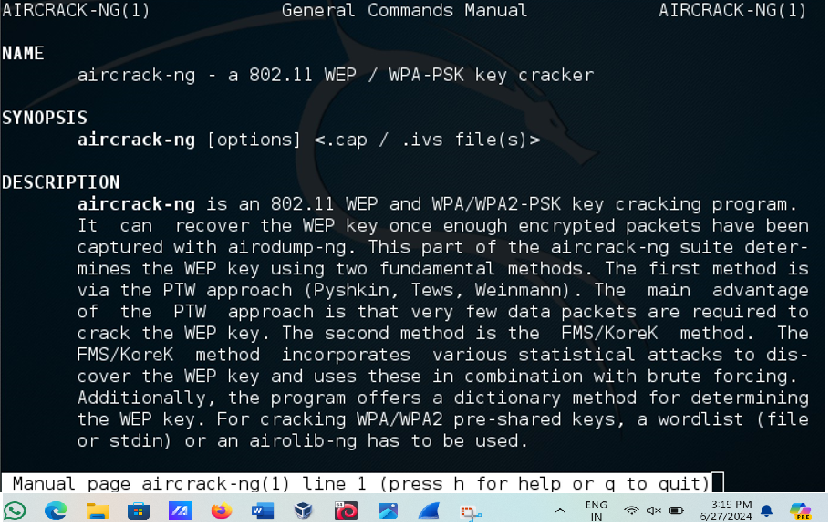
Figure 39: Aircrack-ng
Run the following command to crack the passphrase
$ aircrackng w /usr/share/wordlists/fernwifi/common.txt ~/Desktop/testinstructor monitor.pcap.
Next, we select the index for the WPA2 handshake. The SSID can be used to pull all of this information. From the screenshot, we again see that "Hack3r" has an index of 5. After entering 5, we can observe that the aircraft has successfully cracked the passphrase, as shown in the following screenshot
.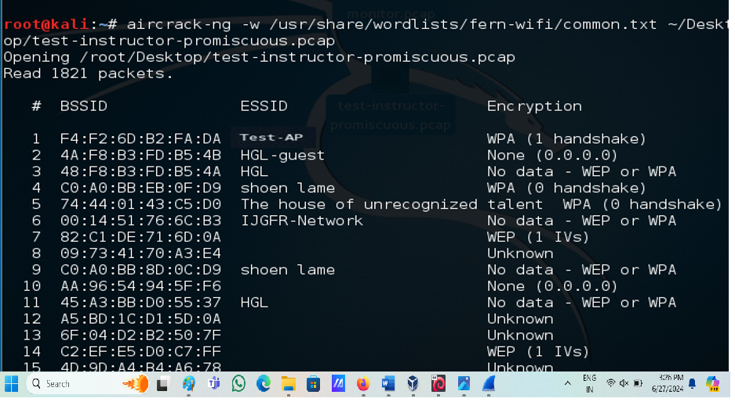
Figure 40 : Get the Encryption bssids
Below are the screenshots for cracking the pcap file captured by monitor mode.
After selecting 1 as the target network interface, the screenshot below shows that the password has been cracked.
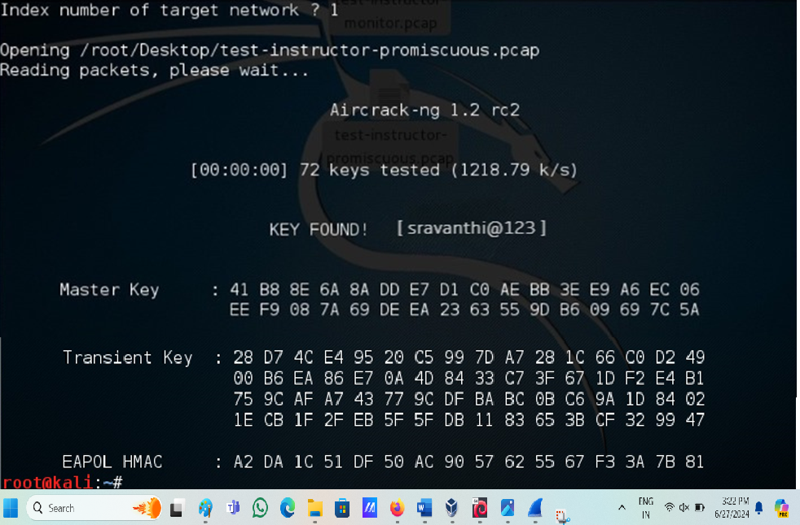
Figure 41: Key Found

5. RESULTS ANS ANALYSIS
The wireless security protocols were successfully cracked via the vulnerabilities that were found by using different types of Attacks, types of attack and status are listed below:
Attack 1:
- Type: Chopchop
- Status: Success
we successfully executed a ChopChop attack on a WEP-protected network. By leveraging vulnerabilities in the WEP protocol, we were able to decrypt data packets without the need for the WEP key. This involved capturing data packets, selecting an appropriate packet for the attack, and iteratively decrypting the packet byte-by-byte. Following decryption, we forged and injected packets to induce the access point to produce more traffic. Finally, we captured enough packets to successfully crack the WEP key using aircrack-ng. This demonstration highlights the inherent weaknesses in WEP encryption, underscoring the necessity for more robust security measures in wireless networks.
Attack 2:
- Type: ARP Replay
- Status: Success
we successfully conducted an ARP replay attack on a WEP-secured network. By capturing ARP request packets and replaying them, we generated a significant amount of network traffic. This allowed us to quickly gather many encrypted packets. Using these packets, we were able to crack the WEP key with aircrack-ng. This attack highlighted the vulnerabilities of WEP encryption and the need for stronger security measures in wireless networks.
Attack 3:
- Type: Brute force
- Status: Success
we successfully performed a brute force attack on a WPA2-secured network. By capturing the four-way handshake packets during the connection process, we acquired the necessary encrypted data. Utilizing a Wireshark tool and aircrack-ng, we repeatedly attempted various passphrases until we discovered the correct one. This exercise illustrated the vulnerabilities of WPA2 encryption when using weak passwords, underscoring the critical need for robust, complex passphrases to ensure wireless network security.

Mitigations
1. Use Strong Encryption Protocols
Method: Implement WPA2-Enterprise with AES Encryption
Explanation: WPA2-Enterprise (Wi-Fi Protected Access 2) provides strong encryption and authenticates users through a centralized authentication server (like RADIUS). AES (Advanced Encryption Standard) is a robust encryption algorithm that ensures data confidentiality. This combination significantly enhances WiFi security by preventing unauthorized access and eavesdropping.
Implementation Steps:
Configure WiFi access points (APs) and WiFi adapters to use WPA2-Enterprise with AES encryption.
Integrate with a RADIUS server for centralized user authentication and secure key management.
Step1: open server manager Dashboard and add the roles and features.
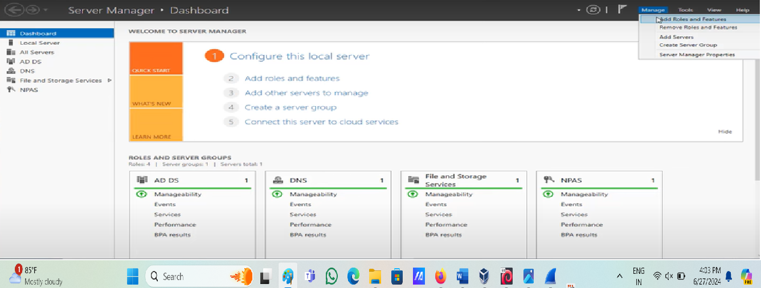
Figure 42 : Server Manager
Step 2: open the login page for accessing a Linksys router's administrative settings via a web interface and get into page login
Step 3: open the "Connectivity" settings page for a Linksys router's web-based interface. This page allows users to configure various aspects of their router's internet connection
Step 4: the "Connectivity" settings page for a Linksys router's web-based interface, focusing on network names and passwords, firmware updates, time zone settings, and activity lights.
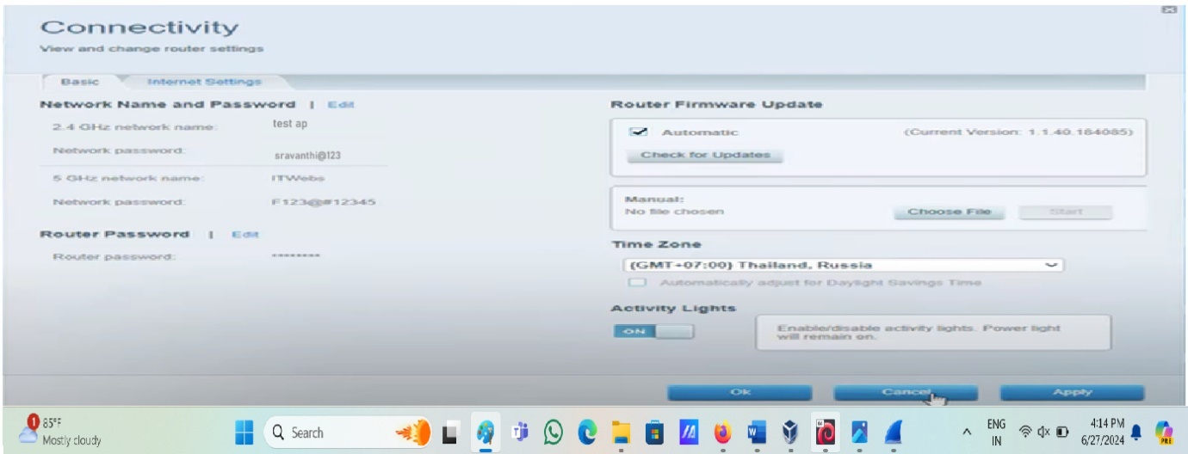
Figure 43 : Focus on name and password and give updates
Step 5: open Troubleshooting and ping the Ipv4
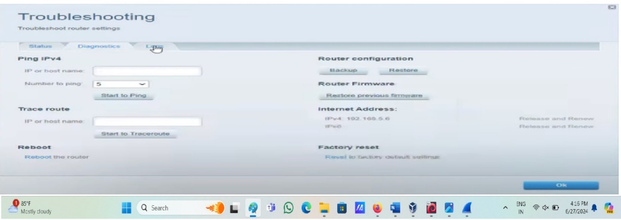
Figure 44: Troubleshooting
Step 6: open wireless and change the GHz Wi-Fi settings
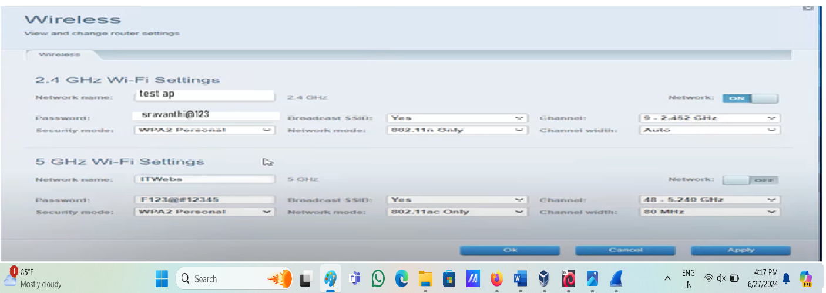
Figure 45: GHz Wi-Fi settings
Step 7: open NPS and go to RADIUS server is create. And start the process.
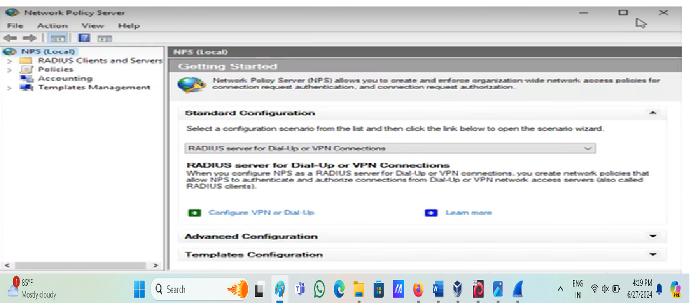
Figure 46: Create radius server
Step 8: open new RADIUS client and enter IP Address of DNS.
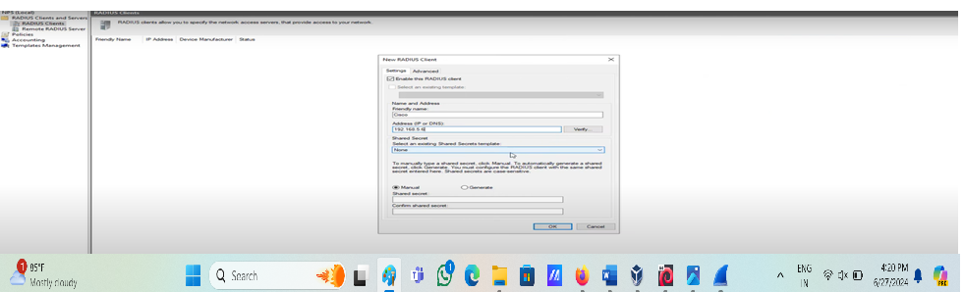
Figure 47: Open new RADIUS client
Step 9: Enter the IP Address

Figure 48: Give Ip add
Step 10: setup the manual type.
Step 11: Add the NAS port type.
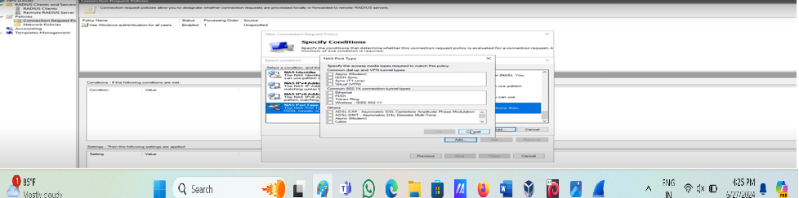
Figure 49 : Add NAS port
Step 12: After that create a user ID.
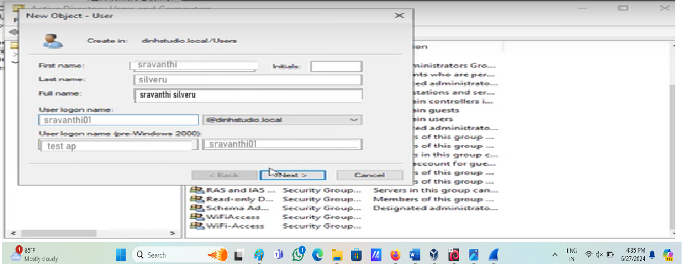
Figure 50 : Create user ID
Step 13: After that create a strong password.
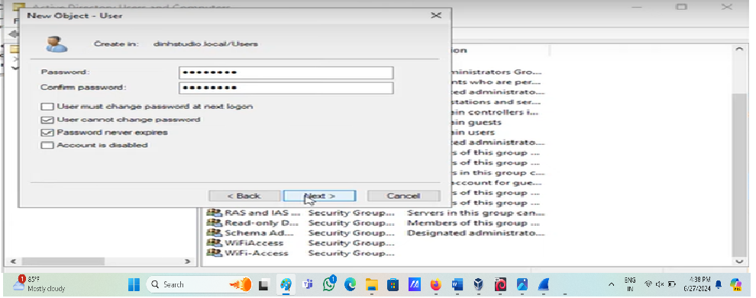
Figure 51: Created strong password
Step 14: Create group use Wi-Fi Access.
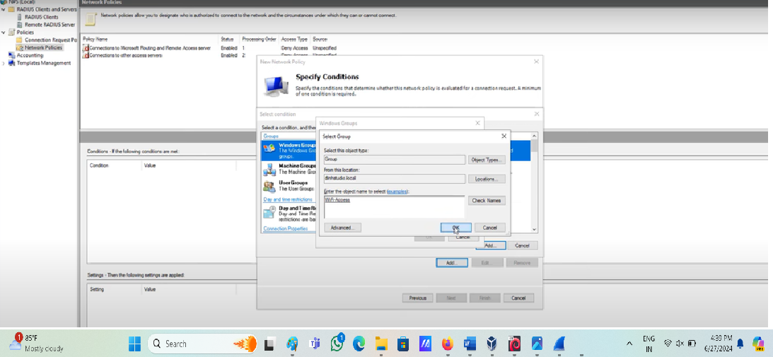
Figure 52: Create Group
Step 15: create a group test.
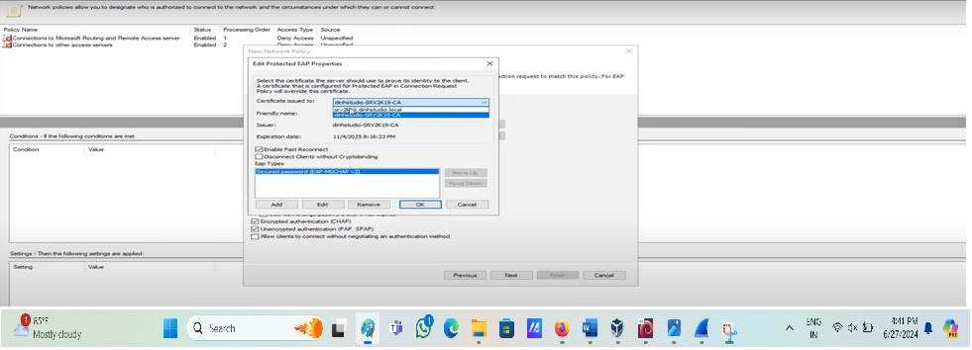
Figure 53: Create Group Test

Then go to windows Defender Firewall and turn off windows defender firewall then go to user and login the page and open ethernet and change the adaptor option settings after that open control pannel and connect to the ethernet connection.
Step 16: check the Wi-Fi status.
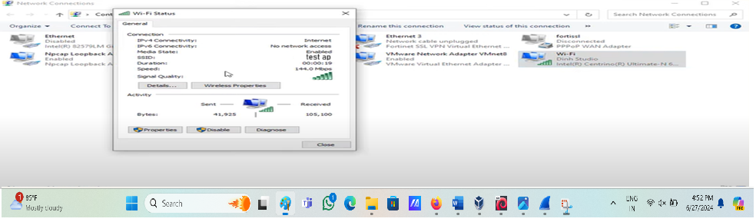
Figure 54: Wi-Fi status
2. Wi-Fi Adapter Configuration Best Practices
Method: Disable Unused Features and Services
- Explanation: Wi-Fi adapters often come with various features and services that may introduce security vulnerabilities if not properly configured or disabled. Disabling unnecessary features reduces the attack surface and enhances security.
- Implementation Steps:
  - Disable unused wireless interfaces (e.g., Bluetooth if not needed).
  - Turn off Wi-Fi adapter features like ad-hoc mode and WPS (WiFi Protected Setup), which can be exploited by attackers.
  - Ensure that Wi-Fi adapters use the latest firmware version with security patches applied.
3. Monitoring and Logging:
Method: Implement Wi-Fi Adapter Monitoring and Logging
- Explanation: Monitoring and logging Wi-Fi adapter activities provide visibility into network traffic, potential security incidents, and policy violations. It enables proactive threat detection, incident response, and compliance with security policies and regulations.
- Implementation Steps:
  - Enable logging on Wi-Fi APs and network infrastructure devices.
  - Configure monitoring tools to analyse Wi-Fi adapter performance, detect anomalies, and identify security threats.
  - Implement alerts and notifications for suspicious activities or policy violations.

5.2 Status of Attacks
After applying mitigations techniques to the device, different types of attack are implemented again to the system, whether the network is secured successfully or not. Types of attacks are listed below and their status:
- Type of Attack: Chop Chop
Status: Fail
After implementing a strong and complex encryption password, our attempts to execute a ChopChop attack on the WEP network failed. Despite using the same methodology to capture and decrypt data packets, the enhanced security measures rendered the attack ineffective. This outcome underscores the importance of using robust encryption passwords in mitigating vulnerabilities inherent in WEP, thereby significantly improving the network's resilience against such attacks.
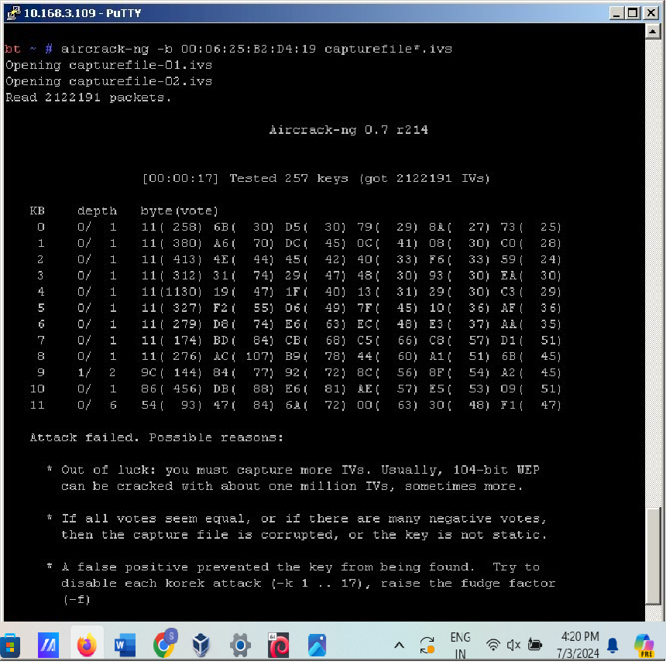
Figure 55 : Chopchop attack Fails
- Type of Attack: ARP Reply
Status: Fail
After securing the network with a strong and complex encryption password, our attempts to conduct an ARP replay attack on the WEP network were unsuccessful. Even though we followed the standard procedure of capturing and replaying ARP request packets, the strengthened encryption rendered the attack ineffective. This result highlights the critical role of using robust encryption passwords in protecting WEP networks from such vulnerabilities, thereby enhancing overall network security.
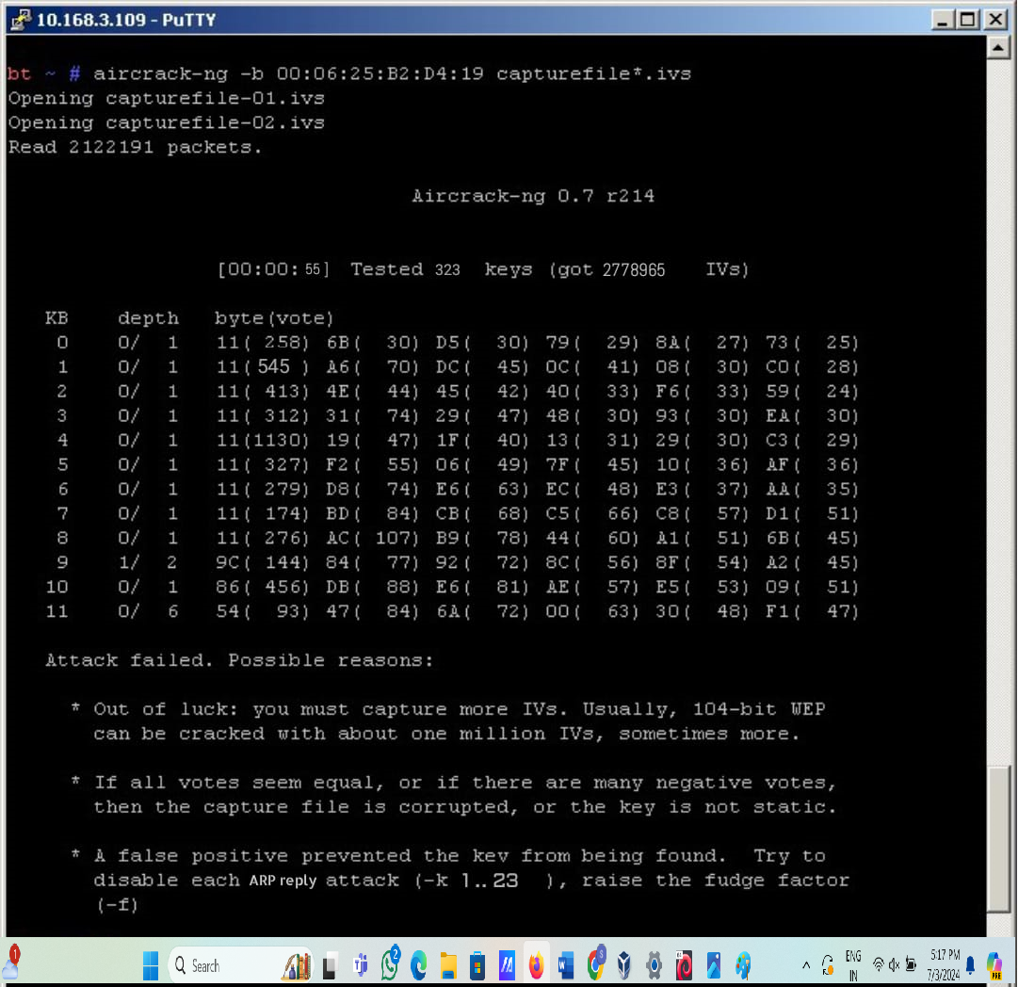
Figure 56 : ARP Reply Attack Fails
- Type of Attack: Brute Force
Status: Fail
Despite implementing a strong and complex password for WPA2 encryption, our attempts to perform a brute force attack were unsuccessful. Using a wordlist and aircrack-ng, we systematically tested various passphrase combinations but did not succeed in cracking the password. This outcome demonstrates the effectiveness of using strong, complex passwords in safeguarding WPA2 networks against brute force attacks, thereby reinforcing the importance of robust security practices in wireless network management.

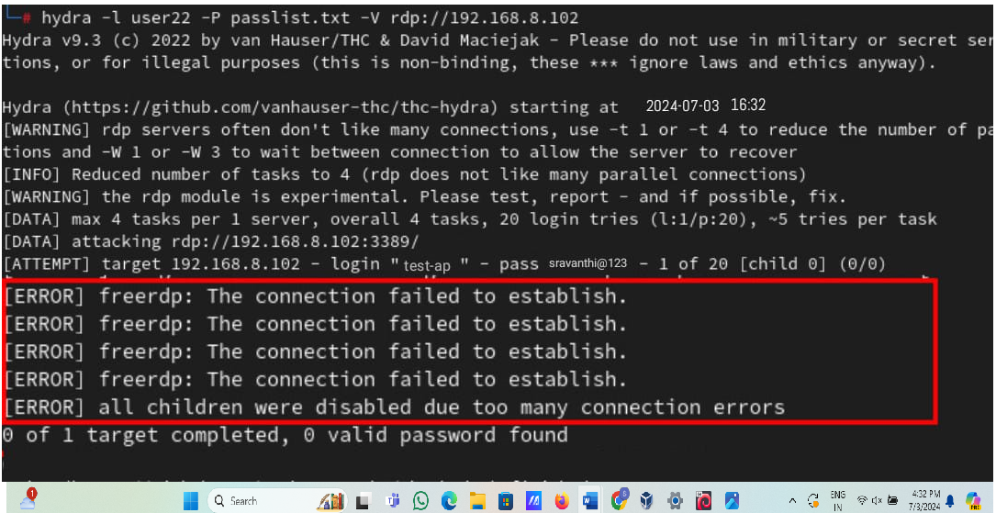
Figure 57: Brute Force Attack Fails

Network | Network System | Mitigation | Status
WEP | Chopchop attack | Strong Encryption | Success
WEP | ARP Replay attack | Strong Encryption | Success
WPA2 | Brute Force attack | Strong Encryption | Success

Table 3: Success of attacks
The experiments conducted in our project successfully achieved the objectives set out for each network and attack scenario. For WEP, both the ChopChop and ARP Replay attacks were executed effectively, highlighting vulnerabilities that can be mitigated with strong encryption practices. Similarly, the WPA2 network demonstrated resilience against brute force attacks due to the implementation of strong encryption measures. These results underscore the critical importance of robust security protocols in safeguarding wireless networks against various cyber threats. Through these experiments, we gained valuable insights into the strengths and weaknesses of different encryption standards, informing best practices for securing network communications in practical scenarios.

6. CONCLUSIONS
The issue of wireless network security has grown over the past few years, especially in IEEE 802.11 WLAN Security protocols. This has been fuelled by extensive penetration testing, which has exposed some gaping holes in encryption protocols like WEP and WPA/WPA2-PSK. One critical analysis is that WEP is highly insecure because it quickly exhausts the 24-bit IV space. This results in replaying IVs and creates a more leisurely route for attackers to crack the WEP key. Furthermore, although the CRC32 checksum is implemented to keep data intact during transmission—that is, it prevents data packets from being tampered with during transit—the effectiveness of CRC32 against data modifications has been challenged. In certain circumstances, the ICV cannot withstand ciphertext attacks, creating a loophole in the security framework.
This has made it so that despite extensive decryption protocols, such as WEP and WPA/WPA2-PSK, by history, an organization is compelled to recognize the existing vulnerabilities and work on them—this means looking and using more solid and secure alternatives.

7. FUTURE WORK
The dynamic penetration testing landscape for wireless networks enables huge strides in network security. Research in this domain has the potential to enhance security measures in the future greatly. One promising avenue could be developing advanced, automated penetration-testing tools that would enable the efficient discovery of vulnerabilities and assessment of networks' security posture. Further investigation into cutting-edge wireless technologies such as Wi-Fi 6 and beyond can offer valuable insight into their security implications.
Another exciting frontier is the integration of AI and machine learning techniques into penetration testing frameworks, which can detect security flaws with a greater degree of accuracy and effectiveness and ensure a proactive position in maintaining network security. Furthermore, due to the unprecedented growth in IoT devices, research on the security of IoT devices and their effect on wireless network security becomes centrally important.
It can be furthered by creating the security frameworks and best practices for wireless networks more comprehensively so companies can practically improve their network security. Collaboration among researchers, business professionals, and policy framers is essential in coping with the dynamic nature of cybersecurity and designing more stringent measures to protect digital infrastructures adequately

REFLECTIONS
Personal Reflections
Reflecting on this project, I realize the complexity and importance of securing wireless networks. Working on vulnerability assessment has deepened my understanding of wireless security protocols like WPA and WPA2, and the potential threats these networks face. Using tools like Wireshark and Aircrack-ng has enhanced my technical skills, particularly in traffic analysis and packet capturing. The ethical considerations involved in penetration testing have reinforced the importance of responsible handling of sensitive information.
One key takeaway from this project is the constant evolution of security threats. Despite advancements in encryption protocols, attackers continue to find ways to exploit vulnerabilities. This highlights the necessity for continuous learning and adaptation in the field of cybersecurity. The practical application of capturing handshake packets and attempting real-life attack methods has been particularly enlightening, showing how theoretical knowledge is applied in real-world scenarios.
Moreover, the project has underscored the critical role of robust security measures and regular network monitoring. The recommendations developed through this project are not only useful for the specific network tested but also applicable to broader contexts. This experience has been invaluable in shaping my approach to network security and my future endeavors in cybersecurity.
Technical Reflections
From a technical perspective, the project provided a comprehensive exploration of wireless network vulnerabilities and the methodologies to exploit and mitigate them. Utilizing Kali Linux and tools like Aircrack-ng and Wireshark, I was able to simulate real-world attack scenarios. These simulations included brute force attacks, deauthentication attacks, and man-in-the-middle attacks, providing a hands-on understanding of how these exploits work.
The technical challenges encountered, such as capturing handshake packets and decrypting traffic, required a methodical approach and a deep understanding of network protocols. This process highlighted the importance of a well-structured methodology in penetration testing, from reconnaissance to exploitation and finally, reporting.
The project's findings revealed specific weaknesses in WPA/WPA2 protocols, particularly in the context of weak passwords and outdated encryption methods. This has emphasized the need for stronger encryption protocols like WPA3 and better network configuration practices. The importance of strong authentication mechanisms, such as WPA2-Enterprise with 802.1X, became evident in mitigating unauthorized access.
Additionally, the use of a TP-Link adapter and DIR-615 wireless N300 router provided a realistic environment for testing. This setup helped in understanding the practical aspects of network configuration and the effectiveness of various security measures.
Overall, this project has enhanced my technical proficiency in network security and provided valuable insights into the practical challenges and solutions in securing wireless networks. The experience gained will be crucial in my future projects and professional development in the field of cybersecurity.

REFERNCES
[1] Y. Xiao, H. Chen, S. Yang, Y. B. Lin, and D. Z. Du, “Wireless network security,” Eurasip Journal on Wireless Communications and Networking, vol. 2009. 2009. doi: 10.1155/2009/532434.
[2] D. N. Astrida, A. R. Saputra, and A. I. Assaufi, “Analysis and Evaluation of Wireless Network Security with the Penetration Testing Execution Standard (PTES),” Sinkron, vol. 7, no. 1, pp. 147–154, Jan. 2022, doi: 10.33395/sinkron.v7i1.11249.
[3] G. Jayasuryapal, P. M. Pranay, H. Kaur, and Swati, “A Survey on Network Penetration Testing,” Proceedings of 2021 2nd International Conference on Intelligent Engineering and Management, ICIEM 2021, pp. 373–378, Apr. 2021, doi: 10.1109/ICIEM51511.2021.9445321.
[4] R. Nazir, A. A. laghari, K. Kumar, S. David, and M. Ali, “Survey on Wireless Network Security,” Archives of Computational Methods in Engineering, vol. 29, no. 3. Springer Science and Business Media B.V., pp. 1591–1610, May 01, 2022. doi: 10.1007/s11831-021-09631-5.
[5] V. Gabale, B. Raman, P. Dutta, and S. Kalyanraman, “A classification framework for scheduling algorithms in wireless mesh networks,” IEEE Communications Surveys and Tutorials, vol. 15, no. 1, pp. 199–222, 2013, doi: 10.1109/SURV.2012.022412.00068.
[6] A. H. Lashkari, M. Mansoori, and A. S. Danesh, “Wired equivalent privacy (WEP) versus Wi-Fi protected access (WPA),” 2009 International Conference on Signal Processing Systems, ICSPS 2009, pp. 445–449, 2009, doi: 10.1109/ICSPS.2009.87.
[7] S. F. Russell, “Wireless Network Security for Users.”
[8] H. B. Zawawi et al., “Rate Adaptation for Quality of Service (QoS) Improvement in IEEE 802.11ax Wireless Local Area Network (WLAN)”.
[9] C. Jittawiriyanukoon and V. Srisarkun, “Performance evaluation of wireless local area network with congested fading channels,” International Journal of Electrical and Computer Engineering (IJECE, vol. 12, no. 1, pp. 411–417, 2022, doi: 10.11591/ijece.v12i1.pp411-417.
[10] A. M. Al Naamany, A. Al Shidhani, and H. Bourdoucen, “IEEE 802.11 Wireless LAN Security Overview,” 2006.
[11] K. S. Kwak, S. Ullah, and N. Ullah, “An overview of IEEE 802.15.6 standard,” 2010 3rd International Symposium on Applied Sciences in Biomedical and Communication Technologies, ISABEL 2010, 2010, doi: 10.1109/ISABEL.2010.5702867.
[12] R. Du et al., “An Overview on IEEE 802.11bf: WLAN Sensing,” IEEE Communications Surveys and Tutorials, 2024, doi: 10.1109/COMST.2024.3408899.
[13] A. Kavianpour and M. C. Anderson, “An Overview of Wireless Network Security,” in Proceedings - 4th IEEE International Conference on Cyber Security and Cloud Computing, CSCloud 2017 and 3rd IEEE International Conference of Scalable and Smart Cloud, SSC 2017, Institute of Electrical and Electronics Engineers Inc., Jul. 2017, pp. 306–309. doi: 10.1109/CSCloud.2017.45.
[14] A. H. Adnan et al., “A comparative study of WLAN security protocols: WPA, WPA2,” Proceedings of 2015 3rd International Conference on Advances in Electrical Engineering, ICAEE 2015, pp. 165–169, Jul. 2016, doi: 10.1109/ICAEE.2015.7506822.
[15] M. Murad and A. M. Eltawil, “Performance Analysis and Enhancements for In-Band Full-Duplex Wireless Local Area Networks,” IEEE Access, vol. 8, pp. 111636–111652, 2020, doi: 10.1109/ACCESS.2020.3001876.
[16] V. Kumkar, S. Shrawne, A. Tiwari, P. Tiwari, and A. Gupta, “Vulnerabilities of Wireless Security protocols (WEP and WPA2),” International Journal of Advanced Research in Computer Engineering & Technology, vol. 1, no. 2, 2012, Accessed: Jul. 02, 2024. [Online]. Available: https://www.researchgate.net/publication/266005431
[17] S. Plosz, A. Farshad, M. Tauber, C. Lesjak, T. Ruprechter, and N. Pereira, “Security vulnerabilities and risks in industrial usage of wireless communication,” 19th IEEE International Conference on Emerging Technologies and Factory Automation, ETFA 2014, Jan. 2014, doi: 10.1109/ETFA.2014.7005129.
[18] A. F. Rochim, B. Harijadi, Y. P. Purbanugraha, S. Fuad, and K. A. Nugroho, “Performance comparison of wireless protocol IEEE 802.11ax vs 802.11ac,” Proceeding - ICoSTA 2020: 2020 International Conference on Smart Technology and Applications: Empowering Industrial IoT by Implementing Green Technology for Sustainable Development, Feb. 2020, doi: 10.1109/ICOSTA48221.2020.1570609404.
[19] M. E. Manley, C. A. McEntee, A. M. Molet, and J. S. Park, “Wireless security policy development for sensitive organizations,” Proceedings from the 6th Annual IEEE System, Man and Cybernetics Information Assurance Workshop, SMC 2005, vol. 2005, pp. 150–157, 2005, doi: 10.1109/IAW.2005.1495946.
[20] O. H. Anayo, O. Christian, A. I. Yinka, and E. Godwin, “Security In Wireless Local Area Network,” Journal of Multidisciplinary Engineering Science and Technology (JMEST), vol. 8, pp. 2458–9403, 2021, Accessed: Jul. 02, 2024. [Online]. Available: www.jmest.org
[21] M. Denis, C. Zena, and T. Hayajneh, “Penetration testing: Concepts, attack methods, and defense strategies,” 2016 IEEE Long Island Systems, Applications and Technology Conference, LISAT 2016, Jun. 2016, doi: 10.1109/LISAT.2016.7494156.
[22] Z. Chen, S. Guo, K. Zheng, and Y. Yang, “Modeling of man-in-the-middle attack in the wireless networks,” 2007 International Conference on Wireless Communications, Networking and Mobile Computing, WiCOM 2007, pp. 2255–2258, 2007, doi: 10.1109/WICOM.2007.562.
[23] M. Guennoun, A. Lbekkouri, A. Benamrane, M. Ben-Tahir, and K. El-Khatib, “Wireless networks security: Proof of ChopChop attack,” 2008 IEEE International Symposium on A World of Wireless, Mobile and Multimedia Networks, WoWMoM2008, 2008, doi: 10.1109/WOWMOM.2008.4594924.
[24] G. Sadhir, Y.-C. Hu, and A. Perrig, “ARP Attacks in Wireless Ad Hoc Networks”.
[25] O. Nakhila and C. Zou, “Parallel active dictionary attack on IEEE 802.11 enterprise networks,” Proceedings - IEEE Military Communications Conference MILCOM, pp. 265–270, Dec. 2016, doi: 10.1109/MILCOM.2016.7795337.
[26] U. Kumar and S. Gambhir, “A Literature Review of Security Threats to Wireless Networks,” International Journal of Future Generation Communication and Networking, vol. 7, no. 4, pp. 25–34, 2014, doi: 10.14257/ijfgcn.2014.7.4.03.
[27] H. Gonzales, K. Bauer, J. Lindqvist, D. McCoy, and D. Sicker, “Practical defenses for evil twin attacks in 802.11,” GLOBECOM - IEEE Global Telecommunications Conference, 2010, doi: 10.1109/GLOCOM.2010.5684213.
[28] Y. Zou, J. Zhu, X. Wang, and L. Hanzo, “A Survey on Wireless Security: Technical Challenges, Recent Advances, and Future Trends,” Proceedings of the IEEE, vol. 104, no. 9, pp. 1727–1765, Sep. 2016, doi: 10.1109/JPROC.2016.2558521.
[29] H. Kim and E. A. Lee, “Authentication and Authorization for the Internet of Things,” IT Prof, vol. 19, no. 5, pp. 27–33, 2017, doi: 10.1109/MITP.2017.3680960.
[30] P. Goyal and A. Goyal, “Comparative study of two most popular packet sniffing tools-Tcpdump and Wireshark,” Proceedings - 9th International Conference on Computational Intelligence and Communication Networks, CICN 2017, vol. 2018-January, pp. 77–81, Jul. 2017, doi: 10.1109/CICN.2017.8319360.
[31] A. Ismail Al-Alawi, “WiFi Technology: Future Market Challenges and Opportunities,” Journal of Computer Science, vol. 2, no. 1, pp. 13–18, 2006.
[32] M. K. Kissi and M. Asante, “Penetration Testing of IEEE 802.11 Encryption Protocols using Kali Linux Hacking Tools,” Article in International Journal of Computer Applications, vol. 176, no. 32, pp. 975–8887, 2020, doi: 10.5120/ijca2020920365.
[33] H. M. Z. Al Shebli and B. D. Beheshti, “A study on penetration testing process and tools,” 2018 IEEE Long Island Systems, Applications and Technology Conference, LISAT 2018, pp. 1–7, Jun. 2018, doi: 10.1109/LISAT.2018.8378035.
[34] A. Gulab Gaikwad and B. Patil, “Securing the Airwaves: A Survey on De-authentication Attacks and Mitigation Strategies,” International Journal of Computing and Digital Systems, vol. 15, no. 1, pp. 1307–1316, Sep. 2024, doi: 10.12785/IJCDS/160196.
[35] D. Ahirwar, P. K. Shukla, K. R. Bhatele, P. Shukla, and S. Goyal, “Intrusion Detection and Tolerance in Next Generation Wireless Network,” https://services.igi-global.com/resolvedoi/resolve.aspx?doi=10.4018/978-1-4666-8687-8.ch011, pp. 313–335, Jan. 1AD, doi: 10.4018/978-1-4666-8687-8.CH011.
[36] “KRACK Attacks: Breaking WPA2.” Accessed: Jul. 02, 2024. [Online]. Available: https://www.krackattacks.com/
[37] B. Saunders et al., “Saturation in qualitative research: exploring its conceptualization and operationalization,” Qual Quant, vol. 52, no. 4, pp. 1893–1907, Jul. 2018, doi: 10.1007/S11135-017-0574-8/TABLES/1.
[38] “research onion layer.” Accessed: Jul. 02, 2024. [Online]. Available: https://www.researchgate.net/profile/Aleksandras-Melnikovas/publication/333388233_Towards_an_explicit_research_methodology_Adapting_research_onion_model_for_futures_studies/links/5d47c8404585153e593cfbec/Towards-an-explicit-research-methodology-Adapting-research-onion-model-for-futures-studies.pdf?_sg%5B0%5D=started_experiment_milestone&origin=journalDetail&_rtd=e30%3D
[39] R. Alturki, “Research Onion for Smart IoT-Enabled Mobile Applications,” Sci Program, vol. 2021, no. 1, p. 4270998, Jan. 2021, doi: 10.1155/2021/4270998.
[40] M. Qaderi, G. Sinha, and D. K. Sinha, “Vulnerability Detection and Security Enhancing Using XAMPP, OWASP and DVWA,” 2023 International Conference on Computer Science and Emerging Technologies, CSET 2023, 2023, doi: 10.1109/CSET58993.2023.10346734.
[41] C. Blackwell, “Towards a penetration testing framework using attack patterns,” Cyberpatterns: Unifying Design Patterns with Security and Attack Patterns, vol. 9783319044477, pp. 135–148, Mar. 2014, doi: 10.1007/978-3-319-04447-7_11/COVER.

