Chantelle Charlotte Slinger
1800653
M4X01966
A Report into the Effectiveness of the Current Structure of the NHS in Wales
Tania Davies

Abstract
This report reflects on the structure of the National Health Service in Wales, by having mentioned the positive and negative aspects of the hierarchical structure that is used and how it effects the NHS. This information was found by using secondary research from statistics and guides from a range of publications and reports in connection to the National Health Service. It will also look at the funding of £7.3 billion pounds, which is split by seven health boards.

Contents

Introduction …………………………………………………………………………………………………………………… Page 3
Information / Statistics / Guides ……………………………………………………………………………………. Page 3-6
Evaluation of Current Structure …………………………………………………………………………………….. Page 7-9
Conclusion …………………………………………………………………………………………………………………….. Page 9-10
Recommendations ………………………………………………………………………………………………………… Page 10
Reference List ……………………………………………………………………………………………………………….. Page 11-12

Introduction
This report looks into the effectiveness of the current structure that is being used within the National Health Service (NHS) in Wales, it will be looking into the different sections and aspects that can be found in the structure.
National Health Service Wales (2019) reports that NHS Wales is a publicly funded National Health Service of wales which provides health care to 3 million people, who live in the country. When it comes to setting health policy for the NHS in Wales and the funding for this service it is the responsibility of the Welsh government.
Health in Wales (2019) mentions the structure within the NHS Wales and how it has been restructured since 2009, by replacing 22 local health boards with seven new health boards, they have a goal to plan, develop and provide different health treatments in their local area. The three NHS trust in Wales provide care to everyone and work to ensure their work is effective to their population, they also invested in providing care to those who are unable to leave their home for treatments.

Information / guides / statistics
When it comes the funding the Welsh Government are responsible for the funding provided to the HS Wales. The Welsh Government have a revenue budget of £ 15 billion. It’s estimated that £7.3 billion of the budget is invested each year and it spent on the health and wellbeing along with the Social Services according to GP One (2019) and the Welsh Government (2019). The Welsh Government is said to invest around £6.5 billion straight into the delivery of these services.
Altogether the National Health Service is allocated a budget of around £7.3 billion pounds each year. The budget is then to be split between the seven health boards and then split father within each of the health boards. When it comes to the budget for each health board it is thoroughly examined and from the help of each of the health boards, they discuss what treatments and care is needed as well as taking into consideration the population. This is then looked over by the Welsh government and the NHS in order to decide the correct amount.
There are now seven health boards in Wales which plan, secure and deliver care services in their area. These health boards are:
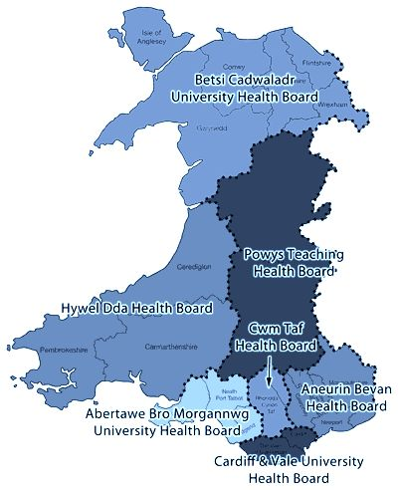
- Aneurin Bevan Health Board, which covers; Blaenau Gwent, Caerphilly, Monmouthshire, Newport Torfaen and South Powys (NHS Wales University Health Board, 2019).
- Abertawe Bro Morgannwg University Health Board, which covers; Swansea, Neath Port Talbot and Bridgend (NHS Wales University Health Board, 2019).
- Cardiff and Vale University Health Board, which covers; the Vale of Glamorgan and Cardiff (NHS Wales University Health Board, 2019).
- Hywel Dda Health Board, which covers; Carmarthenshire, Ceredigion and Pembrokeshire (NHS Wales University Health Board, 2019).
- Cwm Taf Health Board, which covers; Bridgend, Merthyr Tydfil and Rhondda Cynon Ta (NHS Wales University Health Board, 2019).
- Besti Cadwaladr University Health Board, which covers; Anglesey, Gwynedd, Conwy, Denbighshire, Flintshire and Wrexham (NHS Wales University Health Board, 2019).
- Powys Teaching Health Board, which covers a quarter of Wales (NHS Wales University Health Board, 2019).
All of these health boards, depending on their location, the population and the age requirements, will have an effect on the treatments and services that are required for each health board (Health in Wales, 2019). There are currently three trusts within NHS in Wales, those trust are; Welsh Ambulance Service NHS trust, Velindre NHS trust and the Public Health Wales trust (NHS Wales, 2019). Each of these trust have a different aim and play vital roles within the NHS.
The Welsh Ambulance service trust (2019) states that over the past couple of years have become the most clinically advanced ambulance service in the world, there are approximately 3,400 members of staff that work for the trust. The trust provides many forms of support such as NHS Direct Wales, the 111 service and their Clinical Desk.
The Velindre NHS trust provides a specialist cancer and blood service to those who live throughout south and mid Wales, they do so by delivery quality care and excellence to their patients and their donors this is at the heart of their organisation (Velindre University NHS Trust, 2019).
Public Health Wales is the national public health agency in Wales and exists to protect and improve health and wellbeing and reduce health inequalities for people in Wales. They are part of the NHS and report to the Cabinet Secretary for Health, Well-being and Sport in the Welsh Government.
The NHS Wales University Health Board (2019) explains, that the health board with the largest population is Betsi Cadwaladr with around 700 000 people based in this area. The health board with the smallest population is Powys with a population of less than 150 000. When looking at the former allocated budget for 2018 Betsi Cadwaladr received 1.3 billion pounds whilst Powys received 300 million (NHS Wales University Health Board 2019). The difference in population shows a difference in the budget however more factors help decide the budget, factors such as age and medical and care services.

Evaluation of current Structure
When first looking at the structure of the NHS within Wales, it is clear to see that is in a hierarchy format which according to Hierarchy Structure (2019) is a technique used to bring values and categories together. This then sorts them into higher and lower sections/categories which is use within a variety of systems. When organising a company, it is vital that everything is in order so that it is able to run smoothly, this is help by having mangers who sit at the top of the hierarchy with responsibility of passing down information. For this hierarchical structure there is a picture, taken of the structure from a report by the National Assembly for Wales (2015) giving an easy incite on how the NHS is organised.
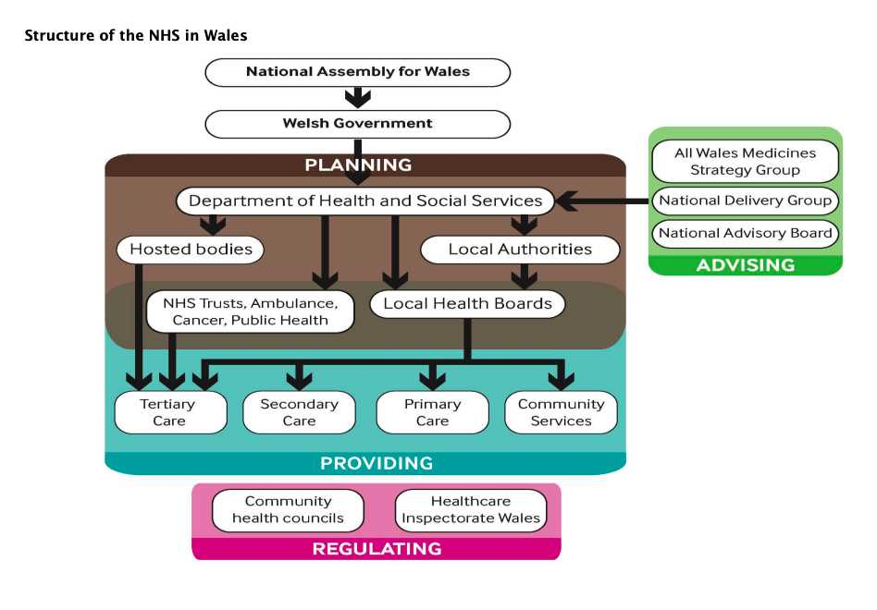
This shows that the NHS in Wales have a structure in which National Assembly and the Welsh government have the highest authority over the health boards, the trusts and the care units in Wales. This is to be seen as a positive factor as the National Assembly, have access to the most up to date statistics and knowledge of information about Wales, which then enable the Welsh Government to make financial decisions in relation to the National Health Service in Wales.
The National Assembly’s role for Wales is to represent everyone within the population and make sure that the Welsh Government are accountable this is explained by the National Assembly for Wales (2019). The Welsh Government is therefore below the National Assembly for Wales (National Assembly for Wales 2015). The Welsh Government (2017) states that they are responsible for the Welsh Education System, the funding for the NHS, Health in Wales, health policies, the economy and environment and many more important matters.
Moving down the structure into the category planning it is over seen by the Department of Health and Social Services (National Assembly for Wales 2015). Department of Health and Social Services discuss with the Welsh Government on policies and strategies in the form of legislations and by the use of funding for the NHS in regard the health and social care in Wales. In this branch the Medicine Strategy Group, National Advisory Board and the National Delivery Group are there to provide their services. The Department of Health and Social Services the filters into four different sections when moving down the structure. These are the Hosted Bodies, Local authorities as well as the seven Local Health Boards and the three Trusts (National Assembly for Wales 2015). The hosted bodies being senior executives, board members and other authorities. The Health Board is also linked to the seven health board and three health trust, the Local Health Boards as mentioned previously are:
- Aneurin Bevan Health Board
- Abertawe Bro Morgannwg University Health Board
- Cardiff and Vale University Health Board
- Hywel Dda Health Board
- Cwm Taf Health Board
- Besti Cadwaladr University Health Board
- Powys Teaching Health Board
The three trusts within NHS in Wales, those trust are; Welsh Ambulance Service NHS trust, Velindre NHS trust and the Public Health Wales trust (NHS Wales, 2019). Each of these trust have a different aim and play vital roles within the NHS.
Below the seven Health Boards and the three Trusts you have the four care units. These are in the providing section and arrange the care needed. These four are:
- Primary Care, which is provided by GPs, Surgeries in Wales and Health Centres.
- Secondary Care, this care is delivered through Hospital and Ambulance services.
- Tertiary Care is the unit that treats illnesses such as cancer and is provided at Hospitals.
- Community Care provides local services and delivers to patients who stay at home.
All of this builds the National Health Service in Wales according to the National Assembly for Wales (2015). The NHS in Wales’s structure is mainly about the seven local health boards along with the three trusts. These are what keep the NHS functioning by looking after the welsh population.
The structure of the NHS in Wales is very well organised and clear in what it aims to do, as well as allocate each section/category their own tasks and responsibilities. This seems to be overall beneficial structure as a whole, as it enables communication through all sections/categories to prevent mistakes. Even though the structure aims to make communication easy between departments it can appear difficult when certain responsibilities need to be discussed. Depending on the number of managers in each department, miscommunication and disagreements between managers over important matters could end up in patients suffering.
Conclusion
This report has looked into how the National Health Service in Wales organises their finances via the Welsh Government, its goals and aims along with its structure being the hierarchical structure and how it has a positive and negative side that effects the NHS. It has looked at the seven health boards and their roles in the structure of NHS as well as the regions that they cover throughout Wales, as well as mentioning the NHS trusts.
It has also briefly mentioned the concerns within the hierarchical structure in terms of communication as there may be a number of mangers that are advising different types of concepts which will in turn make it difficult to come to decision. This could then lead to form of ill treatment of patients due to miscommunication of prescription dosages. Therefore this report has found that there many changes that could be made to the structure of NHS in Wales.
Recommendations
To end this report, here are some potential Ideas that could help the NHS in wales, these recommendation are aimed to help both hospitals and funding within the NHS:
- To terminate prescriptions for drugs which can be bought over the counter as it costs the NHS more money to give them as prescription, than it would to by then at your local pharmacy.
- Publically advertise the importance of non-urgent hospital visits which, could save lives. Encourage the public to visit their local pharmacies as they are able to advice how-to treat symptoms.
- Discharge patients that are no longer in need of a hospital bed faster, due to the lack of hospital beds that are available this would also link into the recommendation made above.

Reference List:
Bianca, A. (2019) Pros & Cons of a Hierarchical Organizational Structure. Available at: https://smallbusiness.chron.com/pros-cons-hierarchical-organizational-structure-24276.html [Accessed 30 04 2019]
GP One (2019) Structure. Available at: http://www.gpone.wales.nhs.uk/nhs-wales-structure [Accessed 10 04 2019]
Health in Wales (2019) NHS Wales – About us. Available at: http://www.wales.nhs.uk/nhswalesaboutus [Accessed 16 04 2019]
Health in Wales (2019) Structure. Available at: http://www.wales.nhs.uk/nhswalesaboutus/structure [Accessed 16 04 2019]
Hierarchy Structure (2019) What is an Example of a Hierarchy? Available at: https://www.hierarchystructure.com/what-is-an-example-of-a-hierarchy/ [Accessed 16 04 2019]
National Assembly for Wales (2015) Research Paper, the organisation of the NHS in the UK: comparing structures in the four countries. Available at: http://www.assembly.wales/research%20documents/15-020%20-%20the%20organisation%20of%20the%20nhs%20in%20the%20uk%20comparing%20structures%20in%20the%20four%20countries/15-020.pdf [Accessed 12 04 2019]
National Assembly for Wales (2019) What is the role of the Assembly? Available at: https://www.assembly.wales/en/abthome/role-of-assembly-how-it-works/what-is-the-role-of-the-assembly/Pages/what-is-the-role-of-the-assembly.aspx [Accessed 20 04 2019]
NHS Wales University Health Board. (2019) Abertawe Bro Morgannwg University Health Board. Available at: http://www.wales.nhs.uk/sitesplus/863/page/66187 [Accessed 16 04 2019]
NHS Wales University Health Board. (2019) Aneurin Bevan University Health Board. Available at: http://www.wales.nhs.uk/sitesplus/866/page/40762 [Accessed 16 04 2019]
NHS Wales University Health Board. (2019) Betsi Cadwaladr University Health Board. Available at: http://www.wales.nhs.uk/sitesplus/861/page/84723 [Accessed 16 04 2019]
NHS Wales University Health Board. (2019) Cardiff and Vale University Health Board. Available at: http://www.cardiffandvaleuhb.wales.nhs.uk/freedom-of-information-guide-class-one [Accessed 16 04 2019]
NHS Wales University Health Board. (2019) Cwm Taf Morgannwg Health Board. Available at: https://cwmtaf.wales/we-are-cwm-tafmorgannwg/ [Accessed 16 04 2019]
NHS Wales University Health Board. (2019) Hywel Dda University Health Board. Available at: http://www.wales.nhs.uk/sitesplus/862/page/40317 [Accessed 16 04 2019]
NHS Wales University Health Board. (2019) Powys Teaching Health Board. Available at: http://www.powysthb.wales.nhs.uk/about-us [Accessed 16 04 2019]
Org Chart (2019) Advantages and Disadvantages of Hierarchical Organisational Structure. Available at: http://www.orgcharting.com/advantages-disadvantages-hierarchical-organisat
Welsh Government (2017) What our role is. Available at: https://gov.wales/what-our-role [Accessed 12 04 2019]

