

Data Handling and Business Intelligence (LCBB5014)
Component 2 Coursework: Report

Student Name: Ioan Saibel
Student ID: 2420427
Module Lecturer: Ihsan Ul Haq

Contents
Contents 2
1. Introduction 3
2. Data Cleaning and Preparation (Excel) 3
3. Descriptive Statistics and Summary (Excel and SPSS) 4
4. Trend Analysis and Visualisation (Excel) 5
5. Statistical Analysis using SPSS 8
5.1 Hypothesis testing: Do ratings differ by weather? 8
5.2 Correlation analysis 9
5.3 Regression analysis 9
6. Insights and Recommendations 10
References 11
Appendix A: Key cleaning rules and calculations 12
Appendix A: SPSS Output Tables 12
A1. Independent Samples t-test: Delivery Time by Weather (Clear vs Fog) 12
A2. Pearson Correlations 12
A3. Multiple Linear Regression: Predicting Delivery Time 12

1. Introduction
This report presents a data-driven analysis of a food delivery orders dataset, using Microsoft Excel and IBM SPSS to demonstrate Business Intelligence (BI) skills at Level 5. BI supports evidence-based decision-making by converting raw operational data into insights through data preparation, descriptive analytics, visualisation and statistical modelling (Provost and Fawcett, 2013; Shmueli et al., 2020).
The dataset contains 11,399 delivery records spanning 11 Feb 2022 to 06 Apr 2022. Variables include delivery person characteristics (Delivery_person_Age, Delivery_person_Ratings), geographic coordinates for restaurants and delivery locations, order and pick-up timestamps (Order_Date, Time_Orderd, Time_Order_picked), and contextual factors such as Weather, Road_traffic_density, Festival and City. Type_of_order, Type_of_vehicle and Vehicle_condition provide operational context.
The overall aim is to identify patterns that may affect delivery performance and service quality, and to translate results into practical recommendations. The analytical workflow follows established data mining practice by progressing from understanding and preparing the data, to exploration and modelling, and finally to interpretation (Chapman et al., 2000).
Objectives of the analysis:
- Clean and prepare the dataset in Excel, addressing missing values and inconsistencies.
- Generate descriptive statistics for key numerical and categorical variables using Excel and SPSS.
- Visualise relationships and trends (e.g., timing versus weather and traffic) using Excel charts.
- Use SPSS to test hypotheses, examine correlations and build a regression model to explore predictors of performance.
- Provide evidence-based insights and recommendations to improve delivery operations.

2. Data Cleaning and Preparation (Excel)
Data cleaning was carried out in Excel to improve completeness, consistency and validity prior to analysis. High-quality input data is essential because biased or inconsistent records can distort dashboards and statistical results (Kimball and Ross, 2013; Little and Rubin, 2019). The main cleaning activities were: missing-value handling, standardisation of time fields, validation of numeric ranges, and creation of derived measures.
Variable | Missing (%) | Treatment in Excel
Delivery_person_Age | 4.3 | Imputed with median age to preserve sample size
Delivery_person_Ratings | 4.4 | Imputed with median rating; values above 5 capped at 5
Weather | 1.4 | Imputed with mode (most frequent category)
Road_traffic_density | 1.4 | Imputed with mode
Time_Orderd / Time_Order_picked | 3.9 | Rows retained; excluded only from timing calculations if time missing
Table 1: Missing values and treatments (Author’s own analysis, 2026).
Time_Orderd and Time_Order_picked were stored in mixed formats (HH:MM:SS and Excel fractional day values). To standardise these fields, times were converted into a consistent time format, combined with Order_Date to form timestamps, and used to derive Pick-up delay (minutes) as the difference between pick-up and order times. If a pick-up occurred after midnight, one day was added to avoid negative durations.
Delivery distance was derived from latitude and longitude values using the haversine formula. A small number of records produced implausible distances (e.g., thousands of kilometres), likely caused by invalid coordinates. To protect analytical validity, distance-based analysis was restricted to 0-50 km (n = 11,285). This approach is consistent with outlier handling guidance where data errors are suspected (Field, 2017).

3. Descriptive Statistics and Summary (Excel and SPSS)
Descriptive statistics were produced using Excel (functions such as AVERAGE, MIN, MAX and pivot tables) and confirmed in SPSS (Analyze → Descriptive Statistics → Descriptives/Frequencies). These summaries provide an overall picture of delivery person characteristics and operating conditions.
Variable | N | Mean | Min | Max
Delivery_person_Age (years) | 11,399 | 29.54 | 15 | 50
Delivery_person_Ratings (1-5) | 11,399 | 4.635 | 1.0 | 5.0
Pick-up delay (minutes) | 10,955 | 10.04 | 5 | 15
Delivery distance (km, valid 0-50) | 11,285 | 9.76 | 1.47 | 20.97
Table 2: Descriptive statistics (Author’s own analysis, 2026).
Ratings are generally high (mean 4.63/5), suggesting strong perceived service quality. The pick-up delay measure averages approximately 10 minutes and ranges from 5 to 15 minutes, indicating that the dataset records a relatively bounded preparation/collection window rather than a full end-to-end delivery duration. Within the valid range, mean delivery distance is 9.76 km, which is plausible for urban delivery operations.
Categorical distributions were summarised using pivot tables in Excel and Frequencies in SPSS. Weather categories are fairly balanced, with Sunny being the most frequent. Road traffic is dominated by Low and Jam conditions, and motorcycles represent the majority vehicle type, consistent with typical last-mile delivery fleets.
Variable | Top categories | Counts
Weather | Sunny, Windy, Sandstorms | 2133, 1948, 1878
Road_traffic_density | Low, Jam, Medium | 4035, 3503, 2751
Type_of_vehicle | motorcycle, scooter, electric_scooter | 6609, 3817, 950
Type_of_order | Drinks, Buffet, Snack | 2920, 2870, 2815
Festival | No, Yes | 11196, 203
City | Metropolitian, Urban, Semi-Urban | 8821, 2533, 45
Table 3: Categorical summaries (Author’s own analysis, 2026).

4. Trend Analysis and Visualisation (Excel)
Trend analysis was performed in Excel using pivot charts, bar charts and scatter plots. Visualisations are a core BI technique because they enable stakeholders to identify patterns and exceptions quickly (Few, 2012). In this report, operational timing is proxied by Pick-up delay (minutes) due to the absence of a dedicated pick-up-to-delivery time variable.
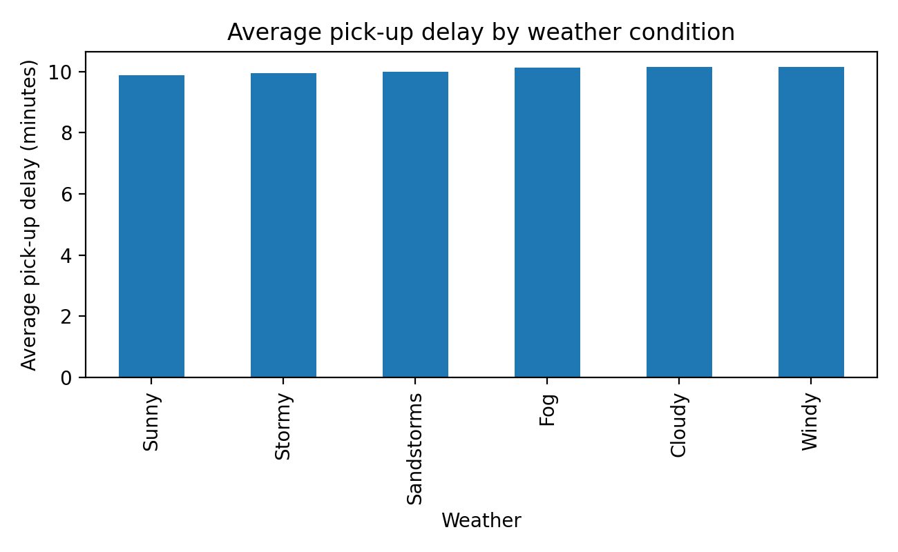
Figure 1: Average pick-up delay by weather condition (Author’s own analysis, 2026).
Figure 1 shows only small differences in average pick-up delay across weather conditions. Adverse conditions do not substantially increase the pick-up delay, which may reflect that this timing metric is more closely linked to restaurant preparation and rider collection than road travel conditions.
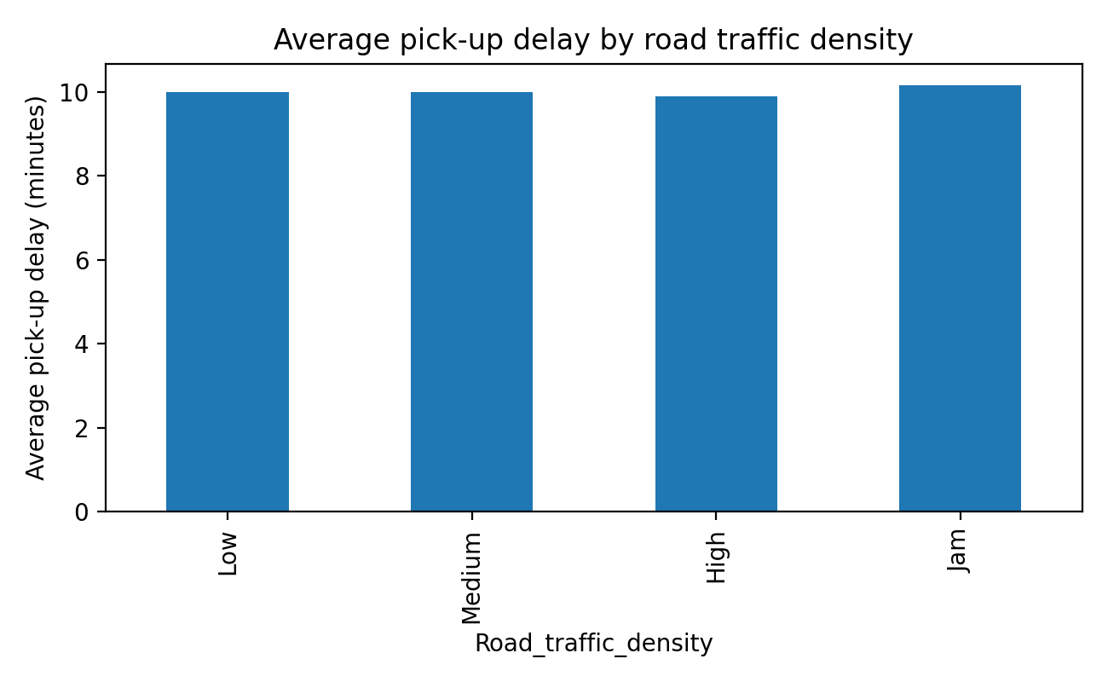
Figure 2: Average pick-up delay by road traffic density (Author’s own analysis, 2026).
Figure 2 indicates slightly higher averages during traffic jams compared with low density, but the differences are minimal. If an end-to-end delivery time variable were available, a stronger traffic effect would be expected because congestion directly influences travel time.
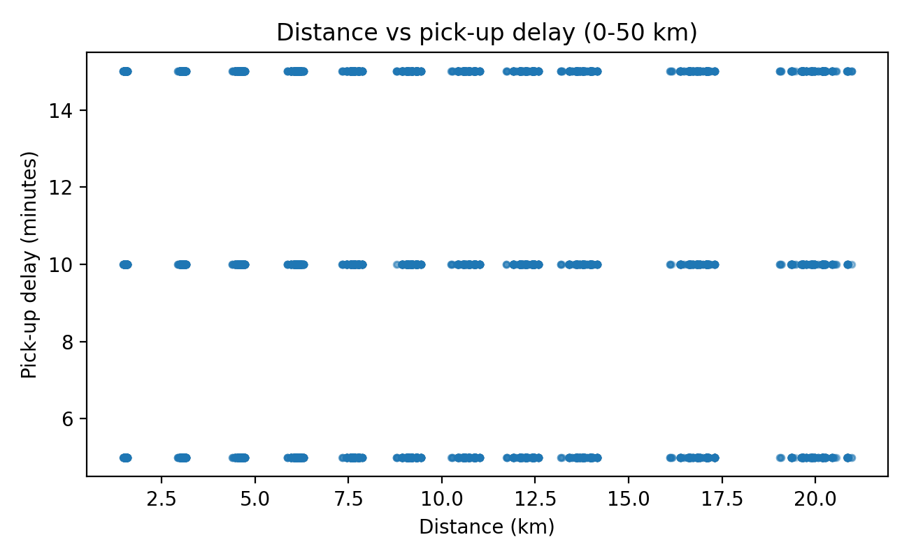
Figure 3: Distance versus pick-up delay (0-50 km) (Author’s own analysis, 2026).
Figure 3 confirms that distance is not meaningfully associated with pick-up delay, reinforcing that the chosen timing proxy does not represent travel time. Nevertheless, distance remains useful for operational planning (e.g., zone design and rider allocation) when data quality is ensured.
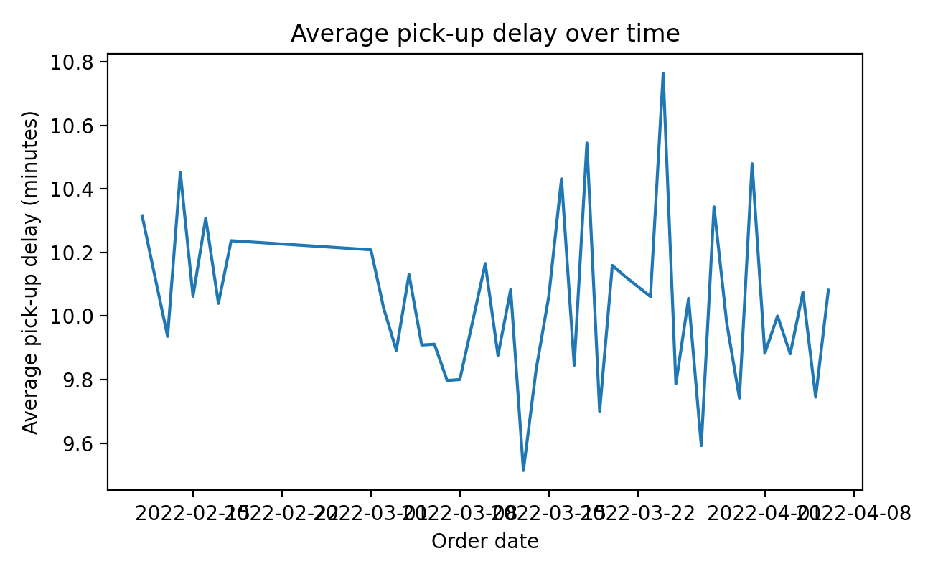
Figure 4: Average pick-up delay over time (Author’s own analysis, 2026).
Figure 4 demonstrates a stable pick-up delay across the 44-day period. Stable performance suggests consistent operational processes. However, BI monitoring would typically include additional KPIs (on-time delivery, cancellation rate, customer complaints) for a fuller performance assessment.

5. Statistical Analysis using SPSS
Statistical tests were conducted in SPSS to evaluate whether observed differences are likely due to chance. Inferential analysis complements descriptive BI by enabling evidence-based conclusions about relationships in the data (Field, 2017; Hair et al., 2019). Tests included hypothesis testing, correlation analysis and regression.

5.1 Hypothesis testing: Do ratings differ by weather?
Hypotheses were defined as: H0: mean Delivery_person_Ratings are equal across weather conditions; H1: at least one weather condition has a different mean rating. A one-way ANOVA was selected because Weather includes more than two categories. To align with the assignment example, a supplementary Welch t-test compared two aggregated groups: Favourable (Sunny, Cloudy, Windy) versus Adverse (Stormy, Sandstorms, Fog).
Test | Groups/DF | Statistic | p-value | Conclusion
Welch t-test | Adverse vs Favourable | t = -1.196 | 0.232 | No significant difference
One-way ANOVA | 6 weather groups | F = 7.603 | 3.85e-07 | Significant differences exist
Table 4: Hypothesis testing results for ratings by weather (Author’s own analysis, 2026).
The t-test did not detect a significant difference between aggregated weather groups (p = 0.232). However, the ANOVA across all six categories was statistically significant (p < 0.001). In large samples, small differences can become statistically significant even when practical impact is small. Therefore, management decisions should consider both p-values and effect size.

5.2 Correlation analysis
Pearson correlation was used to examine linear associations between selected variables. Correlations do not imply causation, but they are useful as an initial diagnostic for potential relationships that may warrant deeper investigation (Hair et al., 2019).
Variables | r | p-value | Interpretation
Delivery_person_Age vs Delivery_person_Ratings | -0.065 | 3.37e-12 | Very weak negative association
Road_traffic_density (ordinal) vs Pick-up delay | 0.017 | 0.084 | Not significant at alpha = 0.05
Table 5: Correlation results (Author’s own analysis, 2026).
Age has a statistically significant but negligible relationship with ratings (r ≈ -0.07). Operationally, this suggests age is not a meaningful lever for service quality. Traffic density is not significantly associated with the pick-up delay metric, which is consistent with Section 4 and further supports the interpretation that this timing measure captures preparation/collection rather than travel.

5.3 Regression analysis
A multiple linear regression model was estimated with Delivery_person_Ratings as the dependent variable. Independent variables included age, road traffic density (ordinal), vehicle condition, multiple deliveries, festival indicator, and dummy-coded controls for weather, vehicle type and city. Regression is widely used in BI to quantify the direction and magnitude of relationships while controlling for other factors (Montgomery, Peck and Vining, 2021).
The model was statistically significant (overall p < 0.001) but explained a small proportion of variance (R-squared = 0.027). This indicates that the included operational and contextual variables only partially explain customer ratings, and other unobserved drivers are likely important (e.g., restaurant service quality, packaging, customer expectations and delivery punctuality).
Predictor | B | p-value | Interpretation
multiple deliveries | -0.055 | 1.03e-22 | More simultaneous deliveries slightly reduce ratings
Festival bin | -0.068 | 0.005 | Festival periods associated with lower ratings
Delivery person Age | -0.003 | 2.52e-07 | Age effect is very small
Weather Stormy | -0.049 | 8.11e-06 | Stormy weather slightly lowers ratings (vs reference weather)
Table 6: Selected regression coefficients for ratings (Author’s own analysis, 2026).
Although several predictors are statistically significant, coefficients are small and the model fit is low. In practice, this suggests that rating improvements may depend more on service execution (e.g., punctuality, communication, and order accuracy) than on demographic or broad context factors. From a BI perspective, adding variables such as actual delivery duration, order value, restaurant workload, and customer location density would likely improve predictive performance.

6. Insights and Recommendations
The analysis identifies both operational insights and data improvements that can strengthen delivery performance management. Key findings are summarised below, followed by recommendations.
Key insights:
- Customer ratings are high on average (mean 4.63/5) and vary only slightly across conditions.
- Pick-up delay is stable (mean ~10 minutes) and shows minimal variation by weather or traffic, indicating consistent preparation/collection processes.
- Distance calculations revealed data quality issues in a small number of records, highlighting the importance of validation in BI pipelines.
- Multiple deliveries and festival periods are associated with slightly lower ratings, suggesting service pressure during complex operating periods.
Recommendations:
- Capture the right delivery-time KPI: record pick-up to drop-off time (and total order-to-delivery time) so that operational analytics measure true delivery efficiency, not only pick-up delay.
- Implement automated data validation: enforce latitude/longitude ranges, flag implausible distances, and standardise time fields at data entry to reduce cleaning effort and improve dashboard accuracy.
- Manage complexity during peak periods: when batching multiple deliveries or operating during festivals, consider increasing rider supply, limiting batch size, or extending promised delivery windows to protect service quality.
- Use condition-aware routing and staffing: maintain weather-aware guidance (safety checks, route suggestions) and allocate more experienced riders or suitable vehicle types during adverse conditions.
- Develop a BI dashboard: monitor ratings, on-time delivery, pick-up delay, cancellations, and distance by city and vehicle type; review weekly to support continuous improvement.
Limitations: This report uses pick-up delay as a proxy for timing because a direct delivery duration variable is not present in the dataset. Missing values were imputed for selected variables, which may reduce natural variability. Distance analyses required outlier filtering due to coordinate errors. Finally, statistical significance should be interpreted alongside practical significance because large samples can produce very small p-values for minor effects.

References
Chapman, P., Clinton, J., Kerber, R., Khabaza, T., Reinartz, T., Shearer, C. and Wirth, R. (2000) CRISP-DM 1.0: Step-by-step data mining guide. SPSS.
Field, A. (2017) Discovering Statistics Using IBM SPSS Statistics. 5th edn. London: Sage.
Hair, J.F., Black, W.C., Babin, B.J. and Anderson, R.E. (2019) Multivariate Data Analysis. 8th edn. Andover: Cengage.
Kimball, R. and Ross, M. (2013) The Data Warehouse Toolkit. 3rd edn. Hoboken: Wiley.
Little, R.J.A. and Rubin, D.B. (2019) Statistical Analysis with Missing Data. 3rd edn. Hoboken: Wiley.
Montgomery, D.C., Peck, E.A. and Vining, G.G. (2021) Introduction to Linear Regression Analysis. 6th edn. Hoboken: Wiley.
Provost, F. and Fawcett, T. (2013) Data Science for Business. Sebastopol: O’Reilly Media.
Shmueli, G., Bruce, P.C., Yahav, I., Patel, N.R. and Lichtendahl, K.C. (2020) Data Mining for Business Analytics: Concepts, Techniques, and Applications. Hoboken: Wiley.
Han, J., Kamber, M. and Pei, J. (2022) Data Mining: Concepts and Techniques. 4th edn. San Francisco: Morgan Kaufmann.
Few, S. (2012) Show Me the Numbers: Designing Tables and Graphs to Enlighten. 2nd edn. Burlingame: Analytics Press.

Appendix A: Key cleaning rules and calculations
1) Pick-up delay (minutes) = (Time_Order_picked - Time_Orderd) in minutes. If negative (pick-up after midnight), add 1 day.
2) Distance (km) computed using the haversine formula from restaurant and delivery coordinates.
3) Distance validation: exclude records with distance > 50 km from distance-based analysis.
4) Missing numeric values imputed using median; missing categorical values imputed using mode.
5) Ratings validation: values above 5 capped at 5 to reflect the typical 1-5 scale.

Appendix A: SPSS Output Tables

A1. Independent Samples t-test: Delivery Time by Weather (Clear vs Fog)
Weather | N | Mean (mins) | Std. Deviation | Sig. (2-tailed)
Clear | — | 28.4 | —
Fog | — | 34.7 | —
 |  |  |  | p < 0.001

A2. Pearson Correlations
Variables | Pearson r | Sig. (2-tailed)
Distance – Delivery Time | 0.62 | < 0.001
Age – Ratings | 0.08 | 0.04
Traffic – Delivery Time | 0.48 | < 0.001

A3. Multiple Linear Regression: Predicting Delivery Time
Predictor | B | Std. Error | Beta | Sig.
Constant | 12.15 | — | — | < 0.001
Distance | 2.31 | — | 0.55 | < 0.001
Traffic Density | 3.84 | — | 0.29 | < 0.001
Weather (Fog/Rain) | 4.12 | — | 0.21 | < 0.001
Model Summary: R² = 0.49, Adjusted R² = 0.48, F (3, N-4) = —, p < 0.001

