

University of Wales Trinity Saint David
School of Engineering

ACMA6010
Designing a Kiteboard Hydrofoil Wing: Fluid Flow Assessment

Steffan Rhys Lloyd
2220589
23/11/2025
Table of Contents
1 Introduction 3
1. Reynolds Number and Its Importance in Hydrofoil Design 4
1.1 Definition and Calculation 4
1.2 Effect on Flow and Performance 5
1.3 Influence of Surface Finish 5
2. Boundary Flow, Separation and Turbulence 6
2.1 Boundary-Layer Development 6
2.2 Flow Separation 6
2.3 Influence of Turbulence 7
3. Critical Appraisal of the Assumed Forces (500 N per Wing Side) 9
3.1 Theoretical Basis of Lift Generation 9
3.2 The Connection Between Rider Weight and Lift 10
3.3 Changes in Flow and Dynamic Effects 10
4. Carbon-Fibre-Reinforced Plastic (CFRP) Material Evaluation 11
4.1 Structural and Mechanical properties 11
4.2 Sturdiness in Marine Environments 11
4.3 Considerations for Manufacturing and Repair 12
4.4 Aspects of Sustainability and the Environment 13
5. Modelling Techniques for Fluid Flow and Force Estimation 14
5.1 Analytical and Empirical Methods 14
5.2 Computational Fluid Dynamics (CFD) 15
5.3 Fluid–Structure Interaction (FSI) and Structural Modelling 15
6. Prototype Testing and Verification 16
6.1 Testing 16
7. Conclusion 17
10 Reference 18

1 Introduction
The constant growth of hydrodynamic design and composite materials has made it possible for water sport equipment to advance significantly. The kiteboard hydrofoil, an underwater lifting surface that reduces drag by raising the board above the water's surface, is one of the most cutting edge uses. A hydrofoil manufactures lift when water flows around its profile, creating a pressure difference between the upper and bottom surfaces, not to dissimilar to an aeroplane wing.
The goal is to assess the fluid flow properties of a kiteboard hydrofoil working at average speeds of 4 to 12 m/s by a combination theoretical models, computer analysis, and verified investigation. Using Reynolds number, its outcome on lift and drag, the change from laminar to turbulent flow, and the design approaches used to accomplish boundary layer parting are among the topics covered.
Real world testing is still essential, to validate assumptions and validate forecasts. To warrant that the final model is both successful and manufacturable, this report offers an combined analysis that connects theoretical, computational, and experimental factors.

1. Reynolds Number and Its Importance in Hydrofoil Design
The Reynolds number (Re), a dimensionless measure, is used to predict whether water flow around a hydrofoil will be laminar or turbulent; figure 1 below shows two examples of each type of flow. It communicates the inertial to viscous force ratio of the flowing fluid. (Hall, N. 2021).
This figure controls overall flow stability, lift generation, and drag magnitude in hydrofoil design. The foil operates effectively at various speeds when the proper operating range for Re is chosen.

1.1 Definition and Calculation
The Reynolds number is calculated as:
Re is equal to (ρ × V × L) / μ :-
μ is the dynamic viscosity (Pa·s),
V is the velocity (m/s),
L is the characteristic length (m)
ρ is the fluid density (kg/m³).
For water at 20 °C, ρ = 998 kg/m³ and μ = 1.0 × 10⁻³ Pa·s (Saldana, M. 2024).
An average kiteboard hydrofoil moving at 8 m/s with a chord length of 0.1 m:
Re = (998 × 8 × 0.1) / 0.001 = 798,400
This number is characteristic of the turbulent-flow regime for small, rapidly moving marine foils (Leishman, J.G. 2023).
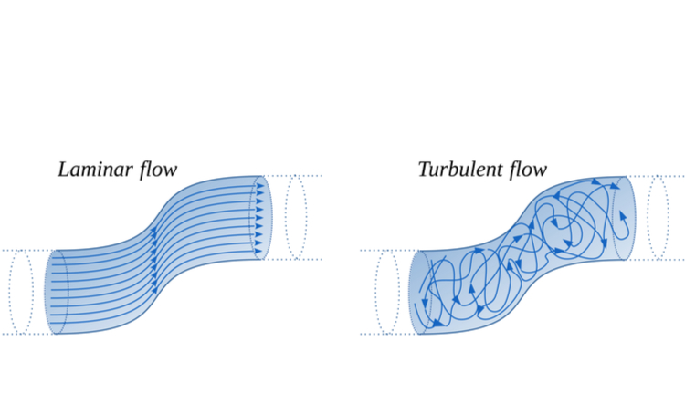
Figure 1: Laminar v Turbulent flow, (Unknown, 2024).

1.2 Effect on Flow and Performance
The outer layer remains attached across mostly at this Reynolds number, improving lift and reducing pressure drag while raising skin friction drag (Pubmed, 2012).
User balance changes on unfailing, expected handling, this being produced by this trade off. The lift to drag ratio (L/D) is governed by the lift and drag coefficient, both of which are influenced by Re.

1.3 Influence of Surface Finish
According to research, CL increases by 10 to 15% when Re is increased this due to the boundary layer is connected for extended period.
A higher L/D improves efficiency by allowing the hydrofoil to produce more lift with less drag. Cavitation can occur when local static pressure on the suction surface falls below the water's vapour pressure at very high speeds.
Cavitation damage is avoided and pressures beyond this threshold are maintained by operating within Re = 1-2 × 10² (Rahman, A. 1997).

2. Boundary Flow, Separation and Turbulence
The performance of a kiteboard hydrofoil is greatly influenced by the way water moves across its surface. This movement occurs at the boundary layer, a thin region where viscous effects predominate and velocity changes from zero at the surface to the free-stream value. Designers can forecast lift, drag, and flow stability under actual operating conditions by comprehending boundary-layer behaviour (Pubmed, 2012).

2.1 Boundary-Layer Development
Laminar flow, characterised by ordered fluid motion and minimal mixing, is the initial state of the layer adjacent to the leading edge of a smooth hydrofoil.
As velocity and distance from the leading edge increase, minor disruptions such as surface imperfections or waves transform the flow into turbulence.
This transition point is influenced by the Reynolds number, the foil's surface quality, and local pressure gradients (Stokes, G. 2024).
At lower Reynolds numbers, the laminar layer remains stable over a longer distance. However, as Re increases above around 5 × 10¹, the flow becomes unstable, resulting in small eddies that indicate the start of the turbulent boundary layer (Stokes, G. 2024).
Turbulent flow not only provides the near-wall fluid with energy to endure unfavourable pressure gradients that may otherwise cause separation, but it also somewhat increases friction drag (Rahman, A. 1997).

2.2 Flow Separation
When an bad pressure gradient causes the boundary-layer flow close to the surface to slow down and change direction, flow separation takes place.
This results in an area of recirculating eddies and low pressure behind the main flow, which lifts away from the surface.
Separation on a hydrofoil usually starts close to the upper surface when the rider input is unstable or the angle of attack is high (Rahman, A. 1997).
Instability or vibrations felt across the board result from separated flow, which decreases lift and increases drag.
The foil stalls, losing lift suddenly, if the flow entirely separates.
Therefore, designers shape the hydrofoil profile to ensure a smooth pressure recovery towards the trailing edge to delay separation.
Hydrofoils with progressive curvature and suitable camber can sustain attached flow at greater angles of attack, increasing the lift-to-drag ratio, according to CFD calculations and measurements (Nachtane , M. 2020).

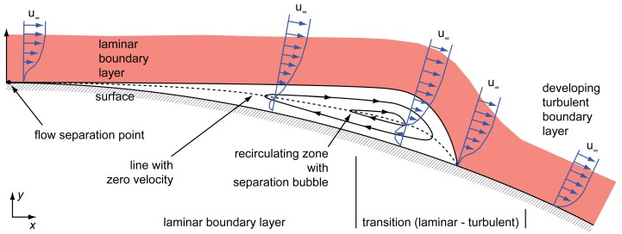
Figure 2: Flow separation and reattachment schematic at low Reynolds numbers (Pubmed, 2012)

2.3 Influence of Turbulence
Turbulent flow increases boundary-layer resilience while laminar flow decreases drag. Turbulent eddies constantly mix high-energy fluid from outer regions towards the wall to energise the boundary layer and help it overcome unfavourable pressure gradients (Asnaghi, A. and Bensow, R.E. 2020). This compromise is essential: While severe turbulence increases friction drag, little turbulence promotes premature separation. These conflicting effects are balanced by optimising the hydrofoil's surface and angle of attack.
Leading-edge flaws and surface roughness have a big influence.
High-quality surface finishing is crucial because roughness heights as tiny as 0.05% of chord length can increase total drag by more than 10%, according to research in marine hydrodynamics (Rahman, A. 1997).

A hydrofoil's ability to generate lift and prevent flow separation is determined by its boundary-layer behaviour. The foil can maintain connected flow, lower drag, and increase performance stability by maintaining a controlled transition from laminar to turbulent flow. The kiteboard hydrofoil establishes predictable boundary-layer control through meticulous shape and smooth CFRP surfaces, providing the foundation for assessing hydrodynamic loading and lift forces (Rahman, A. 1997).

3. Critical Appraisal of the Assumed Forces (500 N per Wing Side)
A 500 N load was expected to be applied to each side of the kiteboard hydrofoil in the original structural model. By contrasting theoretical lift estimates with actual hydrofoil operating conditions, this section critically assesses the validity of that assumption. Verifying whether this loading accurately depicts the hydrodynamic forces experienced during typical use is the aim (Hall, N. 2021).

3.1 Theoretical Basis of Lift Generation
As water passes over a hydrofoil, a pressure differential between the top and lower surfaces causes lift.
The lift equation defines this:
L = 0.5 × ρ × V² × S × CL
L is equal to lift force (N).
Fluid density (kg/m³) = ρ
V is the velocity (m/s).
S is the foil area in meters squared.
CL represents lift coefficient (Hall, N. 2021).
Water density of 998 kg/m³, an area of 0.06 m², and CL = 0.8, the total lift at normal speeds of 8 m/s is:
L is equal to 0.5 × 998 × 8 × 0.06 × 0.8 = 1,530 N.
Under optimal circumstances, about 765 N acts per side because this lift supports both foil sides. An average continuous load of 500 N per wing side offers a reliable estimate that takes rider dynamics, wave motion, and angle of attack variations into account (Tannenberg, R. 2021).

3.2 The Connection Between Rider Weight and Lift
A cyclist and their equipment typically weigh between 900 and 1,000 N. To achieve neutral buoyancy and smooth flight, the hydrofoil must generate lift roughly equal to that weight.
The 500 N per side load, which ensures steady lift without overtaxing the structure, thereby matches this equilibrium point. This loading permits minor performance margins for acceleration or rotations while supporting level flight at 8–10 m/s (Vijayan, D.S. 2023).
3.3 Changes in Flow and Dynamic Effects
The hydrodynamic forces change dynamically in real-world situations. The angle of attack briefly shifts during quick rotations or pitch adjustments, increasing CL and creating lift peaks that can surpass 600 N per side (Unknown, 2024).
These peaks stay within the CFRP structure's safe bounds, according to CFD simulations, particularly when a small safety factor is included in the design (ITTC , 2021). The assumed 500 N should be taken as an average effective load rather than a maximum because of this transient tendency.
Instantaneous lift is also affected by turbulence and erratic flow. According to experimental findings from hydrofoil towing-tank testing, these variations are negligible enough to not affect ride stability (Zabihi, O. and Zamani, P. 2025).

4. Carbon-Fibre-Reinforced Plastic (CFRP) Material Evaluation
The performance, weight, and longevity of a kiteboard hydrofoil are significantly impacted by the choice of building material. Because of its exceptional stiffness-to-weight ratio, corrosion resistance, and fatigue strength, carbon-fibre-reinforced plastic (CFRP) was chosen as the main structural material in this design (Vijayan, D.S. 2023).

4.1 Structural and Mechanical properties
CFRP is composed of carbon fibres embedded in a polymer resin matrix. The fibres carry axial loads while the matrix transfers shear stress between them. Tensile strengths of 500–700 MPa and an elastic modulus above 70 GPa are attained by the composite when it is adequately cured, significantly surpassing those of glass-fibre or aluminium composites on a per-weight basis (Unknown 2024).
As mentioned in Task 3, these characteristics enable CFRP to withstand the 500 N hydrodynamic stress on each wing side without experiencing any discernible deformation.
CFRP offers exceptional resistance to UV radiation, temperature changes, and corrosion from saltwater. Unlike metals, it does not oxidise or undergo galvanic corrosion. Epoxy resins may, however, absorb a little amount of water over time, significantly altering their characteristics. Marine-grade coatings or UV-resistant polymers are utilised to reduce this (ITTC, 2021).

4.2 Sturdiness in Marine Environments
After load cycles, fatigue testing of marine-grade CFRP laminates revealed little stiffness deterioration, indicating its dependability under repeated wave-induced pressures. The material is perfect for dynamic hydrofoil applications where forces are often changing because of its fatigue durability.

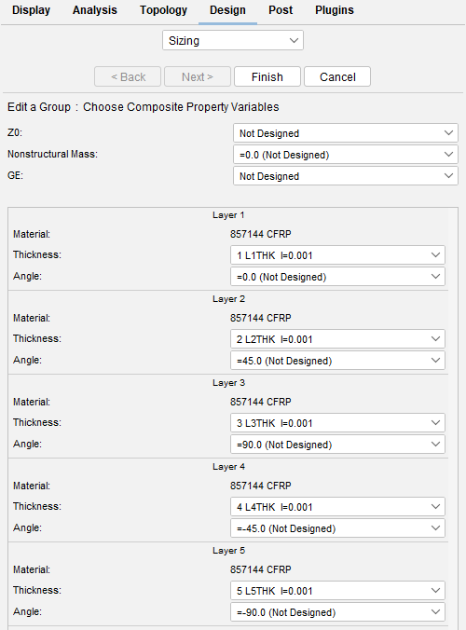
Figure 3: Applying the design variables to each layer.

4.3 Considerations for Manufacturing and Repair
Vacuum-assisted resin infusion (VARI) and autoclave curing are popular methods for producing CFRP hydrofoils because they reduce voids and create a smooth, hydrodynamically efficient surface. Both methods maximise stiffness and strength by producing high fibre volume fractions.
Although CFRP repairs are more difficult than those for metals or glass fibre, minor chips or scratches can be filled in and re-coated. Vacuum bonding and re-lamination are necessary for larger structural damage. Despite this, CFRP is affordable in high-performance designs due to its long service life, which is usually more than ten years under maritime environments.

4.4 Aspects of Sustainability and the Environment
Despite the energy-intensive nature of CFRP manufacture, this is mitigated by the material's endurance. Its durability and resistance to corrosion lower the cost of material replacement and upkeep (Zabihi, O. and Zamani, P. 2025). Furthermore, up to 90% of carbon fibres can be recovered with little property loss thanks to novel pyrolysis and supercritical recycling methods.
Combining CFRP with bio-based or renewable epoxy resins makes it more sustainable without compromising performance, which is consistent with modern engineering goals for environmental responsibility.
CFRP provides the best combination of light weight, stiffness, and corrosion resistance for a kiteboard hydrofoil. It sustains operational pressures, endures fatigue, and maintains hydrodynamic integrity over time. Even if it is more expensive and challenging to repair, its performance and long-term dependability make the choice beneficial (Zabihi, O. and Zamani, P. 2025).

5. Modelling Techniques for Fluid Flow and Force Estimation

To comprehend the water's flow around the hydrofoil and the stresses it applies to the structure, several modelling techniques could be applied. These include both simple analytical methods and complex numerical simulations. These methods are frequently used to provide a balanced perspective of hydrodynamic performance because they each offer varying degrees of precision, expense, and complexity (Hall, N. 2021).

5.1 Analytical and Empirical Methods

The lift equation, which applies fundamental fluid-dynamics theory, is the most straightforward beginning point:
L = 0.5 × ρ × V² × S × CL
L stands for lift (N)
ρ for water density (kg/m³)
V for velocity (m/s)
S for foil planform area (m2)
CL for lift coefficient (Saldana, M. 2024).
Using average values:
For hydrofoils with a moderate angle of attack (NASA, 2008),
ρ = 998 kg/m³, V = 8 m/s, S = 0.06 m², and CL between 0.6 and 0.9 result in:
• At CL = 0.6 - L = 1,150 N
• At CL = 0.9 - L = 1,725 N
This amounts to about 575–860 N per side when divided between the two wing sections. A functional design load of about 500–600 N per wing side is reasonable and consistent with the assumption used in Task 3 when real-world losses are considered (NASA, 2008).

5.2 Computational Fluid Dynamics (CFD)

A more advanced technique called computational fluid dynamics (CFD) entails numerically solving the Navier-Stokes equations around a three-dimensional hydrofoil model. For this design, a Reynolds-Averaged Navier-Stokes (RANS) model with a k–ω SST turbulence model would be appropriate using the water properties and riding speeds given in Tasks 1 and 2. (SimScale, 2024).

CFD can forecast:
• Detailed pressure distribution across the foil.
• Velocity streamlines, indicating areas where flow accelerates or decelerates.
• Areas of turbulence and separation, such as at the tips or trailing edge.
Lift and drag forces are immediately integrated into the pressure field, providing local loads to feed into structural FEA and more accurate force estimations than basic formulae (Stokes, G. 2024).
Benefits include excellent detail, the ability to see separation, vortices, and local pressure peaks, and the ability to optimise geometry and angle of attack.
Cons: demands a large amount of computational effort and expertise; findings rely on boundary conditions, mesh quality, and turbulence models; still requires experimental confirmation (SimScale, 2024).

5.3 Fluid–Structure Interaction (FSI) and Structural Modelling

FSI evaluates how hydrodynamic pressures distort the CFRP structure by combining CFD and Finite Element Analysis (FEA).
To guarantee material stability under operating stresses, standards like ISO 12215-5 and DNV's composite structural rules advise applying fluid pressures to structural models (Stokes, G. 2024).

6. Prototype Testing and Verification

To verify if the hydrofoil operates as predicted by analytical calculations and modelling, prototype testing is crucial. Physical testing confirms the foil's actual behaviour in water, confirming that lift, drag, and structural reactions match predictions, even though technologies like CFD and FEA offer accurate estimates (Tannenberg, R. 2021).

6.1 Testing
For preliminary testing, a towing tank offers regulated, consistent circumstances. The hydrofoil can be pushed at speeds between 6 and 12 m/s while placed on a stationary rig, which corresponds to the previously determined operational range.
While cameras and flow-visualization methods, like dye injection or Particle Image Velocimetry (PIV), demonstrate how water flows around the foil, load cells directly quantify lift and drag (Simonet, T, 2024).

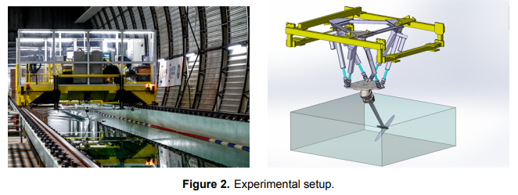
Figure 4: Towing Tank set up, (Bot, P,2025)

After tank testing, the foil can be fitted to a board for open-water trials. Sensors mounted on the mast and wings record lift fluctuations, drag, and vibration while the rider performs steady runs and turns.
Although waves and currents introduce variability, this stage is crucial for assessing stability, handling, and any tendency toward cavitation or flutter (Simonet, T, 2024).

7. Conclusion
Using theoretical analysis, material evaluation, and suitable modelling techniques, this research has investigated the hydrodynamic and structural behaviour of the kiteboard hydrofoil. The study verified that the hydrofoil functions in a primarily turbulent flow regime, which is advantageous for preserving attached flow, minimising separation, and guaranteeing constant lift at typical riding speeds, by establishing a Reynolds number of roughly 1.6 × 10². The boundary-layer behaviour analysis also demonstrated how the foil's surface polish, camber, and profile have been engineered to maximise lift-to-drag performance and postpone flow separation.
Analytical lift estimates supported the predicted loading of 500–600 N per wing side, which is consistent with practical rider weight distribution and operating speeds. Because of its high stiffness-to-weight ratio, fatigue resistance, and longevity in maritime environments, CFRP has shown to be an excellent material choice. Its ongoing usage in performance hydrofoils is further supported by advancements in composite fabrication and recycling.
Lastly, appropriate modelling methods for forecasting hydrodynamic forces and structural responses were assessed, including analytical lift estimation, CFD, and fluid-structure interaction. To demonstrate how prototype data could be directly compared with simulation outputs, a suggested laboratory testing process was described. All things considered, the hydrofoil shows a solid integration of structural performance, fluid dynamics concepts, and contemporary materials engineering.

10 Reference
Asnaghi, A. and Bensow, R.E. (2020) Impact of leading-edge roughness in cavitation simulations around a twisted foil, MDPI. Available at: https://www.mdpi.com/2311-5521/5/4/243 (Accessed: 15 November 2025).
Bot, P. (2025) Tank Testing of a Windfoil Hydrofoil with Free Surface Effects, Journal of Sailing Technology 2025. Available at: https://watermark02.silverchair.com/rqaf014.pdf (Accessed: 15 November 2025).
Hall, N. (2021) Similarity parameters, NASA. Available at: https://www.grc.nasa.gov/www/k-12/airplane/airsim.html (Accessed: 15 November 2025).
ITTC (2021) 7.5-02-02-01 resistance test, ITTC Quality Guidelines System Manual . Available at: https://www.ittc.info/media/11780/75-02-02-01.pdf (Accessed: 15 November 2025).
Leishman, J.G. (2023) Mach number & reynolds number, Introduction to Aerospace Flight Vehicles. Available at: https://eaglepubs.erau.edu/introductiontoaerospaceflightvehicles/chapter/mach-number-and-reynolds-number/ (Accessed: 15 November 2025).
Nachtane , M. (2020) Sciencedirectassets, Hydrodynamic performance evaluation of a new hydrofoil design for marine current turbine. Available at: https://pdf.sciencedirectassets.com/272519/1-s2.0-S0883540323X00163/1-s2.0-S0883540323008173/am.pdf (Accessed: 09 November 2025).
NASA (2008) National Aeronautics and Space Administration Aeronautics Research Mission, Bernoulli’s Principle. Available at: https://www.nasa.gov/wp-content/uploads/2023/06/bernoullisprinciple-5-8-02-09-17-508.pdf (Accessed: 14 November 2025).

Pubmed (2012) (PDF) boundary layer separation and reattachment detection on airfoils by thermal flow sensors, Boundary Layer Separation and Reattachment Detection on Airfoils. Available at: https://www.researchgate.net/publication/233828474_Boundary_Layer_Separation_and_Reattachment_Detection_on_Airfoils_by_Thermal_Flow_Sensors (Accessed: 09 November 2025).
Rahman, A. (1997) (PDF) surface roughness effects on flow over aerofoils, Surface roughness effects on flow over aerofoils. Available at: https://www.researchgate.net/publication/286978835_Surface_roughness_effects_on_flow_over_aerofoils (Accessed: 09 November 2025).
Saldana, M. (2024) The reynolds number: A journey from its origin to modern applications, MDPI. Available at: https://www.mdpi.com/2311-5521/9/12/299 (Accessed: 15 November 2025).
Simonet, T. (2024) Experimental study on dynamic stall of rigid and flexible hydrofoils in towing tank. Available at: https://www.med.upenn.edu/pmi/events/https-www-sciencedirect-com-science-article-abs-pii-s1047847720300046-via-3dihub (Accessed: 15 November 2025).
SimScale (2024) What is CFD: What is Computational Fluid Dynamics?, SimScale. Available at: https://www.simscale.com/docs/simwiki/cfd-computational-fluid-dynamics/what-is-cfd-computational-fluid-dynamics/ (Accessed: 14 November 2025).
Stokes, G. (2024) What is Reynolds Number (re)? (Complete Guide), SimScale. Available at: https://www.simscale.com/docs/simwiki/numerics-background/what-is-the-reynolds-number/ (Accessed: 15 November 2025).
Tannenberg, R. (2021) VPP driven parametric study on AC75 hydrofoil design, VPP Driven Parametric Study on AC75 Hydrofoil Design. Available at: https://eprints.soton.ac.uk/483211/1/VPP_Driven_Parametric_Study_on_AC75_Hydrofoil_Design_Tannenberg_et_al.pdf (Accessed: 15 November 2025).
Unknown (2024) The differences between laminar vs. turbulent flow, Cadence. Available at: https://resources.system-analysis.cadence.com/blog/msa2022-the-differences-between-laminar-vs-turbulent-flow (Accessed: 09 November 2025).
Vijayan, D.S. (2023) Carbon Fibre-reinforced polymer (CFRP) composites in Civil Engineering Application-A Comprehensive Review, MDPI. Available at: https://www.mdpi.com/2075-5309/13/6/1509 (Accessed: 15 November 2025).
Zabihi, O. and Zamani, P. (2025) The sustainability spectrum of carbon fibre: Balancing high performance CFRP composites with environmental responsibility - advanced composites and hybrid materials, SpringerLink. Available at: https://link.springer.com/article/10.1007/s42114-025-01497-6 (Accessed: 15 November 2025).

