STRATEGIC ANALYSIS OF APPLE

Module Name: Strategic Management
Module Code: LCMB7003
Student name:
Student Number:
Word count: 5013
Submission Date:
Executive Summary
The report here focused on executing a comprehensive strategic analysis of a company, selecting Apple as the case study, using different frameworks, models, and theoretical structures. In this regard, from the background, it is evident that Apple is one of the biggest tech giants operating globally. Whereas, the macro analysis discusses the way the external factors affect Apple along with discussing the forces of the industry that may impact the operations of Apple. The internal analyses explain the strength of Apple at strategic resourcing and value chain operations. The SWOT analysis discusses the strength of the company as brand value and higher customer retention. On the other hand, the CSR and green strategies used by Apple for increasing its competitive advantage are also evident to be successful. There are a few recommendations given for Apple to implement in future to improve its performance.

Table of Contents
Introduction 5
Background 5
Mission and Objectives 6
Macro-Environment Analysis 7
PESTEL Analysis 7
Micro-Environment Analysis 10
Industry Life Cycle 10
Porter’s Industry Five Forces Analysis 11
Internal Analysis 13
Strategic Resources and Capabilities 13
Value Chain Analysis 14
SWOT Analysis 17
VRIO Analysis of Distinctive Resources and Capabilities 18
Strategies to Sustain Competitive Advantage 20
Growth Strategies 21
Green Strategy and CSR 23
Conclusion 24
Recommendation 25
Reference List 26

List of Figures
Figure 1: Apple revenue from 2005 to 2023 6
Figure 2: Mission and Vision of Apple 7
Figure 3: Porter’s 5 forces 11
Figure 4: Value chain of Apple 15
Figure 5: R&D expenditure of Apple 16
Figure 6: VRIO analysis of Apple 19
Figure 7: Green Cycle at Apple 23
List of Table
Table 1: PESTLE Analysis 9
Table 2: Porter’s 5 forces 13
Table 3: SWOT analysis 18
Table 4: Ansoff Matrix 22

Introduction
This report attempts to implement a comprehensive strategic evaluation of a chosen case study using different models, theories, and strategic frameworks learnt from the module on strategic management. In this case, this report concentrated on the primary issue encountered by the selected company in a recent time and the way, these were addressed and the competitive advantage would be achieved through the strategic administrative selections of the company. It explains the background and mission of the company along with the macro and micro environment analysis. It implements discussion on internal analysis and SWOT analysis of the company. Further, the report gives VRIO analysis and strategies used by the company for a sustainable competitive edge. Moreover, the growth strategies and green strategies used by the organization are manifested here.

Background
Apple is one of the most favorite technical brands all over the globe, which is an American technology organization founded by Steve Jobs, Ronald Wayne, and Steve Wozniak in the year 1976 (Steven Levy, 2023). In the year 2020, Apple was the first organization all over the globe to reach a $2 trillion market share. The luxury tech business structure of Amazon has been a significant part towards its success as the innovation with breathtaking products like iPhone and iPad has kept Apple ahead of its competitors. The company is concentrated on giving customer experiences and exclusivity with its technical performances. The company relies on its constant service ecosystem, which is an integral part of the marketing structure of Apple, and for future sustainability. in the year 2022, Apple registered USD 394.33 billion in revenues (Federica Laricchia, 2023). The most profitable business division of Apple is the hardware segment which includes items like iPhones, iPads, Apple TVs, and so on.
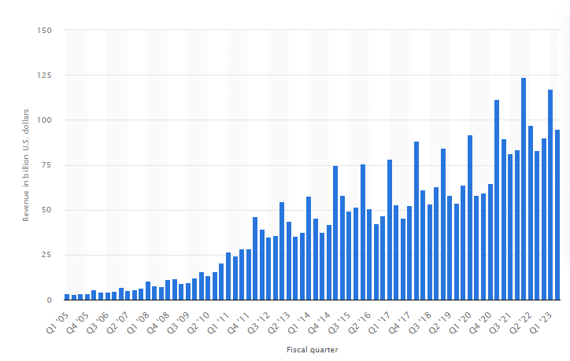

Figure 1: Apple revenue from 2005 to 2023
(Source: Federica Laricchia, 2023)

Mission and Objectives
The mission of Apple company is – “to bring the best experiences of users to its customers through innovative services, hardware, and software”. Whereas, in 2019, the vision of the company also manifested that – “We believe that we are on the face of the Earth to make remarkable products and that’s nothing changing” (Gennaro Cuofano, 2023). Contrary to this, the business goal of Apple is “to gain a competitive edge over its primary competitors”. Through innovation, Apple can give customers unique products that are associated with the changing needs of customers. in order to attain these objectives, Apple uses five KPIs – customer satisfaction, market, share, employee commitment and alignment, core competencies, and shareholder value.
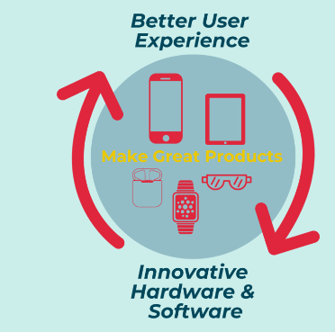

Figure 2: Mission and Vision of Apple
(Source: Gennaro Cuofano, 2023)

Macro-Environment Analysis

PESTEL Analysis
PESTLE analysis is a notion in the principles of marketing used by organizations for implementing analysis on the macro environment of the company (Da Silva, and Castañeda-Ayarza, 2021).
Factors | Analysis
Political | - Apple is extremely reliant on lower manufacturing expenditure in a few regions and hence social and political imbalance in those countries can disturb the manufacturing cost of Apple.  - Since Apple is a US-based American company, the political stability of the USA is extremely important.  - The index of political stability in the USA was 0.03 which is average (The Global Economy, 2021).  - Also, in regions, the higher publicised balances of cash have led to different consequences over the corporate tax law of Apple.  - The outsourcing manufacturing of Apple to China and the conflict between the USA and China have levied different limitations on imports for renewing the manufacture and businesses of the US.
Economic | - The increasing criticality that developed between the biggest economies of the world, makes businesses like Amazon suffer (Jonathan Josephs, 2023).  - With a GDP of approximately $23.32 trillion, the USA is the biggest economy all over the globe in 2021.  - After the USA, China is the 2nd biggest economy with $17.82 trillion GDP.  - This increasing earnings of the residents in these countries may have the potential to widen the market for Apple.  - Contrarily, the need for higher wages for employees can impact the manufacturing expenses of Apple.
Social | - The employment rate indicates Apple sales. For instance, the rate of employment in the USA is 60.30% in 2023 (Trading Economics, 2023). It means in USA, Apple sales is higher, as the higher the employment, the more purchasing power the customers have.  - Customers in different countries have implemented an emotional attachment to the products offered by Apple.  - Racial concerns regarding the manufacturing of Apple in countries could restrict the appeal of Apple products to socially conscious customers.  - also, the bank list of the customers in the regions of the USA and Europe for expensive products may restrict sales and affect the revenue of Apple.
Technological | - One of the key competitors like Google and Samsung has manifested their strong capability to copy the products offered by Apple due to technical advancement.  - The offerings of Apple in pricey accessories to other customers do not match the higher level of innovation.  - Increasing R&D expenses affects Apple’s revenue. For example, the increasing cost of research and development expenditure in the US from $51 billion in 2020 to $717 billion in 2021 increases the expenses of Apple (Anderson et al. 2023).  - Also, in the year 2020, the organisations in manufacturing sectors implemented, 57% of R&D.  - Moreover, the increasing demand for smartphones and iPads among customers with new innovative products can limit the need for the personal computers of Apple.
Legal | - According to the employment law, the minimum wage for workers operating in the US is $7.25 an hour which is among the top 20 maximum minimum wage (World Population Review, 2023). It means, in US, Apple have gets higher employee expenses.  - The legislation imposed in the financial service industry can limit the serviceability of Apple as it had recently entered into the market.  - Also, these business areas include different compliance, expenses and insurance.  - Apple relies on different products covered by the law of intellectual property like software and music and so on.
Environmental | - The biggest environmental problem encountered by Apple is the disposal of utilised or non-working electric products.  - The expenditure for disposal is extremely higher.  - Pollution and other ecological consequences for manufacturing units in countries are an increasing concern.  - The attempt of nations to limit greenhouse gases and fossil fuels can rise electric rates for Apple.  - Also, there are increasing concerns for public companies like Apple to give full disclosure of their climate activities (SEC, 2022).

Table 1: PESTLE Analysis
(Source: Self-made)

Micro-Environment Analysis

Industry Life Cycle
The analysis of the industry life-cycle is a part of the basic evaluation of an organization involving the investigation of the levels the sector is in at a provided time. There are 4 levels in this life cycle – expansion, peak, contraction, and trough (Yan, and Li, 2020). The stages of the industry life-cycle have been explained aligning examples of Apple products.
Expansion: throughout an expansion level in the competitive market, the sector will encounter revenue and profit development. For example, every iPhone model has a very sustainable life cycle in the competitive market. The highest life-cycle belongs to the iPhone 4s as long after it was released, Apple was still producing 8GB capacity in a budgeted version.
Peak: the peak happens when growth reduces to 0; demand in the life cycle has been fulfilled and prevailing economic situations do not motivate additional buying (Bian et al. 2020). Associating this, it can be said that immediately after launching iPhone 6, the demand for the iPhone 4s is reduced to 0 as the Apple company sold numerous iPhone 6 due to overall change in design and screen size.
Contraction: the contraction level in the life cycle starts after the peak arrives. It is featured by the reduced profit as the current sales period is lower compared to its first period. yes, the launch of the iPhone 6 was extremely successful. For example, in Apple, the demand for iPhone 4 is reduced drastically and it also affected sales more than it was at first.
Trough: this is a phrase for adjustment, cooperated with firming of the ecology, observed in employment and CCI. at this stage, the lower degree of demand from the industry is fulfilled by the output capacity (Lessambo, 2022). The laptop products offered by Apple have an average life-cycle of approx 3.5 years with new models issued in the market over once in every 1.5 years. For example, after the release of the iPhone 6, the iPad 2 were still getting demand from the market due to the similar para metres of the iPhone 4S but with less amount.

Porter’s Industry Five Forces Analysis
As per the views of Lessambo (2022), Porter's 5 Forces is a framework that recognises and evaluates the 5 competitive factors of an industry that shapes every sector and helps in deciding the weaknesses of the sector. In this case, it is used to assist managers and analysts to acknowledge the competitive landscape that the organization encounters and to understand the way the organization is located within it.
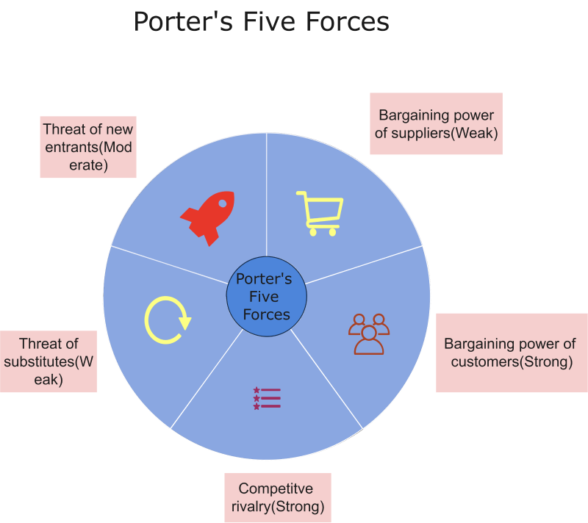

Figure 3: Porter’s 5 forces
(Source: Adelakun, 2020)
Forces | Analysis
Threat of new entrants | The threat of new entrants for Apple is comparatively lower to moderate. Implementing a big organization within this competitive sector is extremely costly and it needs capital, manpower, marketing, and infrastructure. In order to make a remarkable mark on the gadgets and personal computing, it also needs a huge brand recognition. also, the first product code for you that Apple continues with its key competitors, it is not possible for a new entrant to capture the whole market with your new product range.
Bargaining power of suppliers | Apple experiences a comparatively weak force in the bargaining power of suppliers. In the case of Apple, the suppliers have a very less to no bargaining power because of the moderate to higher number of distributors available in the market and a large volume of manufacturers. Apple company is free to sell it to numerous potential suppliers (Adelakun, 2020). Also, the switching cost for the company to exchange from one distributor to another is comparatively lower and is not a significant limitation. Moreover, Apple also gets the benefit of economies of scale and the supplying of Apple products are divided into different parts.
Threat of substitute products | The threat of substitute products for Apple is also a moderate force. This is due to the fact that currently, there are different substitute products available in the market from Amazon and Samsung that can replace the product offered by Apple (Wellner, and Lakotta, 2020). In spite of this, the most potential comparable products have only restricted capacities as compared to the products given by Apple because of its higher involvement in innovative product manufacturing. Also, maximum customers would rather prefer to use the products of Apple based on their advanced functions and convenience. The situation weekend is the strength of substitutions in affecting the business of Apple company.
Bargaining power of consumers | The strong bargaining power of customers is impacting the business of Apple. this is due to the low switching cost of the customers and their collective bargaining strength. it is extremely easier for the customers of Apple to change brands, thereby making them strong in compelling organisations like Apple to make sure that customer satisfaction is achieved (Isabelle et al. 2020). Despite this, the individual bargaining power of Apple is weak because losing a single client base does not affect the revenue of Apple.
Industry competition | The competitor analysis of Apple manifest that various organisations directly compete with Apple like Samsung, Google, and HP. Every organization includes huge R&D to create the most innovative product range. Hence, the competitive rivalry of Amazon is strong. One of the biggest competitors of Apple is Samsung, Sony, Huawei, Oppo, and so on (Isabelle et al. 2020). One factor that makes the sector extremely competitive is the lower cost of switching. It does not need a substantial investment for a customer to switch from Apple’s iPad to Amazon's Kindle. also, the industry competition of Apple is influenced by the higher aggressiveness of organisations and lower product differentiation which are the stronger forces.

Table 2: Porter’s 5 forces
(Source: Self-made)

Internal Analysis

Strategic Resources and Capabilities
Whilst resources mean the elements that a company owns, the capabilities reflect what the organisation can implement. More particularly, the capabilities allude to the ability of an organisation to bundle, authorise, or otherwise misuse resources in such a manner that it gives added value and benefit over its competitors. In recent times, the industry of computer hardware had a volume of $367.5 billion in the year 2001 at a CAGR of 10.9% and the overall spending of the industry of computer hardware is $705.4 billion as this sector needs huge investments in R&D (Bidemi Ogedengbe, 2021). The most remarkable product of Apple is iPhone that has huge competition with Samsung and has been the reason for the reduction in prices for various years. The company maintains a strategic positioning of product differentiation. Apple differentiates itself from its key competitor, Samsung, by putting a lesser concentration on a few factors.
Functionality and design – Apple puts a strong concentration on the design of their products by going in opposite to the Status Quo to make more sleek items. The functionality of these items at the result of in-depth R&D that gives rise to these innovative items like the iPhone, MacBook, or iWatch (Prieto‐ Sandoval et al. 2019).
User experience – simplicity is the keyword for Apple as they try to use Apple products as simply as possible. This also needs efficient design thinking.
Cost advantage – Apple uses innovation and has created a truly sustainable competitive edge which is definitely worth the recent valuation premium. It also leads a very powerful defence force in the area of products and services and these strategic resources are based on horizontal and vertical strategies.
Vertical integration ecosystem – Apple leads a vertical integration that has built them to be developed in the services of software and hardware (Gupta et al. 2020). Similarly, they have also created an ecosystem over their products like the apps that are found in every item of Apple with similar interface.

Value Chain Analysis
Primary Activities
The framework of the value chain is created by five preliminary activities – inbound activities, operations, inbound logistics, sales and marketing, and services. The primary activities of Apple are:
- Inbound logistics – the SC of Apple is huge. The top 20 distributors of Apple holds 98% of the procurement expenditure of the company for materials, product, assembling, and manufacturing (John Dudovskiy, 2023). In order to manage this amount of inbound logistics, Apple needs to implement a tight SCM ship.
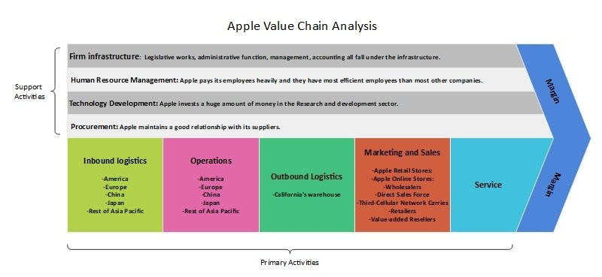

Figure 4: Value chain of Apple
(Source: Federica Laricchia, 2022)
- Operations – in order to keep the operating expenses, less, Apple takes benefit of the lower labour and expenses of raw materials in Japan and China. Outsourcing also assists the organisation to keep the overall manufacturing expenditure, low, which permits improving the profit margin.
- Marketing and sales – the company invest hugely in the efforts of marketing and sales. As an organisation, it is popular for its standard, design, and innovation when it comes to promoting this company and advertising new items (Federica Laricchia, 2022). Even though Apple does not share any other additional data on their spend for marketing and sales, in the year 2015, the marketing budget for Apple company increased to $1.8 billion.
- Services – most of the items sold by Apple company are covered by a one-year warranty and support of 90 days. Customers can book appointments for different technical repairs or assistance. The company also keep Apple technicians as the staff in the different outlets for providing guidance and demos to their customers. As a result, this motivates the buyers to purchase the product.
Secondary Activities
Contrary to the primary activities, there are 4 secondary activities included in this value chain framework, such as – procurement and purchasing, HRM, company infrastructure, and technological development (Delgado et al. 2021). The secondary activities of Apple are:
- Research and development – Apple company invest a huge amount in R&D to maintain its competitive position as the business leader. As per Statista, Apple company’s expenses were registered at $26.25 billion for R&D in 2022 (Frederick, 2019).
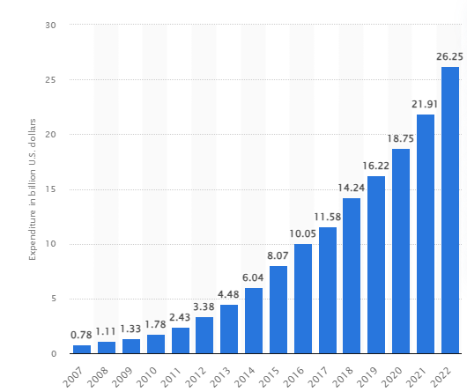

Figure 5: R&D expenditure of Apple
(Source: Federica Laricchia, 2022)
- HRM – Apple has a popularity for offering development opportunities and training activities to their staff, along with competitive salaries. In the year 2021, Apple was rated as the 2nd among the top 50 demanded organisations in HR.

SWOT Analysis
SWOT analysis is a structure utilised to analyse the competitive position of an organisation and to create strategic planning. In this case, this analysis will help in positively evaluating the internal and Eastern elements along with the recent and future potential of the company.
Strengths  - Brand value – Apple was ranked as 1st for the 10th year in a row by Interbrand with a brand value of $408 billion in 2022 (Interbrand, 2022).  - Global icon – Apple is the most valuable and reliable organisation for smart automotive devices and computers.  - Increased R&D – Apple constantly invites a huge amount of capital in RND for future development and competitive advantage.  - Service expansion – Apple has been extending its portfolio of services for several years. For instance, approximately 20% of the yearly revenue, approximately $78 billion out of $394 billion in the year 2022, it was achieved from its services, which is the 2nd largest contributor to this profit after iPhone. | Weaknesses  - Higher price – the products of Apple can be considered as luxury items because of the premium prices. As a result, it is not affordable for middle or lower-earning individuals.  - Limited promotion – Apple has based on its rounds by implementing loyal customers, even with restricted resources of advertising (Palomares et al. 2021).  - Increased service industry competition – Apple is rapidly extending its services into the industry of video, streaming and gaming, where it had its key competitors like Netflix and Disney.
Opportunities  - Consistent customer development – the customer retention rate of Apple is 90% which is remarkable and is an opportunity for the company to create new alliances (Chance Miller, 2021).  - Extended distribution network – Apple has the opportunity to expand its suppliers into a diverse area to increase opportunities for minimal growth.  - Smart wearables – the technology of smart wearables will soon lead the world. As per Forbes, the devices of smart wearables sales would be 2x by 2022, giving an opportunity for Apple Watch and AirPods to expand. | Threats  - Limited countermeasures for AirTags – while the AirTags of Apple were meant to assist individuals to find misplaced items through Bluetooth, which can be are used for other malicious purposes.  - Increasing competition.– even though Apple has implemented itself, strongly enough, emerging organisations like Samsung and Google are giving huge competition to Apple (Benzaghta et al. 2021).

Table 3: SWOT analysis
(Source: Self-made)

VRIO Analysis of Distinctive Resources and Capabilities
The VRIO model assists in analysing the value, organisation, reality, and imitability of the organisation. The ultimate goal of an organisation in this evaluation is to recognise the competitive benefits and core competencies of the organisation based on the variables (Barley et al. 2020). In this context, using this will help Apple to analyse its core competencies.a
Value – the development of the new product of Apple, like the iPhone has also captivated the creation of communication with the internet dissimilation, and capabilities of data storage. It also plans to use the feature of PDAs like compact and rapid access. Moreover, Apple has also incorporated different characteristics of the items like music, iPod and so on (Widayanto, 2022). Thus, Apple has made valuable products as the customer needs different features and benefits for one product. In values, positive customer relationships, innovation propensity, and brand image are the most popular.
Rarity – in mentioning the rarity of Apple, it needs to identify that Apple has successfully implemented iPhone as their brand name. It is easy to utilise the funny features given by Apple which temporary competitive edge as other market competitors have also a brand with different features. This perceived ease mainly focuses on the smooth interface of the touchscreen, synchronisation capability, and iTunes compatibility. However, iPhone is still not basic as customers prefer this product to others in regards to use (Pérez- Uribe et al. 2023). The global presence, the skills of problem-solving, and adaptability are the rare features at Apple.
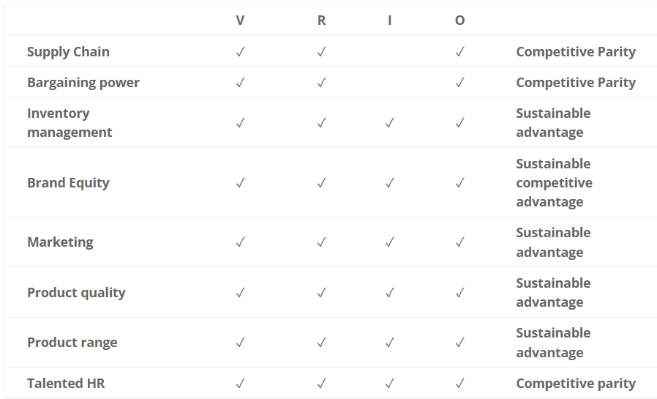

Figure 6: VRIO analysis of Apple
(Source: Sakalauskė, and Leonavičiūtė, 2022)
Imitability – in the industry of telecommunication, the products of Apple are extremely remarkable with different features given. The quality of the product that Apple offers with high consistency is not imitable by its key competitors (Sakalauskė, and Leonavičiūtė, 2022). Also, the customer experience services that Apple gives are unique to its others which helps in engaging your brand with its customers more effectively, which is not imitable.
Organization – in organisational features, the strong financial strength and technical integration along with employee training and huge investment with strong distribution channels are the strategies that Apple implements.

Strategies to Sustain Competitive Advantage
Apple works in a technology industry, that, currently is one of the rapidly transforming industries all over the globe. The industry development and prospects are continuously increasing in the new market that tries to offer more interesting value propositions to its customers and put a strong competition of the current players like Apple (Islami et al. 2020). Apple’s competitors are continuously attempting to outpace the organisation by introducing new services and products that can make an effective impact on their customers. The generic strategy of Apple is associated with the intensive development strategies of the company, particularly in increasing the application of competitive advantage of the organisation.
Cost leadership- the strategy of cost. Leadership has been highly accepted by Apple in its attempts to ensure competitiveness and success in this industry. The administration of Apple has been capable to implement policies and strategies that are focused on ensuring the least cost distributor and producer (Ali, and Anwar, 2021). Also, a few of the strategies and cost leadership that Apple has accepted is to reduce operational expenses, diminishing distribution costs with higher authority on labour. Apple has highly invested in innovation and trees to increase their profit by delivering those products that improve their cost saving. It is further implemented by using different effective facilities of scale, diminishing their marketing and sales expenses.
Differentiation- The first differentiation value that Apple comes from is brand development. The generic strategy of Apple is wider differentiation. This strategy concentrate on the primary features that differentiate the organisation and its data technology and products from its key competitors. Through this differentiation strategy, Apple highlights itself in the market. What instance, elegant, design, product, user, friendliness, and collaboration with high ending branding efficiently, differentiate the automation business.
Cost focus- in reference to dynamics and competition in the sector, there is every requirement for Apple to redefine their strategies to reinforce itself and its stability. It is an effective manner of using the forces of its key competitors along with guaranteeing sustainable development.
Differentiation focus- this strategy has remarkable implications for the strategic objectives of Apple. For instance, in order to use this strategy, Apple needs to continue using innovation through its R&D. It needs to keep developing more creative items so that the company can maintain its competitive position in the market (Firoz Suleman et al. 2019). Competitors, eventually will compete with new products so the brand differentiation strategy can only be the focus with constant innovation. Moreover, to keep continuing with the business development, Apple needs to grow into the market reach like the market of customer electronics worldwide. Apple does not concentrate on any particular market segment. Instead, it completes by selling different products and services that suit divergent segments of this industry.

Growth Strategies
Ansoff Matrixx is an extremely useful technique for organisations to use to devise for alternative strategies of growth (Zugay, and Zakaria, 2023). In this context, this matrix has been applied to Apple company to identify the growth strategies used by the Apple.
Market penetration  - The selling of a maximum number of iPhone products in the current market explains the application of the market penetration strategy used by Apple.  - Apple operates approximately 518 retail outlets in 25 different countries (Cleberg, 2019).  - The company execute this strategy by making iPhones accessible for purchasing in different platforms like Apple stores, telecommunication organisations, and so on.  - It also uses different promotions through media sources and its own websites. It spends approximately $100M yearly on Twitter only for advertising reasons. | Product development  - The development of new products in a periodic basis is one of the core competencies used by Apple.  - Every product of their services nicely fits with their own ecosystem and serves to further intensify their ecosystem.  - Evidently, Apple is remarkable in designing and creating new products (Alfarisi, 2023).  - One of the most promising and popular successes for the product development of Apple is iPhone.
Market development  - Apple being the biggest IT company globally concentrates on emerging economies like Asia as they are an interesting focus market from a sustainable perspective (Reshetko et al. 2023).  - This global technology company appeals to regional culture and sentiments while creating marketing strategies.  - Also, Apple did not only limit itself to just the developed markets but also diversified its operations into emerging markets like India.  - In spite of the huge pursuit of market advancement, the segment of America, including South and North America was the biggest revenue source for Apple in the year 2020, approximately 43% of the overall revenue. | Diversification  - Till now, Apple has been involved in diversification strategy occasionally.  - The application of diversification strategy is evident from the development of products of Apple like Apple Watch, Apple Card, and Apple Pay.  - Similarly, not only diversification in divorce by iPhone makers has been evidenced to be successful.  - For example, in spite of the sudden increase in the industry of video streaming during pandemic situation, Apple TV+ was ranked to be extremely lower than Amazon Prime and Netflix (Wright et al. 2023).

Table 4: Ansoff Matrix
(Source: Self-made)

Green Strategy and CSR
The commitment of Apple to become carbon neutral by the end of 2030 leads everything that the organisation does. It states that every product of Apple will be manufactured with clean energy, even more, recycled and organic materials. Throughout 2022, Apple has achieved development over their incremental goals as a company. Their workers, suppliers, partners, and other stakeholders have also played their major integrated role in assisting the organisation to diminish their effect, create more equitable, resolutions, and lead wider change over their industry and commitments. As an outcome, Apple has diminished their emissions of the value chain by approximately 45% (Apple, 2023).
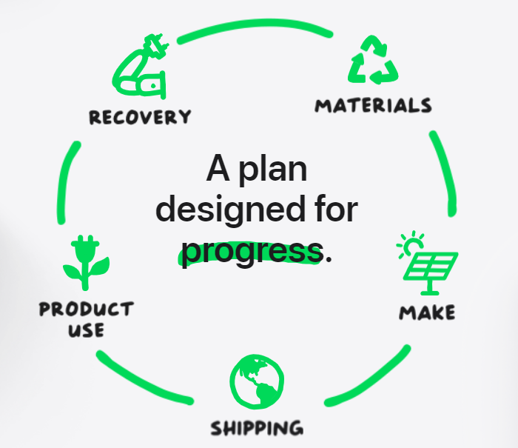

Figure 7: Green Cycle at Apple
(Source: Apple, 2023)
It also ignored almost 28 million metric tons of emissions by implementing transitioning to its SC (Apple, 2023). This was possible for the initiatives that Apple had taken for several years like 100% renewable sourcing. Additionally, Apple also invested an extra $200 million in projects that a neutral. On the contrary, for CSR activities, in accordance with the “Companies Act, 2013 and Section 135”, it has implemented several activities time by time. For example, Apple was extremely included in promoting education involving special education and employment, improving vocational skills and projects of livelihood enhancement. In association with the CSR needs, Apple also seeks to spend 2% of its average profit on a yearly basis.
Apple is committed to explaining that business can and needs to be a strength for good; attaining that takes creativity, cooperation, and a concentration on serving others. As a positive step, from 2017, Apple had attained and maintained equality for gender pay for their workers globally (Mathew Emmanuel Pineda, 2021). In the US, Apple has also attended pay equality in reference to race and ethnicity. Moreover, in 2021, 47% of the roles of open leadership were filled by females worldwide, with a rise of 10% from 2020. As a positive measure, Apple has been operating a recycling program since the 1990s.
Nonetheless, the recent programme of Apple recycling is a worldwide initiative that includes creating and operating different centres, and administrative offices for recovering those recycled materials. On the other hand, as of 2023, more than 250 distributors have committed to changing to 100%, renewable electricity for the production of Apple items, with more than 85% of the direct spending of Apple on materials, production, and assembling globally (Apple, 2023). Every Apple product shows a chance to diminish its carbon footprint – even with the least transformations can yield Suma Cable results. The carbon footprint at Apple assists them to recognise opportunities to diminish the intensity of carbon emissions for their products.

Conclusion
From the discussions above, it is evident that the industry of technology is extremely fierce and needs organisations operating it to be extremely intense in their competitive strategies to gain a competitive edge. The above discussions, the basic understanding of the concepts of strategic management and their capability to use in the real-world business context has been discussed. Also, from the discussions, it can be concluded that Apple company has initiated several strategies for increasing competitive benefit and has successfully been operating in the global market with being the number 1 tech company. on the contrary, from implementing macro and micro environment analysis, it is also evident that the strength of the company is more than that of its key competitors like Google and Samsung. Yet, it needs to constantly strive for innovation and R&D to be in a competitive age and position itself as the business leader in the tech market.

Recommendation
However, even though the operations of Apple company are currently concentrated on customer electronics and providing innovative products, there are a few recommendations that Apple needs to implement.
- The use of AI and robotics along with autonomy can help Apple to captivate a higher market value.
- In order to continue the competitive advantage of Apple, it needs to maintain innovation with these emerging technologies.
- It should further concentrate on cost leadership and re-implementing its prices for its products to captivate the customers having middle and lower earnings.

Reference List
Adelakun, A., 2020. Should Porters Five Forces have Value in Businesses Today. Computing for Business (BSC).
Alfarisi, O., 2023. Cloud Service Marketing Strategy Framework for Higher Value Customer-Segments Deployment.
Ali, B.J. and Anwar, G., 2021. Porter’s Generic Competitive Strategies and its influence on the Competitive Advantage. Ali, BJ, & Anwar, G.(2021). Porter’s Generic Competitive Strategies and its influence on the Competitive Advantage. International Journal of Advanced Engineering, Management and Science, 7(6), pp.42-51.
Apple, 2023. Corporate Social Responsibility Policy of Apple India Private Limited. Apple.com. [Online] Available at: https://www.apple.com/in/legal/more-resources/docs/Apple-India-CSR-Policy.pdf [Accessed on: 17th July 2023]
Apple, 2023. Environment. Apple.com. [Online] Available at: https://www.apple.com/in/environment/#:~:text=And%20by%202030%2C%20every%20Apple,renewable%20electricity%20for%20Apple%20production [Accessed on: 17th July 2023]
Barley, B., Kitamura, A., Loar, T., Ramon-Samayoa, E., Yuzon, J. and Daim, T.U., 2020. An Investigation of the Motivations and Strategies Behind Apple’s Product Design. Innovation Management in the Intelligent World: Cases and Tools, pp.3-27.
Benzaghta, M.A., Elwalda, A., Mousa, M.M., Erkan, I. and Rahman, M., 2021. SWOT analysis applications: An integrative literature review. Journal of Global Business Insights, 6(1), pp.55-73.
Bian, N., Chu, C., Rung, S., Huangphattarakul, V., Man, Y., Lin, J. and Hu, C., 2023. Immunomodulatory biomaterials and emerging analytical techniques for probing the immune micro-environment. Tissue Engineering and Regenerative Medicine, 20(1), pp.11-24.
Bidemi Ogedengbe, 2021. A Strategic Analysis of Apple Inc. linkedin.com. [Online] Available at: https://www.linkedin.com/pulse/strategic-analysis-apple-inc-bidemi-ogedengbe/ [Accessed on: 17th July 2023]
Chance Miller, 2021. iPhone loyalty rate continues to exceed 90%, new CIRP data shows. 9to5mac.com. [Online] Available at: https://9to5mac.com/2021/10/28/iphone-loyalty-rate-data-switchers/ [Accessed on: 17th July 2023]
Cleberg, C., 2019. Strategic Success: The Ansoff Matrix vs. The Balanced Scorecard.
Da Silva, A.L. and Castañeda-Ayarza, J.A., 2021. Macro-environment analysis of the corn ethanol fuel development in Brazil. Renewable and Sustainable Energy Reviews, 135, p.110387.
Delgado, L., Schuster, M. and Torero, M., 2021. Quantity and quality food losses across the value chain: a comparative analysis. Food Policy, 98, p.101958.
Federica Laricchia, 2022. Apple: expenditure on research and development 2007-2022. Statista.com. [Online] Available at: https://www.statista.com/statistics/273006/apple-expenses-for-research-and-development/ [Accessed on: 17th July 2023]
Federica Laricchia, 2023. Revenue of Apple by fiscal quarter 2005-2023. Statista.com. [Online] Available at: https://www.statista.com/statistics/263426/apples-global-revenue-since-1st-quarter-2005/#:~:text=In%20its%202022%20financial%20year,billion%20U.S.%20dollars%20in%202004. [Accessed on: 17th July 2023]
Firoz Suleman, M., Rashidirad, M. and Firoz Suleman, S., 2019. The applicability of Porter's generic strategies in pure online firms: A case study approach. Strategic Change, 28(3), pp.167-176.
Frederick, S., 2019. Global value chain mapping. Handbook on global value chains, pp.29-53.
Gary Anderson, John Jankowski, and Mark Boroush, 2023. U.S. R&D Increased by $51 Billion in 2020 to $717 Billion; Estimate for 2021 Indicates Further Increase to $792 Billion. Ncses.nsf.gov. [Online] Available at: https://ncses.nsf.gov/pubs/nsf23320#:~:text=U.S.%20Total%20R%26D&text=The%20three%20years%20leading%20to,%2C%20respectively%20(table%202). [Accessed on: 17th July 2023]
Gennaro Cuofano, 2023. Apple Mission Statement And Vision Statement. Fourweekmba.com. [Online] Available at: https://fourweekmba.com/apple-mission-statement-vision-statement/ [Accessed on: 17th July 2023]
Gupta, S., Drave, V.A., Dwivedi, Y.K., Baabdullah, A.M. and Ismagilova, E., 2020. Achieving superior organizational performance via big data predictive analytics: A dynamic capability view. Industrial Marketing Management, 90, pp.581-592.
Interbrand, 2022. Interbrand launches Best Global Brands 2022. Interbrand.com. [Online] Available at: https://interbrand.com/newsroom/interbrand-launches-best-global-brands-2022/#:~:text=New%20York%2C%203rd%20November%202022,into%20second%20place%2C%20overtaking%20Amazon. [Accessed on: 17th July 2023]
Isabelle, D., Horak, K., McKinnon, S. and Palumbo, C., 2020. Is Porter's Five Forces Framework Still Relevant? A study of the capital/labour intensity continuum via mining and IT industries. Technology Innovation Management Review, 10(6).
Islami, X., Mustafa, N. and Topuzovska Latkovikj, M., 2020. Linking Porter’s generic strategies to firm performance. Future Business Journal, 6, pp.1-15.
John Dudovskiy, 2023. Apple Value Chain Analysis. Research-methodology.net. [Online] Available at: https://research-methodology.net/apple-value-chain-analysis/#google_vignette [Accessed on: 17th July 2023]
Jonathan Josephs, 2023. US firms 'more negative' about doing business in China. Bbc.com. [Online] Available at: https://www.bbc.com/news/business-65034881 [Accessed on: 17th July 2023]
Lessambo, F.I., 2022. Apple and Microsoft. In Financial Statements: Analysis, Reporting and Valuation (pp. 369-399). Cham: Springer International Publishing.
Mathew Emmanuel Pineda, 2021. Environmental Strategy of Apple: Key Sustainability Initiatives. Profolus.com. [Online] Available at: https://www.profolus.com/topics/environmental-strategy-of-apple-key-sustainability-initiatives/ [Accessed on: 17th July 2023]
Palomares, I., Martínez-Cámara, E., Montes, R., García-Moral, P., Chiachio, M., Chiachio, J., Alonso, S., Melero, F.J., Molina, D., Fernández, B. and Moral, C., 2021. A panoramic view and swot analysis of artificial intelligence for achieving the sustainable development goals by 2030: Progress and prospects. Applied Intelligence, 51, pp.6497-6527.
Pérez-Uribe, R.I., Vargas-Ramirez, I.R. and Ocampo-Guzman, D., 2023. VRIO Analysis Method for Resources Optimization in New Colombian Public Management. In Governance as a Catalyst for Public Sector Sustainability (pp. 305-326). IGI Global.
Prieto‐Sandoval, V., Jaca, C., Santos, J., Baumgartner, R.J. and Ormazabal, M., 2019. Key strategies, resources, and capabilities for implementing circular economy in industrial small and medium enterprises. Corporate Social Responsibility and Environmental Management, 26(6), pp.1473-1484.
Reshetko, N., Vakulenko, S., Kakhrimanova, D., Belozerov, V. and Gašparík, J., 2020. Analysis of the electric vehicle market and the company’s competitive development strategy on it (on the example of “Faraday Future”). In MATEC Web of Conferences (Vol. 329, p. 01016). EDP Sciences.
Sakalauskė, A. and Leonavičiūtė, V., 2022. Strategic analysis of Duolingo language learning platform. Mokslas–Lietuvos ateitis/Science–Future of Lithuania, 14.
SEC, 2022. SEC Proposes Rules to Enhance and Standardize Climate-Related Disclosures for Investors. Sec.gov. [Online] Available at: https://www.sec.gov/news/press-release/2022-46 [Accessed on: 17th July 2023]
Steven Levy, 2023. Apple Inc. Britannica.com. [Online] Available at: https://www.britannica.com/topic/Apple-Inc [Accessed on: 17th July 2023]
The Global Economy, 2021. USA: Political stability. theglobaleconomy.com. [Online] Available at: https://www.theglobaleconomy.com/USA/wb_political_stability/#:~:text=Political%20stability%20index%20(%2D2.5%20weak%3B%202.5%20strong)&text=The%20average%20value%20for%20the,194%20countries%20is%20%2D0.07%20points. [Accessed on: 17th July 2023]
Trading Economics, 2023. United States Employment Rate. Tradingeconomics.com. [Online] Available at: https://tradingeconomics.com/united-states/employment-rate#:~:text=Employment%20Rate%20in%20the%20United%20States%20is%20expected%20to%20be,macro%20models%20and%20analysts%20expectations.&text=In%20United%20States%2C%20the%20employment,of%20the%20working%20age%20population. [Accessed on: 17th July 2023]
Wellner, S. and Lakotta, J., 2020. Porter's Five Forces in the German railway industry. Journal of Rail Transport Planning & Management, 14, p.100181.
Widayanto, M.T., 2022. Review of Aliekperov, Adyl (2021): creating business and corporate strategy: an integrated strategic system, Routledge. Competitiveness Review: An International Business Journal, 32(6), pp.861-864.
World Population Review, 2023. Minimum Wage by Country 2023. worldpopulationreview.com. [Online] Available at: https://worldpopulationreview.com/country-rankings/minimum-wage-by-country [Accessed on: 17th July 2023]
Wright, D.W.M., Jarratt, D. and Halford, E., 2023. The Twilight Effect, post-film tourism and diversification: the future of Forks, WA. Journal of Tourism Futures, 9(2), pp.196-213.
Yan, P.G. and Li, J.N., 2020. Advances in the understanding of the intestinal micro-environment and inflammatory bowel disease. Chinese medical journal, 133(07), pp.834-841.
Zugay, B. and Zakaria, R., 2023. Ansoff Matrix.

