

Module: Changemakers: Creativity and Value Creation
Module Code: BMSW5008_ SWAN
Lecturer: Myfanwy Davies
Assignment Title: Reflection on Research Process
Assignment topic: The Impact of Artificial Intelligence (AI) chatbots on Customer Service in E-Commerce Businesses.

NAME | DANISH IMAN BIN DAHARI
STUDENT ID | 2120943

Table of Contents.

Contents | Pages
Task 1  - Introduction  - Research Methodology  - Data Collection Methods  - Sampling Method and Size | 3  4  5  5-6
Task 2  - Primary and Secondary Research | 6-7
Task 3  - Elevator Pitch Presentation Video Link  - Elevator Pitch Slide Presentation Link  - Reflection on the Elevator Pitch | 7  7  7
Task 4  - Poster | 8
References | 9-10

Task 1
- Introduction
This study looks into how artificial intelligence (AI) is affecting customer support activities in e-commerce platforms. Artificial intelligence is the emulation of human intellect that is processed by technology, particularly computer systems. In general, AI systems function by consuming significant volumes of tagged data, processing the data for correlations and patterns, and then using these patterns to anticipate future situations (Burns, 2022). The research question is to what extent do AI-powered chatbots contribute to customer satisfaction in e-commerce, and what are the key factors influencing their effectiveness?
The usage of AI by companies or businesses that sell their items on e-commerce platforms has quickly risen. A survey found that between 2015 and 2019, there was a 270% increase in the number of businesses actively employing AI solutions (Gartner, 2019). AI improves the convenience of online purchasing for both consumers and merchants. This enables both large corporations and small and medium-sized organisations (SMEs) to take full advantage of the potential presented by AI (Juliet,2022). Due to the fact that 74% of users plan to talk with a chatbot on a website, 87% still prefer people to chatbots for rapid encounters, and 25% of consumers don't care whether they speak to a human or a chatbot, business executives claim that chatbots have improved sales by 67% on average. (Press,2019)
This study will look into how virtual assistants and chatbots powered by AI alter customer interactions, and productivity, and impact consumer satisfaction with online buying on e-commerce platforms. Real-world case studies of e-commerce businesses that have adopted AI-based customer care solutions will be examined in the research, and the effectiveness of these solutions will be evaluated in terms of customer retention, loyalty, and overall business performance.

- Research Methodology

Deductive research methodology, which starts with theory and is committed to testing the hypothesis or generalisation, will be used in this study. The hypothesis or generalisation will be tested through observations and data gathering. By the time the study process is complete, the hypothesis will have either been proven true or false. This research will employ a top-down approach, where it will begin with a broad hypothesis and test it through detailed observations. The results of this research through observation in a natural context may be described using descriptive research.
Mixed methods research, which mixes and integrates qualitative and quantitative research approaches, is being used in this study. In order to better comprehend phenomena and respond to the research questions, this includes gathering and analysing both qualitative and quantitative data. The fundamental idea behind mixed-methods research is that it maximises the benefits of each data type's advantages while minimising the drawbacks (Budert-Waltz, 2021). To assess my research's evidence, strengthen the validity of my conclusions, and compare the outcomes of one approach with those of another, I mix qualitative and quantitative methodologies.
More than merely adding an open-ended question to the conclusion of a quantitative survey constitutes mixed methods research. A mixed methods approach is used in this research for both practical and beneficial reasons. In other words, I combine the two methodologies to produce the results they seek since doing so makes sense given the objectives of their research.
The inductive research technique produces an inference based on observation, frequently of the sample, which is why this study is not appropriate for employing it. Because AI chatbots are so adept at drawing conclusions, we can't guarantee that customers will purchase on online platforms because easier to make a purchase because of AI chatbots. The abduction research approach, however, is also unsuitable for my research since it draws a conclusion from what I already know that isn't sufficient for using this way approach.

- Data Collection Method(s)

To help me with my investigation into the efficacy of chatbots powered by AI in e-commerce, the data gathering strategy for this study will include primary and secondary data collection techniques. Two strategies are utilised to obtain data for study or analysis: primary and secondary techniques of data collecting.
Primary data entails gathering authentic information directly from the source by speaking with the respondents. With the aid of this technique, researchers can get firsthand data that is especially suited to their goal (Saunders et al., 2008). In contrast, secondary data collection entails using information already gathered by another party for a goal distinct from that of the initial collection. To obtain pertinent information, this can analyse and understand the data (Hillier, 2022).
The table below shows the data collection methods from primary and secondary to investigate this research.
Data Collection Methods
Primary | Secondary
Surveys | Literature Review

- Sampling Method & Sample Size
In order to assess the characteristics of the population as a whole and draw conclusions about it, the sampling method involves selecting a small number of people or a sample of the population (Singh, 2018).
Firstly, because it is a useful technique for gathering information from questionnaire respondents, random sampling is used in this study. A researcher uses the method of probability sampling to pick subjects from an individual using a few criteria and a random selection procedure. The probability sampling technique assures that each person in the population has an equal chance of being included in the selected sample by applying randomization. When employing basic random sampling, each element has an equal chance of taking part or being picked to be a part of the sample.
The number of individuals or observations that were used in this study is referred to as the sample size. The target audiences for the surveys and interviews will be individuals who regularly shop online and those who are between the ages of 18 and 55. The provided link will be published on social media sites like Instagram and WhatsApp, where participants can access this survey.

Task 2
- Primary and Secondary Research Techniques
To obtain current data without spending any money, simply time, I will use surveys as my major data collection method. Data gathering will take a lot of time because of the large amount of objective data needed for this project. The survey will be created using Google Forms. Google Forms is used in this study because it offers a great tool for quickly and easily creating surveys, quizzes, and other forms. With Google Forms, you can create forms that are accessible from anywhere, automatically gather responses, and even incorporate cutting-edge features like conditional logic (Chernikov, 2022).
With the help of the literature review, it will also be feasible to summarise the sources important to this study. Many authors of scientific articles believe that their writings are only recaps of previous research on the topic at hand. Service quality in the e-commerce industry can be a game-changer, according to my examination of the literature (Kaila et al.2016,2017b; Kalia 2017a,b). Relationships, personalising assistance, boosting customer satisfaction, and providing recovery in the event of service failures can all be considerably improved by AI. Customer satisfaction may be impacted by AI because these services are more trustworthy, of high quality, consistent, constantly accessible (24/7), and less susceptible to human errors brought on by fatigue and restricted reasoning (Huang and Rust 2018).
Similarly this, it is less difficult for e-commerce companies to engage in marketing activities to establish, maintain, and grow relationships with customers (Lo and Campos 2018). Unfortunately, clients dislike chatbots because they can't manage complex issues. While chatbots are helpful for simple queries, they frequently fail to address more complex problems because consumers frequently feel as though they are being passed around in a never-ending cycle of automated messaging (Giannelis, 2023). Instead, it makes use of information that is openly accessible from current and pertinent sources like scholarly works, research papers, or the most recent studies in the field. This might lead to a full understanding and knowledge of this study. (Academy,2019).
Task 3
- Elevator Pitch Video Presentation Link:-https://www.canva.com/design/DAFsL29W_9A/lVPhCQCo95CqM5EWtuO8pw/view?utm_content=DAFsL29W_9A&utm_campaign=designshare&utm_medium=link&utm_source=recording_view

- Slide of Elevator Pitch Presentation Link:-https://www.canva.com/design/DAFsL29W_9A/RVap84PTvHX1oPsQpJKbYA/edit

- Reflection

My elevator pitch for this research is the activity on which I am currently reflecting. A lift pitch is a concise presentation of this research, and a short lift lasts for three minutes. I use a straightforward slide and record my presentation. My pitch and tone of voice were excellent, and the stakeholders really liked the concept behind the slides and how little information was on them while I was giving them feedback on my elevator pitch. Since they adored the presentation and the style, the stakeholders were highly critical.

The stakeholders have pointed up certain areas where I need to improve, including the fact that my pace was a little brisk at the beginning and conclusion, perhaps because I was nervous or relieved it was over. It may be worthwhile to think about the fact that some of these methods may not be effective when taking my audience into account. Another feedback from the stakeholders was that it would have been wonderful to see references for some of the conversations, perhaps on a slide at the conclusion. In addition to identifying the approaches that will be effective while presenting and the necessity to provide references at the conclusion of the slide, I
will evaluate my presentation tone and take appropriate action.

Task 4
- Poster
Below is shows the conference poster that demonstrates the initial analysis of my findings and highlights key conclusions drawn from this research.
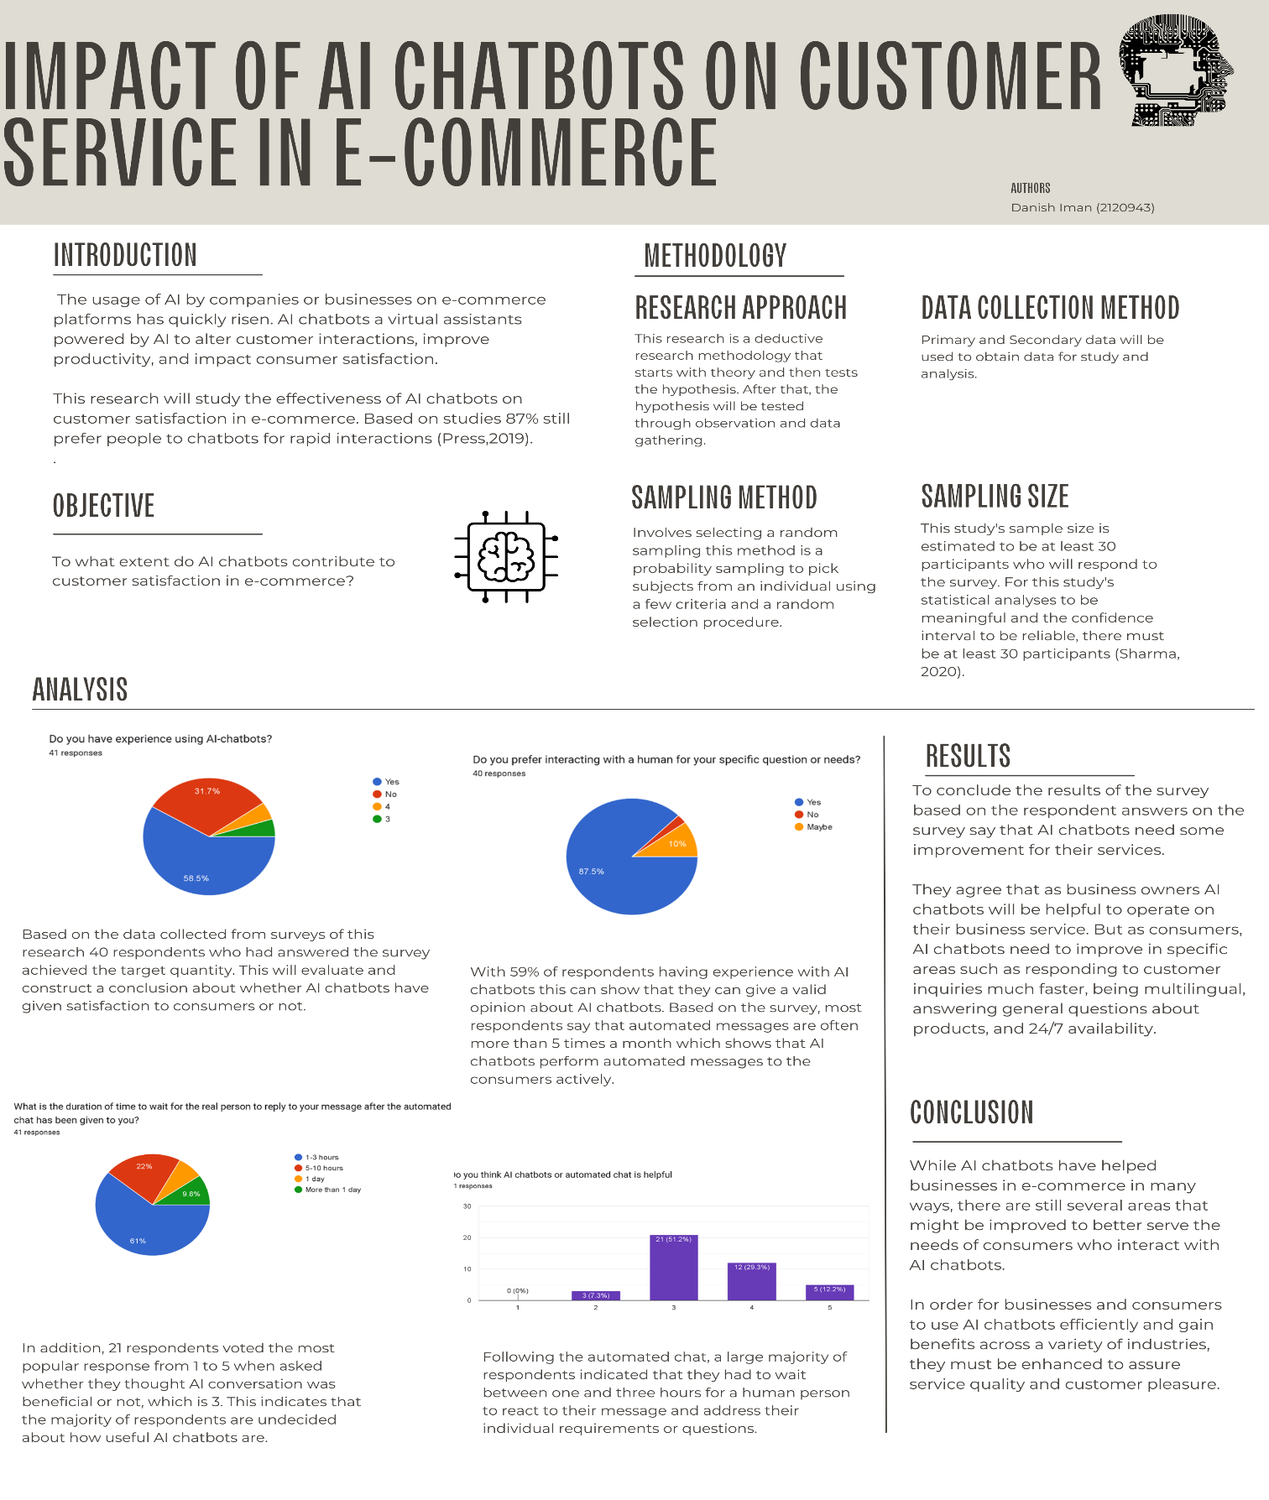
References.

- Academy. (2019). Why is it important to do a literature review in research? – Academy. Retrieved from https://pubrica.com/academy/research/why-is-it-important-to-do-a-literature-review-in-research/
- Bryman A. & Bell, E. (2015) “Business Research Methods” 4th edition, Oxford University Press, p.27
- Budert-Waltz. (2021). What is the Research Methodology? Study.com. Retrieved from https://study.com/learn/lesson/research-methodology-examples-approaches-techniques.html#:~:text=A%20research%20approach%20is%20the,%2C%20qualitative%2C%20and%20mixed%20methods. Retrieved from https://study.com/learn/lesson/research-methodology-examples-approaches-techniques.html#:~:text=A%20research%20approach%20is%20the,%2C%20qualitative%2C%20and%20mixed%20methods.
- Burns, E. (2023). What is Artificial Intelligence and How Does AI Work? TechTarget. Retrieved from https://www.techtarget.com/searchenterpriseai/definition/AI-Artificial-Intelligence
- Chernikov. (2023). 14 Advantages and Disadvantages of Google Forms | Nerdy Form. Retrieved, from https://nerdy-form.com/blog/google-form-maker#:~:text=Google%20forms%20offer%20a%20great,advanced%20features%20like%20conditional%20logic.
- Costello,K. (2019). Gartner Survey Shows 37 Percent of Organizations Have Implemented #AI. (2019). Gartner. Retrieved from https://www.gartner.com/en/newsroom/press-releases/2019-01-21-gartner-survey-shows-37-percent-of-organizations-have
- Giannelis, M., & Giannelis, M. (2023). Why Customers Don&#8217;t Like Or Hate Chatbots &#8211; Annoying &#038; Bad For Business. Retrieved from https://www.techbusinessnews.com.au/blog/why-customers-dont-like-or-hate-chatbots-bad-for-business/#:~:text=Customers%20don’t%20like%20chatbots,ending%20loop%20of%20automated%20messages.
- Hillier. (2022). What is Secondary Data? [Examples, Sources & Advantages]. Retrieved, from https://careerfoundry.com/en/blog/data-analytics/what-is-secondary-data/#secondary-data
- Huang M, Rust RT (2018) Artificial intelligence in service. J Serv Res 21:155-172. https://doi:10.1177/1094670517752459.
- Juillet, R. (2022). What is the impact of artificial intelligence on e-commerce? Retrieved from https://www.bocasay.com/how-ai-transforming-e-commerce/
- Kalia P (2016) Tsunamic e-commerce in India: The third wave. Glob Anal 5:47-49.
- Kalia P (2017) Webographics and perceived service quality: An Indian e-retail context. Int J
- Kalia P (2017a) Service quality scales in online retail: Methodological issues. Int J Oper Prod
- Kruze, A. (2023). Artificial Intelligence In E-Commerce Can Also Benefit Small Businesses. Forbes. Retrieved from https://www.forbes.com/sites/forbestechcouncil/2023/05/19/artificial-intelligence-in-e-commerce-can-also-benefit-small-businesses/?sh=ed2692d1aae4
- Lo FY, Campos N (2018). Blending Internet-of-Things (loT) solutions into relationship marketing strategies. chnol Forecast Soc Change 137:10-18. https://doi 10.1016/j.techfore.2018.09.029.
- Manag 37:630-663. do: 10.1108/JOPM-03-2015-0133.
- Press, G. (2019). AI Stats News: Chatbots Increase Sales By 67% But 87% Of Consumers Prefer Humans. Retrieved from https://www.forbes.com/sites/gilpress/2019/11/25/ai-stats-news-chatbots-increase-sales-by-67-but-87-of-consumers-prefer-humans/.
- Saunders, M., Lewis, P. and Thornhill, A. (2007) Research Methods for Business Students. 4th Edition, Financial Times Prentice Hall, Edinburgh Gate, Harlow.
- Serv Econ Manag 8:152-168. https://doi: 10.1504/IJSEM.2017.10012733.
- Sharma, A. (2021). Is n = 30 really enough? A popular inductive fallacy among data analysts. Retrieved from https://towardsdatascience.com/is-n-30-really-enough-a-popular-inductive-fallacy-among-data-analysts-95661669dd98
- Singh, S. (2018). Sampling Techniques - Towards Data Science. Retrieved from https://towardsdatascience.com/sampling-techniques-a4e34111d808

