INTERNET PROTOCOL ASSESSMENT

Student
Claudiu-Stefan Stelian

- Contents

Part 1. Research Report of IPv6 Addressing

Introduction to IPv6

IPv6 addresses types

Unicast Address

Multicast Addresses

Anycast Addresses

Part 2. IP Addressing Scheme for School of Management and Engineering

VLSM Subnetting Scheme

IP Ranges Table

IPv6 address for 6 Servers

Part 1. Research report of IPv6 addressing

The Internet Protocol version 6 (IPv6) is the successor of Internet Protocol version 4 (IPv4) which was a 35 years project. The IPv4 at the beginning was designed to support 600 hosts on the internet before the World Wide Web and other communication systems. Now those days IPv4 provide a maximum 4,29 billion addresses on 32-bit which seems to be less than an IPv6 addresses. An IPv6 can have a maximum of 340,282,366,920,938,463,463,374,607,431,768,211,456, or 2¹²⁸ addresses.
The advantages of IPv6 providers are seeing substantial increases in performance. Facebook sees 20% to 40% better performance of news feeds with IPv6. Tests at Time Warner Cable show about a 15% performance increase with IPv6. Asia-Pacific Network Information Centre (APNIC) says that IPv6 traffic is faster over trans-Pacific links due to better routing aggregation.
Here you have a example of Windows Running IPv6 by Default
PC> ipconfig
Windows IP Configuration
Ethernet adapter Local Area Connection:
Connection-specific DNS Suffix : localdomain
Link-local IPv6 Address . . . . : fe80::50a5:8a35:a5bb:66e1%7
IPv4 Address. . . . . . . . . . : 192.168.1.101 Subnet Mask . . . . . . . . . . : 255.255.255.0
Default Gateway . . . . . . . : 192.168.1.1
Many people who are new to IPv6 are surprised to learn that IPv6 is much more than just a larger source and destination IP address. Developers of IPv6 took this opportunity to not only improve IP but also many of the protocols and processes related to IP. This foresight has continued, with standards and informational RFCs that go well beyond the Internet of today. For example, the home of tomorrow may look more like an enterprise network of today. Perhaps a home will be connected to multiple ISPs, each providing differentiated services. A home network may include multiple subnets for personal use, business needs, entertainment systems, guest access, smart home devices, and so on.
Let’s look at an example using the address 2001:db8:aaaa:1111::100/64. The longest preferred form in Figure 4-2 illustrates how the /64 prefix length identifies the prefix, or network portion, of the address. The /64 prefix length leaves another 64 bits, which is the Interface ID portion of the address.
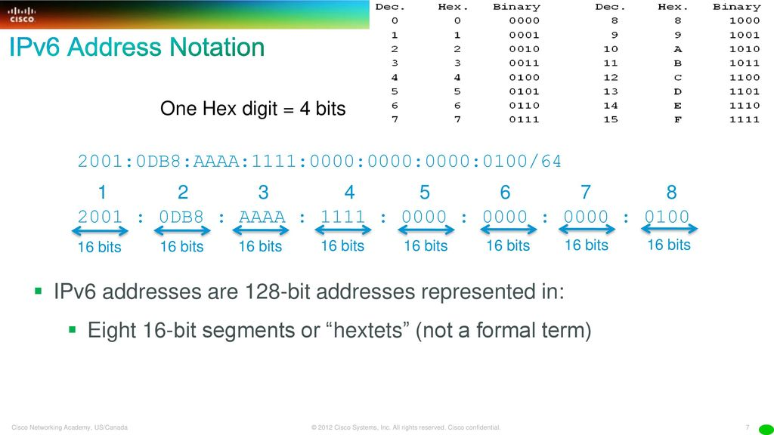
The IPv6 has many types of addresses:
- Unicast
- Multicast
- Anycast

  - Unicast Address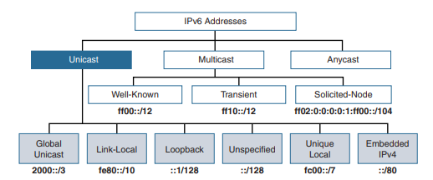
A unicast address uniquely identifies an interface on an IPv6 device. A packet sent to a unicast address is received by the interface that is assigned to that address. Similar to IPv4, a source IPv6 addresses must be a unicast address.

  - Global Unicast Address are equivalent to public IPv4 addresses. The generic structure of a global unicast address, which includes Global Routing Prefix, Subnet ID, and Interface ID is: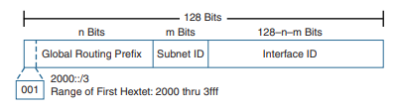
  - Link-Local Unicast Address is a unicast address that is confined to a single link, a single subnet. Link-local unicast addresses are in the range of fe80::/10. The least-significant (rightmost) 64 bits are used as the Interface ID.
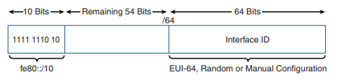

  - Loopback Addresses is ::1, an all-0s address except for the last bit, which is set to 1. It is equivalent to the IPv4 address block 127.0.0.0/8, most commonly the 127.0.0.1 loopback address.

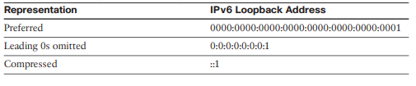
  - Unspecified Addresses is used as a source address to indicate the absence of an address and it cannot be assigned to an interface. An IPv6 unspecified address is an all-0s address that indicates either the absence or anonymity of an IPv6 address. Unspecified addresses are used only as source addresses and never forwarded by an IPv6 router.

  - ULA addresses can be used similarly to global unicast addresses but are for private use and should not be routed in the global Internet. ULA addresses are only to be used in a more limited area, such as within a site or routed between a limited number of administrative domains. ULA addresses are for devices that never need access to the Internet and never need to be accessible from the Internet.
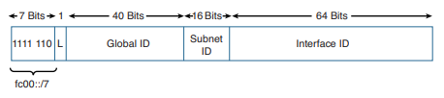
  - IPv4-mapped IPv6 addresses can be used by a dual-stack device that needs to send an IPv6 packet to an IPv4-only device. As shown in Figure 4-10, the first 80 bits are set to all 0s, and the 16-bit segment preceding the 32-bit IPv4 address is all 1s. The last 32 bits in the IPv4 address are represented in dotted-decimal notation. So, the first 96 bits are represented in hexadecimal, and the last 32 bits contain the IPv4 address in dotted-decimal notation.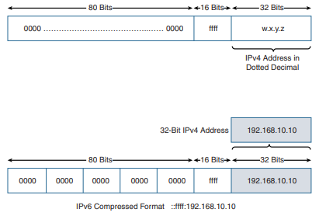

  - Multicast Addresses
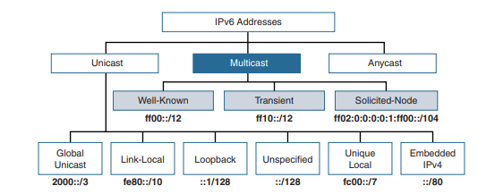
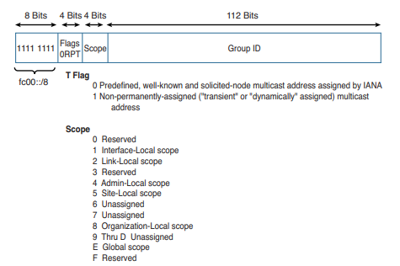
- Well-known multicast addresses: These multicast addresses are reserved for predefined groups of devices, such as all-IPv6 nodes and all-IPv6 routers multicast groups.
- Well-Known Multicast Addresses Well-known multicast addresses have the prefix ff00::/12. This means that the third hexadecimal digit, the Flag field, is always set to 0. Well-known multicast addresses are predefined or reserved multicast addresses for assigned groups of devices. These addresses are equivalent to IPv4 well-known multicast addresses in the range 224.0.0.0 to 239.255.255.255. Some examples of IPv6 well-known multicast addresses include the following:
■ ff02::1: All IPv6 devices
■ ff02::2: All IPv6 routers
■ ff02::5: All OSPFv3 routers
■ ff02::a: All EIGRP (IPv6) routers
- Solicited-node addresses: Every unicast address assigned to an interface also has a special multicast address known as a solicited-node multicast address. These multicast addresses are automatically created using a special mapping by prepending the solicited-node multicast prefix ff02:0:0:0:0:1:ff00::/104 to the last 24 bits of the unicast address. IPv6’s solicited-node multicast address provides a way to reach every device on the link without all those devices needing to process the contents of the packet.

  - Anycast Addresses
Anycast addresses: An IPv6 anycast address is an address that can be assigned to more than one interface (typically different devices). In other words, multiple devices can have the same anycast address. A packet sent to an anycast address is routed to the “nearest” interface having that address, according to the router’s routing table.

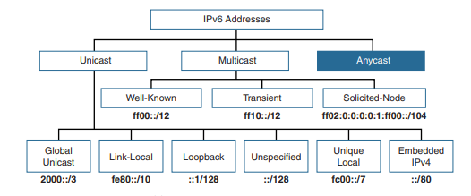
An IPv6 anycast address is an address that can be assigned to more than one interface (typically different devices). In other words, multiple devices can have the same anycast address. A packet sent to an anycast address is routed to the “nearest” interface having that address, according to the router’s routing table.
Anycast addresses are available for both IPv4 and IPv6, initially defined in RFC 1546, Host Anycasting Service. Anycast was meant to be used for services such as DNS and HTTP but was never really implemented as designed. (Graziani, 2013)

Part 2. IP addressing scheme for the School of Management and Engineering

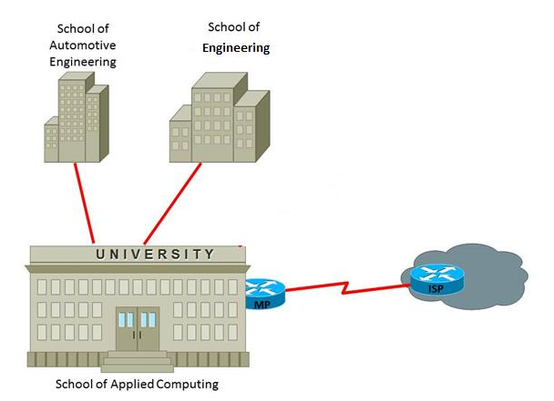
The IP addressing scheme will support:
a) School of Applied Computing: 20 staff, lab301 – 60 pcs, Lab302 – 30 pcs, Lab303 – 36 pcs, Lab 304 – 45 pcs, Lab306 – 40 pcs, Lab308 – 140 pcs, Lab309 – 50 pcs and Lab310 – 18 pcs.
b) School of Automotive Engineering: 25 staff, lab101 – 40 pcs, Lab102 – 25 pcs, Lab103 – 35 pcs, Lab205 – 40 pcs, Lab206 – 48 pcs, CAD lab – 20 pcs and Lab301 – 50 pcs.
c) School of Engineering: 18 staff, lab201 – 20 pcs, Lab202 – 80 pcs, Lab203 – 65 pcs, Lab205 – 25 pcs, Lab404 – 45 pcs, Lab408 – 28 pcs, Lab409 – 80 pcs, Lab410 – 45 pcs.
♣ A Test centre – 20 pcs, 1 IP phone, a printer
♣ An Open Access lab with 245 pcs and 5 printers
♣ Assign appropriate IPv6 address for 6 servers located at the University building
♣ The servers are DNS, Email, Finance, Registry, File server and a Print server. Assign appropriate IPv6 address for the link between MP and ISP.
Counting that we have a big number of hosts that the network will need to cover, I have chosen to use a class B IP Address: 131.168.10.2/16
Before to do the VLSM I added the Hosts from the Test centre and Open Access lab in the School of Engineering resulting in the number of 678 hosts.

Building’s Name | Numbers of PC’s  +Future grow | Network Address | Broadcast Address | First Host | Last Host | Subnet
School of Engineering | 678(+344 future grow) | 131.168.8.0/22 | 131.168.11.255 | 131.168.8.1 | 131.168.11.254 | 255.255.252.0
School of Applied Computing | 439(+71 future grow) | 131.168.12.0/23 | 131.168.13.255 | 131.168.12.1 | 131.168.13.254 | 255.255.254.0
School of Automotive Engineering | 283(+227 future grow) | 131.168.14.0/23 | 131.168.15.255 | 131.168.14.1 | 131.168.15.254 | 255.255.254.0
Interface 1 | 2 | 131.168.16.0/30 | 131.168.16.3 | 131.168.16.1 | 131.168.16.2 | 255.255.255.252
Interface 2 | 2 | 131.168.16.4/30 | 131.168.16.7 | 131.168.16.5 | 131.168.16.6 | 255.255.255.252

The table with the IP ranges per Labs, Staff, Test Centre and Open Access Lab from School of Engineering is:
Lab name | First Host | Last Host | No. of hosts
Staff | 131.168.8.1 | 131.168.8.18 | 18
Lab 201 | 131.168.8.19 | 131.168.8.38 | 20
Lab202 | 131.168.8.39 | 131.168.8.118 | 80
Lab 203 | 131.168.8.119 | 131.168.8.183 | 65
Lab 205 | 131.168.8.184 | 131.168.8.208 | 25
Lab 404 | 131.168.8.209 | 131.168.8.253 | 45
Lab 408 | 131.168.8.254 | 131.168.9.26 | 28
Lab 409 | 131.168.9.27 | 131.168.9.106 | 80
Lab 410 | 131.168.9.107 | 131.168.9.151 | 45
Test Centre | 131.168.9.152 | 131.168.9.173 | 22
Open Access Lab | 131.168.9.174 | 131.168.10.168 | 250

The IPv6 address for 6 servers located at the University building is:
Server’s Name | IPv6
DNS | fc00::/1
Email | fc00::/2
Registry | fc00::/3
Print Server | fc00::/4
File Server | fc00::/5
Finance | fc00::/6
MP | 2002::

References
Graziani, R. (2013). IPv6 Fundamentals: A straightforward approach to understanding IPv6. Cisco Press.

