
Abstract
Manage and maintain network resources, and its services applying suitable policies and drafting security and redundancy practices.
nETWORK oPERATING SYSTEMS AND SERVICES
Casework Component Two

Declaration

I declare that this report is the product of my own work and is not being submitted for any other degree etc.

D M R Kennett

Table of Contents
1. Network topology 4
2. Task 1: Managing and maintaining network resources using network policy and security practices 5
2.1 NTFS 5
2.2 Share Permissions 10
2.2.1 Accessing the file share/server over the network 12
2.3 Utilising Group Policy 14
2.3.1 Group Policy One – Moderating Access to the Control Panel 14
2.3.2 Group Policy Two – Removing Access to the Command Prompt 17
2.3.3 GPO 3 – Restricting Access to Removable Media Drives 18
2.3.4 GPO 4 – Restricting Software Installs 19
2.3.5 GPO 5: Enforcing Password Policy in the ‘nosstask.msft’ domain 23
3. Task 2 – Routing and Packet Filtering with core TCP/IP Services and critical failover/redundancy practices 24
3.1 Utilising ARP and Routing Table 24
3.2 Deploy core services (FTP server) 25
3.3 Installing and configuring the Routing and Remote Access Service 29
3.4 IP Packet Filtering 32
3.4.1 Filter one – stopping anyone in PrivateNet1 from pinging the Router Firewall Service 33
3.4.2 Filter 2: Restrict Access to FTP Service running on Server 2 to only hosts in PrivateNet2. 35
3.4.3 Filter 3 – only allow specific hosts in PrivateNet1 to access the FTP Service running on Server 2 36
4. Password principles 37
5. Failover clustering for high availability systems/services 38
5.1 Advantages and disadvantages 39
5.2 Failover clustering installation process 39
6. Draft network policy 40
7. References 41
8. Appendices 43
8.1 Annex 1 – Key Terminology 43
8.2 Annex 2 - Comparison of different Window file systems 44
8.3 Annex 3 – OSI model 45
8.4 Annex 4 – NCSC Using Passwords infographic [10] 46
Fig 57: NCSC Password Advice 46
8.5 Annex 5 – The 10 most common passwords 2021. 46
8.6 Annex 6: Full network security policy 47

- Network topology
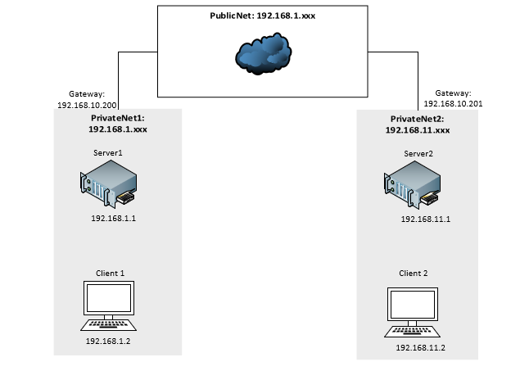
Fig1: Network topology
- Task 1: Managing and maintaining network resources using network policy and security practices
  - NTFS
NTFS (NT File System) is the file system used by the most recent versions of Windows and Windows Server Operating Systems (OS) [1]. See Annex 1 for a comparison of Window file systems.
As well as organising, naming and storing files NTFS also enables file and folder permissions and supports encryption.
All NTFS permissions are attached at local operating system and its user [2]. This allows a granular approach when granting or denying access to the files and folders stored within the NTFS system.
There are six types of permissions:
Type | User permissions
Full Control | - Read, write, edit and delete files and subfolders.  - Control the permission settings for all files and subdirectories.
Modify | - Read and write to files and subfolders.  - Delete the folder.
Read and execute | - View files  - Run executable files including scripts.
List folder contents | - View files and subfolders.  - Execute files (inherited by folders only).
Read | - View the folder and subfolder contents.
Write | - Write to a file.  - Add files and subfolders.
Table 1: Different NTFS file permissions [1] [2].

Permissions can be assigned explicitly or inherited [3]. Explicit permissions are set when an object is created. Inherited permissions are passed down from a parent to a child object.
When creating the “Share_File_NOSS” folder its permissions were inherited from the parent folder (C folder).

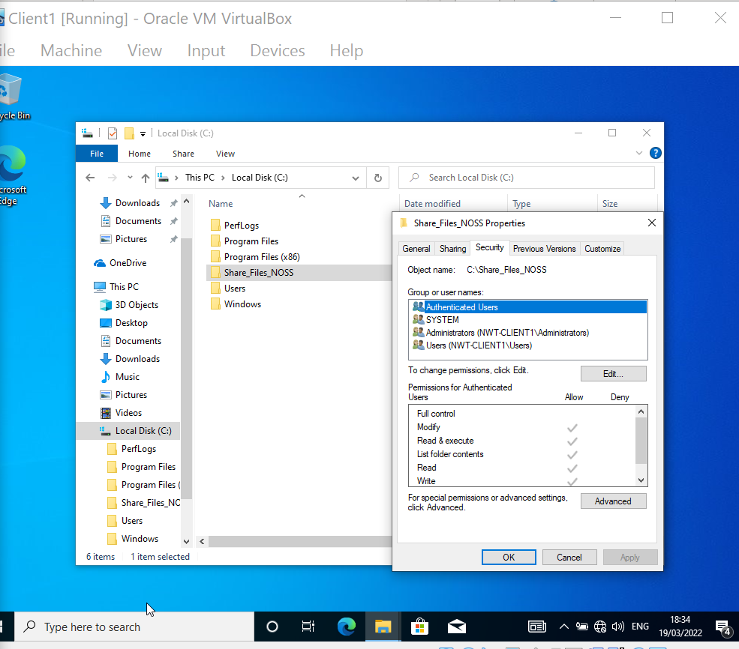
Fig2: Current folder permissions before inherited permissions are removed.

Local NTFS permissions need to be set on this folder and file.
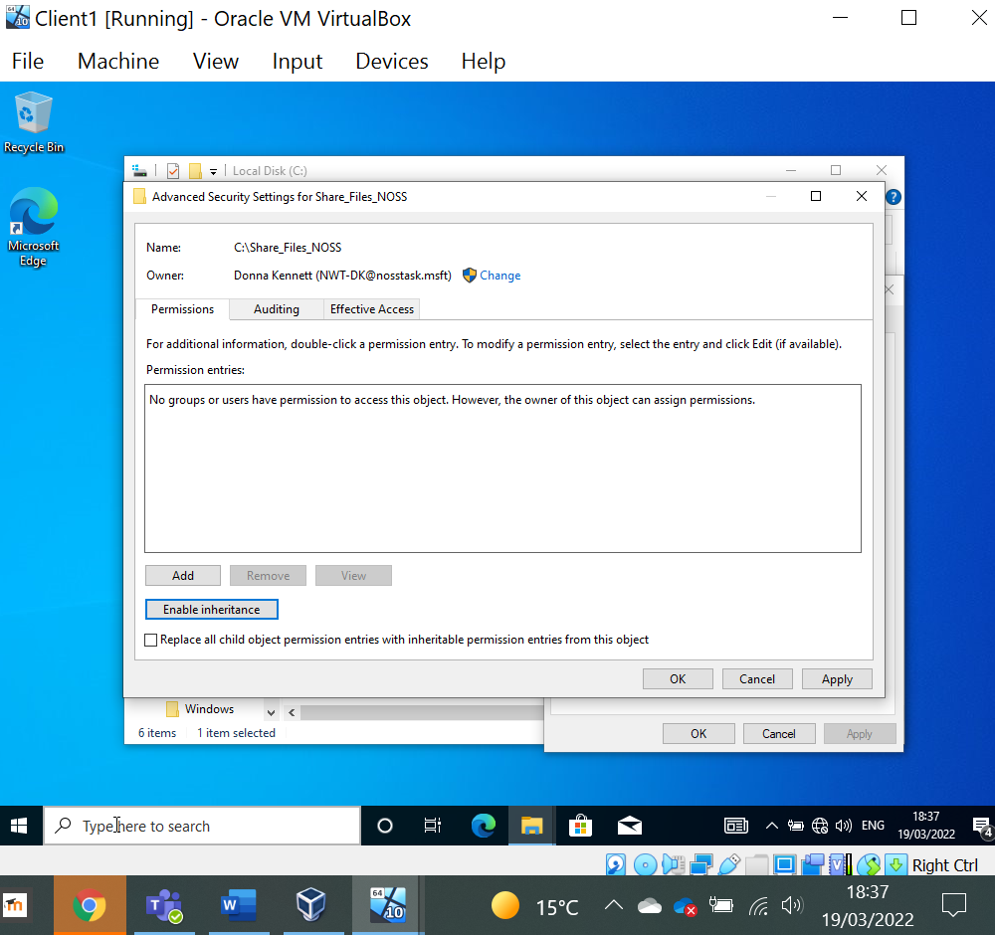
Fig 3: Inheritance has been disabled. This removes the inherited permissions.

As permissions can also be set on a user, two new user accounts were created; one user will have administrative privileges to the file whilst the other will only have read access.
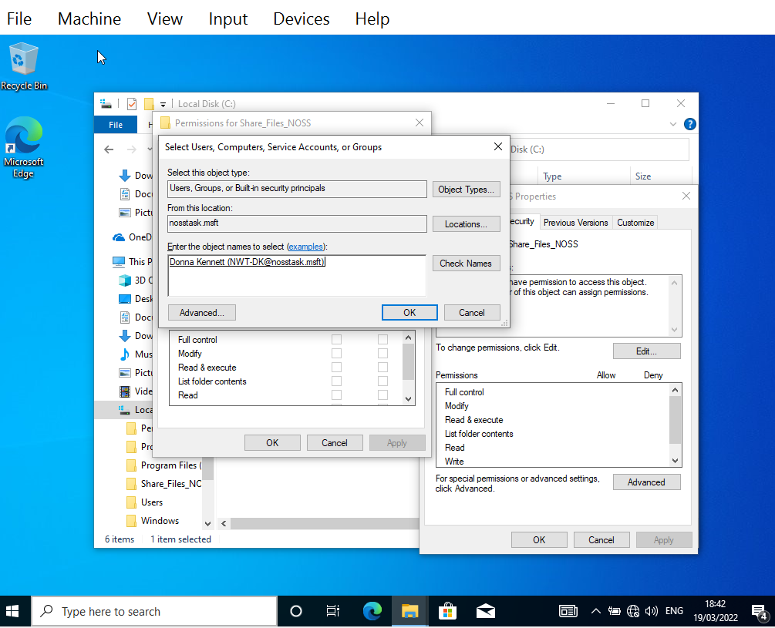
Fig 4: New user with no inherited permissions.
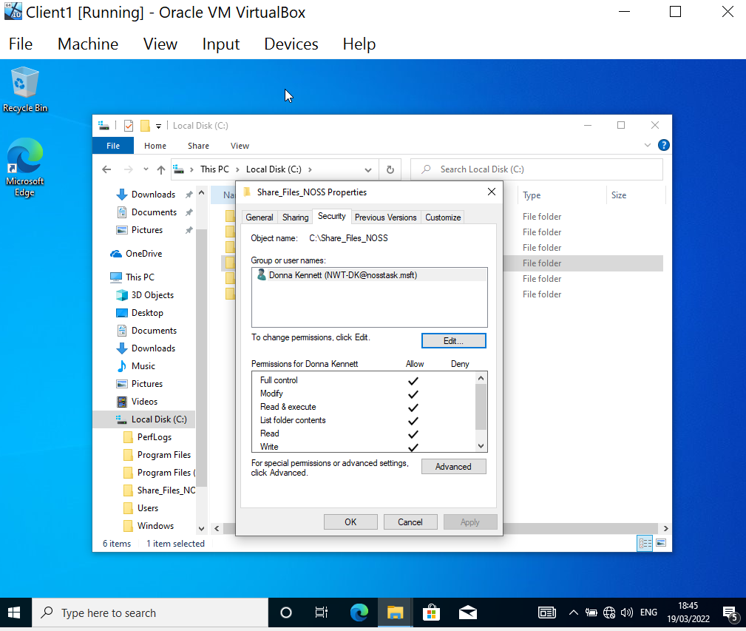
Fig 5: Full control permissions granted for administrative privilege.

These permissions are automatically applied to the files within the folder.
.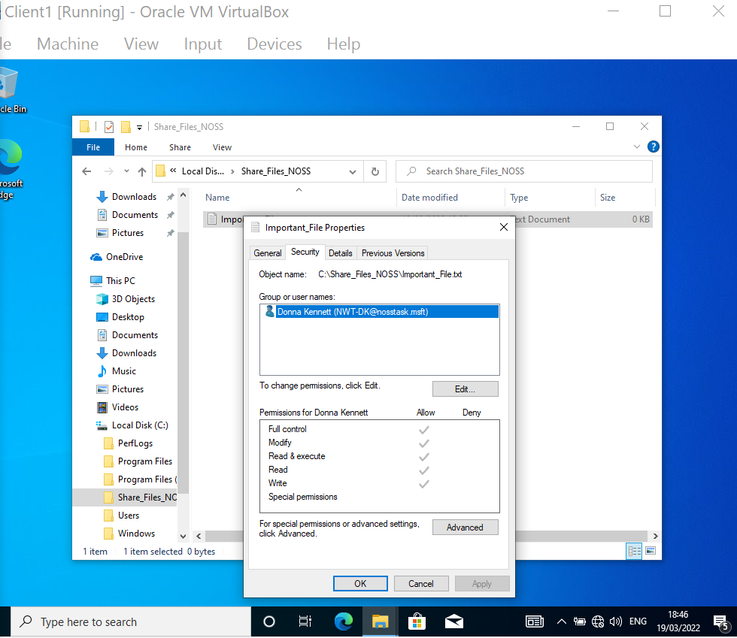
Fig 6: The file has inherited these permissions.
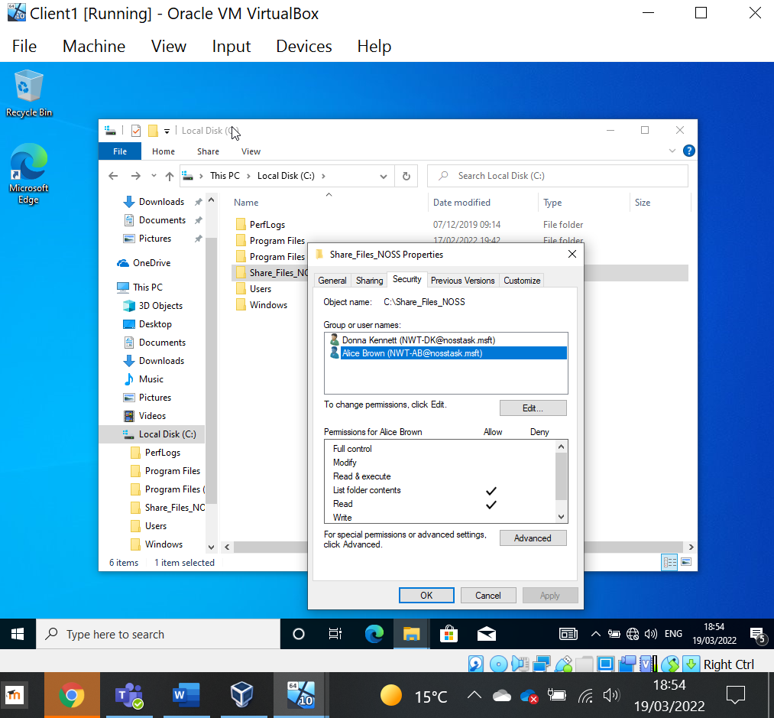
Fig 7: A standard user has now been granted to the folder on a read-only basis.

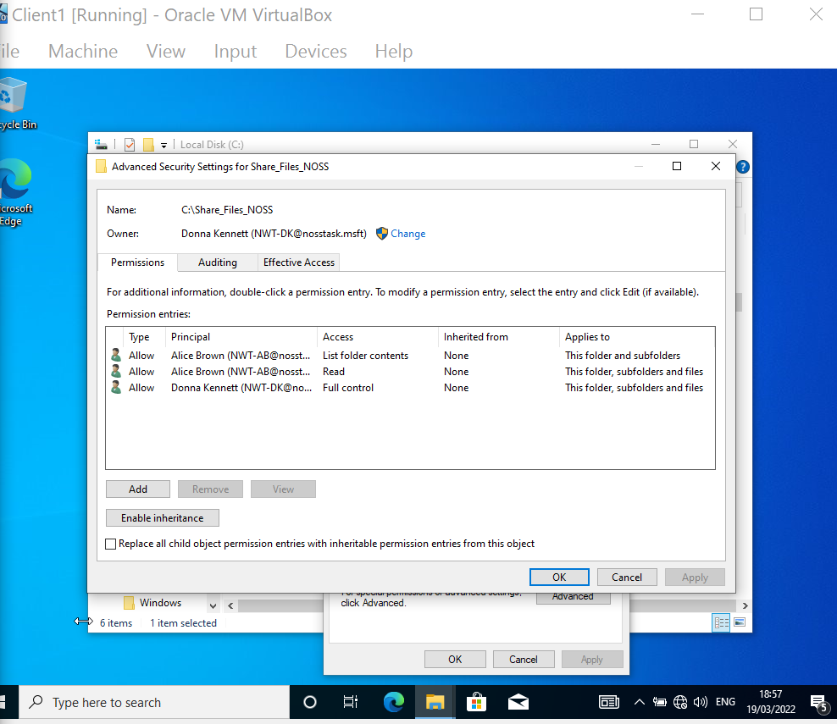
Fig 8: Full permissions set on the folder.

Testing user file permissions for standard user. As shown in Fig 8 above this user should just have Read permissions.
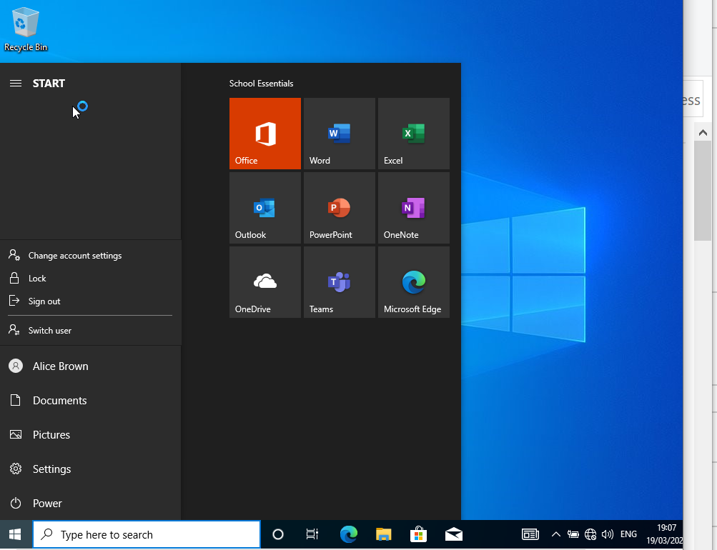
Fig 9: Logged in as non-admin user Alice Brown.

The user can open the folder and see the access to the file but cannot make any changes as per permissions set.
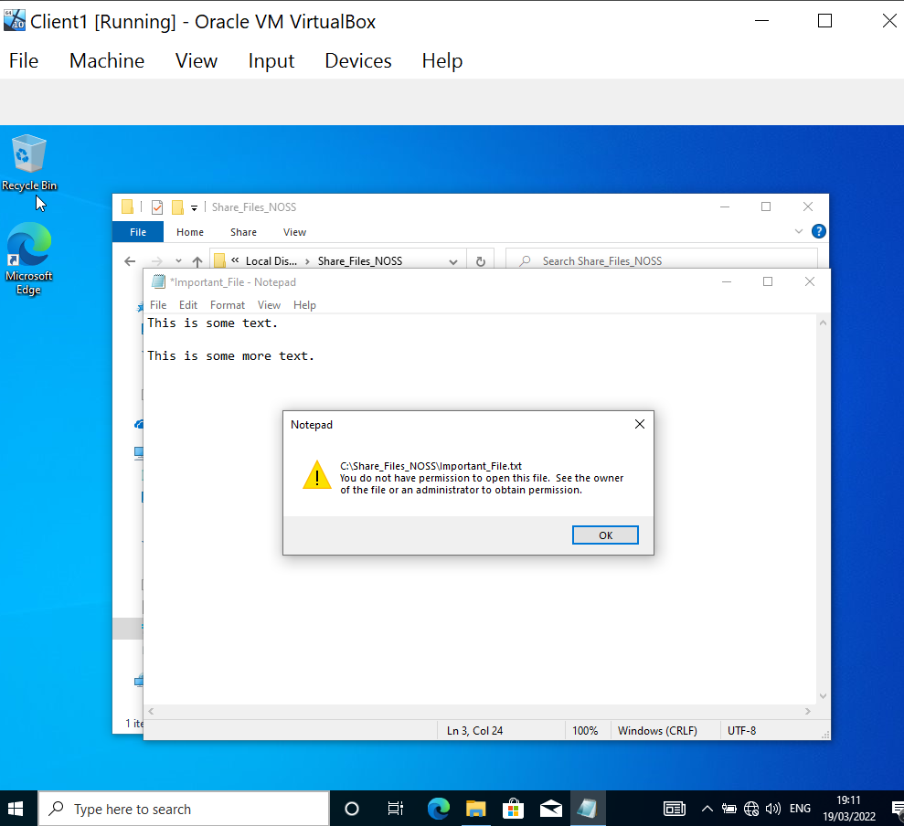
Fig 10: NTFS permissions are correct; the user does not have the relevant permissions to make changes to the file.

As shown above different users can be assigned different permissions for the same file or folder improving information security.

2.2 Share Permissions
Like NTFS, share permissions are used to prevent unauthorised access to resources .
Share permissions are used to control the level of access other users will have to a folder shared over a network [2]. They are less granular than NTFS and have three levels of control:
Type | User permissions
Full control | - Read and edit folder (and files).  - Edit permissions.  - Take ownership of files.
Change | - Read, execute and write.  - Delete folders and files within the share.
Read | - View folder’s content.
Table 2: Share permissions [2]

A new share is created on Server1.

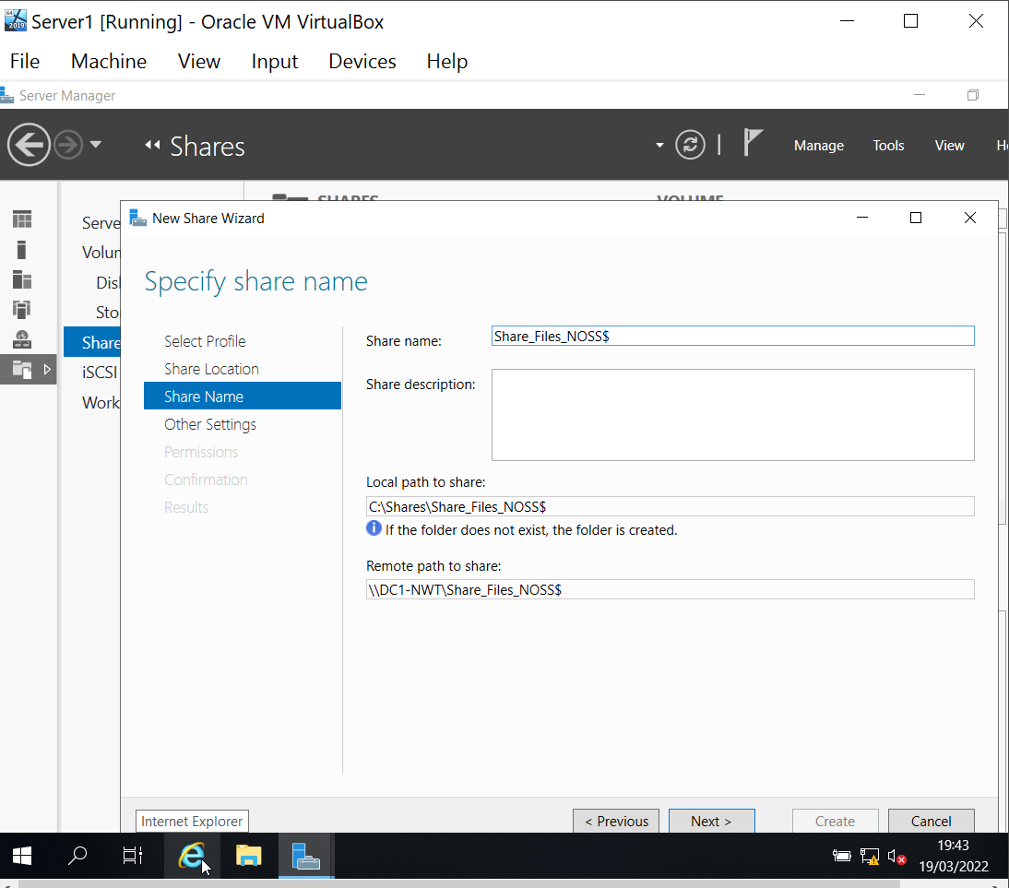
Fig 11: Creating a new share, local and remote share paths.
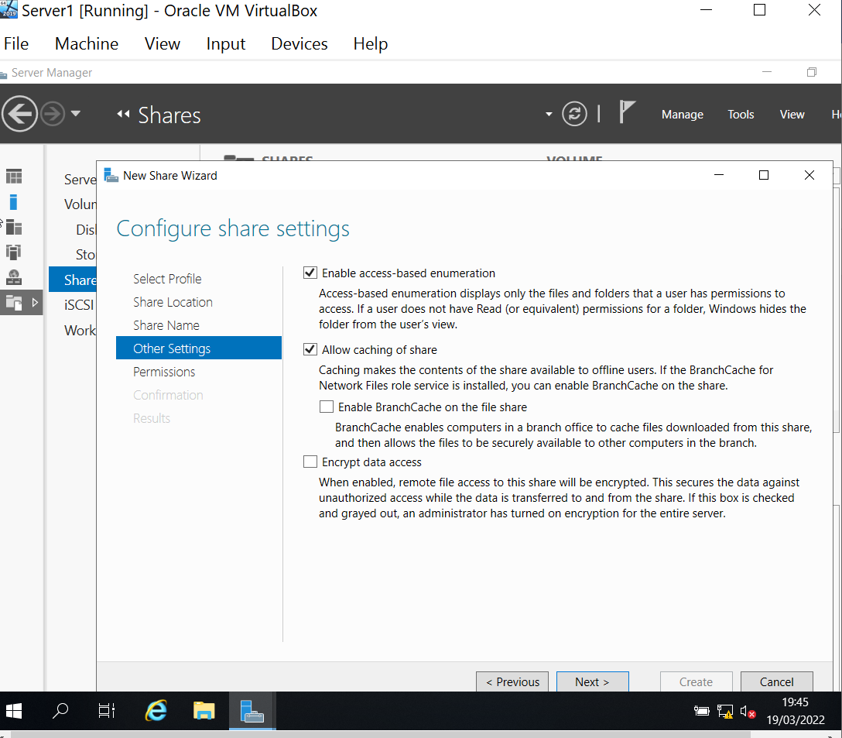
Fig 12: Access-based enumeration works with NTFS permissions enabling access to authorised users only.

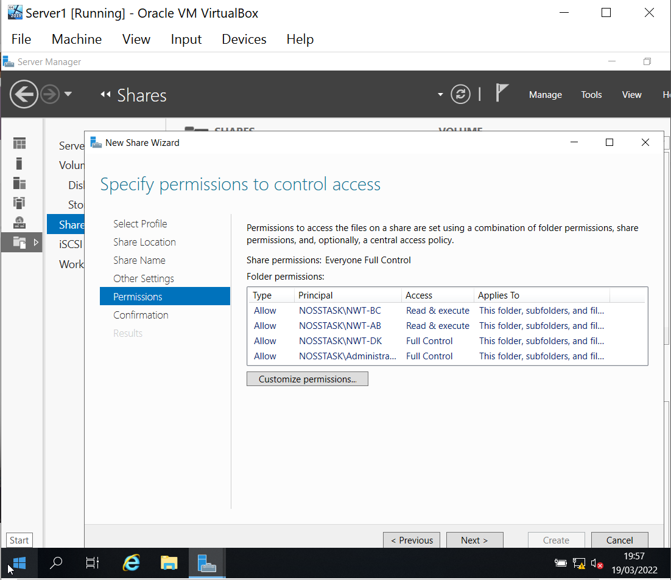
Fig 13: Specifying access permissions for users.
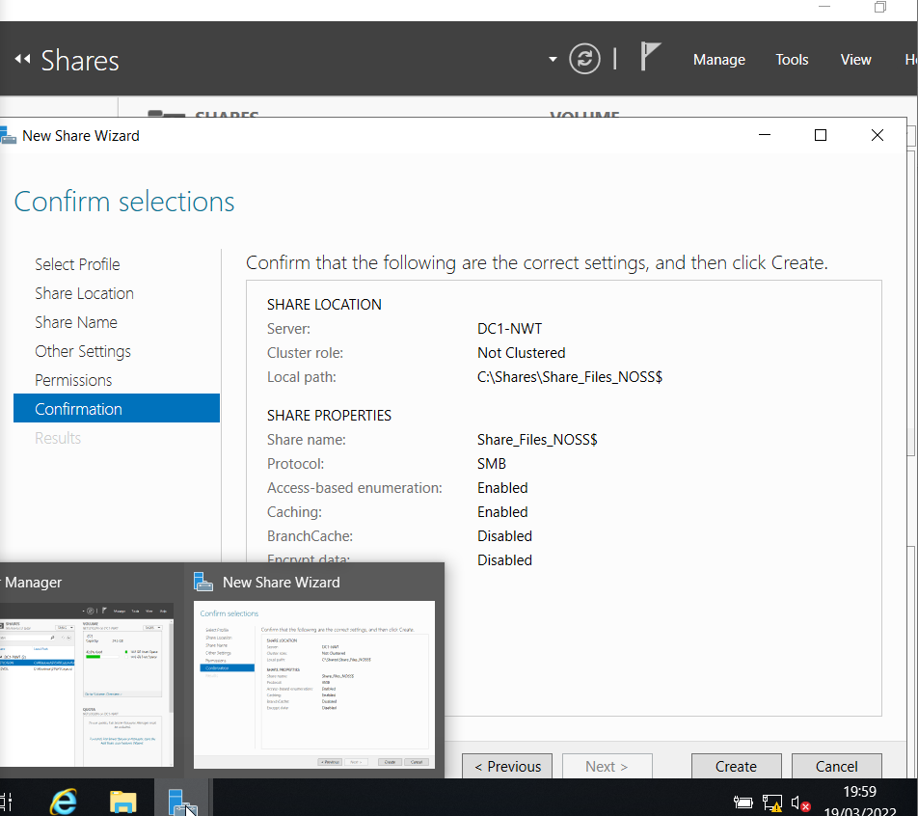
Fig 14: New hidden share has been created. $ is used to hide the share for security, this works with the permissions to ensure the file is only available to authorised users.

2.2.1 Accessing the file share/server over the network
There are several ways to access the share over the network:
- Via File Explorer using the path (if path is known).
- Browsing the computers on the network to find share (if not hidden).
- Using a Mapped Drive.
As this is a hidden share a Mapped Drive is created.
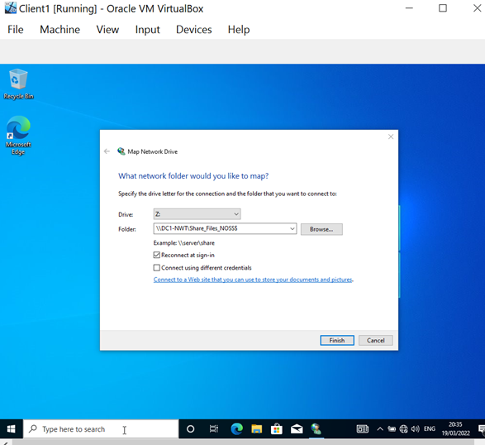
Fig 15: Mapping the Network Drive.

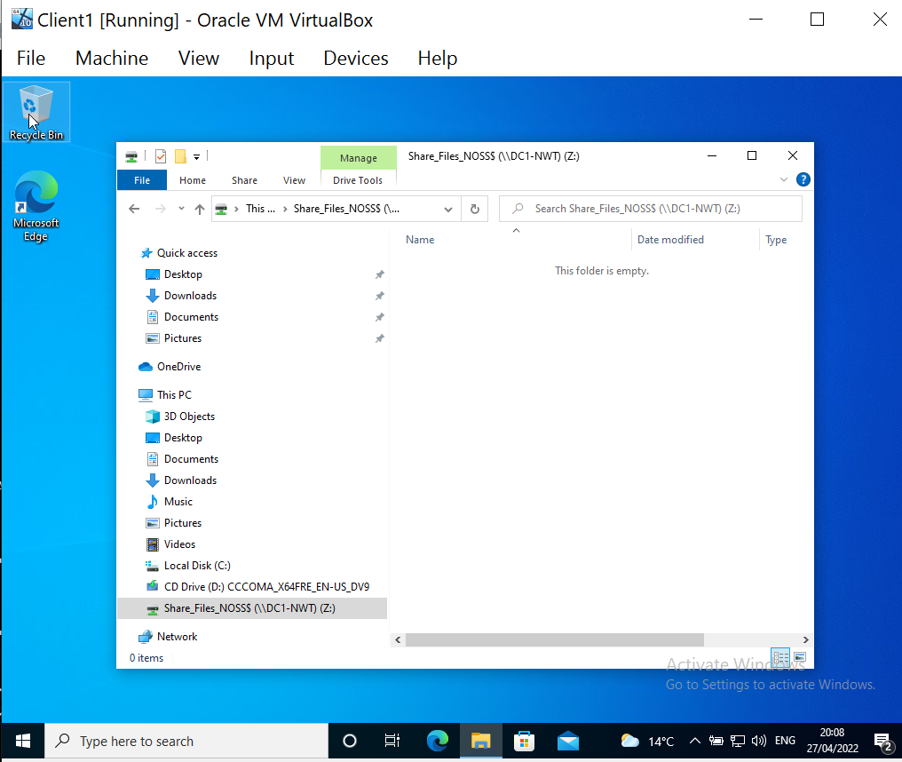
Fig 16: Shared drive is available on Client 1.

2.3 Utilising Group Policy
Group Policy is used to centrally manage domain computers and user accounts within an Active Directory network [4].
There are two types of Group Policy [5]:
- Local Group Policy – each computer has one local group policy that is only available to that computer and the uses that log into it. It is stored locally within the %systemroot%\System32\Group Policy folder and controls what can on the computer.
- Centralised Group policy – each domain controller has one or more centralised group polices. These can be applied to all users and computers in a domain, a site or to an Organisational Unit (OU).
A Group Policy Object (GPO) [5] is a collection of Group Policies. Access Control Lists (ACLs) are used alongside GPO to grant appropriate permissions. It is vital to ensure these do not contradict each as an explicit Deny permission will always override an Allow permission [6].
GPOs are created and managed in the Group Policy Management Console (GPMC).

2.3.1 Group Policy One – Moderating Access to the Control Panel
Restricting access to the Control Panel is a good security policy to prevent unauthorised setting changes.
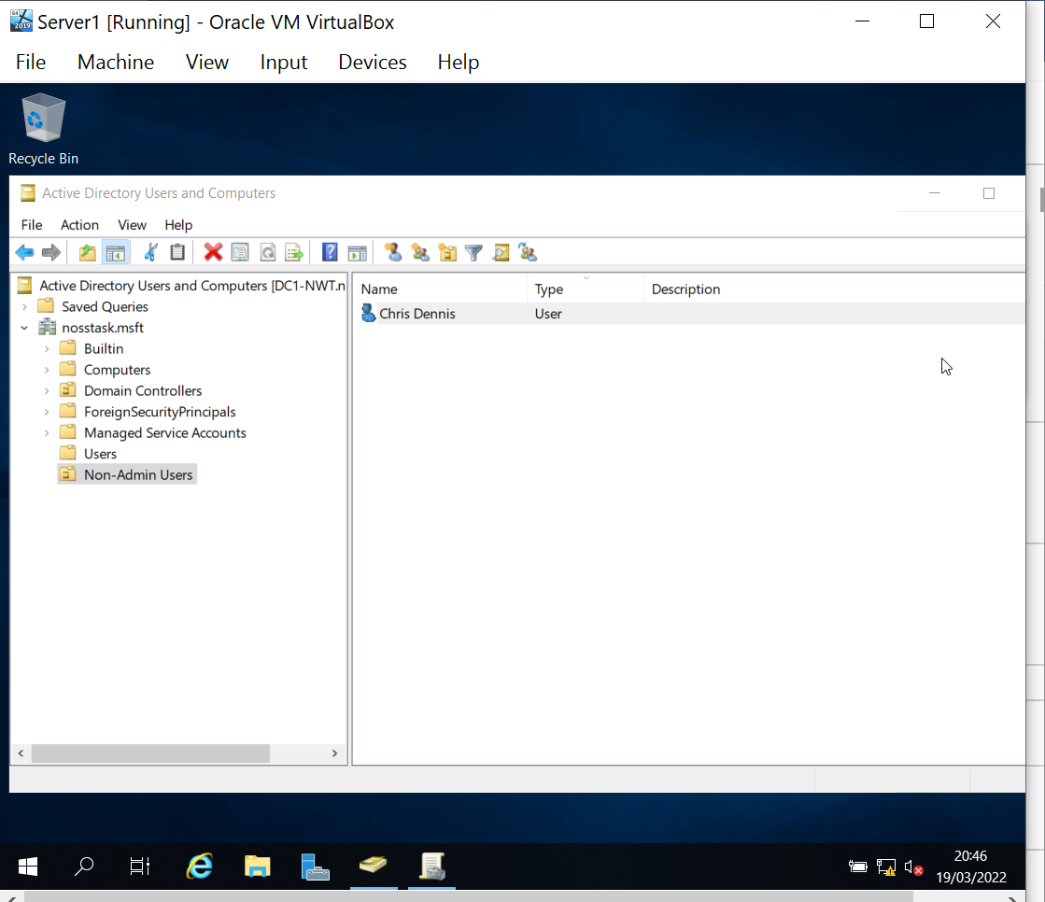
Fig 17: New Non-Admin OU created for non-admin users and a
new user added.

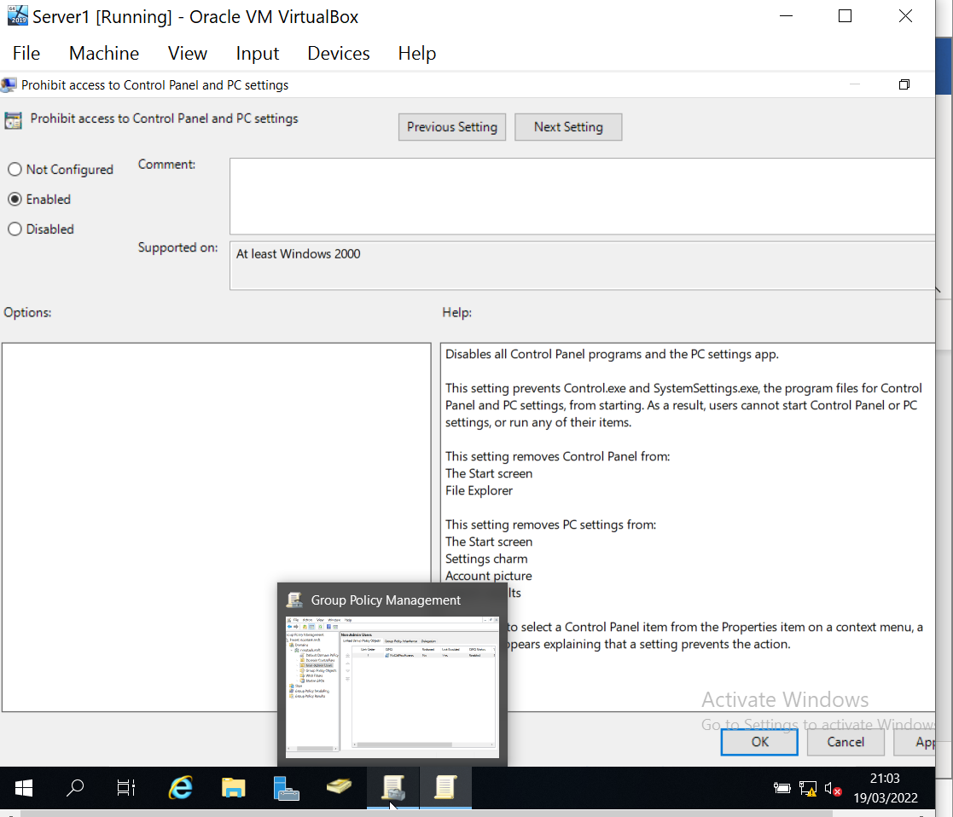
Fig 18: New GPO called NoCmdPrmptAccess to control access to the Control Panel.

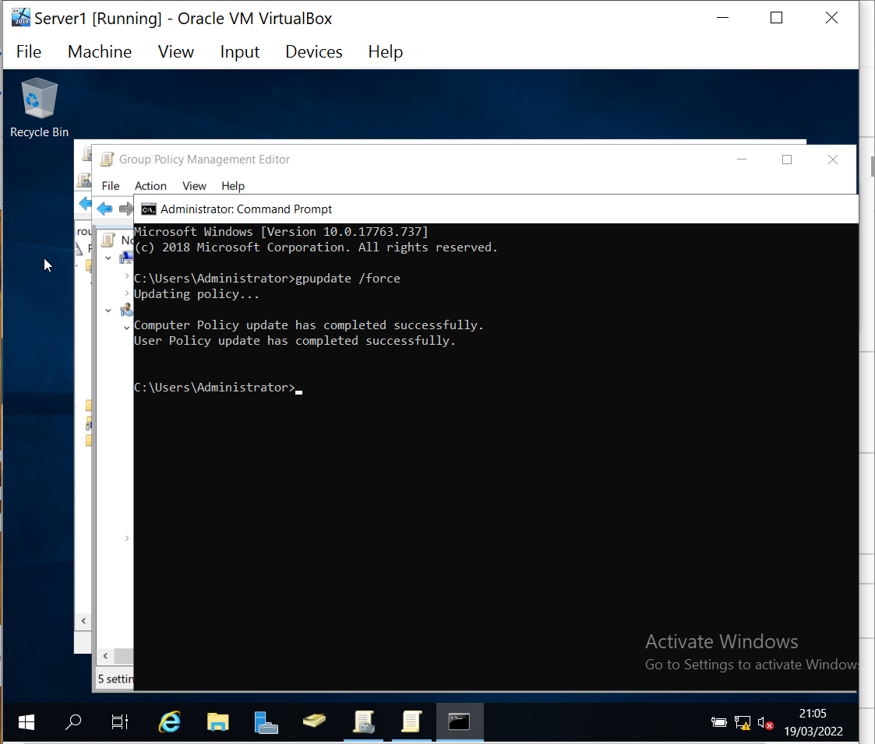
Fig 19: Group policy will update when the user logs back into a device. Another way is to use the gpupdate /force command to force the policy to update.

To test the policy Client1 was logged into using the new user account created in Fig 17.
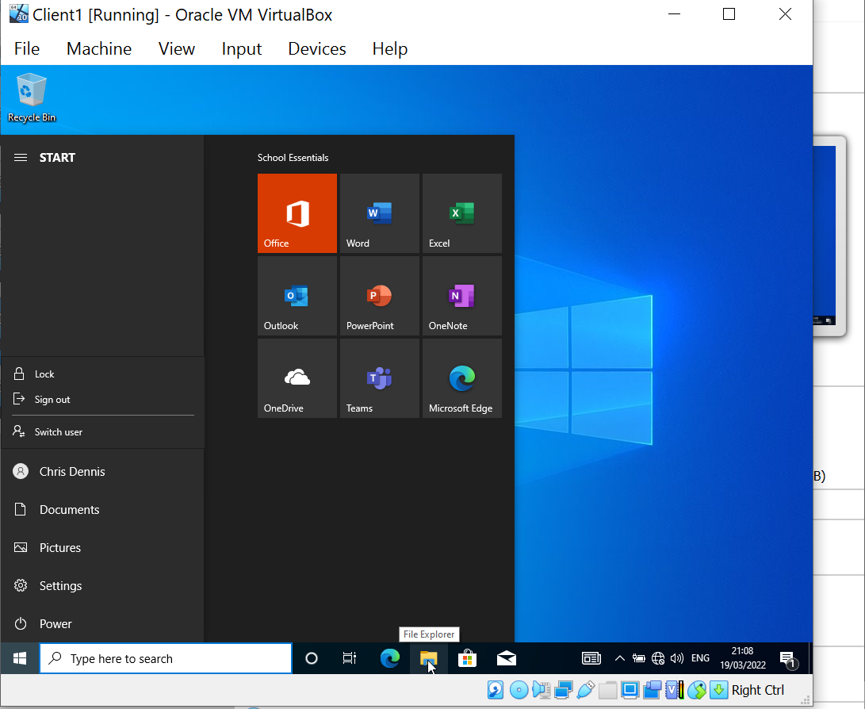
Fig 20: Logging in as the non-administrative user to test policy

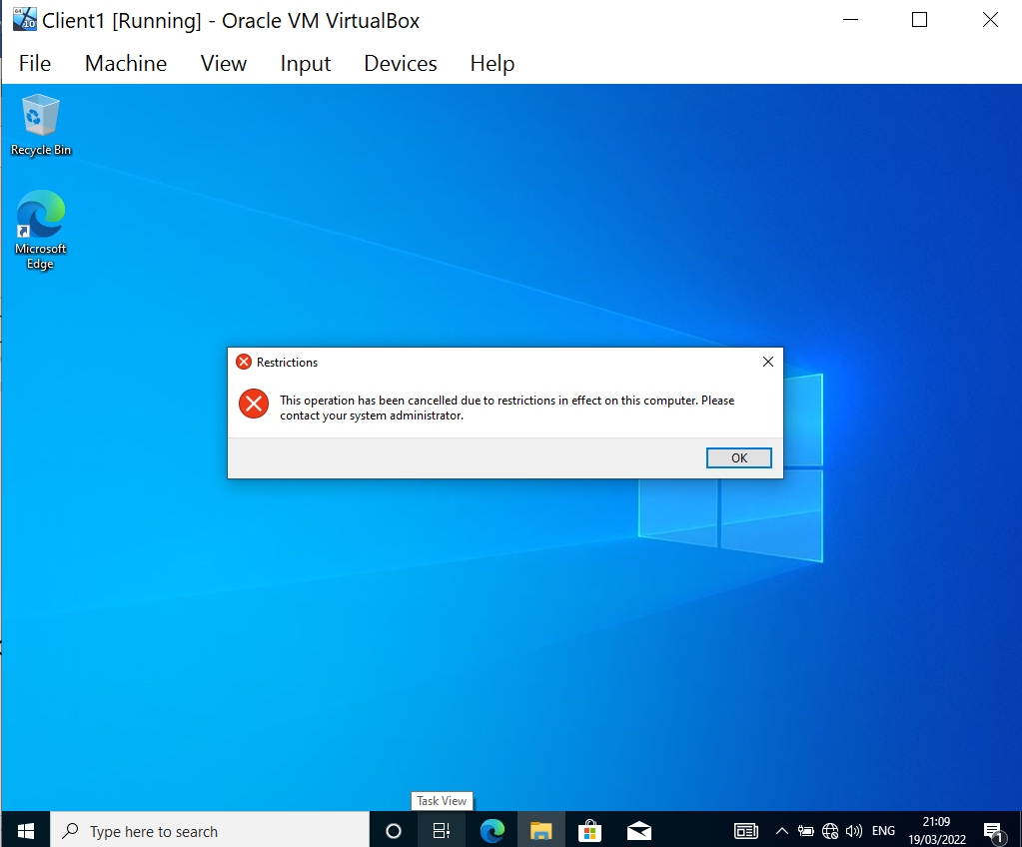
Fig 21: Test show policy works as expected as user is unable to access the control panel.

2.3.2 Group Policy Two – Removing Access to the Command Prompt
As the command prompt can be used to run unauthorised commands to change system setting or elevate access rights (accidently or maliciously) it should be carefully managed.
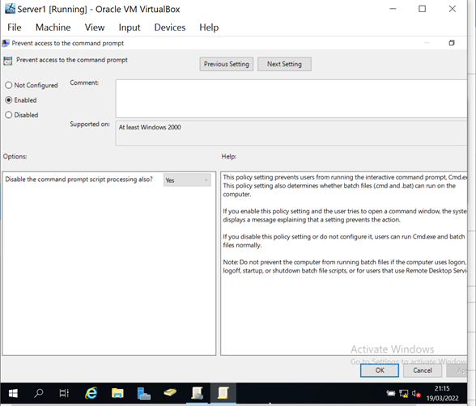
Fig 22: A new GPO is created to remove Command Prompt access for the Non-Admin OU group created previously (Fig 17).
To test the policy gpupdate /force command was used and Client 1 was logged into using the non-administrator account.
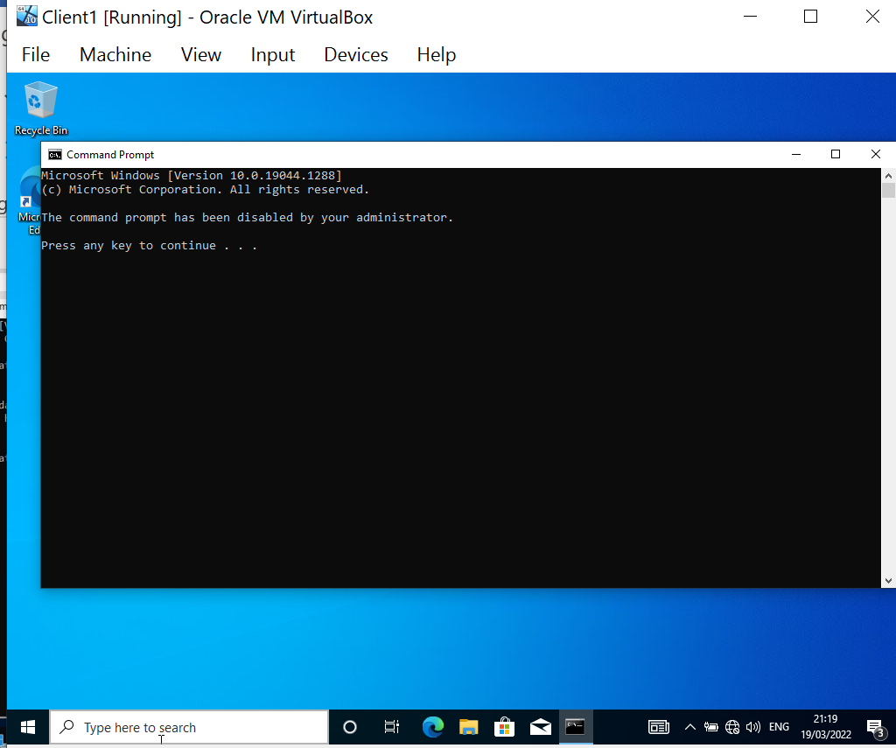
Fig 23: User was unable to access the command prompt due to the policy restrictions.

2.3.3 GPO 3 – Restricting Access to Removable Media Drives
The use of removable media should be restricted for the following reasons:
- Prevent data leakage
- Prevent introduction of malware onto the network.
The 2021 Honeywell Industrial USB Threat Report found that 37% of cybersecurity threats use removable media, an increase from 19% the previous year [7].
To mitigate this attack vector, access to removable media drives should be restricted.
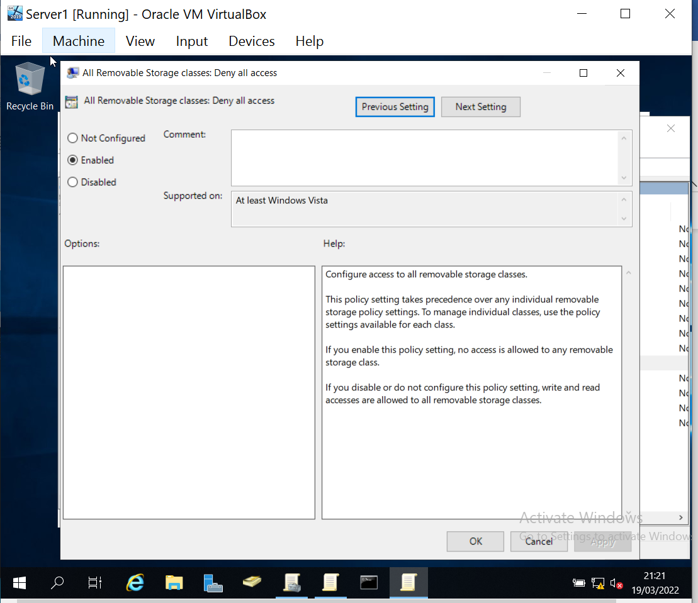
Fig 24: New GPO created to deny access to all removable storage drives.
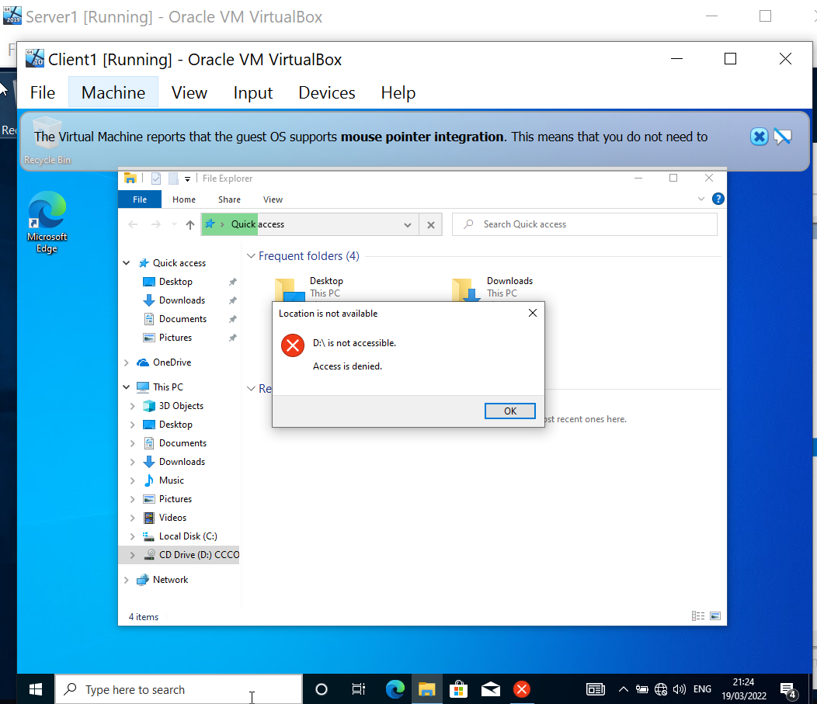
Fig 25: Testing shows access is denied.

2.3.4 GPO 4 – Restricting Software Installs
Software installation policies are needed to prevent unauthorised software being installed (intentionally or accidentally) onto the network.
Any software introduced to an enterprise network must be tested, licensed and patched. Unauthorised software not only introduces the risk of malware it could also provide legal issues surrounding software licenses and increased support costs.
Unlike the previous GPOs which have been applied to a user object, restricting software installs needs to be applied to a computer object. A new OU is needed.
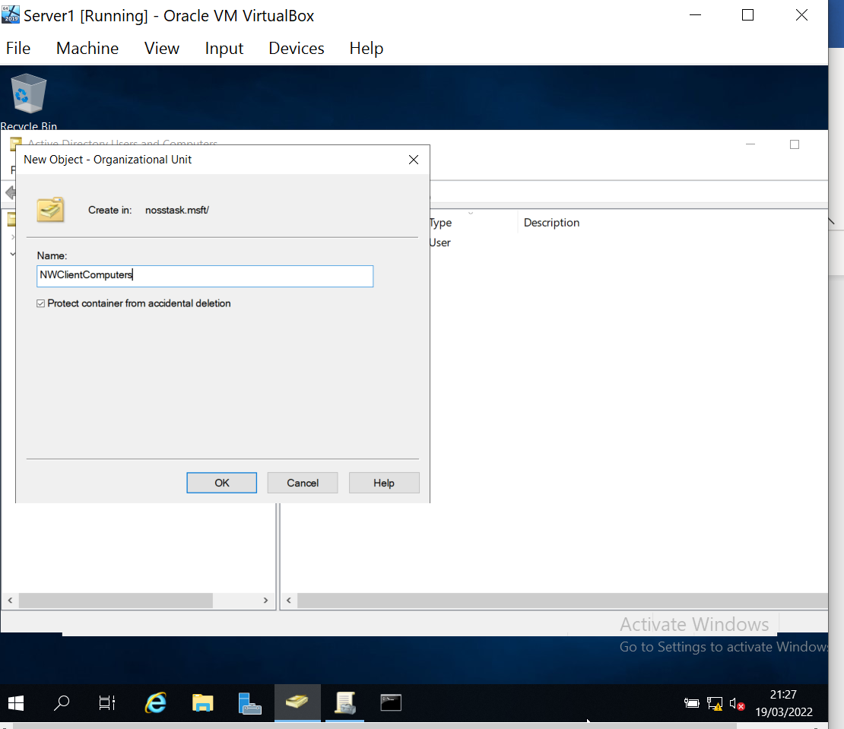
Fig 27: New OU object created.

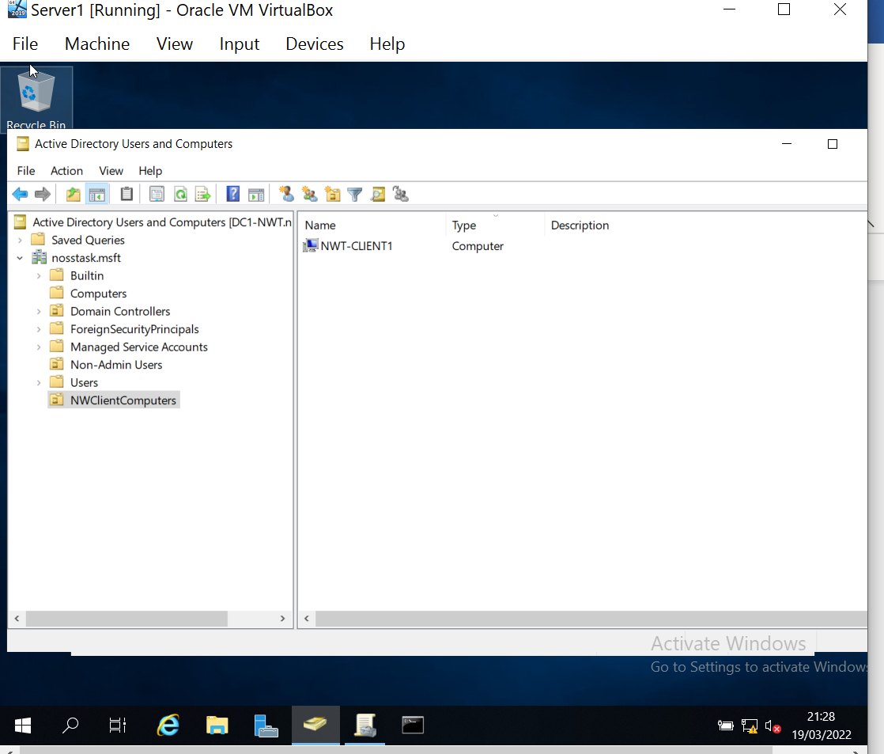
Fig 28: Client 1 workstation added to new OU object.

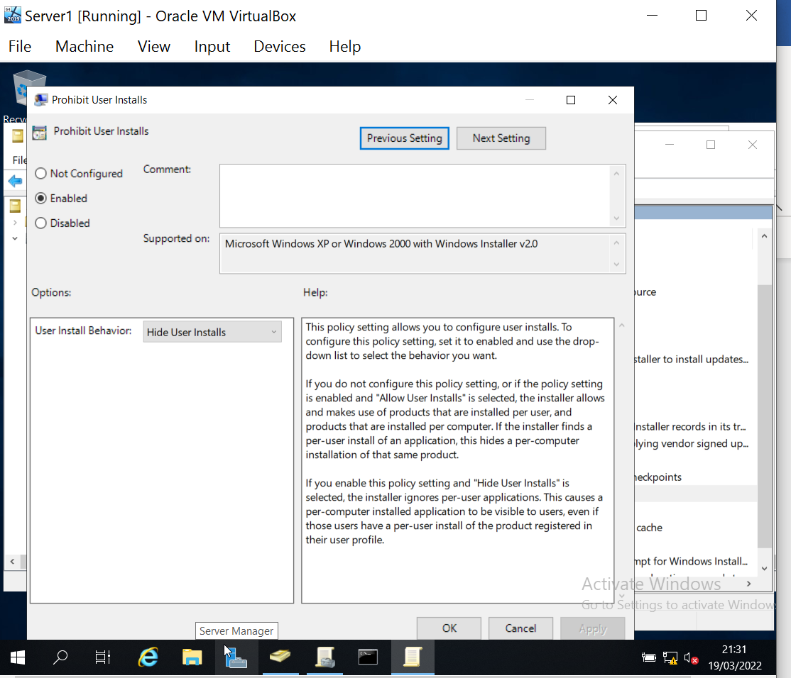
Fig 29: The new GPO to prevent software installs is created withing the new OU object created above (Fig 28).

For this group policy object to be tested the device needs to be given internet access in order find the software to download. To allow this a second internet adapter was created.
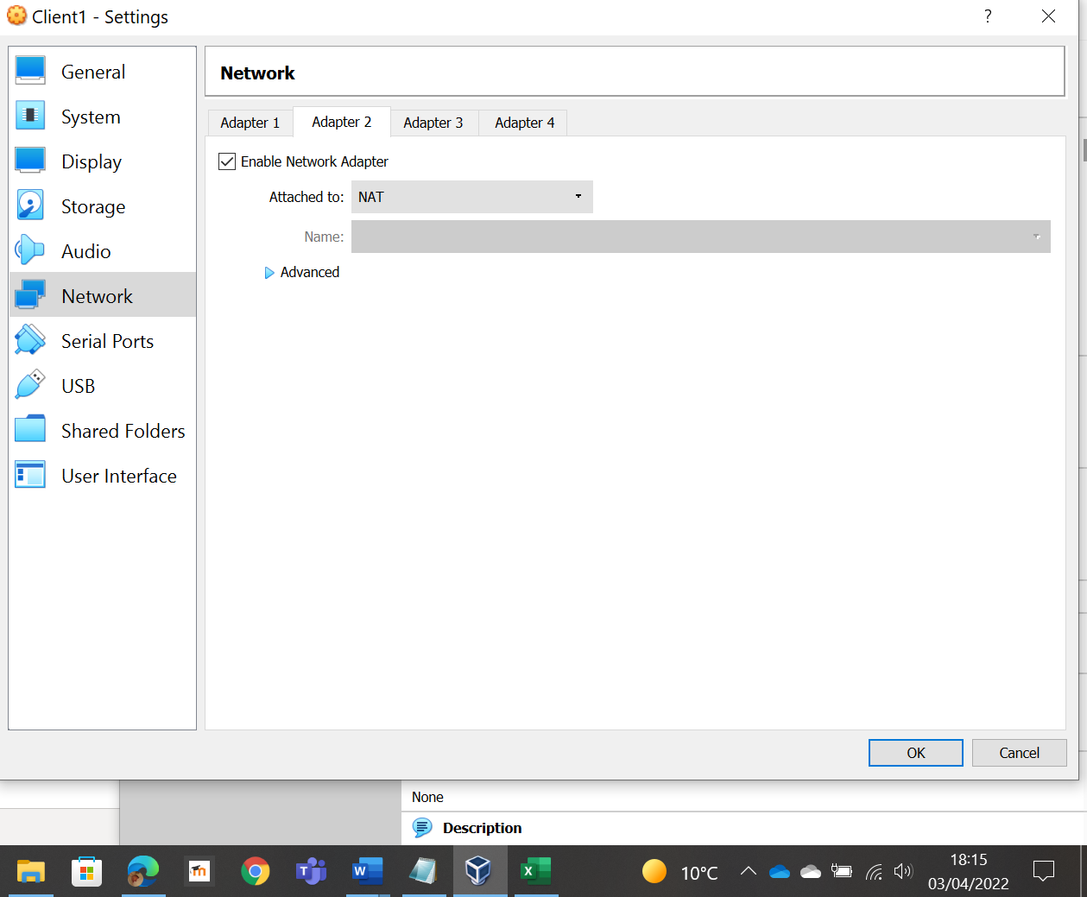
Fig 30: NAT adapter allows the Virtual Machine (VM) to access the internet via the host machine [8].

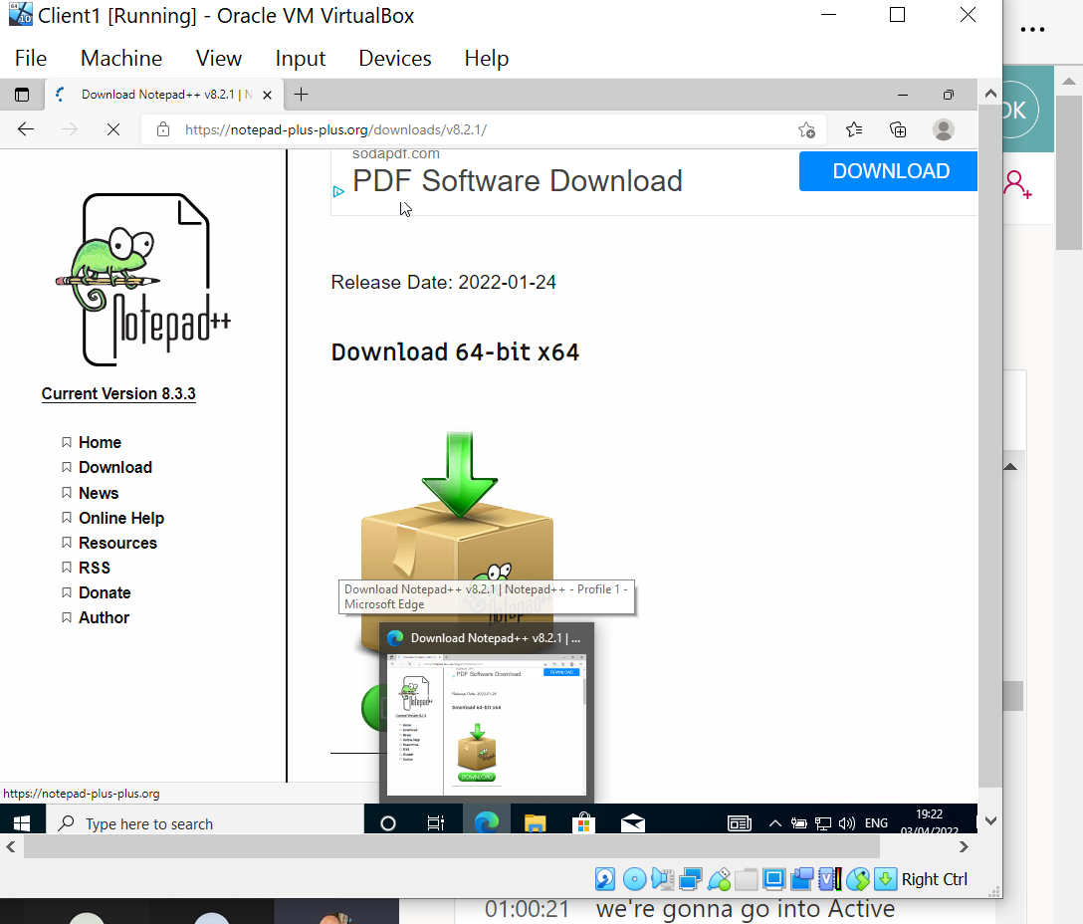
Fig 31: Software to be installed [9]

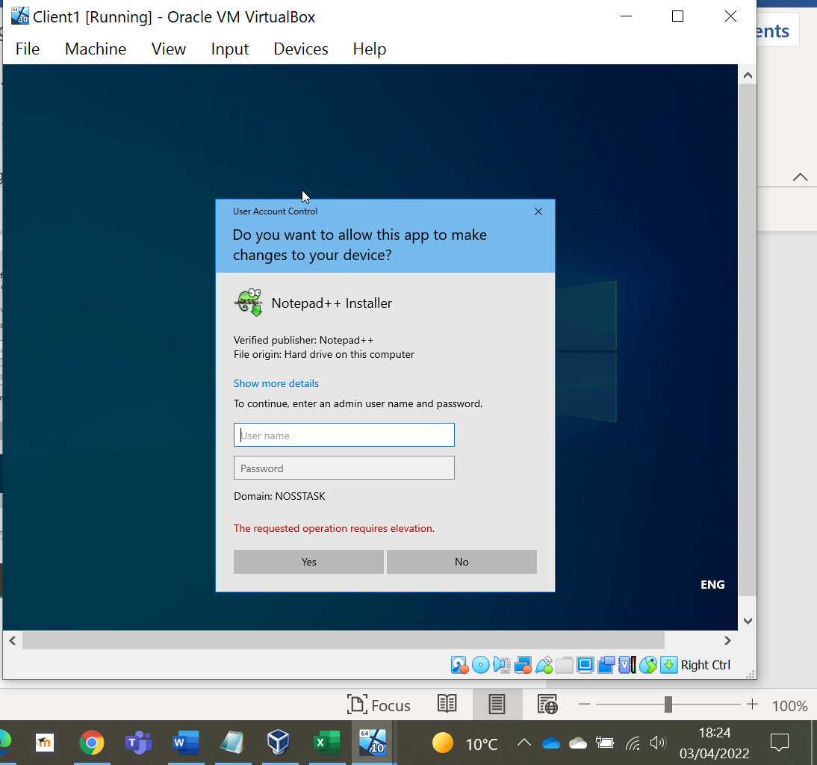
Fig 32: Software installation was denied as user did not have the required permissions.

2.3.5 GPO 5: Enforcing Password Policy in the ‘nosstask.msft’ domain
Password policies are a set of rules to help users create a secure password to help increase security. They are an important part of network security.
Unlike previous GPOs created this is a domain level policy which is created within the Default Domain Policy GPO.

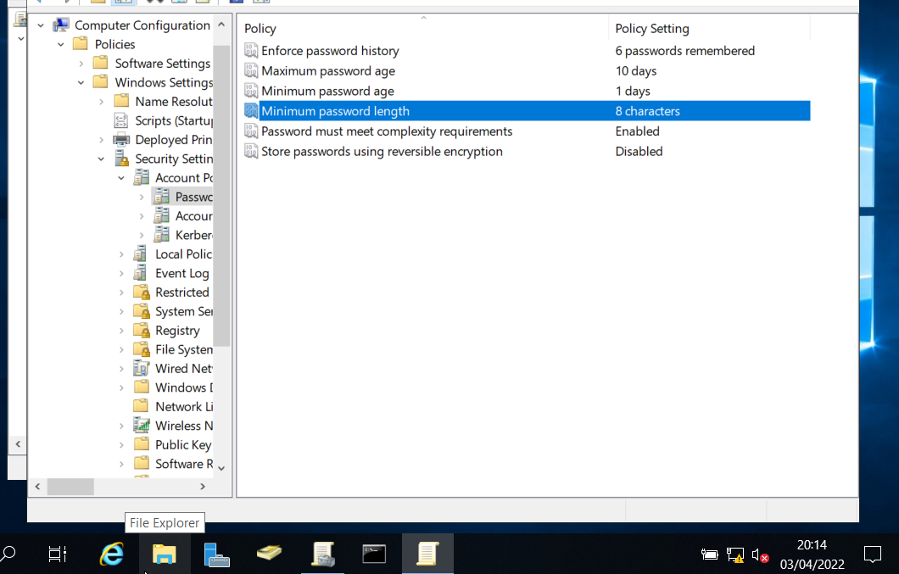
Fig 33: New password policy settings.

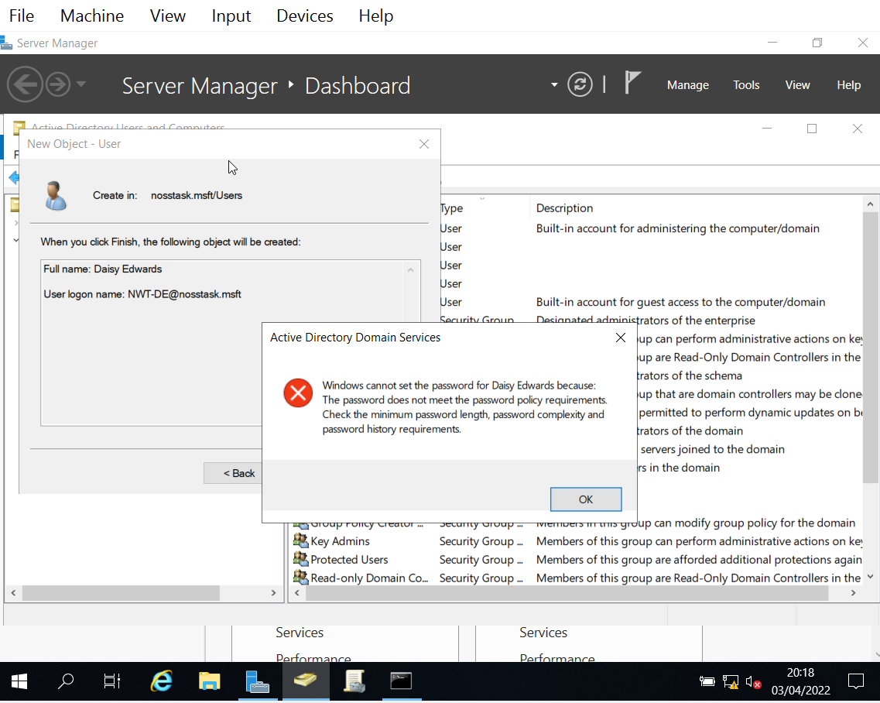
Fig 34: Testing new password policy.
- Task 2 – Routing and Packet Filtering with core TCP/IP Services and critical failover/redundancy practices

3.1 Utilising ARP and Routing Table
ARP (Address Resolution Protocol) is a layer 2 protocol of the OSI model [10]. It is used to translate MAC addresses (layer 2) to IP addresses (layer 3) [11].
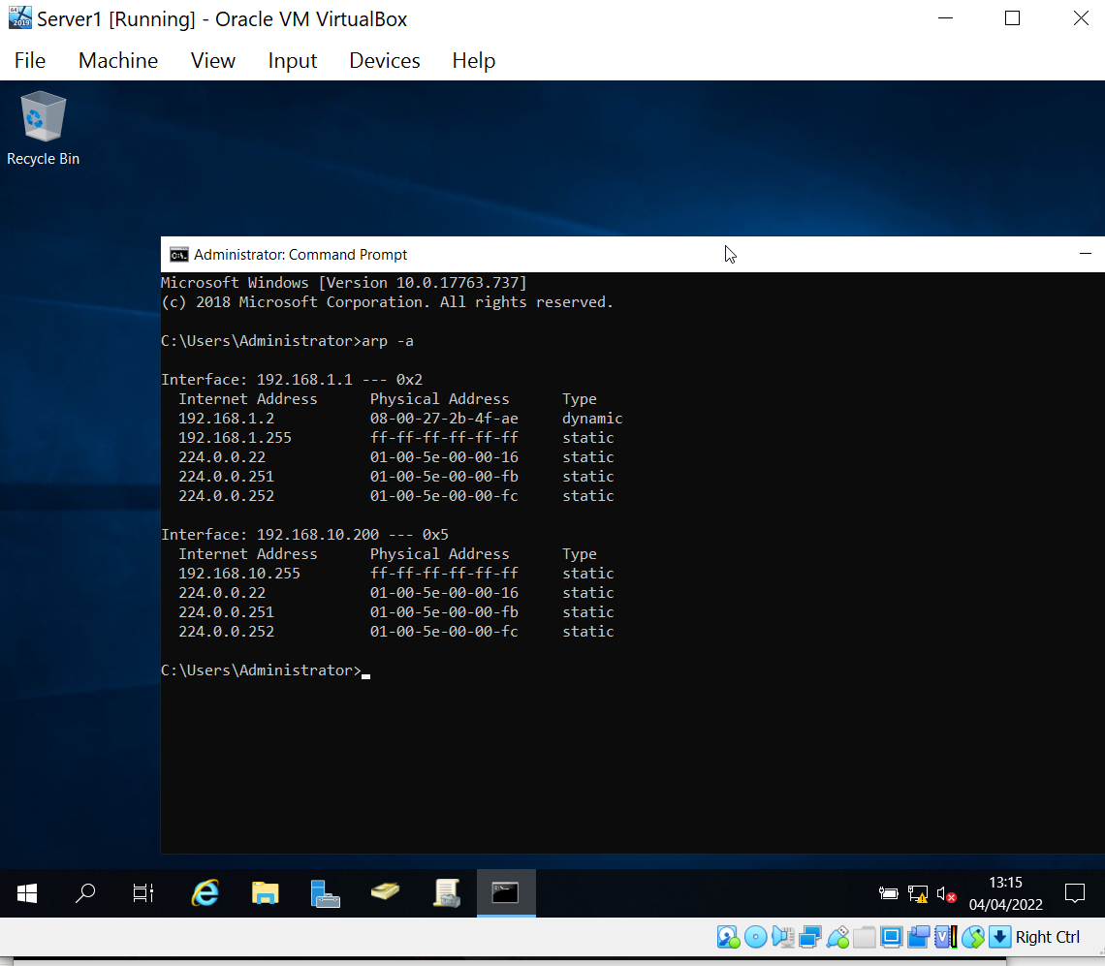
Fig 35: ARP table

3.2 Deploy core services (FTP server)

An FTP server enables files to be available for download using a FTP protocol [12]. It is used to facilitate remote data sharing between computers or over the internet.
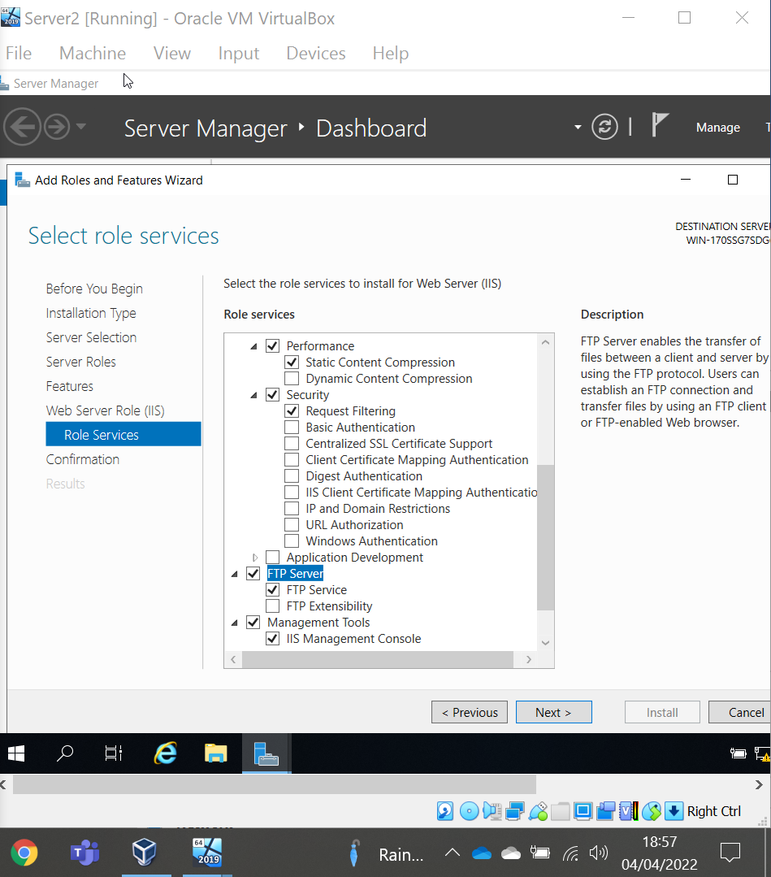
Fig 36: Creating a FTP server.

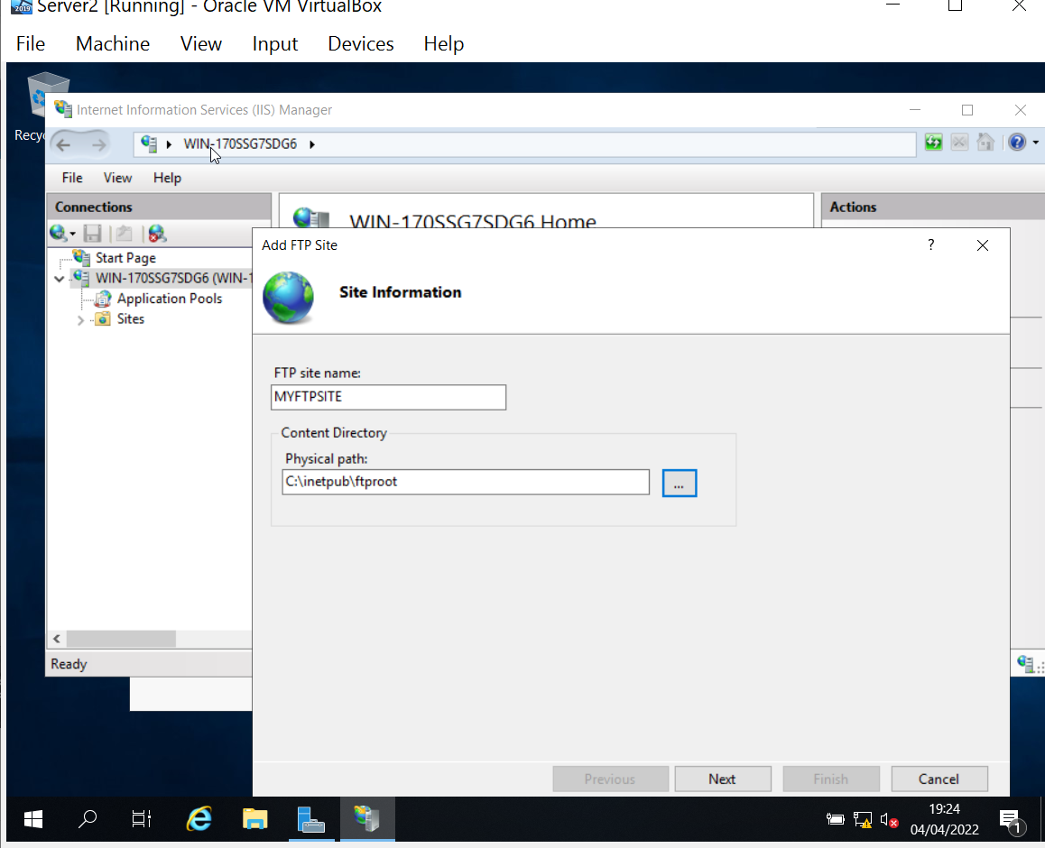
Fig 37: Site information.
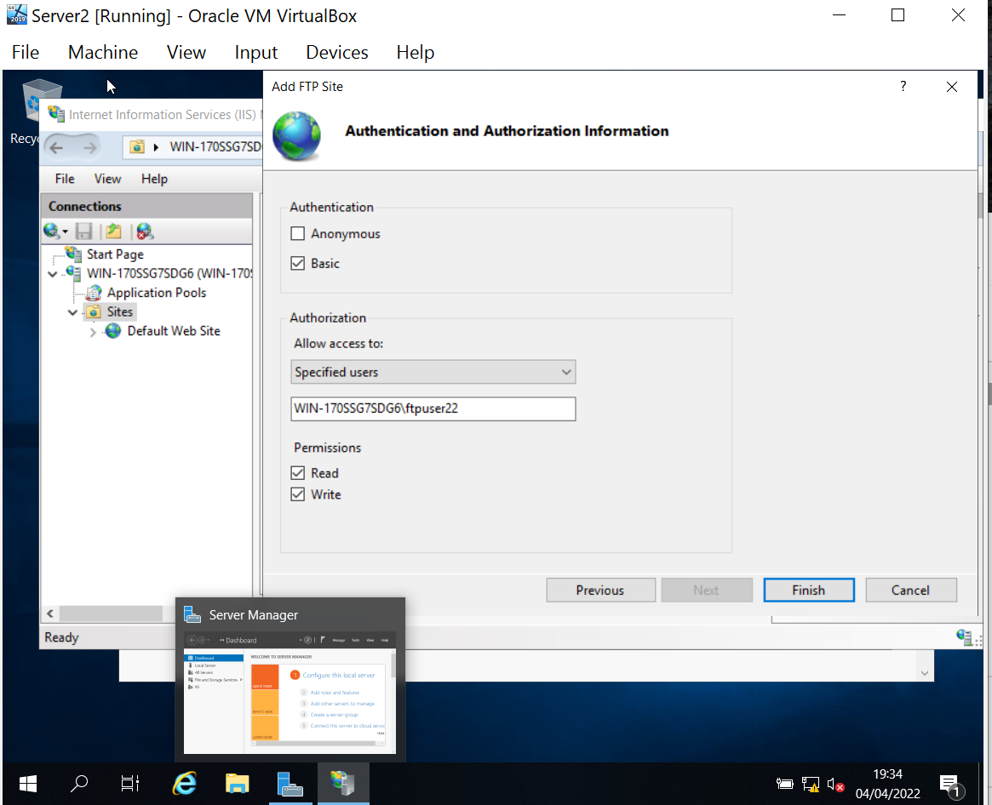
Fig 38: Setting permissions.

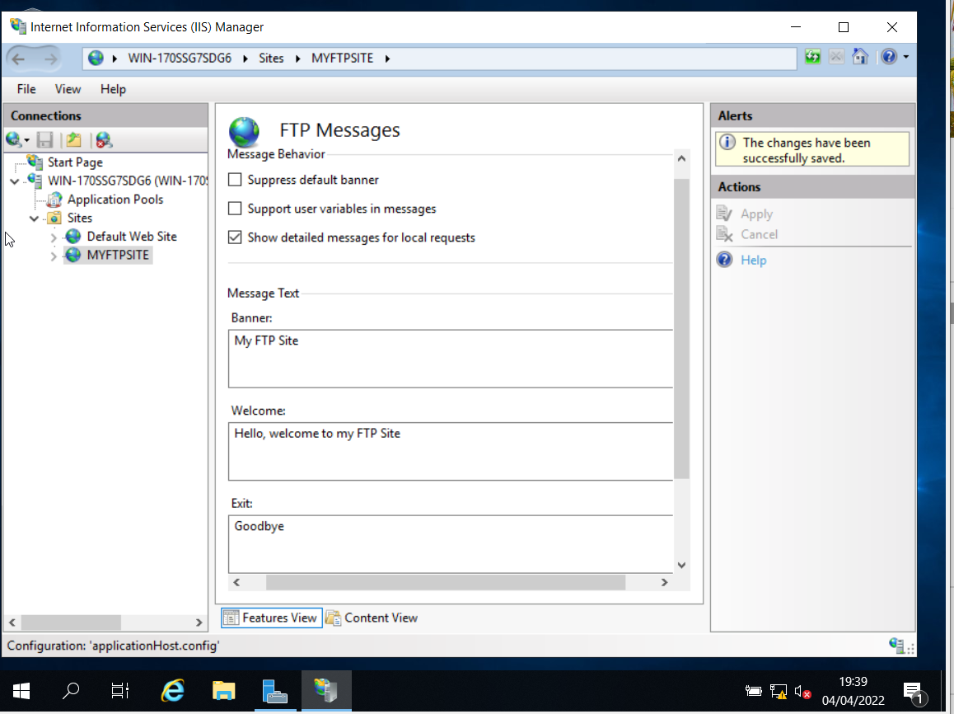
Fig 39: Creating a banner which will be displayed to the users when they connect to the FTP Server.

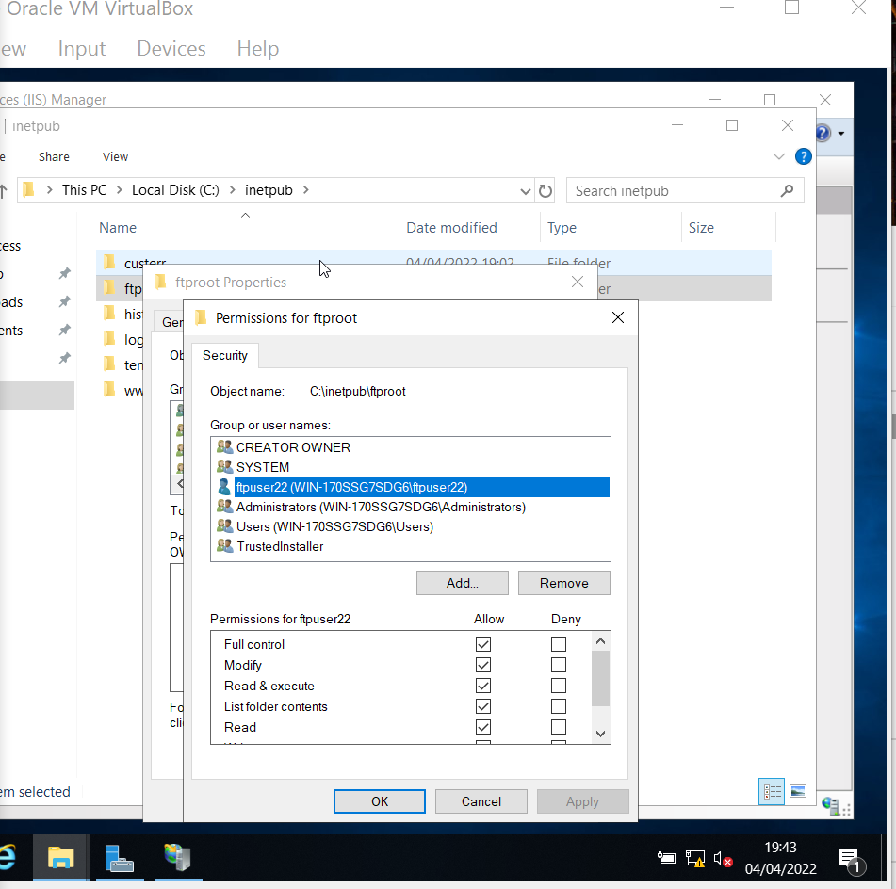
Fig 40: New user created and permissions set.

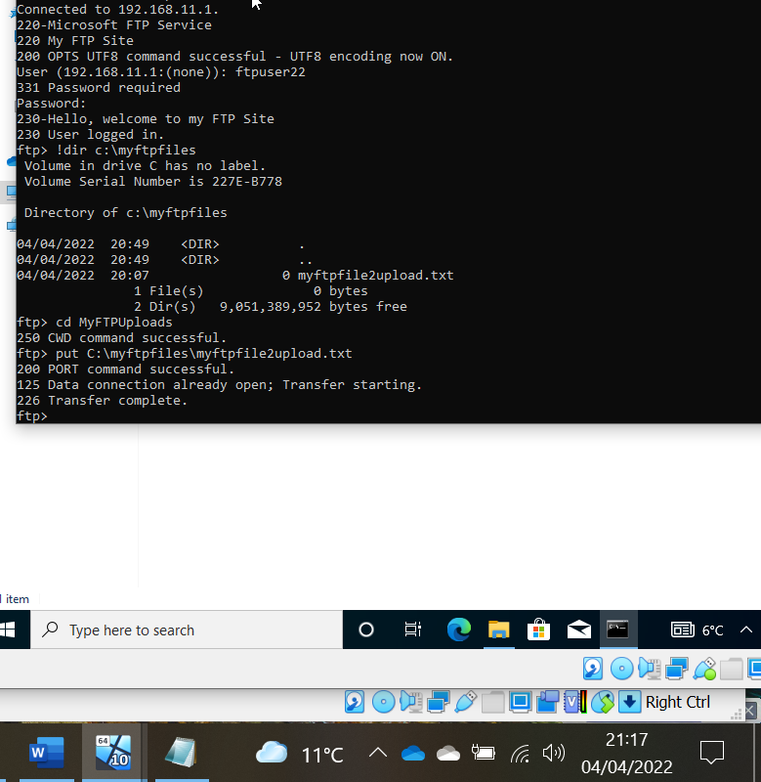
Fig 41: Testing the FTP service by remotely logging onto the server and uploading a new file.

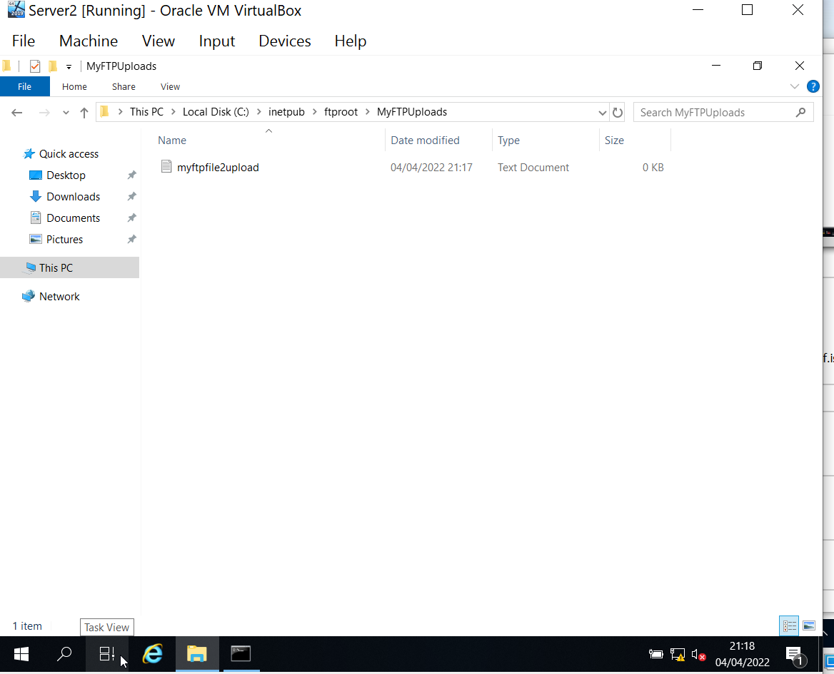
Fig 42: Testing the file has uploads correctly.

Installing and configuring the Routing and Remote Access Service
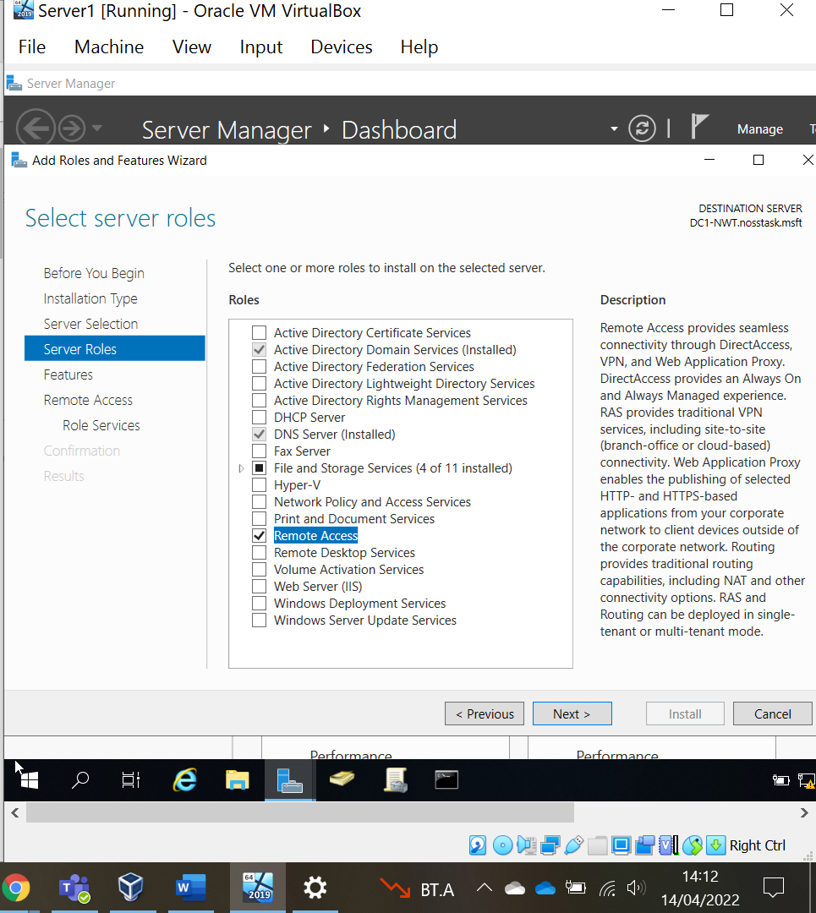
Fig 43: Adding remote access role to server 1 to allow routing services to be enabled. Converged networks use routing protocols to communicate.
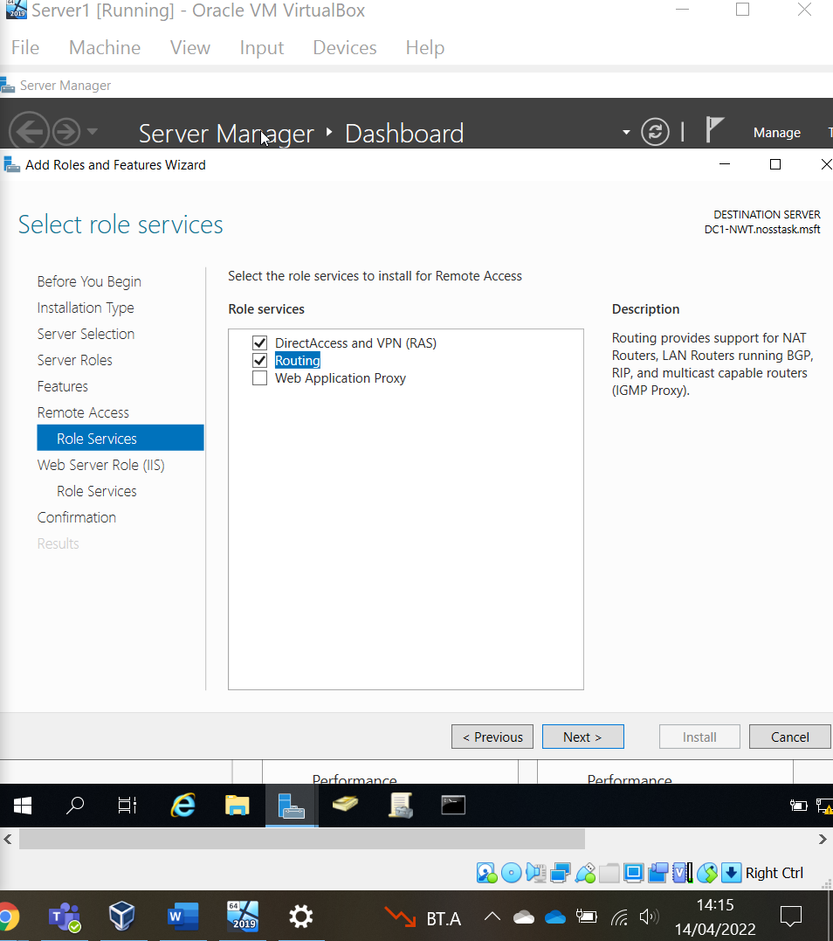
Fig 44: DirectAccess and VPN (RAS) and Routing is enabled on both Servers.

Adding RIPv2 IPv4 Routing Protocol adds routing functionality to the server [13]. The allows the servers to share information about their connected networks [14].
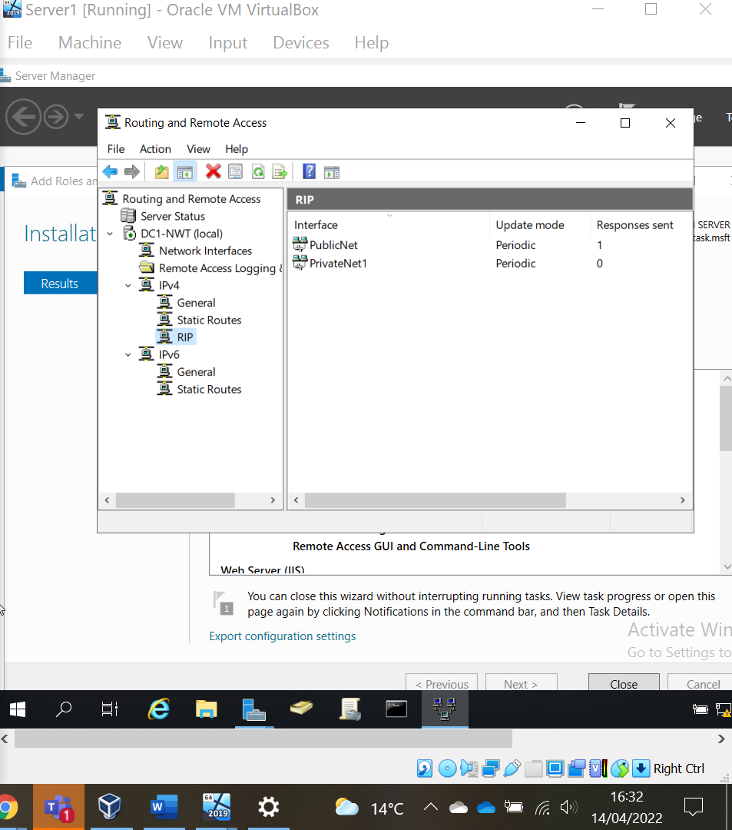
Fig 45: RIPv2 set on Server 1 for the PrivateNet1 and PublicNet interfaces. This is repeated on Server 2 with the PrivateNet2 and PublicNet interfaces

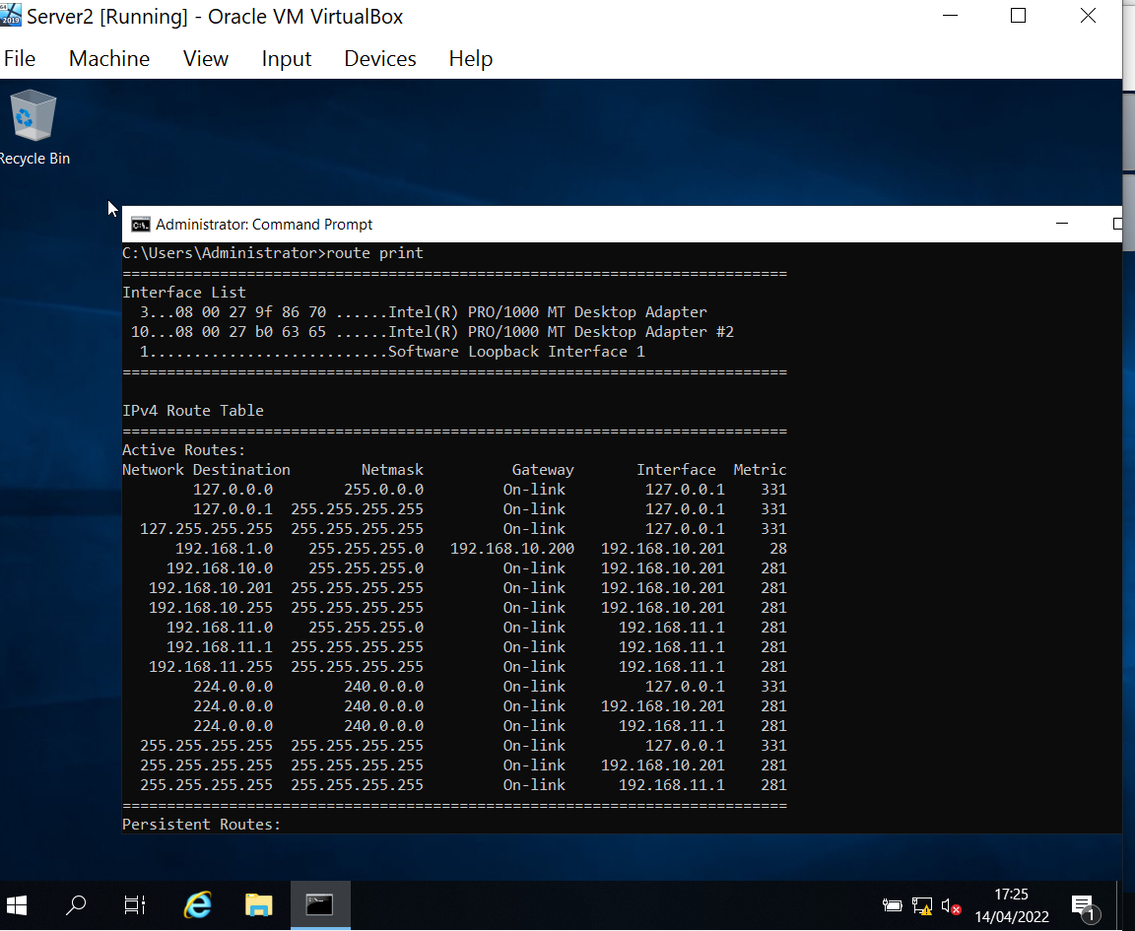
Fig 46: IP Table for Server2 showing routes to other networks.

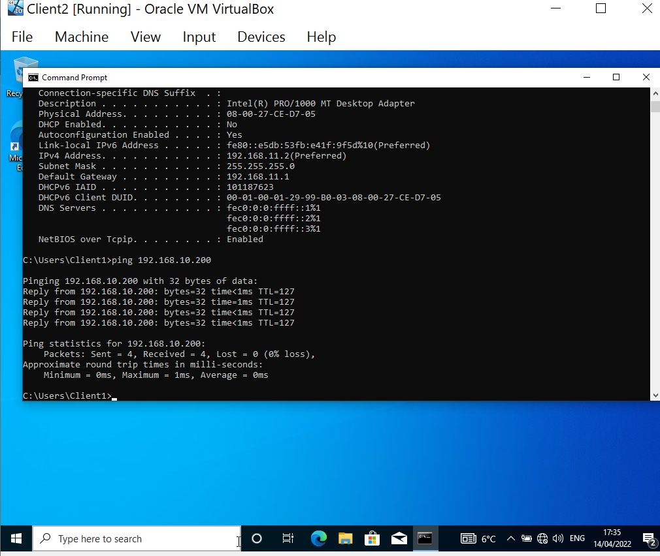
Fig 47: As pings were successful the networks were connected.
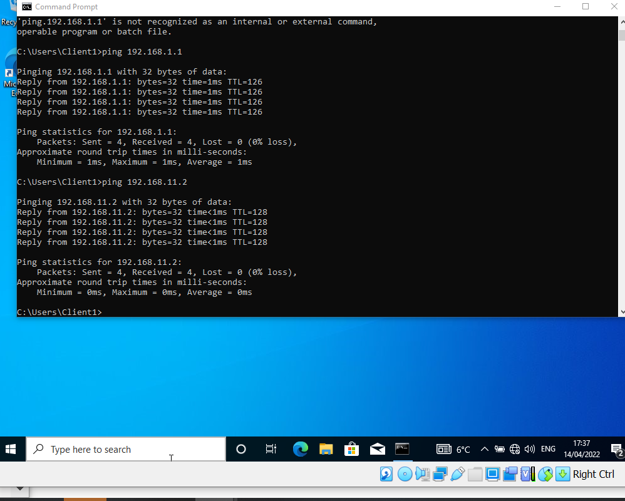
Fig 48: Second ping test to check connectivity to second adapter was also successful showing networks connectivity between clients.

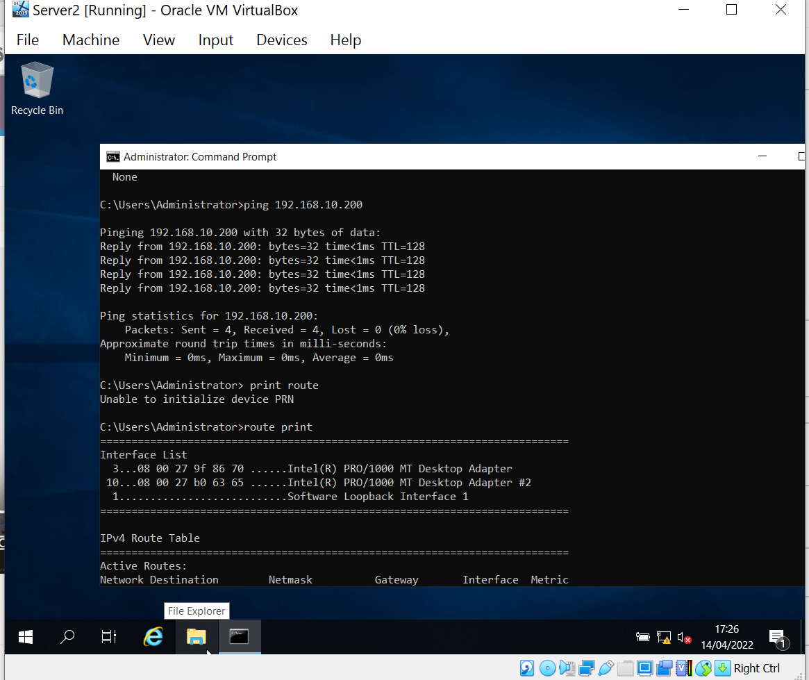
Fig 49: Testing network connectivity between servers.

3.4 IP Packet Filtering
Packet filtering is a firewall technique [15] [16] used to securely manage network access by allowing/denying inbound or outbound packets based on the following:
- Source or Destination IP address
- Protocols
- Ports

3.4.1 Filter one – stopping anyone in PrivateNet1 from pinging the Router Firewall Service
This filter was added to the inbound rules of PrivateNet1 to filter traffic coming into this router.
To stop ICMP traffic from anyone on PrivateNet1 the network gateway address is blocked, if we wanted block a specific host that address would be used instead.
The rule is set to drop any type of ICMP packets, other traffic is not affected.

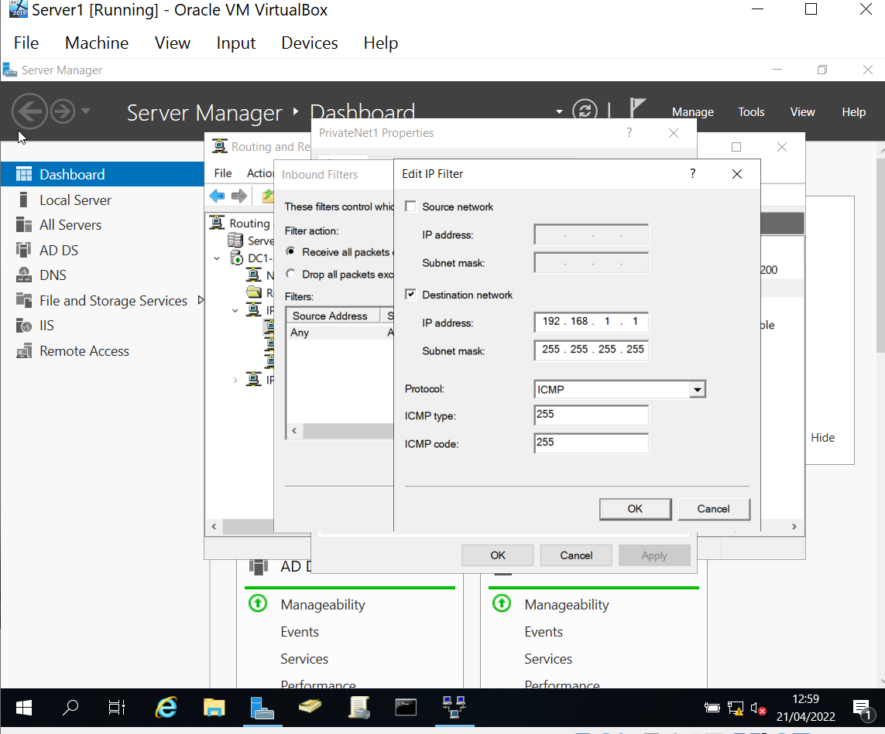
Fig 50: Inbound filter to drop ICMP traffic.
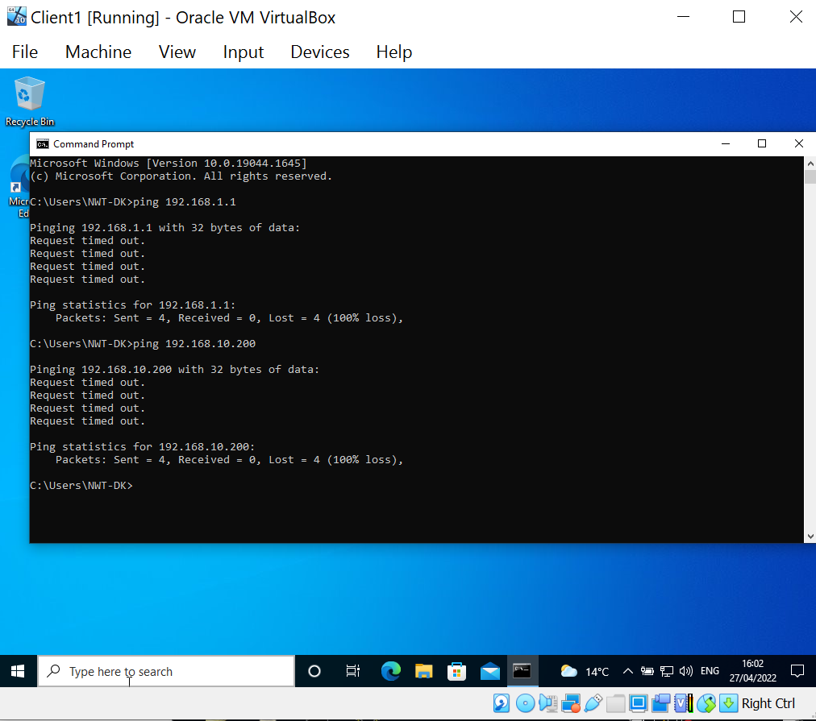
Fig 51: Pings were unsuccessful because ICMP traffic is blocked. The Ping utility uses ICMP packets.

The above test shows ICMP traffic has not been allowed to either of Server 1’s interface. If traffic was allowed a second inbound rule could be placed to drop ICMP traffic on the 192.168.10.200 interface. Alternatively a catch all ICMP rule could be used to drop all ICMP packets by keeping the source and destination addresses blank.
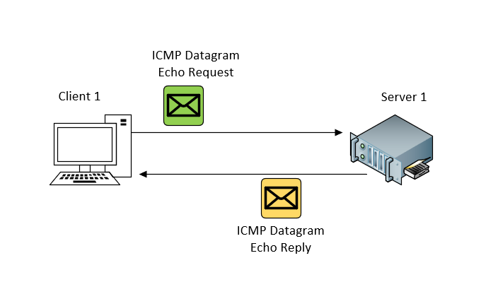
Fig 52: How icmp requests work..

3.4.2 Filter 2: Restrict Access to FTP Service running on Server 2 to only hosts in PrivateNet2.
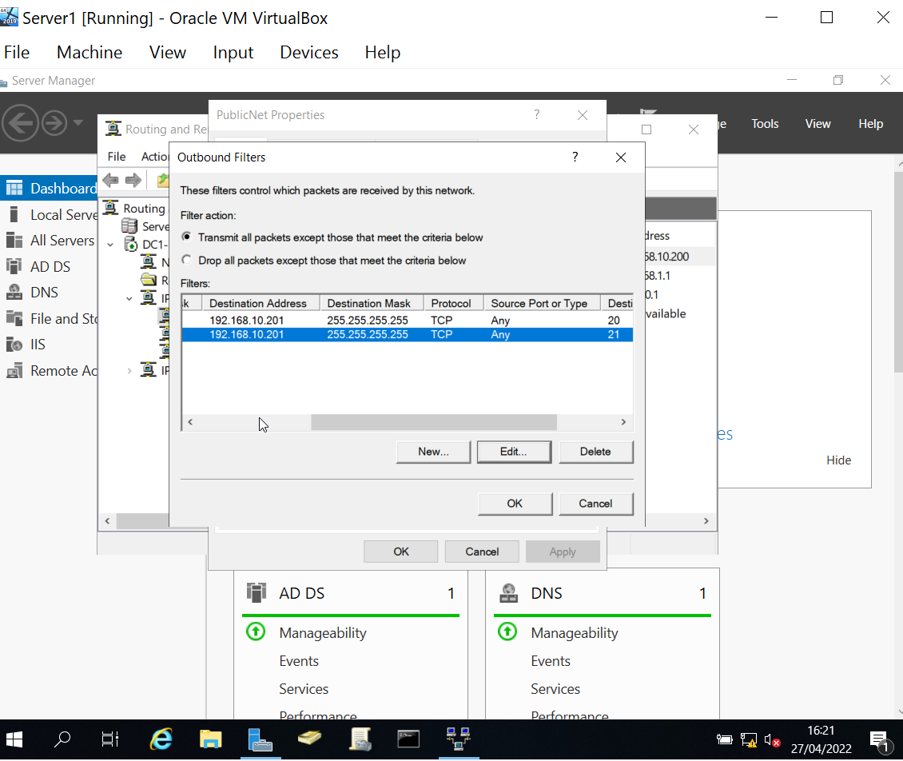

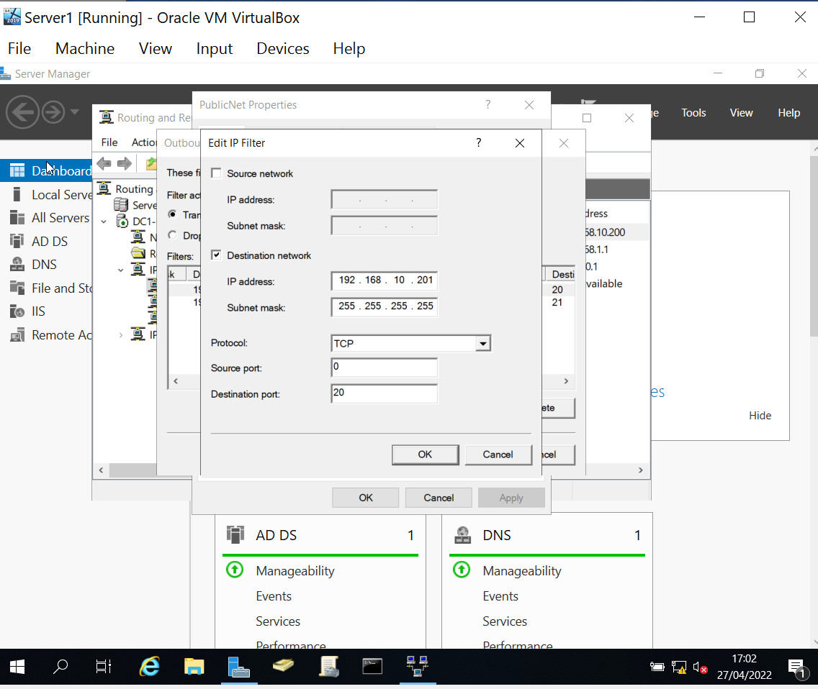
Fig 53 and 54: Outbound filter added to Server 1 router to drop TCP traffic over ports 20 and 21 from the PrivateNet1 network.
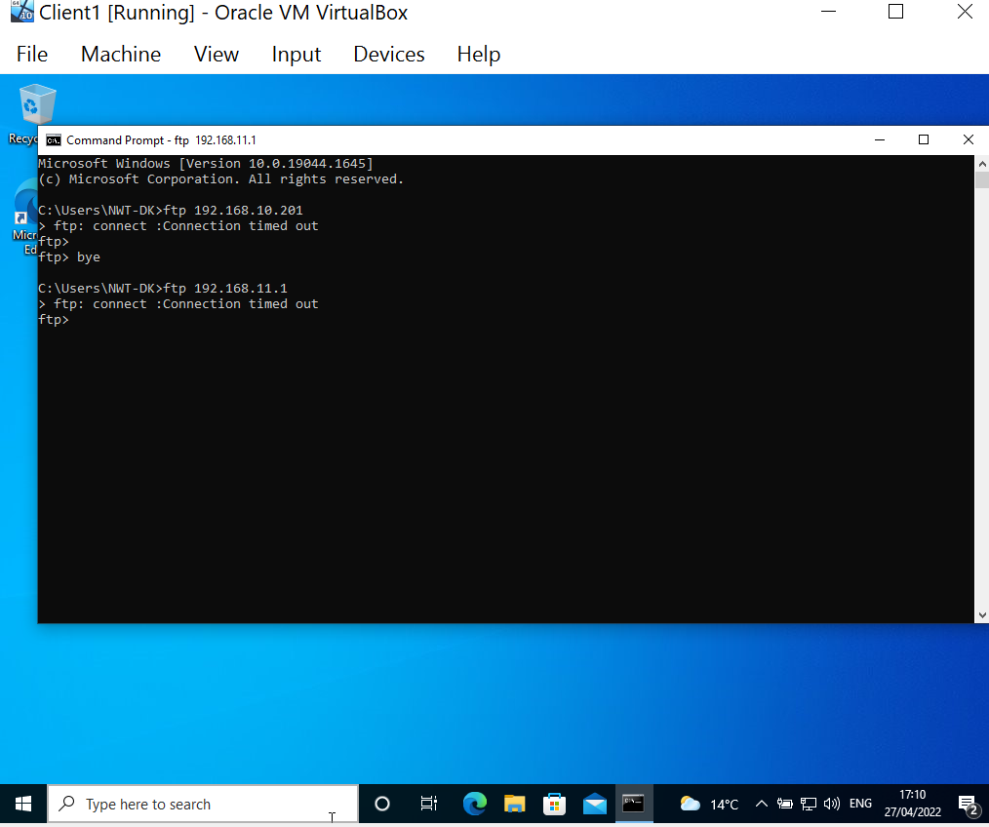
Fig 55: Testing shows FTP connection is no longer available from PrivateNet1. PrivateNet2’s access is not affected.

3.4.3 Filter 3 – only allow specific hosts in PrivateNet1 to access the FTP Service running on Server 2

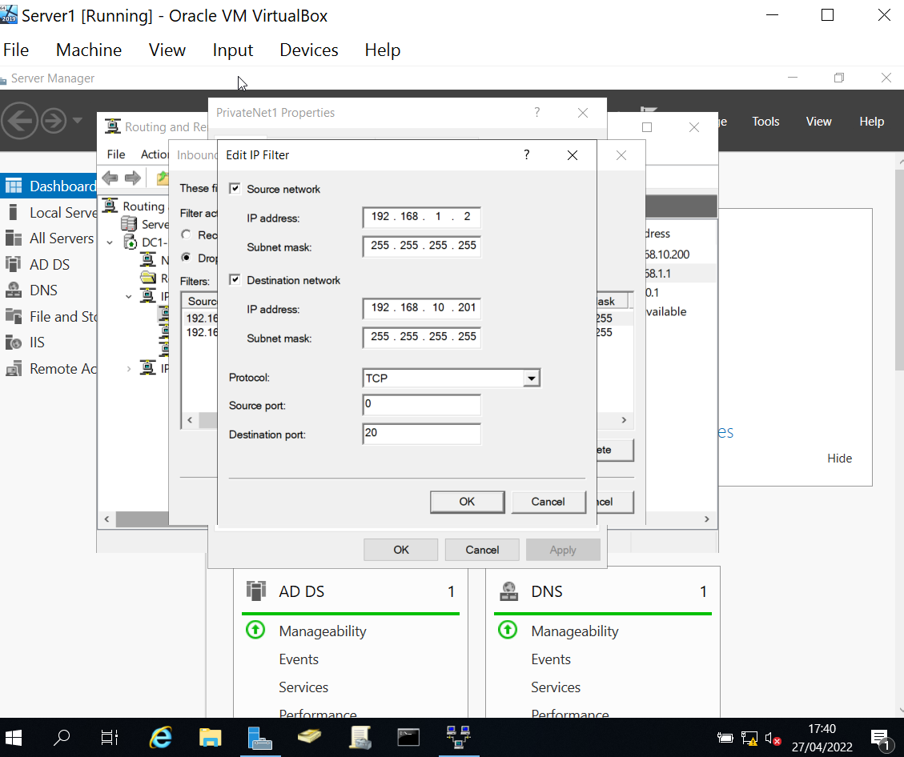
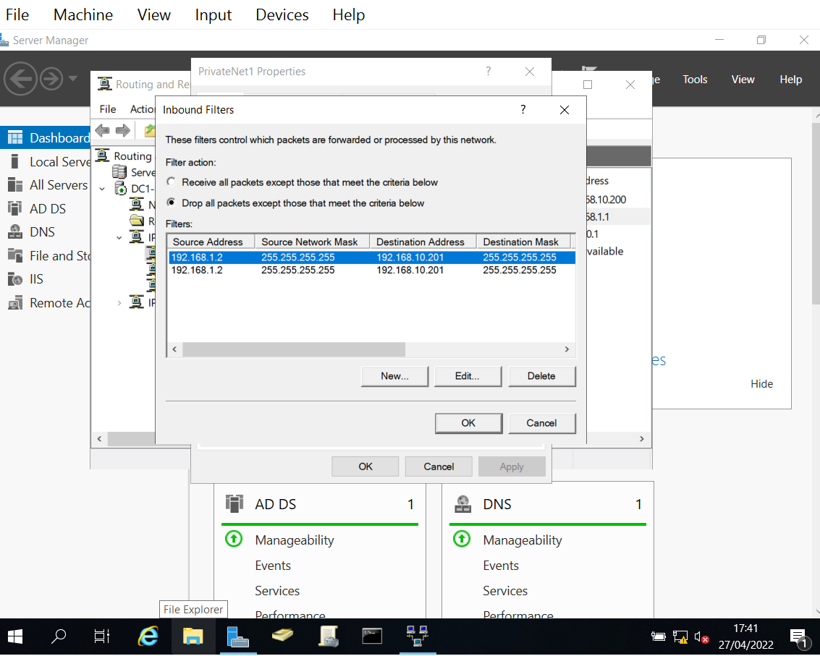
Fig 56 and 57: Creating an inbound filter to only allow access from client1 to the FTP server using ports 20 and 21.

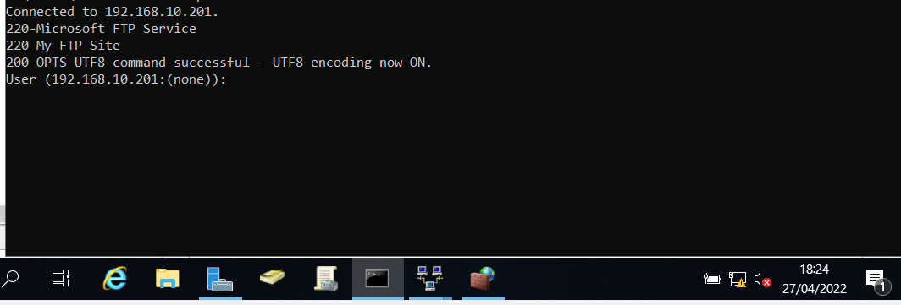
Fig 58: Test shows connection to the FTP server from Client1 (192.168.1.2).

Unable to fully test this rule as there is no client 2 set up on the network.

Password principles
An effective password can resist both dictionary and brute force attacks whilst being easy to remember.
According to a recent study [17] 2,867,917,611 passwords were leaked in Russia in 2021 ( over 19.9 per capita). The most common password used in the world is 123456 (see Annex 5 for the top 10 most common passwords and they time it would take to crack them).
Research by the National Cyber Security Centre (NSCS) [18] found when setting a password:
- 15% use the name of their pet
- 14% use the name of a family member
- 13% use special dates
- 6% use a sports team (Liverpool was the 3rd most popular password in the UK in 2021 [17])
- 6% use “password”
Current advise from industry leaders varies; National Cyber Security Centre (NCSC) recommends using three random words [19] (see Annex 4). Whereas the Open Web Application and Security Project (OWASP) and the National Institute of Standards and Technology (NIST) recommends using a minimum of 8 characters with a mixture of numbers, capital letters and special characters [20].
System administrator can help users create good passwords by:
- Setting a minimum password length of 10 for standard accounts and 12 for privileged or administrative accounts (see Annex .
- Using a passphrase containing 3 random words.
- Not allowing reused passwords.
- Maintaining a list of banned leaked passwords [21]
- Allow the pasting of passwords and encouraging the use of a password managers. Research shows an average user needs to remember over …
- Use Multifactor-Authentication (MFA) and Single-Sign-On (SSO) wherever possible
- Removing the requirement to regularly change passwords.
- Salt passwords with 32 bits of data using a one-way hash [20]

The most important aspect of a password strategy is user education. Research shows users will choose the easiest option when creating a password [22].

Failover clustering for high availability systems/services

Clustering is established by making two or more computers, systems or services work as one. This is very useful for failover systems, load balancing and processing in high availability systems.
With failover clustering if one server fails the other will take over. The good practice to have the servers located in geographical separate locations so if one server is lost the other can take over.
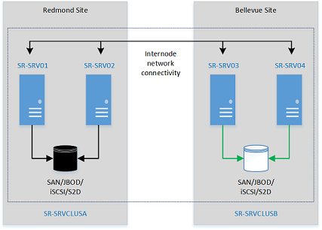
Fig 59: Clustering Diagram [23]

5.1 Advantages and disadvantages

Advantages | Disadvantages
Scalable | Expensive, needs more hardware, monitoring and maintenance than non-clustered options.
Provides High Availability | Not all server types can be clustered
No downtime for maintenance or performance issues as other server can take over
Table 3: Advantages and disadvantages of clustering [24] [25] [26].

5.2 Failover clustering installation process
To install the Failover Clustering feature [27]:
- Start Server Manager
- Select Add Roles and Features
- Select Next on the Before you begin page
- Select Role-Based or featured-based installation on the Select installation type page
- Select the server
- Select Next on the Select server role
- Select Failover Clustering on the Select features page. It should be just below the Enhanced Storage tick box.
- Click add features:
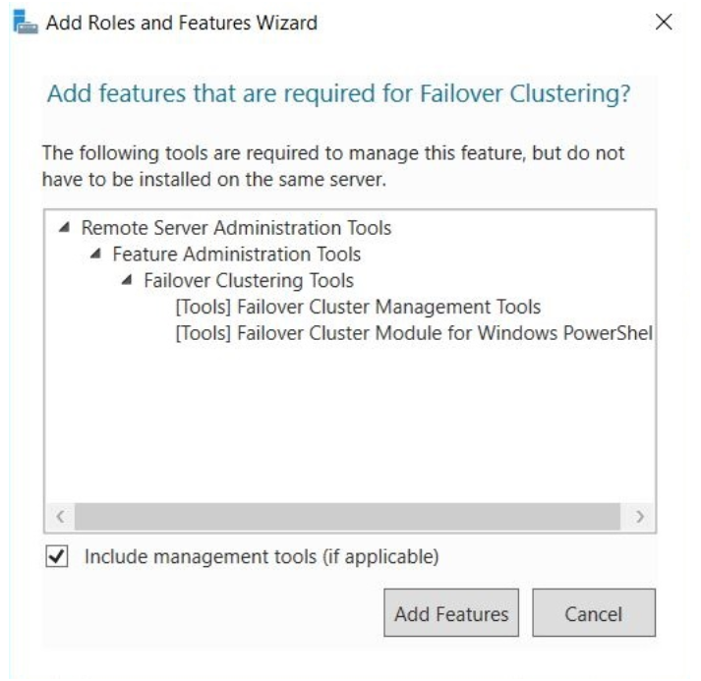
Fig 60: Adding features

- Select Next and Close when the installation is complete.
- Repeat on second server.
- The failover cluster can then be created within the Failover Cluster Manager.
  - Start Server Manager
  - Select Failover Cluster Manager from the Tools menu
  - Within the Failover Cluster Manager pane, select Create Cluster under management
  - Follow Create Cluster Wizard.

Draft network policy
Please see Annex 6 for the full network policy, an extraction is shown below:
Security of network services
Network perimeters must be clearly defined with the required security features deployed at each.
Firewalls must be NCSC or independently assessed by appropriately authorised bodies under NCSC guidelines. Configurations should adhere to best practice guidance as defined by vendors.
External facing firewalls must be configured to allow only specific services and approved traffic (e.g. HTTP, SMTP) to pass between known and well-defined sets of hosts.
Each firewall rule must be supported by an authorised business case and security risk assessment. Firewalls can be used to create DMZs within the network to protect internal systems against external attack.
Firewalls should be configured to silently drop packets instead of actively blocking requests and to fail closed.
Rule bases should be as short as possible.
Those outside the network must not be able to:
• see or map the protected network
• directly address the firewall.
Requests to make changes to firewall policy must be made via the change management process.
High Availability Systems and Load balancing
Regular risk assessment must be carried out on all systems to establish all high availability requirement. Where high available systems are required a minimum of two servers must be configured from geographically separate data centres.
Load balancing is required on critical systems.

References

[1] | “NTFS Overview,” Microsoft, 23 December 2021. [Online]. Available: https://docs.microsoft.com/en-us/windows-server/storage/file-server/ntfs-overview. [Accessed 10 April 2022].
[2] | W. Oliver, “Share and NTFS Permissions,” Microsoft, 6 April 2022. [Online]. Available: https://docs.microsoft.com/en-us/iis/web-hosting/configuring-servers-in-the-windows-web-platform/configuring-share-and-ntfs-permissions. [Accessed 27 April 2022].
[3] | K. Ellzey, “Data Security in Windows 10: NTFS Permissions (Standard),” Infosec, 14 December 2020. [Online]. Available: https://resources.infosecinstitute.com/topic/data-security-in-windows-10-ntfs-permissions-standard/. [Accessed 27 April 2022].
[4] | “Group Policy Overview,” Microsoft, 31 August 2016. [Online]. Available: https://docs.microsoft.com/en-us/previous-versions/windows/it-pro/windows-server-2012-r2-and-2012/hh831791(v=ws.11). [Accessed 27 April 2022].
[5] | “Group Policy Objects,” Microsoft, 31 May 2018. [Online]. Available: https://docs.microsoft.com/en-us/previous-versions/windows/desktop/policy/group-policy-objects. [Accessed 27 April 2022].
[6] | P. S. &. S. C. d. Vimercati, “Access Control: Policies, Models, and Mechanisms.,” Foundations of Security Analysis and Design, vol. 2171, pp. 137-196, 2001.
[7] | H. Forge, “Industral Cybersecurity USB Threat Report 2021,” Honeywell Forge, 2021.
[8] | “Chapter 6. Virtual Networking,” Oracle Virtual Box, [Online]. Available: https://www.virtualbox.org/manual/ch06.html. [Accessed 30 March 2022].
[9] | Notepad ++, [Online]. Available: https://notepad-plusplus.org/. [Accessed 30 March 2022].
[10] | M. M. Alani, “OSI Model,” in Guide to OSI and TCP/IP Models, Springer, 2014, pp. 5-17.
[11] | P. S. J Kaur, “ARP Spoofing-Based MITM Attack in Data Link Layer Using the Hybrid Method,” Journal of Positive School Psychology, vol. 6, no. 4, pp. 1298-1303, 2022.
[12] | M. Gien, “A File Transfer Protocol (FTP),” Computer Networks, vol. 2, no. 4-5, pp. 312-319, 1976.
[13] | G. Malkin, “RFC 2453 - RIP Version 2,” November 1998. [Online]. Available: https://www.hjp.at/doc/rfc/rfc2453.html. [Accessed 28 April 2022].
[14] | N. R. a. B. B. M. Jayakumar, “A comparative study on RIP and OSPF protocols,” in International Conference on Innovations in Information, Embedded and Communication Systems , 2015.
[15] | M. R. J Mothersole, “Optimising Rule Order for a Packet Filtering Firewall,” in Conference on Network and Information Systems Security, 2011.
[16] | D. Rountree, “Introduction to Key Information Security Concepts,” in Security for Microsoft Windows System Administrators, Syngress, 2011, pp. 71-107.
[17] | “Top 200 most common passwords,” NordPress, 2021. [Online]. Available: https://nordpass.com/most-common-passwords-list/. [Accessed 28 April 2022].
[18] | “Paws-word change recommended on National Pet Day,” National Cyber Security Centre, 9 April 2021. [Online]. Available: https://www.ncsc.gov.uk/news/national-pet-day-password-advice. [Accessed 27 April 2022].
[19] | NCSC, “Infographics at the NCSC,” 2020. [Online]. Available: https://www.ncsc.gov.uk/information/infographics-ncsc. [Accessed 27 April 2022].
[20] | R. P. E. N. e. a. P Grassi, “NIST Special Publication 800-63B - Digital Identity Guidelines,” 2017 (updated 2020). [Online]. Available: https://pages.nist.gov/800-63-3/sp800-63b.html. [Accessed 28 April 2022].
[21] | “Pwned Passwords,” [Online]. Available: https://haveibeenpwned.com/Passwords. [Accessed 28 April 2022].
[22] | E. R. Rick Walsh, “Prioritizing security over usability: Strategies for how people choose passwords,” Journal of Cybersecurity, pp. 1-17, 2021.
[23] | “Cluster to cluster Storage Replication,” Microsoft, 29 March 2022. [Online]. Available: https://docs.microsoft.com/en-us/windows-server/storage/storage-replica/cluster-to-cluster-storage-replication. [Accessed 28 April 2022].
[24] | J. Sack, “Failover Clustering,” in SQL Server 2000 Fast Answers, Springer, 2005, pp. 549-561.
[25] | E. H. C Wolf, “Implementing Failover Clusters,” in Virtualization: From the Desktop to the Enterprise, Springer, 2005, pp. 309-345.
[26] | V. S. U Parui, “Introduction to Windows Server Failover Clustering,” in Pro SQL Server Always On Availability Groups, Apress, 2016, pp. 45-52.
[27] | “Create a failover cluster,” Microsoft, 02 November 2022. [Online]. Available: https://docs.microsoft.com/en-us/windows-server/failover-clustering/create-failover-cluster. [Accessed 20 April 2022].
[28] | K. Rusbarsky, “ Forensic Comparison of NTFS and FAT32 File Systems,” Marshall University, Kansas City, 2012.
[29] | Y. Y. M. S. J Heeger, “An Introduction to the exFAT file system and how to hide data within,” Journal of Cyber Security and Mobility, vol. 11, no. 2, pp. 239-264, 2022.
[30] | J. D. J Justiniano, “Computer Forensics Tutorial Disk File Systems (FAT16, FAT32, NTFS),” Polytechnic University of Puerto Rico, 2012.
[31] | B. Meyer, “Most common passwords: latest 2022 statistics,” cybernews, 4 April 2022. [Online]. Available: https://cybernews.com/best-password-managers/most-common-passwords/. [Accessed 28 April 2022].

- Appendices
  - Annex 1 – Key Terminology
- ACL (Access Control List) – a list of rules that allow or deny access to a resource.
- Adapter – an internal component used to communicate over a network
- ARP (Address Resolution Protocol) – connects an IP address to its MAC address.
- Attack Vector – a path or method an attacker can use to gain access to a computer or network.
- Clustering – a group of computers working together to achieve an objective.
- DirectAccess –used to facilitate secure remote access for IT managed Devices.
- Encryption – secures data by encoding using a mathematical algorithm.
- Enumeration – the process of extracting user, device and network information.
- Failover – a backup that takes over when a primary system fails.
- Firewall – a network security device that monitors and filters traffic based on policies.
- FTP (File Transfer Protocol) – a set of rules to allow computers to transfer files over a network.
- High Availability – always available when needed.
- ICMP (Internet Control Message Protocol) – used by devices to communicate data transmission problems on a network.
- Interface – a shared boundary for information exchange.
- IP (Internet Protocol) – a unique address to identify a device on a network. It is also a set of rules for the format of data sent over a network.
- Load Balancing – sharing network traffic so that neither is overwhelmed.
- Malware – malicious software (Viruses, Trojans, RATs (Remote Access Tools), Spyware, Rootkits etc.).
- Mapped Drive – a shortcut to a shared folder on remote system.
- NAT (Network Address Translation) – allows computers on a private network access the internet through one public IP address
- Organisational Unit (OU) – a container in Microsoft Active Directory
- Ping – uses ICMP to test if a destination IP address exists and accepting requests.
- Ports – a communication endpoint.
- Protocol – standardised set of rules. Protocols enable computers to communicate with each other.
- RIP (Routing Information Protocol) – used by routers to exchange network information.
- Routing – the process of moving a packet of data from its source to its destination.
- Server – provides a service to another computer or program.
- VPN – used to facilitate secure remote access for non-IT managed devices.

  - Annex 2 - Comparison of different Window file systems

File Systems | Advantages | Disadvantages | Example use cases
FAT16 | - Suitable for legacy systems (MS-DOS, Windows 95/98/NT/2000 | - Supports small partitions (<2GB)  - Not efficient – lot of space is wasted. | - Legacy systems with old OS.
FAT32 | - Supports 2TB partitions  - Supports most Windows OS and MacOS. | - Poorer fault tolerance and security compared with NTFS | - Removable device for small files (<4GB)
NTFS | - Most used  - Faster speeds  - Large space  - Improved security | - Does not support OS older than Windows XP.  - Can only read in Mac OS. | - Window Hard Drives
ExFAT | - Used on Mac and Linux with full read/write | - No compression support.  - Difficult to restore | - USB drives  - SD cards
Table 4: File system comparison [28] [29] [30]
  - Annex 3 – OSI model

 | Layer | Purpose | Protocol Data Unit (PDU) | Example protocols
7 | Application | Provides different services to the application | Data | HTTP, DNS, FTAM, VT
6 | Presentation | Data representation and encryption | Data | SSL, FTP, SSH
5 | Session | Handles problems which are not communication issues. | Data | API’s
4 | Transport | End-to-end connections and reliability | Segments | TCP, UDP
3 | Network | Routes the information in the network using logical addressing. | Packets | IP, ICMP
2 | Data Link | MAC and LLC (physical addressing)  Provides error control | Frames | Ethernet, Switch
1 | Physical | Media, signal and binary transmissions | Bits | Physical structure.  Coax, fibre, wireless etc.
Table 5: OSI Model
  - Annex 4 – NCSC Using Passwords infographic [19]

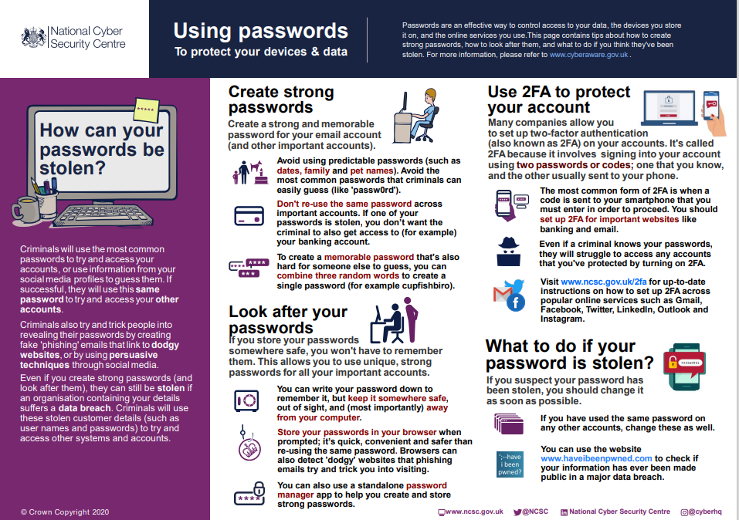
Fig 61: NCSC Password Advice

  - Annex 5 – The 10 most common passwords 2021.

Rank in 2021 [17] | Password | Count | Time to crack (seconds) | Current rank in 2022 [31]
1 | 123456 | 103,170,552 | <1 | 1
2 | 12346789 | 46,027,530 | <1 | 2
3 | 12345 | 32,955,431 | <1 | 5
4 | qwerty | 22,317,280 | <1 | 3
5 | password | 20,958,297 | <1 | 4
6 | 1234578 | 14,745,771 | <1 | 8
7 | 111111 | 13,354,149 | <1 | 9
8 | 123123 | 10,244,398 | <1 | -
9 | 1234567890 | 9,646,621 | <1 | 10
10 | 1234567 | 8,933,334 | <1 | -
Table 6: Top 10 passwords

  - Annex 6: Full network security policy
CONTROL SHEET

Title: | Network Security Policy
Author: | Donna Kennett |  | Privacy Marking: | OFFICIAL
Date of Issue: | 29 April 2022 |  | Document Reference: | 1
Version: | 1 |  | Reviewed By:
Version Status: | New |  | Superseded Documents: | N/A

Amendment History

Version | Status | Date | Author
1.0 | Final | April 2022 | D Kennett

1. Policy Purpose and Description
The objective of this policy is to outline the IT security requirements to ensure the confidentiality, integrity and availability of company systems, data and resources.
2. Delivery and Monitoring
This policy is applicable to all personnel.
3. Review of Policy
This policy is subject to review on at least an annual basis. Ad hoc reviews may be necessary to account for urgent changes.
4. Amendments to Policy
Any changes to this policy must be approved by the Chief Security Officer, with whom ownership of this policy rests .
5. Policy Sections
5.1 User Awareness, education and Training.
The induction process for all employees must include information security content.
Staff must understand and follow the Network Security Policy and keep up-to-date with current information security training.
5.2 Account management
5.2.1 User Accounts
Each user’s account must have an associated set of access rights assigned. The rights must be set to the minimum requirement to allow the user to perform actions on a system that are relevant to their business needs. Access rights must be regularly reviewed in line with ongoing business requirements.
5.2.2 Administrative Accounts
Administrative accounts must not have access to email or web browsing facilities. Administrators should also have an additional ‘standard’ user account for normal business use. Administrators must use different passwords for their administrative and non-administrative accounts.
5.2.3 Use of Passwords
Passwords must:
• be memorable
• be complex
• be immediately changed from default set passwords
• contain a mixture of upper and lowercase letters, numbers and special characters
• be a minimum of 10 characters for standard accounts and 12 characters for administrative accounts ( unless technical requirements of a system do not allow this).

Passwords must not:
• contain personally identifiable information
• contain more than two consecutive identical characters
• contain organisation names or keyboard sequences
• be used on more than one system or changed slightly between uses (e.g. incrementing a number at the end).

Users must keep their passwords secure and must take reasonable steps to prevent other people observing them typing and entering their passwords.
Multi factor authentication (MFA) should be used where possible, and the use of approved password manager software is encouraged.
5.3 Asset management
An inventory of all company assets must be maintained and registered on the relevant management service (MDM, SCCM etc.).
Unauthorised assets must not be used. Doing so will constitute a security breach and may result in disciplinary action in line with HR processes.
5.3.1 Setup and configuration
Configuration control must be applied; a complete record of system configurations and settings must be maintained. Setup and changes to configurations must only be undertaken by authorised system administrators.
Users must not attempt to disable or otherwise affect the security functionality of company devices or software. Doing so will constitute a security breach and may result in disciplinary action in line with HR processes.
Configurations must:
• prevent the installation of unapproved software
• ensure software, firmware and operating systems are maintained at the latest approved version
• include automatic anti-malware updates
• utilise full-disk encryption for hard drives of company issued laptops
• include a method for remote wipe or device lock.

The clocks of all relevant information processing systems should be synchronised to a single reference time source. A master clock should be selected, and network time protocol used to ensure servers remain synchronised.
Once equipment reaches end-of-life or is to be re-used, storage media must be removed, and secure sanitisation processes followed in line with NCSC’s Secure Sanitisation of Storage Media guidance and CPNI’s Standard for Secure Destruction of Sensitive Items.
5.4 Protection against malware
All end-user devices must have approved, up-to-date anti-malware software installed and active.
Web filtering will be applied to all company traffic, whether accessed from a company asset or connected to the company main or guest network.
Access to websites deemed malicious or inappropriate will be blocked.
Malware related incidents must be reported immediately as per section 5.11 Reporting Security Incidents and weaknesses.
5.5 Information Backup
Backup copies of information, software and system images should be taken and tested regularly to protect against loss of data.
Retention periods should be determined in line with operational needs.
In accordance with Business Continuity requirements, the backed-up information must be stored within a secure location that is geographically removed from associated systems.
5.6 Network Access
Access rights to systems should be considered for each user based on the classification of data held within the system and the user’s need-to-know.
Care should be taken to ensure segregation of duties where possible. No individual should be able to access, modify or use assets without authorisation or detection.
5.6.1 Remote Access
Remote access to company’s network or services must only be granted once a user has been successfully authenticated. Remote access must only be possible by utilising the approved remote worker solution.
5.7 Security of network services
Network perimeters must be clearly defined with the required security features deployed at each.
Firewalls must be NCSC or independently assessed by appropriately authorised bodies under NCSC guidelines. Configurations should adhere to best practice guidance as defined by vendors.
External facing firewalls must be configured to allow only specific services and approved traffic (e.g. HTTP, SMTP) to pass between known and well-defined sets of hosts.
Each firewall rule must be supported by an authorised business case and security risk assessment. Firewalls can be used to create DMZs within the network to protect internal systems against external attack.
Firewalls should be configured to silently drop packets instead of actively blocking requests and to fail closed.
Rule bases should be as short as possible.
Those outside the network must not be able to:
• see or map the protected network
• directly address the firewall.
Requests to make changes to firewall policy must be made via the change management process.
5.8 High Availability Systems and Load balancing
Regular risk assessment must be carried out on all systems to establish all high availability requirement. Where high available systems are required a minimum of two servers must be configured from geographically separate data centres.
Load balancing is required on critical systems.
5.9 Cryptography
Cryptographic controls must comply with UK legislation and should be in-line with NCSC guidance.
Individual system documentation should provide clear instructions regarding the security procedures required for the handling and usage of encryption.
Legal issues surrounding cryptographic material differ between countries.
Data within the network and in the cloud must remain protected both at rest and in use.
Key management must be in line with the CSA’s Security Guidance for Critical Areas of Focus in Cloud Computing.
5.10 Event Logging
Event logs must be produced, kept and regularly reviewed.
Network monitoring operates on a continuous basis and potential security incidents must be reported.
5.11 Reporting Security Incidents and weaknesses
All potential security incidents and weaknesses must be reported to the Chief Security Officer but the line manager within 24 hours of discovery.

