A comparative examination of the organisational and leadership responses of health systems to COVID-19 in Spain, South Korea, and Canada
Assessment Type: Case Study Report
Student Name: MD. SAKYF JAWAD
Student Number: 2435265
Lecturer : Shepherd Ziku

Executive Summary
The report addressed how the organisational structures and leadership methods affect the national response to COVID-19 in Spain, South Korea and Canada. It is evaluated in two dimensions which are interconnected with each other, centralisation of the health-system and the crisis-leadership of Salvatore Illa, Chung Sye-kyun as well as Justin Trudeau. All these factors together influenced the pace, alignment, and capability of interventions based on pandemic-related problems.
The Spanish system was so decentralised that there was no ease in the coordination of the process at an initial stage and the national government, in its turn, resorted to the State of Alarm and temporarily centralised the power. According to the initial dismal results, unified reporting, additional control by the national level and the strong system of vaccination logistics could improve performance. Public health apparatus in South Korea were structurally centralised, legally enforced, and eased rapid mass testing, digital tracing and even transparent communication resulting in some of the lowest initial rates of mortality in the world. The federal Canadian system allowed the provinces to develop their own interventions to fit themselves, but resulted in high rates of inconsistency in testing capability, long-term care performance and policy consistency, and did not allow the federal leadership to be effective despite high rates of communication efficiency and high vaccine uptake.
Comparative findings revealed that the structural power greatly affects leadership performance. The centralised systems enhanced the speed and clarity of the decision-making process yet in the case of the decentralised systems, there had to be effective coordination mechanisms to result to the same. The report concludes that the optimal reaction to pandemic is whereby there are convergence between the system design, the leadership capacity, and the ability to swiftly co-ordinate during the periods of uncertainty.
Contents
Executive Summary 2
1. Introduction 5
2. Reassessing Structural Models and National Response Frameworks in the COVID-19 Crisis 6
2.1 Spain: Decentralised Health Governance and Crisis Response 6
2.1.1 Structure of the Health System 6
2.1.2 Pandemic Organisation and Decision-Making 7
2.1.3 Data, Policies, and Evaluation Based on Evidence 7
2.1.4 Assessment of Core Advantages and Structural Limitations 8
2.2 South Korea: Command and Control of Public Health that is Centralised and Rapid Containment 9
2.2.1 Centralised Public Health Apparatus 9
2.2.2 Pandemic Organisation and Decision-Making 10
2.2.3 Tests, Surveillance and Tracing- Technologized 11
2.2.4 Assessment of Core Advantages and Structural Limitations 12
2.3 Canada: Federal-Provincial and Health Authority and Performance and Pandemic 13
2.3.1 Decentralised Provincial Federal power 13
2.3.2 Pandemic Organisation and Decision-Making 14
2.3.3 Information, Policy and Evidence-Based Evaluation 14
2.3.4 System Strengths and Weaknesses 15
2.4 Comparative Analysis Decentralisation vs Centralisation 15
3. Analytical Review of Leadership Models Applied Across the Three Nations 17
3.1 Spain’s Governance Style and Executive Decision-Making in Crisis 17
3.1.1 National Governance Environment Surrounding Leadership Behaviour 17
3.1.2 Leadership Style of Salvador Illa (Transformational, Crisis, Adaptive Leadership) 17
3.1.3 Key Decisions and Leadership Actions 18
3.1.5 Analytical Evaluation 19
3.2 Leadership Dynamics Shaping South Korea’s Pandemic Response 19
3.2.1 Structural and Political Conditions Influencing Korean Leadership 19
3.2.2 Leadership Style of Chung Sye-kyun (Technocratic, Distributed, Transformational Leadership) 20
3.2.3 Key Leadership Actions 20
3.2.4 Leadership Strengths and Weaknesses 21
3.2.6 Analytical Evaluation 21
3.3 Approach to leadership in Canada 21
3.3.1 Leadership Context 21
3.3.2 Leadership Style of Justin Trudeau (Transformational Leadership and Crisis Communication) 22
3.3.3 Key Leadership Actions 23
3.3.4 Leadership Strengths and Weaknesses 23
3.3.5 Analytical Evaluation 23
3.4 Comparative Leadership Discussion 24
4. Conclusion 25
References 26

1. Introduction
This report will explore the impact of the organisational systems and leadership styles on the COVID-19 response in Spain, South Korea and Canada. The report compares the design and functioning of their health systems and the leadership behaviour of key decision-makers to assess the role of structural configurations and leadership styles in the determination of the coherence, pace and responsiveness of national responses (Stephen et al., 2021). It uses the systems thinking theory and the contemporary theory of leadership to find out the reason behind the difference in the outcome of countries with different institutional structures.
One of the main determinants of the pandemic performance is the organisational structure because it defines how the authority, resources, and the duty to carry out the duty to ensure the populace are allocated. Centralised systems are able to respond consistently over short periods of time, but decentralised systems are able to respond more attentively to particular interventions; at the same time, coordination is an issue (Kaye et al., 2021). Another perspective of evaluation based on the leadership theory is transparency, decisiveness, collaboration and trust. The selected jurisdictions have conflicting governance models, which enable making a good comparative analysis of the role of structure and leadership in the shared contribution to pandemic management.

2. Reassessing Structural Models and National Response Frameworks in the COVID-19 Crisis

2.1 Spain: Decentralised Health Governance and Crisis Response

2.1.1 Structure of the Health System
Marked by a high degree of decentralisation, the health system of Spain is characterised by 17 Autonomous Communities that are the key players in planning, financing and providing health services (Erkoreka and Hernando-Pérez, 2022). This form of governance came as a consequence of the reforms that were introduced in the late 1990s and early 2000s to increase the responsiveness of the regions and to unify the democratic process of decentralisation following the transition to the post-dictatorship era (Emami et al., 2024). By 2020, the central Ministry of Health was playing a less significant role in regulation, strategic coordination, pharmaceutical policy and national surveillance, with an estimated 90 percent of the public health spending under the control of the regional government (Ferrinho et al., 2022). This decentralisation of activities led to a system where regional authorities were running large systems of primary care and were operating the infrastructures of hospitals with a large degree of autonomy.
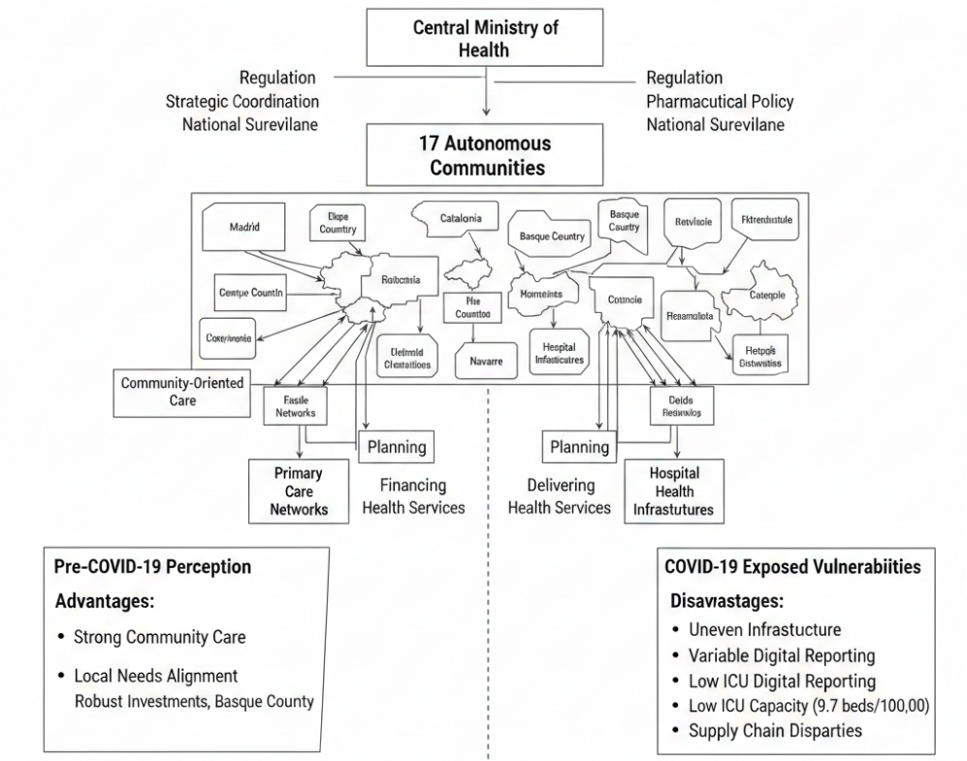
Figure 1: Health System of Spain (Ferrinho et al., 2022)
The concept of decentralisation used to be viewed as advantageous before the COVID-19 pandemic due to the presence of positive community-based care and the ability to align services to the needs of the local population. It was known that the North, commonly abbreviated as Navarre and the Basque Country, had heavy investments in both the public health and the sustainable surveillance systems. However, the decentralisation process also contributed to the great inequality in the infrastructure of public health, the opportunities of digital reporting, and the staff. Despite the comparatively large health spending of Spain, 10.7 percent of the GDP in 2020, the standard ICU bed was quite low, approximately 9.7 per 100,000 people (Borghi and Brown, 2022). This was one of the structural weaknesses as the first wave of the pandemic hit, and the rapid growth of hospitalisations overwhelmed hospitals in Madrid, Catalonia and the other highly populated regions.

2.1.2 Pandemic Organisation and Decision-Making
The first case of the pandemic was confirmed on January 31, 2020. The way Spain is set up to govern itself in a decentralised way affected how the initial reaction to the epidemic was carried out (Balmford et al., 2020). The regional authorities were to implement security measures with regard to case detection, contact tracing and containment, but the Ministry of Health was to arrange the flow of information and offer general guidance. As the cases began to rise drastically in early March, the discrepancies between regional policies, such as school-closure policy, the restrictions on events, and testing standards, created a feeling of chaotic responses among the population, and it was hard to coordinate the entire increase in the whole country.
After understanding that there was a need to act jointly, on 14 March 2020, the central government declared a State of Alarm, temporarily re-centralising control of the regional health systems, the first time it had done so since the 1960s (Chibi and Galea, 2025). This step enabled the Ministry of Health to make orders on the national level, even out the limitations, and even centralise major logistics, including redistribution of the amount of ICU beds, military support, and national acquisition of protective equipment (Homayounifar et al., 2025). It became possible to put an immediate nationwide lockdown, including the restriction of movements, business closures, and curfews, through the State of Alarm.

2.1.3 Data, Policies, and Evaluation Based on Evidence
Fragmented information systems slowed down the response efforts at the initial phase. Epidemiological reporting support systems, definitions and schedules were diverse in Autonomous Communities and hindered the harmonisation of nationally collected information and limited early situational awareness (Hegele and Schnabel, 2021). In the middle of 2020, Spain adopted harmonised reporting protocols, which would make the data more consistent and enable more targeted interventions. By the end of 2020, the number of confirmed deaths was over 50,000, but excess mortality analysis showed a much higher death toll (Emami et al., 2024).
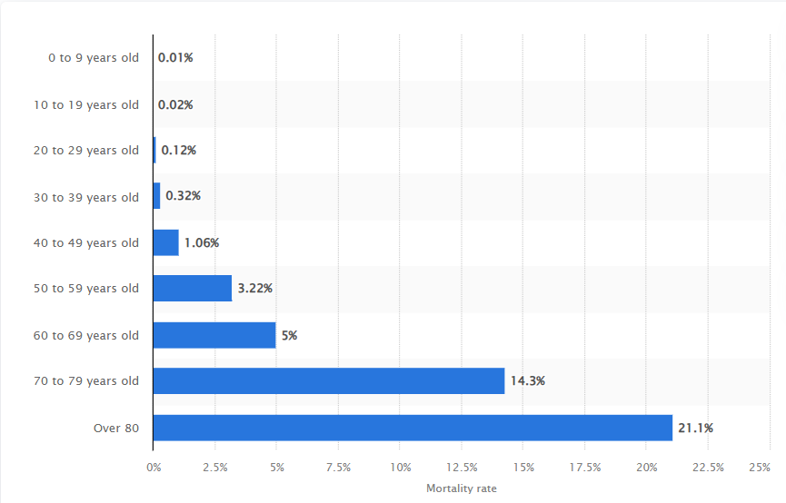
Figure 2: The mortality rate associated with the coronavirus (COVID-19) in Spain (Statista, 2020)
After the first wave, however, Spain had made a lot. Both PCR and antigen diagnostics contributed to the rapid increase in testing capacity (the number of tests per day had dropped to fewer than 20,000 in March, but increased to more than 700,000 tests per day in December). The vaccination, which had begun in December 2020, became one of the most successful in Europe. Spain had good primary care networks with regional logistics that entirely covered 78 percent of the population by October 2021 (Hu et al., 2020).

2.1.4 Assessment of Core Advantages and Structural Limitations
The decentralised model of Spain was stated. Local control supported certain interventions and mobilisation of local networks, particularly in the process of vaccination. The first response, however, revealed such structural restraints as disjointed surveillance, absence of cohesive preparedness and political wrangles that stalled concerted efforts. Temporary re-centralisation helped to solve some of the shortcomings, but could not help to eliminate underlying disparities. Generally, the pandemic has demonstrated the elasticity of the health system in Spain, along with its flaw, which is the decentralised system (Yikilmaz et al., 2024).

2.2 South Korea: Command and Control of Public Health that is Centralised and Rapid Containment

2.2.1 Centralised Public Health Apparatus
The pandemic influenced South Korea to have a robust and unified form of governance regarding the problem of public health, which is, in fact, mostly due to the reforms which have been introduced in the country after the MERS outbreak in 2015 (Greer et al., 2022). Weaknesses in surveillance, laboratory coordination, and transparency had also led to an unwarranted spread and amplified panic amongst the people during MERS. The government responded by introducing major changes that strengthened the power of the KDCA, invested in the modernisation of the infectious disease surveillance system, improved emergency communication schemes and legal tools to enforce quarantine and gather mobility-related data in the event of an outbreak.
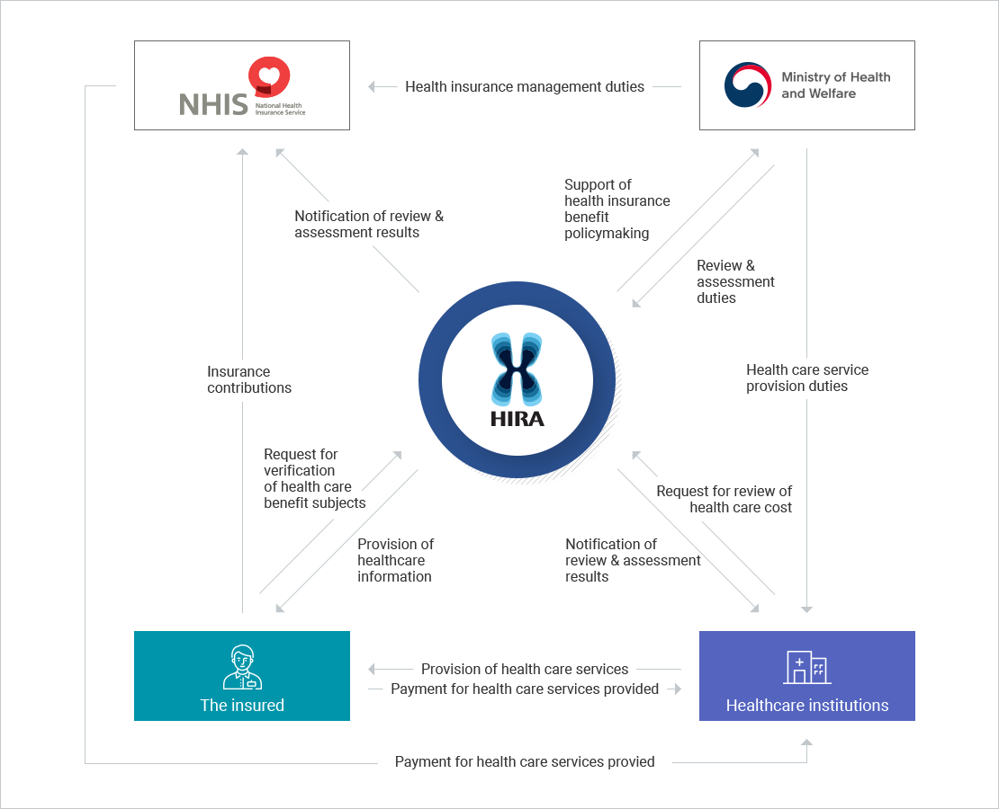
Figure 3: Health Care System in South Korea (Hegele and Schnabel, 2021)
The KDCA became the national command centre for the management of infectious diseases by 2020. It was mandated to do surveillance, testing strategy, epidemiological investigation, risk communication, and inter-ministerial coordination. The health system was instituted on a broader scope of law, which allowed swift distribution of resources and sharing of information between the government agencies and individual labs. The health spending was estimated to be 8.4 percent of the GDP, and the ICU bed capacity was estimated to be 10.6 beds per 100,000 population, which was sufficient to contain it early (Ferrinho et al., 2022).

2.2.2 Pandemic Organisation and Decision-Making
On 20 January, South Korea reported its first case and national emergency response measures were activated. Rather than countrywide lockdowns, the government concentrated on the initial identification of the cases, the mass testing, the active contact tracing, and the effective communication to the population (Chibi and Galea, 2025). The governments held briefings on a daily basis with the presentation of comprehensive epidemiological data, clarification of policy choice and risk clarification, which contributed to the establishment of high-levels of trust and obedience among the population.
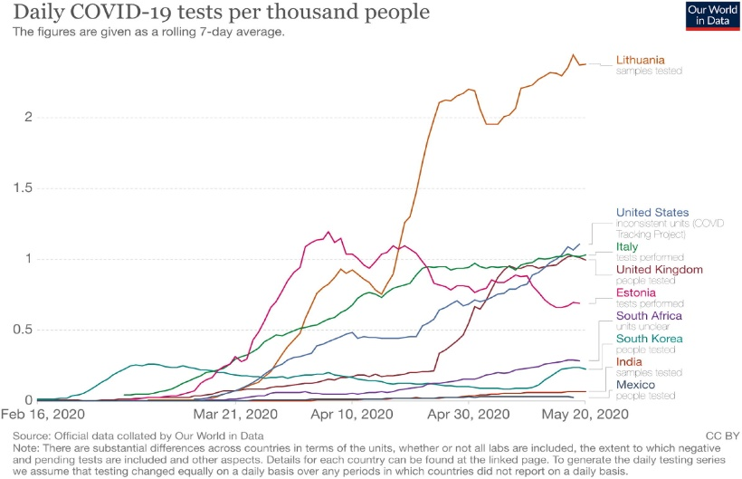
Figure 4: COVID-19 testing in South Korea outperformed other nations(Greer et al., 2022)
The plan was pegged on regulatory flexibility. The government made the certification of the diagnostic test kits speedy, and the laboratories, which were private at the same time, initiated the production. By the time a massive outbreak was found in Daegu at the end of February, South Korea had a system in place to conduct PCR tests nationwide, and it was linked to a religious group (Cummings de-Winton et al., 2025). The government did not impose any huge lockdowns; rather, the specific measures were presented to eradicate the high-risk facilities, issue quarantine orders, and deploy mobile testing units.

2.2.3 Tests, Surveillance and Tracing- Technologized
The adoption of technology in dealing with the pandemic defined South Korea. The country recorded fewer than 1,000 PCR tests daily in January and had over 20,000PCR tests per-day in 2020, the country had over 100,000PCR tests per-day (Klebe et al., 2021). The use of walk-through and drive-through testing sites enabled the sampling to be collected within a short period of time and minimised the risk of exposing health-workers. These inventions were utilised to become global models of mass testing strategies.
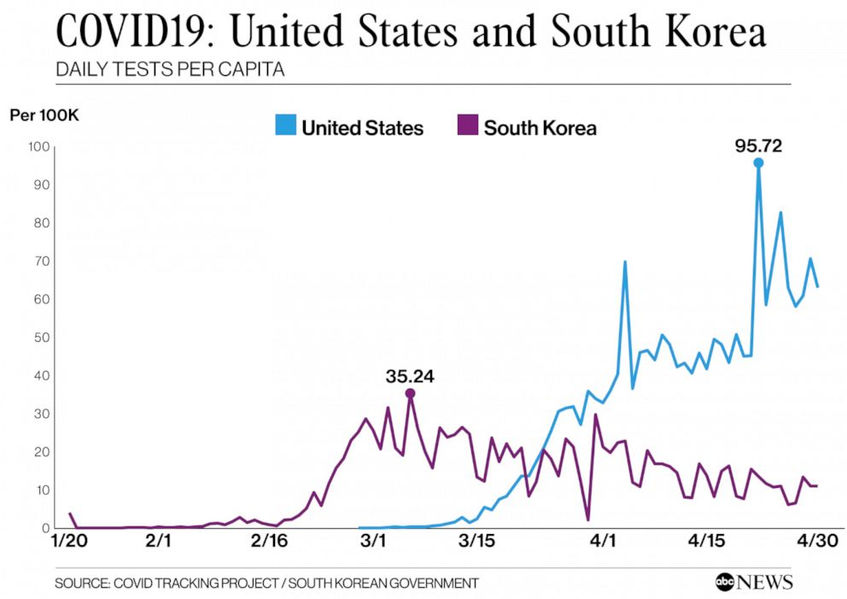
Figure 5: Comparison of the US and SK in Terms of Daily Trials per-Capita (Klebe et al., 2021)
A wide range of digital evidence, including mobile phone GPS and credit card logs, CCTV video and QR-code entry logs, was involved in contact tracing so that single movement trends could be reproduced with high accuracy. This reduced the time on the top contacts tracing taken at the onset of the outbreak by more than 24 hours to under 6 hours by April 2020 (Aida and Shoji, 2022). The public health authorities also informed the people about the risk level and the places of exposure using digital dashboards. One of the causes why the low rate of deaths alone in 2020 was about 1.6 deaths per 100,000 residents, which is one of the lowest in the world, is these steps, which proved the great efficiency of immediate and localised containment.

2.2.4 Assessment of Core Advantages and Structural Limitations
The benefits of the centralised system of governance in South Korea were high: it was quick, flexible, very closely integrated between the government and the business and digitally endowed. The fact that people trusted the government more facilitated the process of obeying the regulations of testing and quarantine, and the legal system ensured that the government could take action. The ability to prevent the nationwide lockdowns indicated the effectiveness of local containment using high-quality data.
However, the problems of the system were also present. The surveillance through digital means was extensively employed, and this was a source of privacy problems, especially regarding the printing of histories of movement, which at times revealed personal sensitive information. Additionally, the work pressures on the teams of the public health were rather high due to the intensive process of contact tracing, requiring the hiring of additional representatives and the use of extended hours (Lal et al., 2020).

2.3 Canada: Federal-Provincial and Health Authority and Performance and Pandemic

2.3.1 Decentralised Provincial Federal power
The health system in Canada is basically decentralised, where the provincial and territorial governments are the central players in the provision of the primary role in public health, hospitals, long-term care and most of the containment measures. The federal government also plays a supporting role: it is subsidised through the Canada Health Transmission, it oversees the control of the border and international travel, it also purchases vaccines, it also plans the national course of action, and it also oversees the federal monitoring of the population through the PHAC. It, however, does not have constitutional powers to impose provincial-level restrictions and this results in a high level of diversity among jurisdictions.
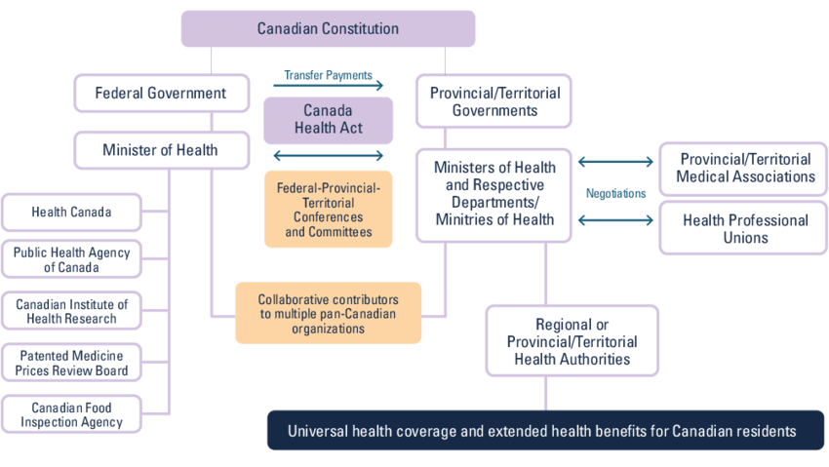
Figure 6: Canada Health care System (Lee and Li, 2021)
The health spending rate in Canada was one of the highest in OECD in 2020 - approximately 12.7 per cent of GDP - which implied that Canada entered into the covid crisis with a high-level of health spending. Mean ICU capacity was about 12.9 beds per 100,000 people, and this was a medium buffer upon the occurrence of initial increases. Nevertheless, the long-term care (LTC), which is also a provincial regulation, had structural gaps that were also a highly disadvantageous feature. The LTCs were poorly staffed, with poor infrastructure and used short-term employees who worked in other facilities as well. Such structural challenges contributed to catastrophic outcomes during the first upsurge because the covid death cases in Canada among the LTC residents were more than 80 per cent during the initial months of the pandemic.

2.3.2 Pandemic Organisation and Decision-Making
Canada had its first case on 25 January 2020. At the initial stages, federal and provincial governments had been moving in the same direction. PHAC issued nationwide recommendations, and provincial health authorities altered the rules based on the local epidemiological realities. The federal government devised border controls, travel warnings, quarantine policies and school shutdowns, restrictions, and business restrictions were met by provinces. However, as the provinces were independent, these actions were disproportional because the time and the degree of their execution varied. To use the example, other provinces have been quick to close down venues and increase testing, and others withhold some of the actions due to economic or political motives.
This was a significant first step by the federal government to declare quarantine on international travellers using the Quarantine Act. The lockdowns, mask requirements, and closed workplaces were further legalised by the provinces, which already had their emergency declaration.

2.3.3 Information, Policy and Evidence-Based Evaluation
The effect of covid on Canada's data systems were insufficiently prepared to support the scale and speed of the pandemic. Cases, laboratories and digital reporting tools had varied definitions in the provinces, and it took time to bring the national statistics together (Lee and Li, 2021). The inability to conduct real-time surveillance at PHAC was restricted by the lack of harmonisation of data standards and the existence of weak interoperability between provincial systems. Such were the anxieties of several autonomous reviews that required modernisation of the surveillance structure in Canada.
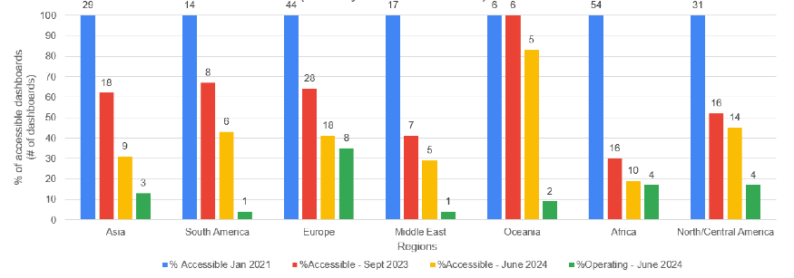
Figure 7: The availability of covid data dashboards (Lv, Luo and Duckett, 2021)
Despite early inconveniences in data, Canada embraced numerous evidence-based policies, including border restrictions, mask recommendations, and screening strategies. The capacity to test many times more by 2020, with numerous new testing possibilities within the provinces: drive-throughs, pilot programs on rapid testing, and expanded networks of laboratories (Greer et al., 2022). The central administration played an important role in the purchase of the vaccines, and they pre-contracted with different manufacturers. The provincial authorities now had the mandate of distribution and prioritisation.

2.3.4 System Strengths and Weaknesses
The model applied in Canada, decentralisation, provided an opportunity to the provinces to adjust the interventions to the local context, but it also created serious problems of coordination. The provinces with greater public health capacity, such as British Columbia or the Atlantic provinces, had demonstrated early success in controlling the transmission. However, the shortcomings of LTC, decentralised surveillance, and the absence of inter-provincial coordination in the country undermined the national unity. The pandemic revealed that the pan-Canadian data control should be more robust, LTC control must be given more attention and improved, and the surge capacity planning must be improved.

2.4 Comparative Analysis Decentralisation vs Centralisation
The extent of centralisation in the three countries had a strong correlation with the speed and cohesiveness of the first response to the pandemic. The centralised model enabled the South to decide in a short duration, carry out mass testing in a timely manner and offer uniform instructions, thus resulting in low mortality and no lockdowns in the entire country. The problem of fragmented surveillance and unequal regional policies existed in the first wave, during which Spain and Canada, both systems of decentralisation, had a problem. The attempts of Spain to overcome such constraints were supported by the temporary re-centralisation, and Canada attempted to do so with the help of federal-provincial negotiation during the crisis. This difference is explained by the fact that South Korea was virtually under surveillance on the spot, and the reporting of Spain and Canada was delayed, which could not give early control. In spite of these differences, decentralised models were helpful once the initial coordination was improved, and as a result, the measures could be tailored at the local level and offered an effective logistics of vaccination.

3. Analytical Review of Leadership Models Applied Across the Three Nations

3.1 Spain’s Governance Style and Executive Decision-Making in Crisis

3.1.1 National Governance Environment Surrounding Leadership Behaviour
The decision affecting the pandemic response in Spain in the process of building their response during the first critical wave was the leadership of the Minister of Health between January 2020 and January 2021 (Salvador Illa). His leadership took place in a very arid climate that was marked by a decentralised health system in Spain, a high degree of political fragmentation and the deteriorating epidemiology. In the regions, the governments had the responsibility for surveillance, testing, and clinical care, but the national outcomes were under the political control of Illa. Madrid, being politically opposed, could not allow a central influence, hence making it difficult to have coordination (Shu and Wang, 2021).

3.1.2 Leadership Style of Salvador Illa (Transformational, Crisis, Adaptive Leadership)
The actions of Illa in the pandemic can be discussed in the context of various leadership theories. His attempt to give regular national messages in the State of Alarm (14 March 2020) meets the requirements of Transformational Leadership, which is aimed at collective identity, shared purpose, and shared vision (Bass and Riggio, 2006). The theme of unity and collective sacrifice was the goal of Illa to create unity among politically polarised parts through the story. However, the transformational effects were limited since he lacked direct control over regional systems, and this hindered his ability to deliver the same messages across.
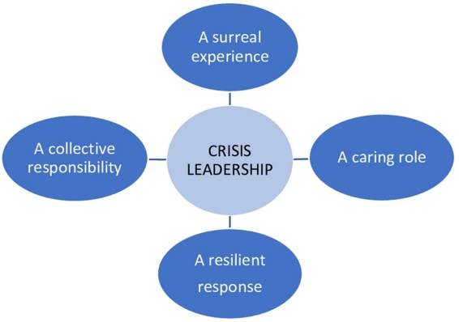
Figure 8: Crisis Leadership theory (Aida and Shoji, 2022)
The Crisis Leadership theory and Crisis Leadership, as put forward by Boin et al., in particular, the model of sense-making, decision-making and coordination, were devastating setbacks to Illa. In the month of February, Spain failed to determine community transmission due to fragmented surveillance systems. Containment decisions were lagging behind worsening indications, and categorical sense-making was put off. As soon as the State of Alarm was declared, Illya performed better in the domains of decision-making and meaning-making by Boin, which helped to make the country more coherent and the process of communication more effective through the daily briefings with Fernando Simón.
Adaptive leadership may also be interpreted as a form of leadership whereby Illa succeeded in engaging the stakeholders to respond to uncertain and complex situations (Heifetz et al., 2009). He had to strike a balance between conflicting sides, including local self-rule, politics, economic destabilisation and social health requirements. Even between these pressures, he was not able to strike a balance. Although during the re-centralisation period he was good at harmonising among regions, he failed to make all the Autonomous Communities have an identical long-term move after emergency powers were withdrawn.

3.1.3 Key Decisions and Leadership Actions
Illa made a number of consequential decisions. The power of control over health services was concentrated by the proclamation of the State of Alarm, and it was possible to enforce a strict lockdown in Spain. His Ministry of Health headed national purchases of PPE and ventilators, but in the initial stages, there was a shortage. Daily press conferences, which were conducted along with epidemiologist Fernando Simón, were an important instrument of communication. The initial planning of the vaccine plan was also led by Illa, who stepped down in early 2021 to run for the position of region.
3.1.4 Leadership Strengths and Weaknesses
The leadership of Illa had some merits particularly that he was able to remain composed and his technocratic way of communication that was extremely reassuring during the period of acute uncertainty. His emphases on unity and scientific instructions worked to stabilise the population on trust in a politically polarised environment. He was also successful in consensus-building during the process of vaccination in Spain. However, his leadership was not perfect either. Illa underestimated the pre-emptive transmission in February 2020 and was hesitant to advocate pre-emptive measures. The poor implementation was caused by poor control over the regional governments especially in Madrid. His ICU expansion has been criticised as being slow and his absence of PPE has been criticised, and academics have termed the Spanish initial response as reactive rather than anticipatory.

3.1.5 Analytical Evaluation
A good case in point is the example of Illa, which proves that decentralised systems may erode the authority of the crisis and contribute to the politics of struggle. The absence of legal power, the gross political disintegration and the epidemiological condition turning more and more complicated all abridged his possibilities of exercising the proactive leadership. Even though the communication and coordination demonstrated by Illa proved to be effective during the centralised phase of the response, the overall impact of the system was constrained by the structure of the system itself.

3.2 Leadership Dynamics Shaping South Korea’s Pandemic Response

3.2.1 Structural and Political Conditions Influencing Korean Leadership
The South Korean national leadership of pandemics was founded on the prime minister, who is Chung Sye-kyun, leader of the CDSCHQ. Unlike in Spain or Canada, Korea possessed a very centralised, legally empowered system of public health with good authority vested in the KDCA. Post-MERS reforms had bestowed more power on emergencies, and more digital monitoring and chains of command were established. Chung began the pandemic with a comprehensive system of governance, established trust between people, and quality bureaucracy. This integration of the leadership power with the structure of the system led to favourable conditions in order to take decisive action.
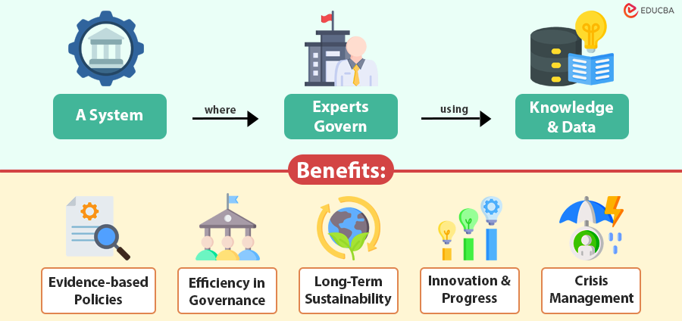
Figure 9: Technocratic Leadership Characteristics (Homayounifar et al., 2025)

3.2.2 Leadership Style of Chung Sye-kyun (Technocratic, Distributed, Transformational Leadership)
The leadership style of Chung can be examined according to three complementary frameworks. Firstly, he was a perfect Technocratic Leader, who prioritised a strong importance on evidence-based choice making, rule-based management, and scientific mastery. His reliance on KDCA experts and established cooperation with line ministries was an institutional model that is competence-driven and has a proper process (Tessema et al., 2021).
Second, his leadership was characterised by the aspects of Distributed Leadership as he took much operational responsibility and delegated it to the KDCA, the industry partners, and the local governments. The theory of distributed leadership has highlighted the benefits of joint authority, and particularly the situations of complex crisis, whereby no single actor can perform all the endeavours (Klebe et al., 2021). Chung used his position to give scientific and administrative agencies strength, and testing, tracing, and supply chain logistics expanded rapidly.
Third, he resorted to the elements of Transformational Leadership and appealed to the aspect of transparency, frequent communication, or appeal to social responsibility to encourage people to collaborate. Korea has prioritised the use of public messages that promote unity, civic responsibility, and safety of the community, which resulted in high compliance and trust, and OECD surveys recorded above 70 percent in 2020 (Stephen et al., 2021).

3.2.3 Key Leadership Actions
Chung did not take long to respond to the first-reported case on 20 January 2020 by activating national emergency procedures. He was the chairperson of the fast-tracking plan in Korea, including the exemptive regulation in the production and deployment of diagnostic tests and drive-through and walk-through testing centres. He planned cross-ministerial cooperation between the Ministries of Health, Interior, Justice and ICT, in particular, the border control and data-sharing and the enforcement of the quarantine rules. His role was important in stabilising the supply chains of PPE, which implied a close partnership with the manufacturers in the private sector. The daily public briefings, which shaped the opinion of the people and their participation, were facilitated by transparency and responsibility.

3.2.4 Leadership Strengths and Weaknesses
Among the strengths displayed by Chung was the fact that he was a leader who had good leadership qualities that helped him make quick and evidence-based decisions because of his scientific background. His open communication led to the generation of confidence among the people and this helped Korea to shun lockdowns on the entire country. Others were able to delegate efficiently to KDCA experts enabling technically autonomous operations where the number of tests per day had reached more than 100,000 by May 2020 (Emami et al., 2024). More than 24 hours of contact tracing were shortened to less than six hours, which facilitated more focused containment and economic activity. The coordination across ministers also helped in efficient mobilisation of public health, technological and regulatory resources. Nonetheless, it was weak on major privacy issues in regards to digital tracing, the high workload among the health teams of the population, and its dependence on institutional benefits like the presence of advanced digital infrastructure and robust state-industrial connections that raise the question of the applicability of the leadership model to other countries.

3.2.6 Analytical Evaluation
An example of how centralisation and technocratic rule can be useful in the formation of a swift solution to a crisis is the Leadership of Chung. His style fitted with institutional architecture that was incorporated in Korea, and a feeling of cohesion between power and action was formed (Shu and Wang, 2021). This was in contrast to Spain or Canada, where the leadership instructions were translated into working implementation. The combination of the factors of technocracy, distributed and transformational, allowed him to follow a strict scientific method and win over the confidence of the people. As per the conditions of crisis leadership that Boin offers, Chung was quite good at sense-making, decision-making, and coordination, which is the indicator of anticipatory, rather than reactive, leadership. The quality of such congruence of leadership and systems is reflected in the outcome of Korea, with 1.6 deaths per 100,000 in 2020 (Lv, Luo and Duckett, 2021).

3.3 Approach to leadership in Canada

3.3.1 Leadership Context
The leadership of the country in Canada was below the control of the Prime Minister named Justin Trudeau. However, contrary to control of power in the hands of the ministers of Spain or the unitary system of command in Korea, Trudeau was operating in a very decentralised federal system where the provinces had constitutional authority in matters of public health, hospitals and containment (Saunes et al., 2021). This limited his power over pandemic policy. The provinces were free to either follow the federal recommendations or not, and this created much disparity in the jurisdictions. Trudeau was rather perceived as a better national communicator, financial booster and coordinator than a real crisis commander. This was the model that determined the way he led and how far he was able to influence.

3.3.2 Leadership Style of Justin Trudeau (Transformational Leadership and Crisis Communication)
Various theoretical styles were employed by the leadership of Trudeau. Firstly, he demonstrated certain aspects of Transformational Leadership, particularly in his emphasis on cohesion, empathy and social cohesiveness. His periodic briefings, which frequently utilised the inclusive language (We will get through this together), were used to generate a sense of national identity and continue to maintain morale at a high level despite the uncertainty (Ohrling, Carlsson and Brommels, 2022).
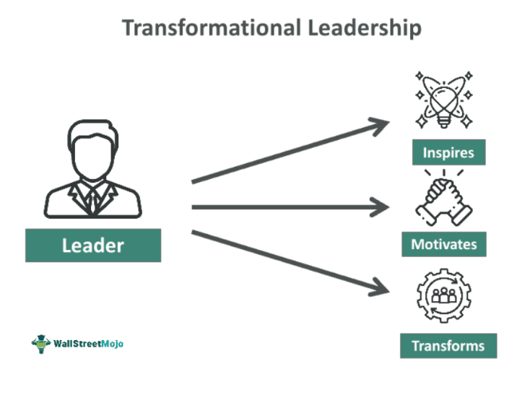
Figure 10: Transformational Leadership (Klebe et al., 2021)
Second, he showed Crisis Communication principles that can be characterised as transparency, emotional reassurance, and the explanation of the federal actions. The communication strategy of Trudeau was that of reducing anxiety and maintaining trust, which is also consistent with what crisis literature says, empathy and honesty as stabilising factors.

3.3.3 Key Leadership Actions
The main decisions of the time of Trudeau were the shutdown of non-essential travel in March 2020 to reduce transmission; the establishment of the Canadian Emergency Response Benefit (CERB), which supported 8.9 million people; the procurement of one of the major per-capita vaccine collections (Mathieu et al., 2021); and funds sent to the provinces and Indigenous communities to increase emergency health services. One of the few areas where the federal authority was explicit was the federal Quarantine Act, which was drafted by Trudeau to guarantee that international travellers were isolated.

3.3.4 Leadership Strengths and Weaknesses
The strengths of Trudeau are communication, coalition-building, and social protection. His empathetic communication style empowered the faith of the individuals and emphasised the strength of the community. Another strategy that he implemented was the power of federal spending, which was economic stabilisation and assistance to the provincial health systems. The procurement policy helped Canada acquire a large number of vaccines at a very early stage, and this may have led to a fast increase in the number of vaccinated people since April 2021.
However, with the structural limits, Trudeau could hardly do anything with his leadership. He had no authority to regulate the national population health using equal policies, and provinces had different responses. The inflexible and fragmented early testing scale-up may have been viewed as reflecting the intergovernmental coordination gaps. In Canada, the vaccine rollout in the early part of 2021 was slower due to low domestic production capacity, and it caused delays in comparison to other nations.

3.3.5 Analytical Evaluation
This is one of the aspects of the leadership of Trudeau, since there is a clash of humanistic communication and minimal executive power (Mattei and Del Pino, 2021). His form of collaboration would have been wanting in the political culture of more centralised systems, but it was adapted well to the Canadian culture. Though he had been very successful in the process of meaning-making and financial mobilisation, he was not so influential in decision-making and coordination of his operations. The executive leadership in Canada during the crisis was diluted in response to federalism, unlike in Korea, where there was a unified system or a temporary re-centralisation in Spain.

3.4 Comparative Leadership Discussion
The leadership style and institutional authority interaction led to the performance of leadership throughout the COVID-19. The central form of South Korea had allowed the technocratic and the distributed leadership of Chung Sye-kyun to deliver the action quick and coordinated as well as the extremely low mortality (Smith et al., 2022). There was a devolution and internal politics limiting Spanish leadership under Salvadore Illa and it could not attain early coherence despite the strengths of technocracy and the flexibility. Justin Trudeau who has been in the context of the federal system of Canada was forced to adopt a mixture of mutual and understanding leadership, however, the provincial autonomy had unequal outcomes and led to disastrous failures in long-term care.

4. Conclusion
The comparative analysis of three country reveals that the effectiveness of the response to COVID-19 in a country depended on the communication between the health scheme structure and the leader's capacity. The coordination was centralised as it is with South Korea, and that enabled rapid decision-making as well as free flow of communication and mobilisation of testing and surveillance through these, which has led to low mortality rates. Both the non-centralised models, Spain and Canada, had shown local flexibility benefits, although they both had problems with initial data integration, common sense, and political fit that constrained the effectiveness of leadership. The examples also show how the leadership style contributes to the development of civic dependence and the implementation of policies: technocratic and open styles were in high demand to ensure obedience in South Korea, whereas in Canada, the structural fragmentation was partly reduced due to collaboration and compassionate dialogue. Broadly, the comparison can be made, where no centralisation or decentralisation can be adequate to decide on the outcome; however, the performance of the crisis is determined by the presence or absence of convergence between the system design, distribution of power and mobilisation ability in the situation of uncertainty.

References
- Ahern, S. and Loh, E. (2020). Leadership during the COVID-19 pandemic: building and sustaining trust in times of uncertainty. BMJ Leader, [online] 5(4). doi: https://doi.org/10.1136/leader-2020-000271.
- Aida, T. and Shoji, M. (2022). Cross-country evidence on the role of national governance in boosting COVID-19 vaccination. BMC Public Health, 22(1). doi: https://doi.org/10.1186/s12889-022-12985-5.
- Aleta, A. and Moreno, Y. (2020). Evaluation of the potential incidence of COVID-19 and effectiveness of containment measures in Spain: a data-driven approach. BMC Medicine, 18(1). doi: https://doi.org/10.1186/s12916-020-01619-5.
- Balmford, B., Annan, J.D., Hargreaves, J.C., Altoè, M. and Bateman, I.J. (2020). Cross-Country Comparisons of Covid-19: Policy, Politics and the Price of Life. Environmental and Resource Economics, 76. doi: https://doi.org/10.1007/s10640-020-00466-5.
- Borghi, J. and Brown, G.W. (2022). Taking Systems Thinking to the Global Level: Using the WHO Building Blocks to Describe and Appraise the Global Health System in Relation to COVID‐19. Global Policy, [online] 13(2), pp.193–207. doi: https://doi.org/10.1111/1758-5899.13081.
- Chibi, M. and Galea, G. (2025). Innovation leadership perspective in public health. European journal of public health, [online] 35(Supplement_2), pp.ii19–ii20. doi: https://doi.org/10.1093/eurpub/ckae217.
- Cummings, P.-J. de-Winton, Baker, K.K., Appell, L., Rios, M.D., Diekema, D.J., Kitzmann, T., Marroquin, N., Raymond, G. and Carvour, M.L. (2025). Equity in epidemic response: an action-oriented framework for guiding public health in equitable responses to major infectious disease emergencies. International Journal for Equity in Health, 24(1). doi: https://doi.org/10.1186/s12939-025-02433-2.
- Emami, S.G., Lorenzoni, V. and Turchetti, G. (2024). Towards Resilient Healthcare Systems: A Framework for Crisis Management. International Journal of Environmental Research and Public Health, [online] 21(3), p.286. doi: https://doi.org/10.3390/ijerph21030286.
- Erkoreka, M. and Hernando‐Pérez, J. (2022). Decentralization: A handicap in fighting the COVID‐19 pandemic? The response of the regional governments in Spain. Public Administration and Development, 43(2). doi: https://doi.org/10.1002/pad.1988.
- Ferrinho, P., Lehman, U., Kovacs, E. and Poz, M.D. (2022). Relevant HRH leadership during public health emergencies. Human Resources for Health, 20(1). doi: https://doi.org/10.1186/s12960-022-00723-2.
- Greer, S.L., Rozenblum, S., Falkenbach, M., Löblová, O., Jarman, H., Williams, N. and Wismar, M. (2022). Centralizing and decentralizing governance in the COVID-19 pandemic: The politics of credit and blame. Health Policy, [online] 126(5). doi: https://doi.org/10.1016/j.healthpol.2022.03.004.
- Hegele, Y. and Schnabel, J. (2021). Federalism and the management of the COVID-19 crisis: centralisation, decentralisation and (non-)coordination. West European Politics, 44(5-6), pp.1–20. doi: https://doi.org/10.1080/01402382.2021.1873529.
- Homayounifar, F., Abdollahi, Z., Davar, G., Ostovar, T., Delavari, S., Ahmadi Marzaleh, M. and Khosravi, M. (2025). Strengthening Primary Health Care for Epidemic and Pandemic Response: A Scoping Review. Journal of Advanced Nursing. doi: https://doi.org/10.1111/jan.16757.
- Hu, Q., Zhang, H., Kapucu, N. and Chen, W. (2020). Hybrid Coordination for Coping with the Medical Surge from the COVID ‐19 Pandemic: Paired‐Assistance Programs in China. Public Administration Review. doi: https://doi.org/10.1111/puar.13253.
- Ibrahim Yikilmaz, Lutfi Surucu, Ahmet Maslakci, Alper Bahadir Dalmis and Meric Ergun (2024). Workplace Buoyancy and Servant Leadership as Catalysts for Sustainable Disaster Management: Mitigating Emotional Exhaustion in Disaster Response Teams. Sustainability, 16(7), pp.2695–2695. doi: https://doi.org/10.3390/su16072695.
- Kaye, A.D., Cornett, E.M., Kallurkar, A., Colontonio, M.M., Chandler, D., Mosieri, C., Brondeel, K.C., Kikkeri, S., Edinoff, A., Fitz-Gerald, M.J., Ghali, G.E., Liu, H., Urman, R.D. and Fox, C.J. (2021). Framework for creating an incident command center during crises. Best Practice and Research. Clinical Anaesthesiology, [online] 35(3), pp.377–388. doi: https://doi.org/10.1016/j.bpa.2020.11.008.
- Klebe, L., Felfe, J. and Klug, K. (2021). Healthy Leadership in Turbulent Times: The Effectiveness of Health‐Oriented Leadership in Crisis. British Journal of Management, 32(4). doi: https://doi.org/10.1111/1467-8551.12498.
- Lal, A., Ashworth, H.C., Dada, S., Hoemeke, L. and Tambo, E. (2020). Optimizing Pandemic Preparedness and Response through Health Information Systems: Lessons Learned from Ebola to COVID-19. Disaster Medicine and Public Health Preparedness, 16(1), pp.1–25. doi: https://doi.org/10.1017/dmp.2020.361.
- Lee, D. and Lee, J. (2020). Testing on the Move South Korea’s rapid response to the COVID-19 pandemic. Transportation Research Interdisciplinary Perspectives, [online] 5. doi: https://doi.org/10.1016/j.trip.2020.100111.
- Lee, J.M., Jansen, R., Sanderson, K.E., Guerra, F., Keller-Olaman, S., Murti, M., O’Sullivan, T.L., Law, M.P., Schwartz, B., Bourns, L.E. and Khan, Y. (2023). Public health emergency preparedness for infectious disease emergencies: a scoping review of recent evidence. BMC Public Health, 23(1). doi: https://doi.org/10.1186/s12889-023-15313-7.
- Lee, Y. and Li, J.Q. (2021). The role of communication transparency and organizational trust in publics’ perceptions, attitudes and social distancing behaviour: A case study of the COVID‐19 outbreak. Journal of Contingencies and Crisis Management, 29(4), pp.368–384. doi: https://doi.org/10.1111/1468-5973.12354.
- Lloyd-Smith, M. (2020). The COVID-19 pandemic: resilient organisational response to a low-chance, high-impact event. BMJ Leader, [online] p.leader-2020-000245. doi: https://doi.org/10.1136/leader-2020-000245.
- Lv, A., Luo, T. and Duckett, J. (2021). Centralization vs. Decentralization in COVID-19 Responses: Lessons from China. Journal of Health Politics, Policy and Law, 47(3). doi: https://doi.org/10.1215/03616878-9626908.
- Mathieu, E., Ritchie, H., Ortiz-Ospina, E., Roser, M., Hasell, J., Appel, C., Giattino, C. and Rodés-Guirao, L. (2021). A global database of COVID-19 vaccinations. Nature Human Behaviour, 5(5), pp.947–953. doi: https://doi.org/10.1038/s41562-021-01122-8.
- Mattei, P. and Del Pino, E. (2021). Coordination and Health Policy Responses to the First Wave of COVID-19 in Italy and Spain. Journal of Comparative Policy Analysis: Research and Practice, 23(2), pp.274–281. doi: https://doi.org/10.1080/13876988.2021.1878886.
- Matteo Nocci, Bassam Dannaoui, Corte, F.D., Luca Ragazzoni, Barone-Adesi, F., Romagnoli, S., Raffaele, A., Rubulotta, F. and Mechi, M.T. (2020). Real-Time Coordination of the Regional Health System During the Pandemic. Disaster Medicine and Public Health Preparedness, 16(4), pp.1296–1299. doi: https://doi.org/10.1017/dmp.2020.501.
- Mendes, M., Esperidião, M.A., Azevedo, K., Marques, F., Celeste, L., Silva, A., Tavares, S., Domingos, I., de, C. and Degrave, A. (2025). Governance and responses of health and surveillance systems to COVID-19 in BRICS countries: A scoping review protocol. PLoS ONE, 20(3), pp.e0319572–e0319572. doi: https://doi.org/10.1371/journal.pone.0319572.
- Ohrling, M., Solberg Carlsson, K. and Brommels, M. (2022). No man is an island: management of the emergency response to the SARS-CoV-2 (COVID-19) outbreak in a large public decentralised service delivery organisation. BMC Health Services Research, 22(1). doi: https://doi.org/10.1186/s12913-022-07716-w.
- Saunes, I.S., Vrangbæk, K., Byrkjeflot, H., Jervelund, S.S., Birk, H.O., Tynkkynen, L.-K., Keskimäki, I., Sigurgeirsdóttir, S., Janlöv, N., Ramsberg, J., Hernández-Quevedo, C., Merkur, S., Sagan, A. and Karanikolos, M. (2021). Nordic responses to Covid-19: Governance and policy measures in the early phases of the pandemic. Health Policy. [online] doi: https://doi.org/10.1016/j.healthpol.2021.08.011.
- Shu, Q. and Wang, Y. (2021). Collaborative Leadership, Collective Action, and Community Governance against Public Health Crises under Uncertainty: A Case Study of the Quanjingwan Community in China. International Journal of Environmental Research and Public Health, [online] 18(2), p.598. doi: https://doi.org/10.3390/ijerph18020598.
- Smith, R.W., Jarvis, T., Sandhu, H.S., Pinto, A.D., O’Neill, M., Di Ruggiero, E., Pawa, J., Rosella, L. and Allin, S. (2022). Centralization and integration of public health systems: Perspectives of public health leaders on factors facilitating and impeding COVID-19 responses in three Canadian provinces. Health Policy, [online] 127, pp.19–28. doi: https://doi.org/10.1016/j.healthpol.2022.11.011.
- Statista (2020). Spain: coronavirus mortality rate by age 2020| Statista. [online] Statista. Available at: https://www.statista.com/statistics/1105596/covid-19-mortality-rate-by-age-group-in-spain-march/?srsltid=AfmBOorOzPgkUmh1aF8Oj7eD5ALs69hn2F9ikpltJrQTHE8Z9G8EGQ-l [Accessed 7 Dec. 2025].
- Stephen, S., Issac, A., Radhakrishnan, R.V., Jacob, J., Vijay, V., Jose, S., Azhar, S., Nair, A.S., Krishnan, N., Sharma, R. and Dhandapani, M. (2021). Scrutiny of COVID-19 response strategies among severely affected European nations. Osong Public Health and Research Perspectives, [online] 12(4), pp.203–214. doi: https://doi.org/10.24171/j.phrp.2021.0068.
- Sturmberg, J.P., Tsasis, P. and Hoemeke, L. (2020). COVID-19 – An Opportunity to Redesign Health Policy Thinking. International Journal of Health Policy and Management. doi: https://doi.org/10.34172/ijhpm.2020.132.
- Sundararaman, T., Muraleedharan, V.R. and Ranjan, A. (2021). Pandemic resilience and health systems preparedness: lessons from COVID-19 for the twenty-first century. Journal of Social and Economic Development. doi: https://doi.org/10.1007/s40847-020-00133-x.
- Tessema, G.A., Kinfu, Y., Dachew, B.A., Tesema, A.G., Assefa, Y., Alene, K.A., Aregay, A.F., Ayalew, M.B., Bezabhe, W.M., Bali, A.G., Dadi, A.F., Duko, B., Erku, D., Gebrekidan, K., Gebremariam, K.T., Gebremichael, L.G., Gebreyohannes, E.A., Gelaw, Y.A., Gesesew, H.A. and Kibret, G.D. (2021). The COVID-19 pandemic and healthcare systems in Africa: a scoping review of preparedness, impact and response. BMJ Global Health, [online] 6(12), p.e007179. doi: https://doi.org/10.1136/bmjgh-2021-007179.

