BA Business Management
Data Handling and Business Intelligence

Table of Contents
Introduction 3
Part 1 4
a) Analysis on the Coffee_Consumption_and_Effects_2023 dataset (provided) using the Excel or SPSS statistical software to evaluate the following. 4
1. Mean value for coffee consumption (in cups) per day 4
2. Median value for coffee consumption (in cups) per day 5
3. Mode of the coffee consumption (in cups) per day 5
4. Standard deviation for effects on the human body (based on a health index score) 6
5. Variable with larger variance 6
6. Variable with a larger standard deviation 7
7. Interpretation of the last three outcomes 7
b) Demonstration of data presentation using any one of Excel functions such as: IF, PIVOT TABLES, CHARTS AND GRAPHS 8
(c) Using SPSS – 10
1. Correlation between coffee consumption and the health index score showing the required workings with full screenshots 10
2. Producing a scatterplot of the two variables 12
Part 2 15
a) Advantages and disadvantages of using SPSS, Excel or Tableau using relevant practical examples. 15
b) Explaining the meaning and importance of Data Mining Cycle with examples. 16
Conclusion 19
References 20

Introduction
This report constitutes two parts. In the first part, a given data set has been analysed using MS Excel and SPSS. Using Excel, different measures of central tendency and measures of dispersion have been calculated for the two variables- coffee consumption and health index score. The given data has been presented in a meaningful way using pivot tables, graphs and charts in the next section. SPSS has also been used in this part to determine correlation coefficient and draw scatter plots. The next part describes the pros and cons of MS Excel, SPSS and Tableau. It also involves a detailed discussion on the data mining cycle and the significance of the data mining cycle along with real life examples.

Part 1

Analysis on the Coffee_Consumption_and_Effects_2023 dataset (provided) using the Excel or SPSS statistical software to evaluate the following.

Mean value for coffee consumption (in cups) per day
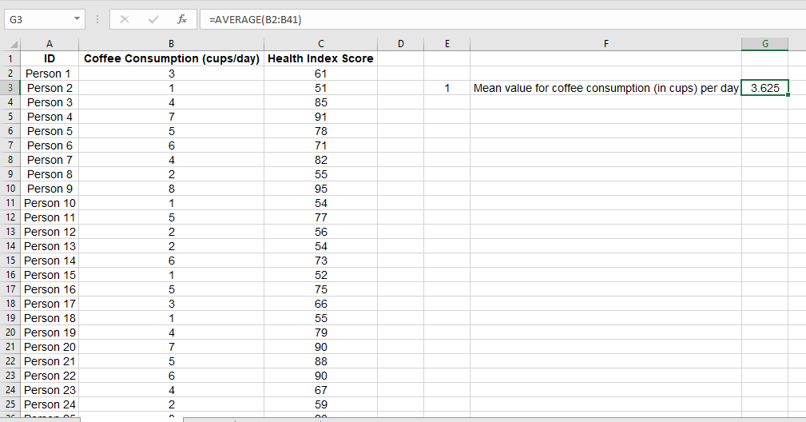
Table 01: Calculation of mean
Source: Self-made
Mean value for coffee consumption has been calculated by determining the average of the 40 persons’ coffee taking habits in MS Excel through the use of “AVERAGE” formula. Generally arithmetic mean for a particular variable refers to the average of the variable’s available data (Divisi, 2017). The daily mean of coffee consumption has been found to be 3.625 which is approximately equal to 4. It states that on an average, a person is seen to take 4 cups of coffee or more than 3 cups of coffee a day. This result is only limited to the selected group of people but gives an estimation regarding the coffee consumption habit of any people. With the inclusion of more samples in the dataset, a more representative sample statistic regarding mean value of coffee consumption can be derived.

Median value for coffee consumption (in cups) per day
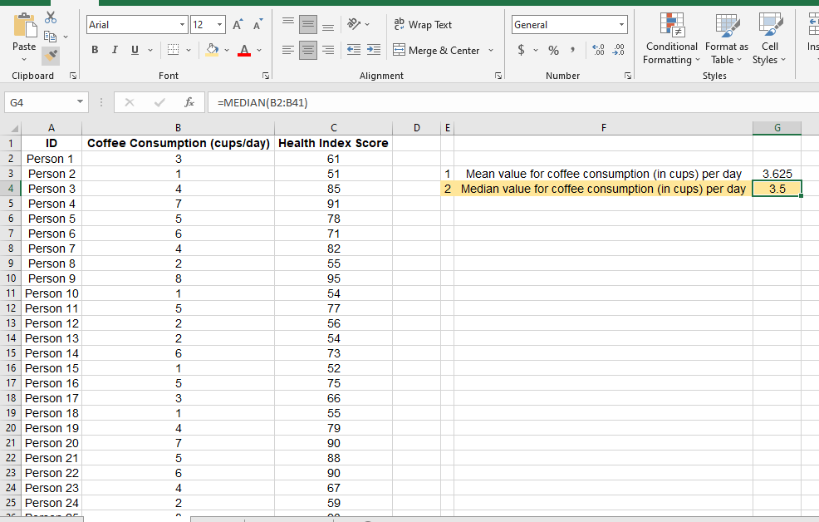
Table 02: Calculation of median
Source: Self-made
Median of the given data for coffee consumption is 3.50. That is, 50% of the people are used to take less than 3.5 cups of coffee and the other 50% more than 3.5 cups of coffee. The value has been calculated in MS Excel by using the built-in “MEDIAN” formula. In this case, at first the formula has been selected followed by specifying the range of data for which median will be calculated. For this specific case, the data is located within cells ranging from B2 to B41. Though, for a normally distributed dataset, the value of mean and median would have been equal, as these are not equal for the given dataset, it can be said that the given dataset is not normally distributed. As mean is greater than median, the distribution has positive skewness (Ali and Bhaskar, 2016).

Mode of the coffee consumption (in cups) per day
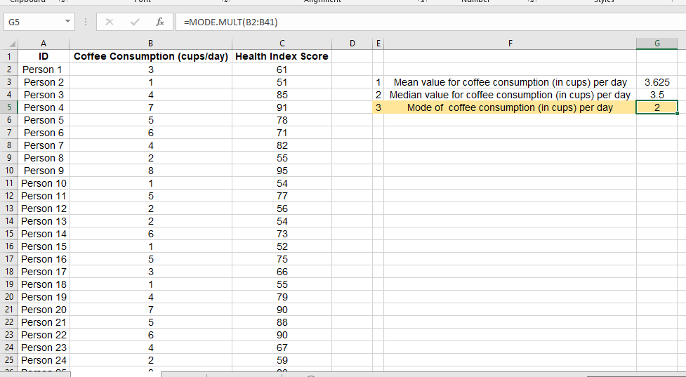
Table 03: Calculation of mode
Source: Self-made
Multiple mode formulas have been used to determine the mode value for the coffee consumption of 40 people. Mode refers to the highest frequency of a variable and there can generate more than one mode for a particular distribution of data (Carlberg, 2014). The value of mode for coffee consumption (in cups) is 2 that indicates if the selected persons are categorised in terms of their coffee taking level, the highest group of people will be categorised in the section where daily 2 cups of coffee are consumed by people. Out of the 40 persons, 9 used to take 2 cups of coffee whereas daily 1 cup of coffee was consumed by 7 people.

Standard deviation for effects on the human body (based on a health index score)
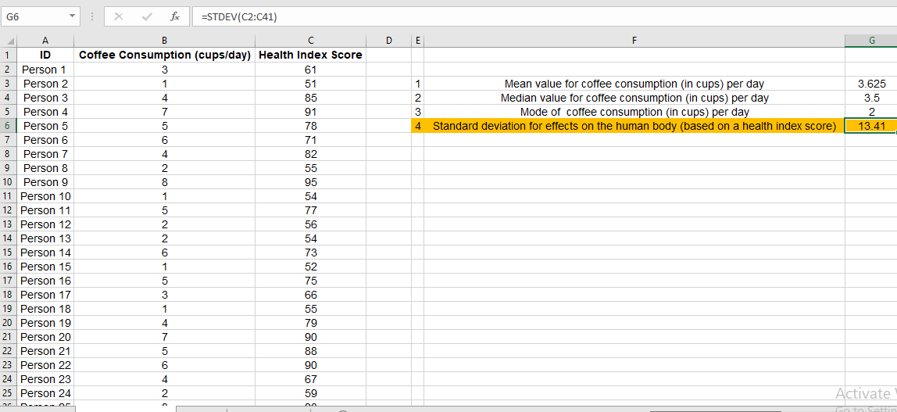
Table 04: Calculation of standard deviation
Source: Self-made
Standard deviation refers to the spread of individual data from its central tendency or mean value. A higher value of standard deviation implies the data are spread in a scattered way from the mean value and there is more deviation among the data (Rosner, 2015). So, for a particular distribution, a lower value of standard deviation is desired. The standard deviation representing the effects on the human body is 13.41. It has been calculated using the “STDEV” formula in the MS Excel.

Variable with larger variance
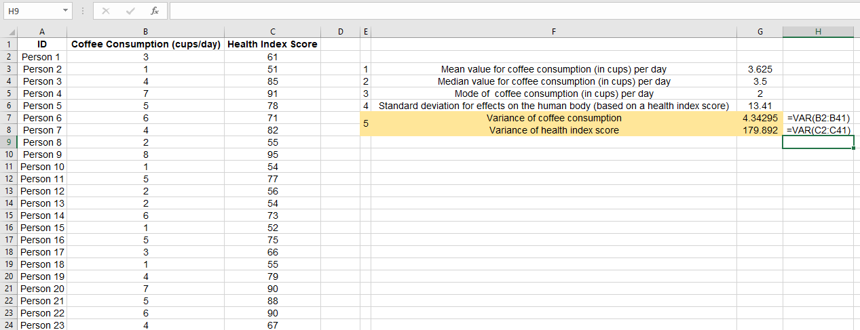
Table 05: Calculation of variance
Source: Self-made
The square of standard deviation is known as variance and like standard deviation, it is also a measurement of dispersion (Anderson, 2016). Variance for coffee consumption and health index score have been determined here using the “VAR” formula. The formula along with the expected results are demonstrated in the above-presented screen shot. The variance is 4.34 for coffee consumption level of 40 samples whereas it is approximately 180 for the health index score. It clearly represents that the health index score represents a highly volatile data set with higher variance and higher dispersion or spreading out of individual data from its measure of central tendency.

Variable with a larger standard deviation
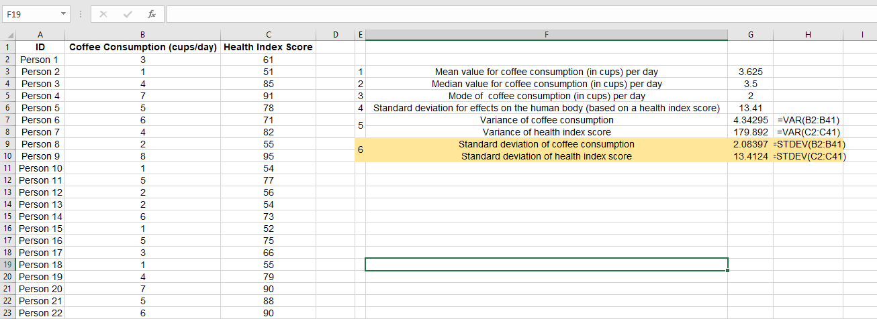
Table 06: Calculation of standard deviation
Source: Self-made
Standard deviation for consumption of coffee is 2.08 whereas for health score index, it is 13.41. The standard deviation that represents the effect of coffee on human health is higher than that of the data representing coffee taking frequency.

Interpretation of the last three outcomes
Standard deviation and variance convey the same implications for a dataset. The main difference is standard deviation is a standardized form of variance. Therefore, it is more appealing to describe the characteristics of a dataset than variance (Newbold, 2013). Both the variance and standard deviation of health index score are significantly higher than that of the daily coffee taking habit. It is because the diet condition or health status of people may be diverse for a variety of factors and it is usual that the factors will not be the same for every person as the lifestyle, habit, food consumption habit, preferences etc. vary from person to person.

Demonstration of data presentation using any one of Excel functions such as: IF, PIVOT TABLES, CHARTS AND GRAPHS
Using MS Excel, unarranged data can be presented in a meaningful way. That is, data can be transformed into information by presenting them using the right tool. The data presented in the MS Excel comprises 40 people's coffee taking habit and the impact of this habit on their health. But if each individual’s coffee consumption level and health index score is observed separately, it will not result in any conclusion regarding the correlation between the presented factors. But by using pivot tables or charts and graphs, the discrete data can be presented in a grouped and systematic way that will convey meaningful insights regarding the significance and connection among the presented factors (Miller, 2014).
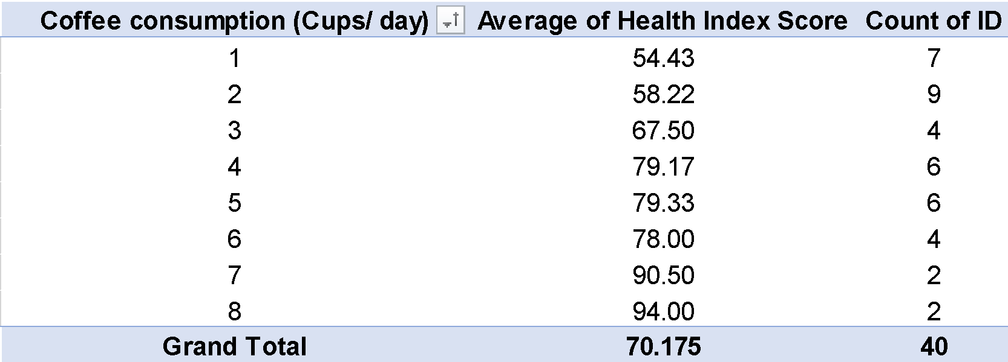
Table 07: Use of pivot table
Source: Self-made
The given data set has been presented in a pivot table. The first column shows the number of cups of coffee that a person may take daily. And against the coffee intake level, average health index score of the persons along with how many persons out of the 40 selected people consume coffee in the particular frequency level. The pivot table shows that 7 persons were found to take 1 cup of coffee daily and their average health index score was 54.43. The average score was 58.22 for 9 persons who consumed 2 cups of coffee daily and it reached to 67.50 and 78 for two distinct groups of 4 persons who took coffee 3 and 6 cups per day respectively. People who used to have 4 or 5 cups of coffee were found to have a health index score of 79. But when the consumption rate rose to 7 to 8 cups, the average health index score skyrocketed to 90.50 and 94.
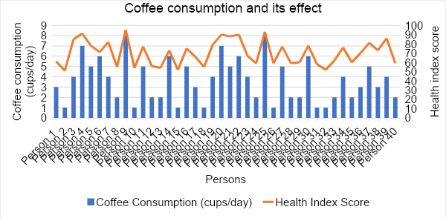
Figure 01: Coffee consumption and its effect
Source: Self-made
The combo chart presented above shows the impact of coffee consumption on the human body. The graph is a combination of line and column chart (Janvrin, Raschke and Dilla, 2014). In the graph, persons’ ID no. has been replaced horizontally and coffee consumption as well as health index score have been presented vertically where the line chart represents health index score and the column chart coffee consumption in terms of cups per day. Apparently, from this graph, a correlation can be seen between how much a person usually consumes coffee and what their current health condition is. The index score is seen to be higher for persons who are used to taking more coffee on a daily basis and vice versa.

(c) Using SPSS –

1. Correlation between coffee consumption and the health index score showing the required workings with full screenshots
To determine the correlation between coffee consumption and its effect on health by using health index score as a proxy variable, first of all, the dataset needs to be inserted into SPSS software (Abbott, 2014). Out of the three variables, id has been defined as a variable representing scale while the other two variables have been defined as nominal variables. Followings are the demonstration of the desired dataset in SPSS.

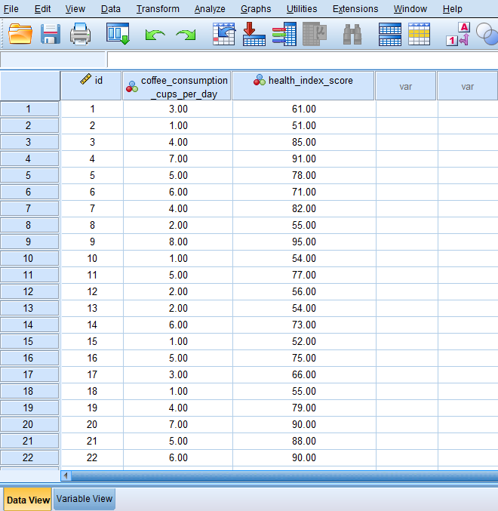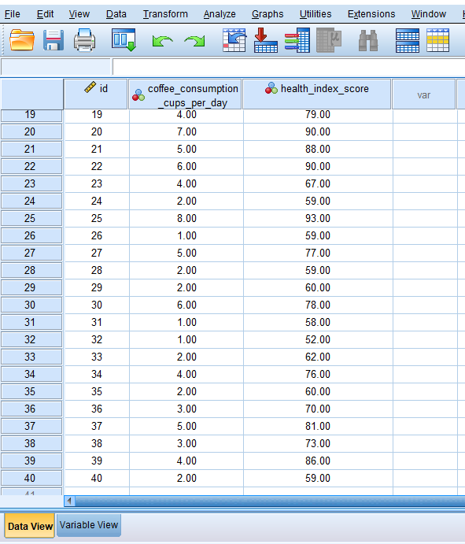
Table 08: Dataset in SPSS
Source: Self-made

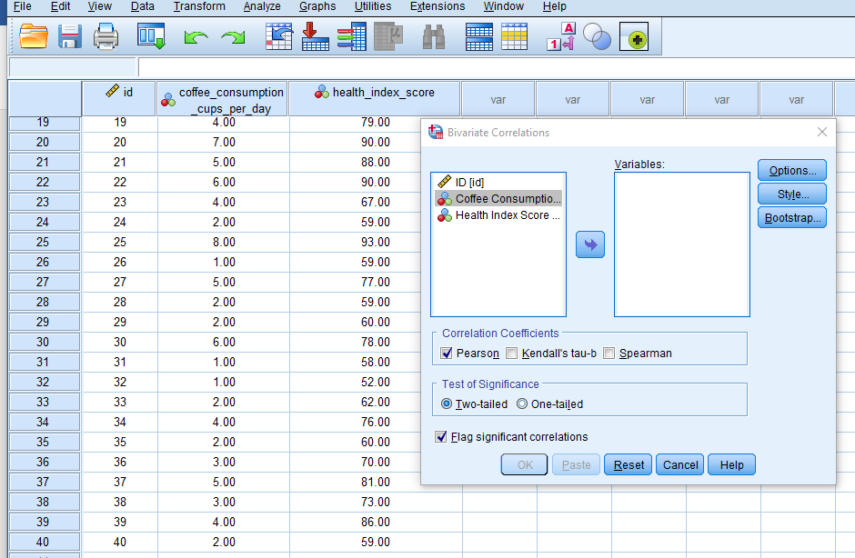
Table 09: Determining correlation coefficient in excel
Source: Self-made

To determine correlation between variables in SPSS, from the menu bar, the option “Analyze” needs to be selected that will present different techniques of data analysis from which “Correlate” followed by “Bivariate” option needs to be selected (Bhunia, 2013). After that the above-mentioned pop-up box will appear on the screen.
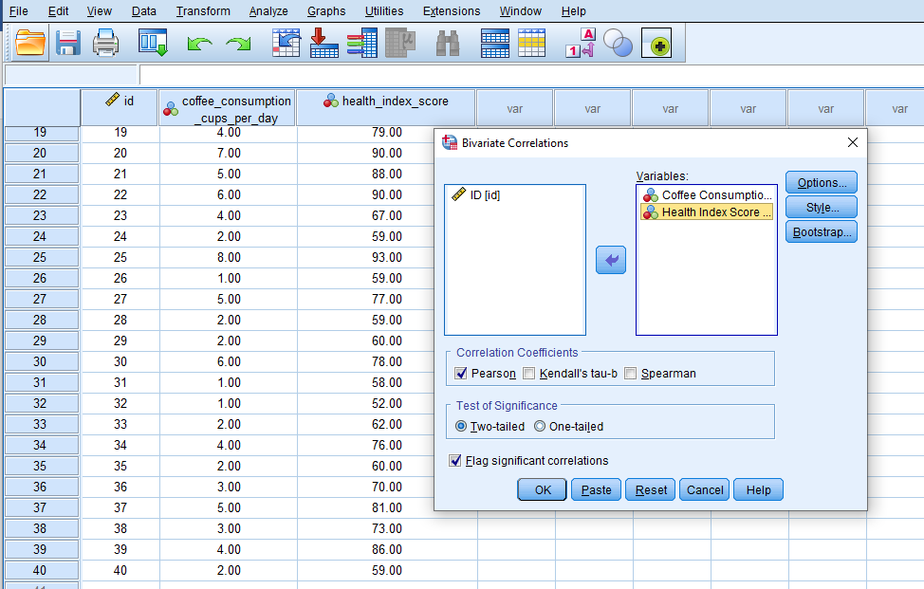
Table 10: Determining correlation coefficient in excel
Source: Self-made
From the left side box, the variables that would be applied to find out the correlations need to be dragged to the right box. Therefore, the two variables namely coffee consumption in terms of cups per day and health index score have been selected and moved to the next box (Verma, 2012). In default, Peason’s correlation coefficient is measured. The SPSS software will automatically lead to the following correlation output after pressing “OK”.
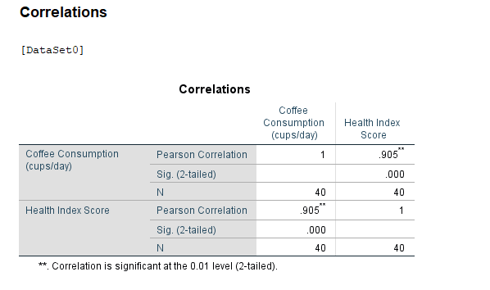
Table 11: Determining correlation coefficient in excel
Source: Self-made
The correlation output shows that there exists a strong positive relationship between the level of coffee consumption per day and its effect on human health. The value of correlation coefficient is 0.905. It states that the health index score will go by 0.905 if a person’s coffee taking rises by 1 cup. The level of significance is less than 1%. It indicates that correlation between these two variables is statistically significant (Schober, Boer and Schwarte, 2018). So, higher coffee consumption results in negatively on human body.

2. Producing a scatterplot of the two variables

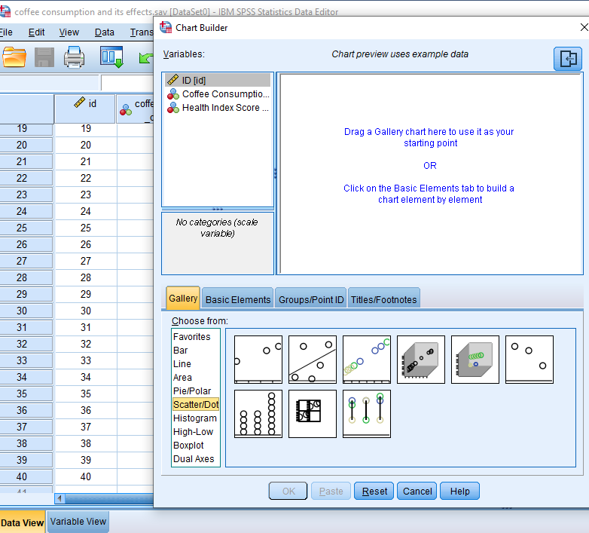
Table 12: Drawing scatter plot
Source: Self-made
Graphs and plots can easily be made using SPSS software by going through some commands. To draw a scatter plot, from the tool bar of the SPSS software, “Graphs” option needs to be selected. That will lead to the above-demonstrated page (Arkkelin, 2014). From the gallery, a scatter plot will be selected and out of the different types of scatter plot, the desired one will be dragged to the upper part of the pop-up page.

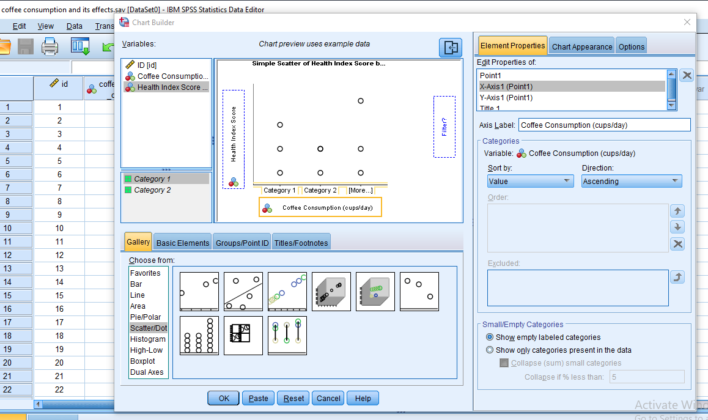
Table 13: Drawing scatter plot
Source: Self-made
To get the scatter diagram, the variable “coffee consumption” has been dragged to the horizontal axis from the left corner and health index score has been dragged to the vertical axis. The next step is to just press “OK” and the SPSS software will automatically lead to the output page that would show the following scatter plot.
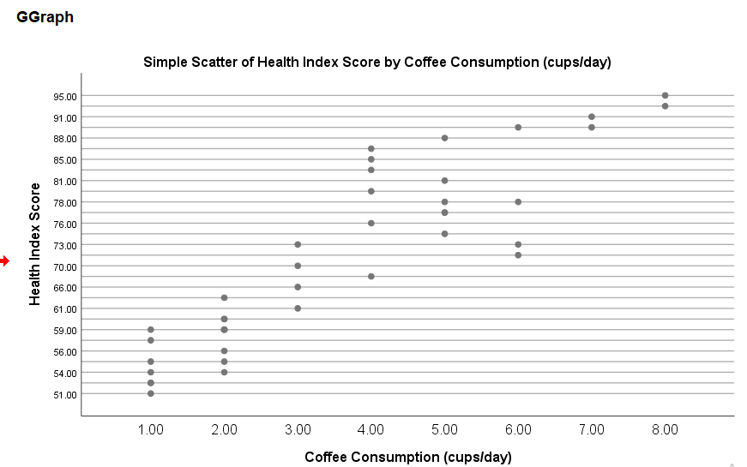
Figure 02: Drawing scatter plot
Source: Self-made
In the scatter plot, for persons who would take 1 cup of coffee per day, the health index score has been seen to range from 51-59 where higher score means more deteriorating health condition. When coffee consumption reaches to 2 cups on a daily basis, the diet and health condition related score ranges from 54 to 66. Here ranges include more than one score because the health status of a person includes a number of things except coffee consumption habits. The score can be 68 to 88 if coffee is taken 4 times a day. For the persons who consume 5 cups of coffee daily, maximum health index score has been found to be 88 and it was 91 with the rise of coffee consumption by additional 2 cups and 95 for individuals who used to consume 8 cups of coffee per day. The scatter plot shows an upward slope from the perceived relationship between coffee taking habit and its impact on the health of the individuals. With the rise of coffee consumption, the selected group of people have experienced a higher score that reflects worsening conditions of health in terms of balanced diet and soundness (Akoglu,2018). In short, people can generally maintain a comparably good balanced diet or healthy lifestyle if they contain their coffee consumption habit to a limited scale.

Part 2

Advantages and disadvantages of using SPSS, Excel or Tableau using relevant practical examples.

 | Advantages | Disadvantages
SPSS | - The interface of SPSS is more user friendly than other types of software that facilitates its users. For example, any graphs, charts etc. can be drawn by some commands and people having little to no statistics knowledge will also be able to operate it.  - The scope of customization is adequate for users in the SPSS with no complex commands. Therefore, people can easily tailor their data in however form they want. They can, for instance, draw a graph by changing the labels, variable, axis etc. | - When it comes to the use of advanced levels of statistical analysis, SPSS cannot offer adequate flexibility. It may not be the appropriate tool to follow for deep or natural language learning processing.  - The costs of getting a license to use SPSS and updating the current version can be higher, particularly for individual users (Chen, 2019).
Excel | - The application of excel is versatile and wide irrespective of purposes or industries. From data recording, analysis, presenting to financial modelling, project management- everything can be done in excel. A scientist may keep track of the results of its experiences and conduct different statistical analysis on the results using Excel whereas a financial analyst can predict the business performance of an organization using excel (Bryant, 2021).  - To visualize and report data, excel can be a very efficient and effective tool. Data can be presented precisely and meaningfully using tables and charts available in excel. The purchase or sales dashboard with pivot tables can be used as an example of the data visualization for a marketing analyst. | - The data handling and processing ability of Excel is hardly efficient when it comes to dealing with millions of rows or columns or large volumes of dataset. In this case, the users may experience slower performance or even crashing of MS Excel.  - It is easier to manipulate data in excel that may destroy the integrity and reduce the reliability of the data recorded in the excel.
Tableau | - More interactive data visualization facility is offered by Tableau through allowing users to use different types of charts and tables that enable exploration and drill-down capabilities (Smith, 2013). For example, a manager can develop an inventory dashboard that will keep record of the current status of inventory in real time.  - To perform complaint data analysis, tableau can be a better option. Along with the built-in statistical functions, clustering, trend and sensitivity analysis, data blending etc. can be performed through the help of tableau. | - The licensing cost and subsequential maintenance and update costs of tables can be quite expensive specially for individual users and small business units. The cost increases as for separate server or desktop, separate license of tableau is required.  - If the dataset is larger than the size that can be processed by tableau, the response time and processing capacity of tableau may fall drastically.

Explaining the meaning and importance of the Data Mining Cycle with examples.
Data mining cycle constitutes a series of steps that altogether is aimed at identifying any connections, patterns and implication from a given data set in a repetitive way. Different types of data mining methodologies are applied in the data mining cycle to transform raw data into meaningful and actionable knowledge and information (Padhy, Mishra and Panigrahi, 2012). The stages of the data mining cycle are more or less limited to the following steps.

Data Collection

Data Preparation

Data Exploration

Modeling

Evaluation

Deployment

Monitoring and maintenance

Figure 03: Stages of data mining
Source: Self-made
The significance of the data mining cycle is discussed below.
Fraud and anomalies detection: In terms of detecting fraudulent activities, data mining can play a proactive role. The use of data mining in identifying unusual or fraudulent transactions is more prevalent in financial institutions who employ different techniques of data mining to prevent any form of window dressing in the financial information (Kaufman, 2012).
Increase of business efficiency: With higher scope of businesses, the complexity of operation, maintenance and controlling rises. But it can efficiently be handled through the use of various data mining techniques. A logistics company can use these tools to reduce their transitory or waiting time and to make decisions regarding where to install warehouses to minimise total costs of the firm.
Pinpointing patterns and insights: From a large dataset, data mining tools will be able to come up with patterns and insights inherent in the dataset. This concept is applied by the business organizations to discover the preferences of their customers and therefore helps the firms in maximizing customer retention level, sales return and profits of the businesses. It also can help businesses in adopting the perfect pricing and marketing strategies compatible with its target customer groups.
Enabling improved decision-making ability: By employing data mining techniques, different types of entities can identify the material factors and accordingly take required actions. In the medical world, data mining technologies are used extensively to analyse patient data to identify populations with high risk, possibility of any disease outbreak etc. (Yoo, 2012).
With the digitalization era, information has become the most important resource for everyone. Though data is available everywhere in a scattered and unmeaningful pattern, right data mining tools and using it in the right way can help the users come up with better decisions and insights that will lead to gaining competitive advantage and driving growth and innovation.

Conclusion
The use of Excel and SPSS has made it easier for researchers and other organisations to deal with large volumes of data and retrieve meaningful insights. SPSS is highlighted for its user-friendly interface, higher coverage of statistical tools and data management capabilities. Excel is recognized for its versatility and data visualization capabilities and tableau for its advanced analytical features and easy data integration. In dealing with big data, data mining techniques can be applied by organizations and thereby can harness the power of their data, improve the current condition of the business and develop their decision-making ability by integrating all the available, meaningful and material information.

References
Abbott, M.L., 2014. Understanding educational statistics using Microsoft Excel and SPSS. John Wiley & Sons.
Akoglu, H., 2018. User's guide to correlation coefficients. Turkish journal of emergency medicine, 18(3), pp.91-93.
Ali, Z. and Bhaskar, S.B., 2016. Basic statistical tools in research and data analysis. Indian journal of anaesthesia, 60(9), p.662.
Anderson, D.R., Sweeney, D.J., Williams, T.A., Camm, J.D. and Cochran, J.J., 2016. Statistics for business & economics. Cengage Learning.
Arkkelin, D., 2014. Using SPSS to understand research and data analysis.
Bhunia, A., 2013. Statistical methods for practice and research (A guide to data analysis using SPSS). South Asian Journal of Management, 20(1), p.154.
Bryant, L.A., 2021. Statistical skills for the workplace: A practical approach to teaching methods with Excel. The Palgrave Handbook of Political Research Pedagogy, pp.289-300.
Carlberg, C., 2014. Statistical analysis: Microsoft excel 2013. Que Publishing.
Chen, G., Liu, Z., XinDa, L.I., Cui, W., Song, Y. and Kang, Y., 2019. Comprehensive Evaluation and Prospect of Data Mining Tool Base for Company Operation Monitoring.
Divisi, D., Di Leonardo, G., Zaccagna, G. and Crisci, R., 2017. Basic statistics with Microsoft Excel: a review. Journal of thoracic disease, 9(6), p.1734.

