University of Wales Trinity St. David

Information Engineering (ACCB4013)
Beverley Holland
In-Class Exam Assignment

Joseph Ross
1702760
14/01/2020
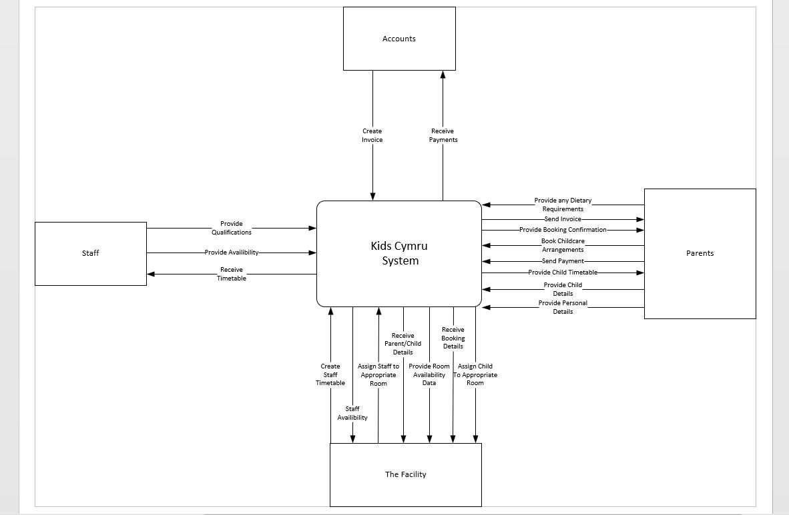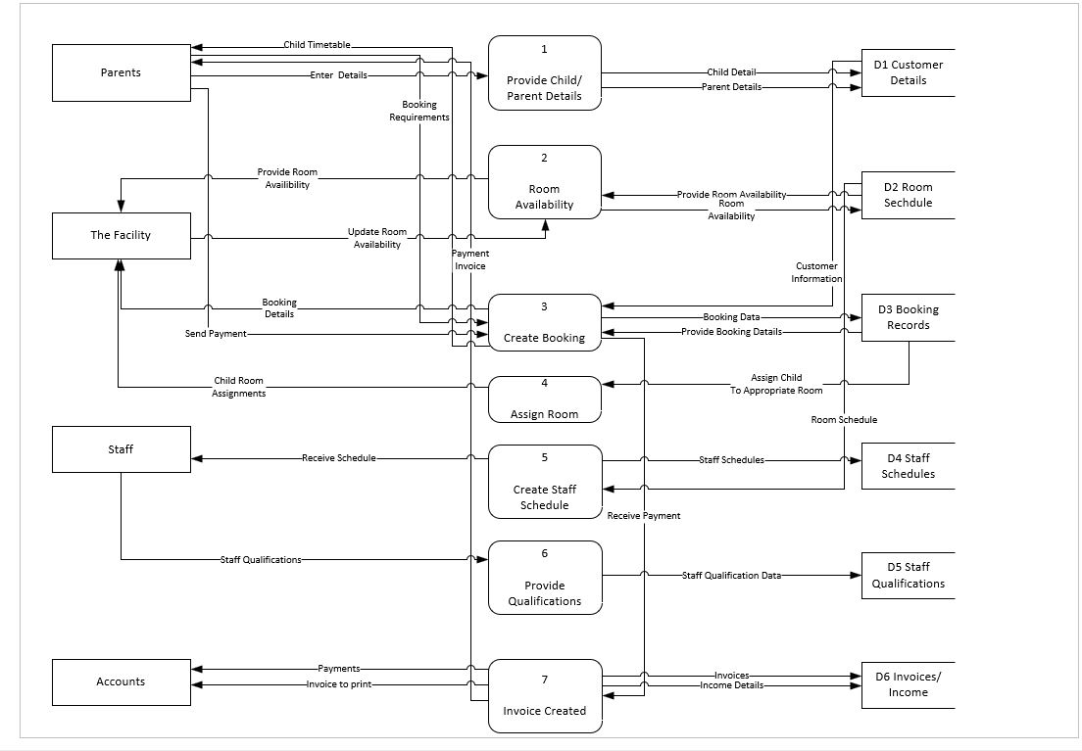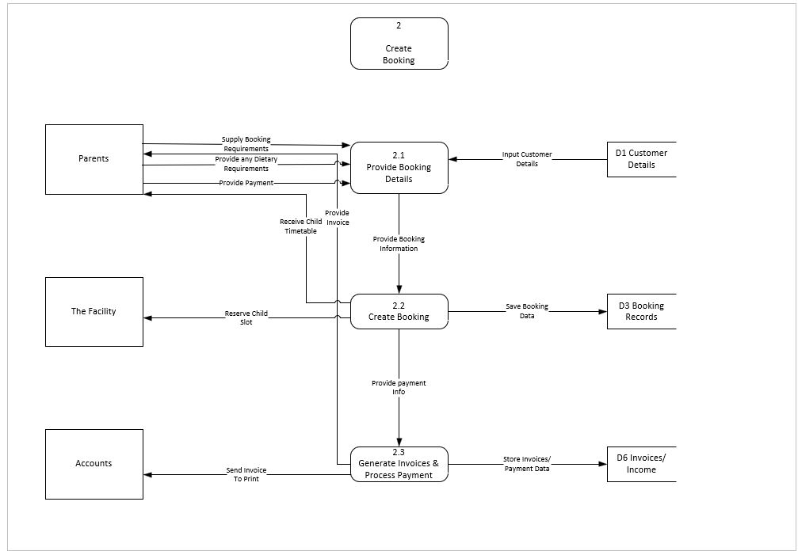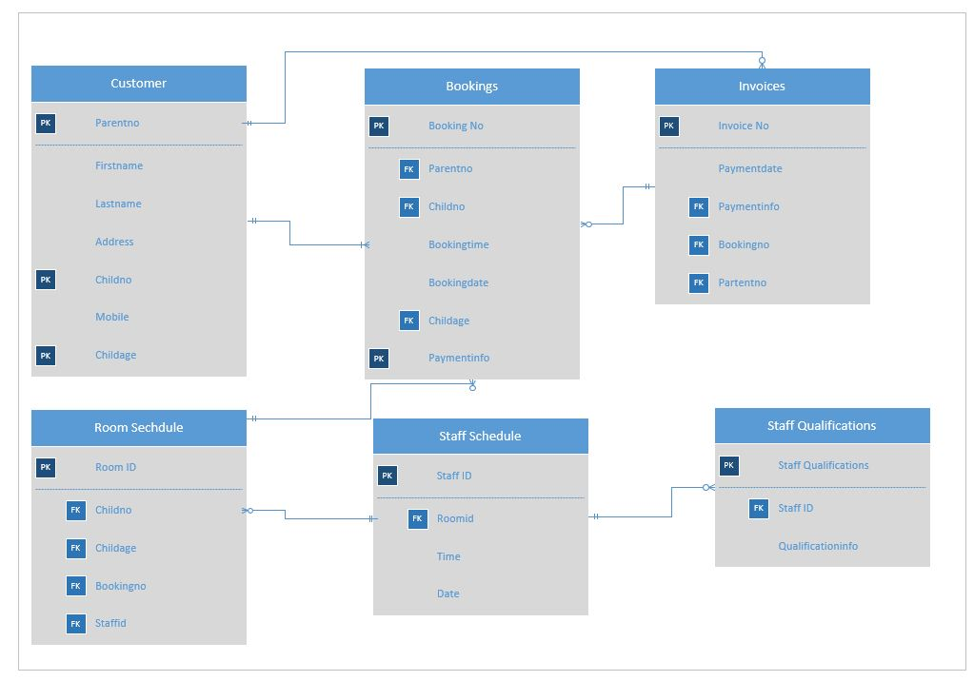
The above diagrams show a solution created for Kids Club Cymru that has been designed to suit their specified requirements by implementing a new system that includes automatic functions and easy data retrieval.

