
Sustainable Taxi Transport in Hospitality: Innovations, Challenges, and Future Directions

Student Name: Jahanara Begum
Student ID: 2245646
Programme: BA International Hotel Management
Module: Sustainable Hospitality & Tourism Management
Module Code: BMIH5006
Lecturer:
Assignment title: Report

AI Acknowledgement Statement
I confirm that I have not used any AI tools in the research and creation of this assignment. I confirm that I have not presented any AI generated materials as my own work. I confirm that I have copies of my drafts, notes and other resources I used, which I may be asked to provide in evidence.

Contents
Executive Summary 4
Introduction 5
Environmental and Societal Impact of Taxi Transport in Hospitality 5
1. Greenhouse Gas Emissions and Air Pollution 5
2. Traffic Congestion and Urban Space Utilization 6
3. Dependence on Fossil Fuels and Rising Costs 6
4. Impact on Community and Local Residents 7
Sustainable Solutions for Taxi Transport in the Hospitality Industry 7
1. Transition to Electric and Hybrid Taxis 7
2. Smart Fleet Management and Ride-Sharing Integration 9
3. Government Incentives and Policy Support for Green Taxi Adoption 9
4. Hotel-Led Sustainable Transport Initiatives 10
5. Future Prospects: Autonomous and Hydrogen-Powered Taxis 11
Conclusion and Recommendations 12
References: 13

Executive Summary
This report investigates the environment impact of taxi transport on hospitality industry. Taxis are important means of guest mobility for travelers and facilitate their convenience, however, they are also responsible for high levels of greenhouse gas emissions, air pollution, and traffic congestion. This report explores these negative effects and provides sustainable solutions to reduce the environmental footprint of taxi transport.
Key solutions include adoption of electric or hybrid taxis that dramatically reduce carbon emissions and operational costs. Ride sharing and carpooling projects are also helping to reduce the number of taxis on the grounds, as well as reducing the amount of fuel used and the traffic congestion. The report also highlights the benefits of alternative fuels, including biofuels and compressed natural gas (CNG), and the partnership role of hospitality businesses with eco-friendly taxi services.
The practicality of these solutions is demonstrated with examples from industry, like Singapore’s hybrid taxi fleet, London’s electric black cabs, and Marriott International’s green transport initiatives. Finally, the report recommends that hospitality sector actively link and embrace sustainable taxi transport policies that will encourage the use of energy efficient taxis that support global environmental goals and also corporate social responsibility deployments.

Introduction
Hospitality transport sector is defined as all of the various modes of transportation which are used to provide transportation of guests, staff, and goods within the context of the hospitality and tourism industry. By connecting airports, hotels, restaurants and tourist attractions, it plays a vital role in ensuring seamless travel experience. Taxis, shuttles, rental cars, public transportation, as well as private chauffeur services are all a part of this sector of the hospitality world, working in tandem to make the hospitality business both convenient and efficient (Ahmad et al., 2023).
This report will exclusively examine taxi transport, a popular method of travel for the hospitality industry. For travelers, taxis offer a vital service of flexibly, on demand transportation, offering comfort and accessibility. It is commonly used by hotels to pick their guests to and from airports, business districts and leisure destinations. While taxis are convenient, however; they have been associated with enormous environmental problems, including greenhouse gas emissions, air pollutions, and urban congestion (Amin et al., 2024). This report will delve into the negative aspects of taxi services and how to minimize their environmental footprint as well as improve efficiency and guest satisfaction.

Environmental and Societal Impact of Taxi Transport in Hospitality
Hospitality transport includes taxis, which are a reliable instrument for tourists and business travelers to ensure convenient mobility. Traditional taxi operations, however, play a major role in environmental degradation, urban congestion, and social challenges.

1. Greenhouse Gas Emissions and Air Pollution
Petrol- and diesel-powered engines are the dominant engine type used by traditional taxis, generating significant quantities of carbon dioxide (CO₂), nitrogen oxides (NOₓ), and particulate matter (PM2.5). Specifically, these pollutants are responsible for climate change and these pollutants cause respiratory diseases particularly in urban areas with these taxi fleets (Bao et al., 2023).
As an example, in London, taxis contributed almost 25% to NOₓ emissions from road transport in 2019, which is the reason why London LLC (the capital’s transport authority) has tightened up emission regulations (Kanwal et al., 2024). Likewise, the yellow cabs in New York City released around 600,000 metric tons of CO₂ each year creating unease over the amount of environmental impact (Bodhanwala and Bodhanwala, 2021).
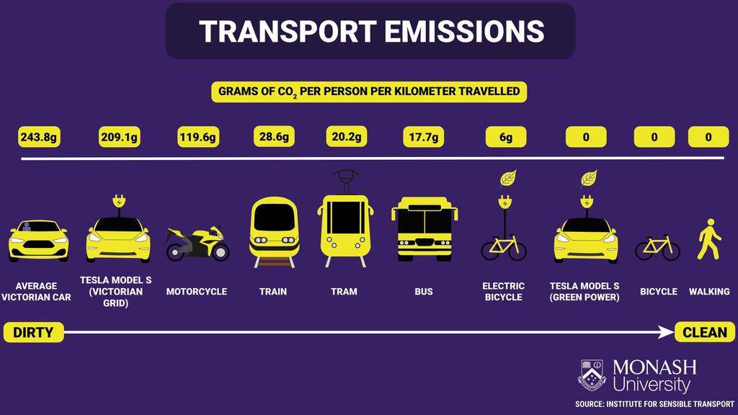
Figure 1: Greenhouse Gas Emissions (Daily Telegraph, 2023)

2. Traffic Congestion and Urban Space Utilization
Traffic congestion is largely due to high concentration of taxis, especially in tourist hotspots, airports and hotel districts. Idle taxis waiting for potential passengers or running on suboptimal routes contribute to road congestion and vehicle waste, deteriorating the efficiency of urban transport networks (Chau and Yan, 2021b).
Studies in Paris found that taxis could spend up to 40 percent of time 'cruising' without passengers, unnecessarily emitting gases. As is the case in Bangkok, which has one of the world’s highest taxi densities, excess taxi congestion contributes significantly to extended travel times and excessive fuel consumption (Chau and Yan, 2021a).

3. Dependence on Fossil Fuels and Rising Costs
Traditional taxi fleet is very much dependent on non-renewable fossil fuels and are therefore vulnerable to the changes in oil prices. Higher petrol and diesel costs for taxi operators lead to higher operational expenses and taxies charging more to consumers. This leads to the taxi transport being less economically sustainable in the long run (IGI Global, 2022).
For instance, in Dubai, taxi operators in recent years have had to introduce fuel surcharges to constrain the impact of fuel price volatility on 'affordability' for travelers. This economic challenge presents an opportunity to develop an alternative source of energy and a less expensive alternative transport solution.

4. Impact on Community and Local Residents
The impact of taxi transport on environmental changes is not the only problem, as taxi transport has a significant impact on the local community. However, noise pollution from idling engines, honking and excessive movement of vehicles disturb residential and hospitality zones. Additionally, tourists' excessive use of taxis exhausts the supply of transport for the local population in periods of high demand.
For example, a case study from Barcelona has shown how over-demand for tourist taxis left locals waiting longer and paying higher fares, making residents frustrated (Crespi-Vallbona and Mascarilla-Miró, 2020). The imbalance brings out the need for a sustainable transport model which can accommodate both the tourists and the locals (Elorrieta, Cerdan Schwitzguébel and Torres-Delgado, 2022).

Sustainable Solutions for Taxi Transport in the Hospitality Industry
Numerous solutions have been proposed or implemented globally to address the environmental and social concerns posed by taxi transport in the hospitality sector. Some of the most impactful and realistic approaches are highlighted below.

1. Transition to Electric and Hybrid Taxis
Adopting electric vehicles (EVs) and hybrid taxis is one of the most effective strategies to make taxi transport more sustainable. Transitioning from traditional petrol and diesel taxis to low emitting vehicles can deliver a reduction in the environmental footprint given the high fuel consumption and carbon emissions associated with these vehicles.
Electrified taxi fleets are already being implemented in many cities. Taxis, for example, are now supposed to be fully electric in Oslo, Norway, by 2025, with the government offering free charging stations, tax exemptions, and lower registration fees. Just like Ultra Low Emission Zone (ULEZ) in London with strict emission limits, more than 6,000 electric black cabs have been adopted. More than 70,000 electric taxis have been introduced to Beijing, where air pollution is a big worry: the taxis help to clean airborne particulate matter and greenhouse gas emissions (Deng, Gan and Hu, 2020a; Deng, Gan and Hu, 2020b).
One hurdle to widespread EV adoption is the absence of charging infrastructure. Cities such as San Francisco and Tokyo are equipping themselves with fast charging networks capable of charging electric taxis fully in under 30 minutes, minimizing downtime for taxi operators (Khalid et al., 2023a).
Key Benefits:
- Reduction in greenhouse gas emissions and improvement in urban air quality.
- Lower fuel and maintenance costs, leading to higher profitability for operators.
- Aligned with sustainability goals, strengthening corporate responsibility for the hospitality industry (Deng, Gan and Hu, 2020c).

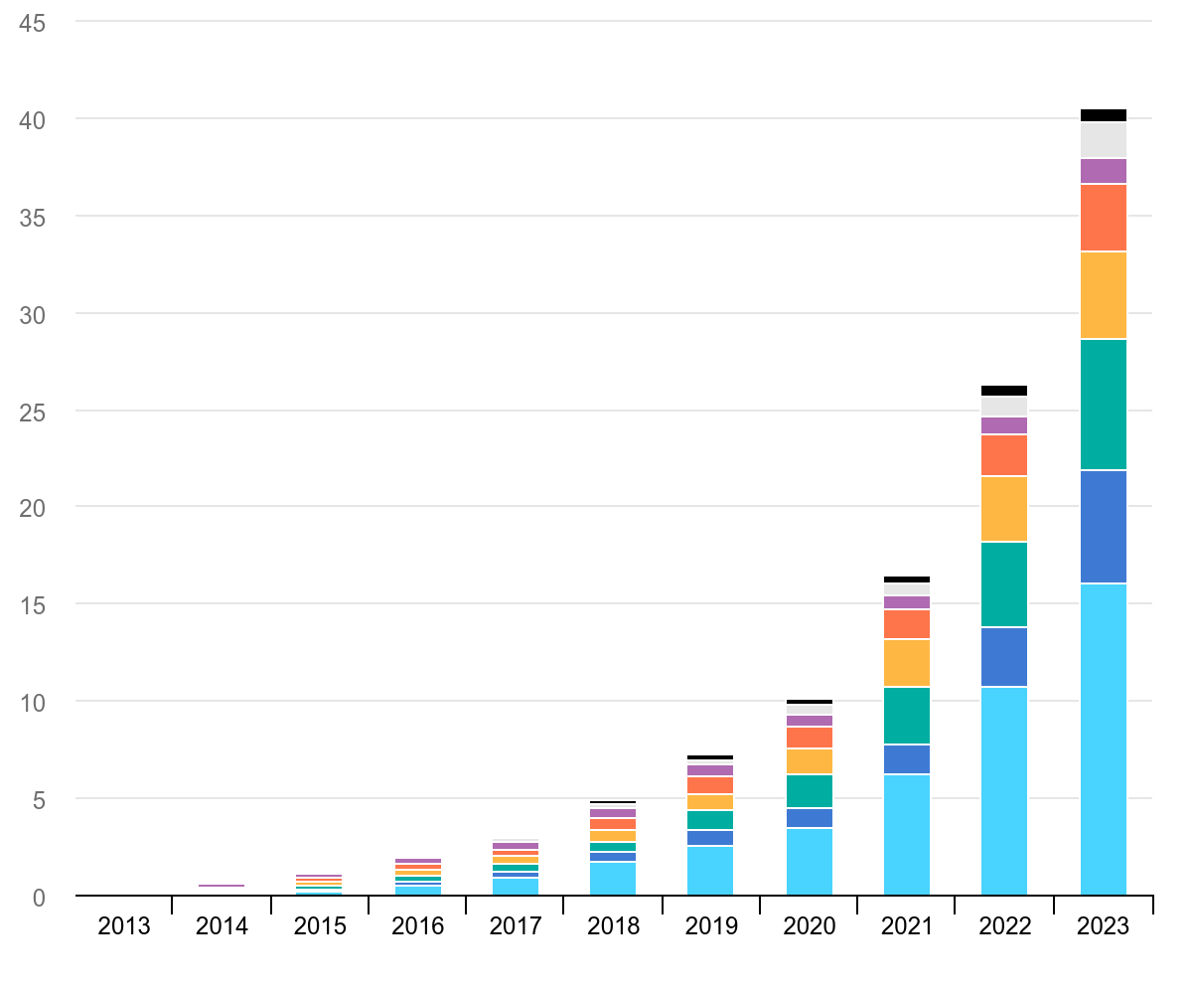
Figure 2: Global electric car stock 2013-2023 (International Energy Agency, 2023)

2. Smart Fleet Management and Ride-Sharing Integration
Implementation of smart fleet management systems and ride sharing models is another innovative approach to reducing the environmental impact of taxi transport. Taxi companies can reduce empty trips, increase fuel efficiency, and decrease congestion in high-density hot spots of the hospitality industry, by using AI driven dispatch, GPS tracking, and data analytics.
For example, AI facilitated fleet management in Singapore’s ComfortDelGro taxi service deploys AI fleet management that analyses real time traffic patterns and passenger demand to determine the optimum routes (Butani, 2023). This has resulted in a 15 percent reduction in idle time, thus reducing overall emissions and improving service efficiency. Similarly, Estonia’s Bolt ride hailing platform also integrated ride sharing features that enabled passengers travelling in the same direction to share a vehicle and in doing so, reduce emissions and making travel more cost effective (Gühnemann, Kurzweil and Mailer, 2021).
Uber and Lyft have also introduced 'Green Mode,' in which a user can request only a hybrid or electric vehicle (Inkson & Minnaert, 2018). This is especially valuable in hospitality hubs, such as hotels and airports, where thousands of guests arrive daily.
Key Benefits:
- Decreased traffic congestion in busy hospitality districts.
- Lower fuel consumption and operational costs for taxi providers.
- Encouragement of eco-friendly transport choices among tourists and locals.

3. Government Incentives and Policy Support for Green Taxi Adoption
Many governments and municipalities have adopted financial incentives, subsidies and environmental regulatory mandates to assist taxi operators in accelerating the transition to sustainable taxi transport using low emission vehicles (He, Liu and Shen, 2022).
For instance, in Norway electric taxis are tax free on the roads, get reduced toll fees and bus lanes, making them a better business and more appealing option for drivers. The "Green Taxi" initiative in New York City allowed drivers switching from gas-powered to hybrid or all-electric vehicles to receive grants, increasing low emission taxis in outer boroughs.
Meanwhile, cities, such as Amsterdam, have also decreed strict emission standards with all the taxi fleet at Schiphol Airport having to become electric in 2030 (Haski-Leventhal, 2018). For this reason, major taxi companies have greatly invested in electric fleets to comply with regulations and take advantage of government subsidies.
Key Benefits:
- Encourages industry-wide adoption of sustainable transport solutions.
- Provides long-term cost savings for taxi operators.
- Aligns with global climate action targets to reduce carbon footprints.

4. Hotel-Led Sustainable Transport Initiatives
In addition to governmental policies, the hospitality sector itself can contribute to the promotion of sustainable taxi transport. Eco friendly taxi partnership can be integrated into hotels, resorts and tourism businesses, shuttle service with electric vehicles can be provided and EV charging station can be installed to support green transportation.
For example, luxury hotels in Dubai and Singapore have introduced electric limousine services for their guests to travel in a sustainable yet comfortable manner. Marriott International has also added EV charging stations at many of its properties, so guests and cab drivers have a convenient way to travel more sustainably (Aneeta Elsa Simon, Lakshmanan and Paul, 2024).
Some hotels in Europe and North America have also started partnering with Tesla and other EV manufacturers to provide green taxi services throughout their hotels in a move to show their dedication to environmentally friendly travel (Sloan, Legrand & Chen, 2017).

Key Benefits:
- Enhances brand reputation by aligning with sustainability trends.
- Attracts eco-conscious travelers who prioritize green initiatives.
- Contributes to local environmental conservation efforts by reducing carbon footprints (Hu et al., 2022).

5. Future Prospects: Autonomous and Hydrogen-Powered Taxis
Looking ahead, the future of sustainable taxi transport is likely to involve autonomous electric taxis and hydrogen-powered vehicles.
- Autonomous Electric Taxis: Companies like Waymo (Google) and Tesla are creating a self-driving taxi service which won’t require human driving and will therefore cut down on human driving inefficiencies, thereby reducing fuel wastage and emissions. Motional and Lyft introduced a fully autonomous electric taxi service in Las Vegas earlier this year, establishing a precedent for global adoption (Costa & Costa, 2022).
- Hydrogen-Powered Taxis: While electric vehicles dominate green transport, the technology behind hydrogen fuel cell is gaining traction. The Hype taxi fleet in Paris is entirely made up of hydrogen powered taxis providing a zero-emission solution with quick refuel times (under 5 minutes). This innovation is a viable solution for the hospitality industry to contemplate long term a sustainable transportation solution (Kosjenka Dumančić, Krupka and Nevenka Čavlek, 2024).
Key Benefits:
- Autonomous taxis reduce operational costs and improve safety.
- Hydrogen-powered taxis offer a clean-energy alternative with rapid refueling.
- Both technologies contribute to long-term sustainability goals in urban transport.

Conclusion and Recommendations
Sustainable taxi transport has an integral role in the integration with the hospitality industry to aid in reducing environmental impact, enhance operational efficiency and meet the developing consumer demands. The report showcased key initiatives such as the transition to electric and hybrid taxis, the use of smart fleet management and ride sharing, the use of government incentives and hotel led sustainability efforts. Benefits of these strategies have included lower emissions, cost savings, reduced congestion, and better guest experiences.
Several measures should be taken to further push the shift of taxi transport to the green side. With increased investment in EV charging stations and fast charging technology, the expanding of EV infrastructure will help to expand EV infrastructure to support widespread adoption of electric taxis. It must also be backed by policy support, with cities providing incentives and subsidies to encourage taxi operators to switch to low-emission vehicles. Hotels can take the lead by engaging green transport partners and offering sustainable shuttle services to make green travel more convenient for guests. In addition, developing new technologies like autonomous and hydrogen powered taxis is a long term, zero emission solution for the industry.

References:
Ahmad, N., Ahmad, A., Lewandowska, A. and Han, H. (2023). From screen to service: how corporate social responsibility messages on social media shape hotel consumer advocacy. Journal of Hospitality Marketing & Management, pp.1–30. doi:https://doi.org/10.1080/19368623.2023.2271448.
Amin, M.A., Hoque, L., Jewel, Amin, M.B., Esayas Degago and Molnar, E. (2024). Optimization of ride-sharing services: An investigation of the ride-hailing service providers. Journal of Infrastructure Policy and Development, 8(12), pp.7920–7920. doi:https://doi.org/10.24294/jipd.v8i12.7920.
Aneeta Elsa Simon, Lakshmanan, G. and Paul, V. (2024). Investing in India’s electric revolution: A case study of OLA electric. Journal of Information Technology Teaching Cases. doi:https://doi.org/10.1177/20438869241255963.
Bao, Z., Ng, S.T., Yu, G., Zhang, X. and Ou, Y. (2023). The effect of the built environment on spatial-temporal pattern of traffic congestion in a satellite city in emerging economies. Developments in the Built Environment, p.100173. doi:https://doi.org/10.1016/j.dibe.2023.100173.
Batabyal, A. (2018) Managing sustainable tourism resources. Hershey, PA: IGI Global.
Bodhanwala, S. and Bodhanwala, R. (2021). Exploring relationship between sustainability and firm performance in travel and tourism industry: a global evidence. Social Responsibility Journal, ahead-of-print(ahead-of-print). doi:https://doi.org/10.1108/srj-09-2020-0360.
Butani, N. (2023). BUILDING AN APPLICATION MODEL FOR EFFICIENT RIDE BOOKING IN RIDE-HAILING INDUSTRY. Electronic Theses, Projects, and Dissertations. [online] Available at: https://scholarworks.lib.csusb.edu/etd/1833/.
Chau, D.S. and Yan, D.L. (2021a). Destination hospitality indicators. Journal of Destination Marketing & Management, 19, p.100537. doi:https://doi.org/10.1016/j.jdmm.2020.100537.
Chau, D.S. and Yan, D.L. (2021b). Destination hospitality indicators. Journal of Destination Marketing & Management, 19, p.100537. doi:https://doi.org/10.1016/j.jdmm.2020.100537.
Cooper, C. (2021) Essentials of tourism. 3rd edn. London: SAGE.
Costa, C. & Costa, C. (eds) (2022) Sustainability and competitiveness in the hospitality industry. Hershey, PA: Business Science Reference.
Crespi-Vallbona, M. and Mascarilla-Miró, O. (2020). Street art as a sustainable tool in mature tourist destinations: a case study of Barcelona. International Journal of Cultural Policy, 27(4), pp.1–15. doi:https://doi.org/10.1080/10286632.2020.1792890.
Deng, T., Gan, C. and Hu, Y. (2020a). Do hotel business benefit from increased tourist accessibility? Evidence from China’s high-speed railway program. Tourism Economics, p.135481662092321. doi:https://doi.org/10.1177/1354816620923216.
Deng, T., Gan, C. and Hu, Y. (2020b). Do hotel business benefit from increased tourist accessibility? Evidence from China’s high-speed railway program. Tourism Economics, p.135481662092321. doi:https://doi.org/10.1177/1354816620923216.
Deng, T., Gan, C. and Hu, Y. (2020c). Do hotel business benefit from increased tourist accessibility? Evidence from China’s high-speed railway program. Tourism Economics, p.135481662092321. doi:https://doi.org/10.1177/1354816620923216.
Elorrieta, B., Cerdan Schwitzguébel, A. and Torres-Delgado, A. (2022). From success to unrest: the social impacts of tourism in Barcelona. International Journal of Tourism Cities, ahead-of-print(ahead-of-print). doi:https://doi.org/10.1108/ijtc-05-2021-0076.
Gühnemann, A., Kurzweil, A. and Mailer, M. (2021). Tourism mobility and climate change - A review of the situation in Austria. Journal of Outdoor Recreation and Tourism, 34, p.100382. doi:https://doi.org/10.1016/j.jort.2021.100382.
Haski-Leventhal, D. (2018) Strategic corporate social responsibility: tools & theories for responsible management. London: SAGE.
He, L., Liu, S. and Shen, Z.M. (2022). Smart urban transport and logistics: A business analytics perspective. Production and Operations Management, 31(10). doi:https://doi.org/10.1111/poms.13775.
Hu, X., Lin, W., Wang, J. and Jiang, J. (2022). Choice of ride-hailing or traditional taxi services: From travelers’ perspectives. Research in Transportation Business & Management, p.100788. doi:https://doi.org/10.1016/j.rtbm.2022.100788.
IGI Global (2022) New governance and management in touristic destinations. Hershey, PA: IGI Global.
Inkson, C. & Minnaert, L. (2018) Tourism management: an introduction. 2nd edn. London: SAGE.
Jafari, K., Özduran, A. and Saydam, M.B. (2021). Hospitality and tourism industry amid COVID-19 pandemic: voices from small Mediterranean town. International Hospitality Review, [online] ahead-of-print(ahead-of-print). doi:https://doi.org/10.1108/ihr-07-2021-0054.
Jauhari, V. (2021) ‘Managing sustainability in the hospitality and tourism industry: paradigms and directions for the future.’ 9th edn. Oakville: Apple Academic Press.
Kanwal, N., Meng, C.S., Watabe, M., Nasaruddin Zainal and Siew, K. (2024). Carbon Footprint of Tourism Activities Including Transportation, Accommodation, and Infrastructure: A Critical Analysis The Need for Sustainable Tourism in an Era of Global Climate Change: Pathway to a Greener Future, 95-120. [online] doi:https://doi.org/10.1108/978-1-83608-668-020241015.
Khalid, R., Conjobeeharry, V., Sanai, A.S., Brown, C.T.H., Afrouzi, H.N. and Hassan, A. (2023a). The feasibility and analysis of electric taxi vehicles in Singapore: A review. Future Energy, [online] 2(3), pp.38–48. Available at: https://fupubco.com/fuen/article/view/76.
Khalid, R., Conjobeeharry, V., Sanai, A.S., Brown, C.T.H., Afrouzi, H.N. and Hassan, A. (2023b). The feasibility and analysis of electric taxi vehicles in Singapore: A review. Future Energy, [online] 2(3), pp.38–48. Available at: https://fupubco.com/fuen/article/view/76.
Khalid, R., Conjobeeharry, V., Sanai, A.S., Brown, C.T.H., Afrouzi, H.N. and Hassan, A. (2023c). The feasibility and analysis of electric taxi vehicles in Singapore: A review. Future Energy, [online] 2(3), pp.38–48. Available at: https://fupubco.com/fuen/article/view/76.
Kosjenka Dumančić, Krupka, Z. and Nevenka Čavlek (2024). Strategies for Urban Evolution: Analysing the Effects of Airbnb and Uber Business Models on the Transformation of Post-industrial Societies. Applied innovation and technology management, pp.47–58. doi:https://doi.org/10.1007/978-3-031-75649-8_4.
Kumar, P. (2021). Hospitality and Tourism Information Technology. USF M3 Publishing, LLC. doi:https://doi.org/10.5038/9781732127593.
Kumar, S., Kapoor, B. and Mushtaq Ahmad Shah (2024). Contemporary Issues and Challenges Facing the Hospitality Industry. Emerald Publishing Limited eBooks, [online] pp.55–64. doi:https://doi.org/10.1108/978-1-83753-734-120241004.
Li, T., Qi, G.-J. and Stern, R. (2021). Taxi Utilization Rate Maximization by Dynamic Demand Prediction: A Case Study in the City of Chicago. Transportation Research Record Journal of the Transportation Research Board, 2676(4), pp.367–379. doi:https://doi.org/10.1177/03611981211059769.
Li, Z., Liang, C., Hong, Y. and Zhang, Z. (2021). How Do On‐demand Ridesharing Services Affect Traffic Congestion? The Moderating Role of Urban Compactness. Production and Operations Management, 31(1). doi:https://doi.org/10.1111/poms.13530.
Lim, W.M., Gupta, G., Biswas, B. and Gupta, R. (2021). Collaborative consumption continuance: a mixed-methods analysis of the service quality-loyalty relationship in ride-sharing services. Electronic Markets, 32. doi:https://doi.org/10.1007/s12525-021-00486-z.
Marek Gnusowski and Lipiec, S. (2023). Country-of-origin Effect in Professional Services: An Empirical Study Based on Legal Services [Efekt Kraju Pochodzenia w Usługach Profesjonalnych: Badanie Empiryczne Usług Prawniczych]. [online] doi:https://doi.org/10.5281/zenodo.10687900.
Momani, A.M., Alsakhnini, M. and Hanaysha, J.R. (2022). Emerging Technologies and their Impact on the Future of Tourism and Hospitality Industry. International Journal of Information Systems in the Service Sector, 14(1). doi:https://doi.org/10.4018/ijisss.287579.
Plyushteva, A. (2021). Commuting and the urban night: nocturnal mobilities in tourism and hospitality work. Routledge eBooks, pp.37–51. doi:https://doi.org/10.4324/9781003142096-4.
Rathore, B., Sengupta, P., Biswas, B. and Kumar, A. (2024). Predicting the price of taxicabs using Artificial Intelligence: A hybrid approach based on clustering and ordinal regression models. Transportation research. Part E, Logistics and transportation review, 185, pp.103530–103530. doi:https://doi.org/10.1016/j.tre.2024.103530.
Sampson Wireko-Gyebi, Nancy Grace Baah, Ricky Yao Nustugbodo, Perpetual Zaazie, Elizabeth Kafui Senya, Bosomefi, V. and Amankona, S. (2024a). Service quality, satisfaction and loyalty among sharing economy vehicle users. Cogent social sciences, 10(1). doi:https://doi.org/10.1080/23311886.2024.2327130.
Sampson Wireko-Gyebi, Nancy Grace Baah, Ricky Yao Nustugbodo, Perpetual Zaazie, Elizabeth Kafui Senya, Bosomefi, V. and Amankona, S. (2024b). Service quality, satisfaction and loyalty among sharing economy vehicle users. Cogent social sciences, 10(1). doi:https://doi.org/10.1080/23311886.2024.2327130.
Shafi, K. and Jin, S. (2023). Enhancing the Hospitality Experience for Foreign Guests in South Korean Hotels: Insights from Online Reviews. doi:https://doi.org/10.1109/icnc-fskd59587.2023.10280882.
Sharma, C. (2021). Greenhouse gas effects on international tourism: a panel quantile evidence. Anatolia, 33(2), pp.266–269. doi:https://doi.org/10.1080/13032917.2021.1919907.
Sloan, P., Legrand, W. & Chen, J.S. (2017) Sustainability in the hospitality industry: principles of sustainable operations. 3rd edn. London: Butterworth-Heinemann.
Wu, Y.A., Lau, Y.-Y., Wong, L.M. and Wu, J. (2023). A Preliminary Feasibility Study of Electric Taxi Promotion in Hong Kong—Behavior Modelling of Driving Patterns and Preferences. Applied Sciences, [online] 13(3), p.1491. doi:https://doi.org/10.3390/app13031491.
Xie, C., Yu, D., Zheng, X., Wang, Z. and Jiang, Z. (2021). Revealing spatiotemporal travel demand and community structure characteristics with taxi trip data: A case study of New York City. PLOS ONE, 16(11), p.e0259694. doi:https://doi.org/10.1371/journal.pone.0259694.

