
Task Management Web Application
Project Proposal
by
Ionut-Cristian Ispas
Course: BSc Cloud Computing
Module: ACCA6020 Independent Project
Supervisor: Osman Elgawi
Project submitted as part of the requirements for
the award of BSc Cloud Computing
July 2026

Table of Contents
1. Introduction 3
2. Statement of the Problem 3
2.1 Background and Rationale 3
2.2 Problem Statement 3
2.3 Aim of the Project 3
2.4 Project Objectives 3
3. Literature Review 4
4. Methodology 4
4.1 Requirements Analysis 5
4.2 Analysis of Objectives and Sub-Tasks 5
4.3 System Design Overview 7
5. Resources Required 7
6. Project Plan and Timescales 9
7. Conclusion 9
8. References 10

1. Introduction
Digital technologies have become more pervasive and are increasingly influencing people's lives both personally and professionally, and as a result have transformed the organization and management of tasks. Many must do several jobs, and it is necessary to keep track of progress, priorities the work and keep productive. The purpose of this project is to develop a web application for task management with user interface, a database schema and implementation of the back end. It will aid the users to create, update, track and manage the tasks efficiently with instant notification of the task activities. The current usage of web technologies and user-centered design principles aims to offer a usable and scalable solution to the issue of task management.

2. Statement of the Problem

2.1 Background and Rationale
From paper planners and spreadsheets to simple to-do lists, the tools that people traditionally use to organize their tasks may not have the advanced capabilities of modern individuals and organizations to execute their tasks with efficiency. There is also a problem with limited productivity and coordination in many of the existing systems as they lack any secure authentication, task prioritization, and real-time updates. As digital collaboration becomes more of a reality, users increasingly depend on secure systems that are able to provide them with timely information about future tasks and improved organization. The real-time notifications ensure effective communication and timely task completion with prioritization supporting users in focusing on key tasks. The purpose of this project is to remove the limitations of these by designing and implementing the web based “Task Management” system hoping that it will provide secure authentication, priority, organization and real-time notification to the user.

2.2 Problem Statement
The problem of this project is dealing with the need for a unified task handling system to handle tasks, priorities the work effectively and get immediate updates on task activities.

2.3 Aim of the Project
This project aims to develop and implement a complete stack Task Management Web App to help users efficiently manage their tasks with immediate access to secure authentication, priority and notifications.

2.4 Project Objectives
The following objectives of the project are given below-
- To design the database and architecture of the system.
- To secure user authentication & authorization.
- To develop models for creating, editing, deletion and tracking tasks.
- To introduce a task prioritization scheme to allow users to prioritise tasks.
- To create real-time notification system.
- To design a usability and responsive interface adapted to various platforms.
- To evaluate the system to determine if it is optimizing the task organization and communication.

3. Literature Review
Task management systems are vital tools in enhancing productivity and organization both in the personal and professional setting [1]. There are several apps available out there with features like task creation and deadline setting, collaboration features like Todoist, Asana and Trello. But a number of those systems don't support high level customization, real-time communications and/or high dollar subscription fees to make them fully functional.
Features like secure authentication, task prioritization, and real-time updates are emphasized in task management systems, recognizing their value in boosting productivity and user satisfaction [2]. React.js, Node.js and MongoDB are all the latest web technologies that have been used to provide scalable and efficient solutions for full stack application development.
But the existing solutions are not having a seamless and integrated task management system with secure authentication, prioritized task handling and making a need for a lightweight user–friendly and integrated task management system that provides secure authentication, prioritized task handling and real time notification in a single platform [3]. The aim of this project is to fill this gap by creating an integrated Web-based application that meets these requirements.

4. Methodology
The project will follow the Agile Software Development methodology that facilitates an iterative approach to development, ongoing testing and regular project review throughout the project. The methodology of the project will be secondary research by mainly doing literature review and technical documentation to know the requirement of the system and best practice [4]. Use of user feedback and usability testing can also be used at the evaluation stage to undertake limited primary research.
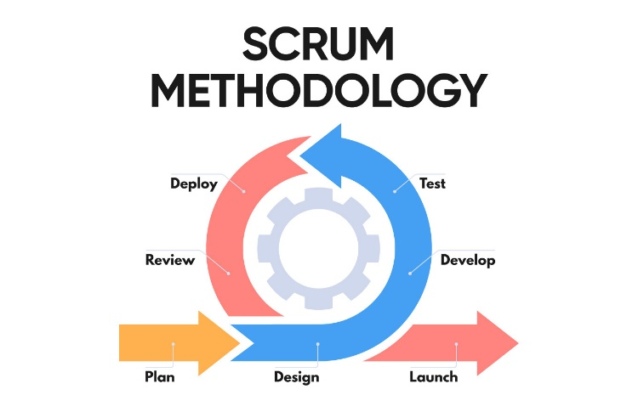
Figure 1: Scrum Development Cycle [4]

4.1 Requirements Analysis
The requirements analysis should be able to extract functional and non-functional requirements from the literature and analyses the existing task management system. The design phase of the system will establish the overall design of the system, the structure of the database, the design of the user interface and the workflow of the application before the development work is started [5]. It will be developed using Agile principles, starting with the user authentication and task management features, and followed by prioritizing and sending real-time notifications. To ensure System reliability and usability, the following types of testing will be performed: Unit testing, Integration testing and User acceptance testing [6]. Then, performance of the system will be measured and evaluated against the Project goals and its improvement will be investigated based on the feedback received from the users and the results of the tests.

4.2 Analysis of Objectives and Sub-Tasks
System Design
The first one is to sketch the overall structure of the system and the general structure of the database. This will involve eliciting requirement, use case diagram, system architecture design and designing a schema of the database to allow functionality of the application.
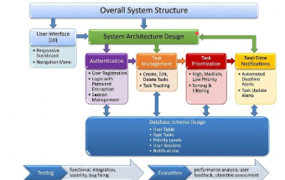
Figure 2: System Design (Author)
Authentication
A secure authentication system will be developed to control access of the users to the system [7]. This encompasses the registration of users, the ability to log in, password encryption and session management, which are critical in securing the information of users and in maintaining the security of the system.
Task Management
This application will have key functions of a task management application including the creation, edit, delete, and tracking of tasks [8]. These functions will help in organizing and keeping track of all daily activities efficiently and will project related tasks.
Task Prioritization
A prioritization system for task prioritizations will be developed. Tasks will be prioritized with High, Medium and Low to help them manage more easily and there will be sorting and filtering options.
Real-Time Notifications
A feature to notify the user in real-time of task updates and deadlines will be added to the system. Relevant task activities will be automatically alerted.
User Interface Development
The interface will be designed to be responsive and user-friendly, ensuring that it can be accessed from various devices [9]. This will include designing a dashboard, navigation that is easy to use, and an attractive design to improve the user’s experience.
Testing
Full testing will be carried out for the quality and reliability of the system. This will include functional testing, integration testing, usability testing and bug fixing to test all the features being developed.
Evaluation
Evaluation of the finished system will be made to see if the project goals are achieved. The application will be assessed by performance analysis, user feedback and objective assessment.

4.3 System Design Overview
The proposed system will be designed with three-tiered system model Presentation, Application and Data. The presentation layer will provide a web-based display which will be responsive and will provide consumers with access to the features of the system [10]. All of the application layers will handle user authentication, business logic, task processing and real-time notifications [11]. The user accounts, task information, priority level and notification history will be stored in the data layer in the database. It should also have some essential functionalities such as user registration and login, secure authentication, task creation, editing and deletion, task status tracking, task prioritisation, notification, and have a responsive dashboard with search and filter [12].

5. Resources Required
It will require a personal computer or laptop equipped with a stable Internet connection for the development and testing of the project. Using HTML5, CSS3, JavaScript, and React.js, the frontend will be created to ensure that it is responsive and interactive [13]. The backend will be developed using a combination of Node.js and Express.js for handling business logic, authentication, and API operations, while the data will be stored in a MongoDB database, which will include user data, tasks, priorities, and notifications. The support of development tools such as Visual Studio Code, Git, GitHub and Postman will assist with coding, version control and API testing [14]. The real-time notifications will be done by leveraging Socket.io, and system reliability and performance will be supported by unit tests with Jest.
Summary of Technologies and Resources
Technology / Resource | Purpose
Personal Computer / Laptop & Internet | Primary hardware environment and connection needed for project development and testing.
HTML5 & CSS3 | Will be used for structuring and styling a responsive layout.
JavaScript | Core programming language used across both front-end and back-end logic.
React.js | Front-end library for building an interactive, component-based user interface (UI).
Node.js | It is a JavaScript runtime environment and will be used to execute back-end logic.
Express.js | Web application framework for Node.js to manage routing, API endpoints, and server logic.
MongoDB | NoSQL database used to store persistent application data (users, tasks, priorities, notifications).
Visual Studio Code (VS Code) | It is an integrated Development Environment (IDE) and will be used for writing and debugging code.
Git & GitHub | To establish a distributed version control system and repository host for managing code changes and collaboration.
Postman | It will help for developing, verifying, and documenting API endpoints.
Socket.io | A JavaScript library that will help to enable real-time, bi-directional communication for instant notification alerts.
Jest | It is a testing framework and will be used for running unit tests to ensure system reliability and performance.

6. Project Plan and Timescales
Activity / Week | 1 | 2 | 3 | 4 | 5 | 6 | 7 | 8 | 9 | 10 | 11 | 12 | 13 | 14 | 15 | 16
Literature Review & Requirement Analysis
System Design (Architecture & Database)
UI Design & Wireframing
Backend Development & Database Setup
Authentication Module
Task Management & Prioritization
Real-Time Notifications
System Integration & Debugging
Testing & Evaluation
Final Documentation & Submission
Figure 3 Gantt Chart.

7. Conclusion
This project is aimed at creation of a web-based application to manage the tasks with the following set of the necessary features, and they are secure authentication, prioritisation of the tasks, real time notifications, etc. Although some of them are good, one of the weaknesses of traditional task management techniques is that there is no structure currently in place that can manage and organise tasks. The system can encompass this by offering the customers a system where they can conveniently administer and control tasks. The web development of the project will be developed using the latest technologies and adhering to the Agile development methodology to provide a solution that can be used, scaled and made usable within the timeline. This will help to understand technical implementation of knowledge to improve task organisation and communication.

8. References
- M. Jaishree, V. Anupriya, and M. Sukitha, “Implementing Agile Task Management System: Leveraging Web Development and Power BI for Enhanced Decision-Making,” pp. 1445–1452, 2024. https://doi.org/10.1109/icssas64001.2024.10761041
- F. A. Nurzi and K. Ab Wahab, “Web-Based Student Task Management System,” Engineering, Agriculture, Science and Technology Journal (EAST-J), vol. 1, no. 1, pp. 50–56, 2022. https://doi.org/10.37698/eastj.v1i1.119
- S. Sehgal, “Task Management Web Application: Technical Report,” National College of Ireland, 2024. https://norma.ncirl.ie/7672/1/satyamsehgal.pdf
- L. Cohen, L. Manion, and K. Morrison, Research Methods in Education, 8th ed., Routledge, 2017. https://doi.org/10.4324/9780203224342
- D. K. Shukla, A. Maurya, M. Pal, and B. D. Shivahare, “A Survey on Exploring the Evolution and Trends of Web Development,” TechRxiv, 2023. https://doi.org/10.36227/techrxiv.23976048
- U. Flick, An Introduction to Qualitative Research, SAGE, 2022.
- N. B. Verma and Sharma, “Task Manager Web Application Using Microservices,” Jaypee University of Information Technology, 2023. http://ir.juit.ac.in:8080/jspui/jspui/handle/123456789/10214
- P. Patel, “A Web-Based Ticketing System: Improving IT Support Efficiency and Employee Productivity,” Theseus, 2025. http://www.theseus.fi/handle/10024/889585
- V. Kamra, T. Saini, N. Shishodia, M. Singh, and P. Sehrawat, “A Novel Approach Towards Full Stack Comprehensive Expense Monitoring System,” 2025 International Conference on Next Generation Information System Engineering (NGISE), pp. 1–5, 2025. https://doi.org/10.1109/ngise64126.2025.11085204
- V. Pathak, V. Shrivastava, R. Buri, V. Gupta, and S. Sharma, “Current Web Development Technologies: A Comparative Review,” Lecture Notes in Networks and Systems, pp. 13–23, 2023. https://doi.org/10.1007/978-981-99-1909-3_2
- I. Loikkanen, “Improving End to End Testing of a Complex Full Stack Software,” Theseus, 2024. http://www.theseus.fi/handle/10024/863548
- D. Drofa, “Optimization of Software Development Processes Through the Use of Full-Stack Technologies and Automation,” Contemporary Issues in Artificial Intelligence, vol. 1, 2025. https://doi.org/10.69635/ciai.2025.12
- I. Herath, “Cross-Platform Development With Full-Stack Frameworks: Bridging the Gap for Seamless Integration,” Theseus, 2024. http://www.theseus.fi/handle/10024/867532
- A. Gurusamy and I. A. Mohamed, “The Evolution of Full Stack Development: Trends and Technologies Shaping the Future,” Journal of Knowledge Learning and Science Technology, vol. 1, no. 1, pp. 100–108, 2020. https://doi.org/10.60087/jklst.vol1.n1.p108

