Data Handling & Business Intelligence
LCBB5014_BIRM

COURSEWORK: REPORT COMPONENT TWO
Student Name: Petre-Daniel Nedelcu
Lecturer Name: Ihsan Ul Haq
Student ID: 2326555

Table of Contents
Introduction 3
Data Cleaning and Preparation 4
Descriptive Statistics and Summary 8
Descriptive Statistics in Excel 8
Descriptive Statistics in SPSS 8
Trend Analysis and Visualisation 12
Statistical Analysis using SPSS 15
Hypotheses 15
Correlation 17
Regression 18
Insights and Recommendations 21
Recommendations 21
Limitations and Future Research 21
Conclusion 22
Reference 23

List Of Figures:
Figure 1: Name column 5
Figure 2: NaN values in the age and rating columns 5
Figure 3: Date format 6
Figure 4: Time column 6
Figure 5: Weather Column 7
Figure 6: festival column 8
Figure 7: Descriptive Statistics in Excel 9
Figure 8: Descriptive Statistics by SPSS 9
Figure 9: Traffic by Weather 10
Figure 10: Order by city, festival, and vehicle type 11
Figure 11: Histogram for Ratings 11
Figure 12: Histogram for Age 12
Figure 13: Age-wise multidelevery 13
Figure 14: Types of order quantities and time of deliveries 13
Figure 15: Order Count By Time 14
Figure 16: Distribution of deliveries into all the types of orders 15
Figure 17: Recode Weather column 16
Figure 18: Distance Formula 16
Figure 19: One Way Anova 17
Figure 20: Mean Plot 17
Figure 21: Correlation 18
Figure 22: Regression Analysis Summary 20
Figure 23: Coefficients for regression analysis 20
Figure 24: Colliner and Residual Statistics 21
Figure 26: Scatter plot for regression analysis 21

Introduction
This report is created to analyse a dataset about food delivery operations to determine the impact of the company on customer satisfaction, workforce characteristics, and the performance of the deliveries. The dataset has 11,399 records of delivery, and the data has details of attributes of the delivery personnel, customer rating, order details, geographical location, road conditions, weather by the roadside, vehicle characteristics, and complexity of delivery. Since the real-world data is real, there were some cases of inconsistency and missing data, and the cleaning of data and preparing it systematically had to be done to ensure accuracy and reliability of the analysis.
There are three objectives of this analysis. The report will first focus on data cleaning and preparation such as filling in the missing values, correction of date and time errors in date and time, and categorical data standardisation. Second, descriptive statistics and visualisation are employed in summarising the important trends linked to the ratings of the delivery persons, age structure, the type of orders, and the conditions of operations. Finally, the test of the relationships between the following operation variables, which are weather, traffic, distance, and multiple deliveries, and the delivery person rating, is tested by trend analysis and inferential statistics, including correlation, one-way ANOVA, and regression analysis. A mix of all the steps will assist in ensuring a holistic view of the performance drivers of delivery.

Data Cleaning and Preparation
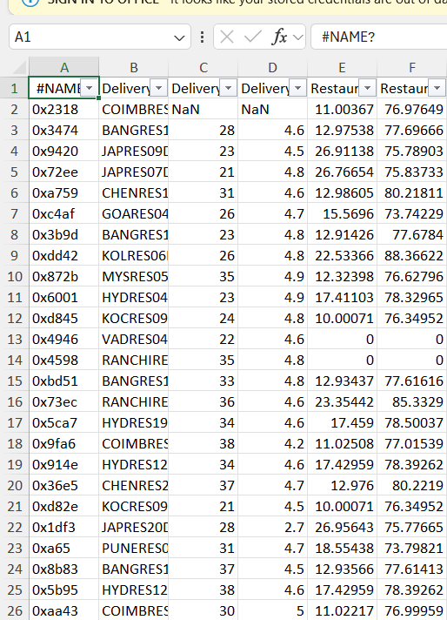
Figure 1: Name column
“Name column” has been written incorrectly as “#NAME?”, changed into a simple way, “Name”.
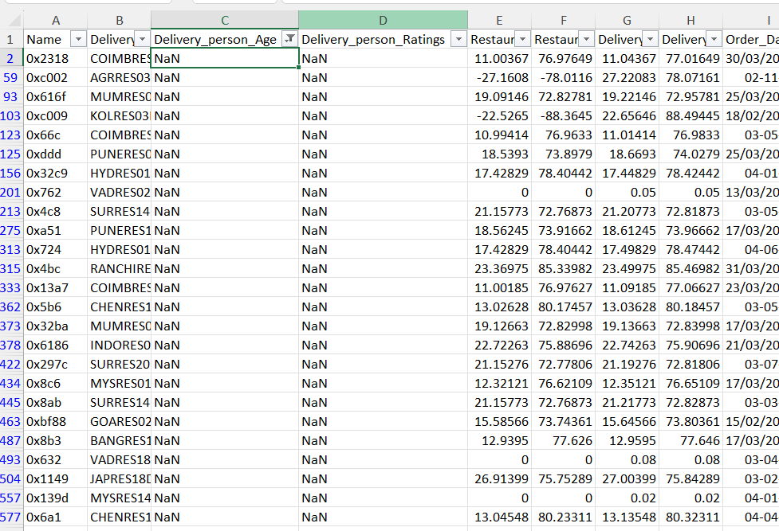
Figure 2: NaN values in the age and rating columns

These values are handled by first replacing them with blanks, then specialising and replacing them with the average column-wise. The average age of a delivery person is 30,” and the average rating for a delivery person is 4.6.
Order date is not in the same format, so put all the dates in the same format by using Text to Column and select the format for this (Kirkby et al., 2024).
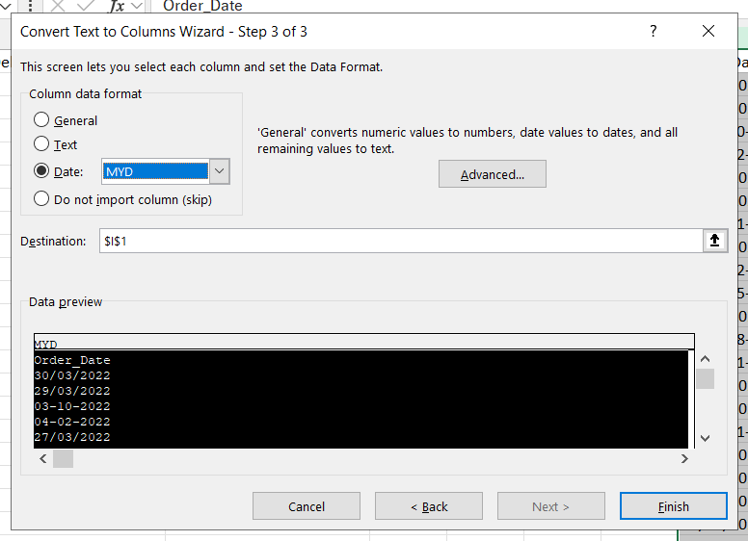
Figure 3: Date format
Order time does contain Nan values and has some inconsistency like data values are not in not Time format, these are in number format. Recover this by changing the whole column of data into time. The ‘NaN’ values were retained in the dataset to avoid introducing bias.
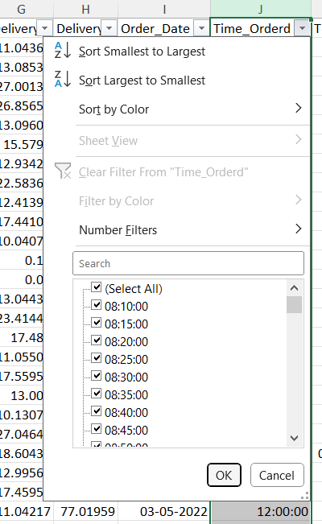
Figure 4: Time column
Same for “Time for picked”, change this into a time format.
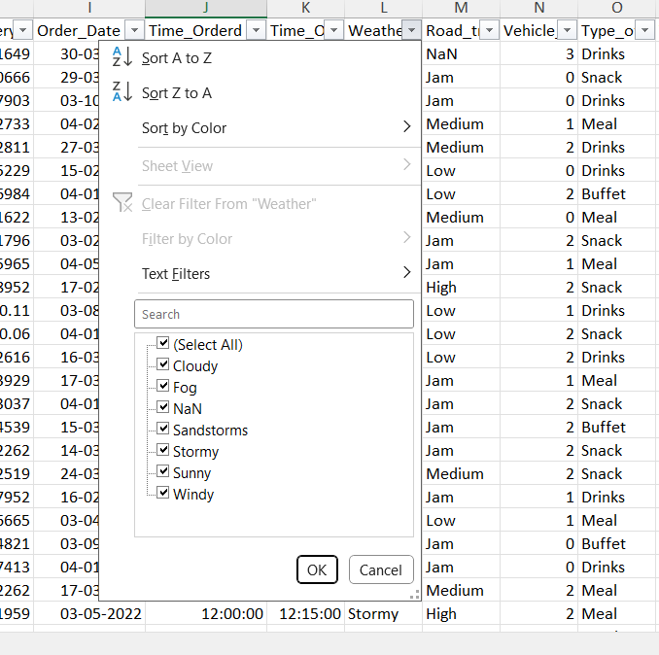
Figure 5: Weather Column
The Weather column contained a small number of NaN values. The corresponding records were removed, as their exclusion was unlikely to significantly affect the overall analysis.
“Multiple deliveries” has “NaN” values in the data; these are recovered by changing them into “banks” and replacing them with median value (Al Maruf et al., 2022)
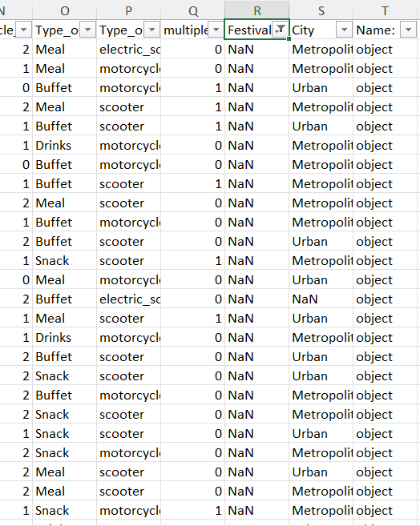
Figure 6: festival column
Festival column has nan values, these would be removed from the dataset to clean the data.
City column also has “NaN” values, keep them unchanged.

Descriptive Statistics and Summary

Descriptive Statistics in Excel
Figure 7: Descriptive Statistics in Excel
The descriptive statistic in Excel is that the average rating of Delivery persons is very high, approximately 4.7, with a relatively low standard deviation (0.4), meaning that the customer feedback is always positive. The mean of delivery is almost 30 years, and the standard deviation is 6.7 years, and this is the reason why the age distribution is evenly distributed. The operations variables, such as the traffic density, the conditions of the vehicles, and different deliveries, have moderate changes as shown by the standard deviations. Overall, the quantitative summaries prove the fact that this information is dispersed and stable enough, which is why it is reasonable to analyse it within the framework of correlation and regression analysis (Microsoft, 2024).

Descriptive Statistics in SPSS
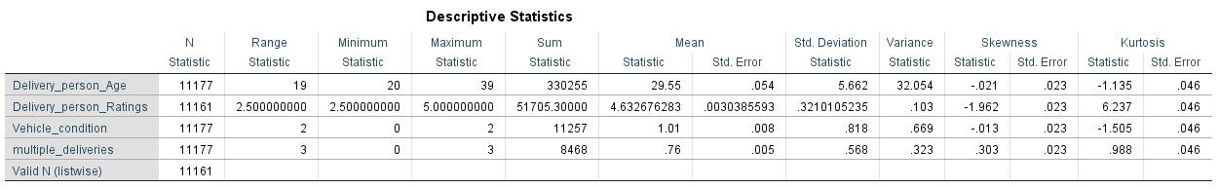
Figure 8: Descriptive Statistics by SPSS
The descriptive statistics indicate that the mean is 29.55 years (SD = 5.66) for the age, which is quite small, and the labour force is very young. The average of Delivery person Ratings stands at 4.63 (SD = 0.32), which shows that there is never a single negative comment regarding the service. The average conditions of vehicles are 1.01, and the multicast deliveries are 0.76, meaning that most delivery is one order with an average variation of conditions of operations (Kent.edu, 2018).
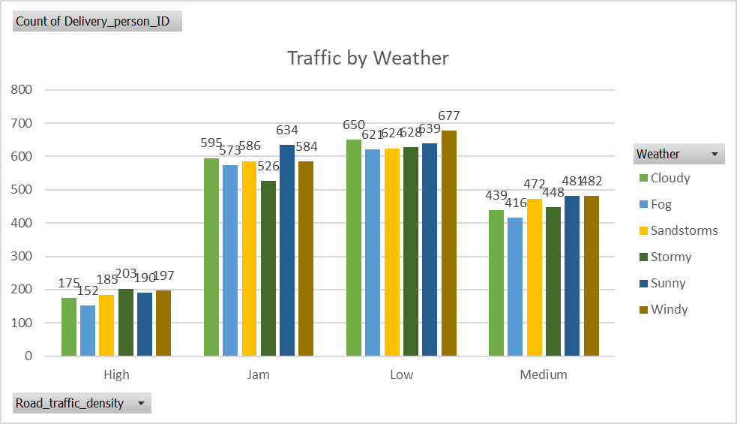
Figure 9: Traffic by Weather
The above image shows the traffic density by weather condition. It is clearly visible that delivery is high in Low and jam traffic density in winter and the cloud season.

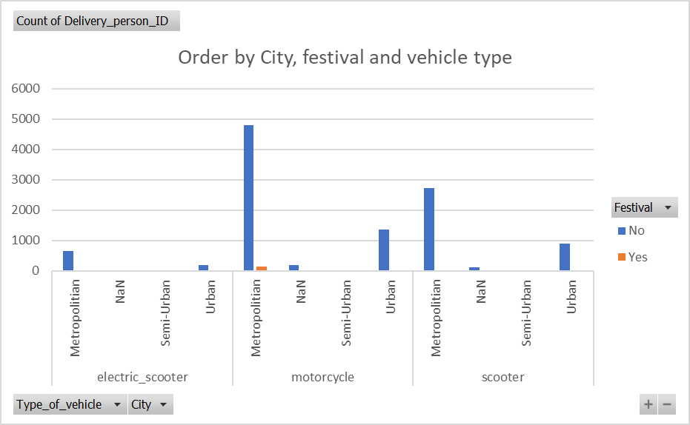
Figure 10: Order by city, festival, and vehicle type
This image shows how delivery is affected by vehicle type, festival and city. Metropolitan cities had the highest deliveries with each vehicle type (Excel-easy, 2021).
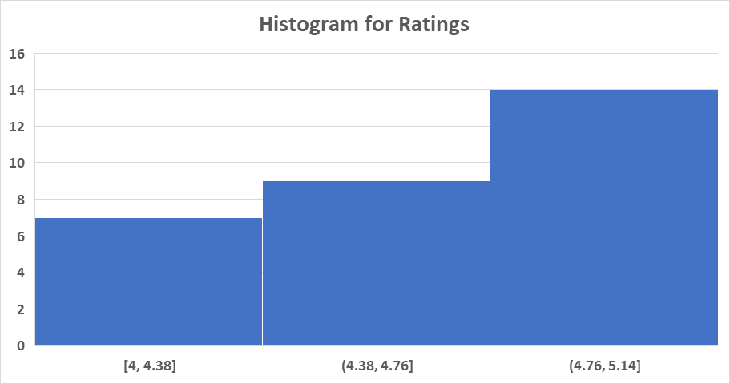
Figure 11: Histogram for Ratings
The histogram shows that the ratings of the delivery persons are found more on the upper end of the scale. The rating is 4.4-5.1 in most of the cases, which is generally a favourable customer rating. The lower-rated frequencies are relatively lower, which points to the absence of variation and left-skewness of distribution.
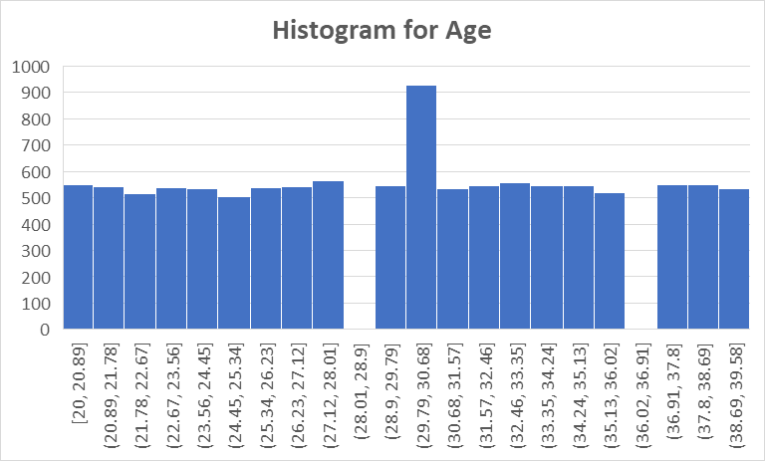
Figure 12: Histogram for Age
The histogram indicates that the age distribution of the delivery personnel is in a wide range within the working age bracket, with a slight cluster in the late twenties and early thirties. The distribution frequencies are spread between most of the age categories, meaning no extreme skewness, and an equal amount of younger and older delivery employees (Guerrero et al., 2019).
Overall, descriptive analysis demonstrates the high delivery person ratings, young and even working force variability, and average variability of operational factors. Also, graphs show that traffic, weather, type of city, and vehicle traffic influence delivery pattern which proves the advantage of the following statistical analysis.

Trend Analysis and Visualisation
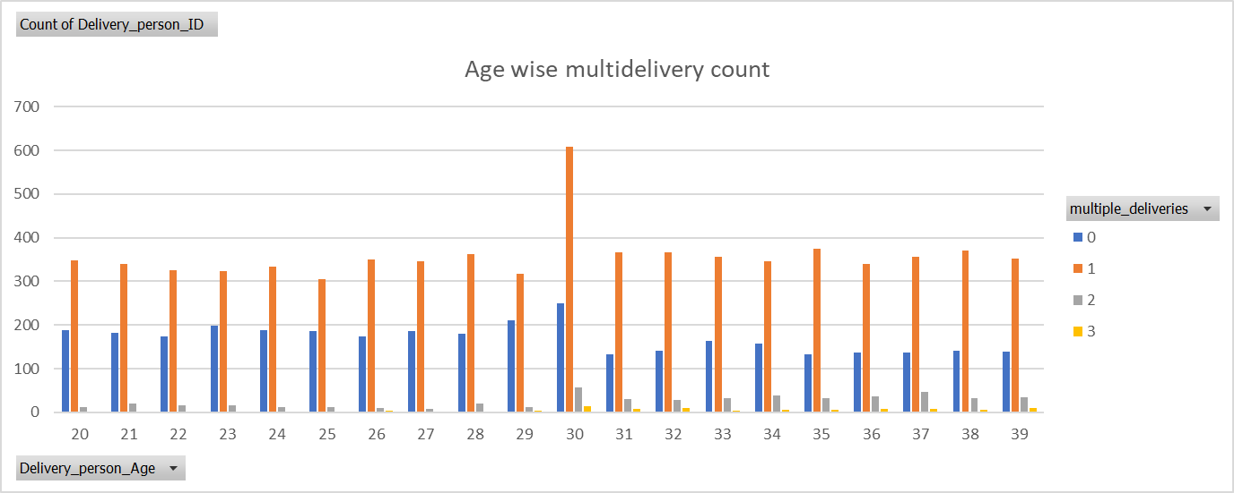
Figure 13: Age-wise multidelivery
The chart indicates the pattern of multi-delivery of the delivery personnel according to age. Single deliveries (one order at a time) are the most common in all the age groups, and this presupposes operations in the usual manner. The focus between 30 and 39 years is very sharp, and it means that there is more movement or higher workforce concentration at this age (Microsoft, 2017).
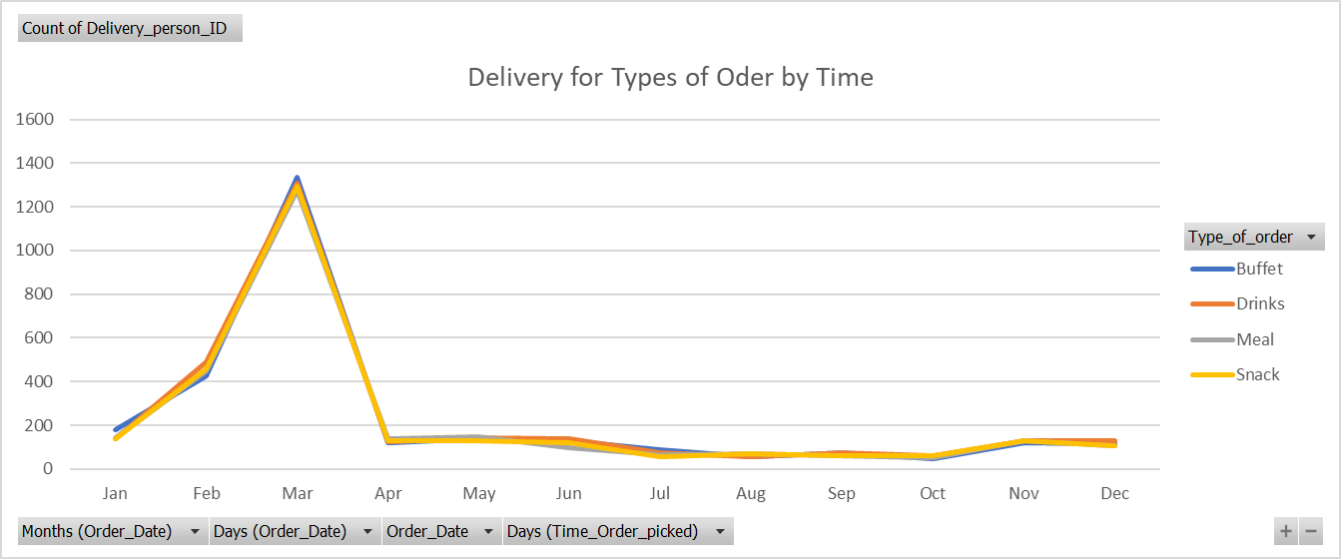
Figure 14: Types of order quantities and time of deliveries
The chart shows the types of order quantities and the time of deliveries. The month of March is high in all the categories of orders, meaning that the month is experiencing a high demand. During the month of post-March deliveries, it is considerably lower and is relatively consistent throughout the rest of the year, with minor increases towards the end of the year in all versions of orders (Sharma, 2026).
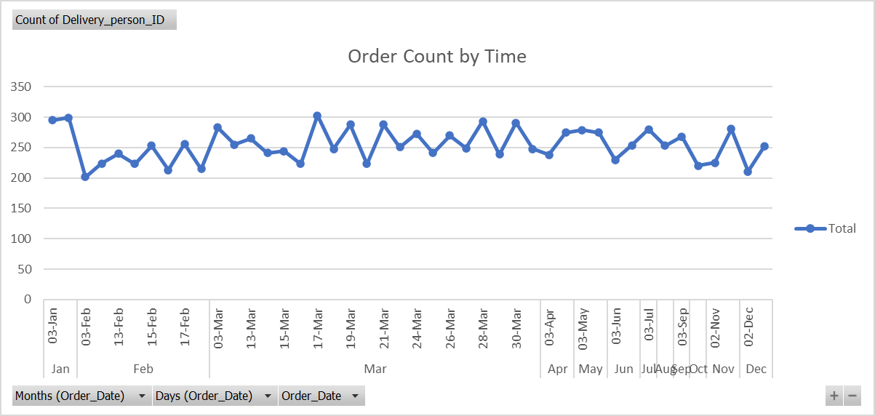
Figure 15: Order Count By Time
The number of orders over time is indicated by using the line chart to illustrate fluctuations moderately, both in terms of days and months. Orders are not huge volumes, and there were about 200-300 orders in each period. The peaks and the drops are both short-lived, the demand varies daily and does not show any drastic seasonal peaks.
Figure 16: Distribution of deliveries into all types of orders
The summary in the table is on the distribution of deliveries into all the types of orders. The leading reason for the number of deliveries is drinks (2,865), and Buffet orders are close behind (2,825). Demand within is also quite high as the volumes of Snack (2,757) and Meal (2,730) orders are quite high (Ahmet, 2023).

The trend analysis refers to the balance and stable delivery activities on different dimensions. An age analysis shows that the percentage of single deliveries dominates all the ages, with some variation that equals the high percentage with the age of about 30, which represents the similarity of workloads. The time analysis suggests high growth in deliveries in March and the subsequent level of demand up to the end of the year, in time to plan the operations smoothly. The order number is approximately variable with time, having a level range, suggesting that customers always need it.

Statistical Analysis using SPSS
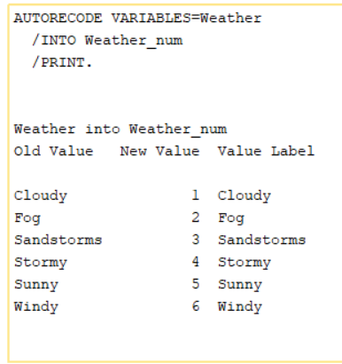
Figure 17: Recode Weather column
Figure 18: Distance Formula

Hypotheses
H₀ (Null): The rating of delivery persons will not significantly differ based on weather conditions.
H₁ (Alternative): The ratings given by delivery persons are significantly different according to the weather conditions.
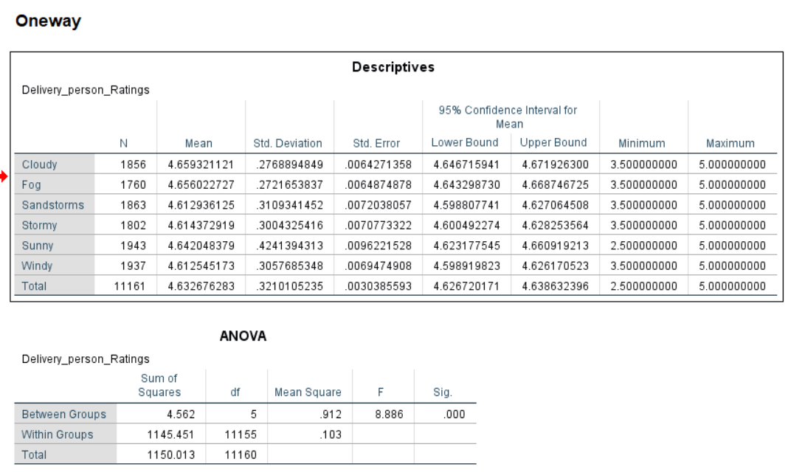
Figure 19: One Way Anova
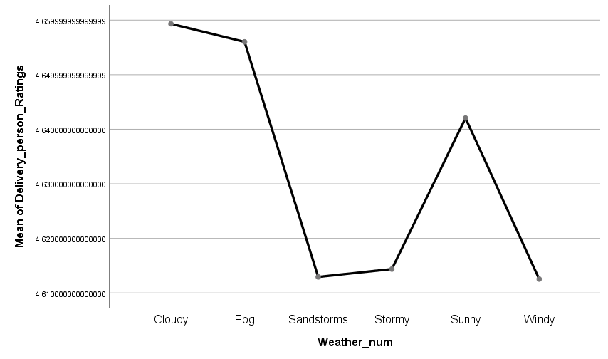
Figure 20: Mean Plot
The hypothesis on whether there is a difference in the rating of delivery persons under different weather conditions was tested using one-way ANOVA. The results show that the ratings are greatly affected by weather, F = 8.886, p = .001; there is dependence between customer ratings and the kind of weather. The greatest mean ratings were observed to be on cloudy and foggy days, as opposed to the lowest ones being observed on the sandstorms and windy days. These dissimilarities are mathematically backed up by the line plot that indicates the difference in the mean ratings in connection with weather categories. The alternative hypothesis is accepted at the expense of the null hypothesis, which verifies that weather conditions are the key determinants of the ratings of delivery persons (Kafle, 2019).

Correlation
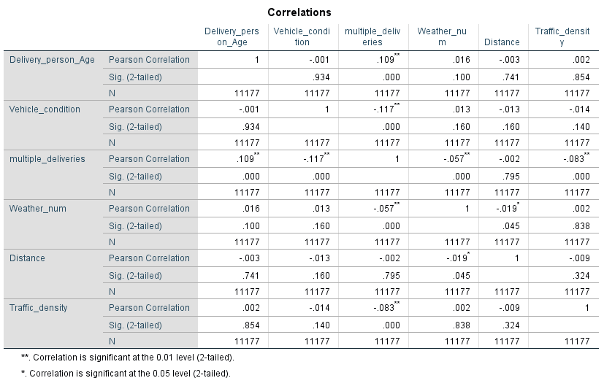
Figure 21: Correlation
This correlation analysis indicates that the number of statistically significant relationship that exists between the variables is a small number of relationships that are generally weak. The age of delivery persons has a positive though insignificant association with multiple deliveries (r = .109, p <.01), indicating that older delivery persons tend to make multiple orders slightly. Vehicle condition and multiple deliveries have a negative correlation (r = -.117, p = .01), meaning that there is an inverse relationship between vehicle condition and multiple deliveries. There is also a low negative relationship between traffic density and multiple deliveries (r = -.083, p =.01). The other variables, like distance and weather, also do not prove to be significantly correlated, which means that there is a minimal number of linear relationships (Laerd, 2018).

Regression
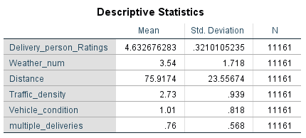
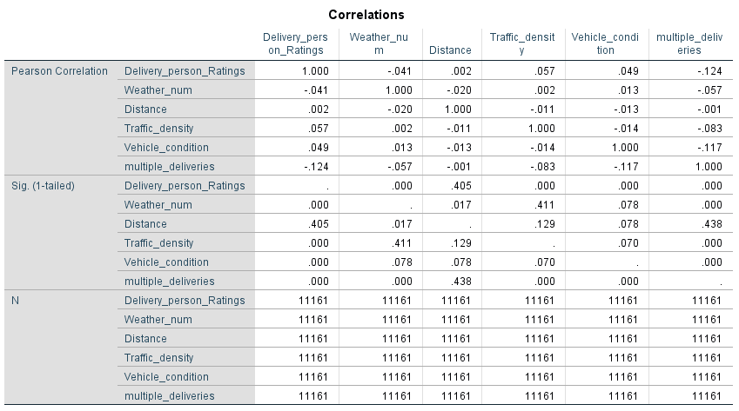
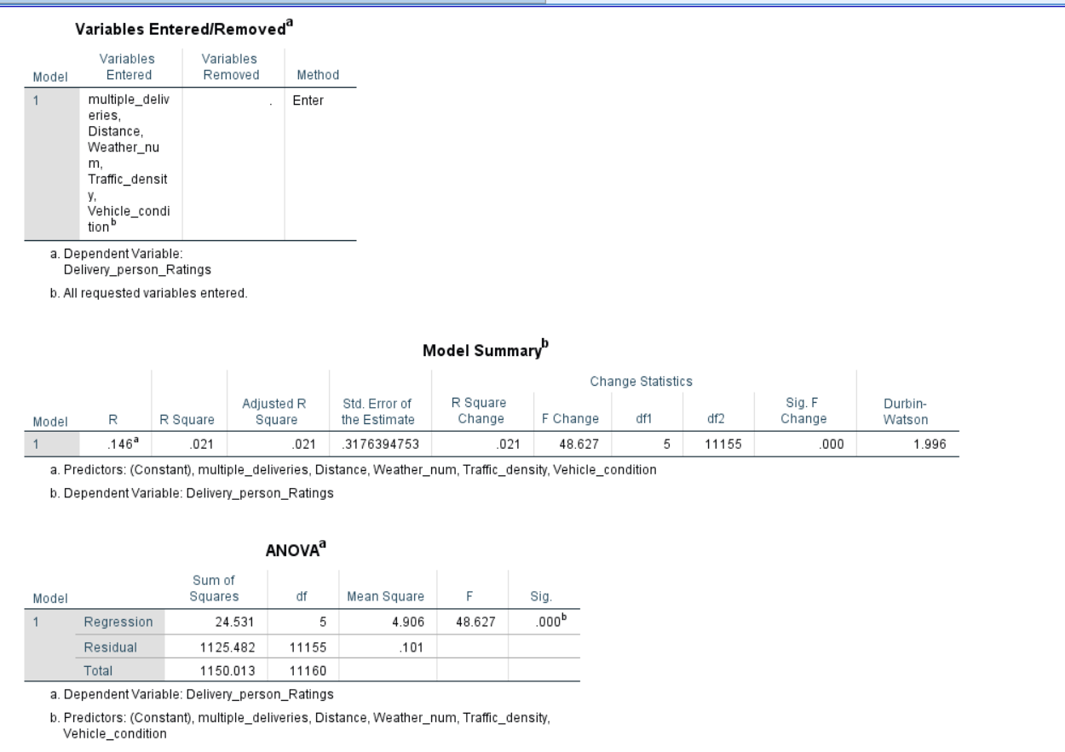
Figure 22: Regression Analysis Summary
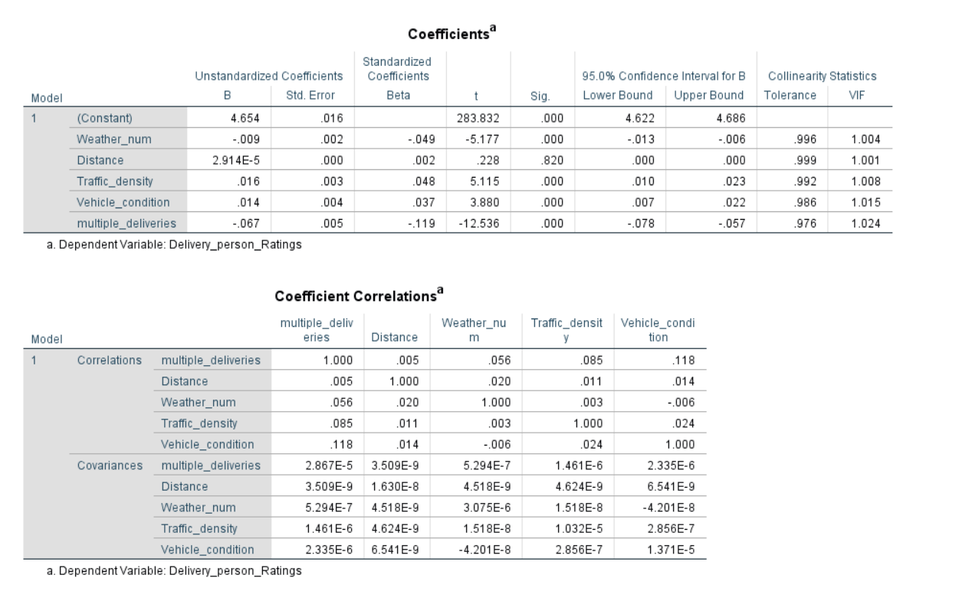
Figure 23: Coefficients for regression analysis

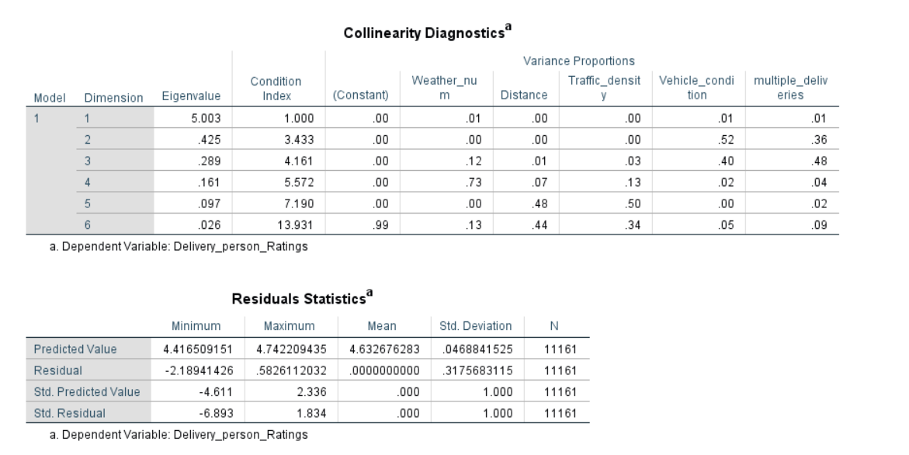
Figure 24: Colliner and Residual Statistics
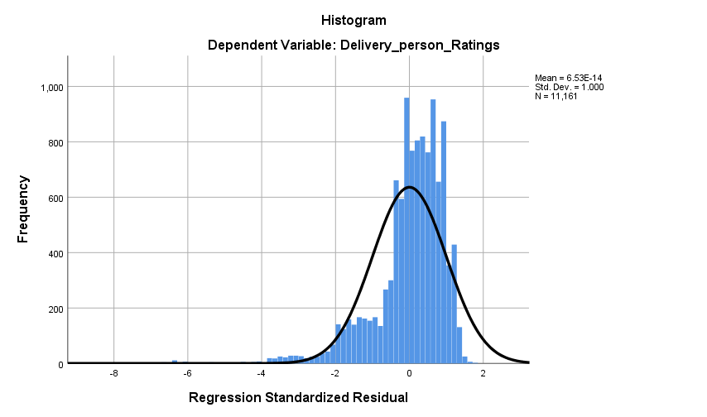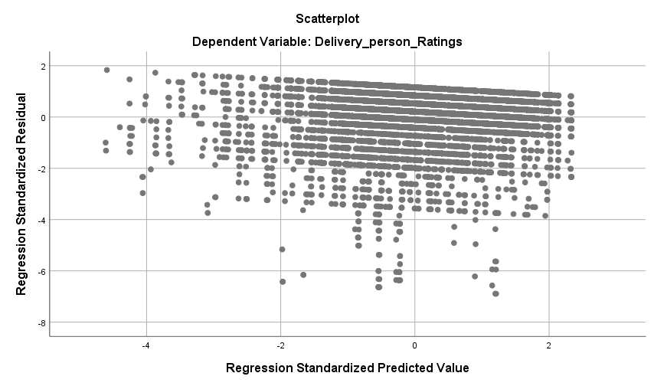
Figure 26: Scatter plot for regression analysis
The multiple regression experiment followed the relationship between the weather, the distance, the traffic, the status of the vehicle and various deliveries to predict the rating of delivery persons. The entire model was statistically significant, F = 48.63, p <.001, which showed that the aggregate effect of the predictors had an effect on ratings. However, the explanatory variance was not high (R 2 =.021), and it can be concluded that the dramatic shift in ratings is largely influenced by other variables that were out of the model. When it came to predictors, the multiple deliveries had a very negative impact, or decreased rating, when the number of orders taken by the rider at a time increased. Traffic conditions and traffic density were slightly impacted, whereas weather conditions were slightly impacted adversely but slightly. A distance was not an important predictor. It was confirmed that the problem of multicollinearity was not present, and the residual normality was nearly acceptable, which implies that the model was free of weaknesses.

Insights and Recommendations
The assessment demonstrates the equal functioning of the delivery and the overall high ratings of clients, and equal demand for different types of orders. The weather conditions were found to influence delivery person ratings quite prominently since the poor weather conditions, such as sandstorms and windy weather, were associated with the low ratings. The trend analysis found that there was gradual growth in the order volume, with maximum volume recorded in March, and the regression analysis found that making more than a single delivery at a time has negative effects on the ratings. Another reason is the traffic congestion and the state of the vehicles, but its effect is not very high. These observations suggest that the operating factors influence the customer perceptions of delivery quality more than the demographic aspects of their customers.

Recommendations
- Use real-time optimisation of routes and time buffer in case of bad weather to reduce delays and rating lapse.
- Limit the number of deliveries made by a rider within the same day, especially during rush hour or bad weather.
- Use well-maintained vehicles on released routes or busy routes, which are challenging, to ensure the reliability of the deliveries.
- Reduce or increase the staffing and resource allocation during peak times, i.e. March, to guarantee the quality of service.
- Individualised dispatch and scheduling orders with the help of real-time traffic and weather.

Limitations and Future Research
The model outlines a low ratio of variation in ratings, which indicates the absence of behavioural or service-based factors. To have a better understanding of what the future research should entail, the most significant variables that should be included in the research are accuracy in delivery time, customer feedback and operational data in real time.

Conclusion
It is possible to note that the activity of the delivery operations is typically marked by high customer ratings and even demand trends, which are revealed during the analysis. Weather conditions, traffic jams, and other deliveries are also significant factors that determine the level of performance of the deliveries. These findings highlight the necessity to possess dynamic working approaches to enhance efficiency and retain customer contentment.

Reference
‌Ahmet, J. (2023). Visualising Data in Excel. [online] Datacamp.com. Available at: https://www.datacamp.com/tutorial/visualizing-data-in-excel [Accessed 3 Feb. 2026].
‌Al Maruf, A., Paul, R., Imam, M.H. and Babar, Z. (2022) “A Systematic Review of The Role Of SQL And Excel In Data-Driven Business Decision-Making For Aspiring Analysts”, American Journal of Scholarly Research and Innovation, 1(01), pp.249-269. https://researchinnovationjournal.com/index.php/AJSRI/article/download/46/35
‌Excel-easy. (2021) Data Analysis in Excel. [online] Available at: https://www.excel-easy.com/data-analysis.html [Accessed 3 Feb. 2026].
Guerrero, H., Guerrero, R. and Rauscher, 2019. Excel data analysis. Springer International Publishing. https://core.ac.uk/download/pdf/326762909.pdf
‌Kafle, S.C. (2019) “Correlation and regression analysis using SPSS”, The OCEM Journal of Management, Technology, and Social Sciences, 1(1), pp.125-132. https://journal.oxfordcollege.edu.np/index.php/ojmts/article/download/14/13
‌Kent.edu. (2018) LibGuides: SPSS Tutorials: Descriptive Stats for Many Numeric Variables (Descriptives). [online] Available at: https://libguides.library.kent.edu/SPSS/Descriptives [Accessed 3 Feb. 2026].
Kirkby, K., Antiporta, D.A., Schlotheuber, A. and Hosseinpoor, A.R. (2024) “Making health inequality analysis accessible: WHO tools and resources using Microsoft Excel”, International journal for equity in health, 23(1), p.205. https://link.springer.com/content/pdf/10.1186/s12939-024-02229-w.pdf
Laerd. (2018) Linear Regression Analysis in SPSS Statistics - Procedure, assumptions and reporting the output. [online] Available at: https://statistics.laerd.com/spss-tutorials/linear-regression-using-spss-statistics.php [Accessed 3 Feb. 2026].
Microsoft (2017) Analyze Data in Excel - Microsoft Support. [online] Available at: https://support.microsoft.com/en-us/office/analyze-data-in-excel-3223aab8-f543-4fda-85ed-76bb0295ffc4 [Accessed 3 Feb. 2026].
‌Microsoft. (2024) Use the Analysis ToolPak to perform complex data analysis - Microsoft Support. [online] Available at: https://support.microsoft.com/en-us/office/use-the-analysis-toolpak-to-perform-complex-data-analysis-6c67ccf0-f4a9-487c-8dec-bdb5a2cefab6 [Accessed 3 Feb. 2026].
‌Sharma, H. (2026) Best Types of Charts in Excel for Data Analysis, Presentation and Reporting. [online] Optimize Smart. Available at: https://optimizesmart.com/blog/best-types-of-charts-in-excel-for-data-analysis-presentation-and-reporting/ [Accessed 3 Feb. 2026].

