Introduction
The Swiss Cheese Model is a systems-based approach to risk management that examines how multiple layers of security work together to reduce risk. It is also known as the “layers of protection” approach and was developed by English psychologist James Reason (1990) as an attempt to explain how and why accidents occur, even when multiple layers of defence are in place.
These layers can be metaphorically compared to slices of Swiss cheese, with the holes in the ‘cheese’ representing the weaknesses in the layers of defence. The model is often used in industrial settings but can also be applied to the outdoor adventure industry to identify potential weaknesses in safety systems and to take corrective action (Reason, 1990).

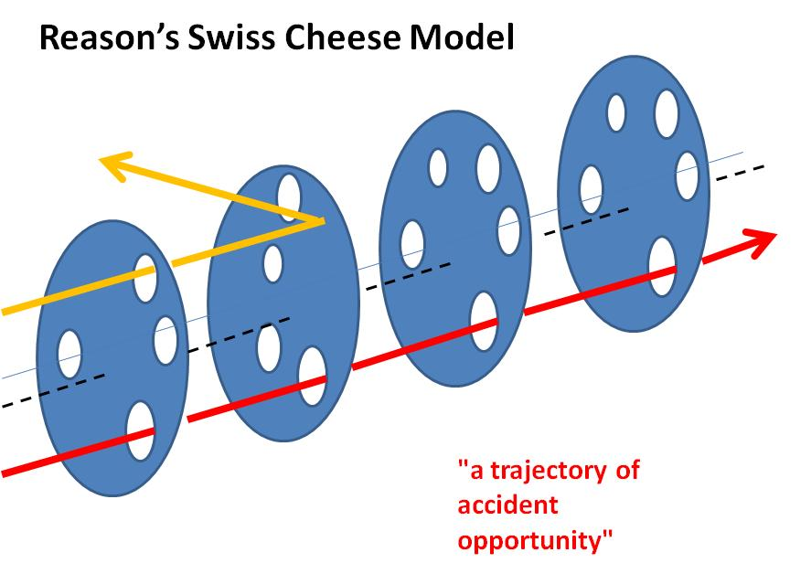
Figure 1 - Reasons Swiss Cheese Model (Skybrary, 2020)
Where we see holes in the layers represents flaws in the system. These holes can align, creating a “window of vulnerability” and is a diagraphical demonstration on how incidents occur within the industry.
The model emphasizes that accidents are caused by a combination of factors and are rarely the result of a single flaw or factor. The model consists of four components:
- Hazards and potential risks
- Active Barriers, reducing risk
- Procedure and process
- Accident sequence
(Li and Thimbleby, 2014)
The model can also be used to identify where improvements should be made to reduce the risk of these line ups and the ‘holes’ in general. It can also be used to analyse previous accidents, therefore allowing organizations to understand how and why an accident occurred to better and improve their standards of safety and instructing.
The strengths of the model lie in its ability to identify potential weaknesses in safety systems and to provide a visual framework for understanding how accidents occur. Additionally, the model is relatively easy to understand, allowing it to be applied in different contexts.
Despite its strengths, there are some limitations. The model does not consider the complexity of real-world systems and may not be able to accurately predict all potential risks. Additionally, the model does not address the human factor, which is an important component of safety systems, especially within the outdoor industry. Finally, the model does not provide a step-by-step approach to risk management, which can make it difficult to implement in practice.

Saxetenbach Canyon
Canyoning in Saxetenbach canyon has been popular since the late 19th century. The area has since become a favored destination for adventurous travelers and outdoor enthusiasts, who come to explore the canyon's many waterfalls and challenging routes. The area's popularity has led to the development of professional canyoning guides, and adventure tour companies to lead groups down the gorge and teach them the necessary skills to safely navigate its terrain.

One of the many adventure tour companies formed in this tourism boom was Adventure World, established in Interlaken in 1992 by experienced mountaineers. Adventure World quickly became renowned for its outstanding safety record and its size, as one of the largest adventure companies in Switzerland. Bringing its 44 employees to the table, with their great deal of experience and familiarity with the mountain, it was often seen as an easy pick for local tourists (Brooks, 1999).
With the company quickly expanding in popularity, Adventure World caught the attention of travel agents Contiki. At the time Contiki was one of the fastest growing agencies offering thrill seeking packages specifically tailored to young people (18-25) seeking adrenaline (Head, 1999).
Being such a large company, Adventure World were eager to impress Contiki and secure an ongoing contract with them. During this process the company saw a drop in its 44 high quality instructors, this was due to the company’s change of focus from safety to money. Therefore, adventure world replaced its missing instructors quickly, for those with less experience, qualifications, and familiarity of the gorge itself.
With this brazen approach to a lack of safety and profit driving on, 27th July 1999 a devastating flash flood resulted in the death of 21 victims, aged between 18 and 31. Following the disaster of 1999, Jenkins (1999) and Head (1999) work on interviewing employees revealed:
“Safety standards we set at the beginning had dropped so dramatically, I just left.”
- Dave Erikson-(Jenkins, 1999)
“Financial concerns overtaking the safety standards.”
“Seven of the eight guides in the canyon on the day of the incident were first year guides”
- Alan Burt -(Jenkins, 1999)

Employing inadequately experienced guides encouraged to take risks with groups to secure profit.
- Head, 1999
“An experienced guide is able to withstand the pressure from the organization as well as say no.”
- Dave Erikson (Head, 1999)
To outline the incident, a group of 44 tourists and 8 guides were canyoning in the Saxetenbach canyon when a localized storm created a sudden rise in water levels of the mountain stream in the ravine. This is believed to have been caused by a natural dam at the top of the gorge breaking due to the intensity of the storm, creating a 10-15 ft tall wave to race upon the group. With few climbing to safety, the rest of the canyoners were engulfed by the wave, becoming either trapped or swept away. The nationalities of the victims were Australian (14), New Zealand (2), Swiss (2), South African (2) and British (1) (Australian Institute for Disaster Resilience, 2012). It took two days to recover the bodies of the victims, ranging from ages 16 to 44.

What Happened that day?
This incident has been attributed to a combination of complex factors, and has been analyzed in accordance with the Swiss cheese model (Reason, 1990).
Firstly, there were various organizational factors that contributed to the disaster. The group were inadequately supervised by the instructors, and Adventure World had failed to ensure that the instructors were adequately qualified and experienced in the area. Following the incident, Hoedle, the owner of Adventure World explained that employees were required to undertake a week long course, followed by 20-50 sessions as an assistant instructor, however in previous years the companies “experienced instructors had held an average of 5 years’ experience under there belt. Erikson believes due to the financial strive quantity overtook quality and therefore ‘experienced’ instructors in fact weren’t experienced at all (Jenkins, 1999).
Furthermore, the instructors that day had been given the green light from there superiors at adventure world. Despite them being warned about the conditions of the canyon by the local fire department and other tour companies.
Secondly, there were various flaws in the tour that led to exposed channels through the Swiss cheese model in regards to environmental factors (Reason, 1990). The canyon itself only holds a length of 100m where the canyon is ‘true’ with steep walls that provide no exits or escape routes, the rest of the canyon has climbable walls for emergency escape routes. On the day of the incident, 2/4 of the groups present in the canyon were unfortunately positioned within this 100m stretch, within these two groups was where we found the most casualties and deaths. The weather conditions on the day were visibly poor with clients pointing out hearing thunder on their way up to the canyon and its dark skies (Jenkins, 1999). The wether reports for the day shown localized storms with poor conditions for canyoning , high winds and heavy rain (Liquisearch, N/A). Saxetbach canyon was not safe to descent in high water levels, such as those that occurred on the day of the accident.
Thirdly, there were various human factors that contributed to the disaster. The instructor had failed to adequately assess the abilities of the group, which meant that they were unprepared for the challenges of the tour (Jenkins, 1999; Head, 1999). Furthermore, the instructor had failed to provide adequate guidance, which meant that the group were unable to effectively manage the risks associated with the tour.
Due to the 4 separate groups being at different stages of the canyon, the group at the top was unable to communicate with those further down de to a lc of communication systems in place, however, due to the speed of the water, even if these were in place would they have been effective?
These environmental challenges were exacerbated by the fact that the group were inadequately prepared, and were thus unable to effectively manage the risks associated with the tour.
In conclusion, the 1999 Saxetbach canyoning disaster was the result of a complex combination of organizational, environmental and human factors. This incident highlights the importance of ensuring that instructors are adequately qualified, and that safety instructions are adhered to.

Safety improvement suggestions
- Use experienced guides. It is recommended that canyoning trips in Saxetburg Canyon should be led by experienced guides. In recent years adventure world had many experienced guides with 5 or so years under there belt, due to the quantity over quality stake the company took to be able to have a larger financial flow, the quality and experience of these instructors dropped massively (Head, 1999). The warning form the local fire department also would have been ignored.
- Ensure adequate safety equipment is used. Participants should be provided with appropriate safety equipment, such as lifejackets, helmets, and ropes. If equipment was kept up to date with regular checks on there safety and security then it would have allowed for them to work correctly during the incident, potentially leading to less casualties of both tourists and guides. The use of bolts and lines in the walls of the canyon should have been larger enforced by the company on the day of the incident. I all members were adequately attached to safety lines and told the means of safety procedures then the risk of death would have been further reduced due to the limitation of being separated from the rest of the group and dragged downstream.
- Be aware of the weather. Weather conditions should be taken into account prior to canyoning in Saxetburg Canyon. The guides should have been aware of the weather conditions and its impact on the canyon, this is gained through experience and research, little of which all instructors on the day had.
- Know the conditions of the canyon. Guide should be aware of current conditions of the canyon, such as water levels, and any debris or obstacles in the canyon and potential areas of danger during risky weather conditions to avoid. If the guides were aware of the conditions of the canyon and understood it more then maybe they themselves would have made the decision not to head down the canyon that day.
- Have an emergency plan. It is important to have an emergency plan in place in case of an accident. There were no escape routes on the 100m stretch of ‘true’ canyon, in this are safety should be enhanced with the option going to tourists on whether they wanted to continue (Challenge by choice). This could have led to less members being swept away due to safety falls in line to prevent this from happening in the worst case scenario.

Reflective account

This account on the incidents that occurred on the 27th July 1999 emphasizes the importance of not only the qualifications of instructors but also there experience in the local environment and there competency and confidence on working with the company. The incident itself has a direct impact on my personal instructing as it really sheds a light and brings the risk factor of instructors roles and responsibilities into fact and reality and I feel as though these can often be forgotten and masked by many.
An instructors role is much more than simply providing a good time. This incident shows up and reminds us the importance of safety procedures and experience when instructing and that they shouldn’t be masked or forgotten about just to improve money flow. The instructors that survived the incident and a handful of those that work for the company have been charged for manslaughter. This is an obviously life changing factor that I feel many instructors might often forget about there responsibility of the groups safety.
For me this incident reminds me of these responsibilities I and others hold. Reminding us that those in charge aren’t always looking out for the best safety interests, and to hold a backbone when you feel conditions and safety procedures are out of line or don’t hold value in certain scenarios and situations as these might just change someone’s life. It is better to be safe and secure in your decisions than it is to put the group in front of unnecessary risk that falls outside of the risk signed up for.

References
- Australian Institute for Disaster Resilience (2012) Flood – Flash Flood Available at URL: https://knowledge.aidr.org.au/resources/flood-flash-flood-switzerland/ (Accessed 18/01/23)
- Brooks (1999) Alps disaster search goes on Available at URL: https://www.theguardian.com/world/1999/jul/29/libbybrooks (Accessed 18/01/23)
- Head (1999) Profit drive blamed for Swiss canyon tragedy. Available at URL: https://www.wsws.org/en/articles/1999/08/swss-a06.html (Accessed 18/01/23)
- Jenkins (1999) A Storm in the Distance Available at URL: https://www.outsideonline.com/outdoor-adventure/exploration-survival/storm-distance/ (Accessed 19/01/23)
- Li and Thimbleby (2014) ‘Hot cheese: a processed Swiss cheese mode’ Journal of Royal College Physicians Edinburgh Vol.44 pp.116-121
- Reason (1990) Human Error. Cambridge: Cambridge University press
- Reason, J. (1990). Human error: Models and management. British Medical Journal, 300(6725), 768-770.
- Skybrary (2020) James Reason HF Model Available at URL: https://www.skybrary.aero/articles/james-reason-hf-model (Accessed 15/01/23)

