

Programme: Master of Business Administration

Module: Marketing Management

Module code: LCMB7024
Lecturer’s Name: Dian Mayasari

Topic: Netflix One: End Of Streaming Fragmentation

Student Name: Rathod Virendrasinh Rajendrasinh

Student ID: 2438323
Submission Date: 19th November 2025, 2 PM
Word Count: 2480

Table of Contents

Element 1: STDP Analysis 3
1. Introduction 3
2. Concept Overview 3
3. Segmentation 3
4. Targeting 4
5. Differentiation 5
6. Positioning 5
Element 1 References: 7
Element 2: Marketing Mix – 7Ps 8
1. Product 8
2. Price 8
3. Place 8
4. Promotion 9
5. People 9
6. Process 9
7. Physical Evidence 10
Element 2 References: 11
Element 3: Marketing Strategy Pitch 12
Element 3 References: 13
Element 4: Reflection 14
1. Introduction 14
2. Reflection on Brand Concept Development 14
3. Reflection on Marketing Mix and Strategy 14
4. Reflection on Pitch Preparation and Delivery 15
5. Future Improvement 15
Element 4 References: 16

Element 1: STDP Analysis

1. Introduction
Netflix is an international streaming service of entertainment, and it is widely recognized for changing the consumption habits of digital content by its audience. The streaming industry has, however, been growing in fragmentation, and many competing services cause subscription fatigue and frustration for the user. In response to this challenge, Netflix launches Netflix One, a single, full-stack streaming platform that brings together the key entertainment platforms on a single subscription. This technology makes it easy to access it, and people are provided with a single application, a single search engine, and a single monthly bill. This evaluation aims to create a holistic Segmentation, Targeting, Differentiation and Positioning (STDP) plan of Netflix One such that it can match the changing consumer preferences and the new market trends.

2. Concept Overview
Netflix One is an innovative idea that is created on the premise of One App; One Search, One Monthly Bill (Netflix, 2025). It combines the collections of the major streaming services like Disney+, Prime Video, and HBO Max into one comprehensive system, in which one can access all their favourite content in a single unified platform. Netflix One makes the process of dealing with multiple accounts and payments a problem of the past because it helps to consolidate subscriptions. Its personalization suggests shows with the help of AI and saves time, and increases the satisfaction of viewing across the services. This innovation will directly solve consumer pain points such as fatigue, increased costs, and content overload as a result of subscriptions.

3. Segmentation
Netflix One is mainly focused on Gen Z, Millennials, and tech-advanced families aged 18-45, who live in urban areas with good internet penetration. These are digital natives who appreciate convenience, diversity, and customization in the kind of entertainment they consume (Owilla, 2023, p11). They often have many subscriptions with many streaming services, which results in subscription fatigue and frustration with piecemeal viewing experiences.
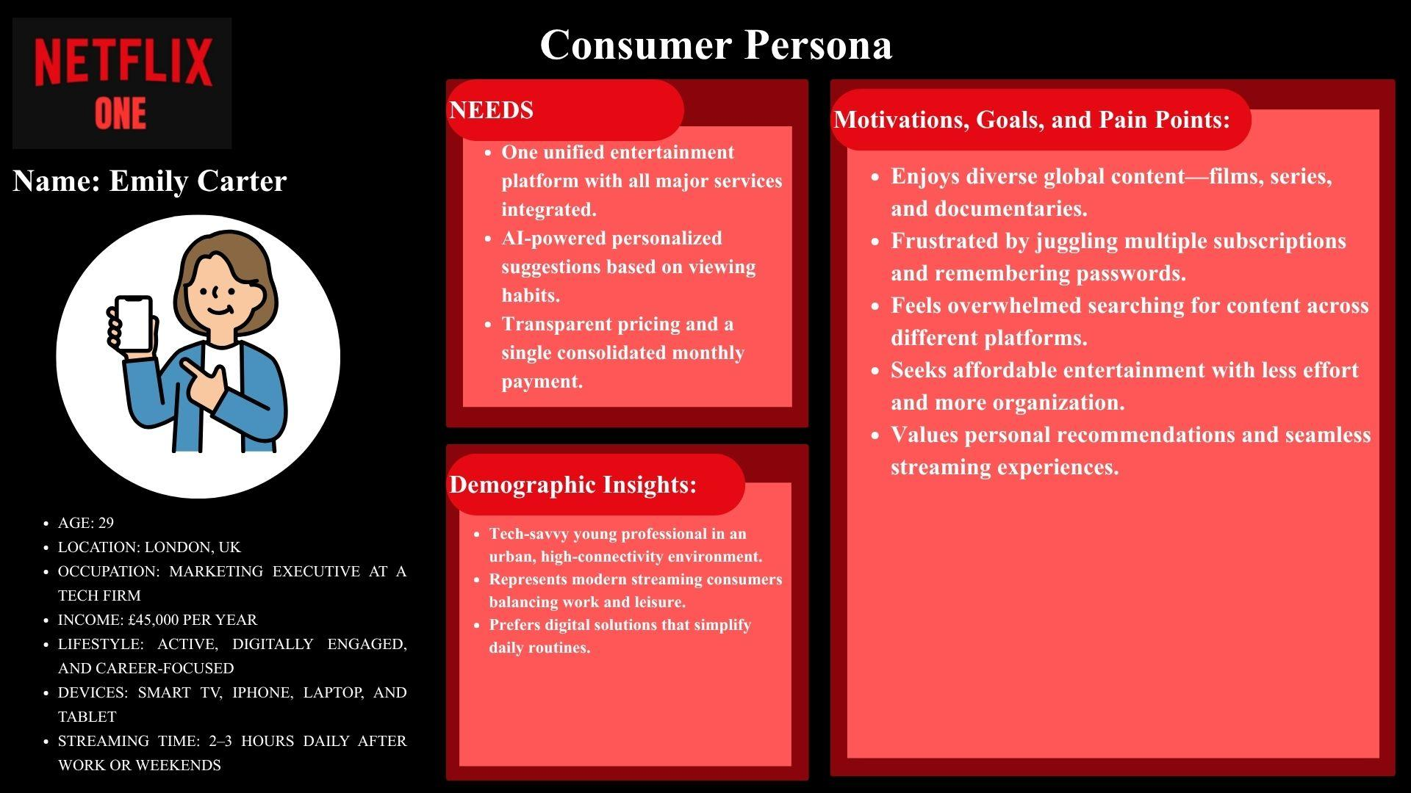
Figure 1: Consumer Persona
(Source: Self-Made)
Netflix One has the ideal customer in the person of the customer, Emily Carter: a time, convenience-seeking, and technology-friendly customer. She does not like the inconvenience of having numerous accounts on streams, and she likes the convenience of consumer-friendly and tailor-made entertainment. An ability to handle her in a single location, bill, and smart recommendations exists in the Netflix One. Netflix One implies the convenience component and streaming fragmentation resolution among end-users like Emily, and therefore future of making digital entertainment convenient to people.

4. Targeting
Netflix, one pursues a differentiated targeting approach that targets busy professionals, young adults, and modern families that actively utilize several streaming platforms. These audiences are demanding to be entertained in one place, have their bills simplified, and recommendations tailored to them that will save on time and money. The existing trends demonstrate that more than half of the streamers subscribe to three or more services, and they tend to be confused by the complexity and price (Colbjørnsen, 2021, p1268). This states the apparent need for integrated and easy-to-use solutions. Netflix one directly answers these pain points by providing a single clever hub that brings together all sources of content. This strategy is consistent with the current number of subscribers that Netflix already has of technology-driven, convenience-driven consumers, and goes after new users who are dissatisfied with the fragmented streaming ecosystems.

5. Differentiation
The originality of Netflix One lies in the fact that it will be the first streaming center where the content of the most requested services will be integrated into all platforms within a single platform that can be accessed and utilized with ease. It is founded on the AI discovery to propose titles in all of the libraries and makes the experience very personal. Compared to its rivals (such as Disney+, Prime Video, or Apple TV plus), Netflix One is not an integrated platform and operates on a simpler and open pricing model, enabling easy billing, and can consume all the services in the same subscription (Vehmas, 2023, p8). It redefines convenience with the help of the global brand trust and the alliances of Netflix, as it is the panacea to streaming discontinuities.

6. Positioning
Netflix One - The New Wave of Entertainment. Unlocked. It is a brand of simplicity, customization, and integration of quality, and it reinvents the act of listening to digital entertainment. Being the last streaming service standing, Netflix One does not need to deal with the variety of subscriptions, but with different types of content integrated into a smart platform. The recommendations are also tailored with the help of AI; hence, it is possible to assume that they would be biased towards the likes and preferences of the individual, which would make discovering and feeling pleasurable with ease (Daya and Aslam, 2024, p4). Positioning Statement: Should the entertainment lovers get besieged by streaming, Netflix One will become one smart platform that will bring all your favourite content to a single stream so that no streaming subscriptions will be like it.

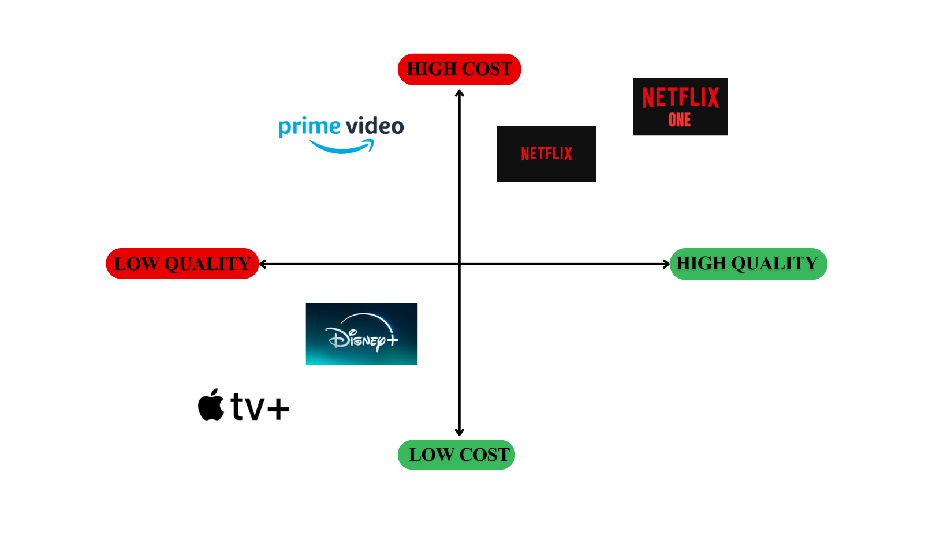
Figure 2: Brand Positioning Map
(Source: Self-Made)
It could be stated in the positioning map that Netflix could boast a high degree of convenience and content variety compared to its rivals. Unlike the traditional platform, which supports rich content, the traditional platform is applied to deliver the rich content only hence resulting in user fatigue and inefficiency. It is beaten by the fact that Netflix incorporates different libraries into a single product and can be watched with a level of convenience that has never been seen before regarding both convenience and entertainment (Boccio, 2025, p2). This twofold strength causes Netflix One to be an unquestionably high language, full-scale streaming platform, which provides the adaptability and ease of use, as well as customer happiness.

Element 1 References:
Netflix. (2025). Netflix – Watch shows online, watch movies online. Available at: https://www.netflix.com (Accessed: 13 November 2025).
Owilla, H., Mogere, C., & Booker, N. A. (2023). Media consumption in an evolving digital world: Millennials and digital natives’ consumption habits and implications for legacy media in Kenya. Aga Khan University Graduate School of Media and Communications. Available at: https://ecommons.aku.edu/eastafrica_gsmc/103/ (Accessed: 17 November 2025).
Colbjørnsen, T. (2021). The streaming network: Conceptualizing distribution economy, technology, and power in streaming media services. Convergence, 27(5), 1264–1287.
Vehmas, V. P. (2023). The Evolution of B2C Subscription Video-on-Demand Platforms: Through power, efficiency, capability, and identity lenses. Master’s Thesis, University of Vaasa. Available at: https://osuva.uwasa.fi/bitstreams/959fd495-2fe8-4599-bf1b-c1bc1bf91403/download (Accessed: 17 November 2025).
Daya, S., & Aslam, S. (2024). A Personalized Restaurant Recommender System for Special Needs Mobile Users Using AI and Accessibility Features. Available at: https://www.researchgate.net/publication/385381678_A_Personalized_Restaurant_Recommender_System_for_Special_Needs_Mobile_Users_Using_AI_and_Accessibility_Features (Accessed: 17 November 2025).
Boccio, J. (2025). Netflix and the Platformization of Film and Television Content Discovery. Doctoral dissertation, University of Central Florida. Available at: https://stars.library.ucf.edu/etd2024/104 (Accessed: 17 November 2025).

Element 2: Marketing Mix – 7Ps

1. Product
This is where the strength of Netflix One resides because it is a single entertainment hub that is convenient and interlaced to an extent where numerous streaming sites are packed into a single one. It is intrinsically available to cross-platform, recommendations of AI ideas, seamless payment, and parental restrictions, all of which are optimal to the individuals and families (Bourdoucen and Lindqvist, 2025, p814). The interactive interface might be considered an attractive design as it is user-friendly and easy to navigate in its nature, which can be seen in smart TVs, mobiles, and tablets as well, due to its intuitive nature. The augmented customer services of 24/7, personalised notification, and full product integration using devices through cloud services are included in the 24/7 customer services. The Netflix One is designed as a high-quality super-aggregator where customers do not have to deal with the annoying experience of having to use various apps and pay different prices.

2. Price
Netflix One adheres to the premium subscription pricing strategy that suggests the outstanding value and convenience of integrated access to numerous streaming services. Its proposed monthly payment of £40-£50 places it in the position of an elite but a valuable alternative to heavy users of entertainment. The Netflix One also proposes tiered plans: Standard, Premium, and Family, which would meet the needs and viewing patterns of different users (Frey, 2021, p196). The pricing value approach will make the users believe that the overall price will be lower than the price of having multiple subscriptions. Other incentives are that long-term subscribers will receive discounts, student offers, and partnerships with internet or mobile companies. Netflix One strikes a balance between exclusivity and accessibility by having fairness, flexibility, and perceived worth.

3. Place
The distribution of Netflix One is fully based on digital channels, which means that it is easily available using the current Netflix application on smart TVs, mobile devices, tablets, and computers. The global brand presence will allow Netflix to launch the brand in the key markets at the same time, with regional content localization to make sure that the brand is local. The service will also collaborate with telecommunication companies, broadband networks, and smart device producers to come up with Netflix One as a premium data or device package to have even greater coverage and ease (Karakulath and Oschinsky, 2023, p7). The ability to work with smart homes will provide seamless access to streaming content with voice features and support Alexa streaming using the Google Assistant.

4. Promotion
The promotion approach of Netflix One will be based on a multi-channel campaign that will help to attract digital people and establish the brand as the answer to streaming fatigue. The slogan that will be used in the campaign will be One App. One Search. One Monthly Bill, with the stress of simplicity and convenience. The advertising will consist of social media campaigns, influencer relationships, and interactive online advertisements expressing the real-life frustrations of having to manage several subscriptions (Wassif, 2024, p6). The anticipation will be created by a global launch event, which will be backed by teaser trailers, celebrity endorsements, and partnerships with YouTube. Emotional narration will highlight the happiness of unproblematic finding out about entertainment. Furthermore, Netflix will utilise its current subscriber base by using in-app notifications and promotional offers.

5. People
The effectiveness of Netflix One depends on a team of professionals who are customer-oriented. The customer care staff will be available 24/7 and will assist the customers via chat, email, and social media. The AI engineers and UX designers will keep on improving the personalization functionalities, maximizing the content discovery in the integrated platforms. Teams in charge of partners will sustain the relations with the other streaming providers and provide a seamless exchange of content and cooperation (Mariam, 2025, p387). The level of training of employees will be regular in regard to digital communication, innovation, and empathy, so that the quality of the services is manifested in the same way, and they are human. Leadership will enhance customer awareness and an innovativeness culture that will enable the staff to predict the needs of the users.

6. Process
Netflix, one has a simplified and user-friendly subscription that is aimed at being as simple as possible. Users are registered through the app or site of Netflix, and all content subscriptions are done through one payment gateway. At registration, a self-driving AI-based onboarding system takes a user through personalized onboarding, connecting his or her existing streaming accounts with ease. The system guarantees the safety of data management and open privacy controls, allowing customers to be sure about the safety of sharing credentials. Ongoing feedback processes and satisfaction surveys will assist in streamlining processes and service enhancement (Famoti et al. 2024, p1559). Renewal of payment and updates of the content are also automated, hence no disruptions. All the processes of subscription, from viewing are user-friendly, dependable, and fast.

7. Physical Evidence
The physical evidence of Netflix One is manifested in its smooth online design and the use of a uniform brand worldwide. The site takes a premium design of red and black and complemented with a smooth effect and minimalistic icons that imply simplicity and innovation. The Netflix One logo is used as a symbol of convenience and harmony. In the app, intuitive navigation, custom-made dashboards, and smooth progressions add to the quality of a highly credible experience. There is a visual consistency in marketing materials such as digital posters, web visuals, and advertisements so that they will be recognized instantly (Bashirzadeh, 2022, p4). The other types of physical evidence are the user testimonials, ratings, and social media interaction that create credibility and trust. Combined with the smart TVs and devices, this further makes it more tangible, increasing the brand's presence. The combination of them conveys the message of Netflix One as an advanced, trustworthy, and attentive streaming service to the contemporary audience.

Element 2 References:
Bourdoucen, A., & Lindqvist, J. (2025). My Data or Our Data? A Comparative Study of Collaborative Family Apps and Parents' Experiences with Apple's Family Sharing. Proceedings on Privacy Enhancing Technologies.
Frey, M. (2021). Netflix recommends: Algorithms, film choice, and the history of taste. University of California Press.
Karakulath, S., & Oschinsky, F. M. (2023). Lights, Camera, Subscription: The Rise of Netflix and Its Disruptive Business Model. Term Paper, Jacobs University Bremen. Available at: https://www.researchgate.net/publication/382441723_Lights_Camera_Subscription_The_Rise_of_Netflix_and_Its_Disruptive_Business_Model (Accessed: 17 November 2025).
Wassif, S. M. (2024). The Challenges and Opportunities Faced by Egyptian Female Social Media Influencers While Owning and Advertising their Brand. المجلة العلمية لبحوث العلاقات العامة و الإعلان, 2024(29), 1-51.‎
Mariam, S. (2025). Exploring Collaboration and Partnerships: A Qualitative Study on Strategic Alliances and Business Networking for Value Creation. Golden Ratio of Marketing and Applied Psychology of Business, 5(2), 386–399.
Famoti, O., Omowole, B. M., Okiomah, E., Muyiwa-Ajayi, T. P., Ezechi, O. N., Ewim, C. P. M., & Omokhoa, H. E. (2024). Enhancing customer satisfaction in financial services through advanced BI techniques. International Journal of Multidisciplinary Research and Growth Evaluation, 5(06), 1558–1566.
Bashirzadeh, Y., Mai, R., and Faure, C. (2022). How rich is too rich? Visual design elements in digital marketing communications. International journal of research in marketing, 39(1), 58-76. https://www.sciencedirect.com/science/article/am/pii/S0167811621000550

Element 3: Marketing Strategy Pitch
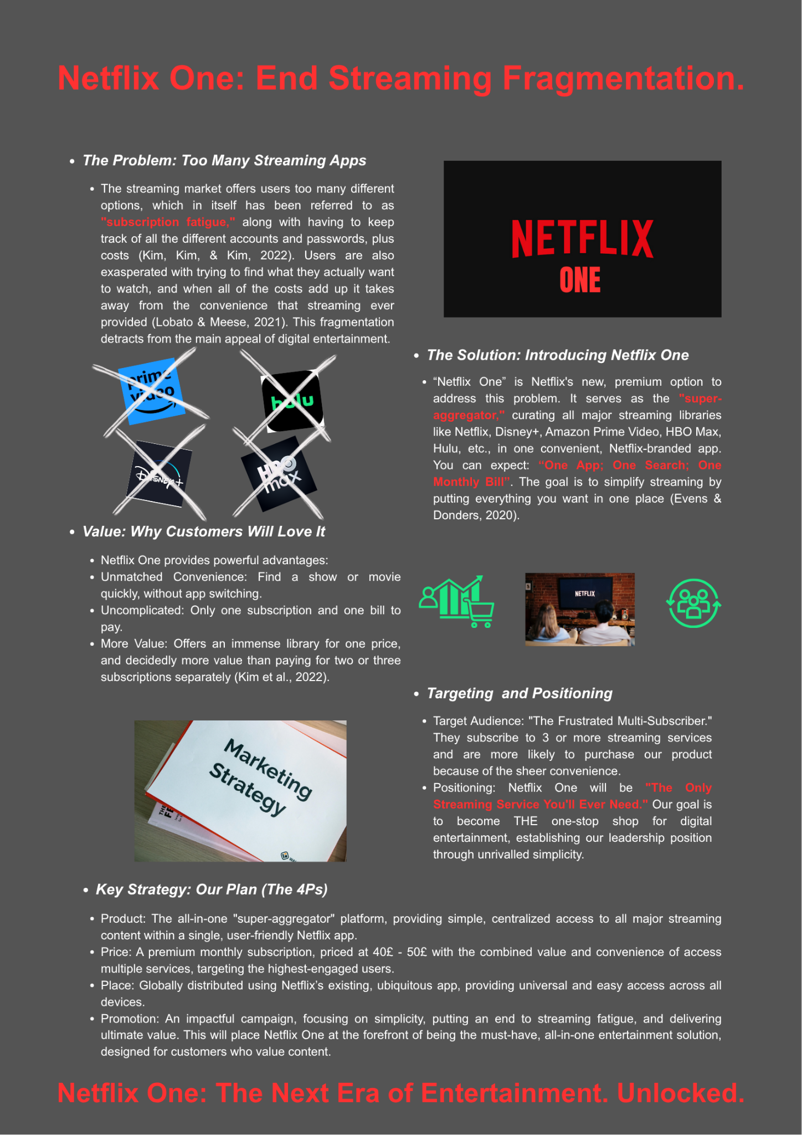

Element 3 References:
Evens, T. & Donders, K. (2020) 'The platformisation of audiovisual content: Implications for media policy', Media, Culture & Society, 42(7-8), pp. 1279-1295.
im, J., Kim, S. & Kim, M. (2022) 'Understanding subscription video-on-demand service discontinuance: The role of service attributes and perceived value', Telematics and Informatics, 72, 101830
Lobato, R. & Meese, J. (2021) Netflix Nations: The Geography of Global Media Disruption. New York University Press.

Element 4: Reflection

1. Introduction
The current project aimed at the creation and commercialization of Netflix One, a new brand concept created to address the problem of streaming fragmentation through the unification of several platforms into one, user-friendly interface. The reflection examines what I have learned in general during the process, with emphasis on the obstacles, revelations, and professional level development (Lara-Prieto and Flores-Garza, 2022, p82). It examines the strategies I used to implement theories of strategic marketing to real-life problems, especially creating a brand concept, the 7Ps model, and pitching, as well as determining the potential areas of personal and professional development.

2. Reflection on Brand Concept Development
The concept development of Netflix One was based on the observation that streaming users were becoming frustrated as they had to use various subscriptions and platforms. I used critical thinking to determine that subscription fatigue is a real problem present in the market and creatively suggested a comprehensive and premium solution. The investigation of the market tendencies and scholarly literature made me sure that people who listen to entertainment now respect simplicity, self-individuality, and integration (Basaran and Ventura, 2022, p118). The creation of the idea helped me become a more creative and strategic thinker since I had to make sure that the idea did not contradict the brand that Netflix has, but was creative.

3. Reflection on Marketing Mix and Strategy
Using the 7Ps model enhanced my perspective of the harmony of marketing factors in a service model. The creation of the marketing mix of Netflix One enabled me to relate theory to practice, particularly in terms of striking the right balance between pricing, distribution, and promotional tactics in the digital entertainment industry. Combining digital innovation with the changes in consumer expectations had to be done thoroughly, as I wanted to provide a high-end but affordable experience (Wu, 2024, p17). The first issue was to make sure not to lose the brand name that Netflix already had. This has taught me the need to ensure consistency between innovation and brand consistency.

4. Reflection on Pitch Preparation and Delivery
The preparation and delivery of the marketing strategy pitch helped me to advance my communication and persuasion skills. The efficiency, assurance, and order in the narration were necessary to write a brief, exciting story during the limited period. My speech was aimed at making the pitch more emotional and at underlining the strategic value of Netflix One and its ability to solve problems (Hsiao, 2024, p765). The rehearsal helped me to become a better deliverer and manage my time better, whereas the feedback of peers assisted me in bettering my tone and confidence.

5. Future Improvement
My future-oriented projects will focus on developing the depth of the analysis by means of data-driven targeting and expansive competitor research. Enhancing my skills in how to interpret consumer data would result in increased evidence-based strategic decisions. Moreover, I will continue to sharpen the skills of presentation and branding to convey ideas more effectively (Rachmad, 2024, p11). In general, the given project has strengthened the role of strategic creativity, critical thinking, and adaptability as the skills that must be used to create creative marketing solutions in the fast-changing online environment.

Element 4 References:
Lara-Prieto, V., & Flores-Garza, G. E. (2022). iWeek experience: the innovation challenges of digital transformation in industry. International Journal on Interactive Design and Manufacturing (IJIDeM), 16(1), 81–98.
Basaran, D., & Ventura, K. (2022). Exploring digital marketing in entertainment industry: a case of a digital music platform. Journal of Management Marketing and Logistics, 9(3), 115–126.
Wu, S. (2024). Research on traditional media integration and innovation strategies in the new media era. Journal of Social Science Humanities and Literature, 7(3), 17–27.
Hsiao, Y. H. (2024). The business strategy analysis of Netflix. Transactions on Social Science, Education and Humanities Research, 11.
Rachmad, Y. E. (2024). Effective Marketing In The Digital Age: Integrating 7p And 4p Concepts With Modern Theories.

