

LOCATION: Swansea
LEVEL 4
EXAMINATION PERIOD
January 2019

MODULE CODE: M4X01163
MATERIALS AND INTRODUCTION TO MANUFACTURING

TIME: 2 HOURS (MOCK EXAM)
answer all questions FROM SECTION A

ANSWER THREE QUESTIONS SECTION B

Equipment or materials required – Calculator

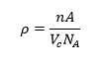
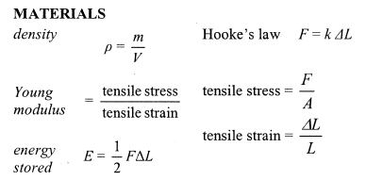

ANSWER ALL QUESTIONS

SECTION A
Multiple choice

1. A material will undergo elastic deformation:
A After the limit of proportionality
B Slightly before the ultimate tensile strength
C Between yield point 1 and yield point 2
D At the breaking point

2. The young’s modulus can be calculated by finding:
A The gradient of a stress – strain graph
B The area under a stress – strain graph
C The gradient of a force - extension graph
D The area under a force - extension graph

3. The co-ordination number of a cubic structure refers to:
A The number of atoms within a unit cell
B The length of a side of a unit cell
C The number of nearest neighbours of an atom within a crystalline structure
D The 3D stacking array of a crystal system

4. A material with a low Young’s modulus is likely to have:
A Cross-linking type bonds
B High ductility
C A high degree of stiffness
D A polymer base

5. Certain types of ceramics are:
A Linear molecular structures
B Cross-linked molecular structures
C Silicates
D Repeated units of hydrocarbon molecules

6. The area under a force-extension graph provides information on:
A Young’s modules
B Spring constant for springs in a series arrangement
C Spring constant for springs in a parallel arrangement
D Stored elastic energy

7. A transgraular crack is the propagation of a crack:
A Along grain boundaries
B Through the centre of grains
C At dislocations in a vertical plane
D At dislocations in a horizontal plane

SECTION B

1. Figure 1 shows a tower crane that has two identical steel cables. The length of each steel cable is 55m from the jib to the hook.
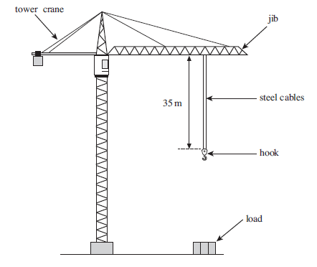
Figure 2

45m

Figure 1

- Each cable has a mass of 7.2kg per meter. Calculate the weight of a 55m length of one cable. [3]
- The cables would break if the crane attempted to lift a load of $2.5×{10}^{6}N$ or more. Calculate the breaking stress of one cable. [3]

Cross-sectional area of each cable = $5.8×{10}^{-4}m^{2}$
- When the crane supports a load each cable experiences a stress of 550MPa. Each cable obeys Hooke’s Law. Ignore the weight of the cables.

Young modulus of steel = $2.1×{10}^{11}Pa$
- Calculate the weight of the load. [3]

- If the unstretched length of each cable is 55m. Calculate the extension of each cable when supporting the load. [3]

- Calculate the combined stiffness constant, k, for the two cables. [3]

- Calculate the total energy stored in both stretched cables. [3]
- When the load is removed it is assumed that the cable returns to its original length. State what assumptions are made here. [2]
- The material used in figure 1 has a body centred cubic structure. Given that
- $4R=\sqrt{3}a$, show that the atomic packing fraction is 0.63. [5]

2. a) A material with an FCC crystal structure, an atomic radius of 0.1473nm, and an atomic weight of 87.43 g/mol. Calculate its theoretical density. [5]
b) Calculate the radius of an atom, given that it has an FCC structure, a density of $13.2gcm^{-3}$ and an atomic weight of $170.9g/mol$. [5]
c) Some hypothetical metal has a simple cubic structure. If its atomic weight is 74.5g/mol and the atomic radius is 0.145nm, calculate its density. [5]

Diwedd/End

