

Student ID number: 2243598
Programme: BA International Hotel Management
Module: Management & Organisational Behaviour
Module code: BMIH5004
Strategic Analysis and Performance Evaluation of Hilton Hotels and Resorts: Growth, Innovation, and Sustainability in the Global Hospitality Industry

AI declaration
“I confirm that I have not used any Al tools in the research and creation or this assignment. I confirm that I have not presented any Al generated materials as my own work. I confirm I have copies of my drafts, notes, and other resources I used, which! may be asked to provide in evidence”

Executive Summary
The report critically assesses Hilton Hotels and Resorts strategy, organisational structure and performance in the global hospitality industry. This discusses Hilton’s hybrid structure, powerful corporate culture, and key growth strategies using Lewin’s Change Model, Porter’s Generic Strategies, and Ansoff’s Matrix. The analysis of Hilton’s commitment to innovation, sustainability and digital transformation is accompanied by the competitive positioning. Balanced Scorecard measures performance in financial, customer, internal process and learning dimensions. The report suggests to improve the franchise compliance, expand into the alternative accommodations, and apply AI-driven personalisation to increase Hilton’s market share and long term sustainability while keeping up the operational excellence.

Table of Contents
1 Introduction 4
2 Organisation Structure, Culture, and Goals 4
2.1 Organisational Structure 4
2.2 Corporate Culture and Operational Influence 5
2.3 Corporate and Unit-Level Goals 5
2.4 Identifying Hilton’s Recent Change Initiatives 6
2.4.1 Unfreeze: Creating the Need for Change 6
2.4.2 Change: Implementation and Adaptation 7
2.4.3 Refreeze: Embedding Change into Organisational Culture 7
2.5 Evaluating Change Management Effectiveness 8
3 Strategic Direction 8
3.1 Porter’s Generic Strategies and Hilton’s Competitive Positioning 8
3.1.1 Differentiation Strategy: Leveraging Brand Strength and Innovation 9
3.1.2 Cost Leadership Strategy: Operational Efficiency and Supply Chain Management 9
3.2 Ansoff’s Matrix and Hilton’s Growth Strategies 10
3.2.1 Market Penetration: Strengthening Market Share 10
3.2.2 Market Development: Expansion into Emerging Markets 10
3.2.3 Product Development: Innovation in Hospitality Services 11
3.2.4 Diversification: Expanding Beyond Traditional Hospitality 11
3.3 Strategic Implementation and Performance Evaluation Using Balanced Scorecard Approach 11
3.4 Future Strategic Considerations and Recommendations 12
3.4.1 Adapting to Changing Consumer Preferences 12
3.4.2 Addressing Franchise Compliance Challenges 13
3.4.3 Expanding into Alternative Accommodation Markets 13
4 Conclusion and Recommendations 13
References 15

Introduction
A flagship brand of Hilton Worldwide, Hilton Hotels and Resorts has more than 7,500 hotels in 124 countries and a presence in every continent, above all their luxury, full-service brands (Zeng, 2021). Famous for its focus on luxury, innovation and customer satisfaction, Hilton has stayed ahead of the curve in its presence worldwide through expansion, technology and sustainability initiatives. This report critically assesses Hilton’s organisational structure, culture, and goals and how the latter affects its operational success. Also, it examines recent change initiatives and determines their effectiveness by utilising Lewin’s Change Model. Porter’s Generic Strategies and Ansoff’s Matrix are used to analyse Hilton’s strategic direction and to identify its key growth approaches (Alameri et al., 2021). Lastly, this report recommends that Hilton improve its corporate competitive advantage by increasing franchise compliance, developing lifestyle brands, offering AI-driven personalisation and moving into the alternative accommodation market.

Organisation Structure, Culture, and Goals

Organisational Structure
As the flagship brand of Hilton Worldwide, Hilton Hotels and Resorts operates in a hybrid organisational structure, whereby there is a centralised strategic direction while operations are decentralised. The model allows the brand to maintain a global identity while responding dynamically to local market conditions for individual hotels (Wharton, 2001). The structure combines functional departments such as marketing, operations and human resources with regional divisions in charge of more than 584 properties in 94 countries. A matrix framework for such a matrix is beneficial as it enables robust coordination. Regional managers indicate that almost 70% of the strategic decisions are derived from local market trends but still conform to corporate policies, giving a customised yet consistent approach to global hospitality management (Linxi, 2021).

Corporate Culture and Operational Influence
The corporate culture of Hilton, fuelled by a commitment to excellence, is embodied by its “Hospitality Promise” and core values of integrity, teamwork and innovation. Considering the concept of culture, this has tangible operational outcomes: recent data also shows that Hilton’s average guest’ rating in terms of satisfaction was 4.5 out of 5 in 2023 (Djatmiko et al., 2022). Moreover, employee engagement surveys show that 85% of staff are empowered to suggest improving things; these companies encourage and reward innovation. In this environment, one continuously learns and adapts, which are necessary characteristics in an industry where guest expectations and market conditions are ever-changing (Fachada, 2023).

Corporate and Unit-Level Goals
Hilton’s corporate goals include achieving a 10% annual revenue growth via investments in technology and environmentally sustainable practices (Matteucci, 2020). At the same time, individual hotel units are operating excellently to keep occupancy rates at more than 75% and challenge the strictest service benchmarks for customers (Wharton, 2001). Such an integrated approach draws a line between local performance targets and global strategic initiatives aligned to achieve momentary operational success and longevity.
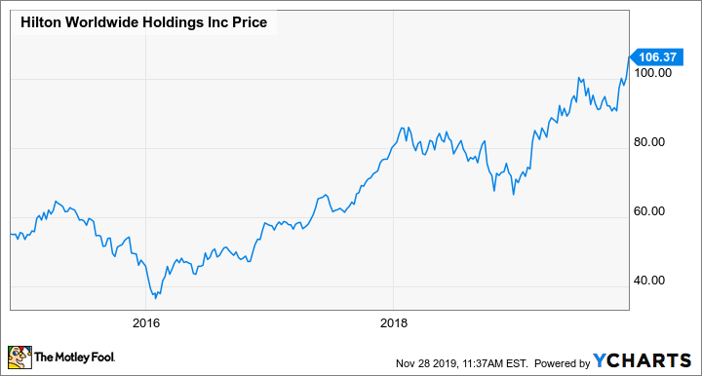
Figure 1 Hilton Worldwide Holdings
Source: Kline (2019)

Identifying Hilton’s Recent Change Initiatives
Hilton Hotels and Resorts has important digital, sustainability, and workforce initiatives to stay competitive. Through the Hilton Connected Room, guests can use the Hilton Honours app to control room settings, and 80% of U.S. rooms will be equipped by 2023, resulting in a 15% reduction in energy per room (Sanli, 2024). How: Through its Travel with Purpose 2030 strategy, the company plans to reduce its carbon emissions by 75% in managed properties and 56% in franchised properties by 2030 and offer flexible work policies for its corporate and frontline staff to help with industry labour shortages. These initiatives can be analysed through the Unfreeze, Change and Refreeze stages using Lewin’s Change Management Model (Fachada, 2023).

Unfreeze: Creating the Need for Change
Guest expectations, sustainability worries, and labour force issues forced Hilton to change. Research demonstrates that 60% of guests prefer mobile-controlled rooms, and sustainability is a priority as it has increased by 30% in 2023 . Furthermore, over 70% of the hospitality turnover rate required constant workforce restructuring. Beforehand, Hilton tapped into stakeholders: it gave franchise owners the blueprints they needed to integrate sustainability and created a digital training program for employees (Negro, 2022). Communication with the urgency of the change and alignment of corporate and franchise operations depended on leadership.

Change: Implementation and Adaptation
To support the Connected Room, Hilton invested $100 million in digital infrastructure to provide additional convenience to guests and operational efficiency. By 2023, hotels within managed hotels will reduce their water usage by 17% due to sustainability measures (Matteucci, 2020). The franchised properties, though, were slow to change, blaming cost. To do this, Hilton provided financial incentives and training programmes to speed up adoption. The reduction in employee turnover brought about by flexible work policies was 12% (Pereira, 2023).
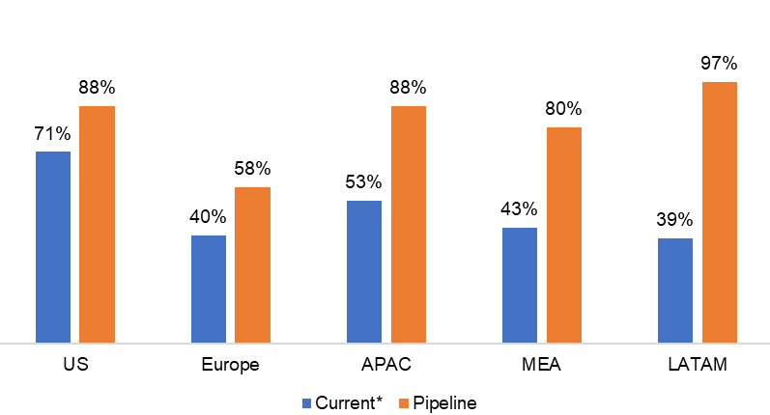
Figure 2 Hilton: Scaling Hotels in Asset-light Way By Monetizing Brand
Source: MBI Deep Dives (2023)

Refreeze: Embedding Change into Organisational Culture
Hilton embedded sustainability and technology adoption into corporate KPIs to sustain these initiatives, such that executive bonuses depend on hitting performance benchmarks (Sanli, 2024). The employee training programs also ensured the smooth implementation and mandatory sustainability reporting for franchisees' targets to complete compliance by 2026.

Evaluating Change Management Effectiveness
Hilton’s change initiatives align with Lewin’s Model; they successfully identify the need for transformation, innovation, and embedding long-term policies. Corporate-owned properties have quickly adapted, while franchises are still very resistant (Negro, 2022). Reinforcement will continue to ensure consistent implementation of all properties with the highest possible guest satisfaction, sustainability goals and workforce stability.

Strategic Direction
Over the years, Hilton Hotels and Resorts has defined a clear strategic direction of growth, digital transformation, sustainability, and workforce development, leading in the global hospitality industry (Chatterjee and Karmakar, 2023). To maintain long-term success, Hilton has always been able to adapt to changing market dynamics and use Porter’s generic strategies and Ansoff’s matrix to achieve competitive advantage and expansion.

Porter’s Generic Strategies and Hilton’s Competitive Positioning
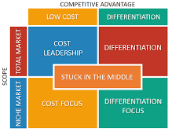
Figure 3 Porter's Generic Strategies
Source: de Bruin (2021)

Differentiation Strategy: Leveraging Brand Strength and Innovation
Hilton’s principal competitive strategy corresponds to Porter’s differentiation strategy and aims to provide high-quality service, a good brand name, and technological innovations. Hilton has more than 7,500 properties in more than 124 countries, so they stress consistency across the brand and keep that coupled with integrating their Hilton Connected Room, allowing guests to control room settings using the Hilton Honors app (Pereira, 2023). With this technology, Hilton had 80% of its U.S. rooms by 2023, making for a convenient and more efficient operation. This strategy has met with customer satisfaction ratings, as Hilton’s average guest satisfaction in 2023 was 4.5 out of 5 (Aryawan, 2024).

Cost Leadership Strategy: Operational Efficiency and Supply Chain Management
Hilton is mostly a differentiation-focused firm, with a cost leadership component integrated based on operational efficiency. In 2021-2023, the company reported a 10% operational cost reduction per property by using advanced technology of automated check-ins, digital key technology, and AI-driven energy management systems (Chatterjee and Karmakar, 2023). Costs have been cut, and environmentally conscious travellers appealed to efforts at sustainability, including a 17% reduction in water usage and a 15% reduction in energy per room in Travel with Purpose 2030 (Menegaki, 2024). Through its franchise model, Hilton can further strengthen its cost leadership since 80% of Hilton properties operate on a franchise basis, transfer capital expenditure risks to franchisees, and carry over revenue via brand fees and management contracts.

Ansoff’s Matrix and Hilton’s Growth Strategies
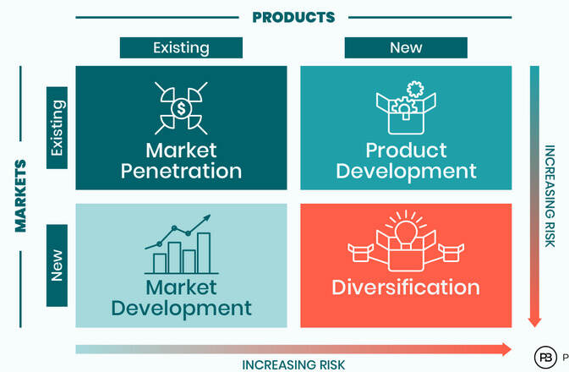
Figure 4 Ansoff Matrix
Source: Boolkah (2023)

Market Penetration: Strengthening Market Share
Hilton aggressively penetrates the market by enhancing customer engagement and promoting brand loyalty. Since 2021, Hilton Honors direct bookings have increased by 25% through exclusive member discounts and easy digital booking experiences (Aryawan, 2024). With over 300 new properties opening across 2023, Hilton has expanded its portfolio and market presence in key tourism and business hubs.

Market Development: Expansion into Emerging Markets
Hilton’s strategic expansion is focused on high-growth regions, including the Middle East, Africa, and Asia-Pacific. It will open 1,000 new hotels by 2027 and strongly focuses on China and India, where middle-class travel demand booms (Sanli, 2024). Hilton’s revenue in the Asia-Pacific market grew by 18% in 2023, a sign of its successful market development strategy. Additionally, Hilton has designed its proposition to meet local preferences, including the launch of Hilton Garden Inn and Hampton by Hilton in China for mid-market travellers (Menegaki, 2024).

Product Development: Innovation in Hospitality Services
Hilton is always improving its service offerings to make itself unique from others. Hilton is focused on innovation, and it’s quite visible in its Connected Room (Hotel room innovation), AI customer service chatbots and Data Analytics and Machine Learning personalised guest experience (Shvaikovskaia, 2022). Product Development is also grounded in sustainability initiatives and, ultimately, on Hilton’s commitment to net zero operations by 2050, which drives hotel design and operations. The company’s carbon working spaces have attracted a 30% increase in corporate bookings from eco-conscious businesses as the company offers carbon-neutral meeting space (Sanli, 2024).

Diversification: Expanding Beyond Traditional Hospitality
Hilton's portfolio has extended far beyond now through vacation rentals, extended stay brands, and lifestyle hotels. Its expansion into the timeshare market through Hilton Grand Vacations also contributed to a 12% increase in revenue in 2023 (Lima, 2023).

Strategic Implementation and Performance Evaluation Using Balanced Scorecard Approach
Hilton uses the balanced scorecard to evaluate strategic effectiveness based on four important dimensions.
Table 1 Hilton Balanced Scorecard
Dimension | Key Metrics
Financial Performance | $11.2 billion revenue (2023), 15% year-on-year growth, 23% EBITDA margin.
Customer Experience | Guest satisfaction scores consistently above 90%.
Internal Processes | 77% average occupancy rate due to automated check-ins and AI-driven demand forecasting.
Learning and Growth | 12% reduction in employee turnover through flexible work policies and leadership development programs.

Future Strategic Considerations and Recommendations

Adapting to Changing Consumer Preferences
Hilton’s ability to incorporate technology and sustainability successfully into its strategy has been successful, yet it needs to adjust to the changing behaviours of consumers in the luxury and budget travel segments (Dixit, 2025). Competitor brands such as Marriott and Hyatt offer boutique hotel offerings, and Hilton should bolster its lifestyle brand portfolio to meet this demand.
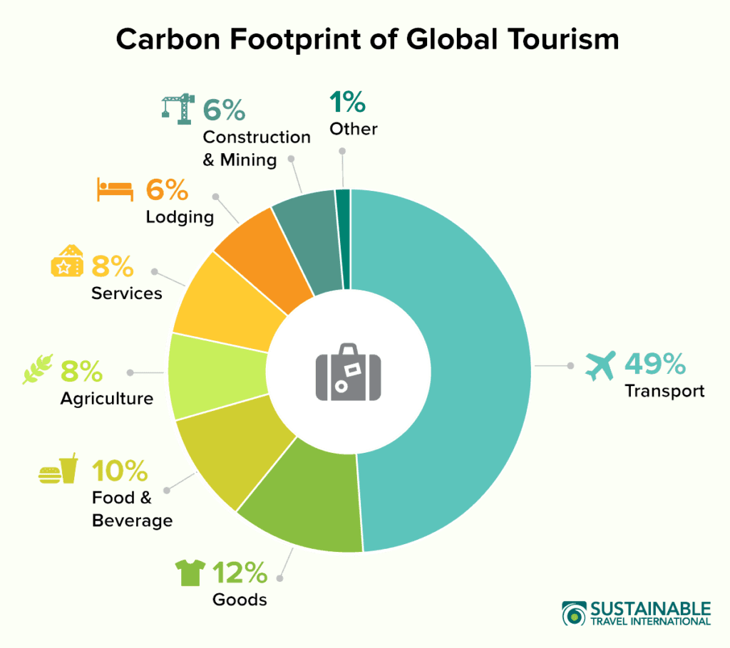
Figure 5 Ultimate Guide to Sustainability in the Hospitality Industry
Source: Revnomix Solutions (2023)

Addressing Franchise Compliance Challenges
A continuing challenge is consistently implementing sustainability and digital transformation initiatives across franchised properties. Hilton should introduce stricter compliance measures, mandatory training programs, and an incentive-based adoption model to accelerate uniformity (Shvaikovskaia, 2022).

Expanding into Alternative Accommodation Markets
Airbnb and the home-sharing platforms represent competition. Since alternative accommodation is an untapped market of $100B, Hilton should look into strategic partnerships or acquisitions to utilise its brand strength (Lima, 2023).

Conclusion and Recommendations
As Hilton Hotels and Resorts has become a global hospitality leader, it must continue to enhance its strategy to maintain a competitive advantage. Consistent sustainability and digital initiatives remain, so there is a need to strengthen franchise compliance and standardisation. Incentive programmes, subsidised financing and mandatory training, will convince franchisees to follow the corporation’s objectives. Nowadays, they are important to attract younger, experience-driven visitors. Hilton should concentrate on urban markets like Tokyo and Berlin while entering into partnerships with local businesses that will help enhance brand authenticity.
Moreover, with the rise of platforms like Airbnb, the alternative accommodation sector comprises a very high growth opportunity. Hilton can create a branded home-sharing platform integrated into Hilton Honours to maintain quality and attract long-term, flexible stay travellers (Prentice et al., 2024). Further, AI and data-driven personalisation should be widened in guests' experience (Dixit, 2025). With AI-driven chatbots, predictive booking engines, and smart room technology, operations and customer loyalty will be optimised. With these strategies and timelines, Hilton can maintain brand consistency to diversify its market presence while meeting evolving consumer demands to achieve sustainability in the long run and profitability in the hospitality sector.

References
Alameri, M., Alshamsi, F., Alsaedi, S., Alkaabi, A., Alamri, R., Alshamsi, M., and Nobanee, H. (2021). Financial Analysis of Hilton Holdings.
Aryawan, P. K. P. (2024). Optimizing Service Quality to Support Upselling Strategies in Hilton Bali Resort Front Office Operations (Doctoral dissertation, Politeknik Negeri Bali).
Boolkah, P., 2023. Ansoff Matrix: What Is It And How To Use It?. Peter Boolkah, 14 April.
Chatterjee, P., and Karmakar, R. (2023). Role of sustainable development goal and digitalization in hospitality industry: A systematic literature review. Fostering Sustainable Businesses in Emerging Economies: The Impact of Technology, 223-245.
de Bruin, L., 2021. Porter's Generic Strategies: Differentiation, Cost Leadership and Focus. Business-to-you.com, 14 April.
Dixit, P. (2025). Marketing in Hospitality and Travel. Educohack Press.
Djatmiko, I. P. N., Bagiastuti, N. K., and Armoni, N. L. E. (2022). Implementation of Green Performance Management to Supporting Environmental Performance at Hilton Bali Resort. Repositori Politeknik Negeri Bali.
Fachada, B. C. (2023). Business Adaptive Strategies in Crisis: The case of Hilton Hotels Worldwide (Master's thesis, Universidade Catolica Portuguesa (Portugal))..
Fachada, B. C. (2023). Business Adaptive Strategies in Crisis: The case of Hilton Hotels Worldwide (Master's thesis, Universidade Catolica Portuguesa (Portugal)).
Kline, D., 2019. How Hilton's Growth Strategy Is Delivering Strong Results. The Motley Fool, 29 November.
Lima, S. D. (2023). Hilton´ s Path to Post-Pandemic Prosperity: The Distinctive Strategy of the Hotel Giant (Master's thesis, Universidade NOVA de Lisboa (Portugal)).
Linxi, X. (2021, September). The Digital Transformation Strategy of Hilton During COVID-19. In 2021 International Conference on Financial Management and Economic Transition (FMET 2021) (pp. 317-321). Atlantis Press.
Matteucci, V. (2020). How can the hospitality industry increase corporate value aligned with sustainable development goals? Case examples from Hilton, Meliá and Sun. Worldwide Hospitality and Tourism Themes, 12(5), 509-523..
MBI Deep Dives, 2023. Hilton: Scaling Hotels in an Asset-Light Model. MBI Deep Dives, 15 August.
Menegaki, A. (2024). Energy Consumption in Hotels Through a Policy-Driven, Case-Based and Scenario Approach. Case-Based and Scenario Approach (November 27, 2024).
Negro, P. (2022). The Smart Hotel: a contactless and digital journey towards sustainability in Malta. The Online Open Access Repository of the Institute of Tourism Studies (Malta)..
Pereira, M. I. M. (2023). The Importance of Training and Development Practices to Retain Talent in the Hospitality Industry (Master's thesis, Universidade NOVA de Lisboa (Portugal)).
Prentice, C., Tracogna, A., and Akbar, Y. H. (2024). The Paths to an Enhanced Ecosystem for International Hotel Chains. Journal of the Knowledge Economy, 1-25.
Revnomix Solutions, 2023. Ultimate Guide to Sustainability in the Hospitality Industry. Revnomix.
Sanli, M. (2024). Digital Transformations in the Hotel Industry (Doctoral dissertation, Long Island University, CW Post Center)..
Shvaikovskaia, E. (2022). Artificial intelligence for innovative service design and guest experience: case: Hotels in Germany.
Wharton, A. J. (2001). Building the Cold War: Hilton International hotels and modern architecture. University of Chicago Press.
Zeng, L. (2021). Analysis of Hilton Worldwide Hotel Group’s Transnational Operation Strategy. Academic Journal of Business and Management, 3(11), 20-27.

