Module Title: Managing Food and Beverage Operations
Module Code: BMIH6002
Student Name: Sayeda Laila Yeasmine
Students ID: 2119793

Contents
Introduction 1
Section 1: Reflection on Experience and Personal Development 2
Section 2: Critical Analysis of Work-Based Skills and Technical Knowledge 3
Section 3: Reflection on Organisational Issues 4
Section 4: Future Action Plan 5
Conclusion 7
References 8

Introduction
This essay has been developed on Managing Food and Beverage Operations topic of Delta Hotel by Marriott situated at Bexleyheath. Managing food and beverage operations is part restaurant, which is one of the most important parts of the hotel business. When a guest or tourist visit a hotel, they take their meals or ensure food supply from the restaurant of that hotel and the manager of the hotel has to prepare a team for operating the food and beverages to the guests according to the demand. The food and beverage department are one of the integral parts of the hotel business or operation of Delta Hotel by Marriott. This department is responsible for ensuring the food and drinks supply to the guest which can be in restaurants, bars or also in-room services. The main purpose of this team should be to ensure guest satisfaction through their services. The main objective of this essay is to define various segments of the food services industry, how personal or technical skills are useful in this department, learn different operational aspects practically etc. This essay will portray the personal experiences of an employee who worked in this Food and Beverage management department.

Section 1: Reflection on Experience and Personal Development
When an individual has to Manage food and beverage operations in a hotel, he or she has to oversee many aspects. A reflective experience and opportunity for personal development have been described below from these aspects.
Menu Planning: When I plan for a menu, I should have a clear idea about the Delta Hotel by Marriott’s target audiences and prepare an analysis of their food habit. For that, the manager should have academic knowledge of how to prepare a customer's menu planning based on the target customer group of the hotel.
Procurement and Investor: Now the food and beverage operation manager knows about the menu and he or she has to ensure the supply of food (Vallen & Jerome, 2014). For that, they should have a smooth procurement process from where the hotel would collect their raw materials of food and for how many and how long they would store the inventory.
Staffing and Training: Now the manager needs to hire employees to support the food and beverage operation team including cooks, waiters, cleaners and many others. After the recruitment process is based on the hotel's demand and applicants’ abilities, the manager needs to arrange a training session to adapt to the hotel's culture (Fallon, & Rutherford, 2010).
Quality Control: The food and beverage operation team must have a quality control officer, who oversees the quality of food, which is served to the guests and will report to the manager (Alzoubi, 2021).
Pricing and Cost Control: The price of food should be reasonable if guest can take their necessary foods from the Delta Hotel by Marriott (Dopson and Hayes, 2020). If the prices become high, they have to go outside to buy food and it must hurt the hotel.
Guest experience: Finally, guest experience is the most important thing. To improve the entire visitor experience, concentrate on offering outstanding customer service (Wood, 2013). Teach employees to be aware, observant, and accommodating to the demands of visitors. Encourage evaluations and input regularly to quickly resolve any problems.

Section 2: Critical Analysis of Work-Based Skills and Technical Knowledge
Work-based skill means the ability to do any task one learns by doing work or from practical experiences. For example, in the restaurant of Delta Hotel by Marriott, a receptionist needs to communicate with customers by sensing the mood of the customers (Vogler et al., 2018). This kind of skill he or she would learn by working practically. It is not possible to develop work-based skills by reading books or doing technical classes. On the other hand, for operating food and beverage operations, one needs to learn the point-of-sale system, inventory system, how to take orders, reservation systems and many more. For this kind of skill development, one needs to get help from experts or academic books (Pauer and Russell Meade, 2020). It is not possible to develop these kinds of skills or gain knowledge by working in the field.
For food and beverage operations necessary work-based skills are-
- Communication Skill
- Skill of working in a team
- Problem-solving skills or conflict management skills (Mumford, 2016)
- Decision-making skill
- Creativity or organising skill
For food and beverage operations necessary technical knowledge is-
- Leadership and Flexibility
- Inventory management
- Learning and development of staff
- Time management in order taking and delivering queue (Buhalis and Law, 2020)
- Event planning and promotion of hotel

Section 3: Reflection on Organisational Issues
Here, I worked in Delta Hotel by Marriott as a food and beverage operation manager. This part of the essay would describe the reflection, and what kind of situations I had to face during the operation management period. Gibb's model is the best framework to describe reflective experiences.
Description: This part provides a brief about the rules and responsibilities, and what I had to perform in the organisation.
Feelings: Working practically in an organisation in the hotel management industry is something wonderful for me. This experience would be helpful for me if I want to build my career in this field (Jeong et al., 2017).
Evaluation: As the manager of the operation, I had to manage many sectors as the parallel situation and my personal skills and academic knowledge helped me to do the task efficiently.

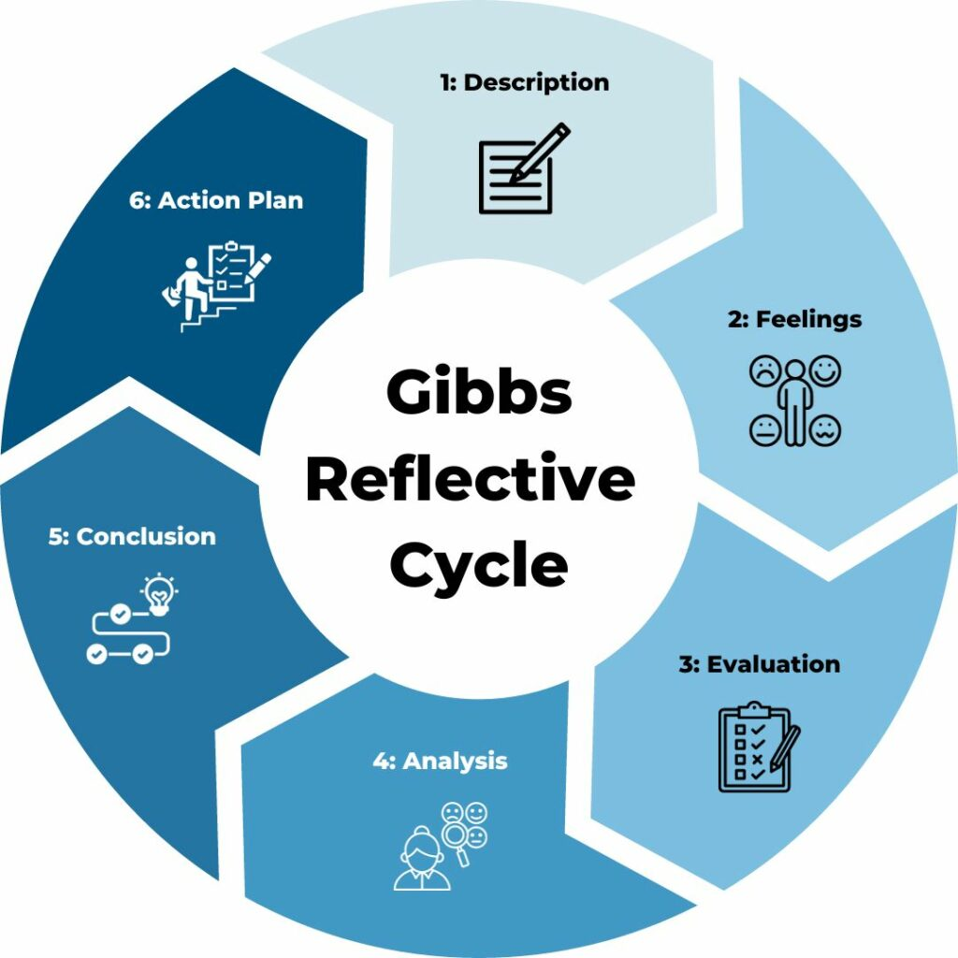
Figure 1: Gibbs Reflection Model
Source: (Kusluvan et al., 2019)

Analysis: In the analysis part, I would describe the things that I performed in the whole experience and what type of challenges I had to face during the period of preparing this essay.
Conclusion: In the conclusion part, I had the opportunity to self-analysis that I could do the task differently and I will keep it as learning and apply it in the next task (Hans-Otto Georgii, 2015).
Action Plan: What skills or knowledge I need to develop or acquire after experiencing this task has been presented through an action plan, which has been written in the next part of the essay.

Section 4: Future Action Plan
The future action plan of an individual has been developed from the reflective part of the essay.
Skills | Current Situation | Goals | Resources | Time Limit
Inventory Control | I am still a beginner in inventory management. | Need to control inventory as if any type of unwanted situation doesn't create in the organisation. | - Articles  - Courses on inventory management | 6 Months
Decision Making | I am not an effective decision-maker. | Want to be a decision-maker considering all the factors which would influence my decision positively (Kurniawan Arif Maspul, 2023). | - Gaining leadership knowledge  - Stay connected with practical field | 1 Year
Organising Skill | I have very poor knowledge of organizing different activities in an organisation | Want to be a good organizer. | - Self-assessment by staying in the practical field  - Taking online courses | 8 Months

Conclusion
This is a reflective essay, which has been prepared on Food and Beverage operating management of Delta Hotel by Marriott’s hotel management. The hotel management industry is active in tourist spots of the country and in this place, companies need to offer quality services as tourists go there to have a good time. The responsibility of the food and beverage operation team is to ensure quality food with good services.

References
Alzoubi, A. (2021). The Impact of Process Quality and Quality Control on Organizational Competitiveness at 5-star hotels in Dubai. International Journal of Technology, Innovation and Management (IJTIM), 1(1), pp.54–68. doi:https://doi.org/10.54489/ijtim.v1i1.14.
Buhalis, D. and Law, R. (2020). Progress in Information Technology and Tourism Management: 20 Years on and 10 Years after the Internet—The State of eTourism Research. Tourism Management, 29(4), pp.609–623.
Dopson, L.R. and Hayes, D.K. (2020). Food and Beverage Cost Control. 7th ed. Hoboken, New Jersey: John Wiley & Sons, Inc.
Fallon, M.& Rutherford, D. (2010) Hotel Management and Operations, Wiley, London.
Hans-Otto Georgii (2015). Gibbs measures and phase transitions. Berlin ; New York: De Gruyter.
Jeong, H.-J., Hwang, D.-Y., Ahn, J.-T., Chun, J.-Y., Han, K.-E., Lee, W.-M., Kwon, J.-K., Lee, Y.-J. and Kang, B.-C. (2017). Development of a Simple Method for Detecting Capsaicinoids Using Gibb’s Reagent in Pepper. Korean Journal of Horticultural Science and Technology, 30(3), pp.294–300. doi:https://doi.org/10.7235/hort.2012.12011.
Kurniawan Arif Maspul (2023). Beyond Self-Discovery: A Proactive Approach to Personal Growth and Empowerment. Literasi Nusantara Abadi Grup.
Kusluvan, S., Kusluvan, Z., Ilhan, I. and Buyruk, L. (2019). The Human Dimension: A review of human resources management issues in the tourism and hospitality industry. Cornell Hospitality Quarterly, 51(2), pp.171–214. doi:https://doi.org/10.1177/1938965510362871.
Lombaerde, P. de and Acosta, E.J.S. (2017). Indicator-based monitoring of regional economic integration: fourth world report on regional integration. Cham, Switzerland: Springer.
Mumford, J. (2016). Understanding Work-Based Learning. CRC Press.
Pauer, E. and Russell Meade (2020). Technical knowledge. Kent: Renaissance Books.
Vallen, G.K. & Vallen, Jerome J. (2014) Check-in checkout: managing hotel operations Ninth edition.; Pearson new international.,
Vogler, J.S., Thompson, P., Davis, D.W., Mayfield, B.E., Finley, P.M. and Yasseri, D. (2018). The hard work of soft skills: augmenting the project-based learning experience with interdisciplinary teamwork. Instructional Science, [online] 46(3), pp.457–488. doi:https://doi.org/10.1007/s11251-017-9438-9.
Wood, R. (2013) Key Concepts in Hospitality Management, Sage, London

