University of Wales Trinity Saint David
School of Engineering

Design, Development and Manufacturing
3-Jaw Cobot End-effector
Manufacturing Design & Technology
ACMA5002

Richard Parker
1902504
27/05/21
Contents
1 Introduction 1
2 Concept Design Appraisal 2
2.1 Customer Considerations 2
2.2 Public Perception Considerations 2
2.3 Quality Function Development and Summary 2
2.4 Design Specification 2
2.5 Concept Appraisal 2
3 Manufacturing Process Proposal 4
3.1 Business Considerations 4
3.2 Outline of Manufacturing Processes 4
4 Design and Development Work Undertaken 5
4.1 Methodology 5
4.2 Design for Manufacturing and Assembly 5
4.3 Design 2 Proposal 7
4.4 Design for Reliability 7
4.5 Design for Performance 8
4.6 Design for Maintenance and Serviceability 9
4.7 Design for Environment and Life Cycle 9
4.8 Material Selection 9
4.9 Final Design Proposal 10
4.10 FMEA of Final Design 12
4.11 Analysis of Final Design and Verification against Specification 12
5 Manufacturing Process Design 13
5.1 Process Plans for Each Component 13
5.2 Manning and Cycle Times 14
5.3 Plant Layout 15
6 Conclusions 16
6.1 Design Conclusions 16
6.2 Manufacturing Conclusions 16
7 References 17
8 Appendices 18
8.1 Project Plan 18
8.2 Quality Function Deployment 19
8.3 QFD Summary 20
8.4 Design Specification 21
8.5 Review Against Specification – Initial Concept 22
8.6 Review against Specification – Design 2 23
8.7 Review against Specification – Final Design 24

Introduction
This report will investigate a concept for a 3-Jaw Gripper End-effector for a Cobot Arm. By first considering the customer’s requirements and corresponding design requirements, a QFD and Design Specification were produced. The report will show the appraisal of the Initial Concept, using this Specification as well as a Design Efficiency Analysis.
The report will then outline and explain the manufacturing processes that would be used to produce the part. Following this, it will show the development work on the system and its individual components, before explaining the specific improvement decisions that were made. It will then show how the Final Design was verified, through a review against the Specification and use of FMEA.
Next, it will display the Process Plans for the manufacture of each part, including assemblies, before finally proposing the Plant Layout which corresponds to these plans.
The work was undertaking following a project plan based on the DMADV method, given in Appendix 1.

Concept Design Appraisal

Customer Considerations
The initial brief stated that the gripper had to be “flexible and adaptable” and perform a “range of pick and place operations”. However, there were many ‘unspoken’ expectations that potential customers and end-users would hold, known as ‘Basic’ expectations on the Kano Model for Quality. These were found in a brainstorming session, before being formalised into lists of Customer Requirements and Design Requirements.

Public Perception Considerations
Research was then carried out investigating how the public perceives engineering and robotics, to see what effect this might have on the design. This was done primarily with respect to the sales potential of the product, and what could be done to the design to benefit this. It was found that two of the public’s “drivers of engagement” with engineering were when a design held a “wow-factor” or was impressive in its “simplicity” (Helen Marshall, 2007). If the product could function well while also targeting these factors, that would be beneficial for its sales.

Quality Function Development and Summary
Once all the requirements had been identified, they were inputted into a QFD, with the aim of better understanding the design priorities. This is given in Appendix 2. Another useful outcome of the QFD was identifying the trade-offs that the design must consider, as well as some affirmation of what requirements worked in conjunction with each other. A summary of the QFD is given in Appendix 3.

Design Specification
Once the requirements were fully understood and prioritised, a Design Specification was created, given in Appendix 4. This Specification would be used at various points throughout the design process, to verify the design’s effectiveness and ensure there was no project ‘drift’.

Concept Appraisal
At this point, the brief was fully understood, and a proper appraisal of the concept could be done. This was done by a formal review against the Specification, shown in Appendix 5. In addition to this, a Design for Manufacture appraisal was done of all the components, using the 9-question appraisal matrix as per the Lucas Method. Table 1 gives the results of this appraisal, showing Essential and Non-Essential Parts. Six out of the eleven parts were found to be Essential, giving a Design Efficiency of 55%.

Table 1 - Concept Appraisal
Essential Parts (A) | Targets to ‘Design Out’ (B)
Jaws x3 | Cylinder x1
Drive Plate x1 | Joints x3
Motor x1 | Shaft x1
Worm x1

Manufacturing Process Proposal

Business Considerations
To be a profitable product, the system will have to be manufactured with attention paid to costs. Often, there is a trade-off between cost and quality, but to achieve maximum revenue, the quality and performance of the system should be a high priority. To increase profits, machines and processes will have to be selected which reduce the following cost drivers as much as possible, without harming quality:
- Initial machine investment cost
- Machine depreciation
- Footprint
- Cycle times
- Down time
- Manning demands
- Wastage and QC rejections

Outline of Manufacturing Processes
The many parts that make up the End-effector will need a wide range of production processes. Where possible, these should be automated to ensure consistency and reduce manning, assuming the initial investment has a reasonable budget. Table 2 shows the options considered to produce each feature of each component. The process selection was done alongside the re-design, so this table has been updated throughout the project.
As components have been added and omitted in the following sections of this report, this table has been edited to include these changes.
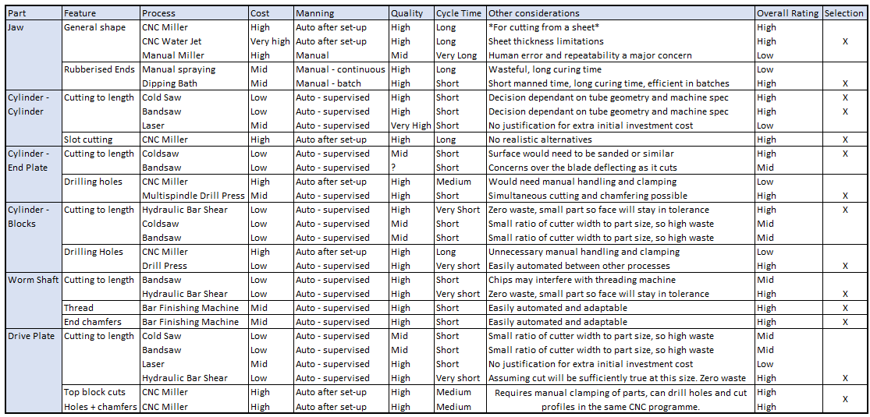
Table 2

Design and Development Work Undertaken

Methodology
As outlined in the Project Plan, the design process would be partially iterative. The focus of the first iteration would be to improve the design with respect to Manufacturing and Assembly – referred to as ‘Design 2’. The second iteration and further improvements would address other considerations, such as reliability, performance, serviceability and the product’s life cycle – culminating in ‘Final Design’. The design would be verified against the Design Specification before progression, with changes being made if necessary.

Design for Manufacturing and Assembly
To begin the development process, a brainstorm was carried out to find ways reduce the B part count while also improving the design. The options identified were as follows:
- Combine Cylinder and Drive Plate
- Combine Shaft and Worm
- Combine Joints and Cylinder
- Reconfigure the Jaw to replace the Joint
For the Gripper to function as designed in the Initial Concept, the Motor and Cylinder must be connected, with the Drive Plate moving in relation to them. This meant Option 1 was ruled out, as it would need a total redesign, as opposed to the ‘optimisation’ specified.
Option 2 was selected as an easy improvement to make. Manufacturing these parts from one length of bar would reduce the part count and the processes involved in Final Assembly, with no negative consequences.
Option 3 was feasible but would mean the Cylinder, which is already a complex part, would become more complex in construction, and more difficult to manufacture.
Both the Joint and Jaw have two pivot points, which meant that the system could be reconfigured so that the Joint wasn’t necessary at all. To do this, one of the pivot points of the Jaw would need to be fixed on the Drive Plate, with the other sliding along it’s Cylinder mount as it rotates. This is displayed in Figure 1. While this added some work to the design process, it meant that the three Joints were ‘designed-out’ and there were no significant problems to overcome, so this was incorporated into Design 2. 
Figure 1 – Suggestion for Sliding Joint configuration
With regards to manufacturability, the two parts of biggest concern were the Cylinder and Drive Plate. Again, the options for improvement of these were done by brainstorming, the most feasible ideas are listed below. Due to it’s complexity, the Cylinder was broken up into it’s constituent shapes with the aim of becoming it’s own sub-assembly.
Cylinder:
- All machined out of one block of material
- End plate welded inside of cylinder
- End plate welded onto end face of cylinder
- End ‘blocks’ separated from cylinder, and parts bolted onto cylinder
- End ‘blocks’ separated from cylinder, and riveted onto cylinder
- End ‘blocks’ separated from cylinder, and friction welded onto cylinder
Drive Plate:
- All machined out of one block as shown in initial concept
- All machined out of one block – with curved end ‘blocks’
- Make general shape triangular
- Make general shape hexagonal
- Leave circular
To make decisions regarding these options, the comparison parameters were identified and weighted out of 5, then the options were scored as shown in Figures 2 and 3.
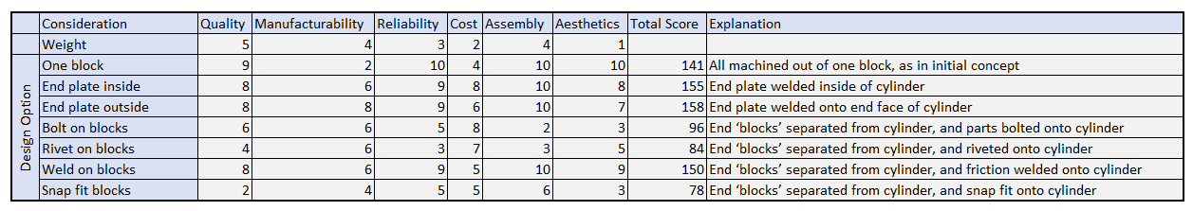
Figure 2 - DFMA for Cylinder
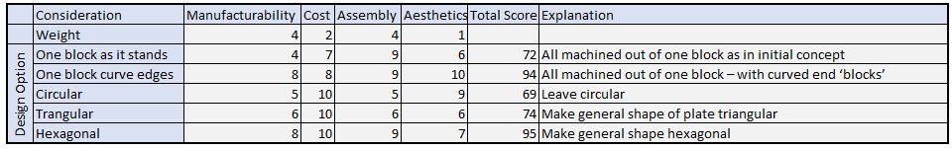
Figure 3 - DFMA for Drive Plate
These Scorecards then informed the selection of features for Design 2, along with some consideration as to what was feasible and what combinations would work well together. It was decided that the Cylinder would be broken up into its constituent shapes, and all of these be welded together to make up a Cylinder Sub-Assembly, as discussed earlier. While this would increase the number of initial parts, the overall manufacturing cost would be reduced, as manufacturing each Cylinder as it was designed in the Initial Concept would force the use of a CNC miller, which would be time consuming and therefore costly.
For the Drive Plate, making the pivot point protrusions (referred to as ‘blocks’) with curved edges seemed an attractive option. However, changing the general shape to a hexagon meant that clamping would be easier at various points in production, so this was selected and superseded the need for round edges on the ‘blocks.’
In addition to these changes, some edges in all components were selected to be chamfered to aid the assembly. This was done by considering what benefits would be attained by chamfering each edge, in relation to the costs incurred by adding another process to the part’s manufacture. There is only one product line, so no consideration for universal/multifunctional parts or modular systems is needed.

Design 2 Proposal
Combining the changes suggested previously produced a more developed concept – Design 2. The following is a summary of these changes:
- A combined Worm and Shaft, manufactured out of a single length
- Joints removed and replaced by the Jaws, with new sliding configuration
- Cylinder broken up into its constituent shapes, which will be manufactured separately before being welded together.
- Drive Plate hexagonal instead of round, with the protrusions adjusted to make space for Jaws.
- Some edges chamfered and holes partially countersunk to aid assembly
- The end portion of the Jaws will be given a rubberised finish to ensure they don’t damage parts and to aid friction to prevent dropping. This will be explored further under ‘Design for Performance’ but was already identified before the Spec review.
Once these changes had been identified, this design was reviewed against the Specification to ensure that it met all the requirements before progression, as shown in Appendix 6. Some points showed that more research or development work was needed before completing the design stage. The only point that was not met was for the product to be Fail-safe. It was decided that the system doesn’t pose any significant dangers if it fails, so the necessary developments to make it fail-safe would overcomplicate the design for very little benefit.

Design for Reliability
The Motor was identified as a significant reliability concern, but as it would be a bought-in part the only significant change that could be made is the procurement of the highest quality motor possible.
In the initial concept, holes are given where the Jaws, Drive Plate, Joints and Cylinder rotate in relation to each other, but no attachments are given. A simple option would be a connecting pin, but this would be prone to wear issues even if greased, solved by the addition of bearings. The small dimensions complicate this and rule out conventional ball bearings, but needle roller bearings are available at smaller diameters. An example is given in Figure 4, which has internal and external diameters of 3 and 5mm respectively (Bearing Shop UK, 2021). Due to their precision, they are expensive at £2.64 each to online consumers, but only 6 are needed and costs would be significantly lower when procured properly. These would need to be greased properly and located in the Jaws.

Figure 4 - Needle roller bearing without 'races' (Bearing Shop UK, 2021)

Design for Performance
As mentioned previously, one improvement needed to prevent surface damage and the likelihood of dropping items was adding rubberised ends to the Jaws. Slip-on sleeves would have been prone to slipping off under load. Silicone Rubber dips were considered, but the two part solution incurs high costs so it is usually only used for medical applications (Piper Plastics, 2021). A lower cost but very similar alternative is Plastisol Dipping, in which a layer of rubberised PVC coats the parts up to the specified thickness (Plastic Coatings, 2021).
In addition to protecting the item’s surface, this has been done to improve the friction between Jaw and item. To aid this further, the Jaw was redesigned with a curved end, so there is always a perpendicular contact point between surfaces. This is shown in Figure 5.
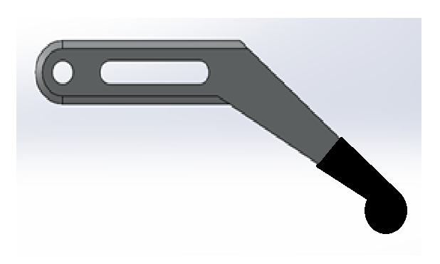
Figure 5 – Redesigned Jaw

Design for Maintenance and Serviceability
Good Maintenance Plans consist of 4 types of action, so to fully meet the End-effector’s maintenance needs, these were considered separately:
- Preventative Actions – Bearings have added to minimise wear.
- Proactive Actions – Bearings and the Worm Shaft will need to be greased initially and at yearly services. Bearing have specific greasing locations which will need to be easily accessible without removal.
- Reactive Actions – Bearings may need to be replaced if they fail or wear faster than expected. Dust or grit may also build up on the Worm Shaft, which will need to be cleaned if noticed. Jaws may also need to be re-dipped if they wear through to the metal. If the system suffers a fault or performance issue, these can be checked easily and repaired.
- Predictive Actions – Frequent checks by the user for squeaks, rubbing or a build up of dirt will help notice issues before they become problematic, then a service can be booked to resolve them.
The system will need to be dismantled in under 30 minutes with minimal tooling, as specified in the requirements. To aid this, the Worm Shaft should project past the end of the Cylinder, and bolts should use standard bits.

Design for Environment and Life Cycle
The PVC used in the plastisol dipping of the Jaws is largely derived from crude oil, so is inherently bad for the environment. However, it is recyclable if it can be removed conveniently at the end of the product’s life, and there are few readily available better alternatives.
An important consideration when selecting any material is its carbon footprint, as well as it’s recyclability. The leading options for the materials for all parts are all metals, which are very energy intensive when first produced, but are widely recycled. There is no significant difference between the options, so this is not a useful selection criteria.
The motor can also be recycled by specialist electrical recyclers.

Material Selection
The brief does not give information regarding the weights of the objects that will need to be handled by the End-effector, but one of the requirements of the Specification is that it must not deform under load. As a result of this plastics are ruled out, and composites would force a significant redesign of the concept. The most useful options remaining are: steel, stainless steel, titanium and aluminium. Use of titanium would result in a high quality part, but the high costs are likely to be beyond the expectations for this product. Steel is prone to corrosion so is ruled out.
The Cylinder and Jaws will be aluminium, as it is stiff enough to not deform significantly, is reasonable cost, and low density so will improve accuracy. However, it is too soft to form a durable thread on. The Drive Plate, Worm Shaft and all connecting pins will be made from stainless steel, due to its hardness.

Final Design Proposal
Figures 6-8 are assembly models of the entire system.
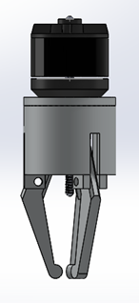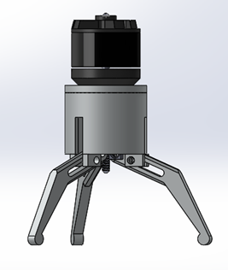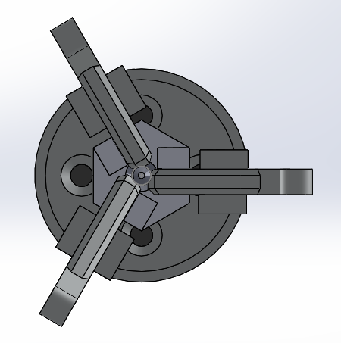
Figure 6 Figure 7 Figure 8

Figures 9 and 10 are models of the Cylinder sub-assembly, which will be welded together to form one solid part.
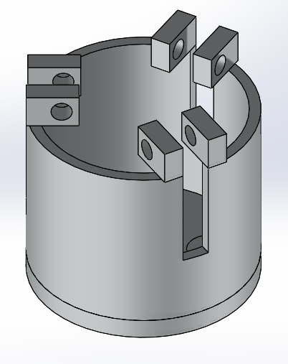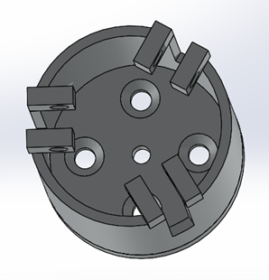
Figure 9 Figure 10
Figure 11 is the Block which acts as an attachment point for the Jaw. The holes would also be partially countersunk to aid assembly.
Figure 12 is the End Plate, with countersunk holes on the top for attachment bolts. The centre hole does not need to be countersunk on the visible side. On the other face it would be beneficial for the centre hole but would complicate manufacturing, so has not been added.
Figure 13 is the Cylinder.
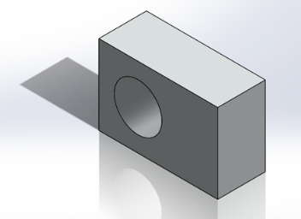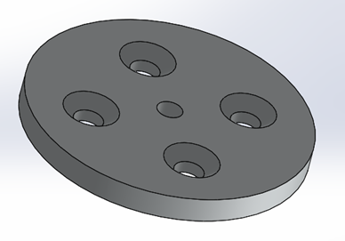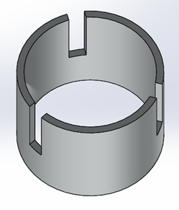
Figure 11 Figure 12 Figure 13

Figures 14 and 15 are of the Drive Plate – now hexagonal, with ‘taller’ protrusions to allow for the redesigned Jaw.
Figure 16 is the Worm Shaft, with chamfered ends.
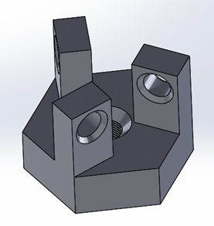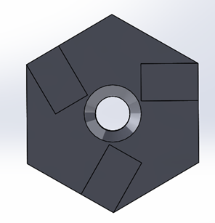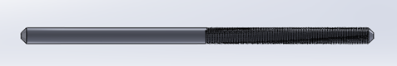
Figure 14 Figure 15 Figure 16

Figure 17 and 18 show the Jaw. Holes are large enough to allow for bearings, which will be inserted before Final Assembly. End rounded to improve friction, and some chamfered edges to aid assembly.

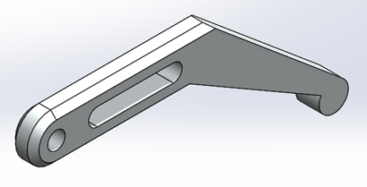
Figure 17 Figure 18 (dipped end not shown)

FMEA of Final Design
As part of the design verification, an FMEA was done to identify if and how the system may fail, shown in Figure 19. It was found that no further development steps needed to be taken.
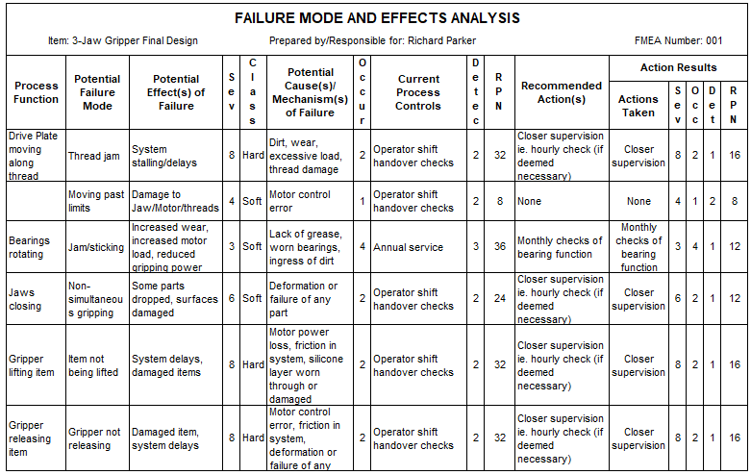
Figure 19 - FMEA of Final Design

Analysis of Final Design and Verification against Specification
Before progressing to Manufacturing process plans, the design needed to be checked against the specification. This is shown in Appendix 7. It was found that the design met the Specification was fully met, although a prototype would need to be produced to test before production started.

Manufacturing Process Design

Process Plans for Each Component
The following process plans make up the individual components of the Cylinder Sub-Assembly, before the Sub-Assembly’s plan. Connectors are numbered to correspond to the following step.
The transfer of parts between processes is done by a mixture of continuous conveyor belts, stacked gravity-feeds, slides, automated machine feeds and manual handling where automation would be excessively complex or demand robotics.
The Cylinder Sub-Assembly will be friction welded together, as the process can be automated and will produce quality joins. To do this, the Cylinder will need to be clamped firmly, then the End Plates and Blocks held in their positions and either spun or oscillated up in position until they reach the necessary temperature.

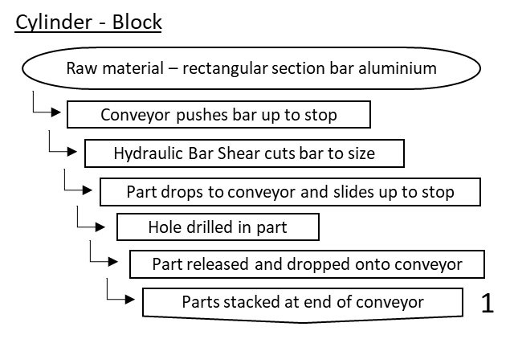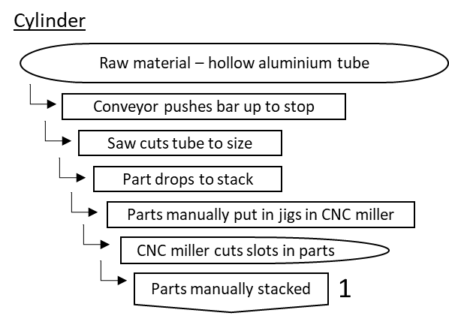

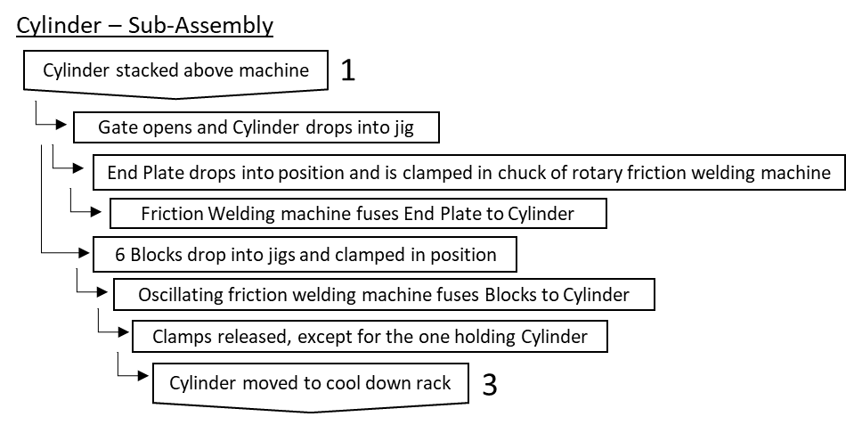
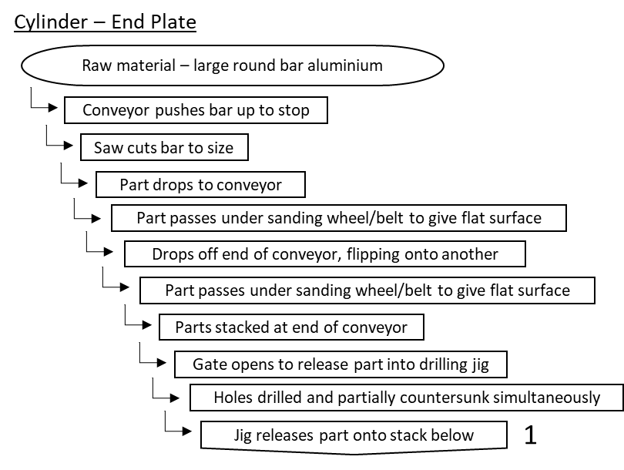

The following plans are for the remaining parts, followed by the Final Assembly Plan.
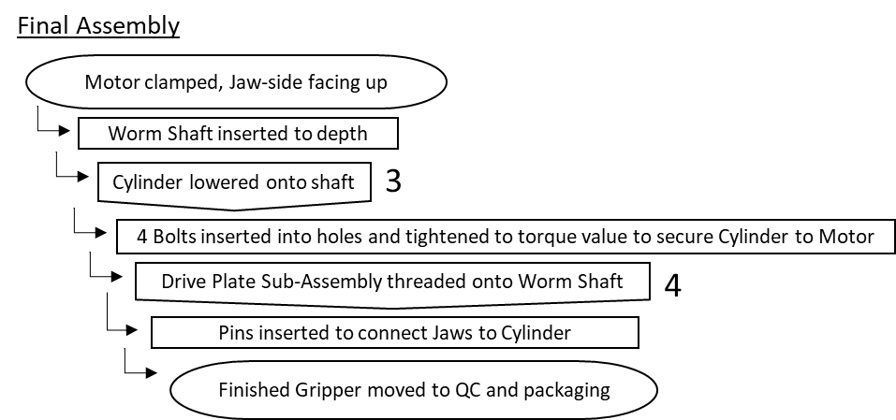
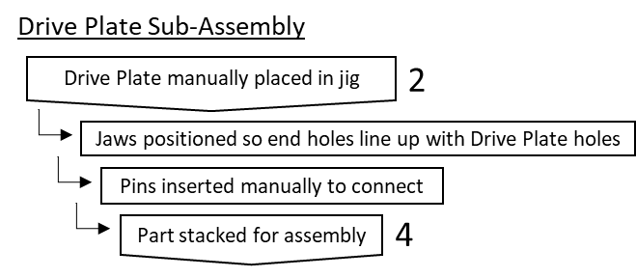
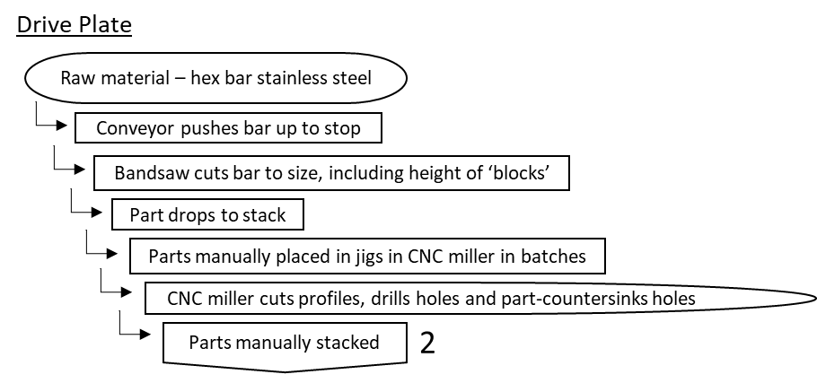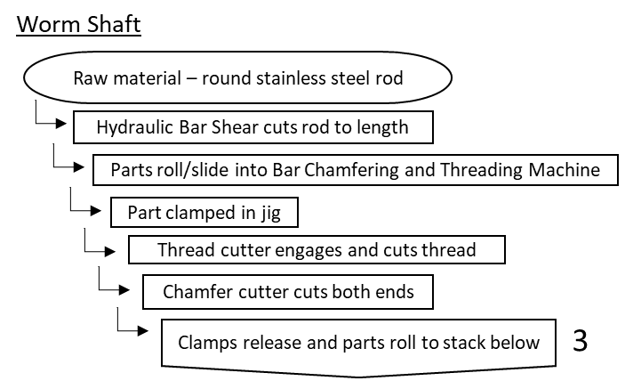
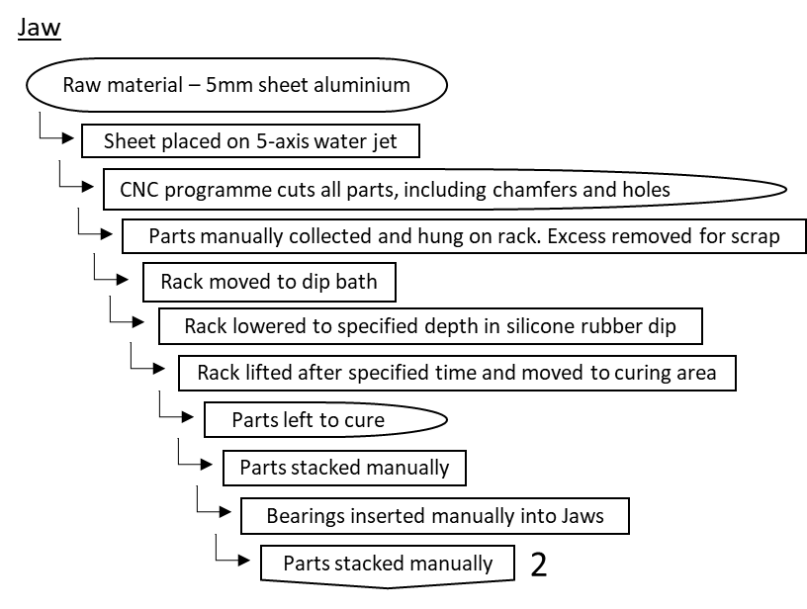

Manning and Cycle Times
The brief states that production volumes will be 1000-2000 per week. For continuous production with 24-hour manning on 5 day weeks, 17 units must be produced per hour. Therefore, each part must have a Cycle Time of 3.5 minutes or less. Final Assembly may need to be duplicated, with 2 simultaneous assemblies, but all other processes should be achievable with allowance for reasonable down time. Selection of specific machines would be needed to confirm this.
Many of the machines can be overseen by a shared skilled operators, such as CNC processes, mechanical cutting tools or conveyor systems - this will reduce costs significantly.

Plant Layout
The Plant Layout below was created under the assumption that all processes took up the same footprint, as without doing a proper machine selection it is not possible to properly optimise the floor usage. The individual components have a production line each, which progress towards the Final Assembly Area.
Man.
Manual movement of materials is represented by adjacent to an arrow. The plain arrows represent automated movement of materials, via slides, conveyor belts or similar.
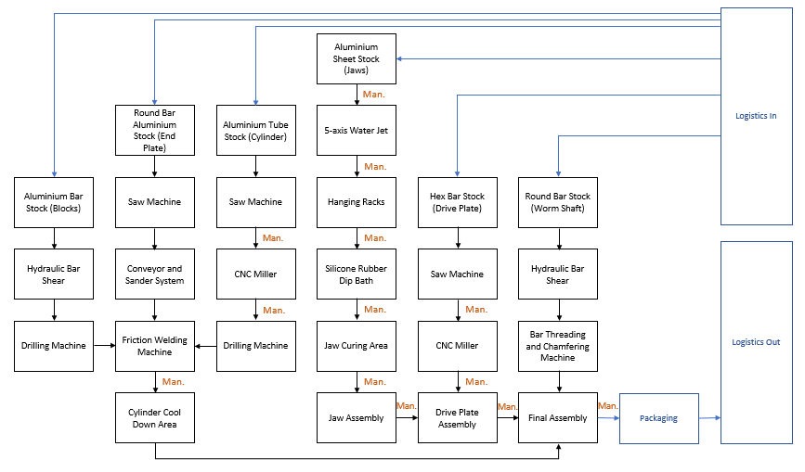

Conclusions

Design Conclusions
The End-effector was optimised with regard to manufacturability and assembly of the system, with the aim of not sacrificing quality or functionality at all. Where possible, these areas have also been improved, and environmental and product life cycle issues have also been considered.
The most significant changes were the omission of the Joints, the breaking down of the Cylinder into a sub-assembly, and the redesign of the Jaw. More discrete changes include the addition of bearings, chamfered edges, the merging of Worm and Shaft and reshaping of the Drive Plate.

Manufacturing Conclusions
The manufacturing processes have been selected so that each part is made in the most cost-effective way, without sacrificing quality. Processes have been automated where possible, but many systems will need to be supervised and set-up, and manual handling of materials is necessary at various points.
Assembly would need very advanced and accurate robotics systems, which would be costly. Depending on the speed of the assembly, two may need to run simultaneously to prevent a ‘bottleneck’. The business would need to decide whether the initial investment in these systems is feasible, or if manual assembly would be more achievable.

References
Bearing Shop UK, 2021. BearingShopUK.co.uk. [Online]
Available at: https://www.bearingshopuk.co.uk/k3x5x7tn/
[Accessed 26 05 2021].
H.N. Gupta, R. G. A. M., 2009. Manufacturing Processes. 2nd ed. New Delhi: New Age International Publishers.
Helen Marshall, L. M. L. J., 2007. Public Attitudes to and Perceptions of, London: Royal Academy of Engineers, Engineerign adn Technology Board.
Jenkins, H., 2005. Design of Robotic End Effectors. In: CRC.Press, ed. Robotics and Automation Handbook. Florida: CRC Press.
Piper Plastics, 2021. Piper-Plastics.com. [Online]
Available at: https://www.piper-plastics.com/processes/plastic-coating-plastisol/
[Accessed 26 05 2021].
Plastic Coatings, 2021. PlasticCoatings.co.uk. [Online]
Available at: https://www.plasticcoatings.co.uk/plastic-coating-processes/plastisol-coating/
[Accessed 26 05 2021].

Appendices

Project Plan
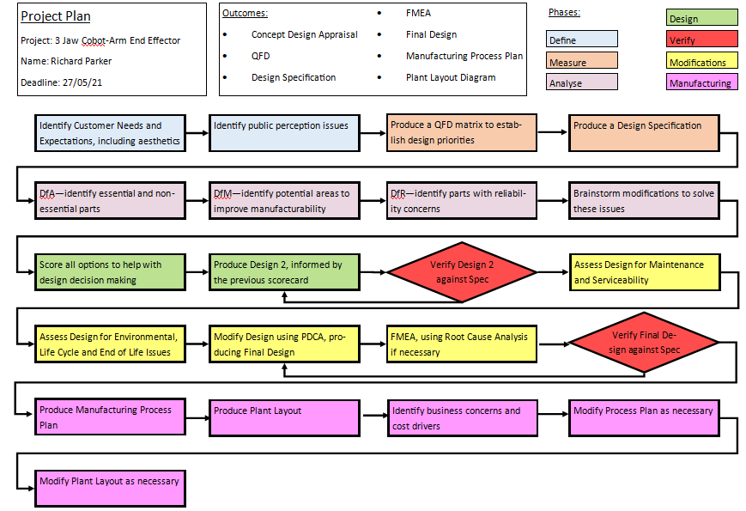

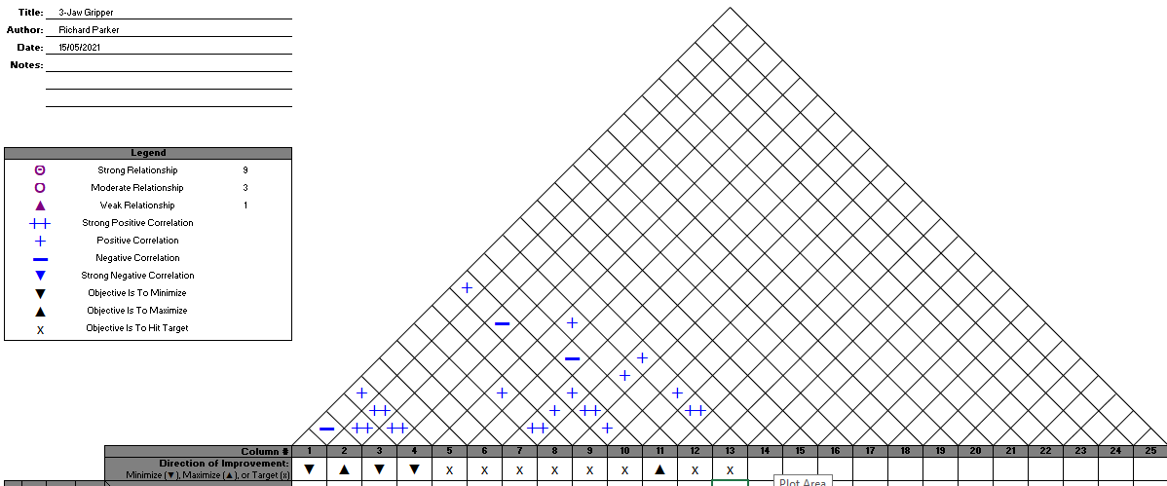
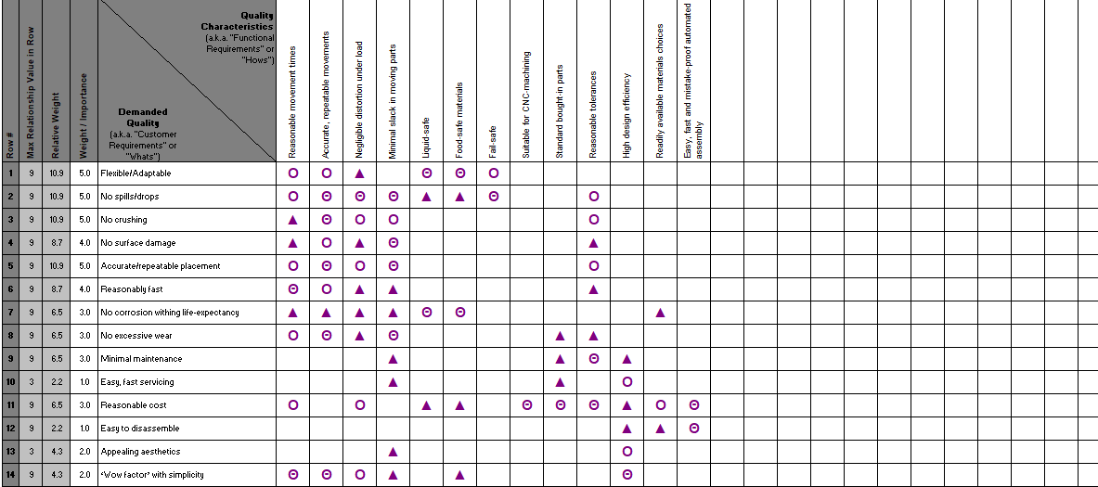
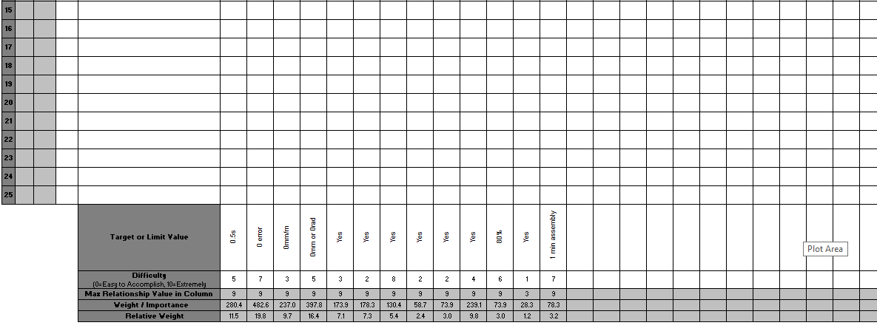
Quality Function Deployment

QFD Summary

Customer Requirements Prioritised:
- Accurate/repeatable placement
- Flexible/Adaptable
- Must not spill or drop any objects
- Must not damage any objects by dropping them
- Must not damage any objects’ surfaces
- Must carry out functions within a reasonable time range
- No problematic corrosion within system’s life-expectancy
- No excessive wear in moving parts
- Minimal maintenance and servicing demands
- Costs should be kept to reasonable levels – in line with existing similar products
- Appealing aesthetics to persuade likely customers
- ‘Wow factor’ with simplicity to excite potential customers
- Servicing should be fast, one-man, low difficulty and require minimal tools
- Easy to disassemble in case of part replacement/upgrade

Design Requirements Prioritised:
- Accurate, repeatable movements
- Minimal slack in moving parts
- Reasonable movement times
- Negligible distortion under load
- Reasonable tolerances
- Food-safe materials in case system is used in a catering environment
- Liquid safe in case of spillage (not submersible)
- System should be fail-safe
- Easy, fast and ‘mistake-proof’ automated assembly with minimal tooling
- High ‘design-efficiency’
- Any bought-in parts should be standard and readily available
- All parts should be suitable for automated machining for expected production volumes
- Material choices should be readily available and not bring about supply chain issues

Notable Requirements Trade-Offs:
- Reasonable movement times vs Accurate, repeatable movements
- Minimal slack in moving parts vs Reasonable tolerances
- Fail-safe design vs High Design Efficiency

Design Specification
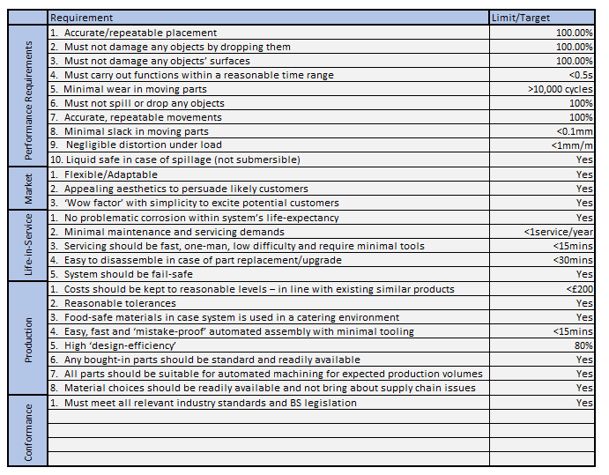

Review Against Specification – Initial Concept
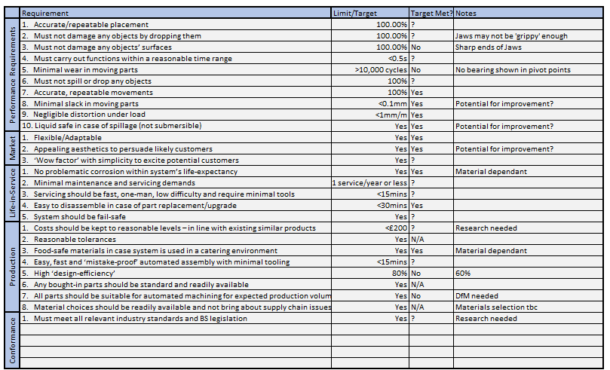

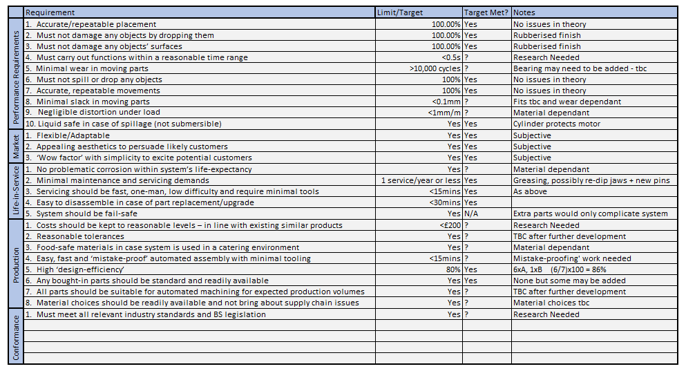
Review against Specification – Design 2

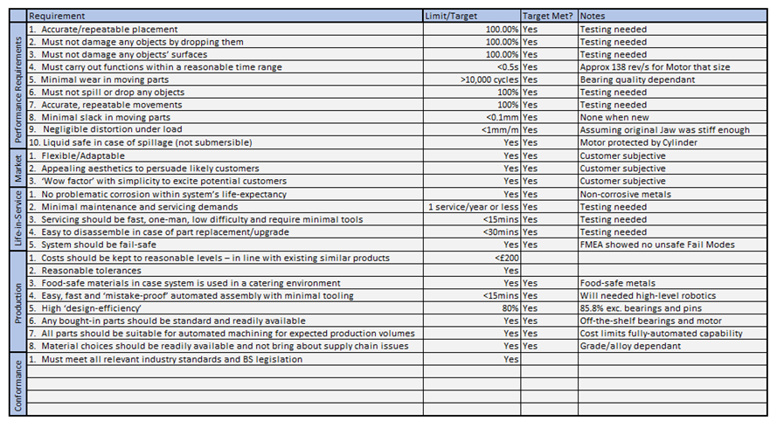
Review against Specification – Final Design

