

University of Wales Trinity Saint David

Student: Petar Konov
Student Number: 1919086
Module Title: International Business Communications
Module Code: LCBB6001
Module Lecturer: Charles Nwaogwugwu
Assignment Title: Assessment 1

Table of Contents

Introduction. 1
2. Applications of Hofstede’s cultural theory. 1
2.1.Power Distance. 2
2.2. Individualism and Collectivism. 2
2.3. Masculinity Versus Femininity. 3
2.4.Uncertainty Avoidance. 4
2.5. Long-term Versus Short-term Orientation 5
2.6 6. Indulgence Versus Restraint 5
3. Cultural sensitivity and recommendations. 6
Conclusion 7
References 8

Introduction.
International business success depends on effective communication between multinational business partners. Undervaluing national and organisational cultural differences may complicate effective communication and reduce business performance. The global business environment of the 21st century is rapidly developing and drawing the interest of both emerging and advanced nations. It is extremely important that the institutions of the countries involved respect and recognise one each other’s cultural diversity. Failure to successfully communicate on a global scale, and disregard for proper business etiquette may fail any business enterprise. Therefore, foreign organizations must recognise the benefit of respecting their business partner's cultures and beliefs as well as try to build cross-cultural awareness and etiquette. Nations around the world should become more interdependent and interconnected in order to secure progression and sustainability in global business. In this paper, I will discuss the possible complications UK based company may experience if moving its production to Somalia.
Somalia's nation is emerging from instability and a long-term crisis, and it aims to enter a sustained period of political and institutional improvement. In 2012 the country established a federal government, following the creation of five new Federal Member States, and the Provisional Constitution in 2011. These factors are reshaping Somalia's new federal map and opening the door for political change. Due to disagreements about how to execute the amended election model that was agreed upon for the 2020/21 elections, ongoing elections continue to be delayed. Federalism offers a way to negotiate power and resources and to regulate economic imbalance between the peaceful northern provinces and the south that is still recovering from violence. As governmental relations continue to change rapidly, Somalia's private sector continues to be a source of resiliency and innovation. The accessibility to these markets offers new potential for Somalia to gain from trade and structural reforms. In order to expand its economy and create new jobs, Somalia has a number of opportunities, including increased urbanisation, a rise in the use of digital technology, and planned investments in industries including energy, ports, education, and health. After a protracted drought, growth in 2019 was predicted to be 2.9%. A triple disaster of COVID-19, locust infestation, and floods led the economy to decline by 1.5%, interrupting a predicted growth rate of 3.2 per cent in 2020. A recovery in the economy is currently taking place, helped by increased profitability and steady capital inflows. In 2021, it is anticipated that private consumption will remain despite a moderate recovery. According to estimations, the global poverty rate would stay at 71% in 2022 and 2023, and this pattern is anticipated to persist. Governmental measures are necessary, in order to increase productivity, create more jobs, and develop poverty programmes (The World Bank in Somalia,2022).

2. Applications of Hofstede’s cultural theory.
According to Welzel (2018), in order to be successful international business experts should be excellent at identifying national culture variations and see these differences as opportunities. They can then plan the most effective approach for their business strategy thanks to this. Understanding regional cultural differences can open doors to emerging economies. Researchers and practitioners may find it useful to acquire a feel of the national cultural values represented in the market. Hofstede (2010) introduced the six aspects of national culture in order to better understand how business principles are influenced by national culture.

2.1.Power Distance.
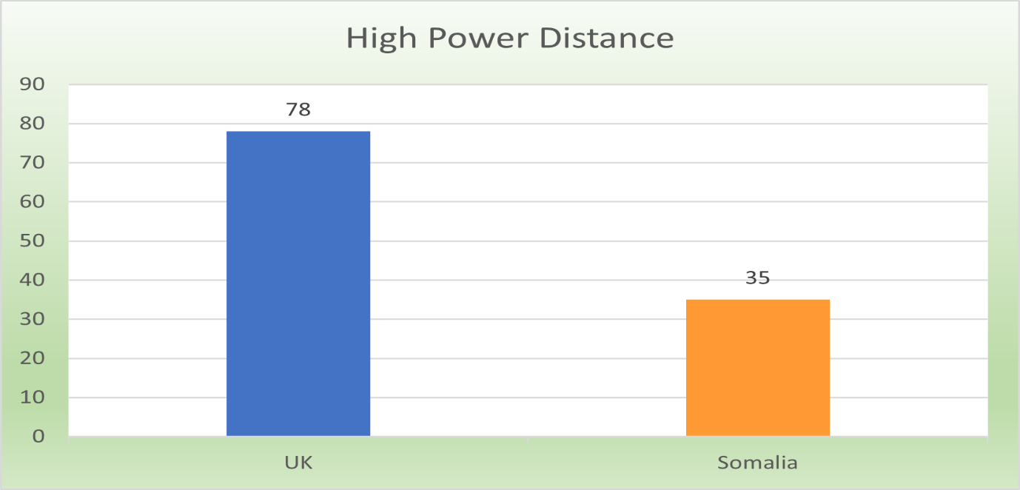
This dimension deals with the unequal allocation of power and evaluates how the weaker members of society have accepted this inequity. According to Mooij & Hofstede (2010), each person has their designated space within the social hierarchy in societies exhibiting a large degree of power distance. It also clarifies how the extent of this discrepancy these people are willing to tolerate, and think is acceptable. This is depending upon the institutions and practises of society. As stated in Minkov (2005), one of the key traits of high power distance index (PDI) nations is a hierarchy, where those in higher positions enjoy greater advantages and power with little opposition, while those who lack power typically respect and submit to authority. Children are taught to pay attention to their parents and teachers, and employees are trained to comply with superiors' orders without objecting. Contrarily, in nations with a low PDI, persons are not evaluated based on their gender, age, money, or social standing. They tend to want to distribute power evenly and have the confidence to challenge authority. In Somalia, men with high income, a stable family background, or personal accomplishments are seen as superior to others (Lewis, 2008). As seen in Figure 1, Somalia’s power distance index is approximately one-third of the United Kingdom’s PDI.
Figure 1. Data: World Population Review (2022)

2.2. Individualism and Collectivism.
These theories are primarily concerned with how individuals relate to the bigger organisations to which they belong. It involves whether a society consistently prioritises the interests of an individual over those of a group. To evaluate an individualistic society, Hofstede (2001) established the Individualism index (IDV). In high IDV cultures, the importance of self-concept is extremely important, independence, individuality, and privacy are strongly encouraged. People who live in an individualistic society primarily focus on their own families and themselves, and they typically approach decisions or judgments from that point of view. Collectivistic societies, on the other hand, place a strong emphasis on the notion of communal responsibility and hold that the interests of the individual should come second to those of the group. Because the group takes care of its members, they are expected to be cooperative and loyal to it, and choices are always made with the group's interests in mind(Hofstede, 2005). In Somalia, people are strongly connected with their own groups from birth, and members of the same group should share both prosperity and hardship. Typically, the groups are their families, tribal groups, political organisations, or even their country (Lewis, 2008). Employees from Rose (2008) argues that employees from Somalia are independent and like to take control. People place significant importance on their freedom and self-expression, show higher enthusiasm for success, and prioritise their own goals over those of the business. Figure 2. shows that the United Kingdom is an individualist nation while Somalia is a collectivist nation.

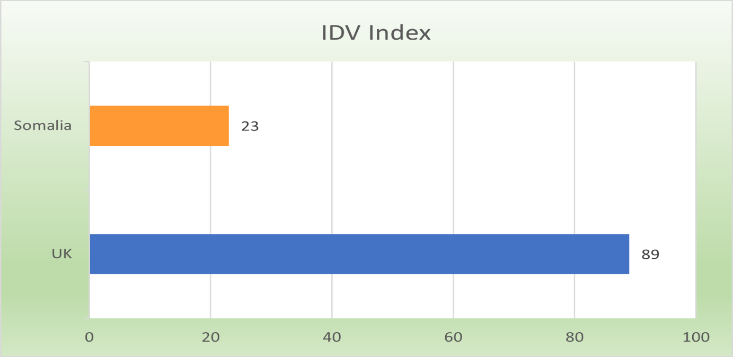
Figure 2.Data: Hofstede insights(2022)

2.3. Masculinity Versus Femininity.
As stated in Rose(2008), in contrast to femininity, the masculinity aspect describes whether a society is more likely to value female qualities like humility and humanity or male qualities like competitiveness and arbitrariness. The Masculinity Index (MAS) was developed to measure how masculine culture is. Gender inequality exists and is accepted as normal in high-MAS societies. Typically, a person's social rank and financial success are used to evaluate them, and success obtained by perseverance is highly regarded. There are differing expectations for men and women in masculine societies. In general, men are trained to be courageous, ambitious, and assertive, while women are encouraged to be kind, delicate, and understanding. And in this kind of culture, women are expected to stay at home and take care of the entire family, according to a more traditional definition of gender roles. However, gender equality is emphasized and accepted in low-MAS societies, whether it occurs at home or at work. Men and women's gender roles are not well-defined, and it is accepted that both genders should be kind and considerate of others' quality of life. Somali employees are typically more concerned with financial compensation than non-monetary ones, and they are constantly striving to raise their social standards. They are usually aggressive and ambitious by nature, and nothing stands in their way of success. These qualities should be valued and rewarded by the company, and they are regarded as important. As a result, the company has a performance-based culture, which improves its progress (Hofstede & Minkov,2010). As shown in Figure 3., Somalia and the United Kingdom both have high MAS indexes, therefore we can consider both to be masculine nations.
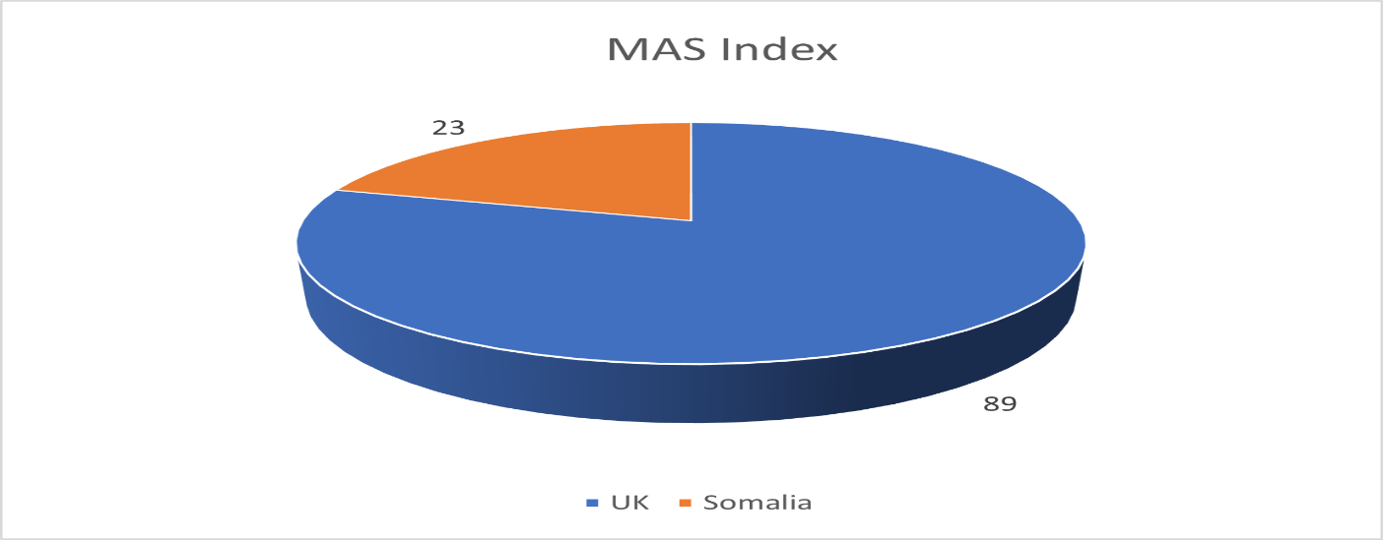
Figure 3.Data: Hofstede insights(2022)

2.4.Uncertainty Avoidance.
When threatened by uncertain events or an unusual environment, a society's ability to avoid and control uncertainty through formal means is measured using the concept of uncertainty avoidance. To measure this dimension, Hofstede(2005) established the uncertainty avoidance index (UAI). A lot of rituals, norms, and formal methods are used in cultures with high UAI to control people's behaviour to maintain security. These cultures also have little tolerance for uncertainty and ambiguity. Members are intolerant to disagreement and resistant to change. Contrarily, those who live in low certainty avoidance cultures are more able to deal with the stress and anxiety that ambiguity and uncertainty. They are encouraged to take risks and try new things and to think that conflict and competition are natural and always can be by negotiation. The Volatile Politics and the Ethics of Engagement in Somalia culture demonstrates an openness to unique ideas and is widely permitted to have unconventional ideas that go against the trend of the workplace. When presented with uncertain circumstances, employees will not get nervous; rather, they will view it as a challenge and a chance to perform better. Additionally, they are more likely to develop original theories and cutting-edge corporate management techniques, which are usually valued by the organisation (Walls,2010). From Figure 4 may be concluded that Somalia’s uncertainty index is much higher compared with the UAI index of the United Kingdom.
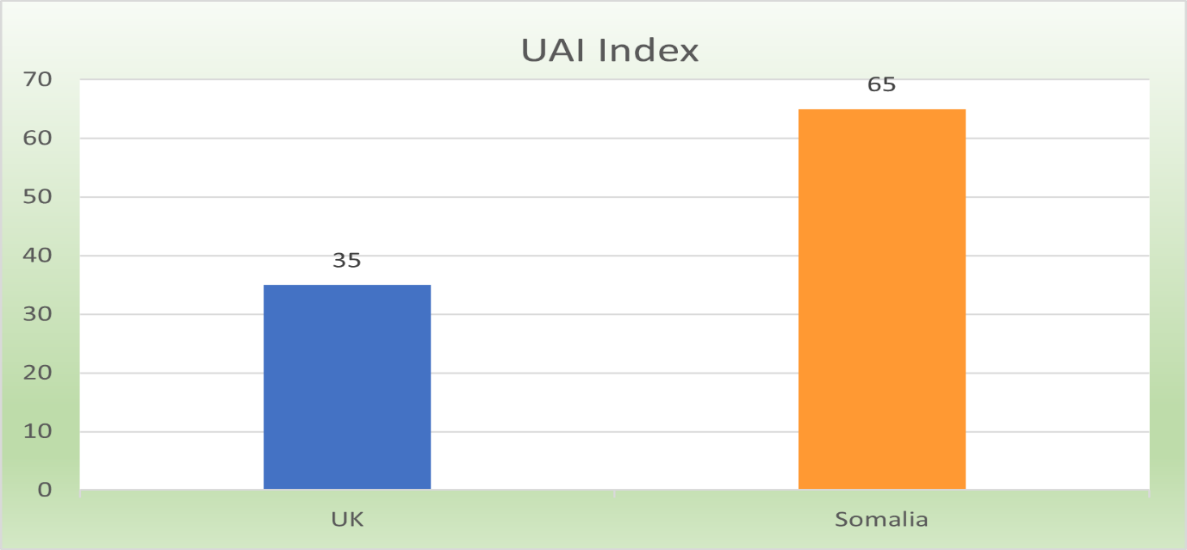
Figure 4. Data: Hofstede insights(2022)

2.5. Long-term Versus Short-term Orientation
According to Hofstede(2006), the difference between long-term and short-term orientation is used to determine how much a culture's members are willing to wait for their social, emotional, and material demands to be met. This aspect was created and developed on the basis of Chinese ideals. People who live in cultures that are long-term oriented tend to set long-term goals and accept that their demands may not be met right away. Children are so trained to be resilient, determined, and humble. Additionally, interpersonal communications are strongly influenced by differences in position and age. Cultures that are focused on the short term emphasise traditions, mutual benefit, and personal stability. When faced with unstable circumstances, members will turn to rituals or customs. Hofstede & Minkov(2010)concluded that employees with a short-term outlook concentrate on short-term gains; they are more focused on making the month's earnings than on the organization's long-term development and success. In comparison with the UK, Somalia is a more short-term-oriented country as we can see in the chart in Figure 5.
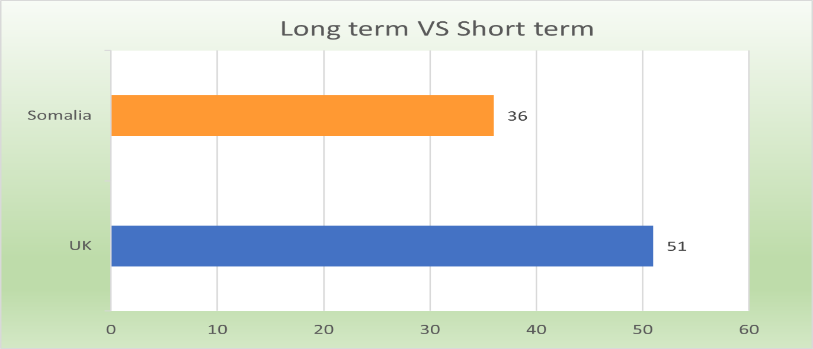
Figure 5. Data: Hofstede insights(2022)

2.6 6. Indulgence Versus Restraint
Indulgence and restraint theory is the newest analytical dimension as stated in Hofstede (2010) although yet widely accepted. It refers to the degree of tolerance for basic human needs and the quality of life in society. Indulgent cultures, where people tend to freely express their desires and enjoy life, place a larger emphasis on freedom, personal happiness, and the satisfying of emotional and social needs. People in constrained societies, on the other hand, are adamant that while happiness, freedom, and leisure are not given equal weight, human needs must be controlled by strict social rules. In such societies, people may feel powerless over their own future and rarely express their emotions. As shown in Figure 6., Somalia is a restraint nation, compared with the United Kingdom which is living a more indulgent way of life.
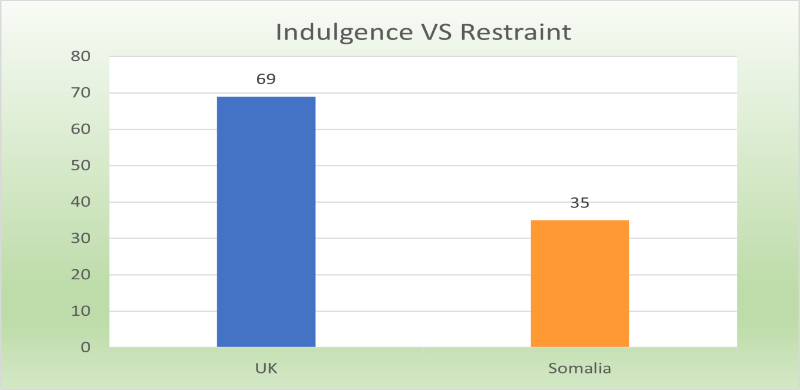
Figure 6. Data: Hofstede insights(2022)

3. Cultural sensitivity and recommendations.
According to Washington(2012), moving business abroad presents various challenges, conflicts, and misunderstandings. The performance of the employees and the entire company is impacted by these difficulties and disputes. Businesses must find a way to integrate a diverse workforce into their internal environments communicating with clarity. Effective communication between individuals is necessary to prevent conflicts and overcome issues to accomplish business goals. To facilitate intercultural communication (Griffith,2002). A business must be aware of the obstacles to cross-cultural communication. The biggest issue with a multi-cultural team is the language barrier. Anyone who is more likely to interact with foreigners should receive language instruction. The ability to engage in a variety of activities, the core of which involves a shared communication protocol, is what Kieser(2002) describes as "cross-cultural competence." Knowledge, skills, and attitudes support this competence. The effective development of cross-cultural understanding is supported by three elements: cross-cultural communication includes cross-cultural sensitivity, cross-cultural awareness, and cross-cultural competency. The emotional aspect of cross-cultural communication is referred to as intercultural sensitivity and its aim is to give people the resources, they need to recognize the differences between various cultures. Through cultivating cross-cultural sensitivity, one can comprehend one's own self-concept, objectivity, and self-possession. The cognitive element of cross-cultural communication is known as cross-cultural awareness. Intercultural awareness leads to increased self-awareness as well as cultural awareness.
In order to show respect to Somali counterparts, it is best to come on time, however, they might not be as prompt. For religious reasons, some people may prefer not to attend meetings or events on certain days or at certain hours. Muslim believers' prayer times may interfere with meeting agendas. When considering moving production to Somalia, a business must take into account the years of political instability and the significant negative impact they had on Somalia's economy and commercial sector. There is also the persistent threat of violence and thievery. Some of the local people might not properly understand occupational health and safety procedures. As a result, the employees may not recognise workplace risks or incidents that are related to their jobs and do not report them. They can also be concerned about the penalties of reporting. In Somalia, the organisational structures are not well established. The majority of the time, managers treat their staff members as friends. It is advisable, that any workplace issues should be dealt with quietly to avoid making the individual in question uncomfortable. When doing business, it is advisable to explain how your offer could benefit Somalia, their clan, or their own circumstances. It is important to note that Somalia is placed 180th out of 180 nations on the 2017 Corruption Perception Index. According to this belief, the public sector of the nation is the most corrupt of any nation(Somali culture,2022).

Conclusion
To conclude, when moving business abroad companies should prioritise creating a new corporate culture. A way of life that is widely accepted, in which respect is shown for and understanding of the values and views of others. The senior management should make a commitment to creating an environment at work free from disagreements and conflicts by increasing employee cross-cultural competency. Providing knowledge training and maintaining the mutual benefit policy brings a diverse variety of workforce benefits. The cultural model developed by Hofstede is a useful tool for examining the cultural characteristics that are present in different countries. Managers who are aware of cultural values, practises, conventions, and regulations can make informed decisions concerning corporate expansion. Understanding cultural norms of behaviour from various cultures is very helpful for international businesses since it helps them better comprehend global organisations and consumers.

References
Beugelsdijk, S. & Welzel, C. (2018) Dimensions and Dynamics of National Culture: Synthesizing Hofstede with Inglehart. Journal of cross-cultural psychology. [Online] 49 (10), 1469–1505.
Blodgett, J. G., Bakir, A., & Rose, G. M. (2008). A test of the validity of Hofstede’s cultural framework. Journal of Consumer Marketing, 25(6), 339-349. doi:10.1108/07363760810902477
De Mooij, M. & Hofstede, G. (2010) The Hofstede model: Applications to global branding and advertising strategy and research. International journal of advertising. [Online] 29 (1), 85–110.
G.,Hofstede, (2006) Culture’s Consequences: Comparing Values, Behaviors, Institutionsand Organizations Across Nations. Shanghai: Shanghai Foreign LanguageEducation Press
G., Hofstede, G.J. and Minkov, M.,( 2005). Cultures and organizations: Software of the mind (Vol. 2). New York: Mcgraw-hill
Griffith, D.A.,(2002). The role of communication competencies in international business relationship development. Journal of World Business, 37(4), pp.256-265.
Hofstede insights, ‘Country comparison’(2022), Available at: https://www.hofstede-insights.com/country-comparison/the-uk/Kieser, A., 2002. On communication barriers between management science, consultancies and business companies. Critical consulting, pp.206-227.
Lewis, I.M.(2008), Understanding Somalia and Somaliland: culture, history, and society, Hurst&Company
Somali culture(2022), Incluude,[Online] https://culturalatlas.sbs.com.au/somali-culture/somali-culture-business-culture#somali-culture-business-culture
The World Bank in Somalia (2022) Available online: https://www.worldbank.org/en/country/somalia/overview
Washington, M. C., Okoro, E. A. and Thomas, O. (2012) “Intercultural Communication In Global Business: An Analysis Of Benefits And Challenges”, International Business & Economics Research Journal (IBER), 11(2), pp. 217–222. doi: 10.19030/iber.v11i2.6776.
Walls, Michael. (2010). Understanding Somalia and Somaliland: Culture, History, Society by IOAN LEWIS. Bulletin of the School of Oriental and African Studies, University of London. 73. 346-348. 10.2307/25703047
World Population Review (2022) ‘High Power Distance Countries 2022’, Available online at: https://worldpopulationreview.com.[Accessed 6 August 2022].

