Elite Estates Market Research Report



Monday, 16 March 2026

Module name: Digital skills for personal development and business growth (BMSW2008_SWAN)

Name: Shannon Allagosta

Student number: 2317186

Word count: 1094
CONTENTS

Table of Contents
1. Introduction…………………………………………………………………………………………... 3
1.1 Report Remit …………………………………………………………………………………. 4

2. Analysis report ……………………………………………………………………………………... 5
2.1 Findings……………………………………………………………………………………...
5

2.2 Personalised Products ……………………………………………………………………. 5

2.3 Segmentation and Marketing and SEO Strategy ……………………………………………...7
2.4 website development …………………………………………………………………………...
7
2.5 Canva market materials ……………………………………………………. 8

3. Conclusion …………………………………………………………………………………………….
8
4.References………………………………………………………………………………………………………………... 10
5.Appendices……………………………………………………………………………………………………………….1

List of Figures

- Figure 1. Platforms used by respondents when searching for rental properties
- Figure 2. Importance of property condition to respondents.
- Figure 3. Monthly rental budgets reported by questionnaire respondents.
- Figure 4. Most popular Swansea areas selected by respondents.

- Introduction

1.1 Report Remit
This report outlines how market research supported the development of a small business idea and the creation of digital content. A questionnaire was designed to gather insights into renter preferences, and the findings informed the development of a two‑page website and Canva marketing materials. The report explains how the research shaped the business concept, website layout, design choices and SEO strategy. It also includes questionnaire graphs, website screenshots and marketing materials to demonstrate the connection between research and final outputs.

2. Analysis report

2.1 Findings
- Renters place extremely high importance on property condition, with all respondents rating it as important or very important.
- Affordability is a major priority, with most renters able to pay £500-£800 per month and rating affordable rent as highly important.
- Certain Swansea areas such as Swansea city centre, Uplands, Mumbles, Landore and Morriston are significantly more popular than others.
- Renters rely heavily on online platforms like Zoopla, Rightmove and Facebook when searching for properties.

- Importance of property condition
Every respondent rated property conditions as important or very important, showing that renters expect clean, modern and well‑maintained homes. This reflects wider UK rental trends where quality and presentation strongly influence decisions. For Elite Estates, this means prioritising well‑maintained properties and using high‑quality visuals on the website.

2. Affordability as a key priority
Most participants selected budgets between £500–£800 per month, aligning with current cost‑of‑living pressures. For Elite Estates, this means focusing on competitive pricing and ensuring transparency across the website and marketing materials.

- Popular Swansea areas
Swansea City Centre, Uplands, Mumbles, Landore and Morriston were the most popular areas. These locations offer good transport links and amenities, making them attractive to renters. This helps Elite Estates focus property sourcing and highlight these areas on the website.

- Reliance on online platforms
Zoopla, Rightmove and Facebook were the most common tools used to search for rental properties. This shows the importance of a strong online presence and ensuring the website is easy to use on both phones and computers.
2.2 Personalised Products
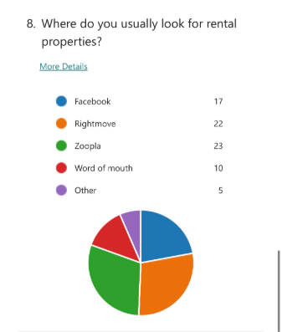
A key finding was that most participants rely on online platforms when searching for rental properties. Zoopla and Rightmove were the most popular, followed by Facebook. This shows that renters prefer digital tools that allow quick comparison and clear visuals.

Figure 1. Platforms used by respondents when searching for rental properties

This trend is supported by Reallymoving (2026), which explains that online platforms dominate property searches due to convenience and up‑to‑date listings. Todd (2022) also notes that renters expect clear photos and simple navigation.

Another strong finding was that all respondents rated property conditions as important or very important.

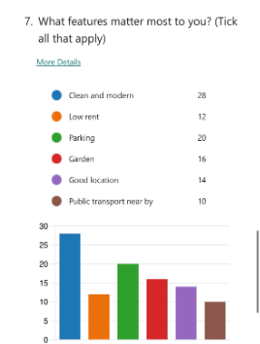

Figure 2. Importance of property condition to respondents.

Rollo (2023) notes that tenants often judge quality based on appearance. This influenced Elite Estates to prioritise high‑quality photos and clean layouts. Marketing materials also highlight modern interiors to match renter expectations.

The questionnaire showed that most respondents had a rental budget between £500-£800 per month, highlighting affordability as a key priority.
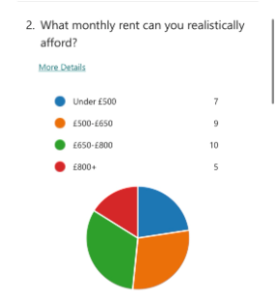

Figure 3. Monthly rental budgets reported by questionnaire respondents.

Research supports this, Norwood, G. (2025) explains that rising costs have made renters more price conscious. However, other studies argue that focusing too heavily on low prices can reduce perceived quality (Evrard, J.-P. 2020). This influenced Elite Estates by keeping pricing clear and competitive, while still presenting properties in a way that maintains a sense of quality and value.

The questionnaire showed that the most popular areas for renters were Swansea City Centre, Uplands, Mumbles, Landore and Morriston. This suggests that respondents prefer locations with good transport links, amenities and access to the city.

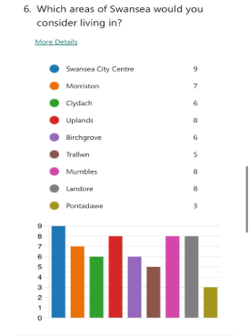

Figure 4. Most popular Swansea areas selected by respondents

Research supports this, Russell, J. (2026) notes that renters often choose areas that offer convenience and a strong sense of place. However, Peppermoney (2025) argues that high-demand areas can push up prices and reduce choice for some households.
This finding influenced Elite Estates by focusing property sourcing and website listings on these high-interest areas. Marketing materials also use location-specific keywords to attract renters searching for certain parts of Swansea.

2.3 Segmentation and Marketing and SEO Strategy
The market for Elite Estates was segmented by income, lifestyle and location preference. Income segmentation was essential, as most respondents selected budgets between £500-£800 per month. Parsons, M. (2024) notes that income-based segmentation helps businesses tailor their offering to realistic customer expectations. Lifestyle segmentation was also relevant, as respondents preferred areas with good transport links and amenities. Zarrabi, M., Yazdanfar, S.-A. and Hosseini, S.-B. (2021a) argues that lifestyle factors strongly influence housing choices, supporting the decision to focus on modern, convenient properties in popular Swansea areas.

The SEO strategy centred on keywords that reflect how renters search online. Nicholson, R. (2024a) explains that effective SEO requires aligning website content with user search behaviour. As a result, keywords such as “Swansea rentals” and “Uplands property” were integrated into page titles, descriptions and listings to improve visibility.

Marketing activity focused on the platforms most used by the target audience. Questionnaire findings showed that Facebook, Rightmove and Zoopla were the most common tools for property searches. Manchester, S. (2020) reports that Facebook remains widely used for UK housing promotion, supporting its inclusion. Visual marketing was prioritised to reflect emphasises on strong imagery in influencing customer perception.

2.4 Website Development
The Elite Estates website was developed as a two‑page layout based on the questionnaire findings. High‑quality images and clear pricing were prioritised because respondents rated property condition and affordability as highly important. The homepage presents featured Swansea rentals, while the second page provides detailed property information. Simple navigation, minimal text and location‑based keywords such as “Swansea rentals” and “Uplands property” were included to support SEO and reflect the areas most preferred by respondents.

2.5 Canva Marketing Materials
Two marketing materials were created using Canva to support Elite Estates’ online presence. The first was a Facebook property post, designed because the questionnaire showed that Facebook is one of the most used platforms for rental searches. It includes a large property image, key features and a clear call‑to‑action. The second material was an A4 property flyer featuring high‑quality images, pricing and a short description. Both designs use consistent branding and highlight modern interiors and affordability, reflecting the priorities identified in the questionnaire.

3. Conclusion

3.1
The questionnaire clearly showed that renters prioritise property condition, affordability, location and online search tools. These insights shaped the Elite Estates website and marketing materials, leading to clear visuals, simple navigation and targeted content. Overall, the research directly informed the business strategy and final design choices.

REFERENCES

Evrard, J.-P. (2024) Globalpraxis: Pricing may decrease your value: Understanding the paradox of low pricing, RSS. Available at: https://www.globalpraxis.com/insights/pricing-may-decrease-your-value-understanding-the-paradox-of-low-pricing2#:~:text=Pricing%20is%20not%20just%20a,wine%20is%20actually%20the%20same. (Accessed: 28 March 2026).
Manchester, S. (2020) Like that House! facebook growing power in property market revealed, The Negotiator. Available at: https://thenegotiator.co.uk/news/facebook-growing-power-in-property-market-revealed/ (Accessed: 28 March 2026).
Nicholson, R. (2024a) Improve your seo with these best practices and expert resources, HubSpot Blog. Available at: https://blog.hubspot.com/marketing/seo (Accessed: 28 March 2026).
Norwood, G. (2025) Renters growing less confident about ever affording to buy, Landlord Today. Available at: https://www.landlordtoday.co.uk/breaking-news/2025/08/renters-growing-less-confident-about-ever-affording-to-buy/ (Accessed: 28 March 2026).
Parsons, M. (2024) What is demographic segmentation?: Examples & Benefits Guide, Experian UK. Available at: https://www.experian.co.uk/blogs/latest-thinking/guide/what-is-demographic-segmentation/ (Accessed: 28 March 2026).
Peppermoney (2025) What affects house prices in the UK?, Pepper Money UK. Available at: https://www.pepper.money/blog/what-affects-house-prices-in-the-uk/ (Accessed: 28 March 2026).
Rollo, M.D. (2026) How landlord attract high-quality tenants, Gilson Grey . Available at: https://gilsongray.co.uk/properties/how-to-attract-high-quality-tenants-in-a-competitive-market/ (Accessed: 28 March 2026).
The reallymoving Team Updated 9th Mar (2026) How to use the internet for house hunting, Really Moving. Available at: https://www.reallymoving.com/conveyancing/guides/using-the-internet-to-find-a-property (Accessed: 28 March 2026).
Todd, J. (2026) Get the picture: Why sellers should use high-quality property photos , Belvoir. Available at: https://www.belvoir.co.uk/guides/stoke-on-trent/get-the-picture-why-sellers-should-use-high-quality-property-photos-2/#:~:text=%2DPhotography%20creates%20a%20powerful%20first,But%20wait%2C%20there’s%20more! (Accessed: 28 March 2026).
Zarrabi, M., Yazdanfar, S.-A. and Hosseini, S.-B. (2021a) Usage of lifestyle in Housing Studies: A systematic review paper - journal of housing and the built environment, SpringerLink. Available at: https://link.springer.com/article/10.1007/s10901-021-09883-4 (Accessed: 28 March 2026).

Appendices

Appendix A - Website design
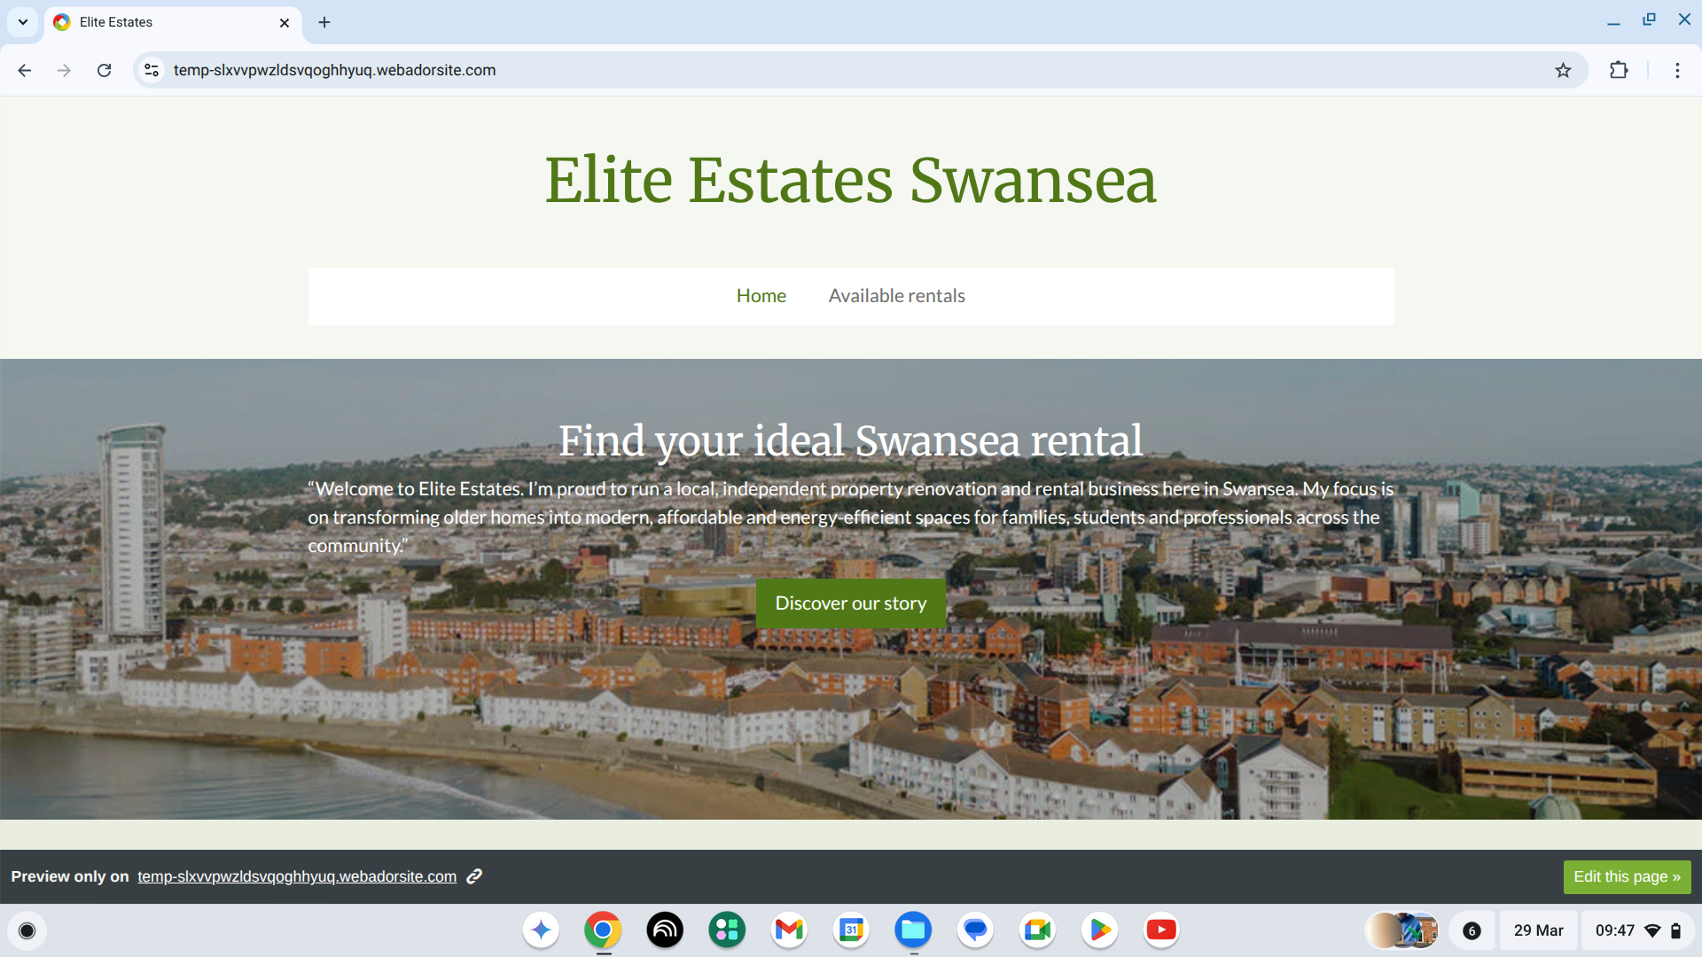

Appendix B - Website design second page
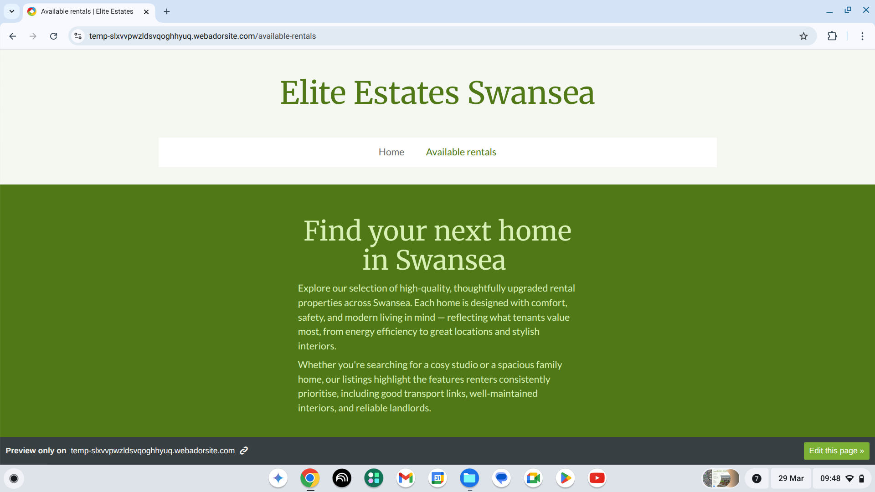

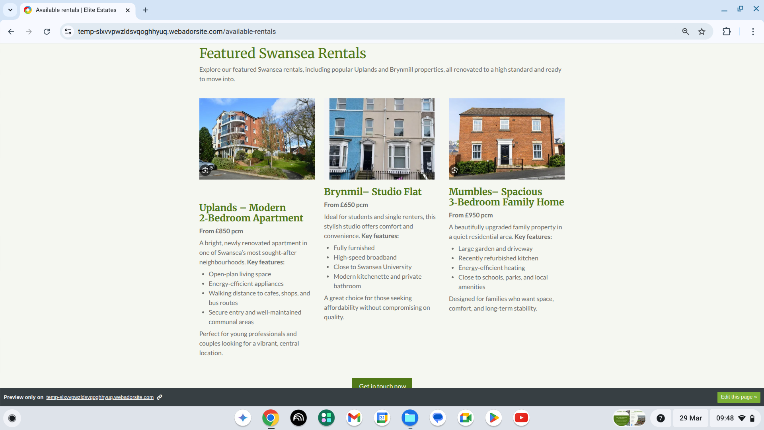
Appendix C - Available properties on website page

Appendix D - Facebook Canva Post (Property promotion)

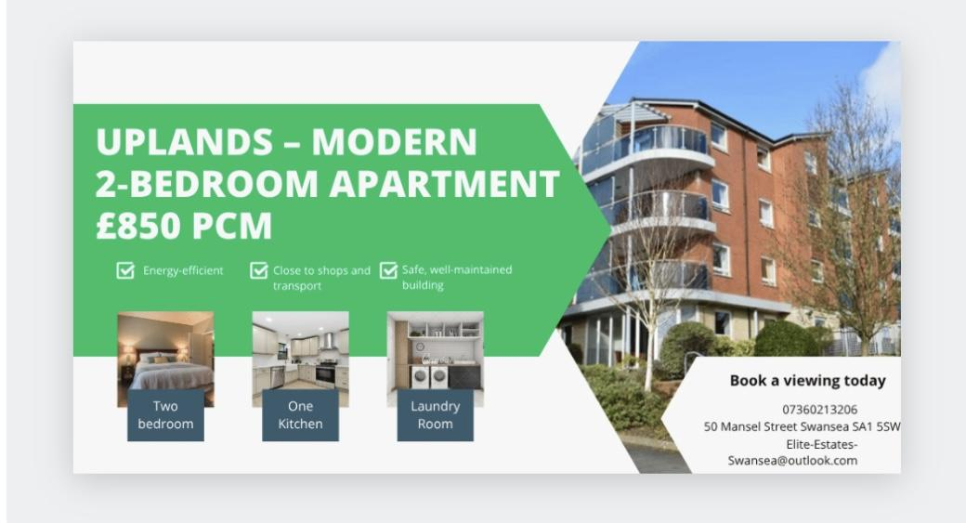

Appendix E - Canva Flyer (Property promotion)


Task 2 - The Importance of Excel in the Digital Era and Its Use in Elite Estates
Microsoft Excel is one of the most important digital tools in modern business. It helps organisations organise information, manage finances and make informed decisions. In today’s digital era, businesses rely on technology to operate efficiently, and Excel provides a flexible platform for handling a wide range of tasks. Whether used by large companies or small start‑ups, Excel supports budgeting, forecasting, reporting and performance analysis. For a small business like Elite Estates, it is especially valuable because it is cost‑effective, easy to use and supports many day‑to‑day operations.
One of the main reasons Excel is so important is its ability to organise data clearly and effectively. Charlesworth, L. (2022) explains that Excel continues to be a key digital skill because it helps users organise and manage information effectively in modern business environments. Businesses can use spreadsheets to record financial transactions, customer details and operational data. For Elite Estates, Excel can be used to track rental income, property information and marketing performance. Having this information stored in one place makes it easier to analyse trends, identify issues and make improvements.
Excel is essential for financial planning, which is a crucial part of running any business. Small businesses must understand their income, expenses and profit to make informed decisions. Sutton, N. (2024) explains that financial forecasting helps businesses plan ahead and manage resources effectively. Excel’s built in formulas make it easy to calculate totals, compare figures and project future performance. For Elite Estates, Excel can create a yearly financial projection showing expected income and key expenses such as marketing, website hosting and insurance. This helps the business assess profitability and supports long‑term planning.
Another major benefit of Excel is its ability to turn data into charts and graphs. Visual information is often easier to understand and can highlight patterns that may not be obvious in a table of numbers. Roelofs, E. (2022) explains that data visualisation helps organisations make better decisions by making trends and unusual patterns easier to identify. For Elite Estates, charts comparing monthly income and expenses can reveal
seasonal patterns, such as higher rental demand at certain times of the year. This insight can help the business plan marketing campaigns, adjust budgets and prepare for busy periods. Visual tools also make it easier to present financial information to potential partners or investors.
Excel also supports automation, which helps save time and reduce errors. Features such as autofill, conditional formatting and pivot tables allow users to analyse data more efficiently. Reisfield, A. (2025) explains that automating tasks in Excel reduces repetitive manual work and improves accuracy, allowing businesses to focus on more strategic activities. For Elite Estates, conditional formatting could be used to highlight months where expenses are higher than income, while pivot tables could summarise property performance or marketing results. These tools help the business work more efficiently and make better use of its resources.
In addition to financial management, Excel can support operational tasks within Elite Estates. For example, the business could use Excel to track property availability, manage viewing appointments, record maintenance issues or monitor client enquiries. Sharma, V. (2024) argues that digital tools play a crucial role in improving operational efficiency and customer service by supporting better organisation and planning. By using Excel to manage these tasks, Elite Estates can ensure that information is accurate, up to date and easy to access.
Excel is also useful for supporting marketing activities. Businesses can use spreadsheets to track advertising costs, monitor engagement and analyse the effectiveness of different campaigns. According to Khan, M. (2025), analysing customer data allows businesses to improve their marketing strategies and respond more effectively to customer needs. For Elite Estates, Excel can be used to record the performance of Facebook posts, website visits or property listing views. This information helps the business identify which marketing methods are most effective and where improvements can be made.
Overall, Excel is a vital tool in the digital era because it supports data organisation, financial planning and decision‑making. Adisa, Z. (2025) highlights that Excel plays a significant role in improving decision‑making by helping organisations analyse information more effectively. For a small business like Elite Estates, Excel provides a simple and powerful way to manage information, track performance and plan future. By using Excel effectively, Elite Estates can improve its financial stability, streamline operations and make informed decisions that support long‑term growth.

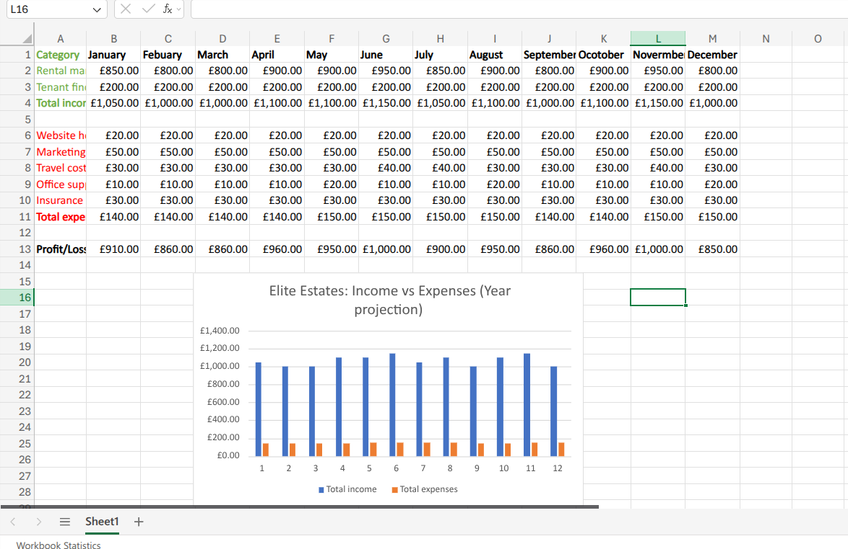

Figure 1: One Year Business Finance Projection (Income vs Expenses)

Word count: 750

REFRENCES
Adisa, Z. (2025) The impact of Excel on decision-making in financial institutions, DEV Community. Available at: https://dev.to/zeeintech/the-impact-of-excel-on-decision-making-in-financial-institutions-301a (Accessed: 29 March 2026).
Charlesworth, L. (2024) What is Microsoft Excel used for and is it still relevant?, Accountancy, bookkeeping, tax and finance training courses. Available at: https://kaplan.co.uk/blog/features/is-microsoft-excel-still-relevant (Accessed: 29 March 2026).
Khan, M. (2025) How data-driven marketing improves your marketing strategy, Dashboard Wireframing Tool: Design and Present. Available at: https://www.mokkup.ai/blogs/how-data-driven-marketing-improves-your-marketing-strategy/ (Accessed: 29 March 2026).
Reisfield, A. (2025) Excel automation: 9 essential methods to save time, reduce errors, and streamline your workflows [updated for 2026], RSS. Available at: https://parabola.io/blog/how-to-automate-excel (Accessed: 29 March 2026).
Roelofs, E. (2022) The five benefits of data visualization: Deloitte Netherlands, Deloitte. Available at: https://www.deloitte.com/nl/en/services/tax/perspectives/bps-the-five-benefits-of-data-visualization.html (Accessed: 29 March 2026).
Sharma, V. (2024) Impact of digital tools on operational efficiency, smartData. Available at: https://www.smartdatainc.com/smartians-speak/impact-of-digital-tools-on-operational-efficiency/ (Accessed: 29 March 2026).

Sutton, N. (2024) 7 reasons why forecasting is essential for your business, OneAdvanced. Available at: https://www.oneadvanced.com/resources/7-reasons-why-forecasting-is-essential-for-your-business/ (Accessed: 29 March 2026).

List of figures

- Figure 1: One Year Business Finance Projection (Income vs Expenses)

