Problem solving and decision Making (task 2)
Student name: Wintana Menghisteab
Student ID: 1921679
Name of the University: University of Wales Trinity Saint David
Name of the Lecturer: Gasso Wilson Mwaluseke

Cover Page
Employee Job Dissatisfaction at Caffe Nero Company Ltd
Table of contents
- Abstract
- keywords
- Introduction and background
Background of Caffe Nero company and problem statement
- The problems that lead employees to be dissatisfied
- Impact
- Literature review
- Analysis of their findings
- Conclusion
- Reference

Abstract
According to Neil F. (2019), the UK's career path is increasingly filled with mental health problems, such as depression, stress, and anxiety. According to research by Robert Half UK on 23,000 workers more than one in eight British employees are not happy and satisfied with the work.
England has been declared as a country with more unhappy and dissatisfied workers. Neil F. (2019).
In this report I will describe and analyse the problems of job dissatisfaction and the impact they have on the workers in the company where I work (Caffè Nero), and the comparison with the research I will conduct that will help me find a more appropriate solution to the problem.
I will evaluate alternative solutions to the principal problem (dissatisfaction in the field of work), we will analyse the data by applying the resolution techniques that we learned at school.
We will develop a plan for the realization of the solution and evaluate the appropriate monitoring techniques to ensure the execution of the solution ending.

Keywords: Work-life balance, solving, dissatisfaction at work, analyse, motivation, efficient communication.

Introduction and Background (Background of Caffe Nero Company and Problem statement)
According to Caffè Nero (2015), Caffe Nero is an English coffee shop, with an Italian style based in London.
Launched in 1197 by Gerry Ford, it is a company that currently has more than 1000 coffee shops in eleven countries, with more than 9,000 people working for them. Caffè Nero (2015).
I am one of these 9,000 people, working in a company that runs a lot of cafeteria leads to not having communication between workers and managers and Caffe Nero is one of them.
The problems that lead employees to be dissatisfied are:
- 50% said they don't have work-life balance, feel stressed, bad communication at work and don't feel valued.
- 35% said there was no communication within the company and received no motivation.
- 10% declared Caffe Nero is a momentary company and that their desire to change jobs.
- 5% have no interest in the subject because they think the situation will not change.

Impact
Workers' dissatisfaction in the workplace has a negative impact on their daily lives.
- 50% of people impact: work drains them to such an extent that they cannot have a life outside of work, which leads them to have a negative lifestyle mentally (they are stressed and frustrated) physically (they are almost always tired that they cannot take care of themselves).
not feeling valued, leads them to have little self-esteem of themselves and their ideas thus creating a vicious circle of negative ideologies about themselves.
Bad communication within the company does not allow workers to solve problems that create frustration.
- 35% of people: communication that does not take place within this company causes a negative work-place environment that makes one feel uncomfortable and compresses the enthusiasm of the worker.
- 10% of people: they want to change jobs because they are tired of the negative situation that they are living at work and want to make new experiments as the company does not give them anything to grow.
- 5% of people have given up and the situation they are experiencing at work, which will lead them in the future to give up easily and not to express their opinions.
According to Bryan L. (2021) The impact that the company has on the people is not only in the field of work but also in everyday life.
Land companies that do not listen and do not recognize the needs of their employees to keep a healthy life and balance with work are suggesting their productivity levels at work. Bryan L. (2021).

Literature review (secondary data)
Work-life balance and value
According to Alan K. (2018), the harmony between professional and private life is important in the field of work, because it reduces stress and burnout (mental exhaustion caused by stress that damages you physically and emotionally).
If the balance is not right (too many work hours, insufficient holidays and no relationships outside the work field), it can create mental and physical problems such as depression, anxiety and chronic pain that cost companies a lot of money.
To create a work atmosphere which, as a result of the balance between private and professional life, can maintain a healthy and productive workplace.
Such creation of a flexible atmosphere can satisfy the needs of the worker by reducing problem and transmitting healthy habits.
Valuing employees is very important because they thus remain connected and interested in the project that the company builds.
In order to implement the Project, companies should give the opportunity to expand the experience of workers and social relationships.
It is very important that this balance should be achieved over time, in the economic and cultural field in such a way as to grant the happiness of the worker in the years to come. Alan K. (2018).
Communication and motivation
According to John P. (2017), motivating your team is important because it does not only helps you increase productivity levels for your business but also to create their skills.
One thing that can help is the communication that makes your workers feel comfortable and part of the company not only as employees. This will improve their motivation.
Effective communication helps your team improve their decision-making course but also their loyalty and trust.
Giving importance and listening to your employees, makes them feel appreciated and will give them the right motivation to work as good as they can. John P. (2017).
Change work and Why Employees Lose Interest to Work?

According to Marco T. (2021), even though changing work is stressful, many people will still do it to obtain new skills and experiences.
Employees need stimuli that always keep them active within the field of work such as a growth of the career (work), that makes them develop new stimuli, face new challenges, create a better work environment and improve their quality of life.
If these aspects were not to develop within the company, employees would lose interest in their work, and this can cause productivity to drop. Marco T. (2021).

Analysis of the findings
Method
To analyze the dissatisfaction of the work at Caffe Nero company (where I work), I decided to create a questionnaire, which will help me collect and find how unhappy the workers are and what impact has on their private lives.
The questionnaire was completed by 55 people, who work for different stores (coffee shops), in different areas.
To get a broader view on the issues, I used online articles and sites that gave me the chance to analyze unhappiness at work (second data).
The main dissatisfactions I found were the lack of work-life balance, bad communication, stress and the lack of feeling evaluated.

Definition of the complex problem
(Employee Job Dissatisfaction at Caffe Nero Company Ltd)
According to Anita P. (2011), work-life balance is a term to describe the conflict between work and life.
When the conflict comes to light it means that work requires not only the use of your time at work but also that of your free time (which you could spend with your family or friends). Anita P. (2021).
Caffè Nero employees are dissatisfied with too many work hours and the stress that leads them to be constantly tired not having so much time for them.
The feeling that the company transmits to me and my colleagues is of not being heard or taken into consideration, thus leading us to feel unevaluated (as workers and as people).

Cause-effect analysis
According to Jonathan T. (2019), to find an effective solution we need to identify defects and failures within the path. Jonathan T. (2019)
That is, I have to break down the problem at the root to find the effects that cause the problem.
From the data analyzed I can say that:
- the work environment does not give motivation and morals to employees that leads them to increase stress even after the work is finished and to disinterest.
- The pay is not enough, this leads us to do more hours (a lot more than those contracted to pay us the expenses), which leads us not to have free time for us.
- They don't have a strong company culture this mean that they don't have core values that creates a natural divorce from Caffe Nero.
- Management does not listen to employee’s problems that create frustration.

An evaluation of alternative solutions to the complex problem
Finding alternative solutions to the complex problem will help us choose the correct decision to solve the work-life balance and communication problem (we cannot be 100% sure it's an effective solution).
Thanks to the research carried out and the data found within the questionnaire, I classified 5 solutions that could help us find a more effective system to solve our problem.
- Creating a flexible working environment with effective communication: According to Eleanor W. (2020), this will help employees to be responsible for organizing, and managing their time, such as participating in the kidneys from home or changing hours, thus giving them the opportunity to have control over their working days so as to have a balance between private and professional life. Communication is a process that must give the worker the opportunity to talk and discuss with their boss about problems or constructive feedback, thus reducing the stress of employers that would make them feel more relaxed about knowing that they have the support of their company. Eleanor W. (2019).
- More holidays for employees: According to University of California (2021), an increase in holiday, could help improve workers' performance in productivity and communication.
Being more relaxed they would feel able to face a working day with greater positivity.
- Activities that stimulate positivity:
Create Group activities once a month to maintain positivity at work.
As with trips with your employees or meetings outside the work structure, this helps the growth of friendships within your company by making your employees feel not only workers but also part of a family.
- Having a psychologist: so, you have someone to talk to about work
- Giving more power to the workers: so they will see themselves as part of the company.
- The most appropriate option
After an evaluation of the workarounds, using swot analysis (which helps you limit and evaluate decisions in a way that understands what you're missing and takes away the chances of failure), the best choice would be to create a flexible work environment with effective communication.
According to Reagan Nickl (2020), the strengths of this solution are:
- Moving away from the rigid demands of work: more flexibility in managing work
- Greater autonomy for workers: it allows employees to organize themselves more effectively.
- Feeling comfortable: with effective communication, employees will open up more
- Morals and positive culture: having the opportunity to attend meetings outside the store creates an esteem for the culture of the company
- Create a relaxed atmosphere and improve your bond with the company

According to minutedock (2020), the weaknesses of this solution are:
- There may be people who work better when they are in a rigid work field: for example, a work camp with precise hours.
- It's hard to know what your remote dependencies do: during a meeting you don't know if they're really following.
- You get distracted more easily: during a meeting you could get caught up in other things
According to CIPD (2019), the opportunities it offers are:
- More free time: Not having to stay an hour longer for meetings you have time for yourself
- Organizing yourself: an opportunity that makes you feel apricated by the company that trusts you.
- Development of new skills: the responsibility to organize will grow on new aspects
- Growing up in the working carrier: having more organization of time you will be able to achieve your goals as a promotion.
- Learning new things about yourself
- More confidence property
- Create good vibes: better communication between the company and you can help create a pleasant work space.
According to Performance dimensions group (2013) the threats would be
- Excessive flexibility: too much freedom [would create a problem within the company.
- Little self-organization: people who don't have the ability to manage themselves, can find the work field much more complicated.
Develop a plan for the implementation of the solution
According to Louise von M. (2020), to implement our decision to create a flexible working environment with effective communication must have a plan that helps us understand and evaluate change. Louise von M. (2020)
The awareness of the meeting with our workers, to have better communication and to let them organize more on their own.
The desire to always motivate our team to make them feel motivated and important as prizes.
Knowledge in the rate of courses for workers so as to give them the opportunity to grow (training).
The ability of empowering your employees asking their opinion and communicating more with them.
And reinforcement by giving them tools by visiting them and try to understand how to communicate with them.
Sharing the plan with the stakeholders
The company should notify us of these changes within a happy time for example the Caffè Nero party.
Inside the initial talk where we are told the news of the company.
Conclusion
I evaluated and analyzed the complex problem (Employee Job Dissatisfaction at Caffe Nero Company Ltd), which gave me the opportunity to see and understand aspects that I did not know.
The solution that I analyzed has been in my opinion the better and I believe that in the future the company can take into consideration these aspects important for the dependents.
According to Hanna Weinhold (2018), greeting workers is essential as it promotes productivity, communication and increases the working environment.

Reference

Neil, F. (2020). One in eight people are unhappy at work. [online] workplacesight.net. Available at: https://workplaceinsight.net/one-in-eight-people-are-unhappy-at-work/ [Accessed 17 April 2021].

Caffè Nero (2021). Our Story. [online] caffenero.com. Available at: https://caffenero.com/uk/about-us/our-story/ [Accessed 17 April 2021]
- Bryan L. (2021). Why it's wrong to look at work-life balance as an achievement. [online]. Available at: https://www.bbc.com/worklife/article/20210302-why-work-life-balance-is-not-an-achievement [Accessed 17 April 2021]
- Alan K. (2018). The Evolving Definition of Work-Life Balance. [online] forbes.com. Available at: https://www.forbes.com/sites/alankohll/2018/03/27/the-evolving-definition-of-work-life-balance/?sh=2b363e629ed3 [Accessed 18 April 2021]
- John P. (2017). Communication Techniques That Motivate Others To Become Better. [online] inc.com. Available at:https://www.inc.com/john-rampton/communication-techniques-that-motivate-others-to-become-better.html [Accessed 18 April]
- Marco T. (2021). Motivi per cambiare lavoro. [online] marcotogni.it. Available at: https://www.marcotogni.it/motivi-cambiare-lavoro/ [Accessed 19 April]
- Anita P. (2011). Work life balance. [online] researchgate.net. Available at: https://www.researchgate.net/publication/264994749_Work_Life_Balance_Problems_and_Solutions_for_the_Fire_Rescue_Service [Accessed 19 April]
- Jonathan T. (2019). Fishbone Diagram: Determining Cause and Effect. [online] reliableplant.com. Available at: https://www.reliableplant.com/fishbone-diagram-31877 [Accessed 20 April]
- Eleanor W. (2020). Making flexible working work. [online] peoplemanagement.co.uk. Available at: https://www.peoplemanagement.co.uk/long-reads/articles/skills-hr-need-2021-make-flexible-working-work#gref [Accessed 20 April]
- Desmond J., Cooperative Extension agricultural economist and director, UC Small Farm Program, from the Agri-tourism Workgroup and Resources, Oregon Department of Agriculture (2021). Why People Vacation. [online] sfp.ucdavis.edu. Available at: http://sfp.ucdavis.edu/agritourism/factsheets/why/ [Accessed 21 April]
- Reagan N. (2020). The Advantages of Flexible Work Environments. [online] spaceiq.com. Available at: https://spaceiq.com/blog/flexible-work-environments/ [Accessed 21 April]
- The Advantages and Disadvantages of Having Flexible Working Hours. [online] minutedock.com. Available at:
- https://minutedock.com/academy/advantages-and-disadvantages-of-flexible-working-hours [Accessed 22 April]
- CIPD (2019). Stress, overwork and poor work-life balance undermine UK job quality. [online] cipd.com. Available at: https://www.cipd.co.uk/about/media/press/poor-work-life-balance#gref [Accessed 22 April]
- Performance Dimensions GROUP (2013). 4 daunting threats to work/life balance. [online] pdgroup.net. Available at: http://www.pdgroup.net/articles/4-daunting-threats-worklife-balance/#.YI2bGi1Q3Uo [Accessed 23 April]
- Louise von M. (2020). How to take Adkar change model from theory to practice. [online] howspace.com. Available at: https://www.howspace.com/resources/how-to-take-the-adkar-model-from-theory-to-practice [Accessed at 24 April]

Appendix (FIRST DATA)
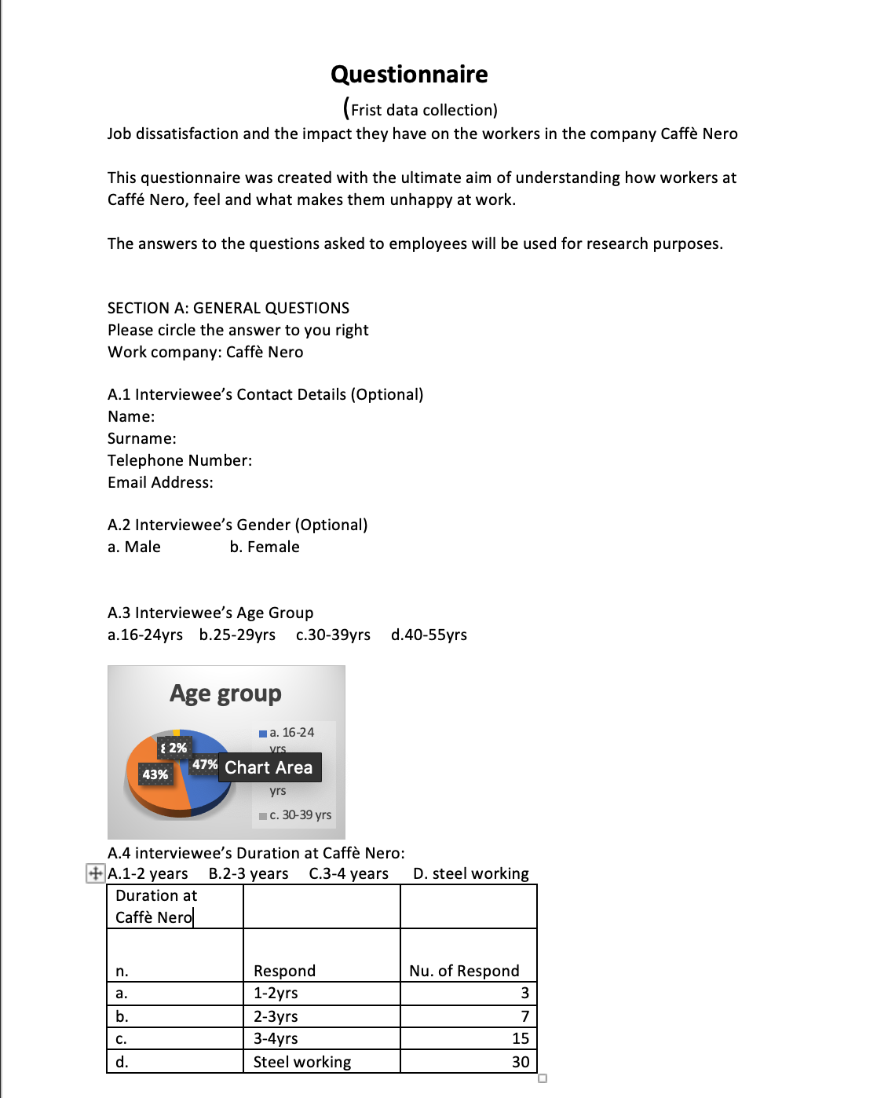

Appendix (FIRST DATA)
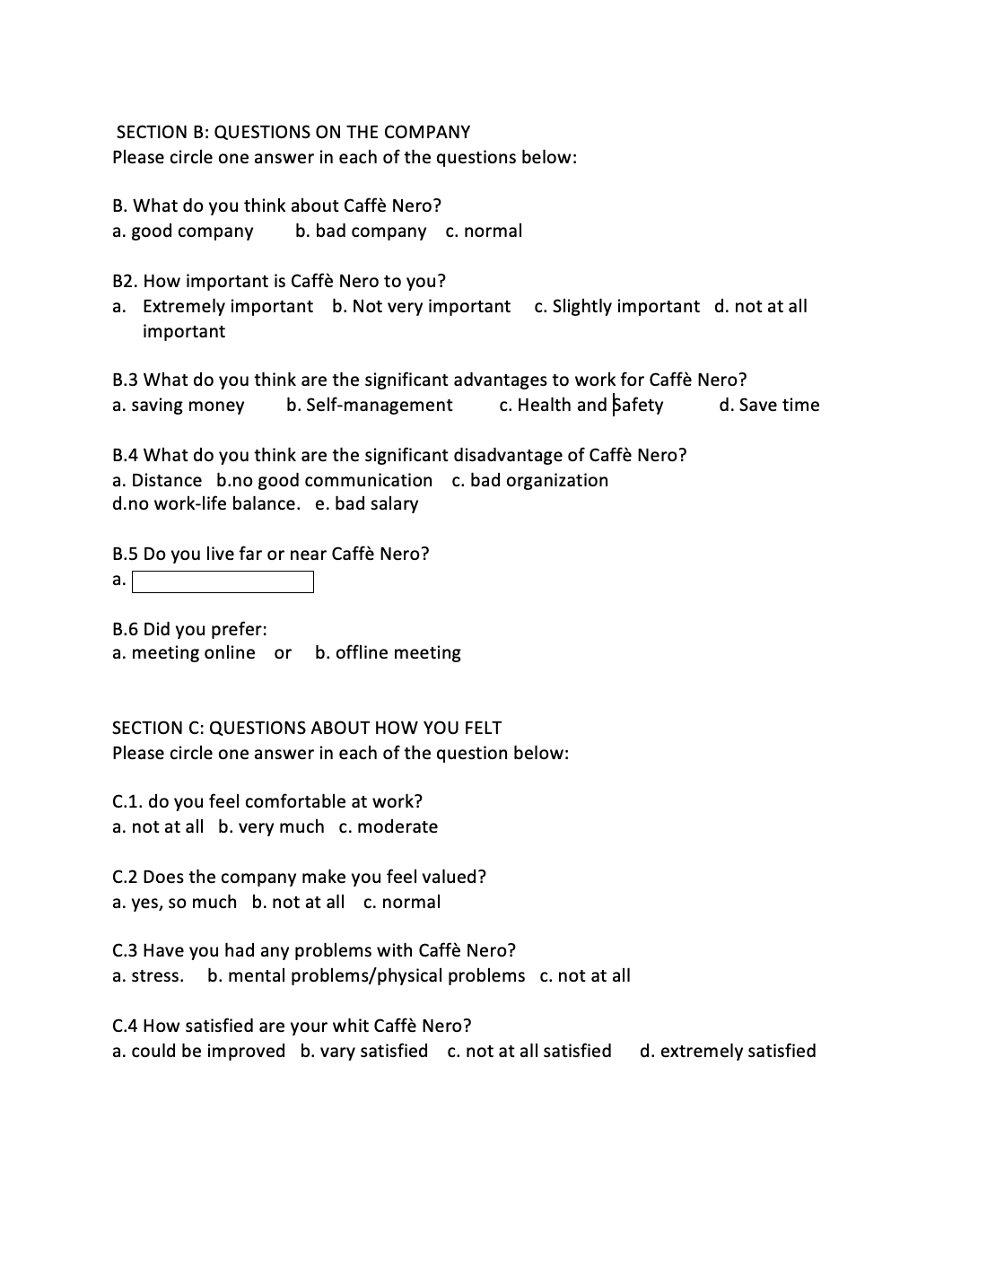

Appendix (SECOND DATA) 

