Applied Leadership and Management
Module Assignment Submission
Student Name: | Jessica Gillingham
Student Number: | 2318119
Module No: | BMSK 4012
Module Title: | Enterprise and Intrapreneurship

Statement of Confirmation of Authenticity
By the act of making this submission, the student declares that this is the work of the student named above. The work has not, in whole or in part, been knowingly presented elsewhere for assessment, or where assessment has been built on a previous assessment, this has been identified. Where materials have been used from other sources it has been properly acknowledged. If this statement is untrue, the student acknowledges that an assessment offense has been committed.
Attention is drawn to the plagiarism and unfair practice policies of both the University and of ILM.

Table of Contents
Executive Summary 2
2. Introduction 2
3. Financial Information: 3
3.1 Fixed costs 3
3.2 Pricing and consumable cost (£ per service offering) 5
3.3 Time and capacity monthly 5
4. Marketing. 8
4.1 USP’s. 8
4.2 PEST and SWOT Analysis 9
5. Revenue and Pricing Strategy: 11
6. Operations 11
7. References 11

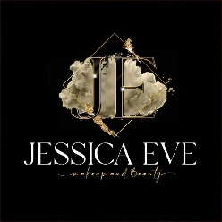
Business Plan

Name of Business Jessica Eve Make Up Artist
Date 29 June 2024
Version 1.0

1.Executive Summary
I am Jessica Eve Gillingham, an established and successful salesperson with a passion for art, beauty, and makeup.

The business plan describes the realisation of my dream, to become a professional Beauty & Makeup Artist operating as a sole trader.As a professional in the business to consumer and business-to-business sales (experience and training gained from telecoms, finance, and internet companies) I have the skills required to market and sell the services I will be offering through cloud-based portals, social media, telephone, local campaigns (to include leafleting, demonstrations, networking, cross-selling opportunities and more).

In researching the business opportunity, I have assessed not only the market but also my suitability by investing in hands-on and theoretical training in delivering the offering to the client base. During this initial training, I have become an expert artist.

2. Introduction
In this assignment, I will identify how I can develop my business by having a clear business plan in place. Always having the end goal in sight is important so you know where you are going. One of the ways to do so is to use support mechanisms and understand the skills and knowledge needed for working effectively. One of those systems is “GO MAD Gilbert, A. and Chackrovaity, I. (2001) “Go Mad: about coaching”. Bath. Bath Press
This allows you to Establish business goals and develop a persona/business plan.
I will continue to outline how I can develop in business financially, how I will continue to grow, which marketing methods will be used, and how much money I need to make to survive as a business.
The business idea is to become a professional beauty and makeup artist who expertise in HIFU, initially operating as a sole trader and delivering services to the local market from a fixed studio as well as operating a mobile offering.

The legal status is to be a SOLE TRADER.

I will be the entire business owner, purchasing initial stock and required equipment from savings. The initial investment will be treated as a loan and repaid monthly. The studio is to be rented, and I will make use of my own vehicle for the mobile service.

The services on offer are various aspects of beauty treatments generally to enhance a customer’s facial appearance. Additional premium level treatments use purchased equipment to supplement the application of the makeup or in one particular case use of ultrasound to improve skin tone in and around the face and the intermate area (HIFU). HIFU is the main source of my business and is a new technology HIFU uses focused ultrasound energy to target the layers of skin just below the surface. The ultrasound energy causes the tissue to heat up rapidly.
Once the cells in the targeted area reach a certain temperature, they experience cellular damage. While this may seem counterintuitive, the damage stimulates the cells to produce more collagen — a protein that provides structure to the skin.
The increase in collagen results in tighter firmer skin with fewer wrinkles. Since the high-frequency ultrasound beams are focused on a specific tissue site below the skin’s surface, there’s no damage to the upper layers of the skin and adjacent tissue. You can use HIFU to tighten the appearance of skin here are some photos from my own portfolio the results are outstanding.
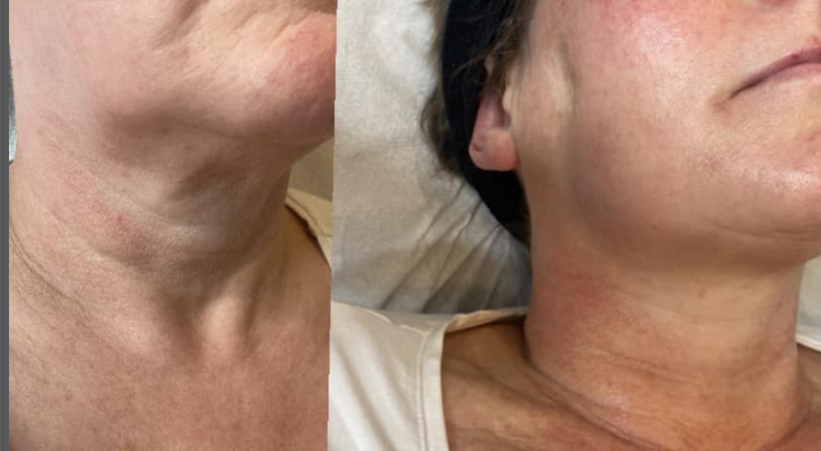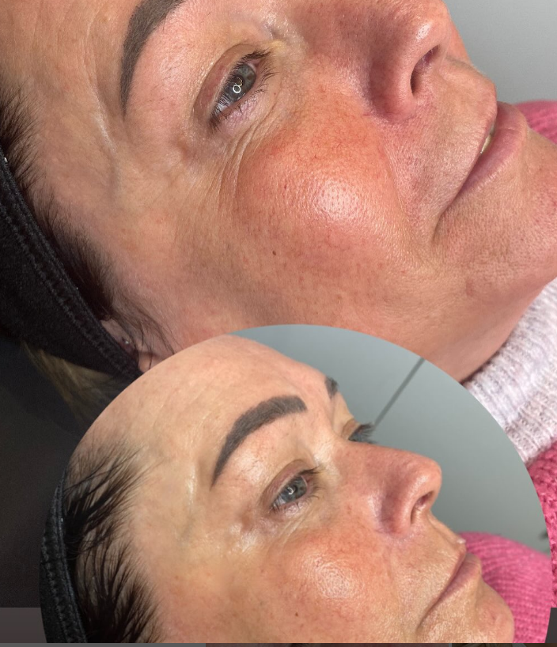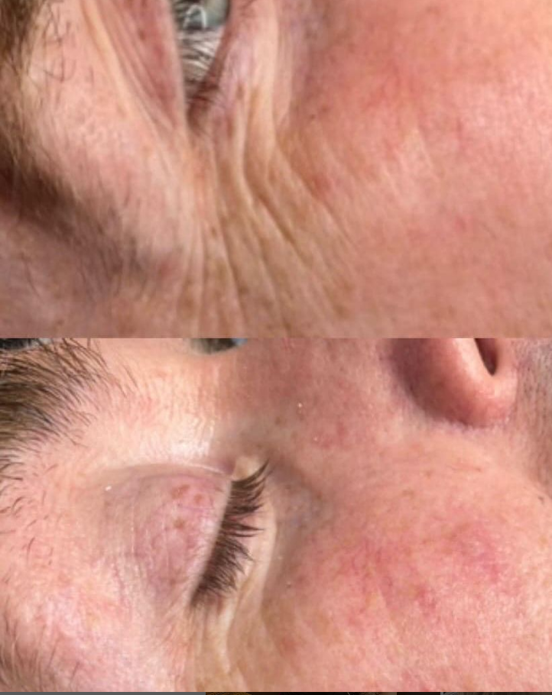

As the aesthetic industry is rapidly growing. The choice to invest in this technology was at the exact right time as many influencers and celebrities swear by the treatment the target market is people who are over 30 and already spent money on these treatments such as Botox the technology is an alternative to injecting your skin with poison and relying on your own body. Another aspect is hifu for tightening the intermate area of a female body to help with stress incontinence this isn’t offered by any other practitioner within a 5mile radius also it isn’t marketed due to the private nature and women feeling embarrassed this is something I aim to change creating a comfortable environment were my clients trust me because I myself as a mother feel that this should be talked about and there should be a solution UK population-based cross-sectional postal study of 1415 women found a prevalence of urinary incontinence of 39.9%. Nearly half of women were asymptomatic, but there were symptoms of [ Cooper et al, 2015 ]

The treatments will be offered in both a studio and mobile to customer locations. This ensures resilience should there be a difficulty with the studio and/or the vehicle and delivers an additional level of service compared to the competition.

All treatments are stand-alone applications; however, they are all complimentary. This allows for the introduction of multi service discounting, offering a reduced price to the customer whilst at the same time a reduced cost to the business.
The beauty industry is not just about looking good its self-care and therapy for some clients by offering multiple services all under one roof takes the stress away from the client as some people find it daunting which over all this is a service which should make you feel good with my business I make everything ng personal it’s like catching up with a friend it’s fun its good for mental wellbeing research done by HELLO magazine Macleod (2023) found study by salon product provider Kao revealed that despite the cost-of-living crisis, more than half of people surveyed still plan to spend the same amount of money on beauty, while 70% of people say visits to the salon count as self-care, and like me, 51% of people say they're as close to their stylist as they are to their friends.

3. Financial Information:

3.1 Fixed costs
The fixed costs are derived from negotiations and a full understanding of the various elements that will be required for the running of the new venture.

Studio rental is a contracted item. Should the price increase during the contracted period the additional cost will be covered by marginal increases in the service offering pricing (see below table under-pricing and consumables cost for a full list of services)

Vehicle running costs include for insurance, tax, fuel and general maintenance of my own vehicle. These have been estimated to cover journeys up to 15 miles from my home or studio location, with a maximum of 21 mobile sales per month, i.e. approximately 300 miles per month. This does not include private use of the vehicle. It is expected that the vehicle costs will be recovered from the business via expenses management.

Vehicle replacement. It is recognised that a good quality serviceable vehicle is essential to the initial, ongoing and future success of the business. Therefore, a monthly provision has been set aside in order to allow for the purchase of a replacement vehicle in five years. This money will be invested into an interest earning account, however currently the potential interest earned is not included.

Equipment replacement. Similar to the vehicle equipment is vital to the success of the business. Based on warranties and manufacturers information it is expected that over five years all the equipment will need replacing at least once. The total cost for replacing all the equipment is covered by this provision. Again, the monies set aside will be invested.

Non beauty consumables. This provision is for items used and not covered by the costs of the direct treatment. Included in this category are things such as cleaning and disinfectant solutions, stationary, good will items and the like.

Insurances. These include public liability insurance, equipment breakage, loss of earnings due to unexpected eventualities etc.

Training revision. In order to operate in this industry certain certification is required to demonstrate to the customers that the service is safely delivered by a professional. Further, to maintain insurance cover certification is required. This provision covers for revision training and associated costs (travel, accommodation etc) every three years.

Software, website, antivirus web-booking etc. bundle. This package has been purchased on a contracted monthly remuneration basis. Should costs increase these will be covered by marginal increases in sales price where necessary.

Telephone. The monthly contract rate for unlimited use.

Wages. This is what I will pay myself (my drawings from the business). It is based on the expected turnover, and at a rate of just over £15 per hour for the service delivery time, or £11.50 per hour for a 40-hour week. These rates have been selected to allow for a reasonable living wage but with the potential to increase based on improved turnover above an initial 75% capacity expectation.

Risk. In life and certainly in business there may be unexpected eventualities not covered elsewhere. This risk provision is to allow for those situations. Ongoing this money will be placed in an interest earning account.

Repayment of startup finances. To get the business off the ground I invested £6000 of my own savings. I intend recuperating this money at a rate of £500 per month. Once these monies have been repaid there is the expectation that the monthly sum will be re-invested into the business in future years.

Item | Monthly £ | Annual £
Studio rental (Inclusive of electricity, waste disposal, water etc) | 820 | 9840
Vehicle running costs | 500 | 6000
Vehicle replacement (5-year plan) | 300 | 3600
Equipment replacement (5-year plan) | 200 | 2400
Non beauty consumables | 68 | 540
Insurances | 23 | 276
Training revision | 40 | 480
Software, website, antivirus, web booking etc bundle | 120 | 1440
Telephone | 50 | 600
Wages (after tax, pension etc) 30 hr week | 2000 | 24000
Risk (additional to cover unexpected events) | 500 | 6000
Repayment of startup finances (36mth plan) | 500 | 6000
Total | 5098 | 61716

3.2 Pricing and consumable cost (£ per service offering)
For each service offering the revenue, which is also the sale price, is derived from market research and cost build up. This has included an evaluation of businesses with a similar offering, understanding the costs, both fixed and variable, and the volume (no. of appointments) at which the business will operate. That capacity is based on a 30-hour operational week, which will give me time for additional functions such as marketing, purchasing, and general business administration. The cost detailed in the table below is purely for the consumables (makeup, creams, wipes etc.). The gross profit is simply revenue minus cost.
Service | Delivery point | Revenue £ | Cost £ | Gross profit £
Facial makeup | Studio | 45.00 | 12.00 | 33.00
Facial makeup | Mobile | 55.00 | 12.00 | 43.00
Eye lashes | Studio | 25.00 | 8.00 | 17.00
Eye lashes | Mobile | 35.00 | 8.00 | 27.00
Eyebrows | Studio | 15.00 | 5.00 | 10.00
Eyebrows | Mobile | 25.00 | 5.00 | 15.00
Deep cleansing | Studio | 55.00 | 7.00 | 38.00
Deep cleansing | Mobile | 65.00 | 7.00 | 48.00
Special occasion (e.g. wedding)  NB. Additional charges may apply | Studio | 225.00 | 60.00 | 165.00
 | Mobile | 275.00 | 60.00 | 215.00
High intensity focussed ultrasound (HIFU) | Studio | 145.00 | 15.00 | 130.00

3.3 Time and capacity monthly
It is expected that delivering the services will take approximately 30 hours per week. The time taken per service offering and the expected number of appointments is detailed in the table below. It should be noted that some of these services can be delivered in a discounted and time efficient bundle, however this fact is not included.
Service | Delivery point | No. / mth | Op. hrs each | Tot op hrs | % time
Facial makeup | Studio | 50 | 0.75 | 37.5 | 35.5
 | Mobile | 10 | 1.25 | 12.5 | 11.9
Eye lashes | Studio | 25 | 0.25 | 6.25 | 6
 | Mobile | 5 | 0.5 | 2.5 | 2.5
Deep cleansing | Studio | 25 | 0.25 | 6.25 | 6
 | Mobile | 5 | 0.5 | 2.5 | 2.5
Special occasion (e.g. wedding) | Studio | 1 | 8 | 8 | 6
 | Mobile | 1 | 10 | 10 | 9.6
High intensity focussed ultrasound | Studio | 20 | 1 | 20 | 20
Totals |  | 142 | N/A | 105.5 | 100

3.4 Expected Revenues and profit.
For each service and based on the business capacity the expected revenues and profits are set out in the table below. The profit has been calculated at 100% of business operating capacity and at 75% of business operating capacity. These figures are crucial to the understanding of the viability of the business. By considering the monthly fixed cost (£5089 per month) and the Profit 75% figure below (£5109 per month) the viability of the business is demonstrated at 75% capacity. There is the potential to offer multi service discounting to improve profit and reduce required operational hours. This would free up more business capacity. Further it can be seen that concentration on more profitable lines would allow for increased overall profitability, however a general spread of services is essential for maintaining steady income and loyalty of customers.

Service | No. | Rev. (£) | Cost (£) | Profit (£) 100% cap. | Profit (£) 75% cap. | Profit (£) 50% cap. | Op. hrs | To top hrs | % prof
Facial stud. | 50 | 2250 | 600 | 1650 | 1238 | 825 | 0.75 | 37.5 | 26.8
Facial mob. | 10 | 550 | 120 | 430 | 323 | 215 | 1.25 | 12.5 | 6.5
Lash stud. | 25 | 625 | 200 | 425 | 319 | 213 | 0.25 | 6.25 | 7.4
Lash mob. | 5 | 175 | 40 | 135 | 101 | 68 | 0.5 | 2.5 | 2.1
DC Stu. | 25 | 1125 | 175 | 950 | 713 | 475 | 0.25 | 6.25 | 13.4
DC mob. | 5 | 275 | 35 | 240 | 180 | 120 | 0.5 | 2.5 | 3.3
SO, Stu. | 1 | 225 | 60 | 165 | 124 | 83 | 8 | 8 | 2.7
SO Mob. | 1 | 275 | 60 | 215 | 161 | 108 | 10 | 10 | 3.3
HIFU | 20 | 2900 | 300 | 2600 | 1950 | 1300 | 1 | 20 | 34.5
Total | 142 | 8400 | 1590 | 6810 | 5109 | 3405 | N/A | 105.5 | 100

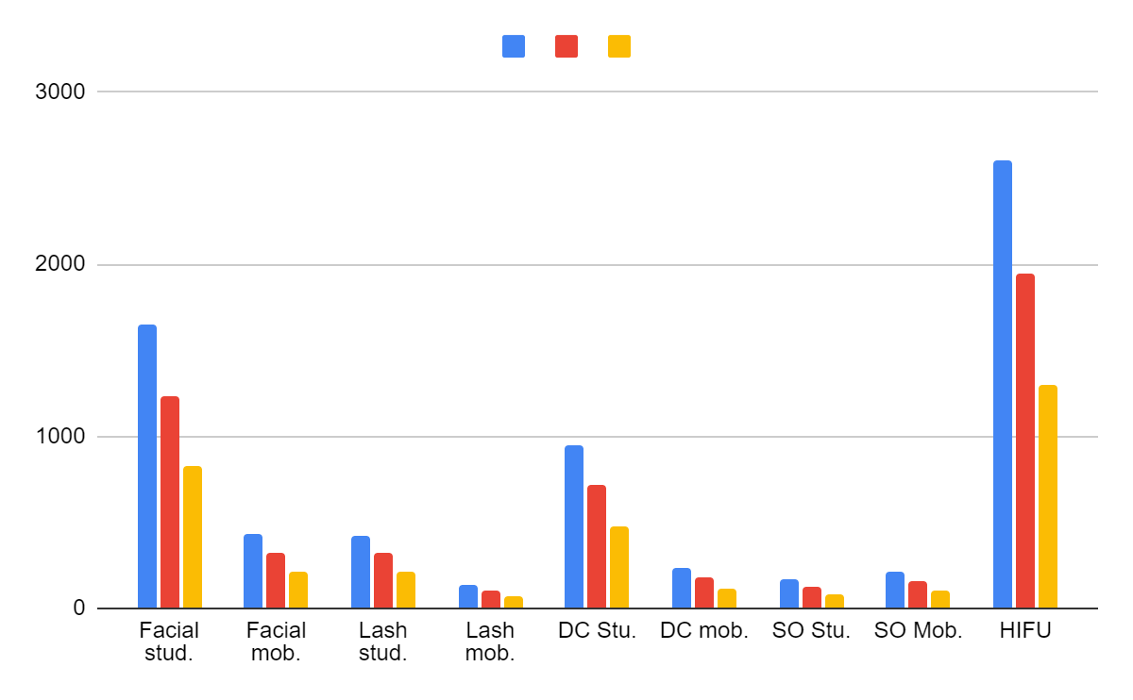
Therefore, at an operational capacity of 75% of available operational hours the projected profit per month is £5109.
The fixed costs per month regardless of the number of sales is £5098.

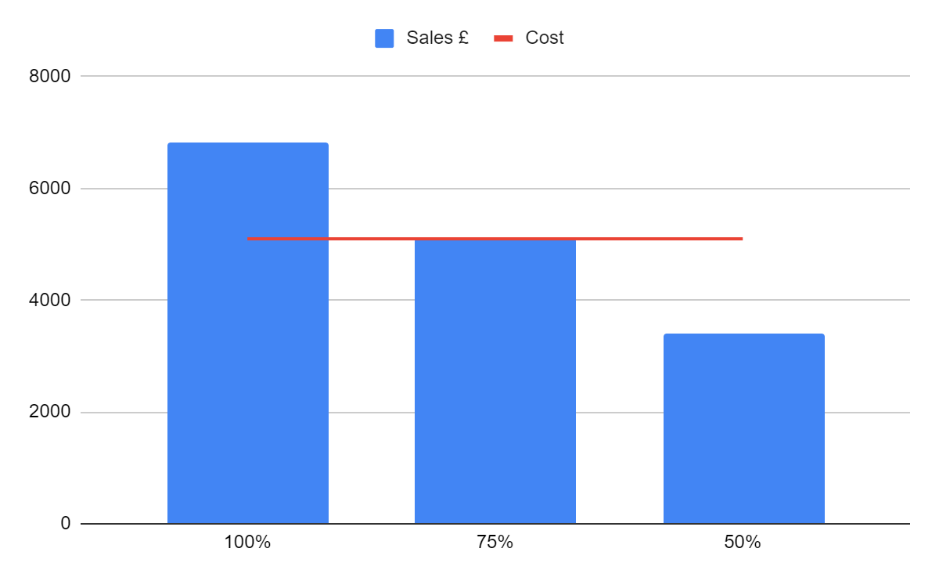
The conclusion is that to maintain a successful business it must operate at a minimum of 75% capacity, but also offering sales across the range of the services offered.

4. Marketing.

The marketing strategy has been derived by researching similar businesses and considering the wide range of available marketing package offerings.

Cross selling – The business is to be located within a premises that has a hairdressing and nail services salon to an established clientele. This clientele will be introduced to the services that are offered by my business. Similarly, I will be introducing my customer base to this hairdressing and nail business.

Local advertising. My business cards and leaflets have been distributed to all local business that allow leaflet advertising on their premises. From time to time, I will have campaigns such as newspaper advertising to possible appeal to clientele not so versed in social media etc.

Social media. This is the main method of advertising the business. I have portals to all the most popular services such as Instagram, Facebook, TikTok etc and will regularly update with new postings of news, successes, locally focussed advertisements and the like. With social media I regularly vlog on my platforms to create a personal rapport with my clients I document my progress of my treatments my clients and potential clients feel like they know my business on a personal level intern makes all marketing I do on those platforms personal and relatable. According to Belle Wong, J.D.2023 Forbes “ 76% of social media users have purchased something they saw on social media”.

Internet booking service Booksey is used to advertise promotions to existing clientele via email and text and booking system, which is connected to Google, Instagram and Facebook.”

An article by Business wire (H.Ashcroft 2021)Booksy solves the challenges of day-to-day operations for service providers, empowering small business owners across the globe by providing them with the tools they need to successfully run their businesses. Instead of spending time returning missed calls or text messages, service providers can focus on their craft. Booksy allows users to automatically schedule appointments at a time that suits them, resulting in 38% of customers booking after hours and increasing visit frequency by 20%, which in turn generates more revenue for the service provider. Data also suggests that by implementing Booksy’s software, service providers can save the equivalent of 12 working days a year, on average.”

Telemarketing. Using expertise gained from previous employment I will tele-market opportunities to existing and potential clients I have a current client base of 1000 which I will call text and email.

Local embedding. I will network and spread the word of the service offering at every local opportunity, including social events, conferences and exhibitions and through word of mouth. The service offering will be nothing short of exceptional with fantastic customer service, my network of social and business contacts is extensive, and therefore I expect this to be a successful route.

4.1 USP’s. The unique selling points I bring to the market are:
- Locality, there is no competitor within a five-mile radius.
- Positioning along an established and complimentary business (hair and nails)
- Range, I have trained and qualified in many treatments to provide an absolutely unique package of services.
- Personalised, some of the treatments on offer are discrete, my personal service is unique in its delivery.
- Customer experience. I work exclusively for the customer, not an employer.
- Mobility, I am able to offer 60% of my services at customer locations, this is essential for weddings for example. If required I could increase this to 100%, however the HIFU system may prove to be prohibitively expensive if delivered remotely.

4.2 PEST and SWOT Analysis
I have inserted PEST analysis Aguilar.(1967) this will help me determine how Political, Economic and technological factors will affect my businesses performance and activities for the long term. This will also allow me to be prepared for any outside factors I already have a successful business and a good reputation, but it is important I prepare especially in the economic climate.

Pest Analysis
Political factors:  - Regulations and licensing requirements for beauty and cosmetic procedures  - Government policies related to healthcare and cosmetic treatments  - Tax policies related to beauty services.  Buying products from overseas an article done by Warn.2021 “Haulage costs have increased from £2.5k to £4.5k. Both courier and delivery costs to consumers have doubled, with alternatives costing up to 3 times that pre-Brexit.” | Economic factors:  - Disposable income and consumer spending trends  - Economic conditions and overall market growth  - Currency exchange rates that may affect the cost of equipment or products used in treatments
Social factors:  - Changing consumer preferences and trends in beauty treatments  - Demographic factors such as age, gender, and income levels  - Social attitudes towards beauty and cosmetic procedures | Technological factors:  - Advances in beauty technology and equipment, such as HIFU devices  - Integration of technology in beauty treatments and services  - Potential cybersecurity risks related to storing client information and payment data

I have done a table of SWOT (Humphreys, 2005) to indicate my strengths, weaknesses, and opportunities and threats. This will help, me identify my development needs for myself and my colleagues. The results are as follows.

Swot Analysis
STRENGTHS  1. High Demand for Non-Invasive Procedures: High-Intensity Focused Ultrasound (HIFU) is a non-invasive treatment for skin tightening and facial rejuvenation, which attracts clients looking for non-surgical options.  2. Advanced Technology HIFU represents a cutting-edge technology that can provide superior results compared to traditional methods, enhancing the beautician's reputation.  3. Quick Recovery Time: HIFU treatments typically have minimal downtime, making it convenient for clients and increasing client satisfaction.  4. Versatility: HIFU can be used for various treatments including face lifts, wrinkle reduction, and body contouring, allowing the beautician to offer a wide range of services. Option for people who don’t want to inject faces or take away the potential risks which come with traditional aesthetics  5. Higher Revenue Potential: Offering advanced treatments like HIFU can justify higher pricing, leading to increased revenue. Once the machine is purchased there isn’t really much more to pay for apart from maintenance of the machine | WEAKNESSES  1. High Initial Investment: The cost of acquiring HIFU equipment is significant, which can be a barrier for new or small businesses and can be seen as a risk because of the outlay.  2. Training Requirements Proper training is essential to safely and effectively perform HIFU treatments, requiring time and financial investment.  3. Potential Side Effects: While minimal, there is still a risk of side effects such as redness, swelling, or temporary discomfort, which can affect client satisfaction.  4. Competitive Market: The beauty industry is highly competitive, and standing out requires constant innovation and effective marketing strategies.
OPPORTUNITIES  1. Growing Market: The market for non-invasive aesthetic treatments is expanding, presenting an opportunity to attract a broader client base.  2. Technological Advancements: Ongoing advancements in HIFU technology can improve treatment outcomes and efficiency, providing a competitive edge.  3. Health and Wellness Trend: Increasing awareness and interest in health and wellness can boost demand for aesthetic treatments that contribute to overall well-being.  4. Expanding Client Demographics: With aging populations, more individuals are seeking anti-aging treatments, expanding the target demographic.  5. Partnerships and Collaborations: Opportunities exist to collaborate with other health and wellness businesses to offer comprehensive packages and reach a wider audience. | THREAT  1. Regulatory Changes: Changes in regulations and standards for aesthetic treatments could impact the ability to offer HIFU services.  2. Economic Downturns: Economic challenges can lead to reduced spending on non-essential services like beauty treatments.  3. Technological Obsolescence: Rapid advancements in technology could render current HIFU equipment outdated, necessitating further investment.  4. Competition from Alternative Treatments: New non-invasive treatments and innovations could draw clients away from HIFU.  5. Consumer Misinformation Misconceptions or negative publicity about HIFU treatments could deter potential clients.

4.3 Competitor Analysis
Locality. There is no other service offering within a five-mile radius of where I am setting up.

Competitor approach – Most competitors offer similar services from within established businesses via trained employees. Where this is obviously successful, it means that tailored offerings are not as personalised as those I offer, and sometimes employees ‘work for the business’ rather than the customer – in this industry the customer experience is vital in delivering ongoing success.

Competitor pricing. Competitors offer similar pricing throughout the wider geographical area. At start up I intend to position my pricing within this range, but I see the opportunity for extra value, luxury, and even reduced service pricing in the future.

4.4 Market sector
Initially the market sector is generally females, ages 16 and over. There is however a growing number of males interested in some of the services offerings. More specifically:
Service | Segment
Makeup | Female 95% Male 5% Age range 16 to 65
Eye lashes and eyebrows | Female 95% Male 5% Age range 16 to 65
Deep cleansing | Female 95% Male 5%, Age range 16 to 65
Special occasion (e.g. wedding) | Female 95% Male 5% Age range 16 to 55
High intensity focussed ultrasound | Female 100%, Mothers 80%, Age range 30 to 65

Market size
As this offering is to 50% of the local population, the market size is approximately 100000 persons within the radius of my local offering. Typically, a customer will have two full beauty treatments a year, lashes 3/month, others 4/yr,

Service | Frequency per year per 1000 people
Makeup | 1000
Eye lashes and eyebrows | 1000
Deep cleansing | 500
Special occasion (e.g. wedding) | 150
High intensity focussed ultrasound | 50

5. Revenue and Pricing Strategy:
- How did you arrive at your pricing strategy? The pricing strategy was derived by a combination of examination of the market, competition and then consideration of the fixed and variable costs, capacity (operational hours available) and an aspirational assessment of what I wanted to earn.
- How much will you charge for your goods and services?
The sale price for each of the services (price list) is set out under the financial information.
- How many income streams will you have?
There are 5 basic income streams.
- How much will you get from each income stream?
The revenue per income stream is set out in the financial information.

6. Operations
- How much will you get from each income stream?
See financial information.
- Locations, premises, equipment.
See financial information.
- Production and distribution processes
The business will be delivered from a main location, the salon, with supplemental services delivered on a mobile basis - see detail in the financial section.
- People, staff, suppliers
I will be a sole operator with no employees. All raw materials and consumables are ordered online from a multitude of suppliers. This allows for efficient and cost-effective purchasing.
- Systems and processes
Use a laptop to access cloud services such as the booking portal, suppliers and so on. All the business systems and process are cloud based. This gives security and flexibility.
- Health & safety, legal compliance.
The premises needs to be licensed for beauty treatments and aesthetics, this requirement is covered by the agreement between myself and the property, i.e. it is included.

7. References

- Humphrey, A. (2005). SWOT Analysis for Management Consulting. SRI Alumni Newsletter. SRI
- International. GO MAD Gilbert, A. and Chackrovaity, I. (2001) “Go Mad: about coaching”. Bath. Bath Press
- Cooper, J., Annappa, M. and Quigley, A. (2015) Prevalence of female urinary incontinence and its impact on quality of life in a cluster population in the United Kingdom (UK): a community survey. Primary health care research and development 16(4), 377-382.
- J., Aguilar, F. (1967). Scanning the business environment. Macmillan.
- Belle Wong, J.D. Top Social media statistics and trends 2024. Forbes Advisor
- Melanie Macleod , 2023 HELLO magazine.
- Harry Ashcroft,businessWire
- Grace warn 2021How is Brexit affecting the British beauty industry. British Beauty Council

