ACADEMIC AND EMPLOIABILITY SKILLS
BMSW4001
TUTORE: RITA UKACHI-LOIS

Student name: Ionut Razvan Gradinaru

Student Number:1906093

TABLE OF CONTENTS

1.INTRODUCTION
2.SUMMARY
3.DISCUSSION
4.CONCLUSION
5.REFERNCES

INTRODUCTION

The report is intended to show my learnings on this academic year and the skills that I have gained during my last semester as student and how those had helped me on my work. The year was very productive as the skills learned in class have helped me at my workplace and significantly improved my productivity and have helped me to save time.

SUMMARY

After last semester as student I have gained some valuable skills that I could not learn from somewhere else then attending to classes, starting from Time Management to Summarise all the skills have had a major impact in my life at work. I have studied and lecture over Moodle and the books provided and not the last in class exercises that helped me do understand and learn new knowledge. Team working is an big gain for me as it helped to develop and improve my team working and my cooperation’s with my colleagues, Summarising was as well very helpful as at the end of my shift I have to present an report with my activity during my day and learning this helped me to be more exact on reporting the vents that happen on my finishing shift, Problems solver and decision making learning was very helpful as all the times my work involved making decision under tension and learning new technics on how to classify my problems and how to make the very optimal decision was resulting in my work to be more efficient and more productive cutting down any errors made in the past. Communication was one of my favourite subjects as it did improve my vocabular and my grammar and helped me look more professional when having a conversation or writing my night report with my supervisor or my manager.

DISCUSSION

Subjects learned and chosen by me to expose and talk about in the follow report are: PROBLEMS SOLVER AND DECISION MAKING, TIME MANANGMENT, SUMMIRISING, TEAM WORKING, COMUNICATION.

Starting with problems solver and decision making I think this is an very important task that every person occur every day and that will reflect on his performance, making the perfect choose and the most rational decision sometimes you have to be capable to step out of the box and take an wider look from different angles and approach of your problem, identifying your problem is very important as it this will be your starting point in making the right decision. “Critical thinking is a process that emphasizes a rational basis for what we believe and provides standards and procedures for analysing, testing and evaluating our believe” (Ruinow& Barry 1994).

Critical thinking

Most people are having trouble making a critical thinking as this enable all of us to have and better understanding of the problem and put us in a position of having an neutral an cold view of that specific issue or problem that we have occurred and making an rational decision. In order to solve an problem the decision maker have to first identify and recognize that the problem exist it may sound obviously but according to recent studies have shown that the most people are ignoring or omit that there is an problem or an issue to resolve and the situation is not clearly labelled as an problem so identifying it is very important. Making the most rational decision it is tightened together with critical thinking and studies have been shown that the best decision have been taken by the people who had the critical thinking and carful analysing the situation instead of those who act much quicker under pressure and failed to get the best result or to solve the problem. Most of the decision we make day to day does not necessary require a critical point of view in order to solve the problems, we can make decision based on rational thinking, but at workplace and under pressure we have to utilise critical thinking.

Creativity

Being creative on your decision is very important as it does stand you out of the ordinary and make you unique in you decision or you vision on the problem most of the time, together with critical thinking it makes you to excel on bringing new solutions or new way to resolve the issue or problem that you occurred.

The rational decision processes

If the decision makers have access to all the information and aspects of the problems and had enough time to gain the best solution possible, they would all the time use the rational decision process. Most of us does not find the time necessarily in order to get the best decision and the information not always are complete and the logical and objective solution it is not possible to be made.

Time management

Time management is critical and very important on your day to day life as a good management of your time does release you from any stress cause by time consuming and resources in order to fulfil all you task. Managing my time especially at work it is a very delicate task and it have to be done properly in order to get the most of my task completed by my end of shift. Time is there if you manage or not it will come and will pass, for us and for me to gain something I have to organise my time to be optimal and to achieve my objectives as planned.
Prioritising and focus on my life goals or objective have increased after learning how to be very good in time management and I do have more time for my hobbies and family that I was thinking I had before. At work prioritising my duties was critical as I am working as an traffic operator having 15 trucks under control every night doing on average of 30 jobs per shift which means 20 jobs out of 30 will occur some sort off issue during the process who I have to deal with and try to solve them. I was coping with all of them but obviously not as good as I am doing now after learning Eisenhower method my work has become more enjoyable and I can make the best decision in order to sort out all of my drivers on priority order. This was an much worthen stress relive and trouble free when I do the hand over at the end of my shift. Giving an quick example of my situation, in one night in between 2000-2100 I can have 5 drivers calling the office one after each other with different issue before being able to prioritise them I was sort the issues on the order they have called despite the fact that lets say 3rd driver could be blocked at the gate somewhere and having traffic build up or getting refused on quay due to reference invalid and no available space to park and forced to drive miles away in order to safe park, and the 1st driver who was having an minor issue like he was interested in next job or of if his day time colleague container was coming form same location as previews night. Giving the Eisenhower method I was able to managing my time and classify my issue in order to get all of them done on the priority order not the calling order, as his matrix shows prioritising your time is very important and it does help you and give you time to take the most accurate and logical decision in order to resolve you issue.

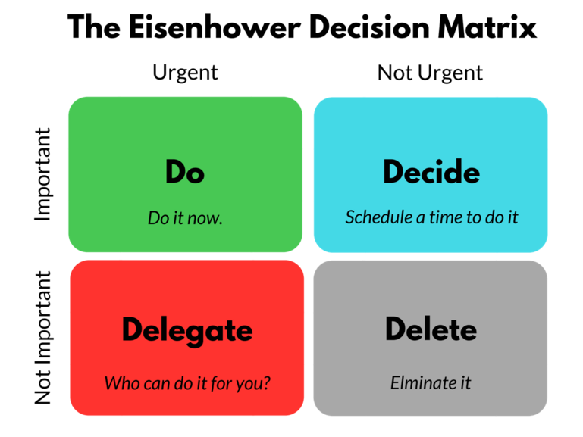
Summarising

Learning how to write an proper summary of my night shift was an big win for me as every morning when I finish my shift I have to present an report on what have done during my shift as there is no manager or higher staff present to verbally report early in the morning I do have write an email containing an summary. I was doing this before studding the subject, but I can see de difference from then to what I am doing now. Writing the most important events that happen overnight and clearly describe them in short sentence have given me a more professional appearance in front of my supervisor a higher management. Learning how to break down my events and how to efficient write the important actions or events happen overnight saved me that awkward phone call for extra information when my manager was reading the report. If my previews report was not that professional or confusing sometimes, now my writing is much better straight to important points making very easy for my colleagues and supervisor to understand and digest the night events happen on my shift. A good summary must fallow few steps and follow the chronological order as the bellow matrix shows.

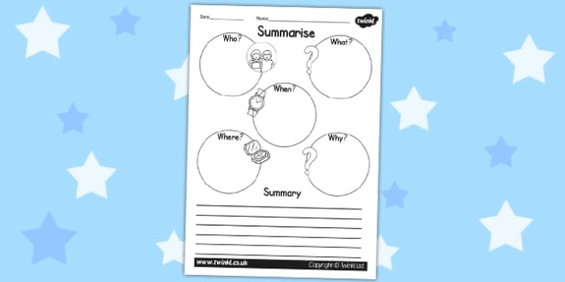

Team working

What is a team? Well a team is not to be confused with an group as an team is an collection of persons who are gathered together to achieve an common objective. On my work being part of team is essential as I cannot fulfil my task without an team behind.
Team developing have 5 important stages
1.Forming
The formation of a team does not have to be necessarily getting together the team members, the new team composition has to be built with individuals that have the same objectives and same area of interests
2.Storming
When the new members are put to work together with different roles within the team some of the individuals may have contradictive thoughts and ideas then the others and this allowed by team lieder to happen in an moderate and constructive manner will always bring the best result out of the team.
3.Norming
In order to get out of any disagreement occurred inside team, the leader and team needs to have in attention some procedure on how to prevent the damaging conflict first and not how to manage the norming rule assure that all team members are listening one to each other and are giving time for every team member to expose his own view or opinion.
4.Performing
Performing is a direct result of the other 3 stages. This is the outcome of a well-developed team and it reflects them value and dedication.
5.Adjourning
This is the final stage of team and this occurs when the task or the objective have been completed. Team leader is directly responsibly to and smooth and normal ending of the team as for most of the members this will trig some emotional feelings.
Knowing this key fact helped me to find my position on my night shift team on my depot and it did give me a huge advantage on becoming a good team lieder and how to act accordantly within my team, knowing to listening to members and how to direct them to achieve they maximum potential for the jobs.

Communication

There is 2 ways of communication verbal and non-verbal
“What is verbal communication? Verbal communication encompasses both words and our verbal fillers” (Andrew Maund ET. Al Certificate in higher Education: Skills for the Workplace)
Shannon and Weaver, Berlo, Schramm are the 3 models of verbal communication.
The first model (Shannon and Weaver) are the most used models on my working place. For example:
I am mostly using my phone and email to communicate with other company members and my team as well and this describe the most accurate the Shannon and Waver model
SENDER, the transmitter in my case it is me
ENCODER, the transmitter which encodes the message in signals
DECODER, the reception place of signal who decode the message
RECEIVER, the destination of my massage (my colleague or my team member)
FEEDBACK, same procedure only that the receiver is the sender

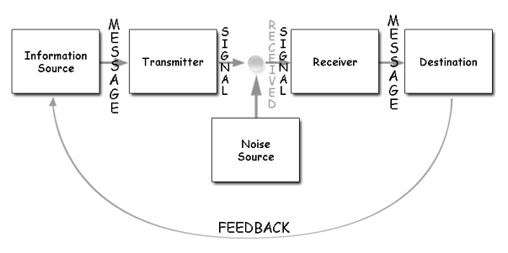
Body posture, face expression, gestures, simply said body communication it is very important especially for receiver s this type of communication frequently comes together with verbal communication and can approve or disapprove the message. For example if an person it is agreed with the message and it does have an positive answered to it his facial express will be more relaxed and his body posture will show relaxed as well he will not hesitate to make eye contact with other person as there is nothing to hide.

CONCLUSION

The last terms at the university have been proved to me being very productive learning bunch of new skills as well as developing new ones, from managing my time efficiency to knowing how to communicate with my team members have helped me to achieve new objectives and step over some communication barriers that I previously had and non the last made me more confident when I am given new task by my supervisors or my managers.

REFERENCING

Morgan, The business Student’s Guide to Study and Employability
Andrew Maund, Michaela Schriek and Paul K. Tinkler, Certificate in Higher Education: Skills for the Workplace

