Business Plan for

<STARRY ESCAPES GLAMPING VENTURES>

Produced by:

GROUP MEMBERS:
Student Name | Student No.
Veronica Moise | 2128048
Gabriela Iuliana Matei | 2126974
Mircea Leva | 2244690
Eugen Gherasim | 2242387

Module Name: Entrepreneurship
Module Code: BMIH5001
Lecturer Name: Christopher Wilkin

CONTENTS

 |  |  |  | PAGE
1. | Executive Summary |  |  | …………………3
2. | The Business Idea |  |  | …………………4
3. | The Team |  |  | …………………6
4. | Market Research |  |  | ………………..11
5. | Marketing Plan |  |  | ………………..13
6. | Key Resources |  |  | ………………..15
7. | Finances & Start-Up Support |  |  | …………………17
APPENDICES:
Appendix A |  |  |  | SWOT Analysis
Appendix B |  |  |  | PEST Analysis
Appendix C |  |  |  | Copy of Pitch Supporting Material

AI Declaration:

I hereby confirm that this business plan report was not generated by artificial intelligence and all research, analysis, and written sections, along with other materials, have been created independently without the use of automated content generators or AI techniques. This paper was created through original research, first-hand expertise, and collaborative contributions from group members.

1. EXECUTIVE SUMMARY

Designed to bring ecologically conscious visitors a special mix of comfort and nature, Starry Escapes is a luxurious glamping experience situated in Snowdonia, Wales and nestled in the picturesque Snowdonia National Park, our glamping site provides visitors with a sustainable and immersive haven replete with opulent yurts with contemporary conveniences. Although each yurt has private facilities, heaters, and outside seating areas especially fit for stargazing, our visitors may interact with nature while enjoying luxury.

Our target market consists in families, couples, adventure seekers, and environment lovers drawn to hotels stressing luxury and sustainability while the growing demand for sustainable tourism, particularly in the field of distinctive outdoor experiences, presents Starry Escapes with a significant market potential.

Our unique offerings—a breakfast bar with locally grown food, BBQ facilities, guided stargazing and hunting trips—help us to stand out and this combination of events distinguishes Starry Escapes since it promotes environmentally friendly travel and draws a diverse audience.

Based mostly on building a loyal customer base via targeted marketing and a dedication to provide exceptional service, financial forecasts show great growth possibility and establishing our brand, improving occupancy rates, and working with nearby vendors to improve the guest experience top priorities right now.

2. THE BUSINESS IDEA

2.1 The Product/Service

Starry Escapes creates a spectacular glamping experience in Snowdonia National Park by combining top facilities with environmentally sustainable ideas, therefore creating an enduring holiday for those who love the natural world and for this reason, our glamping site lets visitors totally enjoy the majesty of Snowdonia without sacrificing luxury by providing large yurts equipped with private bathrooms, heating, outdoor lounge areas, and cosy mattresses. The way each yurt is designed shows our dedication to environmental care by using sustainable materials. (Collins, 2001)

Along with lodging choices, Starry Escapes offers visitors the chance to enjoy the fresh products of the area with a breakfast bar including Welsh cuisine created locally and also, grilling amenities let visitors experience outside cooking with real flair. Our special offers are guided stargazing events using the low light pollution of the park and hunting packages for licensed visitors. Because of its mix of luxury and nature-centric activities, this unique experience appeals to adventure seekers and environmental conscience guests. (Tourism and Hospitality Research, 2023)

2.2 SWOT Analysis Summary
Strengths  • Unique location in Snowdonia with access to scenic landscapes and minimal light pollution for stargazing.  • Eco-friendly glamping yurts with luxury amenities, catering to a growing market of sustainable tourism.  • Diverse range of activities including guided stargazing, hunting packages, and local culinary offerings. | Weaknesses  • Seasonal demand may lead to fluctuations in occupancy, particularly during winter months.  • Remote location could limit accessibility and increase logistical costs for supplies.  • Higher operational costs due to focus on sustainability and luxury amenities.
Opportunities  • Growing interest in eco-tourism and unique outdoor experiences.  • Potential to expand offerings with additional outdoor activities such as hiking and nature tours.  • Partnerships with local businesses to create package deals and enhance guest experiences. | Threats  • Competition from other glamping sites in Wales, offering similar luxury experiences.  • Unpredictable weather conditions may impact guest satisfaction and occupancy.  • Economic downturns affecting travel and tourism spending.

Made by Author

3. THE TEAM

3.1 Key Personnel

Name and Company Position: Veronica – CEO (Chief Executive Officer)
Skills and Experience: Veronica possesses more than ten years of experience in the hotel industry, emphasising sustainable business methods and eco-tourism and she possesses a master's degree in Business Administration, specialising in sustainable tourism.

Role and Responsibilities: Veronica, as CEO, oversees the overall strategy, business development, and administration of Starry Escapes, ensuring alignment with market trends and sustainability goals.

Name and Company Position: Eugen - Facilities and Sustainability Manager

Skills and Experience: Eugen has over 15 years of experience managing construction and refurbishment projects in Italy, Romania, Switzerland and the UK. Qualified in security, ensuring safe and secure environments for staff and guests. Skilled in selecting eco-friendly materials suitable for sustainable tourism infrastructure. Experience overseeing facilities to provide comfort and reliability while maintaining minimal environmental impact.

Role and Responsibilities: Oversee the construction, setup, and maintenance of yurt accommodations, ensuring the use of sustainable materials and environmentally conscious design. Develop and implement safety protocols for guests, staff, and facilities, including secure access to the site and managing risks associated with outdoor activities. Lead efforts to incorporate sustainable practices into every aspect of the site, from renewable energy solutions to waste management.

Name and Company Position: Gabriela – Digital Marketing Specialist

Skills and Experience: Gabriela has over 5 years of experience in marketing in Romania and UK.

Role and Responsibilities: Selling products and finding new customers for the company she was working for.

Name and Company Position: Mircea - Finance and Starters Support
Skills and experience - Mircea excels in financial analysis, budgeting, reporting, regulatory compliance, and client and stakeholder relations. Their analytical and problem-solving skills, financial software experience, and ability to help start businesses are exceptional. They excel at budgeting, financial statement analysis, and forecasting for strategic company decisions. They are skilled in preparing exact financial accounts and assessing regulatory and tax compliance. They excel in explaining complex financial ideas to non-financial people while building strong client and collaborator ties. Their competence in Excel, SAP, and QuickBooks shows a significant ability to increase data administration and analysis.
Role and responsibilities- Mircea exhibits an exceptional level of expertise in the areas of financial analysis, budgeting, and reporting, in conjunction with a distinguished aptitude for the management of clients and stakeholders. Furthermore, they demonstrate significant expertise in enabling the formation of emerging businesses, overseeing projects, and exhibit strong analytical and problem-solving skills, alongside a substantial proficiency in financial software applications. He demonstrates a sophisticated expertise in the formulation and oversight of budgets, the analysis of financial statements, and the production of precise financial reports, all while adeptly conveying intricate financial concepts to individuals lacking a financial background.

3.2 Skills Gaps & Key Partners
Though Starry Escapes has a strong basis in sustainability and hospitality, certain skill gaps call for development as mostly, we are not very good in digital marketing analytics; so, we wish to outsource this responsibility to a digital marketing agency to guarantee efficient campaign monitoring and analysis. To increase our spectrum of activities, we also need mastery of adventure tourism and hired will be a coordinator for outdoor events, experienced in adventure sports and guided tours. We intend to work with a nearby environmental company for guidance on waste management and resource economy in order to enhance our sustainability policies as by means of smart relationships and targeted recruitment campaigns, we can address these shortcomings and improve the running efficiency and visitor experience of Starry Escapes. (Journal of Hospitality and Tourism Research, 2023)

3.2.1 Additional Staff Requirements (Roles and Responsibilities):
- Digital Marketing Specialist: This role is crucial for enhancing how we connect with consumers, evaluating the effectiveness of our campaigns, and overseeing our online visibility and also, this expert will improve our online visibility by addressing the current gaps in advanced marketing analytics. (Cornell Hospitality Quarterly, 2023)
- Outdoor Activities Coordinator: We're looking for an experienced organiser to manage guided tours, nature walks, and stargazing sessions to elevate our adventure offerings and this position will enhance the guest experience and draw in travellers looking for adventure. (Ries, 2011)
- Eco-friendly Maintenance Technician: This technician will make sure that our facilities meet eco-friendly standards and maintain sustainable practices and this position focusses on the technical skills needed for environmental upkeep, highlighting our dedication to sustainability. (Doerr, 2018)

3.2.2 Training and Development:

- Digital Marketing Analytics: The training from HubSpot Academy will give our Digital Marketing Specialist advanced analytics skills, making our campaigns more effective and the training wraps up with a certification and comes with a cost of about £500.
- Eco-Tourism Best Practices: This training will help us align our operations with eco-friendly standards by providing our team with guidance on sustainable tourism practices, thanks to The Travel Foundation and this curriculum costs £350 for each individual.
- Adventure Tourism Safety: The Adventure Travel Trade Association (ATTA) is set to offer training for our Outdoor Activities Coordinator, ensuring they gain the vital skills needed to lead safe and enjoyable trips and the £700 fee for this certification program includes a variety of comprehensive safety modules.

3.2.3 Outsourced Support / Key Partners:

- Digital Marketing Agency: We will grow our online presence by implementing focused advertising campaigns and managing our social media alongside Green Leaf Digital and their services, available for £1,000 a month, will provide solid digital outreach and analytics management.
- Local Environmental Consultancy: EcoWise Consultants will offer sustainability assessments and waste management strategies to help us achieve our environmental objectives and this service costs £600 for each evaluation and will help reduce our environmental impact.
- Local Farm Supplier: We are excited to improve the authenticity of our visitor experience by sourcing fresh, local ingredients for our breakfast bar in partnership with Snowdonia Farms and also, we anticipate spending £500 each month for this partnership, which will help us in our sustainable, local approach.

4. MARKET RESEARCH - Eugen Gherasim

4.1 Market Information, Trends and External Factors
The glamping and eco-tourism sectors are seeing considerable growth as more consumers lean towards sustainable, nature-focused vacations. According to a report by Allied Market Research, the global glamping market is expected to reach $4.8 billion by 2025, with a compound annual growth rate (CAGR) of 10.5% (Allied Market Research, 2022). The increase is linked to the rising interest in distinctive outdoor experiences that combine luxury and nature. Snowdonia National Park draws nearly four million visitors annually, showcasing a strong interest in outdoor accommodations (Snowdonia National Park Authority, 2023). Furthermore, tourism in Wales generates an annual income of approximately £6 billion, contributing significantly to the regional economy (Visit Wales, 2023).

More and more people are showing a keen interest in sustainable travel, particularly younger travellers from the millennial and Gen Z generations. This generation also prioritises environmental sustainability and seeks out unique experiences, making them an ideal audience for Starry Escapes. We can take advantage of this trend by providing luxurious, eco-friendly glamping options (Finn Partners, 2022).

Political: Support for sustainable tourism
- Potential changes in environmental regulations
- Stable political environment in Wales
Economical: - Growth in eco-tourism and glamping markets
- Economic downturns affecting travel spending
- Fluctuations in tourism-related expenses
Social: - Rising demand for sustainable travel
- Increased interest in outdoor, wellness-focused activities
- Growing preference for local, authentic experiences
Technological: - Advancements in digital marketing and booking systems
- Use of sustainable technologies in glamping facilities
- Growth in online travel reviews impacting reputation
(Made by Author)

4.2 Customer Profiles

- Eco-Conscious Millennials: The visitors, primarily between the ages of 25 and 35, focus on sustainability and are in search of unique experiences as they appreciate eco-friendly lodging and find happiness in choosing genuine, nature-focused getaways (Kearney, 2024).

- Adventure Seeking Families: Parents between the ages of 30 and 45 who have young kids and are looking for fun outdoor activities for the whole family as they enjoy experiences that feel safe, well-structured, and focused on the outdoors, such as educational activities, nature walks, and stargazing (Izenstark & Middaugh, 2022).

- Romantic Couples: Couples between the ages of 25 and 40 looking for a peaceful, picturesque getaway from the hustle and bustle of city life and in order to elevate their intimate experience, they focus on privacy, comfort, and special features, like luxurious rooms and stargazing (Travel + Leisure, 2024).

4.3 Competitor Profiles

1. Greener Glamping: This competition is recognised for its environmentally friendly cabins, appealing to those who appreciate nature (Greener Glamping, 2024). However, it does not offer luxurious amenities and activities, like guided astronomy; our distinctive outdoor experiences and luxurious amenities give us an advantage.

2. EcoRetreat Snowdonia: Luxurious accommodations are available in a top-tier glamping spot that focuses on wellness. Even though they focus on a particular group, our improved adventure and family-friendly services give us an advantage over their restricted activity choices (EcoRetreats, 2024).

3. Mountain Yurts Wales: Provides simple, budget-friendly glamping options in a comparable location (Ffrith et al., 2024). However, even though they are cost-effective, they fall short of our commitment to sustainability and quality. Our distinctive blend of eco-friendly design and luxury will attract premium clients.

5. MARKETING PLAN – VERONICA MOISE

5.1 Price
With a premium pricing strategy, Starry Escapes aims to showcase the distinctiveness and high quality of its luxurious glamping experience and also, in the off-peak season, rates begin at £200 per night and increase to £300 per night during peak times and while this price aligns with other high-end glamping options, it allows us to stand out compared to simpler accommodations in the area. We aim to attract travellers who care about the environment and appreciate sustainable luxury, comfort, and quality as these are the values we are committed to delivering. The appendices feature a detailed price list that outlines additional services, such as hunting packages and guided astronomy events. (Dalio, 2017)

5.2 Product
Built precisely to match Snowdonia's natural surroundings, our glamping yurts have warm, earthy tones and environmentally safe materials as this is why every yurt will have luxury furniture, private bathrooms, and outside seating sections featuring stargazing equipment, therefore fostering a rich and friendly environment. Simple logo and earth-toned colour palette define Starry Escapes' branding and underline sustainability, quality, and strong connection to environment whole mock-ups of appendix' branding emphasises our dedication to providing a lavish, distinctive, and ecologically aware experience. (Kahneman, 2011)

5.3 Placement
Starry Escapes will primarily promote its services through our specialised website featuring an online booking system and in order to enhance our profile, we will collaborate with speciality sites such as Glamping Hub and online travel agencies, including Airbnb and Booking.com. To attract visitors to Snowdonia, we will collaborate with local travel agents and tourism offices while working offline and our distribution plan prioritises accessibility for potential customers while still ensuring a strong brand identity is upheld. (Journal of Hospitality, Marketing & Management, 2023)

5.4 Promotion
We will combine traditional and digital marketing strategies to boost brand awareness such as advertising on platforms such as Instagram and Facebook will reach consumers who are passionate about adventure and care for the environment through visually appealing posts and promotions. Collaborating with travel bloggers who align with our values will highlight the distinctive aspects of our glamping experience as. We will also allocate funds to Google Ads and search engine optimisation (SEO) to increase website traffic as we plan to collaborate with local businesses to develop package deals and participate in offline eco-tourism events, which will encourage longer visits and enhance community connections. Review systems can encourage client feedback, which in turn enhances credibility and fosters loyalty. (Sinek, 2014)
6. KEY RESOURCES – Gabriela – Iuliana Matei

6.1 Premises
Starry Escapes is looking for a spacious and stunning piece of land in Snowdonia National Park to establish its glamping resort. The premises should ideally provide ample space for shared facilities, such as a communal fire pit and breakfast bar, an outdoor dining area and up to 10 luxury yurts. Studies show that the annual cost of renting land in Snowdonia can vary between £10,000 and £15,000, depending on the location and how easy it is to acces and also, administrative tasks will be handled remotely to prevent any unnecessary expenses. (Scott, 2017)

6.2 Equipment
Every yurter should have essential tools like high-quality furniture, sustainable yurts, and basic comforts such as heating and outdoor seating and Sustainable Energy Solutions provides solar-powered heating systems for around £1,000 per yurt, aligning perfectly with our dedication to environmental sustainability. GreenChef offers kitchen appliances for the breakfast bar, with additional needs and an estimated cost of £3,000 and will also buy Stargaze Equipment Ltd.'s fire pits and astronomy gear, which cost around £500 each as the choice of equipment is crucial for achieving our sustainability goals and providing a unique experience for our visitors. (Pink, 2009)

6.3 Key Suppliers
We will collaborate with trustworthy suppliers of essential goods and services to uphold our high standards and our breakfast bar will showcase local sustainability by featuring products from Snowdonia Farms, all while keeping our monthly supply cost around £500. YurtWorld will be our primary yurt supplier, with each unit priced at £2,500 while EcoWaste Solutions will take care of waste management for a monthly fee of £200. This service focusses on offering eco-friendly disposal options. High-quality materials and our dedication to eco-friendly practices are crucial to Starry Escapes' operations, backed by these key suppliers.
7. FINANCES AND START-UP SUPPORT - Mircea

EXPENDITURE | Year 1  £
Company Registration | £500
Rent/Rates | £12,000
Staff Wages | £30,000
Travel/Accommodation | £2,000
Telephone (mobile) | £300
Broadband | £300
Utilities | £1,200
Marketing and materials | £5,000
Insurance | £1,000
Capital Expenditure/Equipment | £15,000
Training & Development | £2,000
Accounting/Legal | £1,200
Outside Services | £2,000
Stock/Materials Purchases | £6,000
Bank Charges | £100
Office Consumables | £200
Loans Repayments | £5,000
Total Expenditure | £ 83,800
INCOME | Year 1  £
Sales A ? | £50,000
Sales B ? | £20,000
Sales C ? | £10,000
Capital Introduced | £10,000
Funding | £15,000
Loans/Borrowing | £5,000
Total Income | £ 110,000

YEAR ONE PROFIT/LOSS | £
Total Income | £110,000
Total Expenditure | £83,800
Profit/Loss | £26,200

7.1 Financial Summary
The financial data shown in the charts reflects realistic estimates designed to meet the unique operational needs of Starry Escapes and the main areas of spending include worker salaries totalling £30,000, which shows our dedication to providing excellent guest service, and capital expenses of £15,000 for equipment, essential for acquiring sustainable facilities and eco-friendly yurts. The rental cost of £12,000 is in line with typical land leases for eco-tourism in Snowdonia. We set aside £5,000 for marketing expenses to effectively connect with our target audience, as detailed in the Marketing Plan.

Revenue is expected from various sources, including glamping bookings and additional services, totalling £80,000 in Sales A, B, and C and capital introduced and funding provide an extra £25,000 to strengthen our initial phase, while a £5,000 loan offers added financial stability.

Additionally, we have looked into various options for start-up support, obtaining local grants and eco-tourism incentives to reduce costs and enhance our sustainability objectives, ensuring that our financial plan is both aimed at growth and practical.
APPENDICES

Appendix A – SWOT Analysis
Strengths: Starry Escapes uses its special location in Snowdonia National Park, which is praised for its breath-taking views and little light pollution, so providing the best place for stargazing and while offering opulent yurts built from sustainable materials, the glamping establishment sets itself apart and appeals to environmentally minded visitors. Every yurt has private bathrooms, heaters, and outside lounging spaces to guarantee visitors' smooth integration of luxury and environment And also, the several events—guided astronomy sessions, hunting programs, a locally made breakfast buffet—create a rich and engaging experience that sets Starry Escapes apart from conventional lodging. (Sinek, 2009)

Weaknesses: For Starry Escapes, seasonal demand fluctuations pose a major challenge in the winter months when outdoor events could be less inviting and this periodicity can result in varying income and occupancy rates while although the far-off location is great for an immersive experience, it creates logistical problems with relation to supply availability and more expensive transportation. The dedication to sustainability and elegance leads to higher running expenses, thereby restricting the target audience to rich guests and affecting pricing policies. (Ries, 2011)

Opportunities: Starry Escapes presents a chance to interact with a growing number of ecologically conscious tourists since their company strategy fits very nicely with the expanding trend of eco-tourism and sustainable travel and offering nature walks or hiking trips among other things would help to appeal more to adventure seekers and diversify income streams. Moreover, the visitor experience can be enhanced and the local economy strengthened at the same time by means of package deals formed with local businesses while also, working with local artists, tour guides, and restaurants helps Starry Escapes to be even more unique. (Doerr, 2018)

Threats: For those who value luxury and environmental awareness, Wales presents a range of glamping options that compete with Starry Escapes and also, the variable temperature in Snowdonia could hinder outdoor activities, therefore reducing visitor enjoyment and discouraging returning visits. Economic downturns pose another risk since a drop in consumer expenditure could result in less luxury and ecologically friendly travel while applying adaptive strategies, including stressing the special features of the property and providing flexible booking rules, will help to counteract these risks and guarantee a wonderful visitor experience despite outside difficulties. (Horowitz, 2014)

Appendix B – PEST Analysis

Political: Tourism plays an essential role in Wales, which is marked by a steady political environment and strong support for eco-tourism. Starry Escapes can take advantage of possible grants or incentives by collaborating with government initiatives that promote sustainability in tourism (Green et al, 2023). It is essential to stay informed about potential changes in environmental laws that could affect what we do. New land use or waste management laws might increase our operational costs, but they would also highlight our dedication to environmentally friendly practices.

Economical: The demand for unique and sustainable experiences drives growth in the eco-tourism and glamping industries. Despite potential risks during economic downturns, the glamping market is projected to grow at a compound annual growth rate (CAGR) of 12.8% from 2024 to 2031, reaching USD 9.23 billion by 2031 (Data et al, 2023). This growth is attributed to increasing interest from affluent travellers prioritising sustainable tourism, mitigating certain economic risks. However, rising utility and material costs could affect profitability, necessitating strategic planning to maintain financial stability.

Social: There is a notable shift in consumer attitudes towards wellness and sustainability. Millennials and Gen Z travellers seek experiences that emphasise authentic local culture and environmental stewardship (Booking.com, 2023). Starry Escapes is well-positioned to attract this demographic by offering eco-friendly, nature-focused accommodations that align with their values. Additionally, the growing emphasis on well-being prompts travellers to seek destinations that provide respite from urban life and a sense of tranquillity.

Technological: Advancements in digital marketing and booking systems enable more effective engagement with target audiences. Utilising social media and online travel platforms can enhance Starry Escapes' visibility and attract a global clientele. Integrating sustainable technologies, such as solar power and eco-friendly amenities, can reduce environmental impact and support eco-tourism objectives (Glampitec, 2024). Positive online reviews can further bolster reputation, attracting guests who value environmental sustainability.
Appendix C – Copy of Pitch Supporting Material

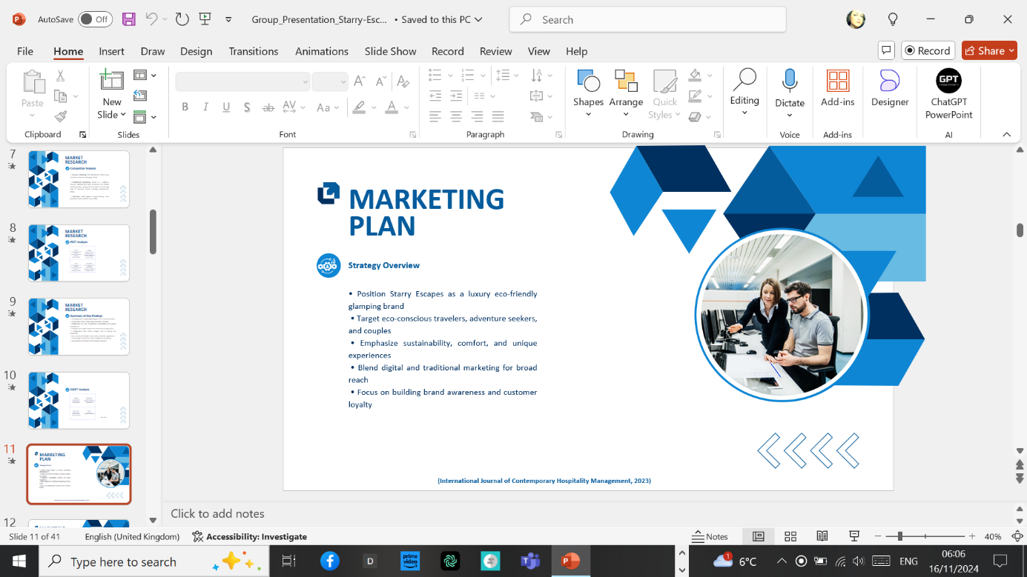

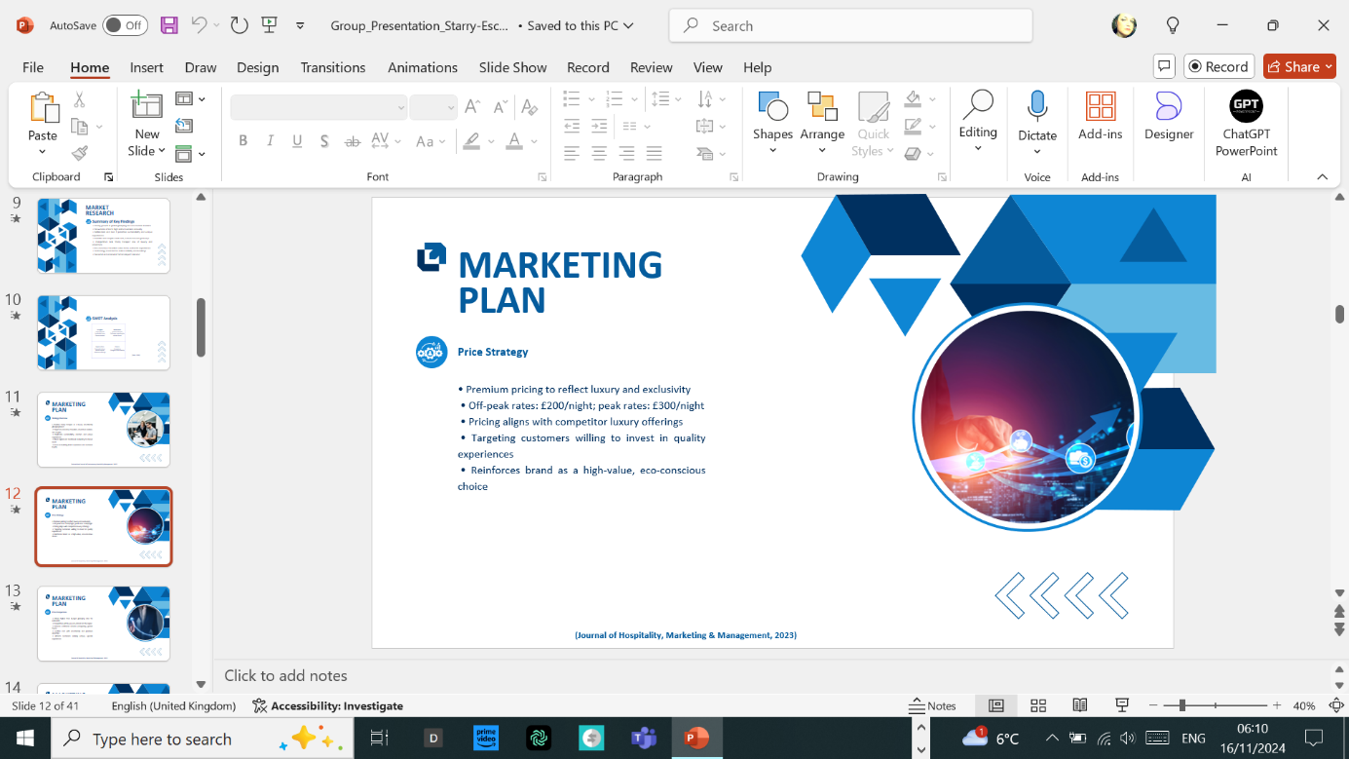
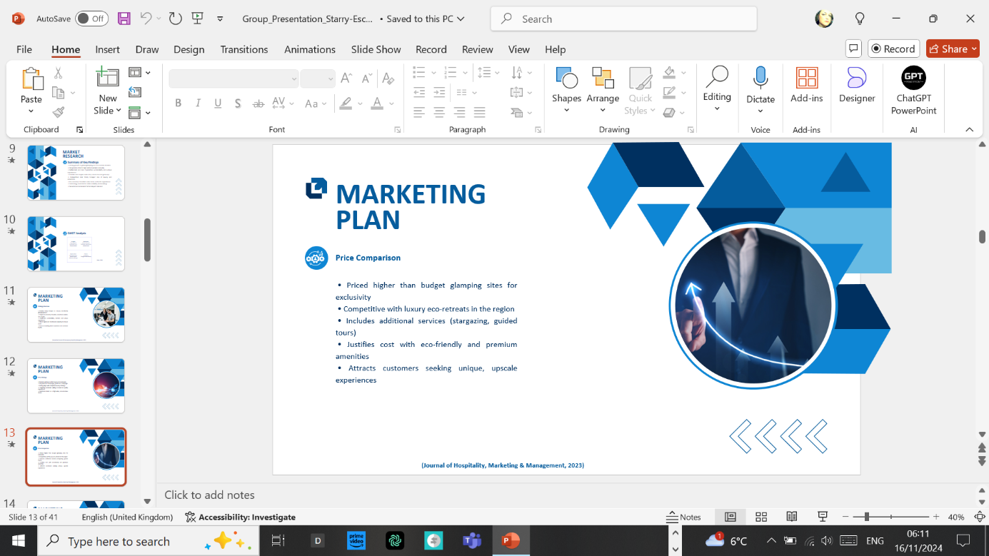
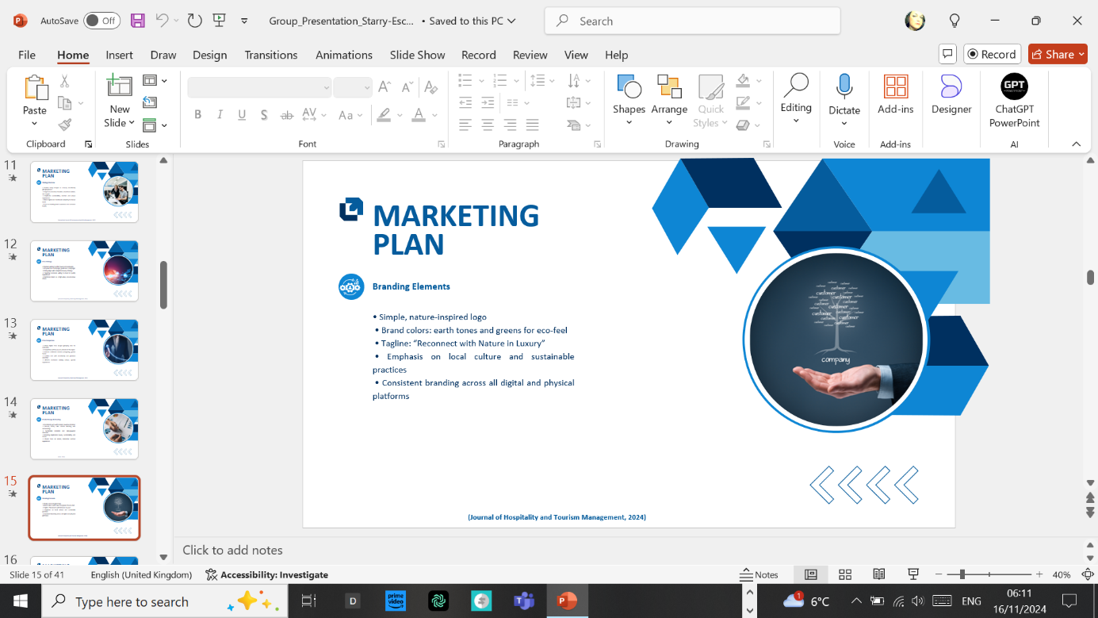
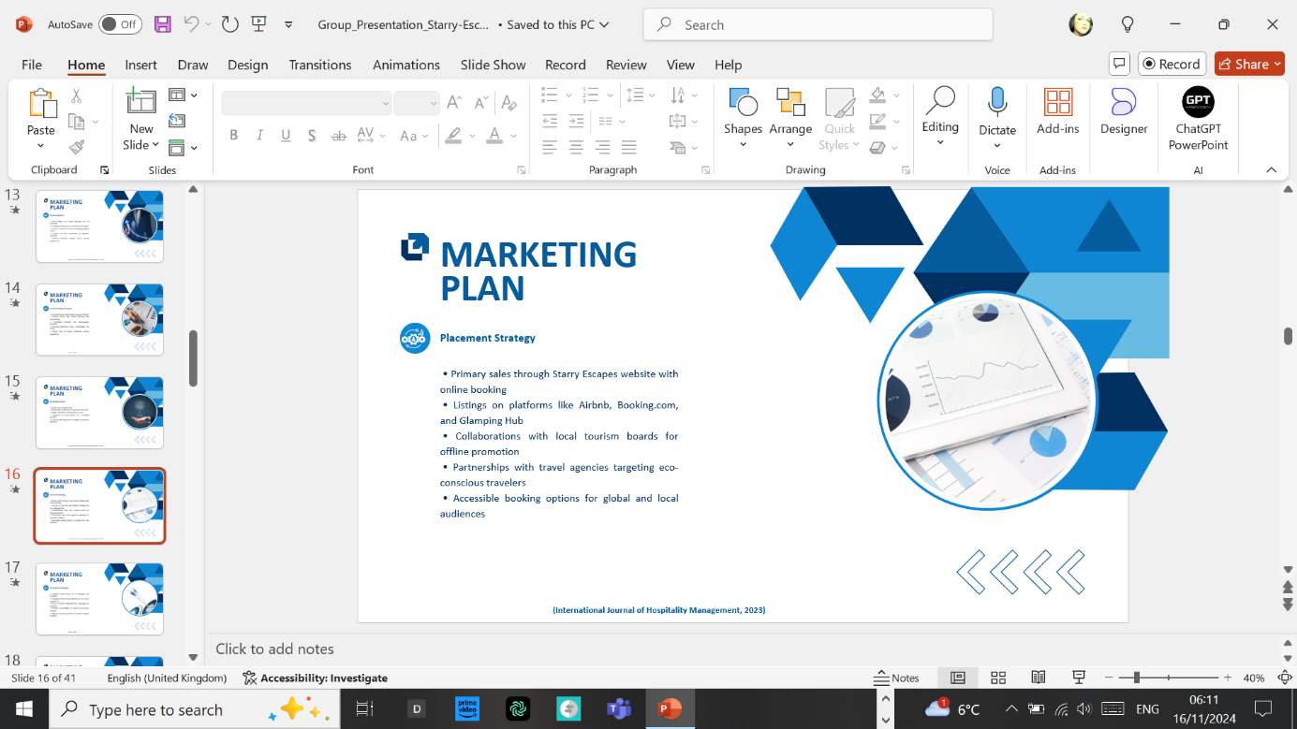
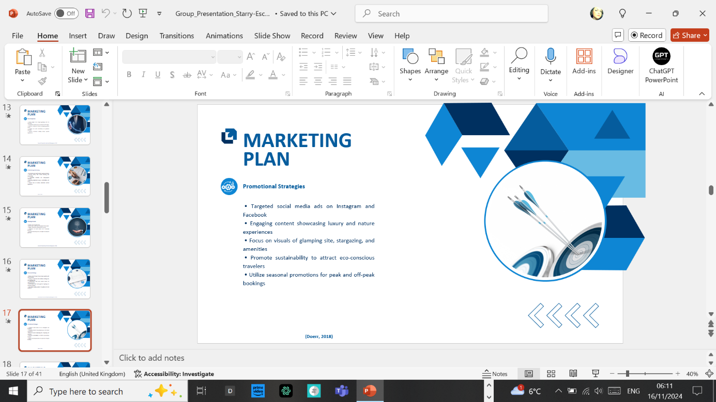
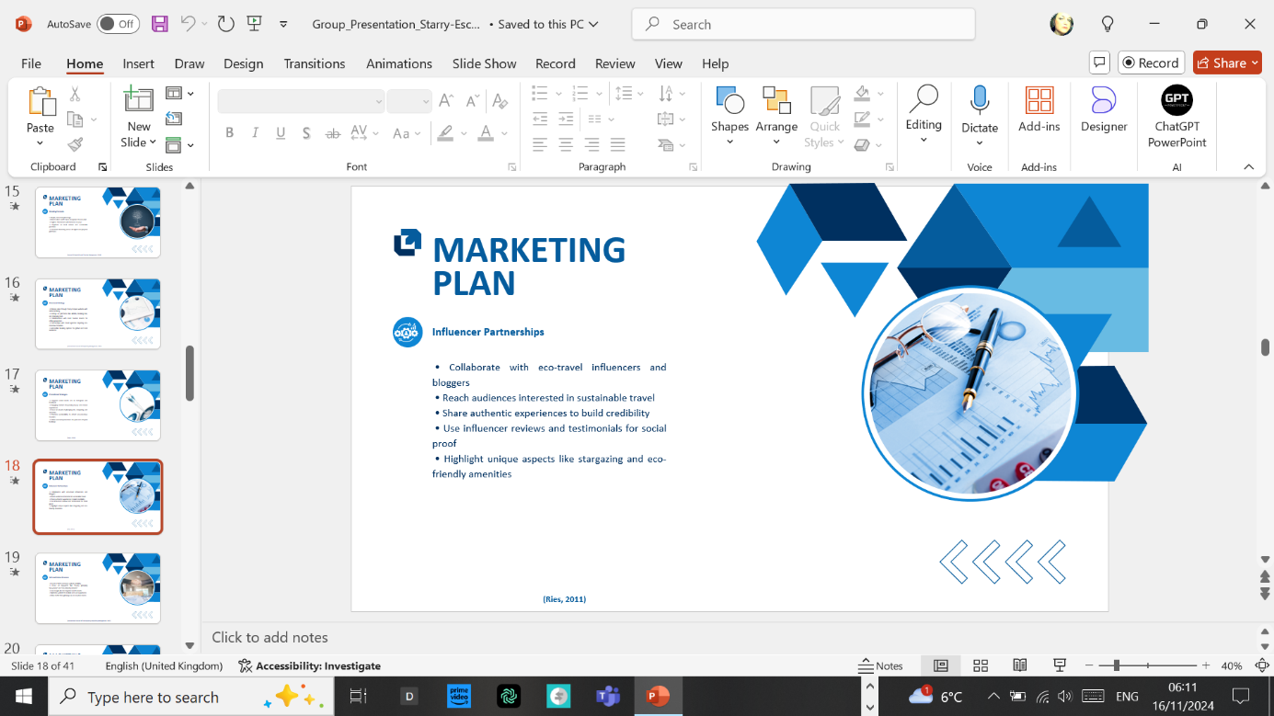
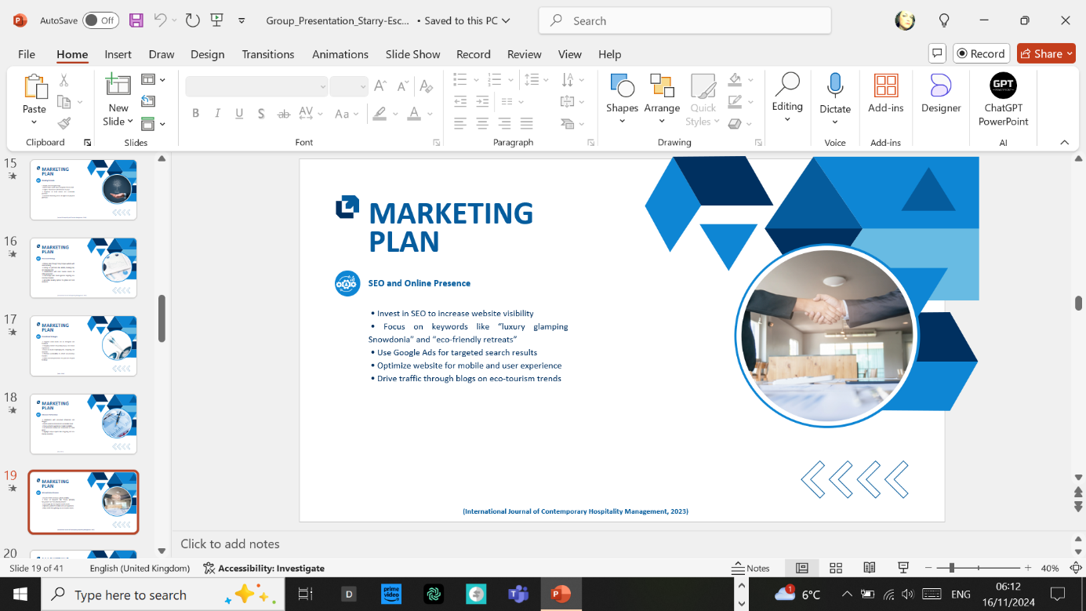
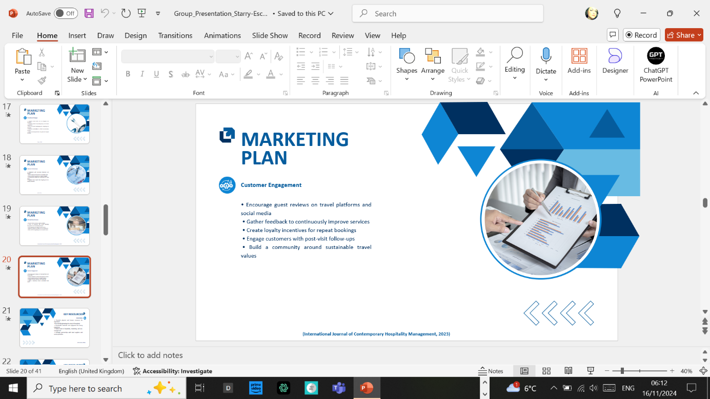

REFERENCE LIST:

Allied Market Research (2022). Glamping Market. Available at: https://www.alliedmarketresearch.com/glamping-market-A16856 (Accessed 29 October 2024).
Booking.com, (2023). Cost vs Conscience: Booking.com Delves into the Dilemma Dividing Sustainable Travel in 2023. Global Sustainable Tourism Council. Available at: https://www.gstcouncil.org/booking-com-2023-sustainable-travel-report/ (Accessed: 29 October 2024).
Christensen, C.M. (1997) The Innovator’s Dilemma: When New Technologies Cause Great Firms to Fail. Boston: Harvard Business Review Press, p. 82.
Collins, J. (2001) Good to Great: Why Some Companies Make the Leap and Others Don’t. New York: Harper Business, p. 87.
Collins, J. and Porras, J.I. (1994) Built to Last: Successful Habits of Visionary Companies. New York: Harper Business, p. 95.
Cornell Hospitality Quarterly (2023) Available at: https://journals.sagepub.com/home/cqx (Accessed: 29 October 2024)
Dalio, R. (2017) Principles: Life and Work. New York: Simon & Schuster, p. 132.
Doerr, J. (2018) Measure What Matters: How Google, Bono, and the Gates Foundation Rock the World with OKRs. New York: Portfolio, p. 45.
Data Bridge Market Research, (2023). Global Glamping Market – Industry Trends and Forecast to 2031. Available at: https://www.databridgemarketresearch.com/reports/global-glamping-market (Accessed: 29 October 2024).
EcoRetreats (2024). Yurt in Wales | Eco Retreats. Available at: https://ecoretreats.co.uk/yurt-in-wales/ (Accessed: 29th October 2024).
Finn Partners (2022). It’s All About the Experience – How Gen Z and Millennials Are Transforming the Travel Industry. Available at: https://www.finnpartners.com/news-insights/how-gen-z-and-millennials-are-transforming-the-travel-industry/ (Accessed: 28th October 2024).
Ffrith Galed Yurts (2024). Ffrith Galed Yurts. Available at: https://www.yurtsnorthwales.co.uk/ (Accessed: 30th October 2024).
Glampitect, (2024). Green Glamping: Innovative Ways to Use Solar Energy in Your Accommodations. Available at: https://www.glampitect.com/us/blog/green-glamping-innovative-ways-to-use-solar-energy-in-your-accommodations (Accessed: 30 October 2024).
Green Economy Wales, (2023). Wales Tourism Investment Fund (WTIF), Green Economy Wales. Available at: https://greeneconomy.wales/wales-tourism-investment-fund-wtif/ (Accessed: 28 November 2024).
Greener Glamping (2024). Yurts and Facilities - North Wales | Greener Glamping. Available at: https://greenerglamping.uk/glamping-yurts-north-wales/ (Accessed: 29th October 2024).
Harden-England, K. (2024). Kearney finds millennials driving shift in tourism as 86% prefer eco-friendly travel options, Travolution, 3 October. Available at: https://www.travolution.com/news/travel-sectors/kearney-finds-millennials-driving-shift-in-tourism-as-86-prefer-eco-friendly-travel-options/ (Accessed: 28th October 2024).
International Journal of Contemporary Hospitality Management (2023) Available at: https://www.emerald.com/insight/publication/issn/0959-6119 (Accessed: 29 October 2024)
International Journal of Hospitality Management (2023) Available at: https://www.journals.elsevier.com/international-journal-of-hospitality-management (Accessed: 29 October 2024)
Izenstark, D. and Middaugh, E., (2022). Patterns of family-based nature activities across the early life course and their association with adulthood outdoor participation and preference, Journal of Leisure Research, 53(1), pp. 23–41. Available at: https://doi.org/10.1080/00222216.2021.1875274 (Accessed: 29th October 2024).
Journal of Hospitality and Tourism Management (2023) Available at: https://www.journals.elsevier.com/journal-of-hospitality-and-tourism-management (Accessed: 29 October 2024),
Journal of Hospitality and Tourism Research (2023) Available at: https://journals.sagepub.com/home/jht (Accessed: 29 October 2024),
Journal of Hospitality Marketing & Management (2023) Available at: https://www.tandfonline.com/toc/whmm20/current (Accessed: 29 October 2024)
Kearney (2024). Kearney finds millennials driving shift in tourism as 86% prefer eco-friendly travel options, Travolution, 3 October. Available at: https://www.travolution.com/news/travel-sectors/kearney-finds-millennials-driving-shift-in-tourism-as-86-prefer-eco-friendly-travel-options/ (Accessed: 29 October 2024).
Ries, E. (2011) The Lean Startup: How Today’s Entrepreneurs Use Continuous Innovation to Create Radically Successful Businesses. New York: Crown Business, p. 123.
Sinek, S. (2014) Leaders Eat Last: Why Some Teams Pull Together and Others Don’t. New York: Portfolio, p. 146.
Snowdonia National Park Authority, (2023). Visitor Statistics. Available at: https://snowdonia.gov.wales/ (Accessed 29 October 2024).
Tourism and Hospitality Research (2023) Available at: https://journals.sagepub.com/home/thr (Accessed: 29 October 2024).
Travel + Leisure, (2024). 50 Best Romantic Getaways for a Couples Trip, Travel + Leisure, 1 October. Available at: https://www.travelandleisure.com/trip-ideas/romantic-getaways/50-best-romantic-getaways (Accessed: 29th October 2024).
Visit Wales, (2023). Tourism Performance. Available at: https://www.visitwales.com/ (Accessed 29 October 2024).

