Student name: Best Moshwe
Student ID: 2513130
Module name: Introduction to Health and Social Care
Module code: LCHS4003
Lecturer name: Christiana Melam
Table of Contents
Element 1………………………………………………………………………………………………………………………………………………………….3
Element 2 4
References 5

Current Functioning of the Midwifery Service

Most community antenatal services start when women make their own appointment for maternal health (known as self-referral), or when a GP or other health service provider refers them to their local NHS maternity unit shortly after they have known about their pregnancy. The woman is referred to attend a full booking appointment with a community midwife as early as 10 weeks of pregnancy. At this appointment the midwife makes a note of medical and obstetric and family history, examines the woman physically and mentally and can identify potential risk factors, and plan individual care for the woman (NHS website, 2025).

Pregnancy care is regular check-ups that are scheduled to keep an eye on a mother's health and her baby's. Midwives take measurements, such as blood pressure, urine testing, abdominal examination and assessing foetal growth as well as organise blood tests, ultrasound and screening programmes for problems such as anaemia, gestational diabetes, foetal abnormalities and chromosomal abnormalities. There are also tips for women on safe feeding, exercise, quitting smoking, drinking and smoking, breastfeeding, vaccines, and preparation for labour and delivery.

If necessary, the community midwives work in partnership with obstetricians, GPs, sonographers, soothing assistance, experts in midwifery and mental health services, and social care services. By communicating, professionals can coordinate care for women with medical or safety concerns, or complicated pregnancies. It recommends continuity of provider to enable women to establish relationships with midwives they know and are comfortable with, to encourage communication, individualised care and the mother experience (NHS England, 2024).
Community based care helps connect with several women, providing flexible referral options, interpreting services and tailored support for vulnerable women. This approach ensures a safe, well-researched and individualised journey through pregnancy, supporting early help and minimizing difficulties and negative outcomes for women and babies.
Key Message

It is imperative that we continue to have community based antenatal services, to support safe pregnancies, reduce complications and enhance maternal and infant health. Meeting labour shortfalls and tackling health disparities will bolster continuity of care, increase service availability and result in equitable and quality maternity services for all women.

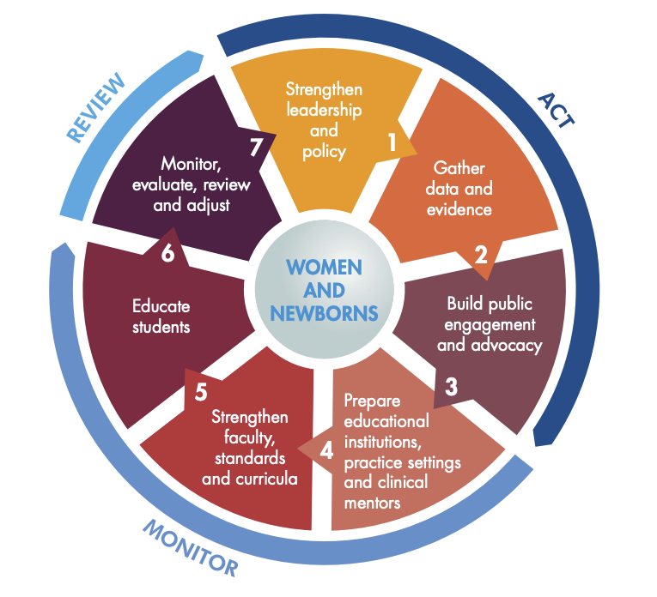
History

Midwifery has been of long standing, using the role of a traditional birth attendant to assist women through both their pregnancy and their birth, in their community. For woman the birth of the National Health Service (NHS) in 1948 brought antenatal, intrapartum and postnatal care universally available, for free at the point of use. Many changes have ensued since then culminating in an evidence-based approach to community midwifery care that is woman centred, routine screening, health promotion and multi-disciplinary (NHS, 2020).

The emphasis on continuity of carer, individualised care planning, access to services at an early-stage and enhanced support for women with multiple health and/or social issues are further developments on community-based antenatal care that are reinforced in recent national policies. High quality, consistent antenatal care in England is continually influenced by NICE guidance.


Challenge 2 – Health Inequalities & Barriers to Early Access

Insufficiently addressing health inequalities is a challenge faced by community-based prenatal midwifery services. Badly off women, minority ethnic groups, recent migrants and linguistic and cultural minorities are more likely to obtain care later in pregnancy when expectant. Antenatal care later in pregnancy is more likely to be accepted by badly off women, minority ethnic groups, recent migrants and language and cultural minorities. Poor maternal and newborn outcomes are increased whenever there are delays in the process of risk assessment, screening, health education, and action. Community midwives help to address access challenges and engage in person-centred and culturally friendly care, while inequalities impact the use of services and pregnancy outcomes. Supporting NICE recommendations, therefore, is coordinated, continuous care during pregnancy thus ensuring accessibility, communication and targeted support (NICE, 2023).

Challenge 1 – Workforce Shortages and Increasing Service Demand
Qualifying midwives are scarce and demand for maternity care has also been increasing, making delivery of community antenatal services very challenging. The complexity of pregnancy, the need to replace staff and retain staff in a short notice creates a larger workload for midwaves and a less time for individualised care. Antenatal provision may be impacted by shortages in labour, which can cause visit delays, interruptions to visits and stress/significant workload. NHS England sees the growth, retention and development of the maternity workforce as key to the delivery of safe, personalised care, while NICE indicates the number of members of the maternity workforce will be sufficient to provide for the needs of women in all maternity settings (NHS England, 2023).

Community Antenatal Midwifery Services

Community antenatal midwifery services are routine or routine and referred services designed to provide women with monitoring and support during pregnancy in services that are in the community for example GP surgeries, community health centres and children's centres. Its intention is to encourage women toward healthy pregnancies, detect any problems early and to educate women and families about childbirth and parenthood. Much of the care that is provided is done by registered midwives who work in collaboration with obstetricians, general practitioners (GPs), health visitors, sonographers, specialist midwifery teams and other health care professionals to provide safe person-centred maternity care (National Institute for Health and Care Excellence, 2021).

The program is offered to ALL pregnant women, no matter age, race or socio-economic status. Women can self-refer or may be referred by a GP or health care practitioner after pregnancy to their local NHS maternity service. In general, NICE suggests that women should go for their booking check-up by 10 weeks of pregnancy to be assessed, screened and have treatment plans tailored to their individual needs, both physically, psychologically and socially.

The primary goal of antenatal care is to maintain and optimize health for the mother and child, prevent risks associated with pregnancy, track fetal growth and maternal well-being through pregnancy, provide education on health topics and support positive lifestyle changes, such as stopping smoking, eating a balanced diet and taking folic acid supplements. Emotional support, good decision-making and a better connection between healthcare providers and women, stem from regular antenatal consultations improving outcomes and morbidity in pregnancy and newborns (NICE, 2021).


NHS COMMUNITY-BASED ANTENATAL CARE
COMMUNITY ANTENATAL MIDWIFERY SERVICES
Best Moshwe [Introduction to Health and Social Care] 2513130@student.uwtsd.ac.uk

Element 2
Community Mental Health Services: Historical Development, Current Practice and Importance in Social Care
Community Mental Health Services (CMHS) are an important part of the UK health and social care system. They provide assessment, treatment and ongoing support for people experiencing mental health conditions while enabling them to remain in their own communities. The main aim of these services is to promote recovery, independence and social inclusion instead of relying on long-term hospital care. The development of Community Mental Health Services reflects changing attitudes towards mental illness, government policy and improvements in healthcare (World Health Organization, 2022).
The origins of Community Mental Health Services date back to the nineteenth and early twentieth centuries, when people with mental health conditions were mainly treated in psychiatric hospitals or asylums. Although these institutions provided care, they were often criticised for overcrowding, poor living conditions and isolating people from society. During the twentieth century, understanding of mental illness improved, and healthcare professionals recognised that many people recovered better when supported within their own communities rather than remaining in hospital for long periods (Thornicroft and Tansella, 2004). The introduction of psychiatric medication during the 1950s and 1960s made community-based treatment more achievable. This led to the Care in the Community approach, which was supported by the NHS and Community Care Act 1990. The Care Act 2014 later strengthened this approach by promoting person-centred care, wellbeing and safeguarding.
Today, Community Mental Health Services support people with conditions such as depression, anxiety, bipolar disorder, schizophrenia and personality disorders. Care is delivered by multidisciplinary teams that include psychiatrists, psychologists, community psychiatric nurses, social workers, occupational therapists and support workers. These professionals work together to produce personalised care plans that address medical, psychological and social needs. Services include psychological therapies, medication management, crisis intervention, recovery programmes and social prescribing. Delivering care in the community allows individuals to maintain family relationships, education and employment while receiving treatment (NHS England, 2019).
Community Mental Health Services have many strengths, but they also face important challenges. A major advantage is that they provide person-centred care close to where people live, helping to reduce hospital admissions and support long-term recovery. Early intervention can prevent mental health crises and improve quality of life. However, the effectiveness of these services is often affected by increasing demand, staff shortages and limited funding. Long waiting times can delay treatment, causing some people’s mental health to deteriorate before they receive support. Access to services also varies across different parts of the UK, meaning that not everyone receives the same standard of care. These challenges show that although Community Mental Health Services are effective, further investment is needed to improve access and reduce inequalities (National Institute for Health and Care Excellence, 2022).
Despite these challenges, Community Mental Health Services play a significant role in improving the quality of life of service users. They encourage independence, reduce social isolation and help individuals remain connected to their families, employment and local communities. Person-centred care enables service users to take an active role in decisions about their treatment, improving confidence and engagement with services. Families and carers also benefit from professional advice and emotional support. Overall, Community Mental Health Services have developed from institutional care into recovery-focused services that promote wellbeing, independence and social inclusion. Although workforce shortages, funding pressures and increasing demand continue to present challenges, these services remain essential in supporting people with mental health conditions and improving long-term outcomes.

References
National Institute for Health and Care Excellence (2021). Overview | antenatal care | guidance | NICE. Www.nice.org.uk. Available at: https://www.nice.org.uk/guidance/NG201

NHS (2020). Your antenatal care and appointments. Nhs.uk. Available at: https://www.nhs.uk/pregnancy/your-pregnancy-care/your-antenatal-care-and-appointments/

NHS England (2023). Three Year Delivery Plan for Maternity and Neonatal Services. Www.england.nhs.uk. Available at: https://www.england.nhs.uk/long-read/three-year-delivery-plan-for-maternity-and-neonatal-services/

NHS England (2024). NHS England » Maternity support worker competency, education and career development framework. Www.england.nhs.uk. Available at: https://www.england.nhs.uk/long-read/maternity-support-worker-competency-education-and-career-development-framework/

NHS website (2025). Refer yourself for NHS pregnancy care. Nhs.uk. Available at: https://www.nhs.uk/nhs-services/refer-yourself-for-nhs-pregnancy-care/

NICE (2021). Recommendations | Antenatal Care | Guidance | NICE. Www.nice.org.uk. Available at: https://www.nice.org.uk/guidance/ng201/chapter/Recommendations

NICE (2023). Quality Statement 3: Continuity of Carer | Antenatal Care | Quality Standards | NICE. Www.nice.org.uk. Available at: https://www.nice.org.uk/guidance/qs22/chapter/Quality-statement-3-Continuity-of-carer

National Institute for Health and Care Excellence (2022) Depression in adults: treatment and management. Available at: https://www.nice.org.uk/guidance/ng222 (Accessed: 8 March 2025).
NHS and Community Care Act 1990. c.19. London: HMSO.
NHS England and NHS Improvement (2019) The community mental health framework for adults and older adults. Available at: https://www.england.nhs.uk/publication/the-community-mental-health-framework-for-adults-and-older-adults/ (Accessed: 8 March 2025).
Thornicroft, G. and Tansella, M. (2004) ‘Components of a modern mental health service: a pragmatic balance of community and hospital care: overview of systematic evidence’, British Journal of Psychiatry, 185(4), pp. 283-290.
World Health Organization (2022) World mental health report: transforming mental health for all. Geneva: World Health Organization. Available at: https://www.who.int/publications/i/item/9789240049338 (Accessed: 8 March 2025).

