PROJECT INITIATION DOCUMENT (PID)
The Marriott Hotel Birmingham
Company Name :LRA

Release Date : 12th June 2020
Date : 12th June 2020
Author : Celia McClelland
Approved by Dr Olu Agebite

Document History
Revision Date | Version | Summary of changes | Reviewer
08/06/2020 | 1 | Draft 1 | Dr Agebite
08/06/2020 | 2 | Timescale updated | Dr Agebite
08/06/2020 | 3 | Outcomes and timescale updated to reflect the final plans | Dr Agebite

Reflection by the Business Development Team
Date | Review officer | Comments for consideration
08/06/2020 | Dr Agebite | Waiting for response

Approvals / Distributions
These documents require approval from the candidates listed below :
Name of person /group
Dr Olu Agebite
Marriott Manager
Marriott Assistant manager
HR Manager

- Purpose of document
  - - This Project Intimation Document focuses on the Birmingham Marriott Hotel- Research on the PID report is waiting on approval by members listed above , by the 12/06/2020.Based on the evaluation of the hotel, its procedures and the hotel operation system. It focuses on the recommendations that the Manager may want to implement in the future. It outlines the planned stages that would make progression in the hotel , this report will offer a strong foundation for the Marriott managers and an estimation of the project’s success.
2. Project Description
2.1 The recommendations from this PID report offers recommendations that may want to be implemented in the future. As the hotel is centrally located and offers a 4.2 rating it offers leisure , buisness and commercial client needs. This project will suggest significant improvements of the infrastructures . the enhancements to the quality of communication and refurbishment. The final recommendations plan is based on suggestions from guests and employees and observations.
2.2. This 4.2 rating hotel revival scheme will have operational measure , due to the global pracademic the time scale for the recommendation will be short.The location offers a strong tourist facility as listed below:
- Bull Ring
- National sea life centre
- Birmingham botanical gardens

3. Background
3.1 The Marriott Birmingham is part of a global organisation , which has multiple programmes which support the buisness such as the Marriott Bonvoy which is a loyalty programme for guest which they benefit rewards such as complementary parking , suites and gifts. The location on broad street operates a successful nightlife and being surrounded by local amenities , which accommodates needs for every buisness , leisure and family needs.
(Marriott, 2020)
3. Currently the Marriott hotel is rated at :
4/5 – Trip advisor
8.6/10 – Booking.com
4.4/5 – Facebook
(Bing,2020)
3.6 A proposal plan is being designed to modify is the companies’ by the internal and external consultants and is predicted to be implemented by the managers following client and employee consultation in June 2020.
4. DEVELOPMENT AIMS AND ACHIEVEMENT MEASURES
4.1 Productions
The project needs to have a SWAT and PESTLE analysis to identify if the target markets are being met.
(Agebite ,2020)
4.2 Macroenvironmental PESTLE Analyse
POLITICAL – There has been a ripple of travel bans due to the corona virus pandemic as the Marriott hotel in Birmingham is most popular for international clients , after the new normal is finalised it will be a struggle to get sales as they once were, as the Marriott add travel points to their clients stay for travelling.
Economical – The market share , the hotel being aware of a new emerging trend such as air B&B’s and how they offer clients a rented apartment instead of a hotel room. Since 2020 Air B&B has shown to be popular and the Marriott has recognised this so not far from the Marriott in Birmingham they have expanded their umbrella to this tourist trend which is adapting to change by giving guest the chance as it is not all about luxury but comfort.
Social – There is a high demand for unique/different lodging and guest experiences. The advantage the Birmingham Marriott is close to famous sporting events such as tennis , opera and many more , as the F&B restaurant do weekly activities for guests which allows them to interact with the community.
Technological – The Marriott international have teamed up amazon , on using Alexa in guest rooms to give them assistance with curtains being drawn , lights being turned on which should be innovated in Birmingham as it is a high in demand for buisness clients.
Legal – the Marriott Birmingham should imply with UK laws while being an American branded market , it implies terrorist regulations and plans in case any events happen , where other hotels do not apply these regulations
Environmental – By researching the new trends the Marriott has recognised Sustainable tourism massive in the hospitality sector. By implementing changes such as paper straws can increase profit as they will be saving money and will be giving the Marriott a new brand face of becoming sustainable and giving back to the environment.
(unknown, 2020)
4.2 Microenvironment SWOT analysis
Swot analysis on the Marriott in Birmingham
Strengths
- Near by transport
-Reasonable price rooms
- Excellent service
- High standard in for dietary requirements ( vegetarians , gluten free , vegan)
- Event planning for service at functions
- Training programmes for staff
- Follow the Marriott customer care guidelines
Weaknesses
-Small leisure facility
- Leisure facility hygiene below average
- £13 a night parking
Opportunities
- larger leisure facility
- Refurbish hotel
- Expand limited parking
- Pay rise for staff
Threats
- stronger communication
- Competitive hotels
(TripAdvisor, 2020)
4.3 Project deliverables
4.1Outcomes
- . Outcomes The project is estimated to deliver:
• Existing jobs protected
• Modern accommodation
• Reaching out to community projects ( funding conferences )
• return on asset on the capital spent on the suggested ideas
• Improvements tourism ventures , offering transportation
5. scope
5.1
-increase profits
- listening to employees and clients needs
- Revamping organisations have a booking confirmation list and exciting times for employees to show of the new workplace.
(Shriver ,1993)
6. Products constraints
-Endorsement and timescales of conveyance of recommendations
- Timing and use imperatives of certain financing streams
- Arranging imperative
7. Project assumptions
- A practical Masterplan, including traffic light suggestions
- Private and public subsidizing can be raised to support advancement expenses and financing holes
8. Project Costs
8.1.Below is a chart on estimations which all link together and gives a guide of how all the recommendation can link together to make more profit , by investing in the company regarding its location profit can be doubled. More information is available upon request.
However due to covid 19 when buisness plans are up back to meeting their target markets maybe employee wages can be looked into the future.

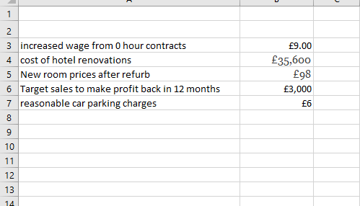
The costing for the refurb , will be done by internal consultants due to be global organisation but the main refurb would be the bedrooms and corridors, also by considering that the hotel have followed the mothball technique.

9. Project approach

9.1 The Marriott Birmingham usage will include a blend of in-house, internal and external consultancy assets. It will continue by means of the arrangement the manager that will deal with the refurb/parking/employee program, timescale and choice of improvement accomplice. It will likewise concur the manner by which expenses and advantages are done by the finance department.
10. Project Plan
Task number | Milestones | Completion date | Responsible owner | Dependency
1.A | Communication strategy | Unknown | E
2.A | Funding for consultant | Unknown | H
2.B | Procurement process to begin | Unknown | E/F
2.C | Appointment of Consultants | Unknown | E/F
3.1 | Engagement with Partners | Unknown | E/F
3.2 | Select developer | Unknown | E/F
4.1 | Conclude conditional contract to appoint developer | Unknown | C
4.2 | Design development | Unknown | D
4.3 | Deliver development | Unknown | E/F /H

10. Project team
Name | Role
Marriott / stakeholders | Project sponsor
A | Legal
B | Finance
C | Project Coordinator/Technical Support
D | Policy Planning
E | External consultant
F | Internal consultant
H | Manager

11. Communication

The selected individuals will be kept educated through a monthly report Individuals' Notice, bespoke email correspondence, as vital, workshops and reports, on a special case premise, to the Business Program Board and Directing Gathering/Development Board. Individuals will be kept educated through reports to Corporate Supervisory group.

Meeting material will be made accessible on the site. A Correspondence Technique will be developed, a Correspondence Methodology will be created.
Brand Auditing
Inspecting the Marriott hotels brand audit in the hospitality sector, stated by Haywood (1983) “it allows the consultant to differentiated itself against nearby competitors. Which can allow an accurate appraisal of its productivity”. Analysing the Marriott’s strong points composed alongside their weaknesses , this allows contemporary development to be formed.
The 3 main components that our company can offer to help the Marriott’s journey is firstly by Internal grouping of the brand values and philosophy. Vigila ( 2020 ) stated “by looking at an external view of marketing and advertising resources ( online with social media existence) this can encourage strong relations with the public who would want to get in contact for information or booking.
-customer satisfaction
- Marketing.
-Sale development
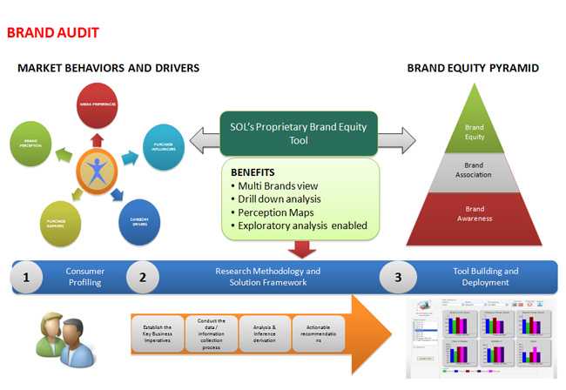

Figure 1
Figure 1 represents a diagram of a brand audit which explains the examining process. This information broken down shows
- If the financial statues of the company if it is reaching targets or is below targets
- Identify the problem
- Audit the brand to make it more viable
(De Chernatony,1990
Sustaining a knowledge to investigate the background of the company’s audits. Becoming a successful consultant is having many years of knowledge and being able to work within a strong team of individuals who are experienced and have brilliant knowledge on different department which the Marriott hotel will require from :
- Electronic information dispensation department
- Financial Management
- Kitchenette
- Marketing and sales
- Revenue Centre
- Security department
(Patior et al,2020).

12. Risk Log

The accompanying dangers have been distinguished along with an evaluation of their seriousness and moves that can be made to moderate the hazard. Intricacies of all task dangers will be recorded as and when they are recognized. This will be concluded on different document ready for the selected option.
13. Timescale
The time scale is unknown due to the manager creating a selection, but 3 months would be ideal depending on the budget.

References

Agebite.agebite@uwtsd.ac.uk. School of International Hotel Management BA International Hotel Management. 12/05/2020
Bing. (2020). Marriott Hotel Birmingham Rating. Available: https://www.Bing.com/search?q=Marriott+Hotel+Birmingham+rating&FORM=EDGENA&PC=HCTS&refig=7d7d2401786d4455b9d3edc8a2a6f8ee. Last accessed 16/05/2020.
De Chernatony, L., 1990. Auditing the Factors Influencing Brand Success. Marketing Intelligence & Planning, 8(7), pp.33-37.
Marriott, 2020. Birmingham Marriott Hotel. [online] Marriott International. Available at: <https://www.marriott.co.uk/hotels/travel/bhxbh-birmingham-marriott-hotel/> [Accessed 9 June 2020].
Patior. A & Wang. (2020). Journal of Hospitality and Tourism Management. Managers' leadership, compensation and benefits, and departments’ performance: Evidence from upscale hotels in Australia. 42 (1), p.29-39
Shriver, S., 1993. Strategic pl manning for hotel operations. Quality Management in Health Care, 2(1), pp.57-62.
TripAdvisor, 2020. BIRMINGHAM MARRIOTT HOTEL - Updated 2020 Prices, Reviews, And Photos - TripAdvisor. [online] TripAdvisor. Available at: <https://www.tripadvisor.co.uk/Hotel_Review-g186402-d193218-Reviews-or35-Birmingham_Marriott_Hotel-Birmingham_West_Midlands_England.html#REVIEWS> [Accessed 2 June 2020].
unknown, 2020. Marriott International SWOT & PESTLE Analysis | SWOT & PESTLE. [online] SWOT & PESTLE.com. Available at: <https://www.swotandpestle.com/marriott/> [Accessed 2 June 2020].

