Level 4 Assessment

Student name: Francesco V
Course name: Computing IT
Instructor Name:
Institution: University of Wales Saint David Birmingham campus
Date:

- A link to the online e-portfolio homepage.
https://sites.google.com/d/1IKqxnqeZxAxkWvCVIU-sUtFQO-7Q-GYO/p/1UJyr1I5JnsyyiSbpy-H5EgGbU5nRpPcC/edit

- A screenshot of the e-portfolio homepage.
- 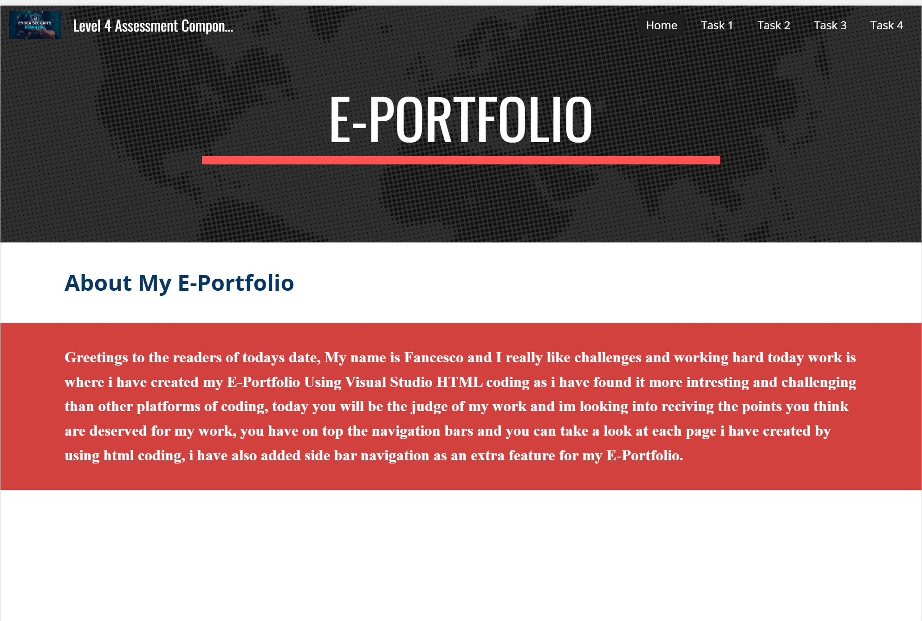

#Task 1 – Written summary.
* A screenshot/s of the task answer in the e-portfolio.
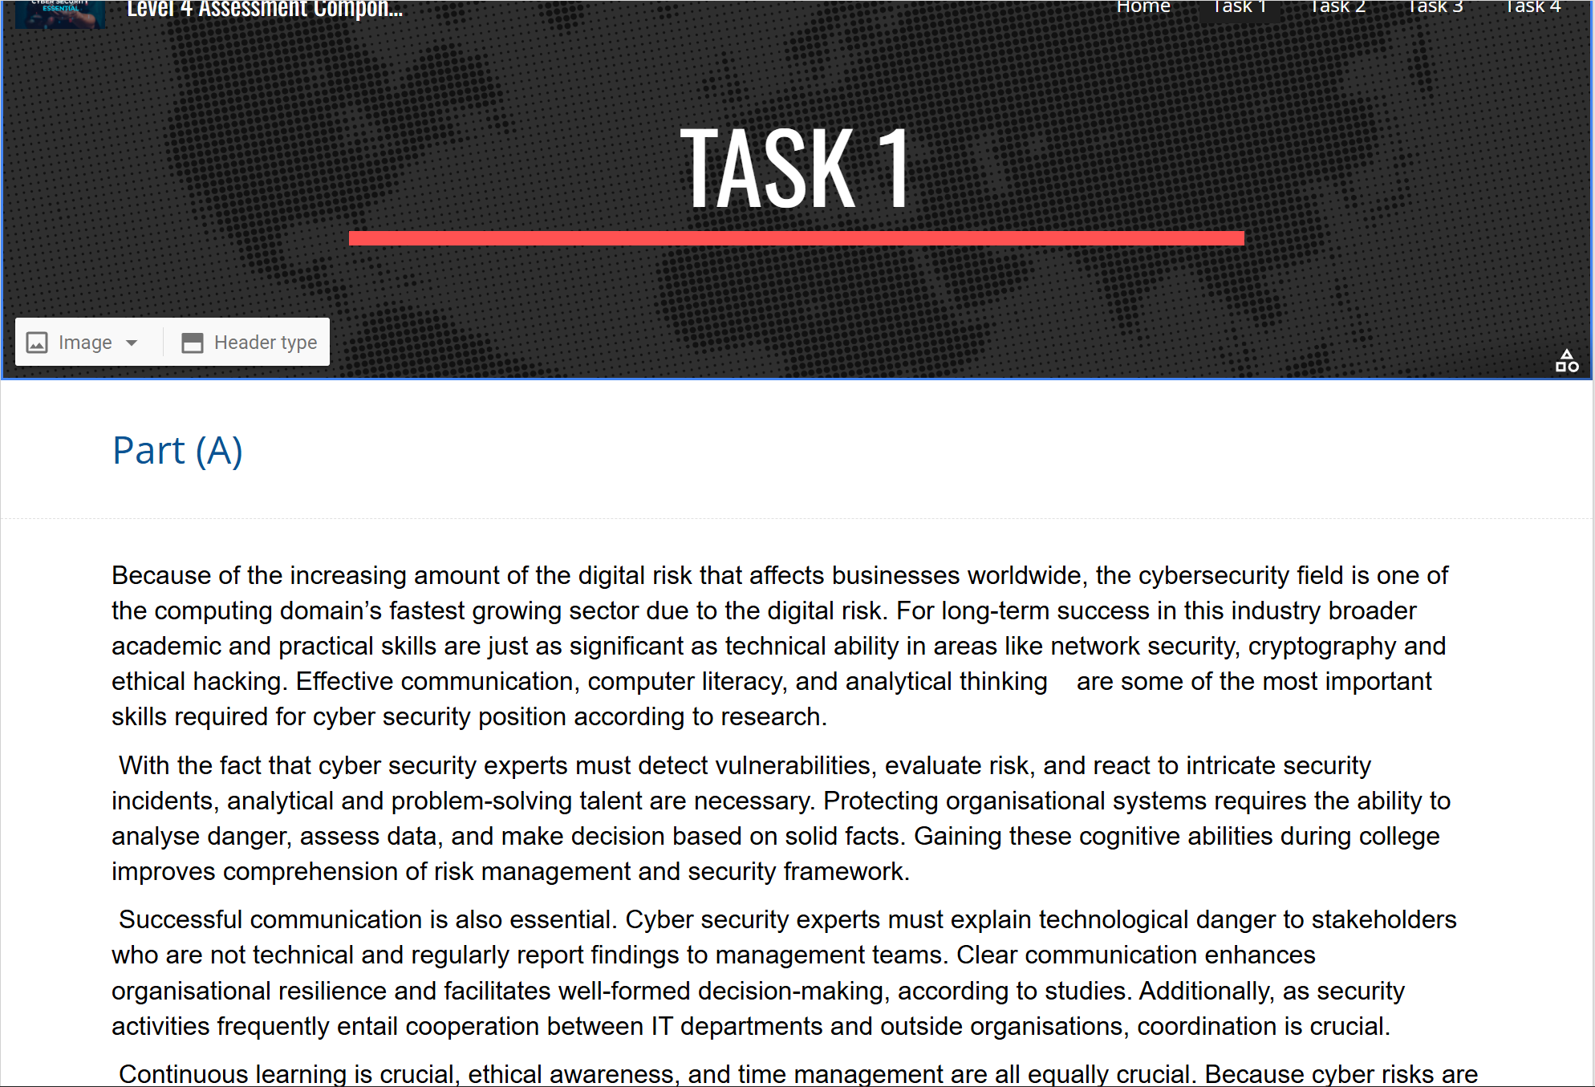
Task 2 – Mind Map & Academic poster.
1. A screenshot of the Mind-map. And a link to view the Mind-map online.

2. A screenshot of the Poster. And a link to view/download the Poster from it’s cloud storage (e.g. OneDrive, Google drive).
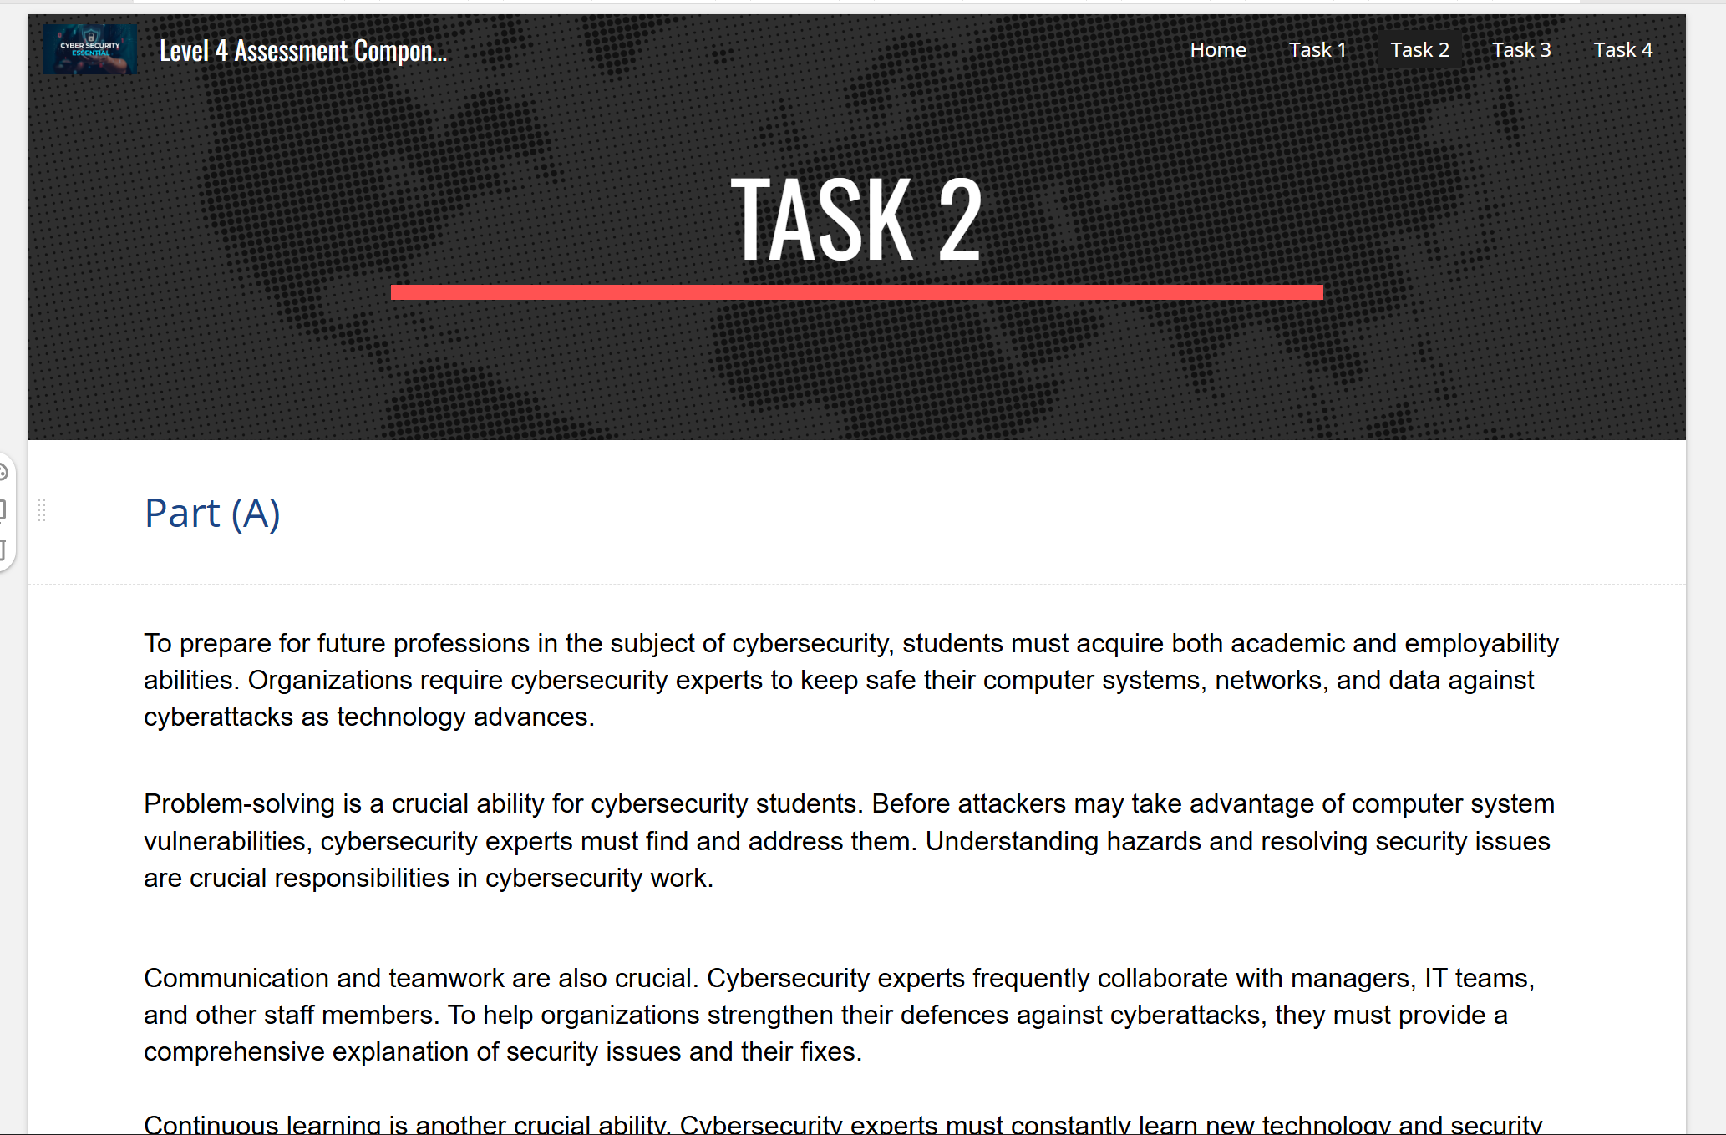
Task 3 – Automatic Referencing tool.
* A screenshot of the task answer in the e-portfolio.
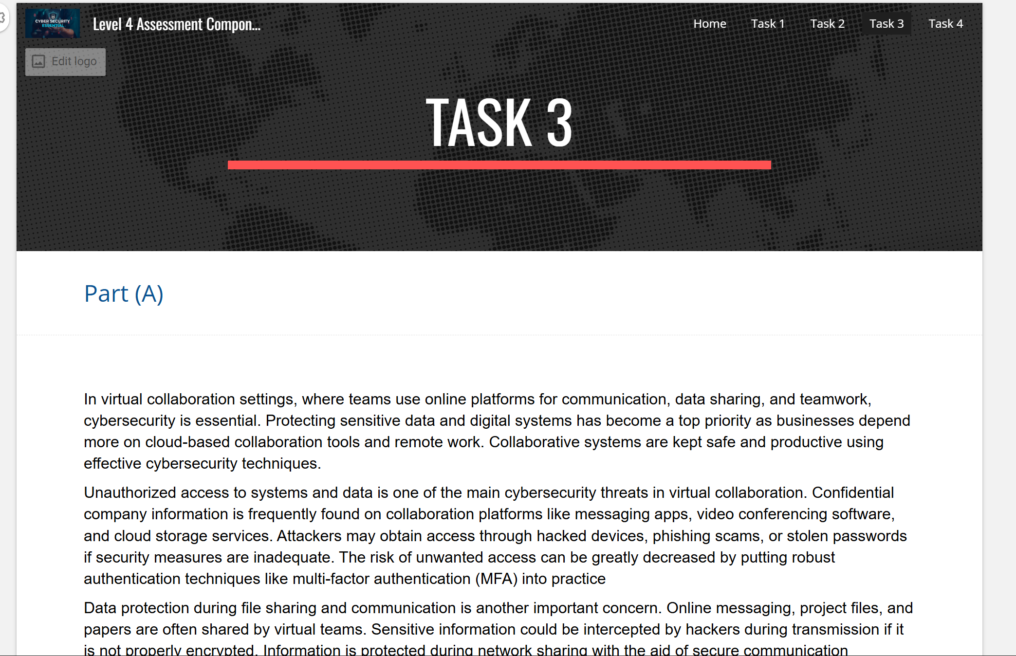

Task 4 – e-Portfolio creation and review.
* Include a screenshot of each page of your e-portfolio.


