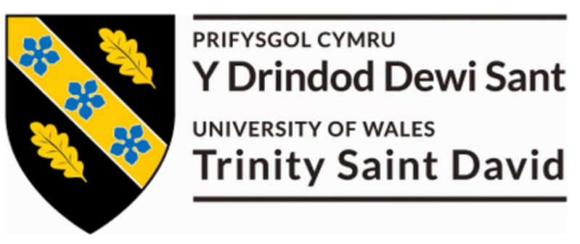


Luke Steven Prance
Materials & Processes Assignment
November 14th 2022

Introduction

For this assignment, we were tasked with finding the stress/stain curves of a rubber material of our choice. To enable us to find these curves the assignment involved us to design an experiment that would provide us with the results we required. While designing the experiment it was essential that we could be as accurate as we possibly could to ensure the results were credible. We were also asked to consider the properties of rubber and display an understanding of this in our report. I have included a list of rubber physical properties below.

Ultimate Tensile Strength
“the maximum stress that a material can withstand while being stretched or pulled before breaking”
https://en.wikipedia.org/wiki/Ultimate_tensile_strength
Engineering Stress
“engineering stress is the applied force devided by the underformed area”
https://www.sciencedirect.com/topics/engineering/engineering-stress#:~:text=Stress%20(engineering%20stress)%20is%20the,Bonding%20(Second%20Edition)%2C%202021
Engineering Strain
Engineering strain refers to the degree of deformation that a material withstands in the direction of applied forces in relation to its original length. Engineering strain is directly proportional to the amount of elongation experienced by an object
https://www.corrosionpedia.com/definition/6405/engineering-strain
True Stress
True stress is determined by dividing the tensile load by the instantaneous area.
https://ahssinsights.org/forming/formability/engineering-stress-strain-true-stress-strain/#:~:text=True%20strain%20is%20the%20natural,to%20the%20original%20gauge%20length.
True Strain
True strain is the natural logarithm of the ratio of the instantaneous gauge length to the original gauge length.
https://ahssinsights.org/forming/formability/engineering-stress-strain-true-stress-strain/#:~:text=True%20strain%20is%20the%20natural,to%20the%20original%20gauge%20length.
Hardness
“Hardness is the resistance of a material to localised plastic deformation.”
https://www.southampton.ac.uk/engineering/research/facilities/360/nCATS_facility/hardness.page#:~:text=Hardness%20is%20the%20resistance%20of,to%20plastics%20and%20soft%20tissues.
Experiment Method
 | Band 1 | Band 2 | Band 3
Length (mm) | 80 | 80 | 80
Width (mm) | 7 | 4 | 2
Thickness(mm) | 2 | 2 | 2
Area (mm^2) | 14 | 8 | 4
Cross Sectional Area (mm^2) | 28 | 16 | 8
To gather the data required for this assignment myself and my colleague Matthew Dewhurst designed the following experiment. Initially we recorded all the data we could from the bands before doing anything. We collected the following data from the bands, the length, the width and thickness from this I then worked out the cross-sectional areas of the bands. We did this because as far as we were aware the bands were in their original untested state, we used Vernier Callipers to be as accurate as we could.

Following our initial data collection, we collected the following tools (Fig.1)
- Fishing scales
- Vernier Callipers
- Tape Measure
- Carabiner
- Scaffolding board with a hook screwed into the top

The experiment involved attaching the carabiner to one of the elastic bands, then hooking the rubber band over the hook that was attached to the top of the board and then using the hook on the fishing scales to stretch the elastic band to the force we wanted. Once we had applied the force we wanted to, we would then take a recording of the length of the elastic band using the tape measure and jot that data down on our spread sheet next to the force we had applied. To ensure we were as accurate as possible and that our results could be credible, we ensured that each time we stretched the band that the fishing scales were zeroed and that we took the measurement from a set area on the scaffolding board. Shown in (Fig.2)
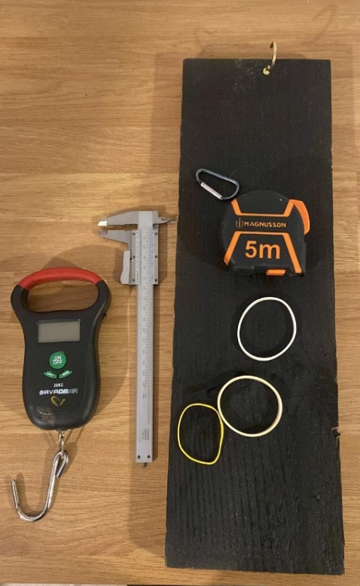
(Fig.1)
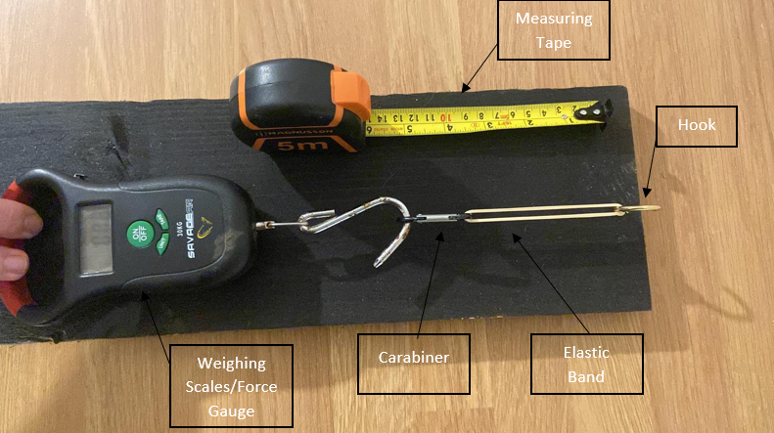
(Fig.2)

Results
Prance & Dewhurst - Raw Data
Force in grams (g) | Band 1 (mm) | Band 2 (mm) | Band 3 (mm)
100 | 85 | 91 | 98
300 | 87.5 | 97 | 140.5
500 | 89 | 103 | 176
700 | 92 | 129.5 | 242
900 | 94 | 153 | 274
1100 | 100 | 178 | 303
1300 | 106 | 188.5 | 329.5
1500 | 113 | 210 | 369
1700 | 115 | 235 | 397
1900 | 123 | 249 | 422
2100 | 133 | 276 | 458
2300 | 142 | 296 | 481.5
2500 | 160 | 314 | 518
2700 | 162 | 322 | 546
2900 | 171 | 356.5 | Snap
3100 | 175 | 372
3300 | 179 | 393.5
3500 | 183 | 409
3700 | 186 | 416
3900 | 189.5 | 435
4100 | 195 | 443
4300 | 201.5 | 459
4500 | 211 | Snap
4700 | 230
4900 | 238
5100 | 280
5300 | 289
5500 | Snap
Below is a table of the results collected from the above experiment across the 3 different sized bands. As you can see from the table myself and Matthew continued the experiment until all 3 bands snapped, the reason behind this is that we wanted to see what the ultimate tensile strength of each band. As you can see from the below table, we measured the force in grams and the length of the band in mm.

After me and Matthew had collected the raw data together, we went our separate ways to analyse the results alone. The first thing I did was to use the data we had initially gathered to find out the engineering strain, true strain, engineering stress and true stress of the rubber bands based on our results. Below there are 2 graphs showing the results of these points.

Analysis of Results

Band 1
For our initial sample ‘Band 1’ we used a band with a cross sectional area of 28mm² and applied multiple forces in increments of 100g until we could find the ultimate tensile strength of the band. Ultimate tensile strength means the amount of stress a material can take before breaking. When looking at the Engineering Stress/Strain Graph, Band 1 had extended 2.6 times its original length. Again, looking at the true stress/strain graph we can see that the band can withstand 6.7N/mm² of stress before failing, Meaning the ultimate tensile strength of this band is 6.7N/mm². We can use the data from these graphs to calculate the youngs modulus of elasticity.
Youngs Modulus of Elasticity = $\frac{σ}{ε}$
Youngs Modulus of Elasticity = $\frac{1.2}{6.7}$
Youngs Modulus of Elasticity = 5.2174 Nm².
Band 2
For our second sample ‘Band 2’ we used a band with a cross sectional area of 16mm² and applied multiple forces in increments of 100g until we could find the ultimate tensile strength of the band. When looking at the Engineering Stress/Strain Graph, Band 2 had extended 4.7 times its original length. Again, looking at the true stress/strain graph we can see that the band can withstand 15.1N/mm² of stress before failing. Meaning the ultimate tensile strength of this band is 15.1N/mm². We can use the data from these graphs to calculate the youngs modulus of elasticity.
Youngs Modulus of Elasticity = $\frac{σ}{ε}$
Youngs Modulus of Elasticity = $\frac{1.7}{15.1}$
Youngs Modulus of Elasticity = 8.64 Nm²

Band 3
For our Last sample ‘Band 3’ we used a band with a cross sectional area of 12mm² and applied multiple forces in increments of 100g until we could find the ultimate tensile strength of the band. When looking at the Engineering Stress/Strain Graph, Band 3 had extended 5.8 times its original length. Again, looking at the true stress/strain graph we can see that the band can withstand 15N/mm² of stress before failing. Meaning the ultimate tensile strength of this band is 15N/mm². We can use the data from these graphs to calculate the youngs modulus of elasticity.
Youngs Modulus of Elasticity = $\frac{σ}{ε}$
Youngs Modulus of Elasticity = $\frac{1.9}{15.9}$
Youngs Modulus of Elasticity =7.83 Nm²

True Stress/Strain
When looking at this graph we can see that the bands become harder the further they are stretched. This is a clear indication on the hardness property. Rubber has brilliant hardness properties due to the structure of the elastomers. The steeper the curve on this graph the harder the band.

Analysis of Experimental Accuracy and Cost/ Quality Trade off
Looking back on the experiment It is my opinion that myself and Matthew took the necessary precautions to attempt to be as accurate as we could due the budget we had (£0). We ensured the lengths of the bands were recorded from the same place each time, used vernier callipers to measure the bands initially, zeroed the fishing scales each time we added force.
However, if we had an unlimited amount of time and money to repeat this experiment, there are many improvements we could have made. Firstly, I would have got my hands on a set of 100g weights so that I could accurately add 100g each time with ease. As we were using fishing scales it was difficult to apply the correct force by hand as on each pull sometimes the bands had forces that were higher or lower before reaching the desired 100g increment (this took a long time!)
Secondly, I would have like to test the bands at difference that temperature would have had on the experiment. My initial idea was to use a spray booth in work to test the band at around 40 degrees Celsius, then test the band at 21 degrees Celsius (temperature spray booth is at when spraying cars) and then test the band outside on a cold day. Unfortunately, due to time restrictions in the paint shop at work, I was unable to convince the paint shop manager that my university experiment was more important than his rework for his cars!
Thirdly, on further analysis of the elastic bands that we had used, it was apparent that they were made of different variations of rubber, the texture and colour were not the same, with band 1 having a slight dust coming from it. If I was to do this experiment again, I would ensure the types of rubber were the exactly the same to ensure I was comparing the exact same types of rubber and testing the effect of different sized bands as intended!
Fourthly, I would have taken into consideration one health and safety point. When stretching the band to find the tensile strength I knew the band would snap and inevitably I was hit 3 times by the bands! I would have invested in a pair of gloves to prevent any pain being inflicted.
Fifthly, I would have liked to have analysed the bands further to gain data to compare how creep in the rubber bands would have affected the experiment, this could have been done by remeasuring the bands after applying the various increments of force
Finally, I would have liked to invest in a fully calibrated force gauge that had been designed for push/pull tests. I would be able to say that the results are completely accurate as the gauge would be calibrated and we could be much more reliable results.

Conclusion
To conclude myself and Matthew have managed to design plan and carry out an experiment on 3 different rubber bands which varied in size. We managed to do this with no cost being incurred, we performed many precautions to ensure our results were as accurate as they could possibly be. From this experiment we were able to produce a large table of raw data, this allowed me to produce an Engineering stress/strain graph, True Stress/Strain Graph find the ultimate tensile strength of the bands which was:
Band 1 ultimate tensile strength = 6.7N/mm²
Band 2 ultimate tensile strength = 15.1N/mm²
Band 3 ultimate tensile strength = 15N/mm²
And find the youngs modulus of each band which was
Youngs Modulus of Elasticity = 5.2174 Nm².
Youngs Modulus of Elasticity = 8.64 Nm²
Youngs Modulus of Elasticity =7.83 Nm²

Acknowledgements
For this Assignment, I had the help of one of my colleagues Matthew Dewhurst, together we managed to plan, design and carry out an experiment with a budget of £0. This was a two man plan and enabled us to get a set of results that were as accurate as possible considering the budget, which allowed me to create the above engineering stress/strain and True Stress/Strain Graphs, which allowed me to then analyse results that I could consider as reliable.

References
https://en.wikipedia.org/wiki/Ultimate_tensile_strength
https://www.sciencedirect.com/topics/engineering/engineering-stress#:~:text=Stress%20(engineering%20stress)%20is%20the,Bonding%20(Second%20Edition)%2C%202021
https://www.corrosionpedia.com/definition/6405/engineering-strain
https://ahssinsights.org/forming/formability/engineering-stress-strain-true-stress-strain/#:~:text=True%20strain%20is%20the%20natural,to%20the%20original%20gauge%20length.
https://ahssinsights.org/forming/formability/engineering-stress-strain-true-stress-strain/#:~:text=True%20strain%20is%20the%20natural,to%20the%20original%20gauge%20length.
https://www.southampton.ac.uk/engineering/research/facilities/360/nCATS_facility/hardness.page#:~:text=Hardness%20is%20the%20resistance%20of,to%20plastics%20and%20soft%20tissues.

