ACCA4023: introduction to web and Database concepts.
Assignment 2: Database Concepts.

Nia Davies - 2518521
University of Wales Trinity Saint David

Table of Contents
Contents
Table of Contents 1
Task 1 – Scenario Analysis 2
Task 1 – Entity Relationship Diagram (ERD) 3
Task 1 – Data Structure Development 4
Task 1 – Validation Rules Implementation 5
Task 1 – Normalization Compliance 6
Task 1 – Sample Data Population 7
Task 1 – Query Development 8
Task 1 – Testing and Reporting 9
Task 2 – Report. 10
References 11

Task 1 – Scenario Analysis
The following report documents the process of building a database to capture the data involved in a bike-rental scheme, called EcoRide. The purpose is to track bike locations, monitor rentals, record servicing history and maintain accurate data for the databases required entities.
Creating a database with appropriate keys, relationships and cardinality will be applied throughout and using a database, as opposed to paper forms will enable summaries and reports to be gathered from the database and the data to be analysed where required.
The entities identified were;
- Rentals: to capture each rental transaction. Attributes included were selected to ensure all relevant rental details are captured.
- Riders: EcoRide Rider or member details are stored here including, ID numbers and other required information.
- Bikes: to track the bikes involved in the scheme.
- Servicing: to track maintenance and repairs.
- Staff: to capture necessary data relating to EcoRide staff members.
- Locations: to track EcoRide locations, where bikes are stored, collected and returned.
- Billings: containing billing details relating to rentals.

Once the entities were created within the table, the relationships between them were established using primary and foreign keys allowing information to be shared across the whole database, without duplication.

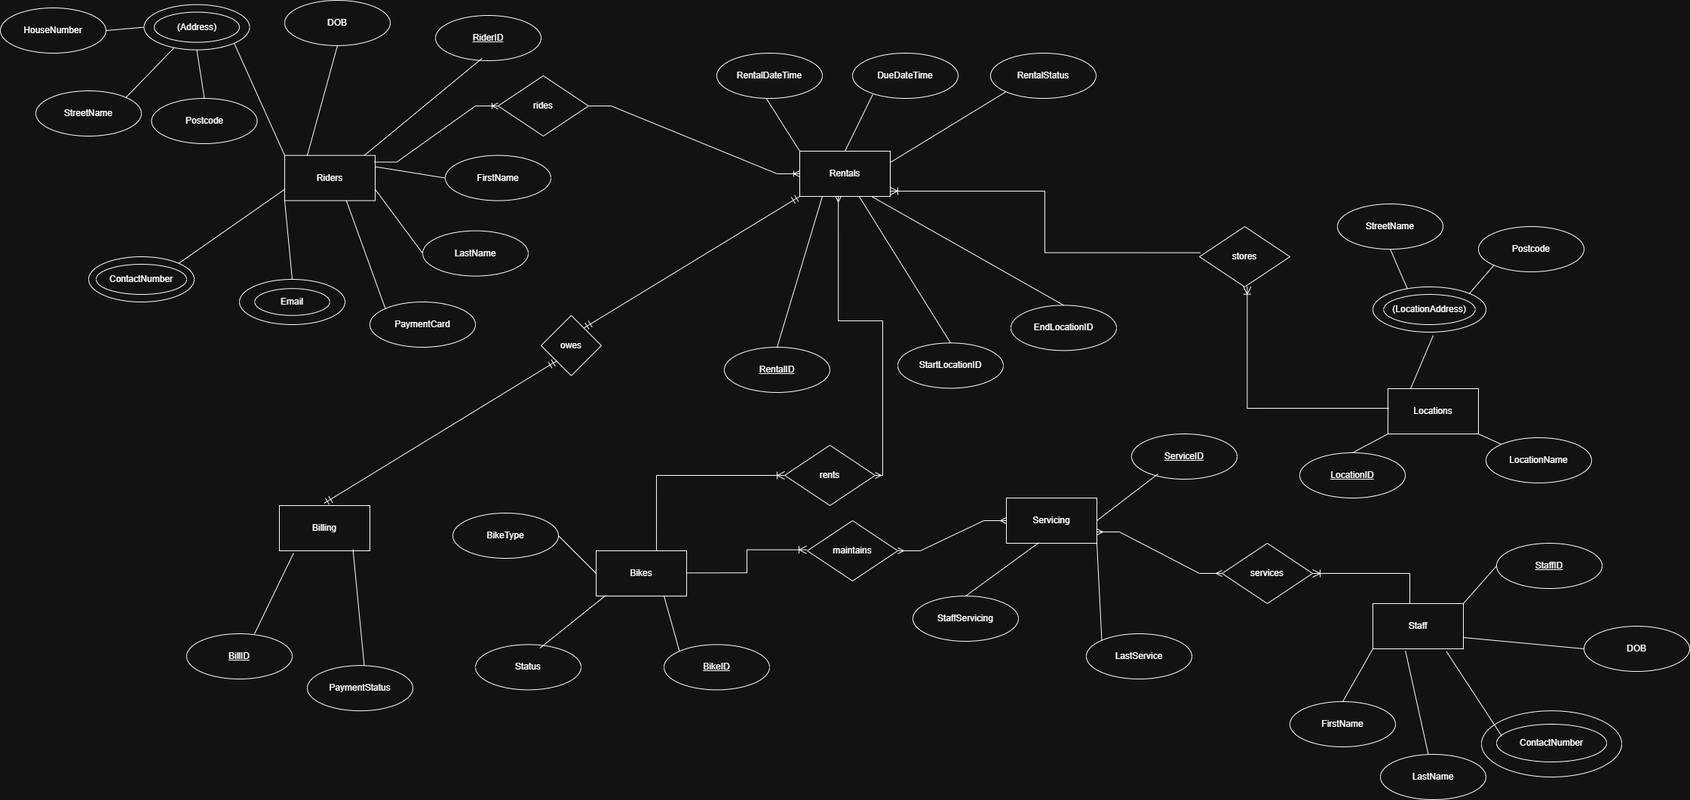
Task 1 – Entity Relationship Diagram (ERD)
[Figure 1: ERD Diagram for EcoRide Database]

Task 1 – Data Structure Development

The following data structure was developed from the Entity-Relationship model to create a clear framework for the data within this database. Entities identified within scenario analysis were then given relevant attributes to capture the required information. Primary keys were assigned within each entity to allow users to uniquely identify records, and foreign keys, with relevant cardinality constraints to establish relationships, maintain relationship consistency and avoid duplication of data.

- Rental Entity.
Rentals contains the necessary information regarding rentals and is related to various other entities within the database. RentalID acts as the primary key, ensuring each rental has a unique identifier. BikeID is related and added as a foreign key, associating a bike to a rental. One-to-many cardinality has been added as a single bike will have multiple rentals.
RiderID is also associated as a foreign key and associates a rider to the rental. This relationship also shows One to Many cardinalities to show one rider can be associated to many rentals.
Locations is also related via attributes Start and End Location ID, tracking the start and end point of each rental. Many-to-one cardinality included to demonstrate that many rentals, will start or end at an individual location.
Also associated, is Billing. One-to-one cardinality shown accounting for one bill to be associated to one rental and vice versa.

- Riders Entity.
The Riders Entity contains information regarding the members signed up to this scheme. Each member is given a RiderID, acting as the primary key for the entity and a relationship established between this entity and the Rental Entity, as listed above.

- Bikes Entity
This entity contains information relating to the bikes used within the scheme. As above, it has been associated to Rentals but has an established relationship with the Servicing entity, linked via a one-to-many cardinality between them to represent the many services that one bike may have.

- Servicing Entity
As listed above, the Servicing Entity is related to the Bikes entity but is related to the Staff entity to relate the staff undertaking the service to the service itself. One-to-many cardinality has been established to represent the individual staff member who may undertake multiple services.

- Staff Entity
This entity has an established relationship with the Servicing entity which has been detailed above.

- Locations Entity
The Locations Entity, as noted, is related back to the Rentals entity, representing associated EcoRide Locations.

- Billings Entity
This entity is associated to the Rental entity with one-to-one cardinality.

Task 1 – Validation Rules Implementation

Validation has been implemented where appropriate or necessary to ensure accuracy and consistency. Not all attributes require validation rules as some are controlled through established relationships and supported with referential integrity.
Rentals
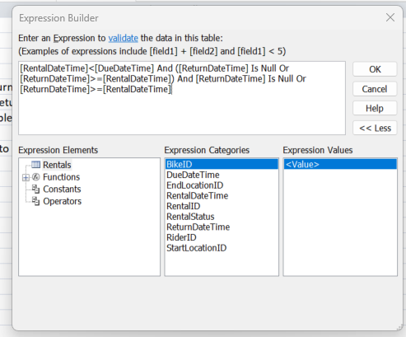
[Figure 2: Expression Builder for Rentals Entity]
Figure 2 shows validation rules applied to the Rentals Entity. Applying these rules to the table enables us to compare attributes against one another. Here, rules have been applied to ensure dates can only be entered in a logical order, specifically, to ensure that the Due Date cannot be before Rental Date and the Return Date cannot be before either the Rental Date. The rules will allow for a blank Return Date to accommodate for active rentals.

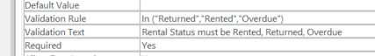
[Figure 3: RentalStatus Validation Rules]
Rules will ensure only valid Status options can be entered.

Riders
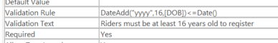
[Figure 4: DOB Validation Rules]
Rule applied to ensure no riders are under sixteen years of age based on current date.
[Figure 5: ContactNumber Validation Rules]
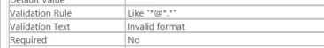
[Figure 6: Email Validation Rules]
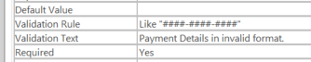
[Figure 7: PaymentCard Validation Rules]
Validation Rules applied to Rider ContactNumber, Email and PaymentCard attributes to ensure data is only entered in an acceptable and valid format.

Bikes
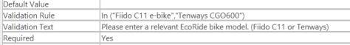
[Figure 8: BikeType Validaiton Rules]
[Figure 9: Status Validation Rules]

Locations
[Figure 10: LocationName Validation Rules]
[Figure 11: LocationAddress Validation Rules]

Figures 8-11 show similar rules. These have been added to ensure that only accepted input can be entered within the database.

Servicing

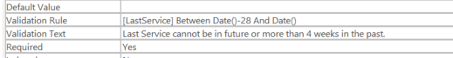
[Figure 12: LastService Validation Rules]
Rule applied ensures that LastService cannot contain a future date or a date more than 4 weeks in the past.
Staff
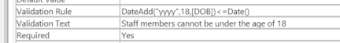
[Figure 13: DOB Validation Rules]
Rule applied to ensure only people over 18 years of age can be listed as Staff members.

Billing
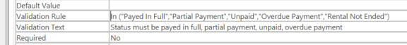
[Figure 14: PaymentStatus Validation Rules]
Rules applied to ensure only accepted statuses can be added to database.

Task 1 – Normalization Compliance
First normal form (1NF) has been achieved as each entity has a primary key that can uniquely identify each record and each value within the attributes contain atomic (indivisible) values. Second normal form is achieved as there are no partial entities within the database. Each non-key attribute is functionally dependent on the tables primary key. Third Normal Form (3NF) "ensures that every non-key attribute is directly related to the primary key and not to another non-key attribute". [1] This stage of normalisation has also been achieved within this database as no non-key attributes rely on other non-key attributes. Where data from other entities is required, it has been liked using a foreign key, rather than duplicated. Normalising assists in reducing data redundancy and maintains data integrity.

Examples of normalization in this database include;
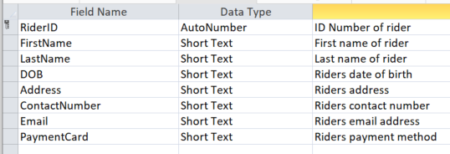
[Figure 15: Riders table]
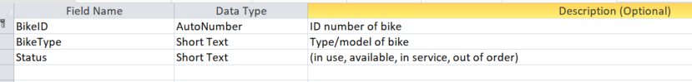
[Figure 16: Bikes table]
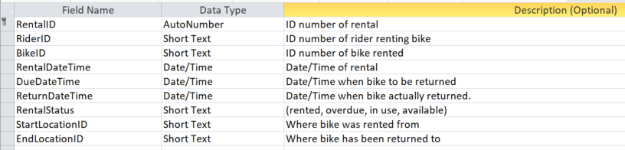
[Figure 17: Rentals table]
[Figure 18:Locations table]
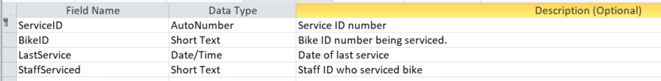
[Figure 19: Servicing table]
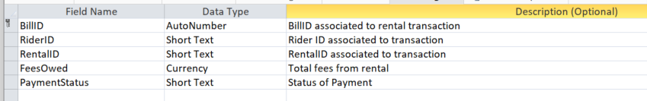
[Figure 20: Billing table]
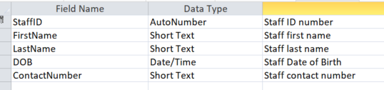
[Figure 21: Staff table]
As demonstrated, the database structure complies with Third Normal Form (3NF) as each entity uses a primary key to uniquely identify records and non-key attributes are dependent on their primary key. Therefore, no transitive or partial dependencies are present. Where data is required within other entities, an appropriate relationship has been established using foreign keys, rather than duplicating the data across tables.
This normalisation process reduces data redundancy and supports ongoing database maintenance by ensuring data is stored consistently, therefore remaining accurate across the listed entities. Normalisation also supports database amendments and minimises update, insert and deletion anomalies, maintaining data integrity, creating a scalable and functional database.

Task 1 – Sample Data Population
To support testing, query execution within the database, sample data was entered as demonstrated below. The dataset was designed and applied to reflect realistic scenarios and expected system use based on the requirements set out for this database.
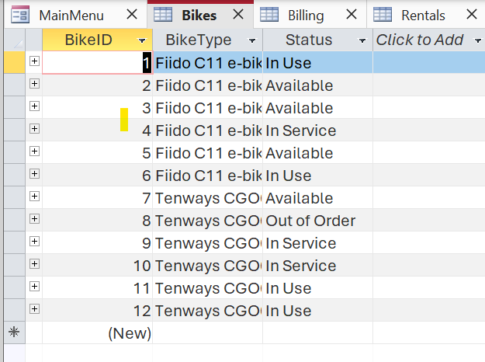
[Figure 22: Bikes table data]
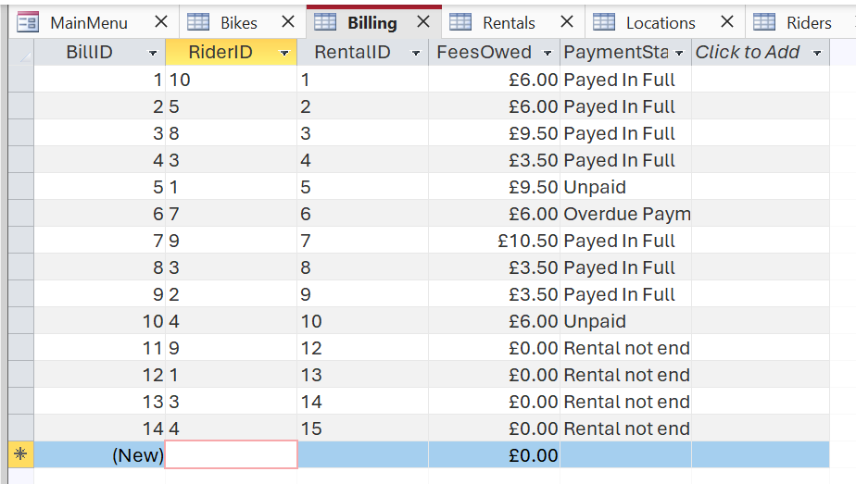
[Figure 23: Billing table data]
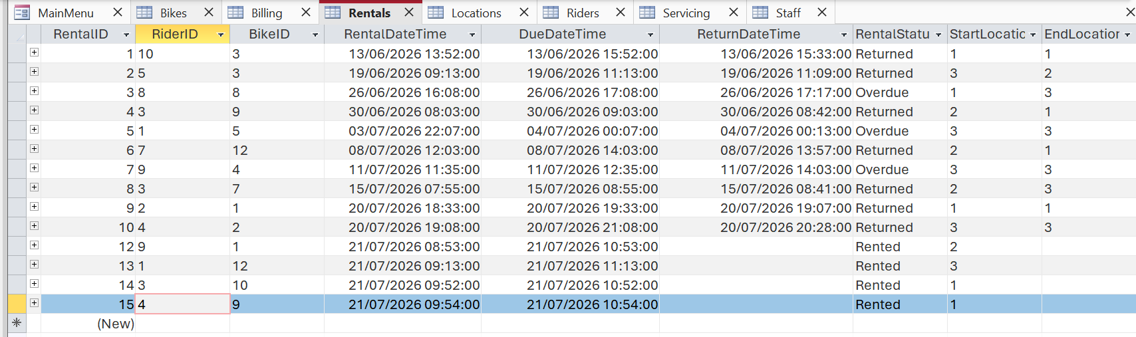[Figure 24: Rentals table data]
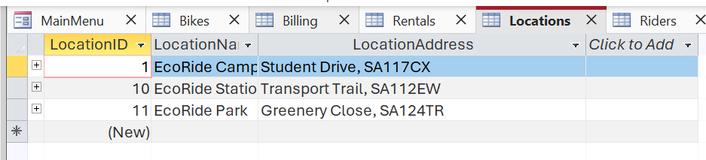
[Figure 25: Locations table data]
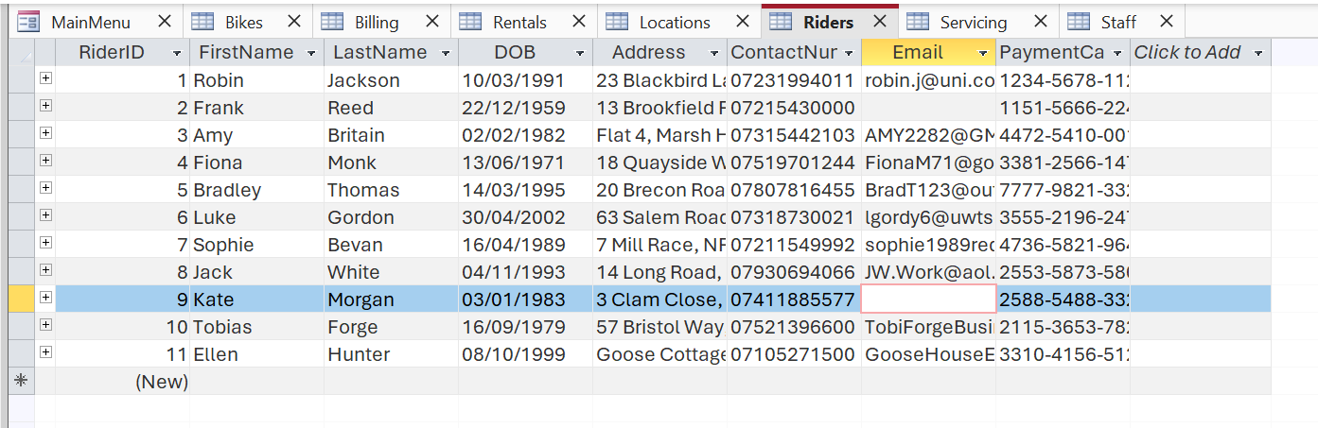
[Figure 26: Riders table data]
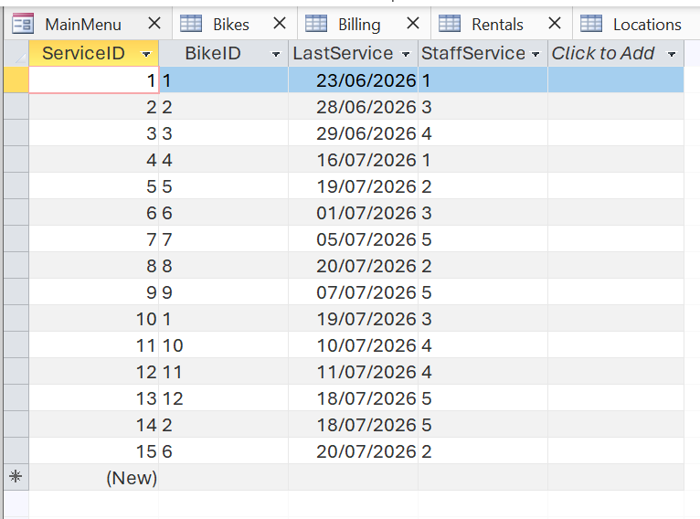
[Figure 27: Servicing table data]
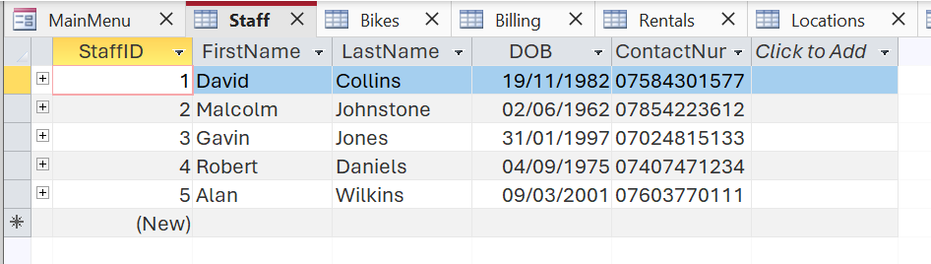
[Figure 28: Staff table data]

Task 1 – Query Development
Following the inclusion of sample data, queries have been developed with realistic scenarios in mind and the outcomes documented below.
- Unpaid Bills
Riders FirstName and LastName added into Query Design, FeesOwed and Payment Status entered from Billings table. When run, query below has been produced.
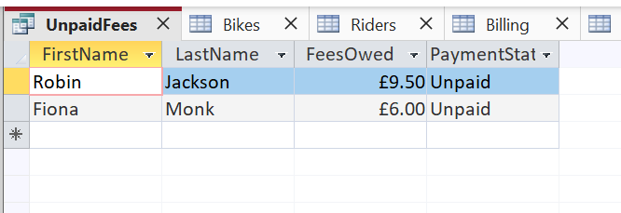
[Figure 29: UnpaidFees Query]

- Bikes currently in rental status
This query combines data across Riders, Rentals and Bikes tables using primary key and foreign ket relationships to show bikes that are currently in "rented" status.
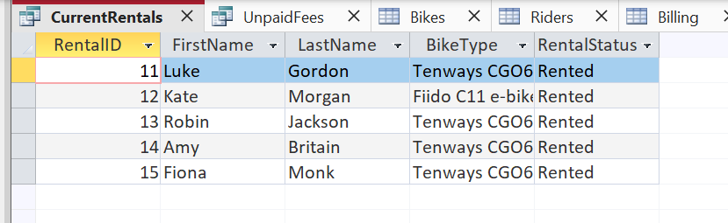
[Figure 30: CurrentRenals Query]

- FrequentUsers
Further research into databases and queries was undertaken for this query. Using Totals in queries can provide users with further information not manually included in the database. Totals "makes it easier to find information and comprehend a report. [2] In the below example, the above is demonstrated, as the total rentals per rider is calculated and output for us.
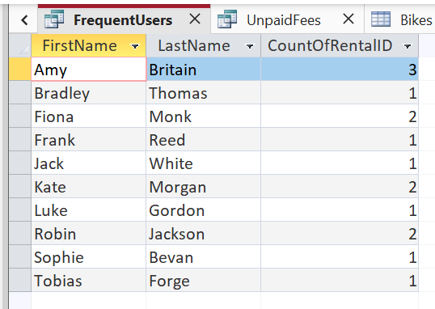
[Figure 32: FrequentUser Query output]

- StaffID4 Service History
Attributes used from Staff and Servicing Tables. Criteria of "4" entered under StaffID in Query Design to only show the Services undertaken by person associated to StaffID 4.
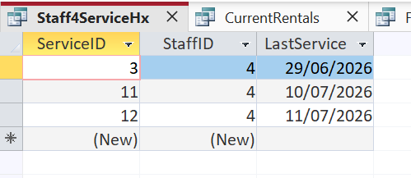
[Figure 33: StaffID 4 Service Query]

- Rental history
Information was taken from Riders, Bikes and Rentals, with RentalDateTime being sorted into descending order to display a historic log of all rentals, including Rider Names and the bikes used.
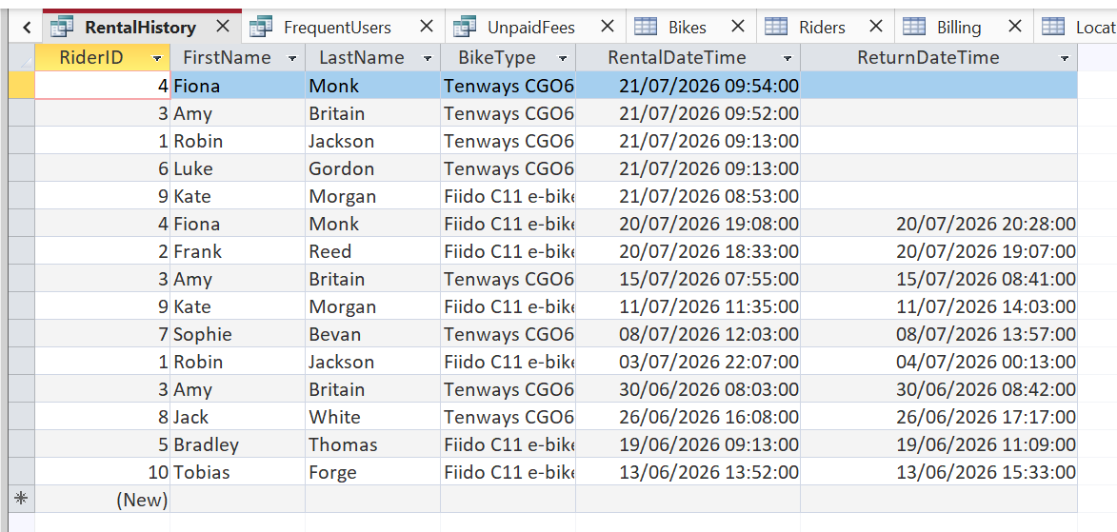[Figure 34: Rental history query]

- Service Required
Query attributes used from Bikes and Servicing tables to identify Bikes approaching service deadlines. Within identified requirements for this database, bikes should be serviced at least every 28 days. Criteria "<Date()-21" included under LastService to identify bikes approaching this servicing deadline.
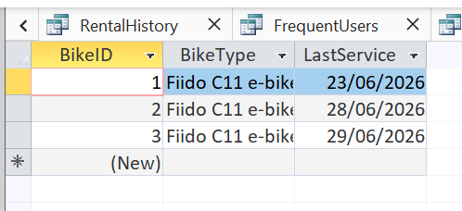
[Figure 35: ServiceRequired query]

Task 1 – Testing and Reporting

The database was tested throughout design and development and as a result, is functional and fit for purpose. The structure of the database supports data integrity using primary and foreign keys as well as the relationships between the entities and validation rules are applied where appropriate or necessary to reduce risks of incorrect or incomplete data being entered.
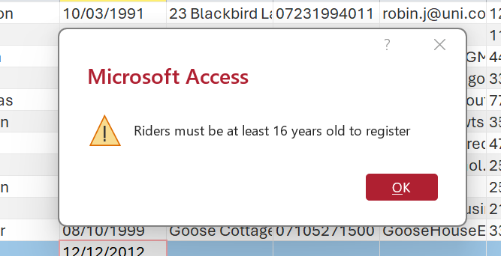
[Figure 36: Error message, triggered by validation rules]

The queries were designed to retrieve accurate and relevant information from the database, supporting the schemes business requirements. Data throughout appears logically and can be filtered further, with potential for further queries to be run successfully to obtain any required data.

Task 2 – Report.

The result of the above has resulted in a functional and relational database using MS Access. The aim was to create a structured database that had the ability to store any relevant information with the ability to run queries to analyse the input data. Throughout this process, principles of database design, such as normalisation, entity relationships and query design were applied to ensure reliability.
The core tables were initially created and relationships established using primary and foreign keys, which allowed data to be stored in multiple tables, rather than duplicating that data. According to Microsoft Support, one of the key objectives of good database design is to reduce redundancy by separating data into subject specific tables and linking them [3].

Though the database is functional, there are several areas that could be improved by further development. One example being the inclusion of PaymentCard within the Riders table. In retrospect, a more effective solution may have been to create a separate PaymentDetails entity, linked to Riders through a one-to-many relationship. This would enable a rider to store multiple methods of payment and improved a normalised structure. The inclusion of a new PaymentDetails table would able allow the database to have further scalability for future development.
In addition, while the database has been populated with enough sample data to run queries and test functionality, more samples would have been beneficial. A larger dataset could allow more extensive testing and more advanced queries and will "typically encompass a wider variety of scenarios, which helps models learn complex patterns that smaller datasets might miss" [4].

During earlier stages of development, the Riders table featured an Age attribute. However, when looking to begin the Normalisation Process and reaching Third Normal Form (3NF), this was removed from the database. As stated above, 3NF requires non-key attributes to not depend on other non-key attributes and as Age would be derived from DOB fields, the data becomes redundant and if needed, Age could be calculated from DOB if needed. Removing the field further secured data integrity as it eliminates the risk of inconsistencies as Riders age.
This change demonstrated the importance of database normalisation as ensuring data is stored only once improves data integrity and reduces duplication and inconsistencies. As a result, database maintenance becomes more efficient and overall accuracy is improved.

Some challenges were experienced within development, particularly when designing queries. Several queries initially generated data type mismatch errors, preventing them from being executed. Upon review, some attributes associated to related attributes were given an incompatible data type, causing them to fail. A similar challenge was identified regarding the relationship between primary and foreign keys. Again, some of these keys has incompatible data types given to them.
The issue highlighted the importance of ensuring fields are assigned with the appropriate data type at the beginning of development. Data types are not only required for accurate storage and functionality but also to "allocate storage space and optimize query performance" [5]. Once the data types were amended as required, the queries were run without issue.

In summary, a functional database has been created, meeting the main objectives. The development process demonstrates practival application of database design principles, such as normalisation, relationships management and query design. The challenges encountered provided a opportunity to develop understanding of database best practises further. The current database provides a scalable system, which could be improved and developed further with further entities and more sample data.

References
[1] A. R. Valdez, SQL Programming Fundamentals: A Beginners Guide to Database Systems Management. Jul, 4. 2026. [Online]. Available: https://www.google.co.uk/books/edition/SQL_Programming_Fundamentals_A_Beginner/wPPuEQAAQBAJ?hl=en&gbpv=0. [Accessed 21, Jul. 2026.]
[2] S. E. Slack, Brilliant Microsoft Access 2007 Pocket Book. Harlow, U.K: Pearson/Prentice Hall, 2007.
[3]“Guide to table relationships | Microsoft Support,” 2024. Accessed: July 22, 2026. [Online]. Available: https://support.microsoft.com/en-US/Access/guide-to-table-relationships. [Accessed 22, Jul. 2026]
[4]“What are the benefits of using big datasets versus small datasets?,” Dec. 2024. Accessed: July 22, 2026. [Online]. Available: https://zilliz.com/ai-faq/what-are-the-benefits-of-using-big-datasets-versus-small-datasets, [Accessed 22, Jul. 2026]
[5]Arief Wicaksono, “Why data types and data structures are important in Data Analysis?,” July 2025. Accessed: July 22, 2026. [Online]. Available: https://medium.com/@ariefwcks303/why-data-types-and-data-structures-are-important-in-data-analysis-bd40222d4023 [Accessed 22, Jul. 2026]

