Riley Tippett 2305603
Jacqui Jones
International travel operations
BMTP5017
Back office Document

Itinerary Introduction
This travel package will be a six-day educational trip for a group of fourteen students to Barcelona. This will be a business-to-customer package. My Target Audience is students studying travel and tourism or cultural studies at university. The reason this trip is happening is to give students a better idea of Barcelona's culture, history, and life. To provide a unique learning experience outside the classroom, allowing participants to develop soft skills, cultural awareness, and industry insight in a practical environment. An educational tour blends immersive cultural, historical, or industry-specific experiences with predetermined learning objectives. It strikes a balance between engagement and instructional value to reinforce important concepts in a practical setting. The trip will be from the 13th of June to - 20th of June

Travel Arrangements
Everybody will meet at the UWTSD waterfront campus at 9:30 am and walk to Swansea bus station to get the 10:05-12:50 coach to Bristol airport, which will cost £7.50. The group will then arrive at the airport at 13:00 and go through customs, baggage check, and passport control. The flight to Barcelona from Bristol will be at 18:20, and we will arrive in Barcelona at 21:20. The flight back home will be on the 20th of June, which departs Barcelona at 22:05 and will be back in Bristol at 11:30. We will then get a coach from Bristol at 02:45 to arrive back into Swansea at 05:45

Accomodation
For the upcoming educational trip to Barcelona from the 13th to the 19th of June 2025, the group of 14 students and 2 teachers (16 people in total) will be staying at the Barcelona Century Hotel. This 3-star hotel is located in the central Eixample district of Barcelona, offering convenient access to a variety of educational and cultural attractions. The nearest metro station is Urgell (L1 - Red Line), which is only a five-minute walk from the hotel, making it an ideal base for exploring the city via public transport.
The hotel will provide 8 twin rooms—7 for students and 1 for teachers—with two guests per room. Each room includes modern amenities such as air conditioning, free Wi-Fi, ensuite bathrooms, satellite TV, a safe, and daily housekeeping. A breakfast buffet is included in the stay when booked directly through the hotel. The hotel also offers 24-hour reception service, which is important for the safety and comfort of a school group.
The estimated cost for accommodation is €140 per twin room per night. For 8 rooms over 6 nights, the total cost comes to approximately €6,720. This estimate is based on average June 2025 rates and may vary slightly depending on availability and group booking offers. Group discounts may be available by contacting the hotel directly for an educational package.
The Barcelona Century Hotel was chosen for its central location, safety, student-friendly atmosphere, and excellent reviews for cleanliness and customer service. Its proximity to the metro ensures that the group can move efficiently around the city to attend educational excursions and sightseeing opportunities. The hotel is also close to supermarkets, restaurants, and pharmacies—ensuring convenience for both students and staff.

Finances
Coach - £14.98 pp for round trip
Flights - BRS To BCN - £46.99/ BCN to BRS - £64.99 = £111.98 for round trip
Hotels - 140 euros per twin room per night
La Sagrada Família - 15 Euros pp
Park Güell - 35 euros pp
Gaudí Experience - 9 euros pp
Picasso Museum - 12 euros pp
Poble Espanyol - 13.50 euros pp
Flamenco Show at Tablao Cordobés - 48 euros pp
CosmoCaixa Science Museum - 8 euros pp
L'Aquarium Barcelona - 27 euros pp
Torre Bellesguard - 20 euros pp
Hidden City Tours - 10 euros pp
FC Barcelona Camp Nou Experience - 20 euros pp
Perry Tours Bike Tour - 25 euros pp
The total estimated cost per student for the entire trip to Barcelona is approximately €811.04. And about £500 spending money.

Day 1 – Friday, June 13: Arrival & Orientation
Upon arrival at Barcelona-El Prat Airport, the group will be transferred to the hotel and assigned rooms. After some time to unpack and rest

Day 2 – Saturday, June 14: Gaudí & Modernism
The group will start the day with a guided tour of La Sagrada Família, Gaudí’s architectural masterpiece and an ongoing symbol of creativity and faith. The tour will explore its intricate symbolism and design features, tying into art, architecture, and religious studies. In the afternoon, students will explore Park Güell, a whimsical public park created by Gaudí that showcases his unique vision and colorful mosaic structures.

Day 3 – Sunday, June 15: Art & Culture

In the morning, the group will visit the Picasso Museum, which houses an extensive collection of Pablo Picasso’s early works and highlights the artist’s connection to Barcelona. In the afternoon, students will engage in cultural immersion at Poble Espanyol, an open-air museum with Spanish village replicas and hands-on workshops such as pottery and local cooking. To finish the day, the group will enjoy an evening Flamenco show—a dynamic display of dance, music, and Spanish passion.

Day 4 – Monday, June 16: Science & Environment
This day will be dedicated to science and nature. The morning begins with a visit to CosmoCaixa, Barcelona’s interactive science museum offering exciting exhibits in physics, biology, and sustainability. Students can participate in hands-on learning that supports STEM subjects. In the afternoon, the group will head to L’Aquarium Barcelona to explore marine life and environmental conservation. The venue features Europe's longest underwater tunnel, and learning materials are available for students to engage with topics like biodiversity and ocean ecosystems.

Day 5 – Tuesday, June 17: History & Social Education
In the morning, the group will visit Torre Bellesguard, a lesser-known Gaudí structure combining medieval and modernist architecture. This visit enriches students’ knowledge of Catalonia’s history and cultural identity. In the afternoon, students will take part in a powerful, socially focused Hidden City Tour, guided by individuals with past experiences of homelessness. This experience raises awareness about social issues and gives students the chance to reflect on real-life urban challenges from a new perspective.

Day 6 – Wednesday, June 18: Sports & Exploration
The morning will feature an exciting visit to FC Barcelona’s Camp Nou Tour. This immersive experience takes students through the stadium and museum, highlighting sports history, marketing, and leadership. In the afternoon, the group will enjoy a guided bike tour of the city, stopping at key locations such as Arc de Triomf, Ciutadella Park, and Barceloneta Beach. The evening concludes with a farewell dinner at a local Spanish restaurant to celebrate the week’s experiences.

Day 7 – Thursday, June 19: Departure
After breakfast, the group will check out of the hotel and travel to Barcelona-El Prat Airport for their return flight. This final day provides an opportunity for reflection and group discussion about what students have learned, experienced, and enjoyed during their time in Barcelona.
Transport Options
Local Transport in Barcelona

🔹 Metro & Bus Network
- Operator: TMB (Transports Metropolitans de Barcelona)
- Highly efficient, safe, and ideal for groups
- Stations are accessible and located near all major attractions

Group Ticket Options avilable
- Hola BCN Travel Card (Unlimited travel on metro, buses, trams, trains):
  - 2 days: €17.50
  - 3 days: €25.50
  - 4 days: €33.30
  - 5 days: €38.00
- Cards can be ordered online in advance

Ticket Type | Description | Price
T-Casual | 10 journeys, non-transferable | €12.15
Hola Barcelona Card | Unlimited travel (2–5 days) | €35.40 (5-day)
Single Ticket | One metro/bus journey | €2.55

Documentation Requirements
All teachers and students participating in the educational trip must have a current passport that is valid for at least six months beyond the date of return. To enter Spain, each passenger may additionally need a Schengen visa, depending on their nationality. Each tourist is responsible for verifying their eligibility for a visa and, if required, applying promptly.

Residents of the UK and the EU should have a current EHIC or GHIC card with them so they can obtain any medical care they need when travelling. All participants must also have full-coverage travel insurance that includes coverage for medical emergencies, trip cancellation, and property damage or theft.

A rule of behaviour will be implemented in order to preserve a courteous and safe atmosphere. Both children and their parents or guardians must sign this paper, which specifies the norms of behaviour expected throughout the trip. The group leader or tour coordinator must also gather and safely store an updated emergency contact information for every student.

Lastly, a copy of the trip itinerary will be given to each student and guardian. This guarantees that throughout the trip, all parties are fully informed about the itinerary, lodging, activities, and contact details.

Communication plan
During the trip, teachers and staff will maintain regular contact with students through daily briefings and group messages via a dedicated WhatsApp group or similar secure messaging platform. This will allow quick updates, reminders, and emergency instructions to be shared instantly. A designated group leader will carry a fully charged mobile phone at all times to handle communications with transport providers, hotels, and emergency services if needed.

Risk Assesments
Group: 14 students, 2 staff
Dates: 13–20 June 2025
Location: Barcelona, Spain
Prepared by: [Riley Tippett Travels]
Reviewed by: School/College Trip Coordinator

1 . General Travel & Flights
Hazard | Risk | Likelihood | Impact | Control Measures | Responsible
Flight delays/cancellations | Disruption to itinerary | Medium | Medium | Monitor airline updates; buffer time; ensure travel insurance covers delays | Trip Leader
Lost passport/tickets | Student unable to travel | Low | High | Staff to hold spare copies; students carry photocopies separately | Staff + Students
Illness on plane | Health concerns | Low | Medium | Hand sanitiser; face masks if required; emergency medical kit available | Staff

2. Accommodation
Hazard | Risk | Likelihood | Impact | Control Measures | Responsible
Fire or evacuation | Injury/fatality | Low | High | Fire exits identified; fire drill briefing on arrival | Hotel + Trip Leader
Students leaving premises | Going missing/unsafe situations | Low | High | Curfews enforced; room checks; buddy system | Staff
Room-sharing issues | Conflict or safeguarding issues | Medium | Medium | Pre-arranged pairings; separate staff/student rooms; adjustments for needs | Trip Leader

3. Local Transport
Hazard | Risk | Likelihood | Impact | Control Measures | Responsible
Getting lost on metro/bus | Student separation | Medium | Medium | Clear meeting points; students carry emergency contact cards | Staff + Students
Boarding wrong train/stop | Delay/separation | Medium | Medium | Staff supervise all transfers; use Hola BCN passes | Staff

4. Excursions & Attractions
Hazard | Risk | Likelihood | Impact | Control Measures | Responsible
Crowd-related issues | Separation or panic | Medium | Medium | Headcounts before and after entry; pre-arranged meeting points | Staff
Pickpocketing | Loss of money/phones | High | Medium | Advise students to carry minimal cash, use anti-theft bags | Students + Staff
Slip/trip at sites | Minor injury | Medium | Low | Wear suitable footwear; caution on uneven paths (e.g., Park Güell) | Students + Staff
Allergies/medical emergency | Serious illness | Low | High | Collect medical info beforehand; carry first-aid kit; know emergency numbers | Staff

5. Meals & Dining
Hazard | Risk | Likelihood | Impact | Control Measures | Responsible
Food allergies | Allergic reaction | Low | High | Medical forms collected; restaurant notified; EpiPens carried where needed | Staff
Food poisoning | Illness | Low | Medium | Use trusted, well-reviewed restaurants; ensure students drink bottled water | Trip Leader

6. Outdoor/Bike Tour
Hazard | Risk | Likelihood | Impact | Control Measures | Responsible
Road accidents | Injury/fatality | Low | High | Bike helmets required; professional guides; pre-tour briefing | Perry Tours + Staff
Dehydration/heat | Fainting, sunstroke | Medium | Medium | Sunscreen, water bottles, rest breaks, light clothing | Students + Staff

7. Safeguarding & Supervision
Hazard | Risk | Likelihood | Impact | Control Measures | Responsible
Inappropriate behavior | Safeguarding breach | Low | High | Code of conduct; room checks; clear behavior expectations | Staff
Stranger danger | Student approached by outsider | Low | High | Group stays together; no one alone in public areas | Staff + Students

8. Special Needs/Accessibility
Hazard | Risk | Likelihood | Impact | Control Measures | Responsible
Inaccessible locations | Difficulty for students with mobility issues | Low | Medium | Hotels and activities pre-checked for accessibility; assistance arranged | Trip Leader
Medical needs unmanaged | Health emergency | Low | High | Medical plans collected; staff aware of conditions and actions | Staff

Terms and conditions
All travel arrangements for this educational trip are protected under the ATOL (Air Travel Organiser’s Licence) scheme. This means that in the unlikely event of the travel company going out of business, students and teachers will either be refunded or returned home safely if already abroad. The ATOL certificate will be issued upon confirmation of flight bookings and must be retained as proof of financial protection. Additionally, the trip is booked through an ABTA (Association of British Travel Agents)-registered tour operator. ABTA provides reassurance that the travel arrangements meet high standards of service, safety, and financial security. It also offers support and a complaint resolution service if any problems arise before or during travel.

Appendicies
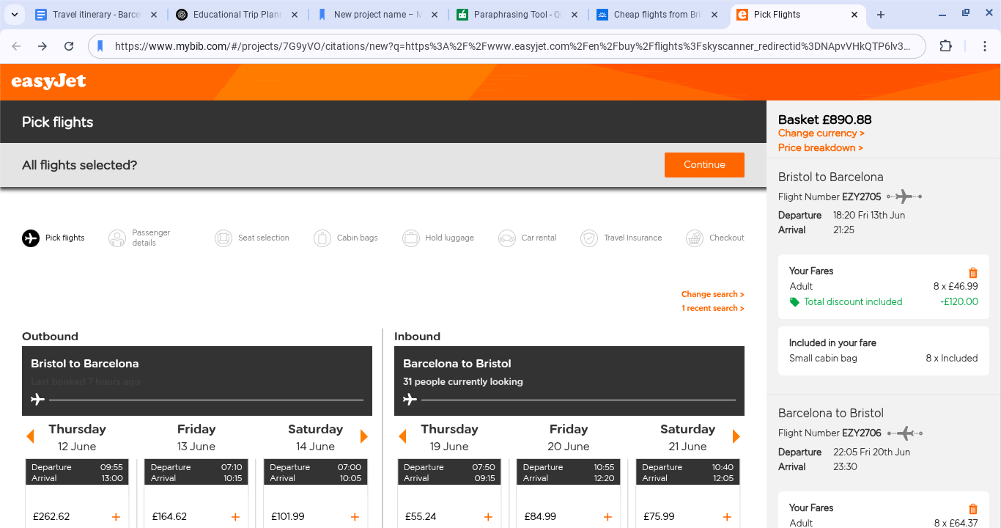

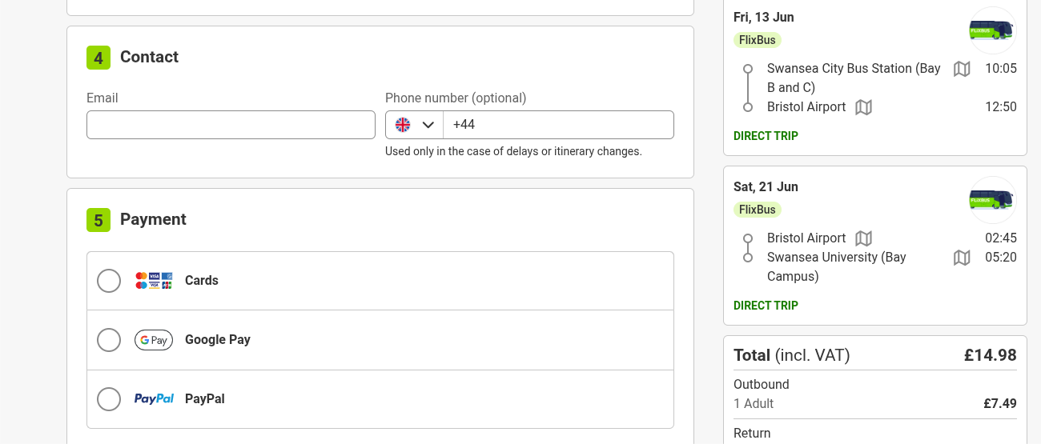
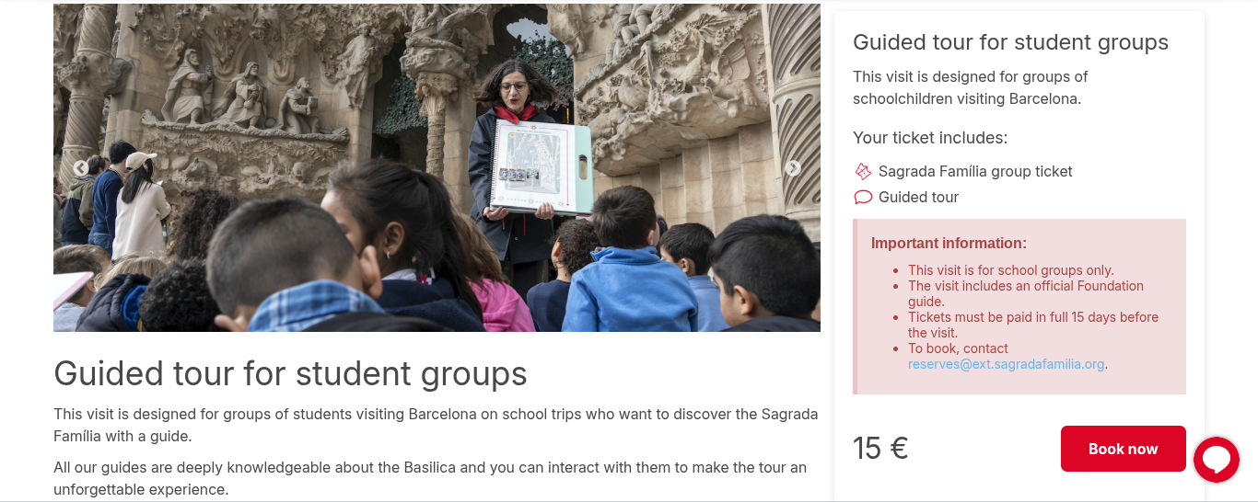
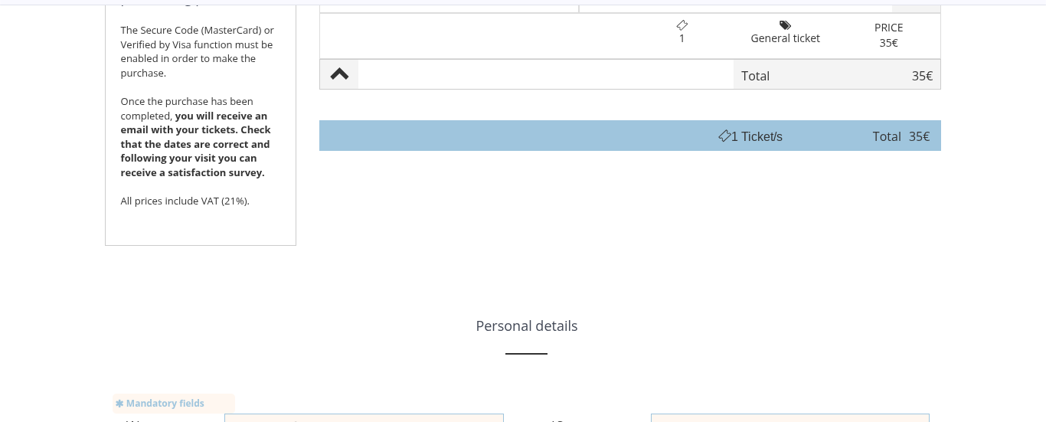
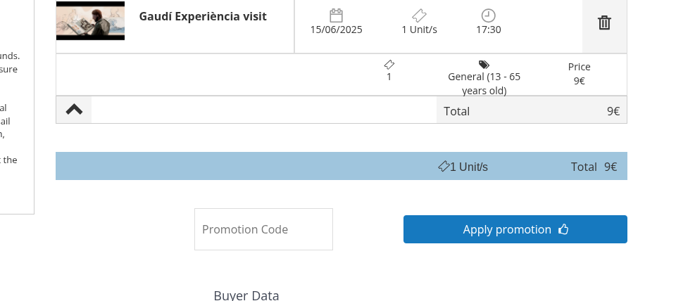
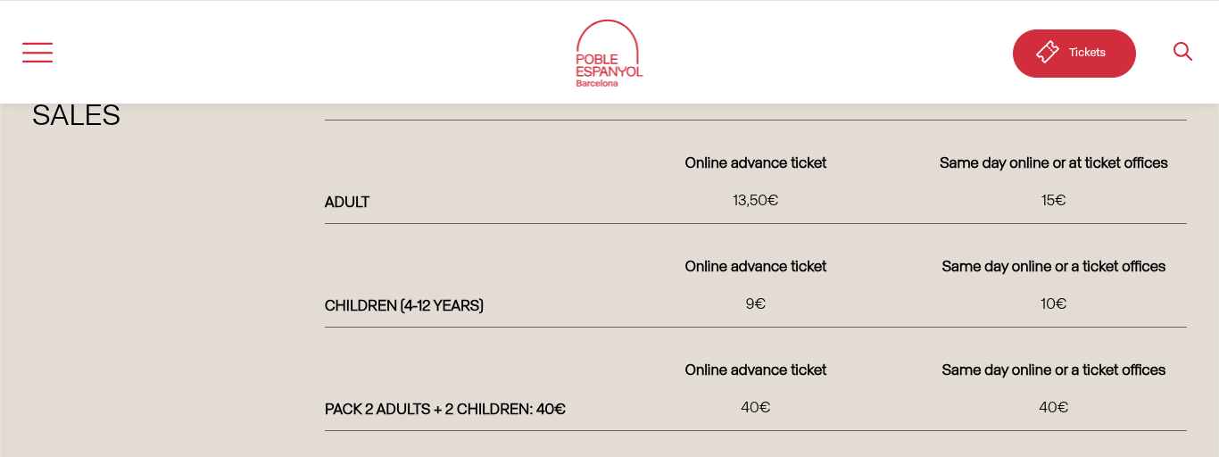
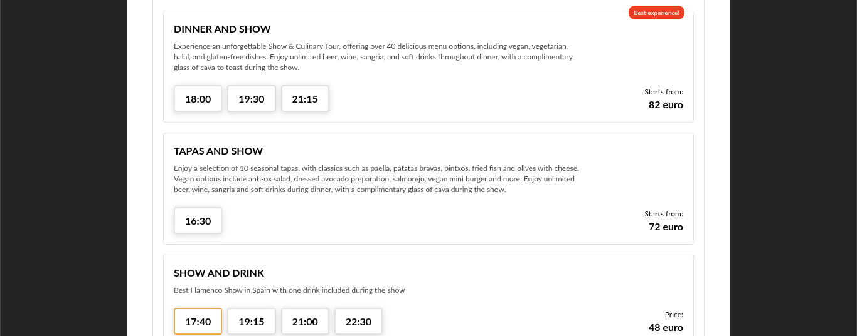
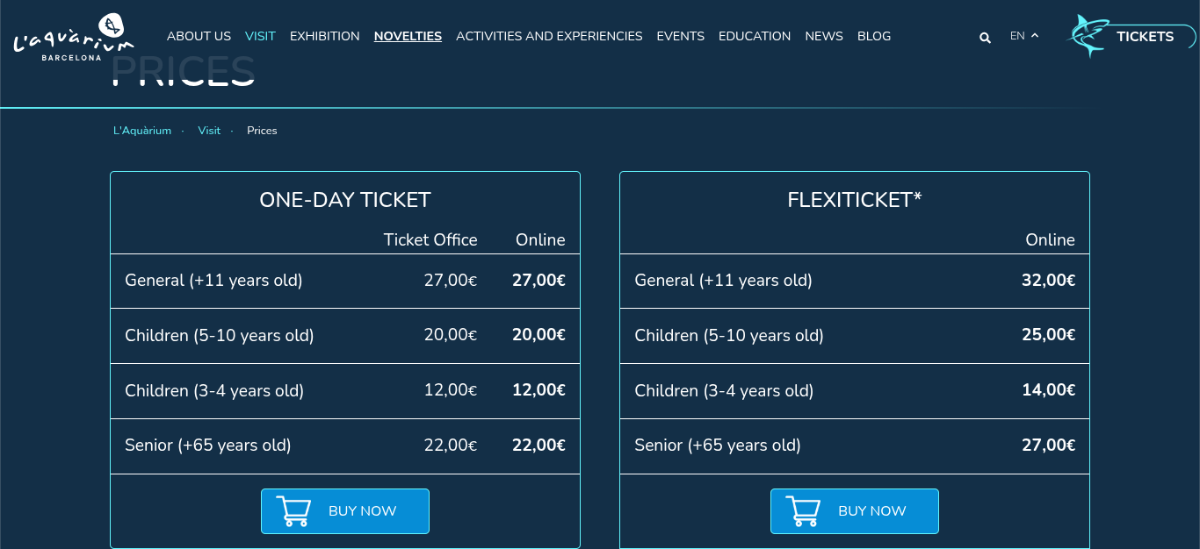
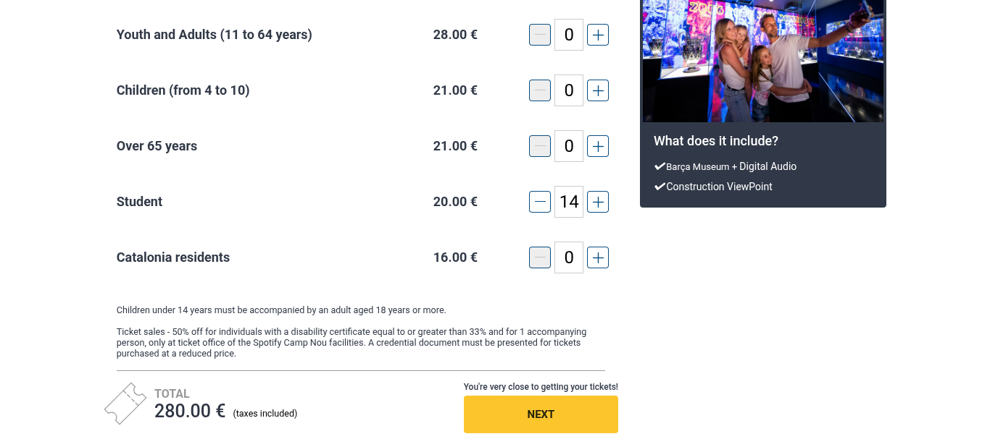

References
ABTA. “Who We Are.” ABTA, 2019, www.abta.com/about-us/who-we-are.

“Barça Stadium Tour & Museum – Schools | FC Barcelona Official Website.” Fcbarcelona.com, Barça, 2024, www.fcbarcelona.com/en/tickets/camp-nou-experience/schools.

Barcelona Century - Hotel Barcelona Century. Hotel Barcelona Century, 22 Nov. 2022, www.barcelonacentury.com/en/.

Buy Tickets | Web Oficial Park Güell | Barcelona. Parkguell.barcelona, parkguell.barcelona/en/buy-tickets.

Buy Tickets and Opening Hours | Picasso Museum Barcelona | Official Website. Museupicassobcn.cat, museupicassobcn.cat/en/plan-your-visit/buy-tickets-and-opening-hours.

Buy Tickets for the Tour | Torre Bellesguard. Obra Modernista de Antoni Gaudí En Barcelona | Torre Bellesguard, 22 Mar. 2022, bellesguardgaudi.com/en/buy-tickets/.

Choose Your Flights | EasyJet.com. Easyjet.com, 2018, www.easyjet.comen/buy/flights?skyscanner_redirectid=NApvVHkQTP6lv3FPpXrDnA&utm_medium=metas&utm_source=skyscanner.uk&utm_campaign=route&utm_content=dbooktest&utm_term=brs-bcn. /

Credit, Edutravel For. “What Is Educational Travel? EduTravel, 10 Oct. 2024, edutravelforcredit.com/what-is-educational-travel/.

Essential Cook, R et al (2013) Business of Hospitality Tourism and Travel Pearson International

Flamenco Show in Barcelona | Tablao Flamenco Cordobés. Tablaocordobes.es, 2025, booking.tablaocordobes.es/.

FlixBus. Shop.flixbus.co.uk, shop.flixbus.co.uk/checkout.

Guided Tour for Student Groups - Sagrada Familia. Sagradafamilia.org, 2023, sagradafamilia.org/en/guided-tour-student-group.

Health and Safety Executive. “Managing Risks and Risk Assessment at Work.” Health and Safety Executive, 2022, www.hse.gov.uk/simple-health-safety/risk/index.htm.

MindTools | Home. Www.mindtools.com, www.mindtools.com/a9wsomu/communications-planning.

perry Tours. Perry Tours - Fietstour Barcelona, 5 Dec. 2024, perrytours.eu/en/bike-tour-barcelona/tour-for-students/.

Practical Information. Poble Espanyol, 21 Mar. 2025, poble-espanyol.com/en/the-poble-espanyol/practical-information/.

Prices - L’Aquàrium. L’Aquàrium, 27 Jan. 2025, www.aquariumbcn.com/en/visit/prices/.

Science Museum CosmoCaixa Barcelona | Barcelona Tickets. Barcelonaturisme.com, 2025, bcnshop.barcelonaturisme.com/shopv3/en/product/325/science-museum-cosmocaixa-barcelona-.html.

Tours, Hidden City. “Hidden City Tours.” Hidden City Tours, hiddencitytours.com/.

Your Visit - Gaudi Experiencia. Gaudi Experiencia, 28 Oct. 2022, www.gaudiexperiencia.com/en/visit/.

