

Introducing the Modern Workplace
LCBB(4003)
Dr. Aparna Venkatesan

Sandra Iulia Ghinescu
2118454

Table of Contents
Introduction 3
Personal reflection 3
Conclusion 7
Reference 8

Introduction
Teamwork is a great aspect to improve relationships as well as knowledge sharing. Different personal skills can also be improved with the help of being part of teamwork. This report will be conducted to analyse different changes that have felt by me after taking part in group projects. In this aspect, different personal skills will be mentioned that have been improved during group projects.

Personal reflection
The experience that I have gathered along with the skills and knowledge that I have been able to develop can easily be evaluated with the help of the Gibbs’ Reflective Cycle.
Description
Working in a group can be beneficial for improving a number of skills (Carney et al., 2019). I have improved in a number of areas during working with my classmates as a group. My teammates have helped me to improve different areas including communication skills, time management skills, analytical skills, team management and leadership skills. I have also built proper relationships with other teammates during group projects. This project has also helped me to gain knowledge of different leadership theories as well as skills that are required to operate different business aspects. Apart from that, I have gained a huge knowledge regarding different factors that can impact group and team behaviour. On the other hand, I have gained knowledge about different organizational structures along with the impact of all these structures on the performance of an enterprise.
Feelings
I have felt thankful to all my teammates for the improvisation of different personal skills. There were a number of skills in which I was weak before. I was weak in communication skills, technical skills, analytical skills, time management skills and leadership skills. Now, I can interact with other people in a proper way due to improvisation in communication skills. There are different reasons behind the improvisation of personal skills. Interaction with my teammates has helped me to improve my communication skills (Fathi, et.al., 2019). Improvisation in all these areas is going to help me to achieve success in the future. Improvisation in communication skills is going to help me in achieving the trust of other people.
Evaluation
Improvisation in leadership skills, analytical skills and technical skills can be introduced as the positive outcomes that have been achieved from teamwork. Proper decision-making during different aspects related to group projects has helped me to improve my leadership skills. I have improved my analytical skills with the help of analysing different financial aspects of different enterprises. Improvisation in analytical skills can be beneficial for achieving a higher post in an established enterprise. Improvisation in leadership skills can also be beneficial for achieving managerial posts in the future (Andresen, et.al., 2020). However, there are a number of areas that should also be focused on by me in the future. Networking skills, research skills and academic tone should be focused on in the future. Focusing on all these aspects can help to develop the quality of a project. On the other hand, improvisation in networking skills can be beneficial for taking advice regarding different academic aspects and future careers.
Analysis
Teamwork or group work has helped to prove knowledge sharing between all the team members. Improvisation in different skills including leadership skills, communication skills, time management skills and team management skills can help me to develop my career. I have improved my time management with the help of focusing on the deadline of different academic projects. Interaction with efficient teammates has been beneficial for improvisation in analytical skills and communication skills (Schmutz, et.al., 2019). As a result, building proper relationships with efficient team members can be beneficial for improvisation in personal skills. On the other hand, knowledge sharing with efficient team members can also help to improve knowledge regarding the ways of interacting with other people. I have to focus on my networking skills, research skills and academic tone now. In this aspect, I have to follow a number of strategies. Research skills can be improved with the help of following different research as well as the resources that have been used in those researches. On the other hand, networking skills can be improved with the help of continuous interaction with seniors. Academic tone can be improved further with the help of following the ways of conducting different peer-reviewed journals and articles.
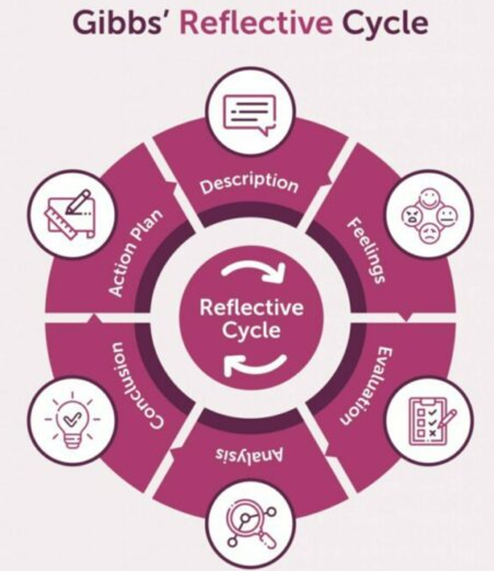
Source: (Andresen, et.al., 2020)
Conclusion
Improvisation in communication skills is going to help me to achieve trust in the management of the enterprise in which I am going to work in the future. Better communication can also be helpful in inspiring others to be polite and improving ways of interacting with others. Improvisation in leadership skills can be beneficial for proper decision-making as well as achieving the post of a leader in an established enterprise in future (Šerić and Garbin Praničević, 2018). Apart from that, improvisation in analytical skills is going to help me to achieve a higher designation in the finance department. I can be benefitted by submitting organizational projects on time with the help of improvisation in time management skills. However, improvisation in research skills is going to help in developing different academic projects by maintaining higher quality. I can also achieve higher marks after conducting academic projects in a systematic way with the help of improving my academic tone. Proper networking skills can be beneficial for taking career-related advice from seniors.
Action Plan
There are different steps that can be followed to improve communication skills further. Following body language and dressing can help to interact with other people in a smart way. Leadership skills can be improved with the help of the following biographies of successful leaders (Lohmann et al., 2019). Improvisation in problem-solving is also another great step to improve leadership skills. Time management skills can be improved further by focusing on the progress of work as well as the deadline of the projects.

Conclusion
It can be concluded that teamwork has helped to improve my communication skill, time management skill, leadership skills and analytical skills. Improvisation in all these areas is going to be beneficial for achieving future targets. Improvisation in all these areas can also be beneficial for achieving academic success.

Reference
Andresen, L., Boud, D. and Cohen, R., 2020. Experience-based learning. In Understanding adult education and training (pp. 225-239). Routledge.
Carney, P.A., Thayer, E.K., Palmer, R., Galper, A.B., Zierler, B. and Eiff, M.P., 2019. The benefits of interprofessional learning and teamwork in primary care ambulatory training settings. Journal of interprofessional education & practice, 15, pp.119-126.
Fathi, M., Ghobakhloo, M. and Syberfeldt, A., 2019. An interpretive structural modeling of teamwork training in higher education. Education Sciences, 9(1), p.16.
Lohmann, G., Pratt, M.A., Benckendorff, P., Strickland, P., Reynolds, P. and Whitelaw, P.A., 2019. Online business simulations: authentic teamwork, learning outcomes, and satisfaction. Higher Education, 77(3), pp.455-472.
Schmutz, J.B., Meier, L.L. and Manser, T., 2019. How effective is teamwork really? The relationship between teamwork and performance in healthcare teams: a systematic review and meta-analysis. BMJ open, 9(9), p.e028280.
Šerić, M. and Garbin Praničević, D., 2018. Managing group work in the classroom: an international study on perceived benefits and risks based on students’ cultural background and gender. Management: Journal of Contemporary Management Issues, 23(1), pp.139-156.

