University of Wales Trinity Saint David University

[ACCB6019] Emerging Trends
[Assignment 1] Hackathon 2024

Joshua Piecko
Student Number: 2112389

17th May 2024

Contents
1. Introduction 2
2. Personal Contribution and Reflection 3
2.1. Research and Data Analysis 3
2.2. Presentation Slide Production 3
2.3. Team Leadership and Coordination 9
2.4. Overcoming Challenges 9
2.5. Personal Reflection 9
3. Team Performance 10
3.1. Team Dynamics 10
3.2. Team Collaboration 10
3.3. Individual Team Member Performance 11
4. Technical Reflection 12
4.1. Solution Strengths 12
4.2. Solution Limitations 13
4.3. Risk Factors Encountered 14
5. Conclusion 14
References 15

Introduction

The UWTSD Hackathon 2024 provided an exceptional opportunity for students to apply their academic knowledge and technical skills to real-world problems through innovative solutions. Our team, comprised of five members: Tom Cahill, Alex Jenkins, Cian West, Phoenix Webb, and myself. We collaborated to address the growing issue of obesity using emerging trends in technology. Our focus was on leveraging Virtual Reality (VR) to create a comprehensive health and fitness application.
Obesity is a critical issue, with 26% of adults in England being obese and an additional 38% overweight [1]. Globally, over two billion adults are overweight or at high risk of becoming obese [2]. Recognizing the severity of this problem, we aimed to design a VR application that simplifies and enhances healthy living, making fitness more accessible and enjoyable.
Our proposed solution integrates the best features of existing fitness applications with the immersive experience of VR. The application offers personalized virtual companions to motivate and guide users, interactive challenges and rewards, and educational tools for nutritional guidance. This approach addresses common barriers to fitness such as accessibility, motivation, and knowledge about healthy lifestyles.
Throughout the hackathon, we engaged in extensive research, utilized advanced technology, and collaborated as a team. We held regular meetings using Discord, ensuring continuous communication and progress.

Personal Contribution and Reflection

My role in developing and presenting our VR-based health and fitness application involved focusing on research, data analysis, and key presentation slides (2, 3, 5, 9, and 20-25).

Research and Data Analysis

I conducted in-depth research on obesity statistics and trends, both globally and within the UK, establishing a statistical basis for our project's objectives and highlighting the potential impact of our VR application.

Presentation Slide Production

The slides I produced covered essential topics:

Slide 2: Introduction to Obesity Statistics

Provides an overview of obesity rates and trends.
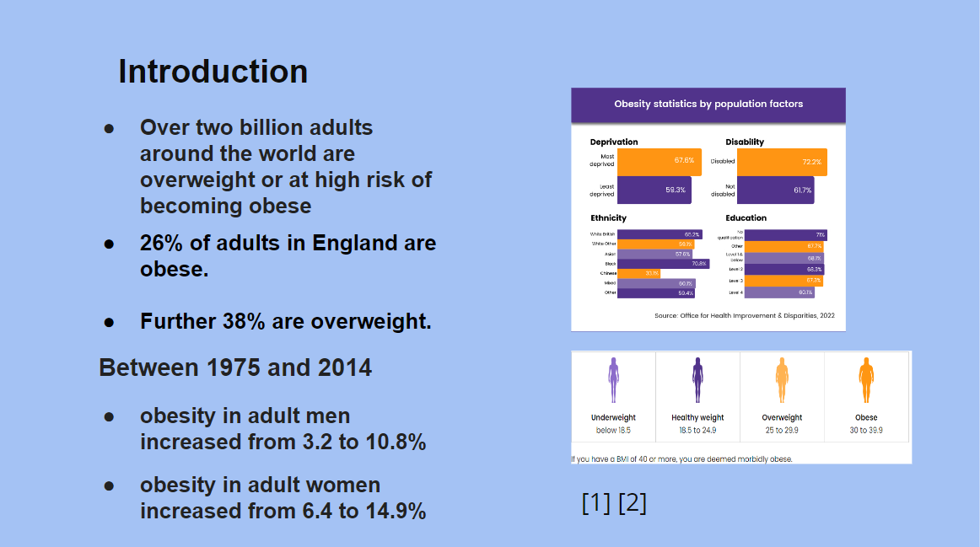

[Figure 1: Final Presentation PowerPoint Slide 2, an Overview of Obesity Rates and Trends]

Slide 3: Team Members

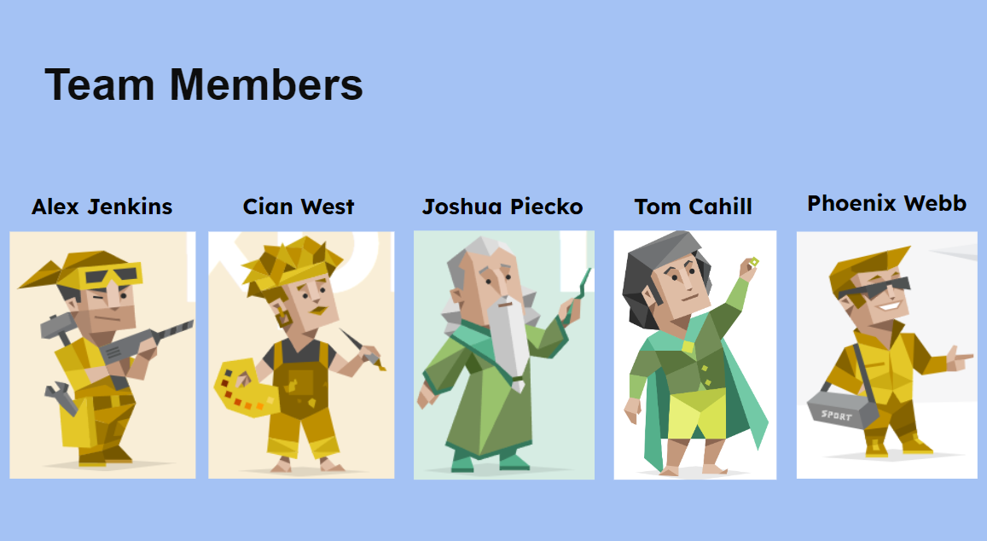
Highlights the members of the team.

[Figure 2: Final Presentation PowerPoint Slide 3 - Team Roles]

Slide 5: Emerging Trend – Virtual Reality

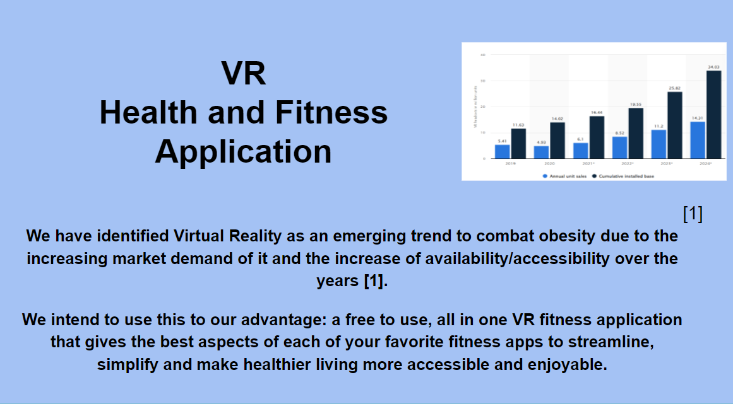
Introduces VR as an emerging trend, explaining its relevance to our project.

[Figure 3: Final Presentation PowerPoint Slide 5, VR as an emerging Trend]

Slide 9: Research on Competitors

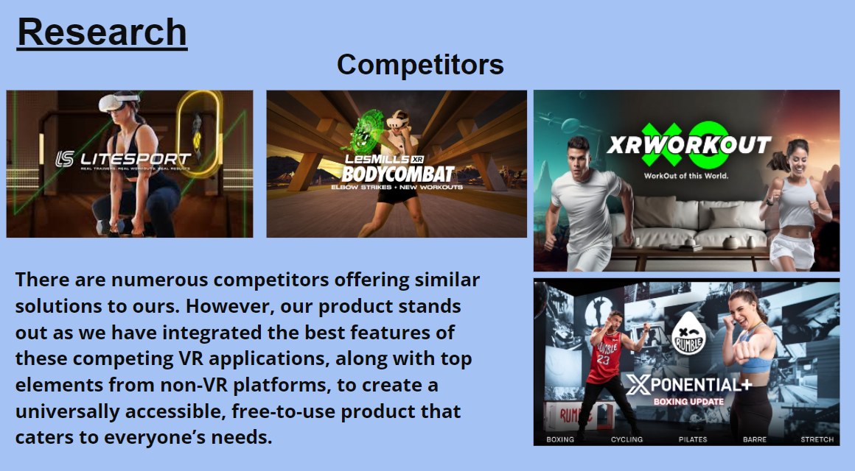
Analyzes existing solutions and identified market gaps, highlighting our application's unique features.

[Figure 4: Final Presentation PowerPoint Slide 9 - Research on Competing Applications]

Slide 20-25: Introduction to Obesity Statistics
Summarized the project outcomes, reflected on the process, and discussed lessons learned and potential future improvements.
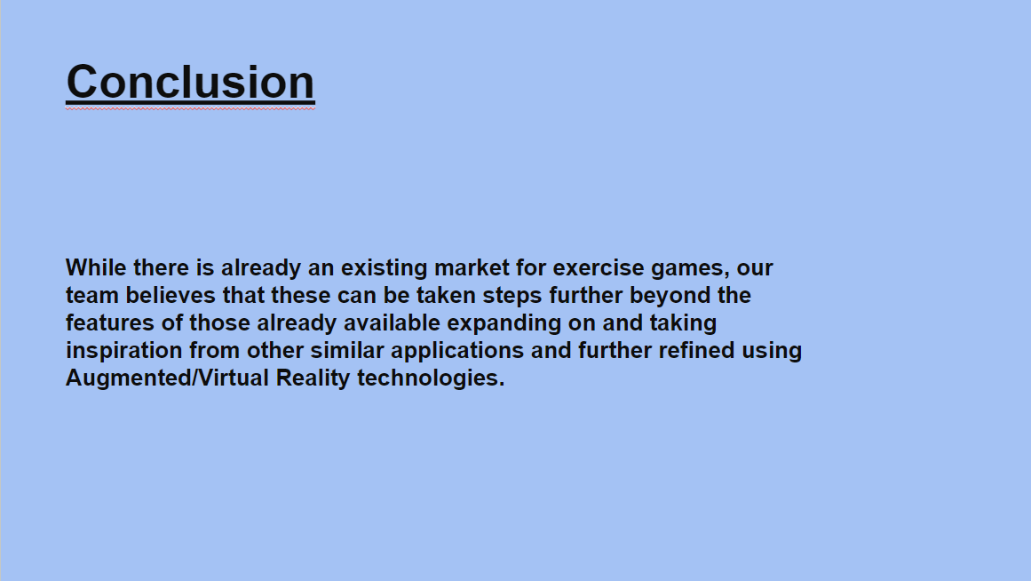

[Figure 5: Final Presentation PowerPoint Slide 20 – Conclusion]

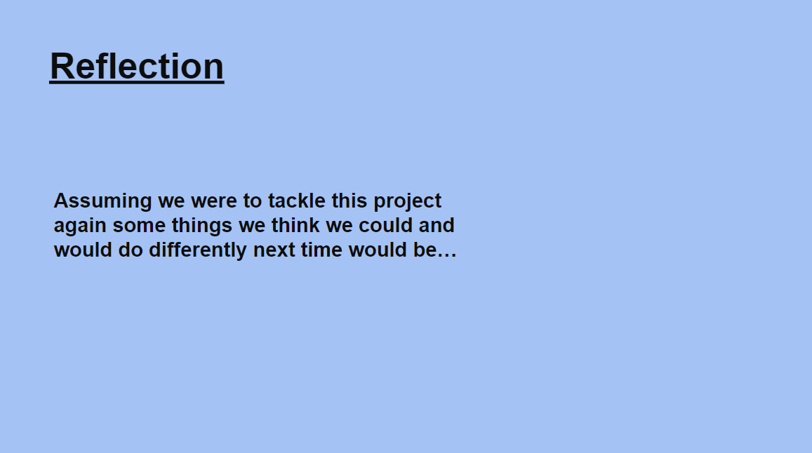
[Figure 6: Final Presentation PowerPoint Slide 21 - Reflection Intro]

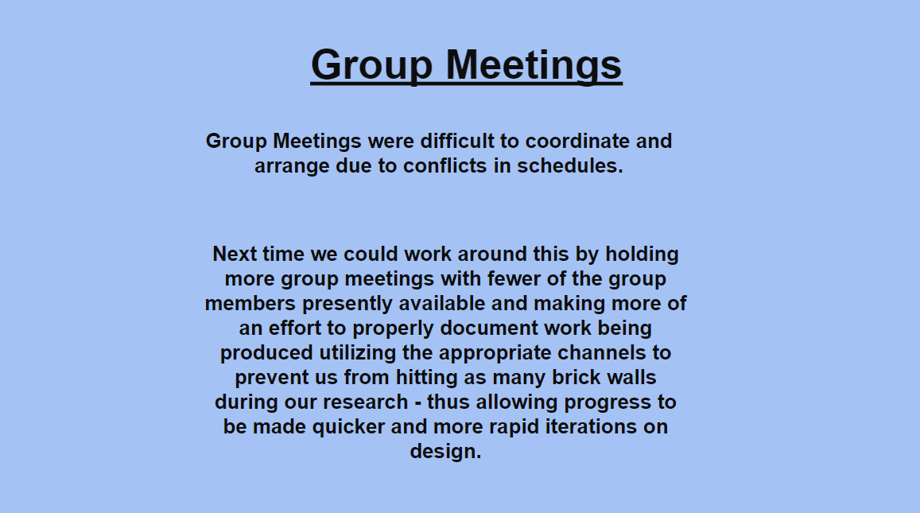

[Figure 7: Final Presentation PowerPoint Slide 22 - Reflection, Group Meetings]

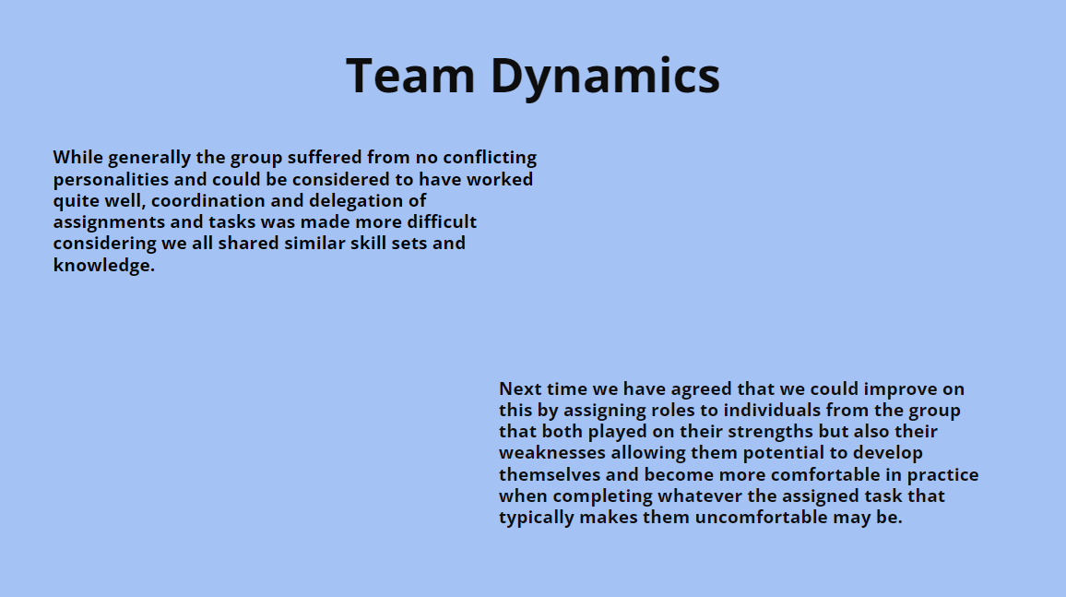
[Figure 8: Final Presentation PowerPoint Slide 23 - Reflection, Team Dynamics]

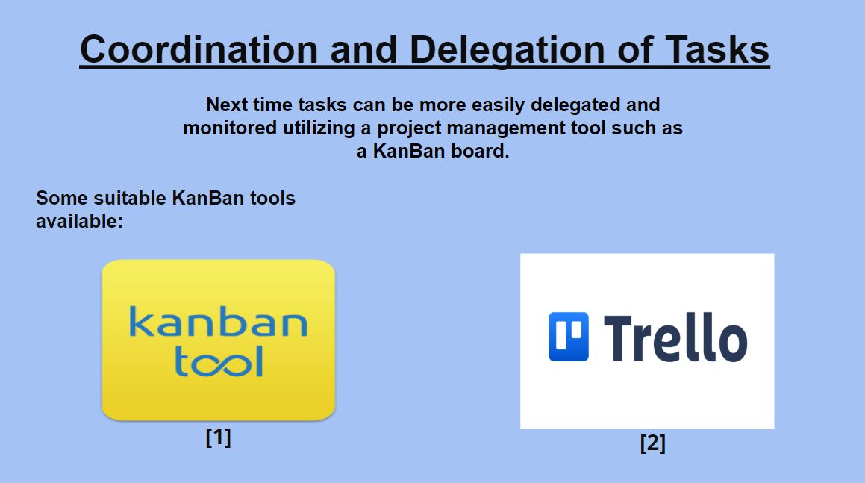
[Figure 9: Final Presentation PowerPoint Slide 24 - Reflection, Coordination and Delegation of Tasks]

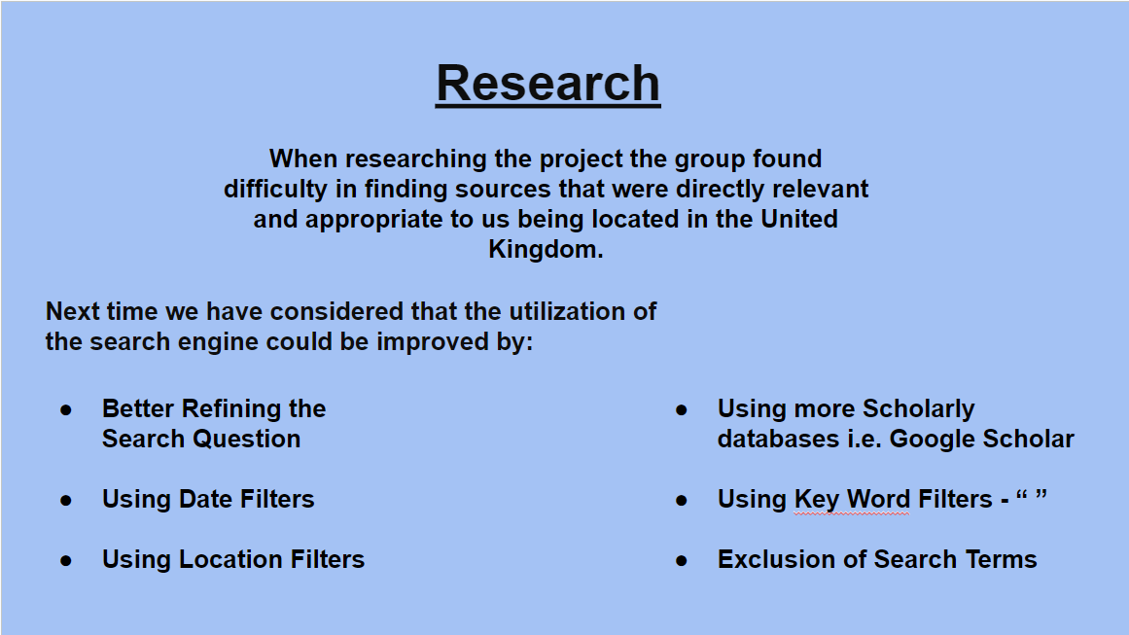
[Figure 10: Final Presentation PowerPoint Slide 25 – Reflection, Researching]

Team Leadership and Coordination

I occasionally led the team, coordinating meetings, assigning tasks, and providing support to maintain momentum despite challenges like inconsistent attendance and communication issues.

Overcoming Challenges

Designing technical documentation was challenging due to the lack of coherent explanations from other team members regarding the features we intended to implement. Last-minute decisions complicated the production of detailed documentation such as entity relationship diagrams and class sequence charts. To address this, I prompted the team to hold regular meetings and improve communication, highlighting the importance of clear and timely project management.

Personal Reflection

Participating in the hackathon provided valuable insights into teamwork, project management, and technical development.
I adapted to challenges such as coordinating with team members with conflicting schedules and managing additional responsibilities when others were unavailable. This experience underscored the necessity of flexibility and resilience in a collaborative environment.
During the second progress presentation, I was unable to contribute due to deadlines for my independent project. Poor personal management prevented me from being available to the team. However, had the team not left tasks until the last minute, I would have been available on other meeting dates we had set but subsequently pushed back.
For the final presentation, although I was sick and unable to be physically present, I still contributed significantly to the preparation and content. Despite my absence, my prior work and input were integral to the team's success.
Through research, presentation development, and proactive leadership, I helped shape our VR-based health and fitness application. Despite significant challenges, my efforts ensured that we presented a comprehensive solution. This experience failed to strengthen my technical abilities and highlighted the importance of better teamwork and more effective communication in achieving project goals.

Team Performance

Team Dynamics

Our team of five faced challenges in team dynamics and communication despite establishing clear roles. Scheduling conflicts often hindered progress, even with regular meetings via Discord.

Team Collaboration

The collaboration within our team had moments of productivity, but it was also marked by frequent obstacles. We utilized various online tools to facilitate our work, including shared documents for collaborative writing, and real-time messaging for quick updates. However, effective communication was often lacking, and team members struggled to coherently explain the features we were going to implement. This confusion made it extremely difficult for me to design any technical documentation, such as user stories and entity relationship diagrams. Additionally, many decisions were left until the last minute, leading to poor time management and increased stress as deadlines approached.

Individual Team Member Performance

Tom Cahill – rating: (4.25/5)
Tom served as a designer, focusing on developing the companion characters and their interactions within the VR environment. His creativity enhanced the user experience. Moreover, Tom regularly took the initiative to lead the team, especially during times when I was unavailable. His ability to steer discussions and ensure tasks were completed on time was invaluable. Despite these efforts, the lack of clear communication from other team members sometimes hindered his progress.

Cian West – rating: (3.75/5)
Cian was responsible for designing the fitness diagrams and ensuring they were clear and informative. His background in drawing was invaluable, as it provided a solid foundation for the content he developed. However, Cian, like others, had difficulty explaining the features and the overall vision of the project. This lack of clarity made it challenging to integrate his work seamlessly with other components. While his work was generally excellent, there were instances where clearer communication and more timely completion of tasks could have improved our progress.

Alex Jenkins – rating: (3.5/5)
Alex took on the role of researcher, specializing in user interface design. His research and innovative ideas were critical in creating a user-friendly interface. However, Alex often struggled to articulate his concepts clearly, which contributed to the overall communication issues within the team. Additionally, there were occasional delays in his deliverables, which he managed to overcome with additional effort and dedication.

Phoenix Webb – rating: (2/5)
Phoenix led research on trends and architecture, but frequent absences and language barriers posed challenges.

Technical Reflection

Solution Strengths

One of the primary strengths of our solution is its high level of personalization and engagement. The application tailors workout routines and dietary plans to individual needs and preferences, enhancing user engagement and adherence to fitness goals. The inclusion of virtual companions adds an interactive element that makes the fitness journey more enjoyable and motivating, providing real-time feedback and encouragement, which can significantly improve users' commitment to their fitness regimen.

Accessibility is another significant advantage of our solution. By providing a platform that users can access from the comfort of their homes, we overcome common barriers such as time constraints, location limitations, and financial resources. The VR environment allows for a more immersive and engaging experience compared to traditional fitness apps, potentially attracting users who might find conventional workouts monotonous or uninspiring.

Additionally, our application includes comprehensive educational tools that teach users about balanced nutrition, how to read food labels, and how to plan healthy meals. This addresses a significant knowledge gap and empowers users to make informed dietary choices. Gamified elements, such as earning points and unlocking new content, provide additional motivation for users to stick with their fitness and dietary plans.

Solution Limitations

One primary limitation of our VR application is the dependency on VR hardware, which may not be accessible to all potential users. The cost of VR headsets and the need for compatible devices could limit the reach of our solution. Furthermore, technical issues such as motion sickness and the need for adequate physical space to use VR effectively could pose challenges for some users.

Developing a comprehensive VR application requires significant resources, including time, expertise, and financial investment. The complexity of integrating various features, such as real-time feedback and personalized guidance, demands robust testing and quality assurance processes to ensure a seamless user experience.

Introducing users to a new technology, especially one as immersive as VR, involves a learning curve. Users may need initial training to navigate and utilize the application effectively. Ensuring user retention and long-term engagement can be challenging, particularly if users encounter technical difficulties or find the VR experience overwhelming.

Risk Factors Encountered

We encountered several risk factors during the development of our application. Technologically, ensuring the application is compatible with various VR headsets and devices was a significant concern.

From a user experience perspective, some users may experience motion sickness when using VR applications. We addressed this by providing options for adjusting movement speed and offering alternative control schemes to enhance user comfort. Ensuring the application is accessible to users with disabilities was also a priority. We planned to incorporate features such as adjustable text sizes, voice controls, and customizable colour schemes to accommodate diverse user needs.

Conclusion

Participating in the UWTSD Hackathon 2024 allowed our team to apply our skills to a real-world problem using VR technology to combat obesity. I contributed through research, presentation development, and team leadership. Despite challenges like poor communication and last-minute decisions, our efforts resulted in a well-justified VR-based solution. Key lessons include proactive leadership, effective communication, and time management, underscoring the importance of teamwork and resilience.

References
[1] Obesity statistics - House of Commons Library, https://commonslibrary.parliament.uk/research-briefings/sn03336/ (accessed May 9, 2024).

[2] A. Al-Rasheed et al., “Virtual reality in the treatment of patients with overweight and obesity: A systematic review,” MDPI, https://www.mdpi.com/2071-1050/14/6/3324#B28-sustainability-14-03324 (accessed May 9, 2024).

