

APPENDIX GA36d

LEVEL 7 ASSESSMENT SPECIFICATION

Student name: | SRAVANTHI SILVERU | Student ID number: | 2228080
Programme: | MSc/PgDip/PgCert Cybersecurity and Digital Forensics
Module: | Digital Forensics Analysis
Module code: | ACCA7031 | Contribution to Overall Module Assessment (%): | 100%
Lecturer: | Dr. Nitheesh Kaliyamurthy | Internal Verifier: | Munyaradzi Murira
Assignment Title: | Research, Analyse and Investigate Digital Cybersecurity incidents and perform digital forensic assessment | Word count (or equivalent): | 5000
Submission deadline: | 12th January 2024 | Return date of provisional marks & written feedback: | TBA

TABLE OF CONTENTS
ABSTRACT 3
INTRODUCTION 4
LIST OF FIGURES AND TABLES 5
TASK 1 6
Current state of the field on digital forensics 6
Intersection of digital forensics and cybersecurity 7
Emerging trends 8
Key Challenges 9
National and International Job Market 10
TASK 2 11
Current State Of Digital Forensic Tools, Their Features And Capabilities 11
Cellebrite UFED ( Universal Forensic Extraction Device ) 11
Forensic Toolkit 12
Encase 13
Evaluate Open-Source Tools With Commercial Forensic Tools 13
Open-Source Tool (Autopsy) 14
Commercial Forensic Tool (Encase) 14
TASK 3 15
HDD GROUP REPORT 15
Scenario: corporate crime 15
ANALYSIS REPORT BASED ON EVIDENCE ANALYSED 23
Challenges 25
Video link 25
TASK 4 26
Mobile Forensic Investigation 26
1. Executive Summary 26
2. Case Information 26
Data Acquisition 27
SUMMARY OF ANALYSIS 33
REFERENCES 38

ABSTRACT

Field of digital forensics, including its state at the moment, new trends, difficulties, and relationship to cybersecurity. In Task 1, the importance of digital forensics in modern criminal investigations is examined, with a focus on how it has developed and how it works with cybersecurity. Task 2 examines well-known digital forensic software, comparing free and paid versions. Task 3 involves presenting a group report on a fictitious corporate crime, outlining the difficulties encountered in examining a hard drive and locating proof of the reasons behind a data breach. Task 4 describes a mobile forensic investigation for an automaker, exposing the suspect's global travels and possible compromise of data. The report ends with suggestions for additional research in a fictitious situation. Overall, this abstract provides important insights for experts and researchers in the field by summarising the many facets of digital forensics, from theoretical underpinnings to real-world applications in situations involving hard drive analysis and mobile forensic investigations.

INTRODUCTION

Digital evidence is pivotal in investigating a range of crimes, from murder to cybercrimes like fraud and terrorism. This shift results from the intersection of crime and technology, demanding swift adjustments in digital forensics. As a critical tool in combating crime, digital forensics evolves, integrating new techniques like cloud computing, machine learning, artificial intelligence, and the Internet of Things (IoT). These innovations automate tasks, allowing investigators to focus on complex cases.
The fields of cybersecurity and digital forensics are increasingly overlapping as they work together to defend businesses against online threats. Cyber forensics, the intersection of cybersecurity and digital forensics, is essential to the investigation of cybercrimes and the efficient handling of incidents.
Digital forensics is witnessing specialization in emerging fields like network, IoT, cloud, and social media forensics, enhancing our understanding and application in investigations. The increasing cybersecurity threats globally elevate the demand for specialists. Recognized certifications like CDFE and CISSP play a vital role in showcasing knowledge and commitment in the job market..
Furthermore, the evolution of digital forensic tools, such as Cellebrite UFED, Forensic Toolkit, Encase, and Autopsy, reflects the field's response to the challenges posed by cybercrimes. Investigative teams have to choose between commercial and open-source tools based on their budget and the unique requirements of their investigations.
The following sections provide a thorough understanding of the current state of digital forensics and its critical role in combating digital crimes. They also explore challenges in HDD group reports and provide specific details of a mobile forensic investigation case.

LIST OF FIGURES AND TABLES
Figure 1: Disk Patrion 16
Figure 2: BitLocker using PowerShell Command 17
Figure 3: BitLocker using PowerShell Command 17
Figure 4:Screenshot showing all four partitions 18
Figure 05: Screenshot showing each drive and storage capacity…………………………….18
Figure 06: Screenshot showing root folders present in the HDD……………………………18
Figure 07: Screenshot showing root folders present in the HDD…………………………….18
Figure 08: Evidence of Credit card details recovered from the HDD………………………..19
Figure 09: Evidence of email accounts recovered……………………………………………19
Figure 10: Evidence of IP addresses…………………………………………………………19
Figure 11: Evidence of different URLs ……………………………………………………..19
Figure 12: Evidence of Phone numbers recovered………………………………………….20
Figure 13: We took a new image of the un-hidden drive partition (drive J)………………...21
Figure 14: data size…………………………………………………………………………..21
Figure 15: data size ………………………………………………………………………….21
Figure 16: Evidence of unallocated spaces…………………………………………………..22
Figure 17: Evidence Location of files with Metadata from the new image …………………22
Figure 18: Database Of Company……………………………………………………………23
Figure 19: Verification……………………………………………………………………… 23
Figure 20: Bank statement……………………………………………………………………24
Figure 21: The SQL File……………………………………………………………………...25
Figure 22: Data Extraction …………………………………………………………………...28

Table 01: New Image Of Drive J ……………………………………………………………..22

TASK 1

Current state of the field on digital forensics

In today's digital era, digital forensics is a crucial tool in combating crime, evolving rapidly with new methods and technologies. This blog post explores the current state of digital forensics, its applications in crime prevention, and resolving digital investigations. The focus extends to items found on diverse digital devices, such as computers, digital cameras, mobile phones, and other gadgets. Researchers and developers have contributed to the development of numerous forensics applications in recent years. [1]. The new apps broaden the field of digital forensics to include volatile memory. Every day, memory forensic methods advance from deep searches to operating systems analysis, structural memory analysis, and string searches and other Methods like cloud forensics and network forensics are becoming more popular.
In general, digital forensics The conventional approach entails data extraction, identification, analysis, and report generation. new approaches are developing as a result of the growth of cloud computing, the Internet of Things (IoT), and virtualization. [2]. To make forensic investigators' jobs easier, a variety of digital tools are now available. The tasks these tools can perform are limited. Certain tools, like Autopsy Sleuthkit, FTK, Redline, Belkasoft Evidence Centre, Xways Forensics, Encase, etc., are suitable for certain tasks.

Machine learning and artificial intelligence are poised to transform digital forensics, automating tasks and freeing investigators for complex cases. The growing prevalence of cloud computing will also wield considerable influence. Despite potential criminal benefits, investigators can utilize cloud services for efficient information sharing and collaborative case work..[3].

Intersection of digital forensics and cybersecurity

The merging of cybersecurity and digital forensics becomes prominent as digital and everyday life intertwine. Advancing technology and sophisticated cyber threats blur the line between these domains, fostering increased integration. Cybersecurity and digital forensics work hand in hand to protect enterprises from contemporary cyberattacks. Cybersecurity is putting protections in place to keep data, networks, and systems safe from online threats. On the other hand, digital forensics finds, protects, retrieves, and records digital evidence to support inquiries or fight cybercrime, especially in cases where security protocols are breached.

Cyber forensics is the area of study where digital forensics and cybersecurity intersect. When a cybersecurity precaution fails to stop a breach, cyber forensics become essential. Cyber forensics experts are responsible for finding security flaws and offering advice on how to fix them.[4]

Cybersecurity aims to protect the digital environment by taking preventive, investigative, and reactive actions against various threats, covering areas like application and network security. In contrast, digital forensics focuses on post-incident analysis, investigating cybercrimes and understanding the 'how' and 'who' using various tools and techniques. The integration of digital forensics in cybersecurity is crucial in responding to cyberattacks effectively, allowing the identification of weaknesses, improvement of security protocols, and preparation for potential threats.[5]

Organisations must comprehend how cybersecurity and digital forensics interact to properly safeguard their digital assets. It matters for a few reasons:
- Effective Incident Response
Quick and effective incident response, including digital forensics, is crucial to minimize damage caused by cyber-attacks.
- Better Cybersecurity Measures
This intersection informs improved cybersecurity by identifying weaknesses and suggesting preventive measures for future incidents.
- Legal and Ethical Consideration
Digital forensics involves analyzing personal data, posing legal and ethical concerns. Cybersecurity must address these, considering privacy laws and confidential information handling.
- Continuous Improvement
Digital forensics informs continuous improvement in cybersecurity, identifying weaknesses and proposing preventive measures for future incidents.

Emerging trends
Digital forensics is evolving with a trend towards specialization, focusing on new areas like social media, the internet, and Internet of Things forensics. This study explores these novel applications, enhancing our understanding of digital forensics and its utility in forensic investigations.[6]

- Network Forensics
Network forensics, a key aspect of digital forensics, records and analyzes network traffic for data collection, legal artifacts, and intrusion detection. Proactive investigations involve establishing post-attack procedures tailored to organizations' needs and network infrastructures.

- IoT Forensics
The Internet of Things (IoT) extends into telecommunications, covering various devices. IoT forensics, a subset of digital forensics, investigates cybercrimes involving IoT devices, sensors, and data, addressing security threats like surveillance and ransomware.

- Cloud Forensics
Cloud forensics applies scientific principles to organize events by identifying, collecting, storing, testing, and reporting digital evidence. It gains attention due to cloud computing's resource pool, cost-effectiveness, dynamicity, and widespread access.

- Social Media Forensics
It is a subset of Network Forensics, involves cyber research and digital analytics to collect information on platforms like Facebook, Instagram, Twitter, LinkedIn, etc. It aids criminal investigations with experts utilizing sophisticated tools for effective legal evidence gathering[7].

Key Challenges

Digital forensics faces challenges with encryption impeding evidence retrieval and technology's rapid evolution surpassing tool development. Persistent issues include evidence collection, privacy, and legal complexities. Standardizing tools is complicated by diverse devices, platforms, and smartphone encryption. Emerging cybercrime models, such as Crime as a Service (CaaS), simplify attacker access. Subsequent sections analyze key challenges in the DF field.[8]

Smart devices employ varying strength password and encryption protection. DF tools can extract simple passwords; Android relies on patterns. BlackBerry excels in protection, though encryption key reset is possible through BES for organizational devices with BES access.

Network forensics faces challenges in handling large data volumes, making evidence retrieval tedious. Internet protocol unpredictability and address modifications add complexity. Specialized software aids in forensic analysis, facilitating case resolution. The ultimate aim is to provide evidence for successful criminal prosecution in various domains.[9]

Investigating IoT devices poses challenges due to non-compliance with existing forensics methods, including restricted access to crime scenes, service-level contract limitations, dynamic computing architecture, and hardware/software standardization issues.

The field of DF grapples with a significant surge in big data—structured and unstructured—collected from various sources like digital devices, networks, cloud, IoT, and social media. This surge contributes to delayed investigations and legal proceedings.

National and International Job Market

Digital forensics professionals are in high demand across various industries, including law enforcement, government, corporations, and consulting firms.[10]

- National Job Market
Digital forensics experts are increasingly sought after in the national job market. Government agencies, law enforcement, and private sector businesses demand specialists in computer and mobile device forensics to investigate and analyze digital evidence in response to rising cybercrime complexity and frequency.
Digital forensics specialists, categorized under information security analysts, anticipate job growth faster than average, driven by the continuous need for businesses to strengthen cybersecurity defences, as per the Bureau of Labour Statistics (BLS).
The private sector, encompassing financial institutions, tech firms, and consulting entities, increasingly values proactive digital forensics for safeguarding sensitive information. Businesses seek experts to enhance cybersecurity by implementing preventive measures and responding to incidents.

- International Job Market
The need for specialists in digital forensics is a widespread occurrence on the global scene. Countries all over the world are investing in cybersecurity infrastructure in response to the growing threat of cyberattacks, which is creating a shortage of qualified workers.
To address the continent's expanding cybersecurity challenges, the European Union Agency for Cybersecurity (ENISA), for example, highlights the necessity of having a skilled workforce in Europe. Experts in digital forensics play a crucial role in assisting with incident response and advancing overarching cybersecurity plans.[11]
In Asia, countries like Singapore and India have seen a rise in demand for digital forensics professionals as they position themselves as regional cybersecurity hubs. The significance of digital forensics in mitigating cyber threats is heightened by the growing digitization of economies in these areas.
The Middle East's expanding digital infrastructure has heightened the demand for skilled digital forensics specialists, fostering employment growth in cybersecurity.

- Certification And Skillsets
The dynamics of the labour market are significantly influenced by globally recognised certifications such as Certified Digital Forensics Examiner (CDFE), Certified Information Systems Security Professional (CISSP), and others. Candidates with certifications are frequently given preference by employers, who view them as evidence of their expertise and dedication to ongoing professional development.[12]

TASK 2

Current State Of Digital Forensic Tools, Their Features And Capabilities

Digital forensics tools have advanced significantly, addressing challenges posed by cybercrimes. These contemporary tools create forensic images from the source, providing binary abstractions for comprehensive data analysis. [13]

Cellebrite UFED ( Universal Forensic Extraction Device )
A mobile forensic tool called the Cellebrite UFED Pro series accesses, decodes, analyses, reviews, manages, and controls data to aid in investigations. Functions of, analysing encrypted data, unblocking cloud-based evidence, retrieving real time data, accessing all iOS and high-end devices, analyse and report video evidence, live data acquisition and forensic imaging are capable with this toolkit.[14]
Features:
- Physical and Logical Extraction: Using a variety of mobile devices, forensic investigators can carry out both physical and logical extractions using Cellebrite UFED. This entails retrieving data from devices that are locked or damaged as well, offering a thorough overview of the contents on the device.
- Data Decoding and Analysis: Complex data structures can be interpreted thanks to UFED's sophisticated data decoding capabilities. Call logs, messages, multimedia files, application data, and other types of digital evidence can all be extracted and analysed with its assistance.
Capabilities:
- Bypassing Device Locks: Cellebrite UFED has features that allow it to get past passcodes and device locks in order to access protected data. For investigations involving devices that are password- or encryption-protected, this is essential.
- Cloud Data Extraction: By extracting and analysing data from cloud services, UFED can give investigators information about a suspect's online habits and correspondence history.[15]

Forensic Toolkit
Access Data developed the digital forensic software Forensic Toolkit, which is designed for Windows. Data analysis deleted file recovery, MD5 and SHA hash verification, file analysis of FAT, NTFS, Ext2, and CDFS, and graphical file viewing are all supported by this tool. [16]The FTK Imager application, which is a part of the FTK Toolkit, is also used for disc imaging.

Features:
- Integrated Analysis Platform: With features for data collection, analysis, and reporting, FTK offers a single platform for digital forensic investigation. The investigative workflow is streamlined by this integration.
- Artefact Correlation: Detectives can connect and correlate disparate digital evidence pieces thanks to FTK's sophisticated artefact analysis features. The ability to reconstruct timelines and events during an investigation is improved by this feature.
Capabilities:
- Keyword Search and Filtering: Investigators can find pertinent material more quickly thanks to FTK's robust search and filtering features. To enable effective data analysis, this includes the capability to search for particular keywords, file types, or metadata.
- Analysis of Windows Registry entries and Email Data: FTK is also capable of comprehensively analysing email data. This is useful for deciphering coded messages and comprehending how people interact in virtual spaces.

Encase
Encase is a paid platform that comes pre-installed with a number of investigative tools and methods. It performs in-depth analyses of registry, timeline, gallery, hash value, internet history, signatures, recovering deleted files, sorting and reviewing files, and signature analysis. EnCase organises the content with the help of the bookmarking feature and provides a very comprehensible and clearly formatted report that explains crucial details. [17]
Features:
- Extensive Analysis: For digital forensic analysis, EnCase Forensic offers an extensive feature set. Disc imaging, file recovery, and device analysis are supported, guaranteeing a comprehensive review of electronic evidence.
- Evidence Integrity and Validation: EnCase places a strong emphasis on evidence integrity by offering tools for confirming and validating the information gathered. This guarantees that throughout the investigation, the evidence will be maintained in a forensically sound manner.
Capabilities:
- Registry Analysis: EnCase is excellent at registry analysis, enabling detectives to comb through the Windows Registry and retrieve important data. This ability is essential to comprehending system configurations and activities.
- Keyword Searching and Filtering: With EnCase's sophisticated keyword search and filtering features, investigators can find pertinent data in huge datasets with ease. This helps to concentrate on important pieces of evidence and expedites the analysis process.

Evaluate Open-Source Tools With Commercial Forensic Tools

Investigators have to make a crucial decision regarding digital forensic tools: whether to use open-source or commercial options depends on a number of factors, including the demands of the investigation and budget. Using Autopsy as an example of an open-source tool and Encase Forensic as a representative commercial tool, we will examine important factors to consider when comparing open-source and commercial tools in this evaluation.[18]

Open-Source Tool (Autopsy)
A GUI-based, open-source digital forensic tool called Autopsy is useful for efficiently analysing smartphones and hard drives. Thousands of users use Autospy all over the world to look into what really happened on the computer.
Autopsy's plugin architecture enhances adaptability and extensibility in forensic scenarios, allowing investigators to customize functionality for tailored digital forensics.[19] The web interface promotes seamless collaboration, enabling multiple team members to simultaneously access, view, and contribute to real-time case analysis, particularly valuable for large investigative teams, streamlining collaboration and knowledge sharing.

Commercial Forensic Tool (Encase)
EnCase Forensic excels in creating precise forensic images using "bitstream imaging," ensuring accurate copies of data from various devices. Supporting multiple imaging formats, including EnCase Evidence (E01), preserves data and metadata integrity, crucial in legal proceedings. [20]The tool's file system analysis suite enables deep exploration of digital artifacts, supporting various file systems like FAT, NTFS, HFS+, and Ext2/3/4. Advanced file signature analysis aids in reconstructing file hierarchies and understanding the context of digital evidence.

The quality, accessibility, security, ease of use, customizability, and software development freedom of commercial and open source tools frequently vary. This is a comparison between various open-source and commercial forensic tools.

- Regarding Costs:
Commercial Tools: Although the initial cost of tools such as Encase Forensic is high, they frequently offer a wealth of documentation, frequent updates, and excellent customer support.
Open-Source Tools: Since Autopsy is open-source, there are no licence costs. However, users without specialised support might have to climb a steeper learning curve.

- Extensibility And Flexibility:
Commercial Tools: Although commercial tools frequently have a large number of built-in features, they might not have as much extensibility and customisation as open-source tools.
Open-Source Tools: One notable aspect of Autopsy is its extensibility. Its adaptability is increased by the plugin architecture, which lets users customise the tool to suit their own requirements.

- Support:
Commercial Tools: To guarantee that users have access to help when they need it, commercial tools usually provide specialised customer support and training.
Open-Source Tools: Autopsy is enhanced by the contributions of a user and developer community. Support can be found in community forums and documentation, but it might not be as thorough as that offered by for-profit companies.

TASK 3

HDD GROUP REPORT

Scenario: corporate crime
An online dating company called Red Hot Passion has received veiled threats that confidential information such as (Payment information, Names, Addresses, Job positions, and Photographs) stored in database documentation and other communications via text messages emails, and videos could be leaked by unknown sources.
The sensitivity of this information is heightened by the website's nature, offering a platform for marital infidelity. Users, often holding high-ranking positions in Fortune 500 companies and managerial roles, trust the site to keep their information confidential. A breach not only jeopardizes their job security due to potential firing but also threatens the integrity of their marriages, placing them under immense pressure.
It is believed that several employees/employees of administration staff could have potentially had access to this sensitive information and have left the company recently. These employees could have potentially been disgruntled and could have had reasons to want to take revenge against the company due to previous payment disputes.
SIZE OF HDD: 250GB
DISKPART> detail disk

JMicron Generic SCSI Disk Device
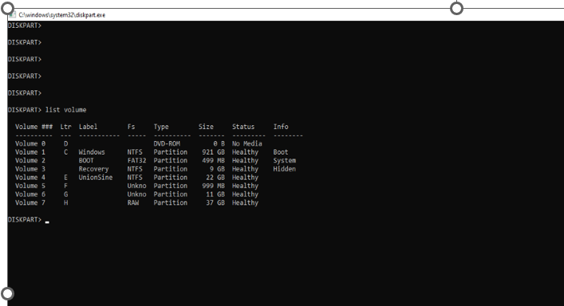

Figure 1: Disk Patrion
The HDD came with about 4 different partitions, lettered E, F, G, and H. Part. F and G have BitLocker password encryption without a password given.
We tried to disable the BitLocker using a PowerShell command “disable-BitLocker”, but it didn’t work. Except we use the system that was used to add the BitLocker on the HDD.
The screenshots below are proof of the PowerShell command.

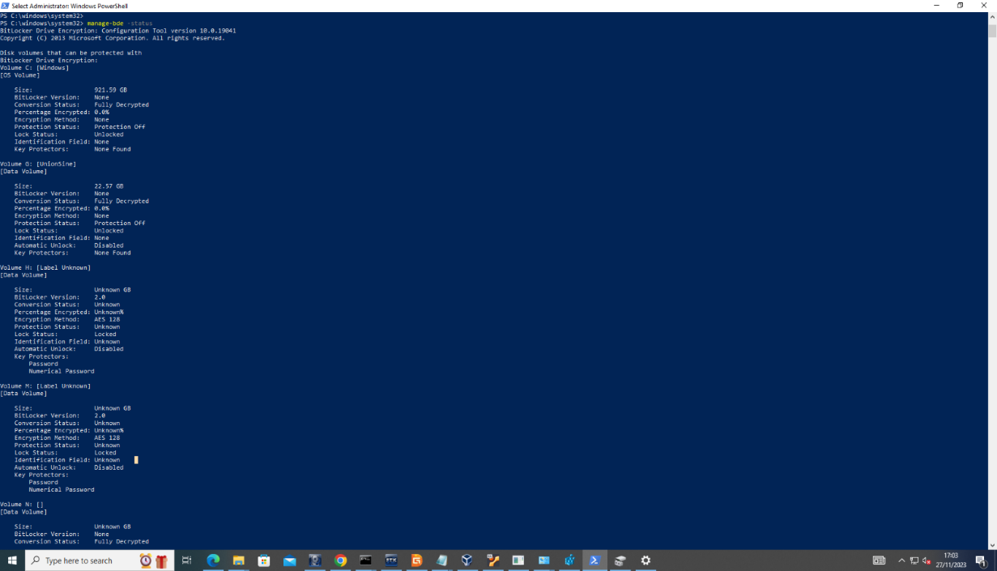

Figure 2: BitLocker using PowerShell Command

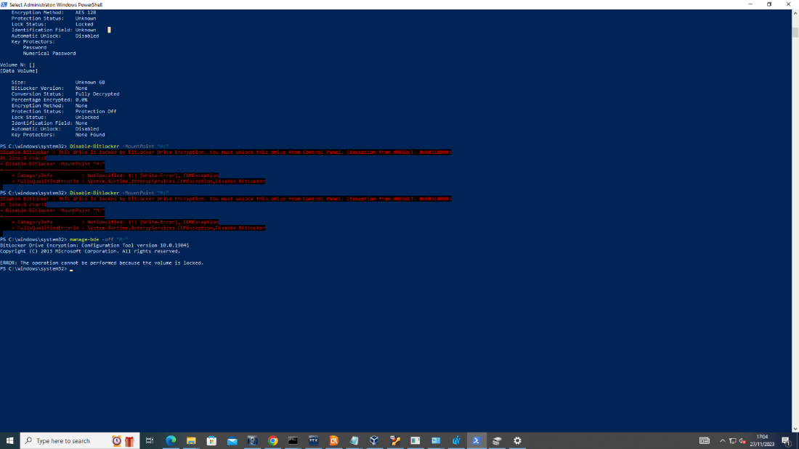

Figure 3: BitLocker using PowerShell Command

After several attempts to unlock the BitLocker drives, we reached out to Team A concerning the difficulties we encountered trying to unlock the BitLocker, we were informed that the BitLocker drives don’t contain any files and that we should ignore it.
We took an Image of all visible partitions on the HDD using FTKImager, we tried to analyze the image using the Autopsy tool, and we could recover previously stored and deleted files from the HDD.
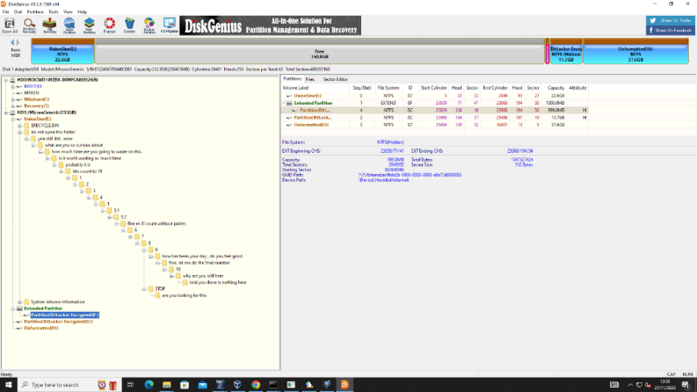
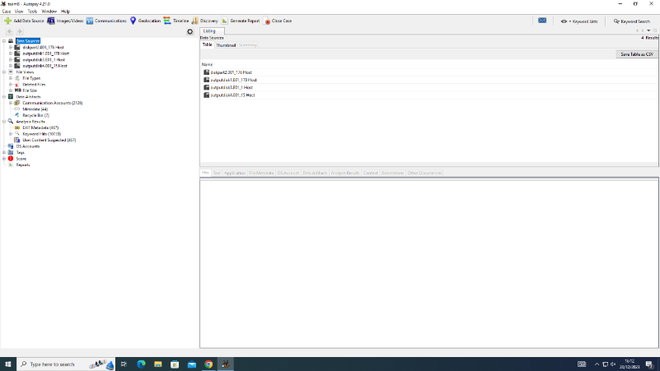
Below are screenshots of those files recovered.

Figure 4:Screenshot showing all four partitions
Figure 05: Screenshot showing each drive and storage capacity
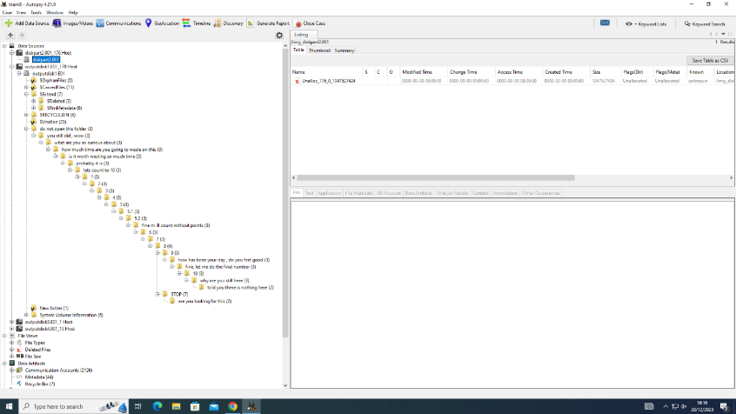
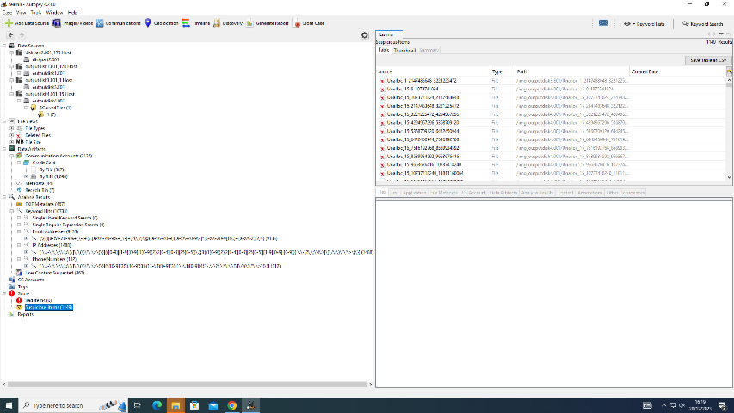

Figure 06: Screenshot showing root folders present in the HDD
Figure 07: Screenshot showing root folders present in the HDD

Evidence of recovered files and folders found on the image taken of the HDD.

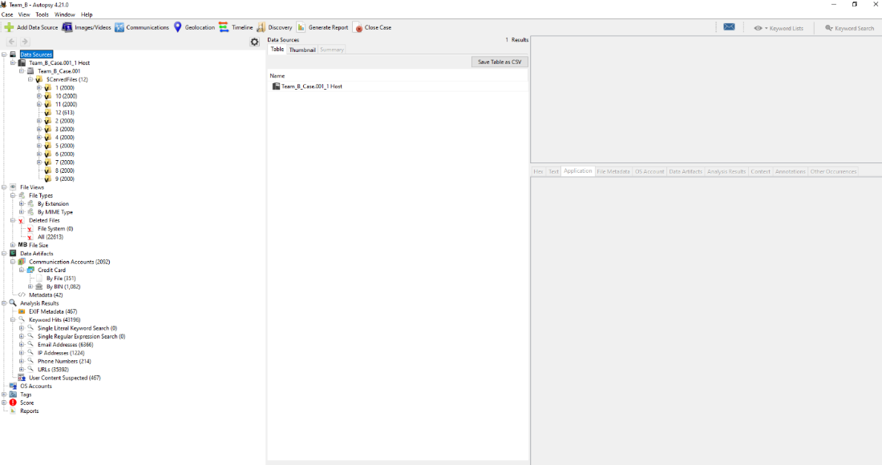

Figure 08: Evidence of Credit card details recovered from the HDD.

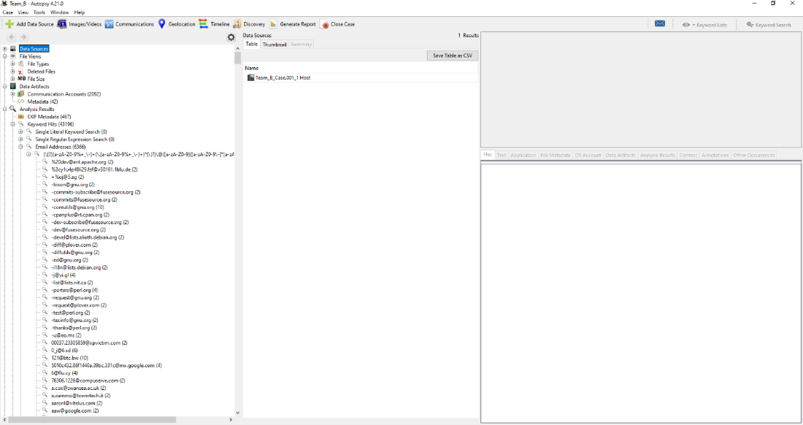
Figure 09: Evidence of email accounts recovered.

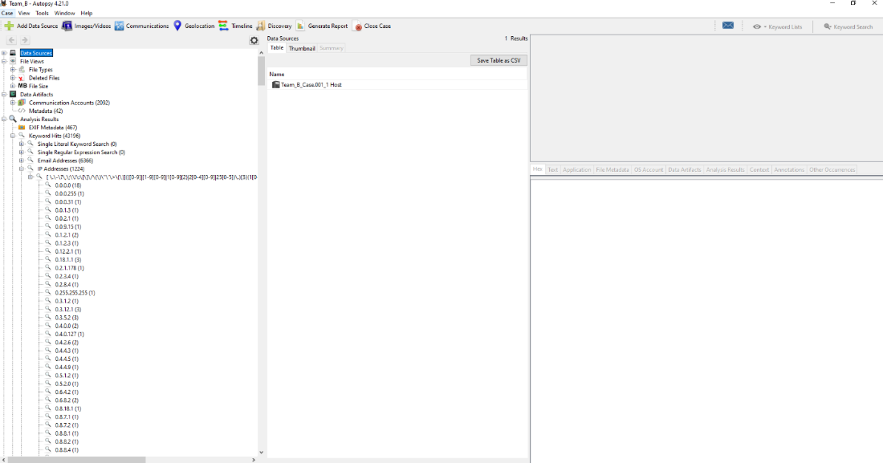

Figure 10: Evidence of IP addresses.

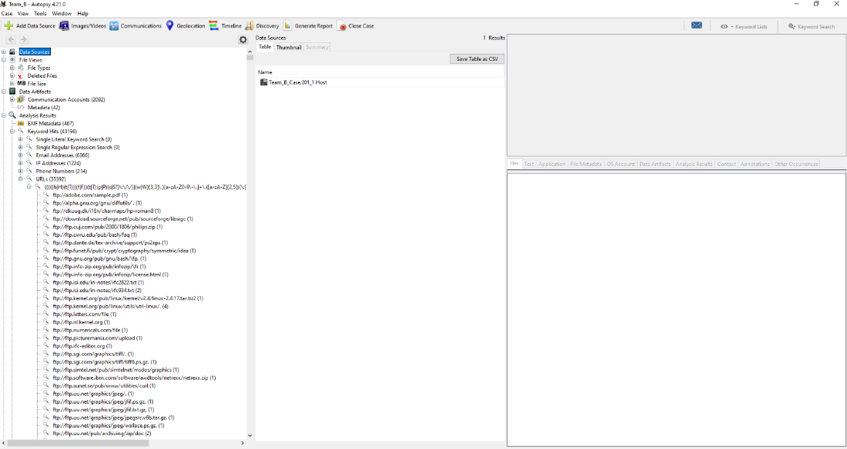

.

Figure 12: Evidence of Phone numbers recovered

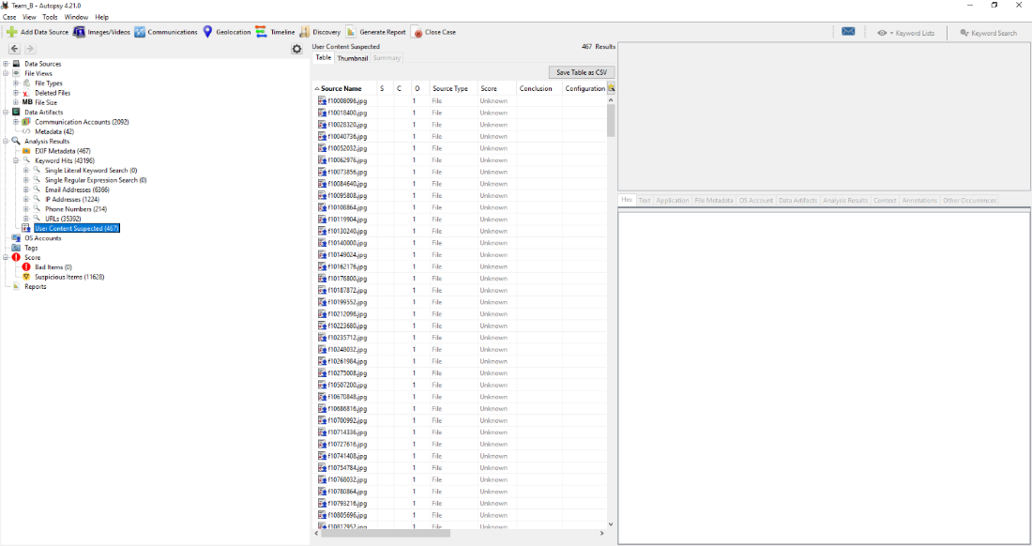

Evidence of user contents, including images, audio, videos, document files, etc.

Having recovered the files, we proceeded to analyze them sequentially. To our surprise, the evidence did not align with the provided scenario. We contacted the team to verify if the recovered files matched the evidence copied into the HDD; they confirmed that the files were not theirs.
Team A informed us that there was a hidden drive partition on the HDD, and their actual evidence files are likely saved on that hidden drive partition.
After several attempts in trying to find the hidden partitions failed, we did some research and found a tool called VeraCrypt, this tool was used to encrypt the drive

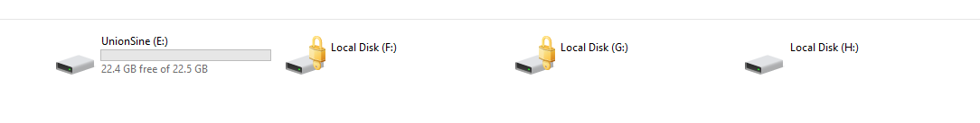
This is the drives partitions that were visible before we used the VeraCrypt

We used the VeraCrypt to dismount all drives in the HDD after which we mounted a new drive with a different drive letter, it requested for a password, which we collected from Team A.
The next shot below shows the new mounted drive, lettered “J”
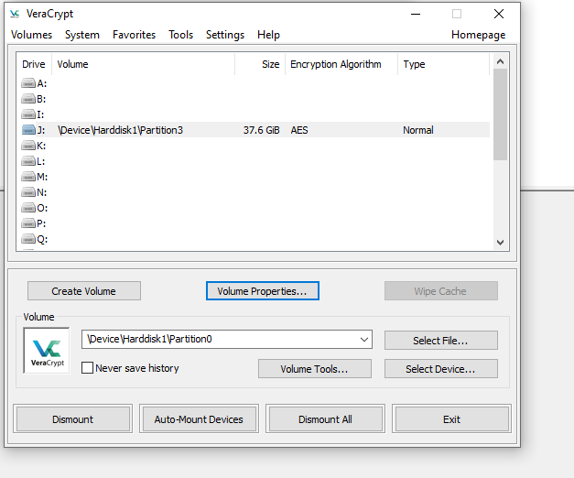

Figure 13: We took a new image of the un-hidden drive partition (drive J)

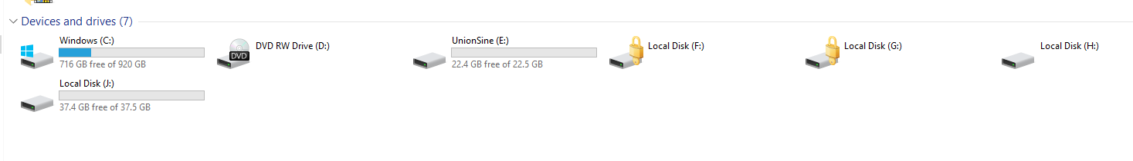
We now have five drives partitions. Drive J is the hidden drive which contains evidence files from Team A.

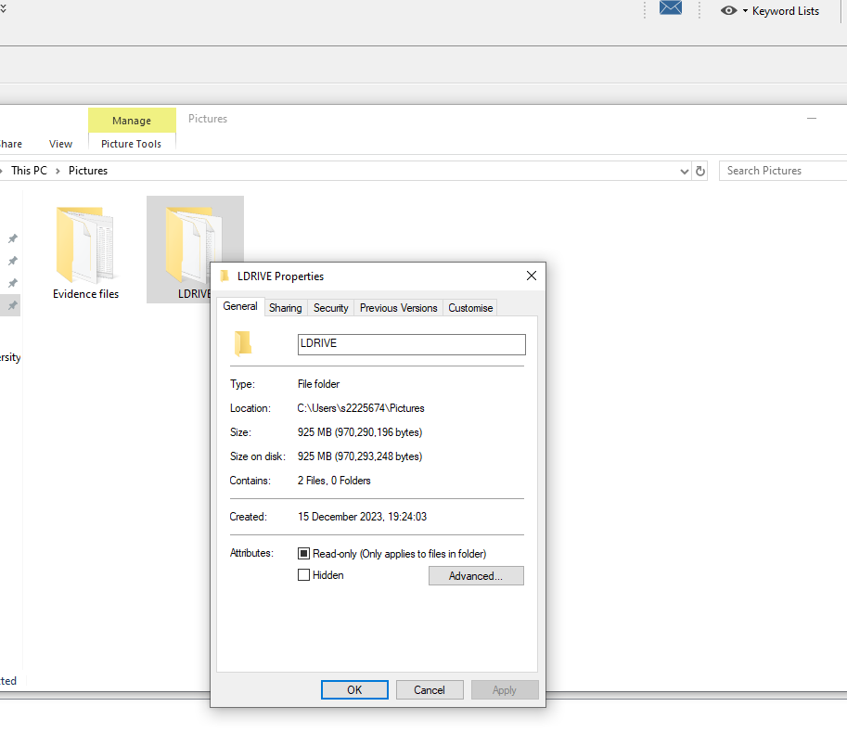
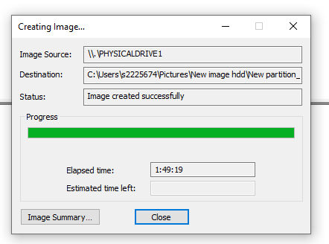
Figure 14 and 15: Size of Data: The total size of an image taken of Local disk J is 925MB 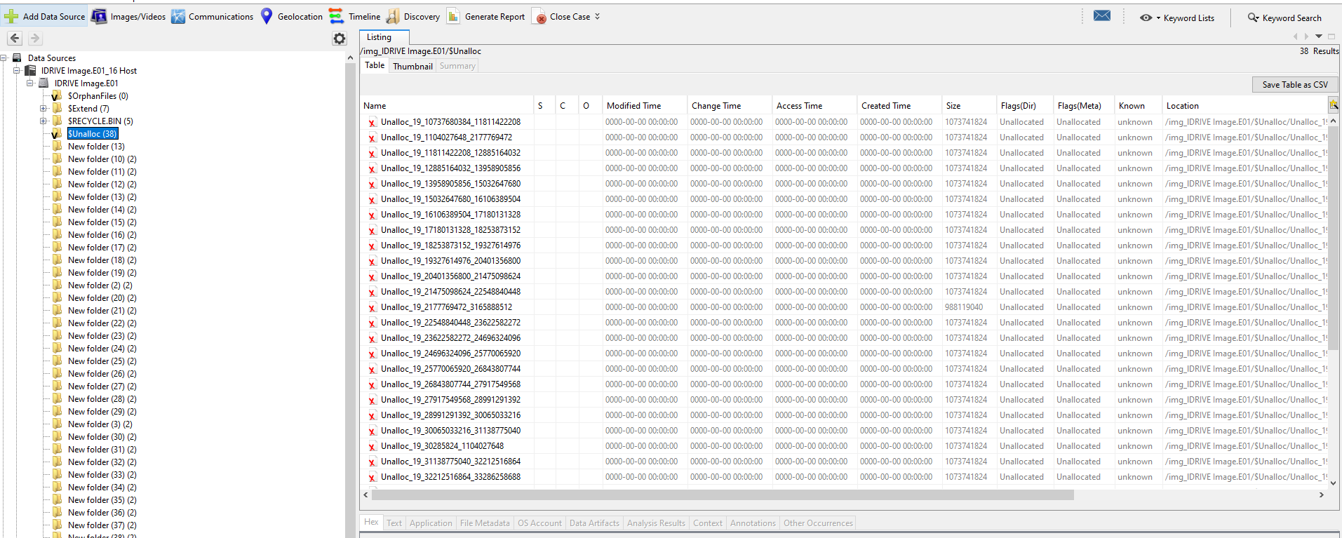

Figure 16: Evidence of unallocated spaces

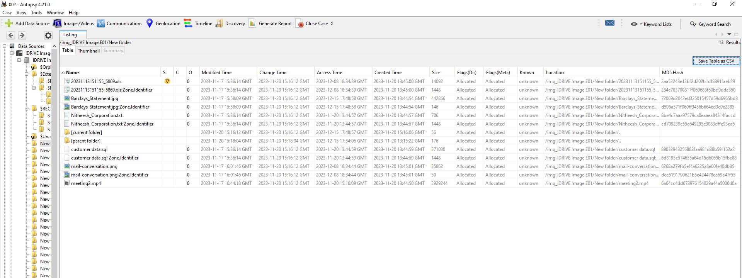

Figure 17: Evidence Location of files with Metadata from the new image

The following are files found in the new image of drive J.

Evidence Title | Format | Extension
- 20231113151155_5869 | Excel sheet document | XLS
- Barclays_Statement | Image | jpeg
- customer data | Mysql Database | Sql
- mail-conversation | Image screenshot | Jpeg
- Nitheesh_Corporation | Notepad text file | txt
- meeting2 | Video | Mp4

Table 01: New Image Of Drive J

ANALYSIS REPORT BASED ON EVIDENCE ANALYSED
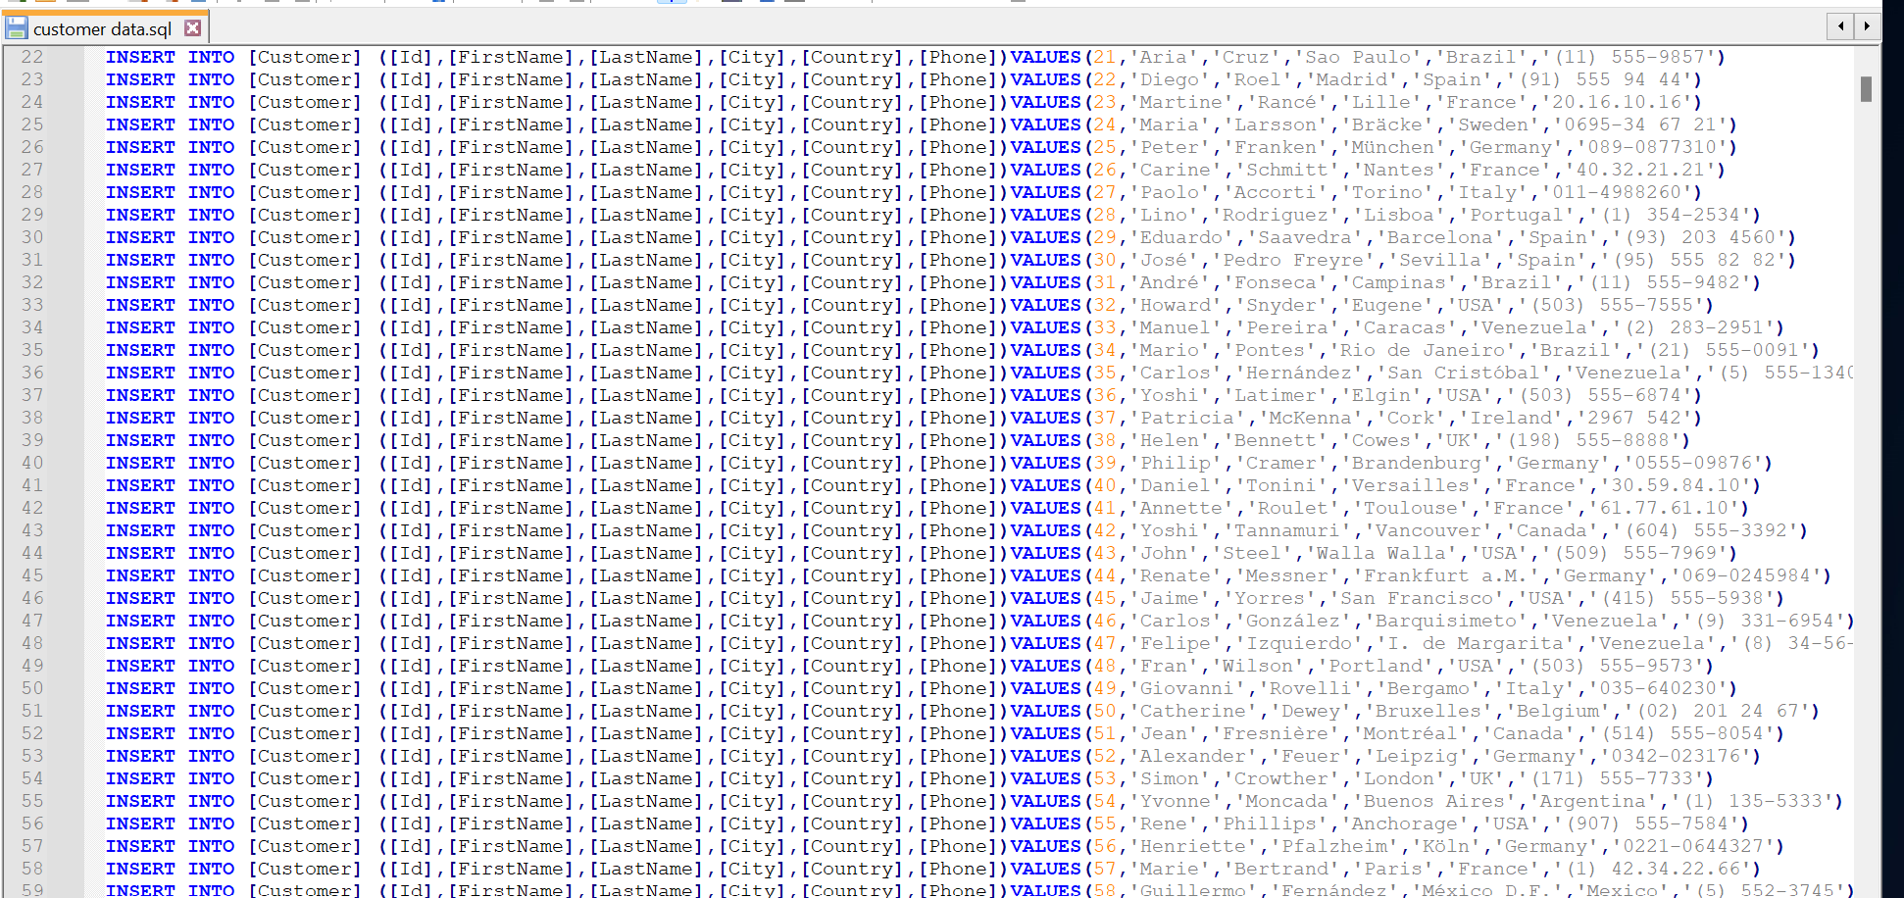
- In the aforementioned situation, the customer database of the dating company "Red Hot Passion" was hacked, revealing user details of patrons who hold high-ranking positions at a Fortune 500 company. This breach exposed the names of various customers, including top employees in managerial roles at "Nitheesh Corporation."

Figure 18: Database Of Company

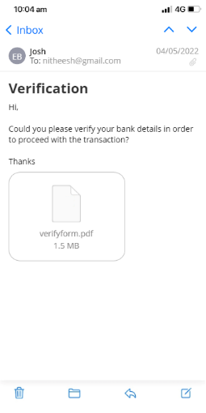
- An email from an unidentified sender, Josh, is sent to Nitheesh (nithesh@gmail.com). Josh's identity is unknown as he doesn't appear in the leaked database. The email requests Nitheesh to verify his bank details, raising suspicions of potential hacking. It's unclear why Nitheesh's cooperation is sought, and there's a possibility that the sender is impersonating someone close to Nitheesh, emphasizing the need for caution when receiving such verification requests.

Figure 19: Verification
- The database holding confidential and bank card details of Nitheesh Corporation's employees may have been leaked by former administrative staff who departed due to issues. These former employees, having extensive access to nearly all records and data, could potentially be responsible for the unauthorized release of employees' bank card information.
The reason is they want to take revenge against the company due to previous payment disputes.
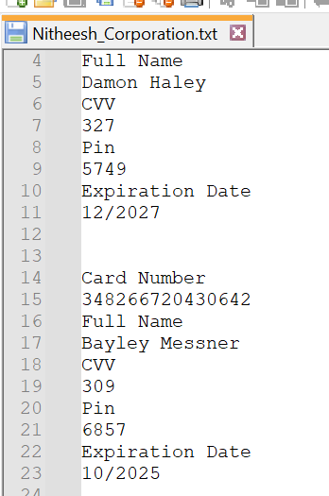
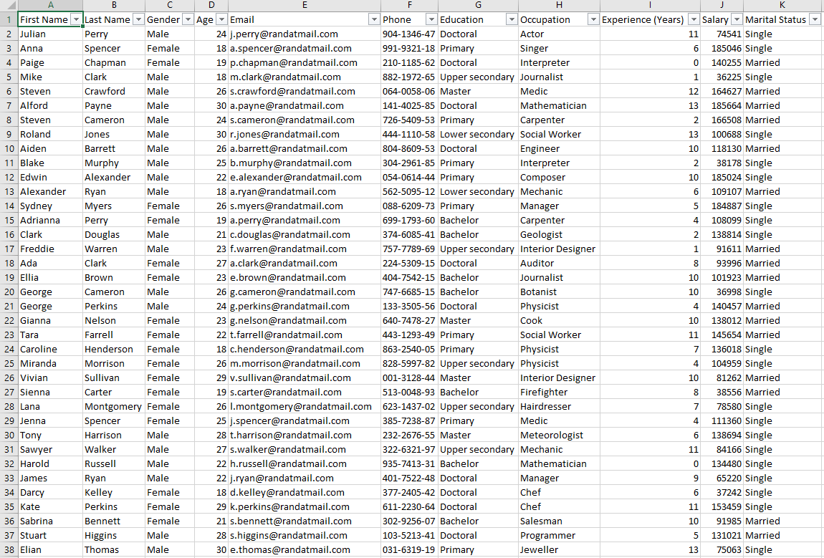

- An account statement having the name John Doe Lee, there's no record of John Doe among the list of either customer data of Red-Hot Passion or the database of Nitheesh Corporation. He may be the hacker, who was paid by the suspects who leaked confidential data of Nitheesh's cooperation. From his bank statement, there was a deposit of £540 into John Doe's account on 12 Jan. On 19 Jan. he paid £39 for transport to London.


Figure 20: Bank statement
Who are these culprits? we can't say for sure, but from the bank statement, John Doe made a card payment to London on 19 Jan. 2022. From the SQL database, about seven names appeared to live in London, I suspect that John could've possibly traveled to meet with these people. Those names have been highlighted below from the SQL file.

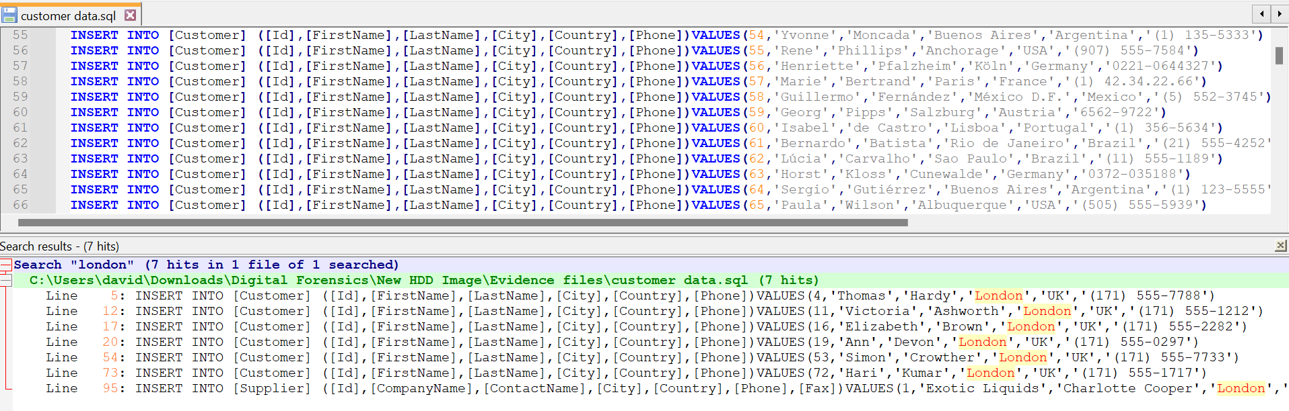

Figure 21: The SQL File

Challenges
Not able to ascertain the actual size of HDD and size data on the HDD, because it contained hidden partitions and unallocated spaces.
2. HDD contains 2 BitLocker encryption partitions, and no password was given.
3. The HDD Contains malware, that automatically displays multiple windows, which causes a disruption of operations on the PC.
4. In trying to recover hidden partitions using autopsy tools, the autopsy tools recovered previously deleted files on the HDD, these files amount to over 160GB. Below is a screenshot of the files recovered.

CONTRIBUTION
In the digital forensic investigation, I meticulously collected data from diverse social media platforms, including Instagram, Twitter, WhatsApp, and Facebook. Employing a rigorous chain of custody, I ensured the preservation and integrity of the acquired evidence throughout the process. The Forensic Toolkit (FTK) tool played a pivotal role in the analysis, allowing for in-depth examination of the collected data. This approach facilitated a comprehensive investigation, uncovering valuable insights and contributing to the overall success of the digital forensic process and documentation work.

Video link: https://shorturl.at/bsx03

TASK 4

Mobile Forensic Investigation

Executive Summary
Background
Our client, a car manufacturing company, is developing a new model of AI self-driving cars, facing competition in various countries. They aim to safeguard the project's privacy but suspect that one of their technical officers might be illicitly selling the research data to competitors.
Scope
Specify the analysis scope, encompassing devices, applications, and data types. The company has tasked us with verifying allegations by examining the suspect's mobile phone. Utilizing Cellebrite tool kits, we'll conduct both logical and physical analyses on the device.
Key Findings
Summarize the major findings and highlights of the mobile forensics analysis.
From the analysis, we discovered over 64 images taken with the suspect's mobile phone camera, 23 audio recordings, and 7 video files. A summary of the evidence discovered is included in this report.

Case Information
2.1 Case Details
Case ID: MP-0140124
Date of Request:18/12/2023
Requesting Authority: Team B
Case Investigator: Team B
Device Information: ulefone
Manufacturer: China
Model: Note 14 (16)
Serial Number: S/N:3102SH1010027469
IMEI/MEID: IMEI-1:355617730545789

Methodology
Explain the methods and techniques used during the mobile forensics analysis, including tools, procedures, and any challenges encountered.
The mobile phone was handed to us by the company, and every authorization process was sorted by the company. We ensured to maintain a chain of custody after receiving it
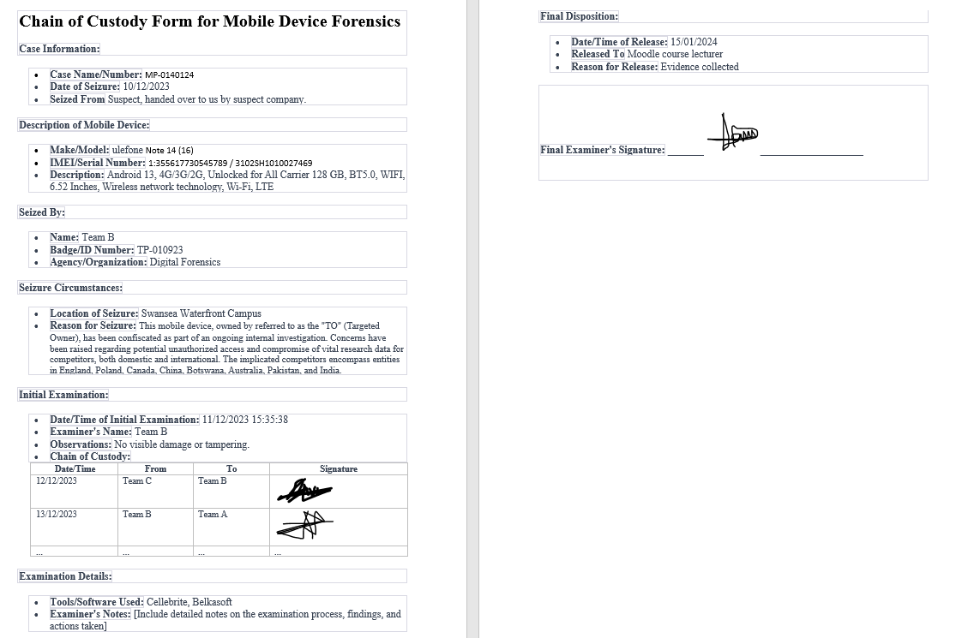

Data Acquisition
Device Identification
The phone was handed to us by the company where the suspect works, due to an ongoing investigation involving a breach of data. Every verification was done by the company before the phone was handed to us.

Data Extraction
We extracted a logical filesystem using the Cellebrite forensics toolkit. Due to the model of the phone, we could not perform a physical extraction.

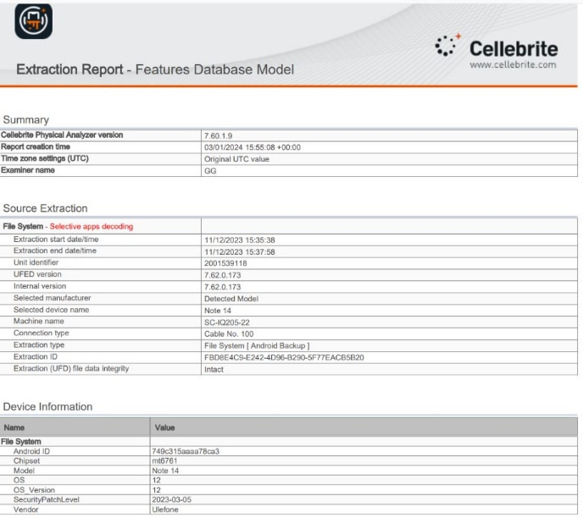
Figure 22: Data Extraction.

Data Preservation
Detail the steps taken to preserve the integrity of the evidence throughout the analysis.
To maintain data integrity, we set up a forensics lab in the Cisco lab, using virtual machines with operating systems installed on them. All digital extraction and analysis took place in this environment. Every piece of evidence collected and analyzed was stored on OneDrive.

Data Analysis
Overview
Utilizing the Cellebrite Physical Analyzer and Belkasoft forensics tool, we scrutinized data containing images depicting various locations visited by the suspect. We traced their journey by analyzing image positions extracted from the device. Additionally, audio recordings with event details were discovered, some requiring transcription due to low audibility. Below, we present screenshots of the evidence, complete with timestamps, locations, and detailed information about each piece uncovered.
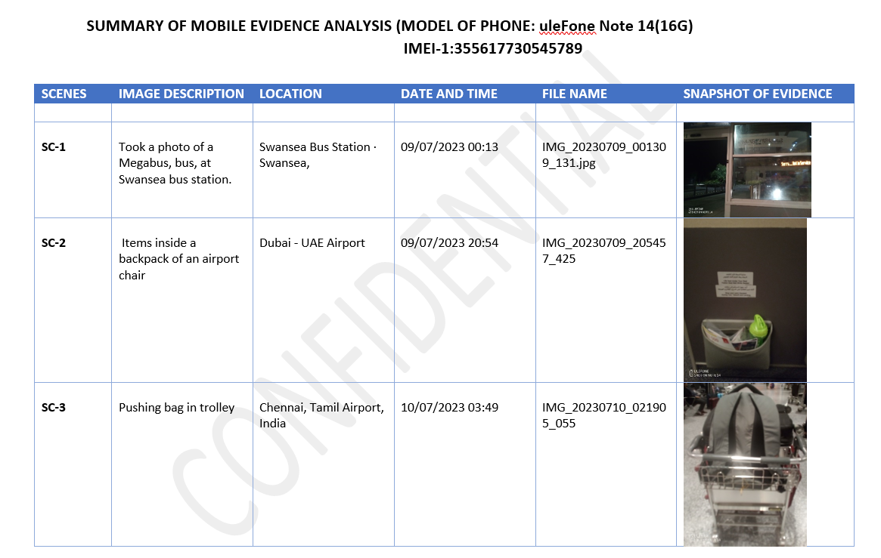
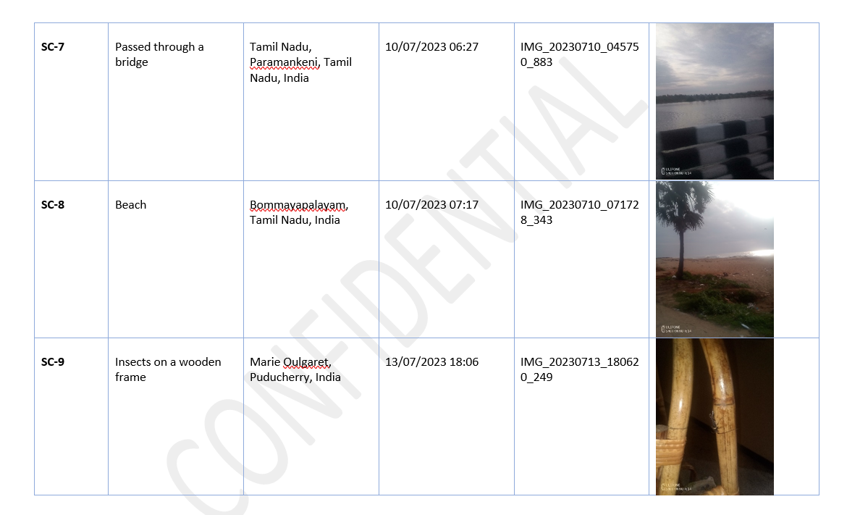
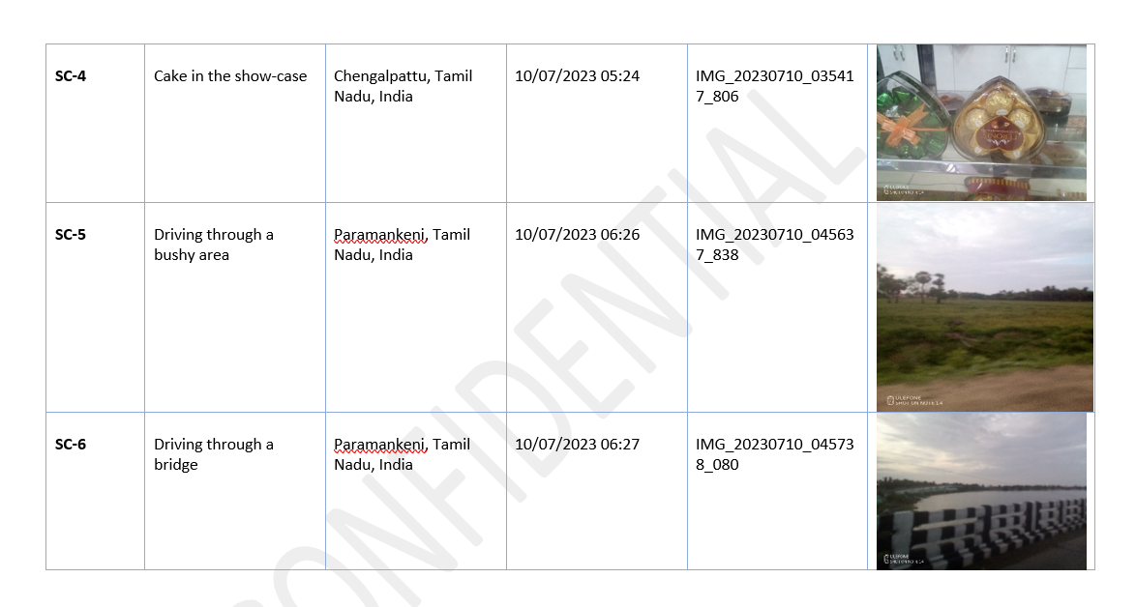

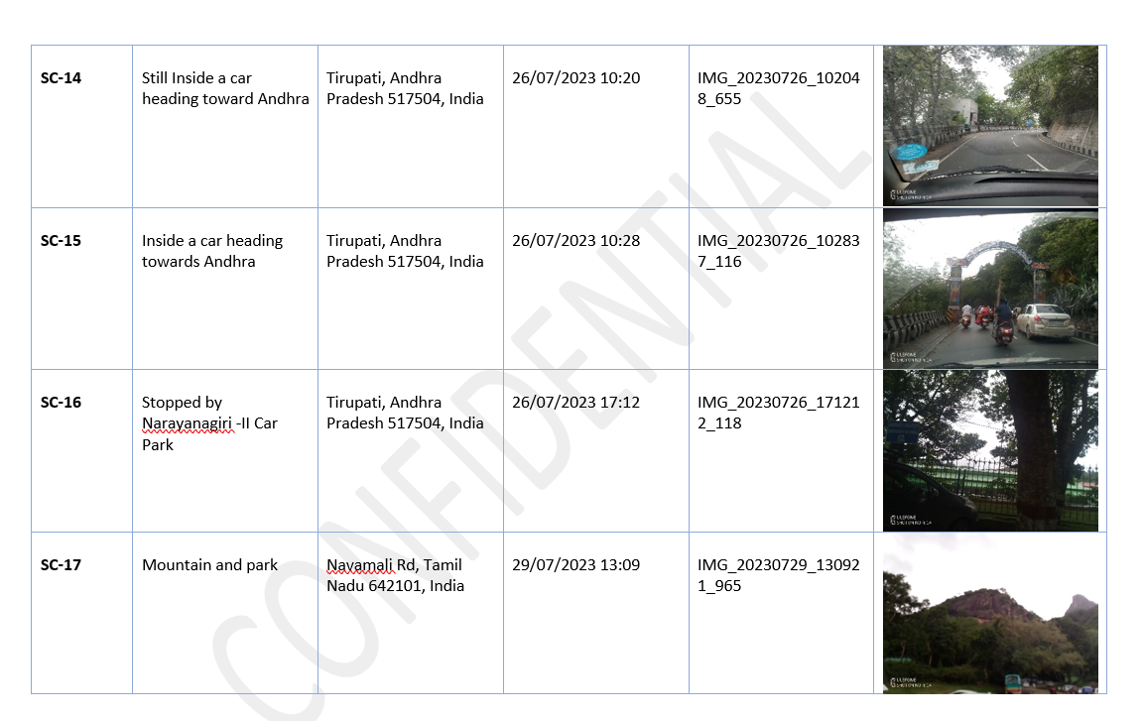
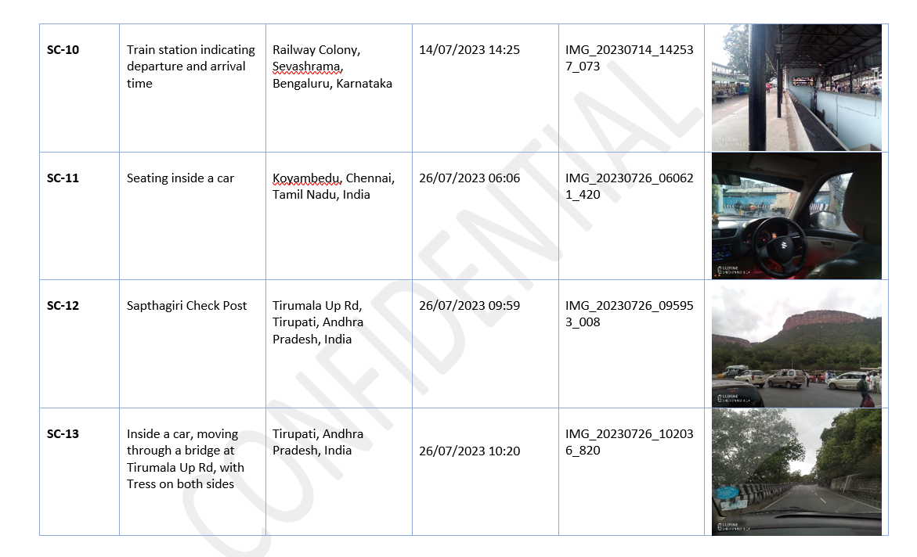

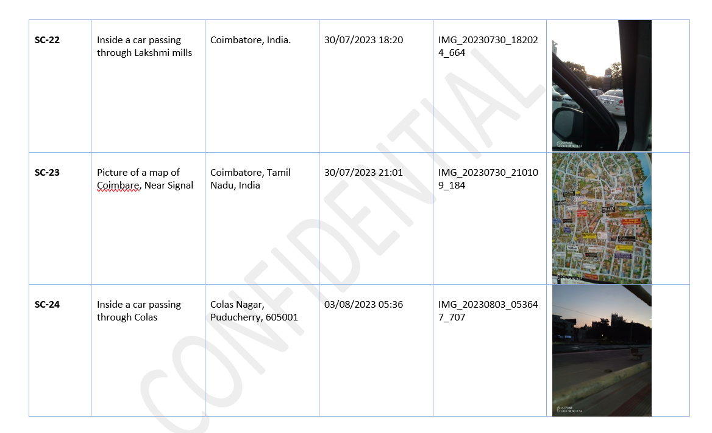
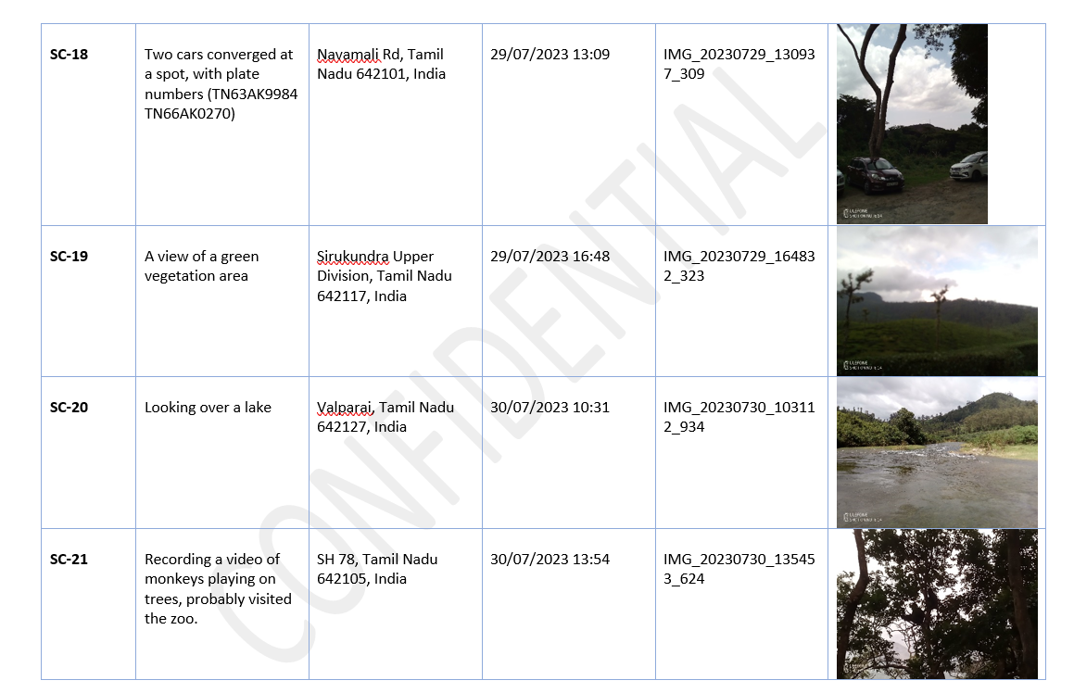

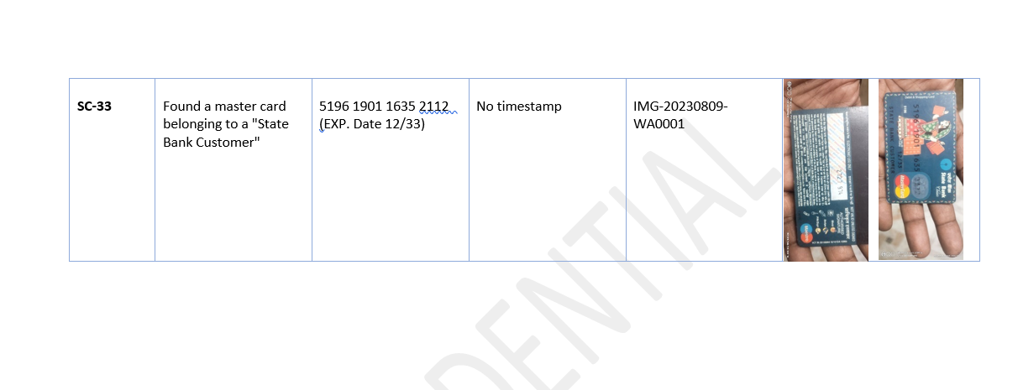
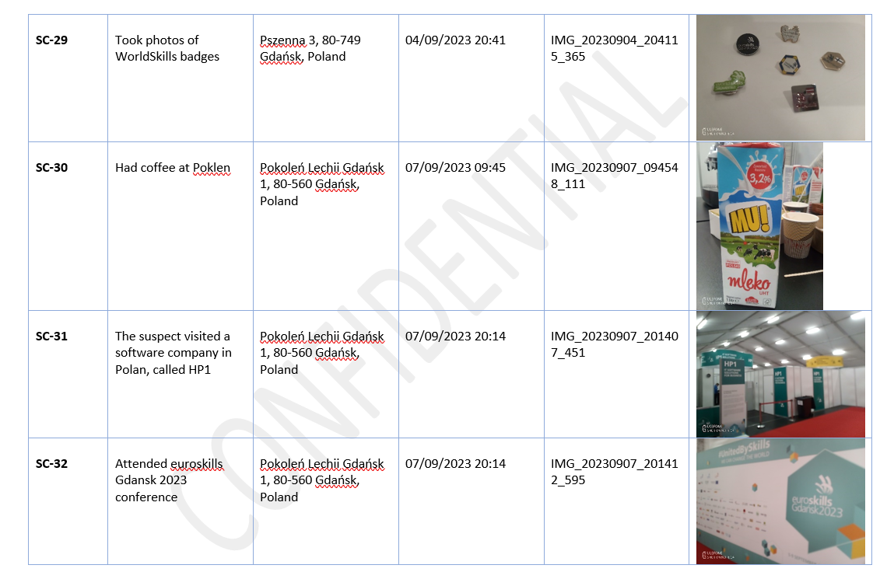
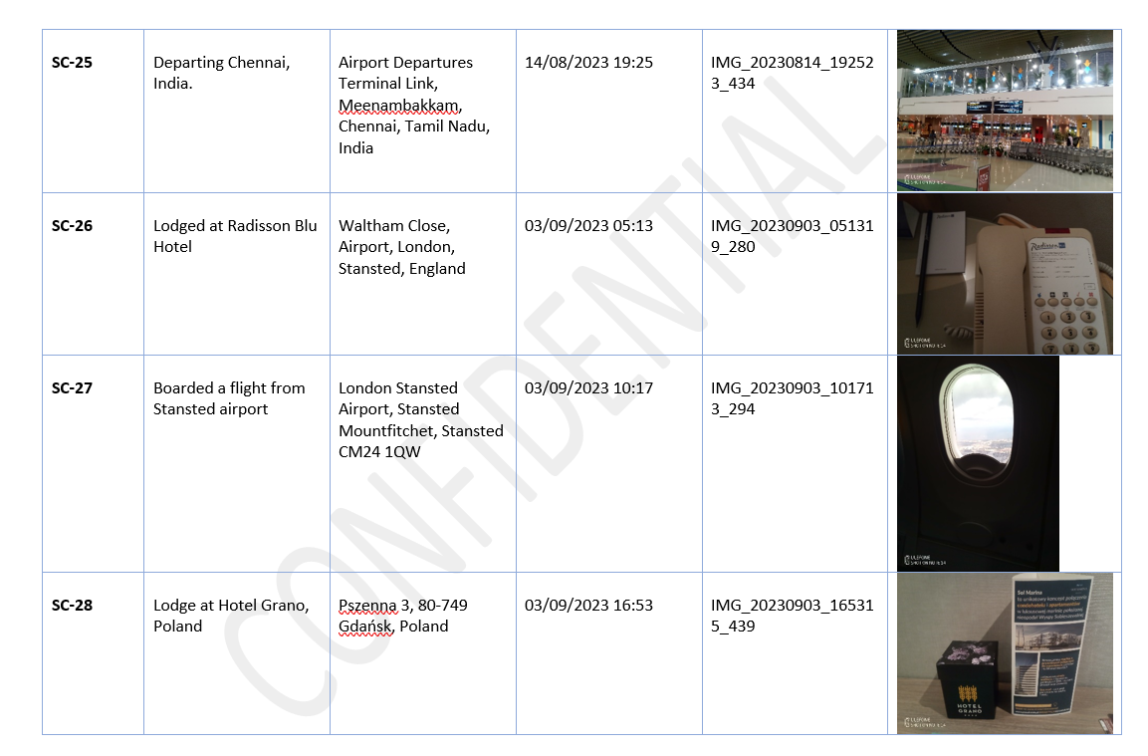
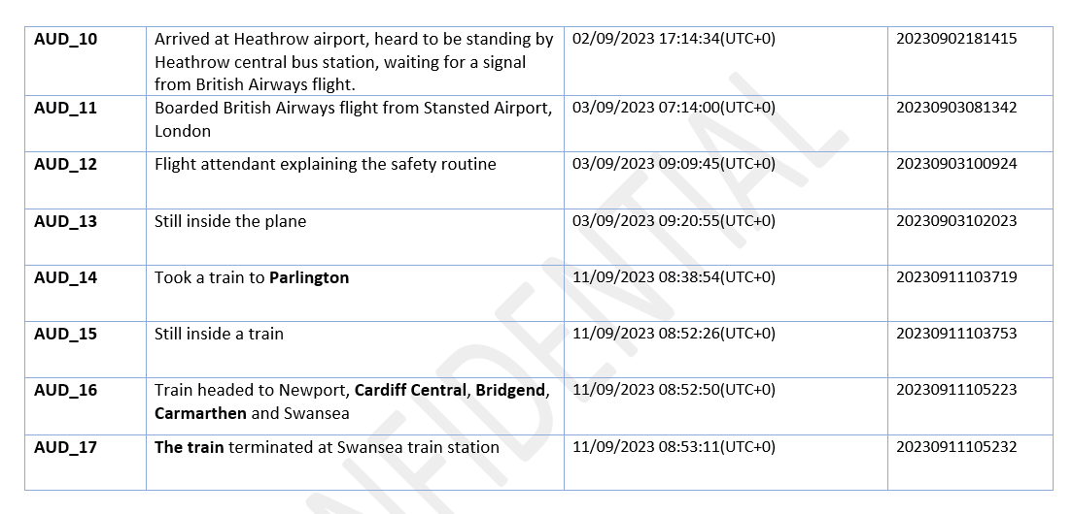
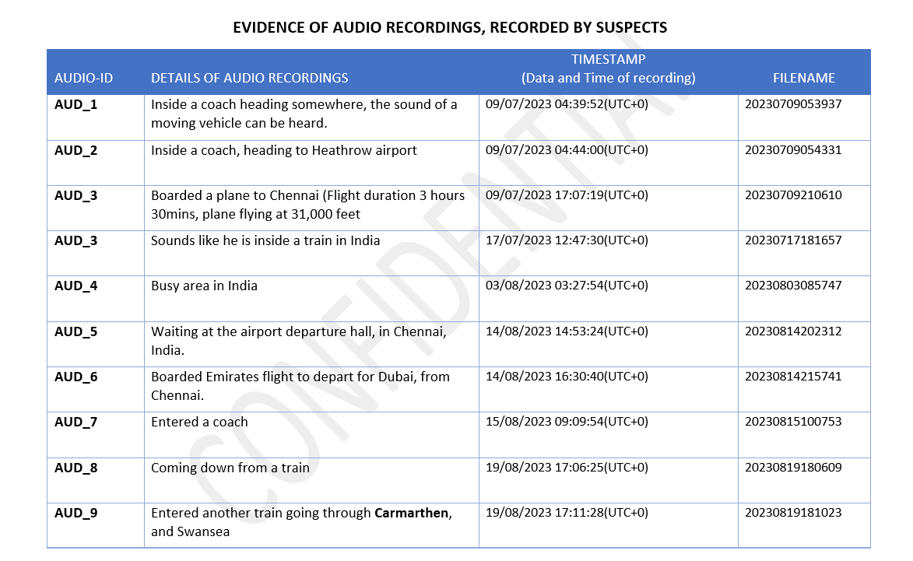

SUMMARY OF ANALYSIS

The evidence provided contains a detailed analysis of the suspect's activities and locations throughout his journey.
The suspect embarked on two different trips.
- He began his first trip from Swansea to London, where he boarded a flight from Heathrow Airport, stopped at Dubai Airport, and took a reconnecting flight to Chennai, India, as indicated in Sc-1 and Sc-3.
- While in India, he met with an unknown person, as seen in SC-18, two vehicles are seen to converge in Navamali Road, Tamil, Nadu. One of the vehicles was probably used in transporting the suspect. The plate numbers of these vehicles have been captured for further investigation.
- He was in India for about 35 days starting from 10/07/2023 to 14/08/2023, Sc-1 to sc-25, AUD_1 to AUD_9.
- His first trip ended when he returned to Swansea on 19/08/2023.
His second trip started on 02/09/2023, as indicated in AUD_10.
- He arrived at Heathrow Airport and waited for a flight signal from British Airways.
- He was next spotted at the Radisson Blu Hotel, Stansted Airport, England on 03/09/2023,
Sc-26.
He boarded a flight that same day to Poland, at about 10:17, SC-27, AUD_11 to AUD_13.
- At about 16:53 of that same day, he lodged at Hotel Grano, Gdansk, Poland, Sc-28.
- While in Poland, he visited an IT company called HP1, located at Pokenlen Lechoo, Gdansk 1, Sc-31.
- He also attended euroskill Gdansk 2023 Conference, Sc-32. A payment card was also found in the suspect phone, but we can't confirm who the owner is, Sc-33.
- He returned to the UK on the 11/09/2023, AUD_14 to AUD_17.
- He spent about 8 days in Poland, and about 4 days in the UK.

Recovered Data

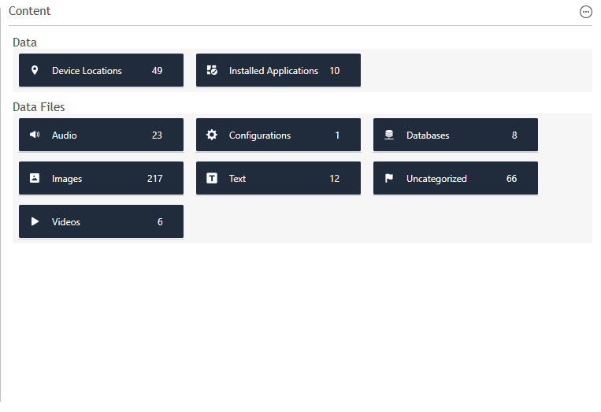

Deleted Data
We didn't recover any deleted data.

Forensic Artifacts

Artifacts Overview
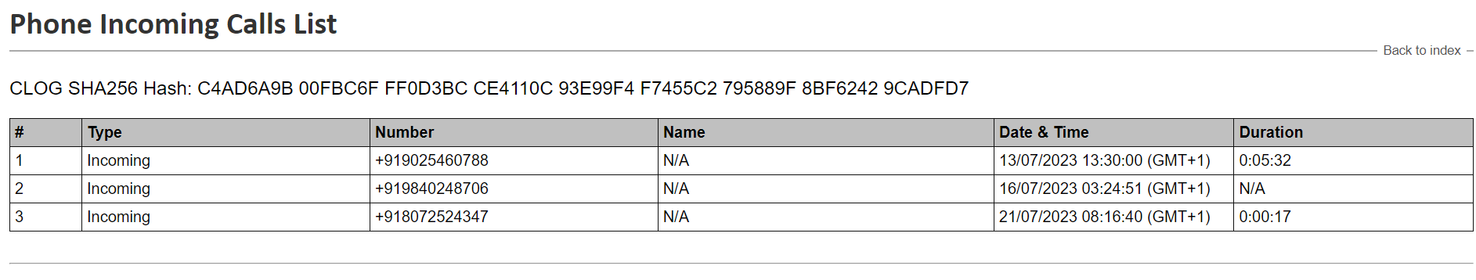
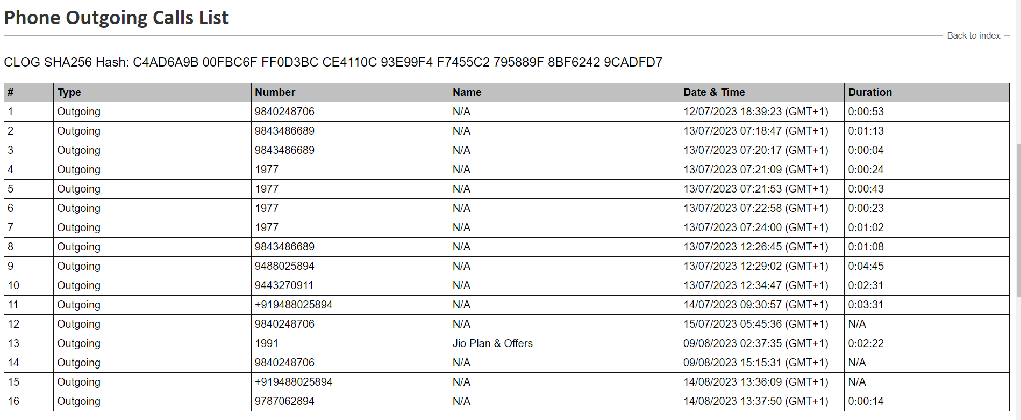
Below is the file system structure of the mobile device and the data structure contained in the phone.

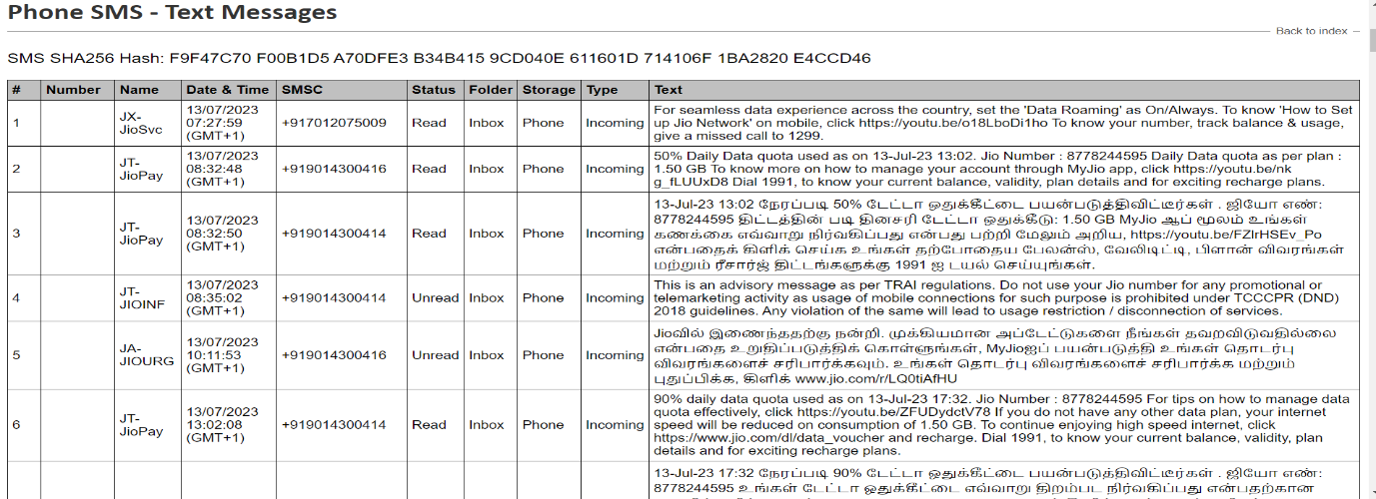
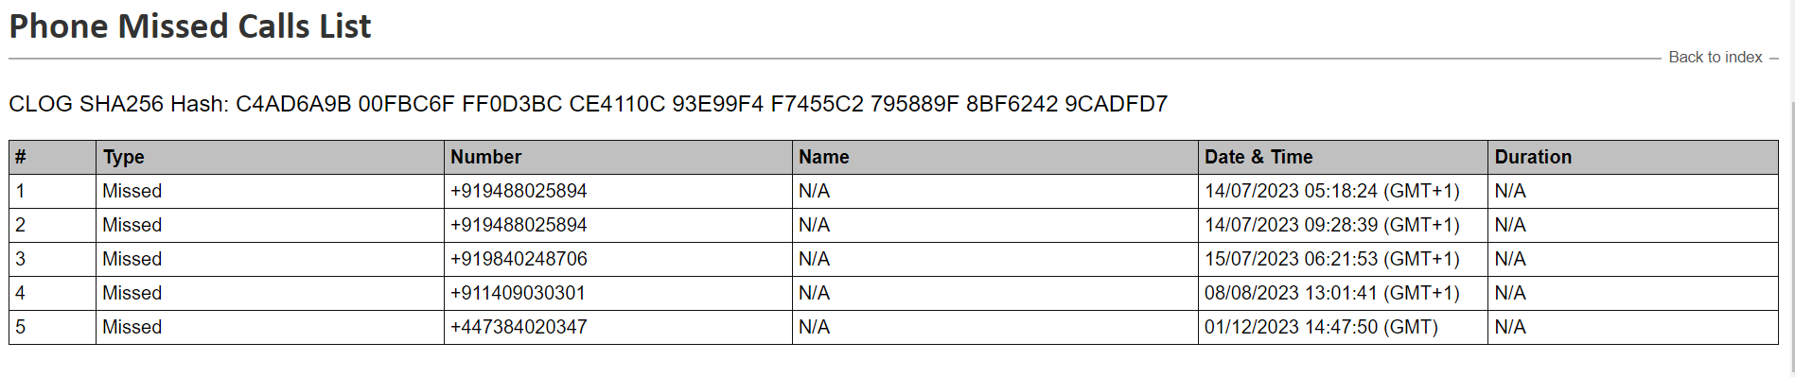

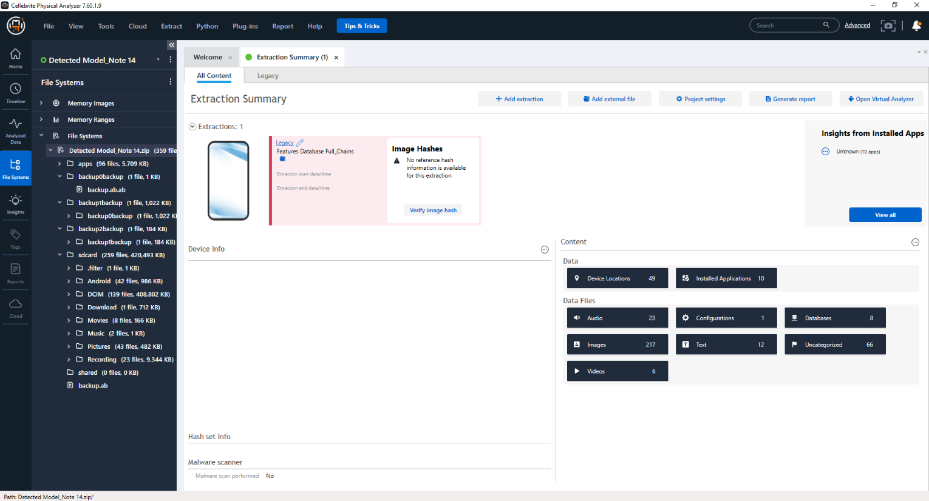
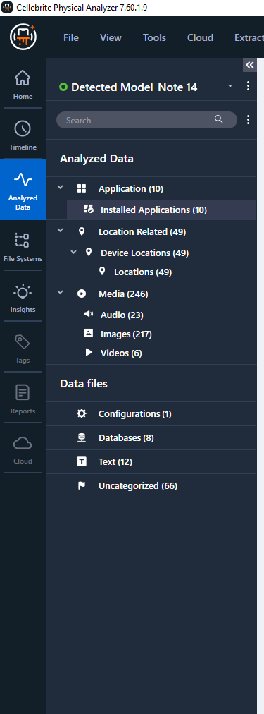

Notable Findings
From our analysis, we discovered that the suspects:
- Visited 4 different Countries, the United Kingdom, United Arab Emirates, India, and Poland.
- Spent more time in India than the other 3 Countries.
- Met with someone in India.
- Visited an IT company in Poland.
- Was careful not to leave any trace of the leaked research data on his mobile device.

CONTRIBUTION
In utilizing the Cellebrite tool for digital forensics, I contributed by employing its advanced capabilities in password cracking through brute force techniques. This involved systematically attempting various password combinations to gain access to secured digital devices. Additionally, my role extended to the meticulous identification of crucial information within the extracted data and comprehensive documentation of the forensic work undertaken. The Cellebrite tool proved instrumental in enhancing the efficiency of password recovery processes, enabling a more thorough examination of digital evidence and contributing to the overall success of the forensic investigation.

CONCLUSIONS
Our analysis has identified compelling evidence indicating that the suspects visited three countries from the list (England, Poland, Canada, China, Botswana, Australia, Pakistan, and India). This substantiates the claim that they compromised the research data of their company.

RECOMMENDATIONS
We recommend that further investigations be conducted to discover who he met with in India, based on the car plate numbers captured.
The IT company he visited should also be investigated to confirm this claim.

LIMITATIONS
Not enough evidence to establish a convincing case of stolen research data. There was no chat, text, or email of any conversation between the suspect and his accomplice.
Some features on the Cellebrite UFED and Physical analyzer didn’t effectively. If we had more sophisticated proprietary forensic tools Magnet AXIOM, Oxygen Forensics Detective, and others.

ACKNOWLEDGMENTS
The report is based on a group discussion. Each team member played a different role in ensuring the integrity of every evidence and analysis performed. Every fact and assumptions made were based on the team agreement.

REFERENCES

[1] “IEEE Xplore Full-Text PDF:” Accessed: Jan. 11, 2024. [Online]. Available: https://ieeexplore.ieee.org/stamp/stamp.jsp?tp=&arnumber=9678340
[2] A. Al-Dhaqm et al., “Digital Forensics Subdomains: The State of the Art and Future Directions,” IEEE Access, vol. 9, pp. 152476–152502, 2021, doi: 10.1109/ACCESS.2021.3124262.
[3] K. Barmpatsalou, T. Cruz, E. Monteiro, and P. Simoes, “Current and Future Trends in Mobile Device Forensics,” ACM Comput Surv, vol. 51, no. 3, pp. 1–31, May 2019, doi: 10.1145/3177847.
[4] “Cybercrime and Digital Forensics: An Introduction - Thomas J. Holt, Adam M. Bossler, Kathryn C. Seigfried-Spellar - Google Books.” Accessed: Jan. 11, 2024. [Online]. Available: https://books.google.co.uk/books?hl=en&lr=&id=XR1tEAAAQBAJ&oi=fnd&pg=PT20&dq=+Intersection+of+Digital+Forensics+and+Cybersecurity+in+mobile,+computer+forensics.&ots=GrKZ-V5al_&sig=FwY7lyzNhaOuVVEwZGhSfKV9htQ#v=onepage&q&f=false
[5] V. R. Kebande, N. M. Karie, R. D. Wario, and H. S. Venter, “Forensic profiling of cyber-security adversaries based on incident similarity measures interaction index,” 2018 International Conference on Intelligent and Innovative Computing Applications, ICONIC 2018, Jul. 2018, doi: 10.1109/ICONIC.2018.8601279.
[6] B. K. Sharma, M. A. Joseph, B. Jacob, and B. Miranda, “Emerging trends in Digital Forensic and Cyber security-An Overview,” ITT 2019 - Information Technology Trends: Emerging Technologies Blockchain and IoT, pp. 309–313, Nov. 2019, doi: 10.1109/ITT48889.2019.9075101.
[7] A. Tiwari, V. Mehrotra, S. Goel, K. Naman, S. Maurya, and R. Agarwal, “Developing Trends and Challenges of Digital Forensics,” 2021 5th International Conference on Information Systems and Computer Networks, ISCON 2021, 2021, doi: 10.1109/ISCON52037.2021.9702301.
[8] E. A. Vincze, “Challenges in digital forensics,” Police Practice and Research, vol. 17, no. 2, pp. 183–194, Mar. 2016, doi: 10.1080/15614263.2015.1128163.
[9] V. Fernando, “Cyber Forensics Tools: A Review on Mechanism and Emerging Challenges,” 2021 11th IFIP International Conference on New Technologies, Mobility and Security, NTMS 2021, Apr. 2021, doi: 10.1109/NTMS49979.2021.9432641.
[10] M. Losavio, K. C. Seigfried-Spellar, and J. J. Sloan, “Why digital forensics is not a profession and how it can become one,” Criminal Justice Studies, vol. 29, no. 2, pp. 143–162, Apr. 2016, doi: 10.1080/1478601X.2016.1170281.
[11] “Digital Forensics and Investigations: People, Process, and Technologies to ... - Jason Sachowski - Google Books.” Accessed: Jan. 11, 2024. [Online]. Available: https://books.google.co.uk/books?hl=en&lr=&id=MjkPEAAAQBAJ&oi=fnd&pg=PP1&dq=National+and+International+Job+Market++in+digital+forensics&ots=FOYWMipBzo&sig=X_6GZ1ydQTuJoCGv5pglLflgV2U#v=onepage&q&f=false
[12] R. Apau and F. N. Koranteng, “An overview of the digital forensic investigation infrastructure of Ghana,” Forensic Sci Int, vol. 2, pp. 299–309, 2020, doi: 10.1016/j.fsisyn.2020.10.002.
[13] M. Rafique and M. N. A. Khan, “Exploring Static and Live Digital Forensics: Methods, Practices and Tools,” Int J Sci Eng Res, vol. 4, no. 10, 2013, Accessed: Jan. 12, 2024. [Online]. Available: http://www.ijser.org
[14] T. Hermawan, Y. Suryanto, F. Alief, and L. Roselina, “Android Forensic Tools Analysis for Unsend Chat on Social Media,” 2020 3rd International Seminar on Research of Information Technology and Intelligent Systems, ISRITI 2020, pp. 233–238, Dec. 2020, doi: 10.1109/ISRITI51436.2020.9315364.
[15] P. Wang, M. Rosenberg, and H. D’Cruze, “Integration of Mobile Forensic Tool Capabilities,” Advances in Intelligent Systems and Computing, vol. 738, pp. 81–87, 2018, doi: 10.1007/978-3-319-77028-4_13/COVER.
[16] “File System Forensic Analysis - Brian Carrier - Google Books.” Accessed: Jan. 12, 2024. [Online]. Available: https://books.google.co.uk/books?hl=en&lr=&id=Zpm9CgAAQBAJ&oi=fnd&pg=PT13&dq=Carrier,+B.+(2005).+File+System+Forensic+Analysis.+Addison-Wesley.&ots=6NAM19lFEE&sig=e0m9q2yA75-mcDrQD46ZZS4UEBo#v=onepage&q=Carrier%2C%20B.%20(2005).%20File%20System%20Forensic%20Analysis.%20Addison-Wesley.&f=false
[17] N. Kumari and A. K. Mohapatra, “An insight into digital forensics branches and tools,” 2016 International Conference on Computational Techniques in Information and Communication Technologies, ICCTICT 2016 - Proceedings, pp. 243–250, Jul. 2016, doi: 10.1109/ICCTICT.2016.7514586.
[18] R. Padmanabhan, K. Lobo, M. Ghelani, D. Sujan, and M. Shirole, “Comparative analysis of commercial and open source mobile device forensic tools,” 2016 9th International Conference on Contemporary Computing, IC3 2016, Mar. 2017, doi: 10.1109/IC3.2016.7880238.
[19] E. Vlastos and A. Patel, “An open source forensic tool to visualize digital evidence,” Comput Stand Interfaces, vol. 30, no. 1–2, pp. 8–19, Jan. 2008, doi: 10.1016/j.csi.2007.03.002.
[20] F. Flandrin, W. J. Buchanan, R. Macfarlane, B. Ramsay, and A. Smales, “Evaluating Digital Forensic Tools (DFTs).”

