SUSTAINABILITY PROJECT

Student Name: GOVINDA KHANAL
Student ID: 2239355
Module Title: Sustainable Hospitality
Module Code: BHIM4011
Module Tutor: DANIEL PAYNE

TABLE OF CONTENTS
- Introduction 4
- Discussion 4
- Specific aspects of sustainability in the hotel industry 4
- Impacts of Sustainability Practices with Positive and Negative Impacts 6
- Positive Impacts 6
- Negative Impacts 9
- Theories and Models of Sustainability 9
- Innovation and adaptation of the UK’s hotel industry 10
- Future of sustainability in UK hotels 12
- Conclusion 13
- References 14

Introduction
Every year, millions of people stay in hotels, which makes industry very important to the world economy. But as people become more aware of environmental and social problems, hotels are being looked at more closely to see how they affect things. Because of this, sustainability has become important as properties try to make plans to lower their impact on the environment, get involved in their communities, and make sure they can stay around for a long time. This show looks at some of the most important parts of making a hotel sustainable, such as protecting the environment, making the business profitable, and being socially responsible. This will look at important processes that have to do with water, energy, trash, and social interactions. Find out about the pros and cons of new ideas and upcoming trends. This project gives an overall picture of how sustainable hotels are now and how they will change in the future.

Discussion

Specific aspects of sustainability in the hotel industry
Hotels play a crucial role in the economy; each year many people go there. Some travel for business purposes and others for leisure purposes. In any case, the more people learn about environmental issues and social matters, the sector is being checked at how it influences the world and the way the networks work at a large scale. Therefore, sustainability has become a topic of serious concern for hotels in many countries. Hotels try to lessen their environmental footprint, join local organizations, and secure their long-term existence.

Environmental sustainability
Hotels can protect the environment and save money in the long run by reducing the damage they do to it (Pereira-Moliner et al. 2021). One of the most important things hotels can do to be more environmentally friendly is to use less energy. Hotels make a lot of trash every day, so trash control is especially important for protecting the environment. Restaurants may be able to care for the environment and keep trash out of landfills by starting to recycle programs, processing organic waste, and using less single-use plastics.
Economic sustainability
To keep hotels, open for a long time, it's important that they are economically sustainable. Hotels can cut costs, work more efficiently, and run their businesses better by using lean methods. For instance, changes in the environment not only lower the cost of energy but also raise the value of hotel assets on the market. Hotels can get cheap, reliable electricity for a long time by using renewable energy sources like solar panels. Using devices that save water will also help lower the cost of water and stop problems from happening in the future. Also, the hotel business should keep changing for the better in the future, even though market facts and laws are always changing (Calisto et al. 2021). Hotels can keep up with the times and attract guests who care about the environment by using sustainable practices. For instance, hotels that support environmentally friendly growth are more likely to get green customers who are ready to pay more for eco-friendly rooms.
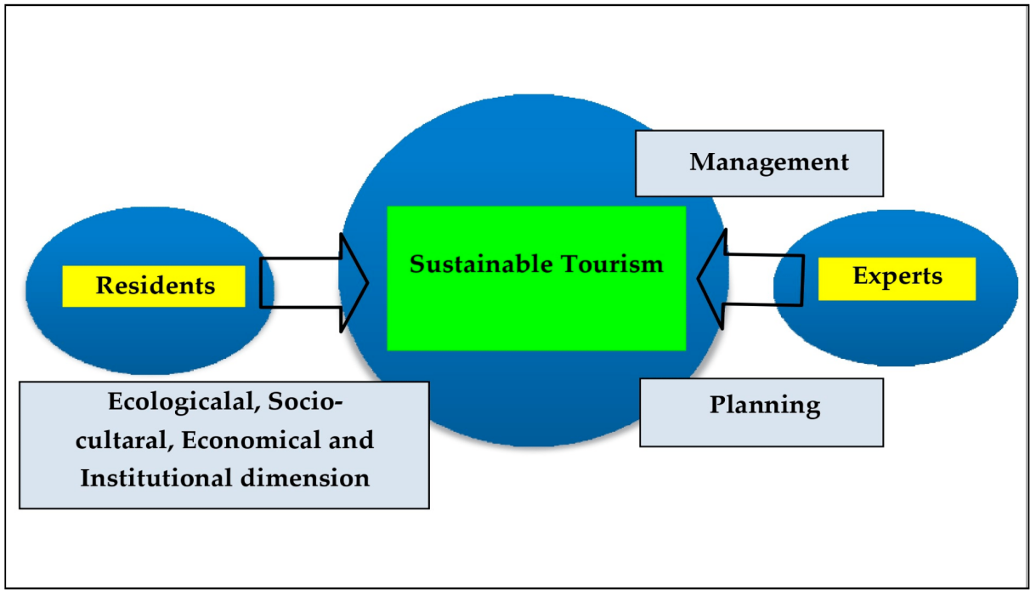
Figure 1: Sustainable Tourism Framework
(Source: www.mdpi.com)
Social sustainability
Although hotels help communities grow, the main goal of the hotel industry should be to bring about social change to ensure its long-term success. Hotels can be held responsible for doing good things for the community. Building relationships with local businesses and groups, as well as taking part in Corporate Social Responsibility (CSR) programs, are all ways that hotels can help improve society.
Support operations and strategy in hotels.
By using environmentally friendly technology, hotels can lower their costs, leave less of an impact on the environment, and help people (Floričić, 2020). As an example, making a hotel more energy efficient can cut costs and energy use while also showing a commitment to sustainability and attracting guests who care about the environment. There is also a link between how well hotels take care of the environment and their economic and social strengths.
Hotels can improve their business, cut costs, and help the environment by using sustainable practices. In this way, it helps businesses make more money, boosts sales, and builds customer loyalty. Hotels should interact with communities, encourage giving back to the community, and promote diversity and acceptance while also improving the health of the community. Being able to build strong brand trust and relationships with customers will also have a positive effect on society and make living conditions better in the area (Ng, and Tavitiyaman, 2020). As hotel companies look for ways to cut costs, get involved in the community, and have less of an effect on the environment, the sustainability trend has reached its peak.

Impacts of Sustainability Practices with Positive and Negative Impacts

Positive Impacts
Cost Savings
Hotel chains could save a lot of money over time by using environmentally friendly methods. Hotels also use a lot of energy, and efforts to make them more energy efficient will have long-term benefits for the economy. Putting in lights, heaters, air conditioners, and appliances that use less energy will save one a lot of money on utility bills. Smart management of energy also influences making things more efficient. Using low-flow faucets, showers, and toilets is one way to save water. This will lower water bills and budget in the long run. Collecting rainwater can be used for irrigation, which reduces the need for fresh water. Communities can cut down on trash and recycle more, which will lower the amount of trash that needs to be sent away. Getting rid of food waste in landfills can be done by recycling all organic materials.
All of these environmentally friendly methods go straight into underground storage, which increases the amount of space available (Duric and Potočnik Topler, 2021). Lowering the costs of utilities like energy, water, and trash collection by a large amount saves people money every year. The extra money that hotel owners and managers can make from sustainability efforts can be very helpful for those who want to make money and add long-term value. The cost savings will help the hotel use less fuel and stay environmentally friendly.
Competitive Advantage
Sustainability has become an important factor in the hotel business. More and more green travelers are looking for places to stay that are good for the environment and society. Ecological certifications like LEED or BREEAM show that the hotel cares about the environment. This group of people also likes strong corporate social responsibility programs that focus on things like helping communities, giving back, fair labor practices, and including everyone. Long-term performance and property value aren't the only things that sustainable practices like the water conservation process improve. Buildings that use less energy have much lower operating costs (Leyva, and Parra, 2021). Compared to traditional hotels, modern heating, lighting, and air conditioning (HVAC) systems save a lot of money on utility costs. Strategies for saving water also cut utility costs by a large amount. Cutting down on waste also lowers the cost of transportation.
Hotels that are built in a way that doesn't harm the environment are very profitable, which makes them a good investment for owners and investors. When they are well built and make money, eco-friendly hotels are worth a lot more than regular hotels. Eco-friendly products can make more money after being stored for decades (Han, 2021). The trend is growing, with more green hotels and investors looking for high-performance homes. Higher-income and profits come from people living better, spending more, and homes going up in value. Differentiating hotel brands through presentation and a clear guarantee gives them an edge over their rivals when it comes to getting guests and investment money.
Reputation Enhancement
Hotels can benefit from trying to be more environmentally friendly. Installing renewable energy, cutting down on waste, and saving water are all environmentally friendly things that can be done to help the environment. Through community development programmer that help charities, events, and non-profits, the hotel can give back. Because of these environmental and social projects, hotels need to start being good corporate citizens when it comes to the environment. People who care about the environment are more likely to buy from brands that are committed to sustainability. Also, employees are proud to work for a company that is making the world a better place, and they see this as a sign that the company's values are being shared. The public also thinks that hotels that are more environmentally friendly are more socially conscious.
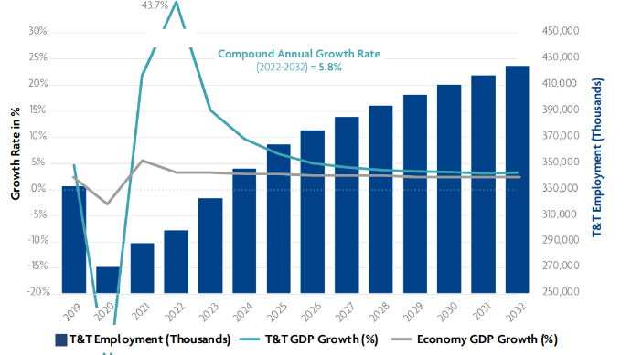
Figure 2: Growth and forecast of the travel and tourism industry in the UK.
(Source: www.hospitalityinsights.ehl.edu)
People looking for jobs think that a company's strong corporate social responsibility shows its culture, leadership, and honesty. Engagement makes workers happier, more loyal, and more likely to stay with the company. Current employees help hire new ones by telling their friends and family about the company's good reputation (Sáez-Fernández et al. 2020). Hotels can use their green credentials to set themselves apart now that sustainability is part of brand identity. Conservation, community, and social programs let customers, employees, and people who are interested in our industry know what our core values are. Hotels of the UK have worked hard to become a place where eco-friendly travelers want to go and where top talent looking for mission-critical jobs wants to work. Hotels look better overall when they follow sustainability rules (Olya et al. 2021). The hotel is a good corporate citizen because it cares about the environment and has strong social ties. A good reputation for doing the right thing brings in loyal customers and job seekers, which in turn gets customers interested and boosts employee pride.

Negative Impacts
High Upfront Costs
Hotels must make big investments up front to do things that are good for the environment, like using sustainable building design and reducing waste. It costs a lot of money to put up solar panels, replace old equipment with ones that use less energy, or make buildings greener to meet building codes. Some hotels, especially smaller, independent ones, may not be able to go green because of these high costs.
Inconvenience
Some steps to be more environmentally friendly make things harder for hotel guests and staff. To save water, programs that let one reuse towels and sheets may make guests less likely to expect clean linens every night. Additionally, features such as lighting that turns off automatically when the room is empty may bother both staff and guests.
Complex Coordination
Many parts of sustainable development show how big hotel chains hurt people (Abdou et al. 2020). Every place has its own set of social norms, laws, building restrictions, and environmental problems that need a coordinated response. It takes a lot of money, time, and work to make policies and programs that cover everything.

Theories and Models of Sustainability
Theories
Natural Resource-Based View (NRBV): The environmental resource-based approach (NRBV) is a way of thinking that says hospitality companies will have a competitive edge if they can get and use natural resources well. This includes being able to manage products, stop pollution, and keep growth going (Legrand et al. 2022). NRBV says that hotels that practice environmentally friendly practices can cut costs by making more money and attracting guests, employees, and investors with better style and popularity.
Model
Sustainable Tourism Eco-Certification (STEP): The STEP system is an environmental certification and sustainability management system made just for tourism and hospitality businesses. Hotels and other tourism businesses can use the STEP standards to help them with four main areas: sustainable management, social responsibility, cultural heritage, and environmental responsibility. Hotels could use STEP steps to reduce their effects, help local communities, safeguard culture and habitats, and get certified to show how dedicated they are. The STEP method gives hotels a full, step-by-step plan for becoming more environmentally friendly that covers all their management and operations.

Innovation and adaptation of the UK’s hotel industry
Great Britain's hotel and hospitality industry has come a long way in adopting rules and habits that will assist them in putting sustainability modules into action. The industry also focuses on quickly changing policies to lessen the effects of climate change and making good use of the resources that are available. In 2022, customers were the ones who made the decision to tax plastic packaging as part of these policies. A carbon footprint calculator was also made so that people could figure out how much carbon they were putting into the air (Floričić, 2020). Several multinational hotel chains knew how important it was to take eco-friendly steps that would help them lessen their impact on the environment. In addition, this would help them meet the needs of more tourists.
Energy efficiency
A lot of attention is paid to how efficiently hotels in the UK use the energy they have. Lighting and sensors that pick-up motion have been used by many hotel chains because they use less energy (Darvishmotevali et al. 2020). They also used smart building management systems to help them get the most out of the energy they used. When it comes to energy sources, a lot of hotel chains, like Marriott and Holiday Inn, have put up solar panels and started using biomass boilers. They would be able to use less fossil fuels if they adopted these technologies.
Water conservation
Another important thing that can be done to raise the level of sustainability is to save water resources and manage them more efficiently. Some of the ways hotels are trying to save water are installing low-flow showerheads and toilets with two flushes (Jiang, and Wen, 2020). They also started a system to reuse graywater. Some hotels have even put in rainwater collection systems to get water that isn't drinkable and use it for things like cleaning and watering plants.
Waste Management
The hotels in the UK is concerned because the problem of disease is still not clear. Most of trash are being generated from the hotels where they make it like food scraps and single-use plastics. The hotel industry of the UK in the year 2022 amounted almost 13.1 metric tonnes of solid food waste only (Jeswani, et al. 2021). In fact, they started a complete" waste management and recycling " project with this aim (Khan et al. 2020). Hence, food wastage should be turned into compost and the use of disposables such as plastics which are not reusable needs to be cut down. Additionally, the leading hotel chains were also very attentive about the ways digital technologies might be implemented so as to reduce the usage of paper a great deal. Hotels chains however, have also made useful changes and are now applying new technologies and business models (Sharma et al. 2020). In line with the need to become more environmentally friendly, some UK hotels implement vertical farming.

Implementation of Collaborative Partnerships
Hotels are now working in union with environmental groups, local communities, and government bodies to find, together with other establishments, the best ways of doing things, sharing information, and taking part in sustainable tourism related projects.
Even despite of these positive changes there still exist some challenges to address. Some hotels, especially the small ones with limited sources for carrying out such practices and more expensive ones to implement from, are not able to adopt environmentally friendly practices (Mousa, and Othman 2020). Not only hotels reduce the environmental impact by adopting sustainable technologies, but they also incorporate the local community and meet the tourism demand of the sustainable kind, thus creating a competitive and an eco-friendly consumer market.

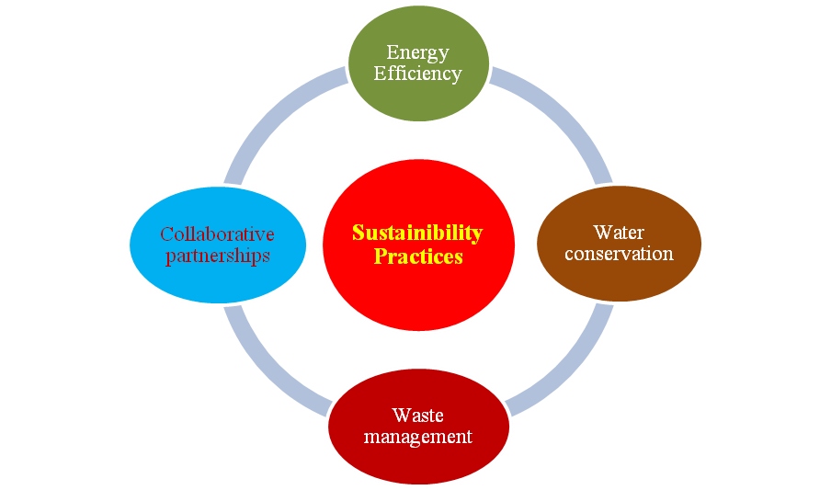
Figure 3: Sustainability Practices
(Source: Self-created in MS Word)

Future of sustainability in UK hotels
Due to the fact that the environmental issues and social responsibilities are attracting more consumers’ attentions, sustainability point of view became a popular topic in hotel management. In their attempts to protect the environment their carbon footprint is lowered, and there is the chance of saving money and following moral guidelines (Ibnou-Laaroussi et al. 2020).
The nature of the business will be likely to face long time change behaviour since it is due to the move to know more about sustainability. The corporate receptions in upcoming situations will increase, this is a positive outcome for the environment. The report by the association also reflects that the travel industry will continue to boost by 4.0 to 7.0 % per year in the future (Alzoubi et al. 2020). This rise is because customers want green options and there is more attention on corporate social responsibility. As more and more homes adopt green practices, it stands to reason that the organization will follow suit.
When talking about sustainability, don't forget how important rules and regulations are for how businesses run (Oláh et al. 2020). The UK's goal of having no fossil fuel byproducts by 2050 is one example of a government initiative that is encouraging hotels to adopt environmentally friendly practices. Because of limits on trash collection, energy use, and water use, hotels have had to rethink how they run their businesses. The English government is getting ready for hotels to be more eco-friendly by putting in place stricter rules and paying for eco-friendly practices. Professionals in the hotel business have said that long-term partnerships are very important. A lot of experts agree on one thing: sustainability needs to be taken seriously and environmental travelers’ problems need to be fixed.
In the long run, sustainability in UK hotels looks good because companies will switch to green and social practices (Rajbari et al. 2021). Hotels have the chance to lead the way in environmentally friendly travel thanks to higher costs for reception, legal and administrative consequences, help from experts in the field, and reviews of how important environmental responsibility is to recovery after a pandemic. By focusing on sustainability, UK hotels could not only have less of an impact on the environment, but they could also get more visitors who care about social issues. There are clear opportunities for sustainability in the lodging industry, with a lot of room for growth and progress.

Conclusion
Going green is what the hotel business is all about now, and hotels around the world are very aware of their social, economic, and environmental responsibilities. The change will cost a lot of money and hurt relationships in the community, but in the long run it will be good for the hotel, the neighborhood, and the environment. Sustainability encourages people to be creative and persistent, especially during tough times like pandemics, and it does so in a way that people like. Hotels can lead the hospitality industry toward a more sustainable future by making changes to their venues that focus on using less energy and getting involved in the community. Sustainability in hotels is now an important way to help communities, protect the environment, and ensure the long-term success of the industry in a global setting. When hotels in the 21st century become more eco-friendly, it could help their businesses, brands, and communities grow in many ways.

References
Pereira-Moliner, J., López-Gamero, M.D., Font, X., Molina-Azorín, J.F., Tarí, J.J. and Pertusa-Ortega, E.M., 2021. Sustainability, competitive advantages and performance in the hotel industry: A synergistic relationship. Journal of Tourism and Services, 12(23), pp.132-149.https://www.jots.cz/index.php/JoTS/article/download/282/112
Calisto, M.D.L., Umbelino, J., Gonçalves, A. and Viegas, C., 2021. Environmental sustainability strategies for smaller companies in the hotel industry: doing the right thing or doing things right?. Sustainability, 13(18), p.10380.https://www.mdpi.com/2071-1050/13/18/10380/pdf
Floričić, T., 2020. Sustainable solutions in the hospitality industry and competitiveness context of “green hotels”. Civil Engineering Journal, 6(6), pp.1104-1113.https://scholar.archive.org/work/7hl237oyurevnk4zlcm7w7ctfa/access/wayback/https://www.civilejournal.org/index.php/cej/article/download/2171/pdf
Ng, A.W. and Tavitiyaman, P., 2020. Corporate social responsibility and sustainability initiatives of multinational hotel corporations. International business, trade and institutional sustainability, pp.3-15.https://www.researchgate.net/profile/Usha-Iyer-Raniga/publication/336830965_Circularity_in_the_Built_Environment_A_Focus_on_India/links/60494477299bf1f5d83d8b80/Circularity-in-the-Built-Environment-A-Focus-on-India.pdf#page=17
Duric, Z. and Potočnik Topler, J., 2021. The role of performance and environmental sustainability indicators in hotel competitiveness. Sustainability, 13(12), p.6574.https://www.mdpi.com/2071-1050/13/12/6574/pdf
Leyva, E.S. and Parra, D.P., 2021. Environmental approach in the hotel industry: Riding the wave of change. Sustainable Futures, 3, p.100050.https://www.sciencedirect.com/science/article/pii/S2666188821000095
Sáez-Fernández, F.J., Jiménez-Hernández, I. and Ostos-Rey, M.D.S., 2020. Seasonality and efficiency of the hotel industry in the balearic Islands: Implications for Economic and Environmental Sustainability. Sustainability, 12(9), p.3506.https://www.mdpi.com/2071-1050/12/9/3506/pdf
Olya, H., Altinay, L., Farmaki, A., Kenebayeva, A. and Gursoy, D., 2021. Hotels’ sustainability practices and guests’ familiarity, attitudes and behaviours. Journal of Sustainable Tourism, 29(7), pp.1063-1081.https://eprints.whiterose.ac.uk/161790/1/Sustainability-Olya.pdf
Abdou, A.H., Hassan, T.H. and El Dief, M.M., 2020. A description of green hotel practices and their role in achieving sustainable development. Sustainability, 12(22), p.9624.https://www.mdpi.com/2071-1050/12/22/9624/pdf
Legrand, W., Chen, J.S. and Laeis, G.C., 2022. Sustainability in the hospitality industry: Principles of sustainable operations. Taylor & Francis.https://thuvienso.hoasen.edu.vn/bitstream/handle/123456789/8505/Contents.pdf?sequence=3&isAllowed=y
Darvishmotevali, M., Altinay, L. and Köseoglu, M.A., 2020. The link between environmental uncertainty, organizational agility, and organizational creativity in the hotel industry. International journal of hospitality management, 87, p.102499.https://www.academia.edu/download/62310400/Altinay7320200308-71936-1x1q6j.pdf
Han, H., 2021. Consumer behavior and environmental sustainability in tourism and hospitality: A review of theories, concepts, and latest research. Journal of Sustainable Tourism, 29(7), pp.1021-1042.https://www.tandfonline.com/doi/pdf/10.1080/09669582.2021.1903019
Jiang, Y. and Wen, J., 2020. Effects of COVID-19 on hotel marketing and management: a perspective article. International journal of contemporary hospitality management, 32(8), pp.2563-2573.https://methodorecherche.com/wp-content/uploads/2022/05/Example-of-perspective-article.pdf
Sharma, T., Chen, J. and Liu, W.Y., 2020. Eco-innovation in hospitality research (1998-2018): a systematic review. International Journal of Contemporary Hospitality Management, 32(2), pp.913-933.https://www.researchgate.net/profile/Tanmay-Sharma-9/publication/338964528_Eco-innovation_in_hospitality_research_1998-2018_a_systematic_review/links/5f0e525fa6fdcc3ed7080a97/Eco-innovation-in-hospitality-research-1998-2018-a-systematic-review.pdf
Ibnou-Laaroussi, S., Rjoub, H. and Wong, W.K., 2020. Sustainability of green tourism among international tourists and its influence on the achievement of green environment: Evidence from North Cyprus. Sustainability, 12(14), p.5698.https://www.mdpi.com/2071-1050/12/14/5698/pdf
Batool, F., Mohammad, J., Awang, S.R. and Ahmad, T., 2022. The effect of knowledge sharing and systems thinking on organizational sustainability: the mediating role of creativity. Journal of Knowledge Management, 27(5), pp.1251-1278.https://www.researchgate.net/profile/Fatima-Batool-27/publication/362162157_The_effect_of_knowledge_sharing_and_systems_thinking_on_organizational_sustainability_the_mediating_role_of_creativity/links/645ba2ac2edb8e5f094db4ea/The-effect-of-knowledge-sharing-and-systems-thinking-on-organizational-sustainability-the-mediating-role-of-creativity.pdf
Mousa, S.K. and Othman, M., 2020. The impact of green human resource management practices on sustainable performance in healthcare organisations: A conceptual framework. Journal of cleaner production, 243, p.118595.https://www.academia.edu/download/96100283/j.jclepro.2019.11859520221220-1-5g9mfy.pdf
Oláh, J., Aburumman, N., Popp, J., Khan, M.A., Haddad, H. and Kitukutha, N., 2020. Impact of Industry 4.0 on environmental sustainability. Sustainability, 12(11), p.4674.https://www.mdpi.com/2071-1050/12/11/4674/pdf
Ranjbari, M., Esfandabadi, Z.S., Zanetti, M.C., Scagnelli, S.D., Siebers, P.O., Aghbashlo, M., Peng, W., Quatraro, F. and Tabatabaei, M., 2021. Three pillars of sustainability in the wake of COVID-19: A systematic review and future research agenda for sustainable development. Journal of Cleaner Production, 297, p.126660.https://www.ncbi.nlm.nih.gov/pmc/articles/PMC8580193/
Alzoubi, H., Ahmed, G., Al-Gasaymeh, A. and Kurdi, B., 2020. Empirical study on sustainable supply chain strategies and its impact on competitive priorities: The mediating role of supply chain collaboration. Management Science Letters, 10(3), pp.703-708.http://m.growingscience.com/msl/Vol10/msl_2019_260.pdf
Khan, S.A.R., Zhang, Y., Kumar, A., Zavadskas, E. and Streimikiene, D., 2020. Measuring the impact of renewable energy, public health expenditure, logistics, and environmental performance on sustainable economic growth. Sustainable development, 28(4), pp.833-843.https://epublications.vu.lt/object/elaba:67353143/67353143.pdf
Eid, R. and Agag, G., 2020. Determinants of innovative behavior in the hotel industry: a cross-cultural study. International Journal of Hospitality Management, 91, p.102642.https://irep.ntu.ac.uk/id/eprint/40431/1/1351869_a839_Agag.pdf
Sharma, A., Shin, H., Santa-María, M.J. and Nicolau, J.L., 2021. Hotels' COVID-19 innovation and performance. Annals of Tourism Research, 88, p.103180.https://www.ncbi.nlm.nih.gov/pmc/articles/PMC9754958/
Williams, A.M., Rodriguez Sanchez, I. and Škokić, V., 2021. Innovation, risk, and uncertainty: A study of tourism entrepreneurs. Journal of Travel Research, 60(2), pp.293-311.https://openresearch.surrey.ac.uk/esploro/fulltext/journalArticle/Innovation-risk-and-uncertainty-a-study/99515027002346?repId=12139685670002346&mId=13140591840002346&institution=44SUR_INST
Hussain, I., Mu, S., Mohiuddin, M., Danish, R.Q., and Sair, S.A., 2020. Effects of sustainable brand equity and marketing innovation on market performance in the hospitality industry: Mediating effects of sustainable competitive advantage. Sustainability, 12(7), p.2939.https://www.mdpi.com/2071-1050/12/7/2939/pdf
Donate, M.J., González-Mohíno, M., Appio, F.P. and Bernhard, F., 2022. Dealing with knowledge hiding to improve innovation capabilities in the hotel industry: the unconventional role of knowledge-oriented leadership. Journal of Business Research, 144, pp.572-586.https://www.sciencedirect.com/science/article/pii/S0148296322001114
Floričić, T., 2020. Sustainable solutions in the hospitality industry and competitiveness context of “green hotels”. Civil Engineering Journal, 6(6), pp.1104-1113. https://scholar.archive.org/work/7hl237oyurevnk4zlcm7w7ctfa/access/wayback/https://www.civilejournal.org/index.php/cej/article/download/2171/pdf
Jeswani, H.K., Figueroa-Torres, G. and Azapagic, A., 2021. The extent of food waste generation in the UK and its environmental impacts. Sustainable Production and Consumption, 26, pp.532-547. https://www.sciencedirect.com/science/article/pii/S2352550920314202
Websites
Mdpi.com, 2023. Sustainable Tourism in Protected Areas—Application of the Prism of Sustainability Model [Available at: https://www.mdpi.com/2071-1050/15/6/5148 Accessed on: 10.02.2024]
Ehl.edu, 2023. What is the Hospitality Industry? [Available at: https://hospitalityinsights.ehl.edu/hospitality-industry Accessed on: 10.02.2024]

