Andrew Chick 1909134
Evaluating the Effectiveness of Chosen Maintenance Strategies for Dedicated Equipment
Lecturer: Andrew Thorn
Module: Plant and Asset Engineering
Programme: BEng Advanced Manufacturing Operations



Contents
1. Introduction 3
2. The Equipment Chosen 4
3. Current Maintenance Practices 5
3.1 Current Reactive Maintenance 5
3.2 Advantages of the Current Reactive Maintenance 8
3.3 Disadvantages of the Current Reactive Maintenance 8
3.4 Current Preventative Maintenance Practices. 10
3.5 Advantages of the Current Preventative Maintenance Practices. 12
3.6 Disadvantages of the Current Preventative Maintenance Practices. 12
3.7 Current Predictive Maintenance Practices. 13
3.8 Current Reliability-Centred Maintenance Practices. 13
4. Recommendations for Improvements. 14
5. Recommendations on managing change 15
References 17

List of Figures and Tables
Figure 1 – Mazak i100ST CNC Machine 4
Figure 4 - SAP Maintenance Request 6
Figure 5 - Equipment Reliability Board 6
Figure 6 - Pages 1 and 2 of Job Notification 7
Figure 7 – SAP Data Example 7
Figure 8 - 5 Why root cause example 9
Figure 9 - SAP data represented in Graph Form 9
Figure 10 -Human error guidance (HSE) 10
Figure 11 – 6 Monthly PM for Mazak 11
Figure 12 - 12 Monthly PM for Mazak 11

Table 1 - Maintenance Strategies including Pro's and Con's 3
Table 2 - ISO Requirement Summary 5
Table 3 - 0 - 6 Month Recommendations 14
Table 4 - 6 - 12 Month Recommendations 14
Table 5 - 1 - 3 Year Recommendations 15

1. Introduction

Zimmer Biomet is a global company that was founded in Warsaw in 1927. It operates in over 25 countries and sells products in over 100 countries worldwide. The company designs, manufactures, and markets musculoskeletal technologies to help improve patient mobility, pain relief, and overall quality of life.
Zimmer Biomet's maintenance procedures are essential to guaranteeing the equipment's reliability and lifespan. Four different maintenance strategies are shown in Table 1 along with their pros and cons. (Kelly, 2006) (Mobley, 2002) Additionally, there are basic standards in the medical device industry that must be met. Equipment failures can be avoided, downtime can be decreased, and productivity can be increased with proper maintenance. However, the complexity, age, and condition of the equipment, as well as other factors, affect how successful maintenance procedures are. We will analyse the current maintenance procedures used at Zimmer Biomet, Bridgend, in this critical study. The review will begin by briefly describing the functions and operation of the equipment. The study will also assess the advantages and disadvantages of the existing maintenance procedures as well as the justifications for the decision to employ this strategy in the past. In addition, a review of how the current maintenance strategy could be improved by taking into account other approaches that could be used in future maintenance strategies will be conducted. Finally, based on the report's results, conclusions and suggestions for the short, medium, and long terms. will be made (Wenbin, 2017)
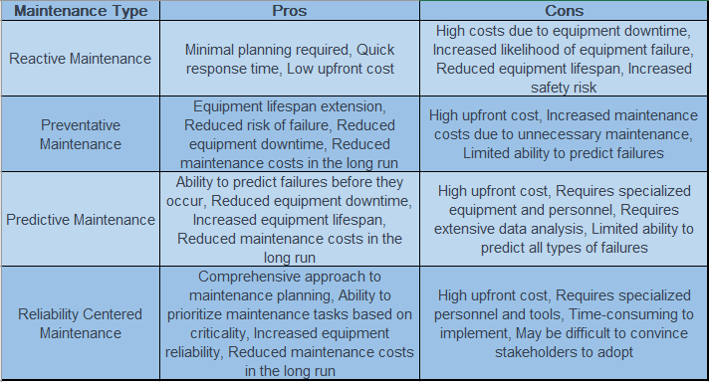
Table 1 - Maintenance Strategies including Pro's and Con's

2. The Equipment Chosen

The Mazak i100ST 5-axis CNC machine, illustrated in Figure 2, is a sophisticated piece of equipment used in the manufacturing industry to produce complex and precision parts. This machine has five axis of movement, allowing for the production of parts with intricate shapes and angles. It uses computer numerical control (CNC) technology to precisely control the machine's movements and produce high-quality parts with consistency and accuracy. The Primary functions of this equipment include speed and output of product, the secondary functions include safeguarding the user, and efficiency. (Thorn, 2023) The i100ST model is also designed to be compact, making it ideal for small to medium-sized manufacturing operations. (Mazak, 2022)
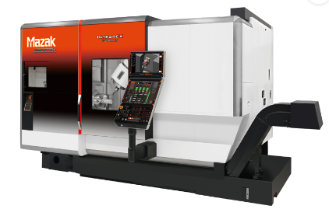
Figure 1 – Mazak i100ST CNC Machine

Medical device manufacturers must comply with several regulations related to maintenance of computer numerical control (CNC) equipment used in their operations. (ISO, 2016) These regulations are created to reduce the likelihood of equipment failure or malfunction during production and to guarantee the safety and effectiveness of medical devices. The required standard is ISO 13485, an international standard which specifies standards for a quality management system for medical devices, including those for equipment calibration and maintenance. The requirements for maintaining the equipment selected are shown in Table 2. Another law that requires compliance is the 1974 Health and Safety at Work etc. Act. (Legistlation.Gov, 1974)

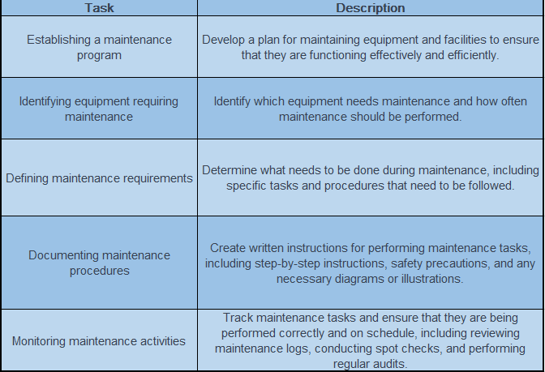
Table 2 - ISO Requirement Summary

3. Current Maintenance Practices

3.1 Current Reactive Maintenance
The Zimmer Biomet Bridgend Maintenance Department is open twenty-four hours a day. Reactive Maintenance is the responsibility of the personnel on shift. This kind of maintenance is a response approach that entails fixing broken equipment. When there is no other choice and the equipment or system cannot continue to operate without repairs, reactive maintenance is normally carried out. Finding the root cause is one of reactive maintenance's most important components. This may assist in avoiding a recurrence of the same problem in the future. Its foundation is the idea that fixing equipment after it has broken is less expensive than doing routine maintenance. this kind of maintenance might shorten equipment lifespan and cause downtime for the equipment. (John D. Campbell, 2015)
A request is issued to start the reactive maintenance procedure within the SAP system. This request includes breakdown detail outlining the problem. Figure 4 depicts an example of such a request.
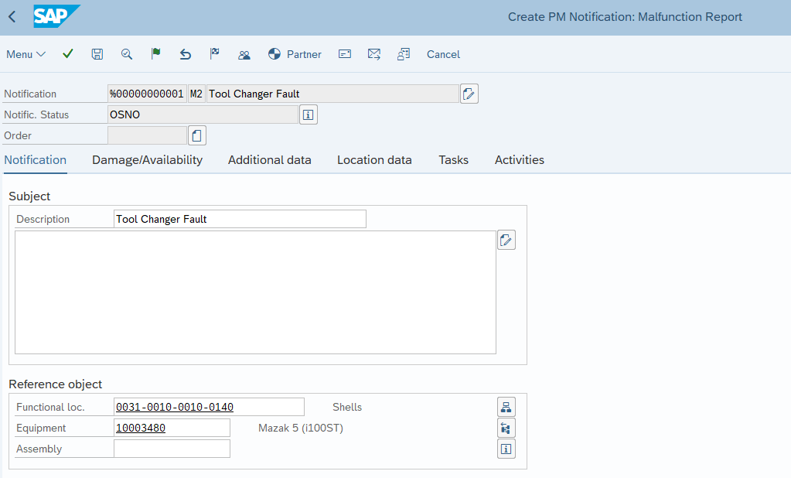
Figure 2 - SAP Maintenance Request

Upon generation of the SAP request, a Maintenance job is dispatched to the printer and subsequently posted on the Equipment Availability board, in accordance with its priority level, by the Supervisory Team. The job board is visually represented in Figure 5, while an example of a job notification is illustrated across pages 1 and 2 in Figure 6. It is noteworthy that, throughout the course of the year 2022, the aggregate number of Breakdowns on the Mazaks was recorded as 126, which is presented in Figure 7. However, it should be noted that significant inconsistencies were identified in the data entries with regards to malfunction failures. Following the completion of the Job Notification Form, the detail is placed in to SAP.
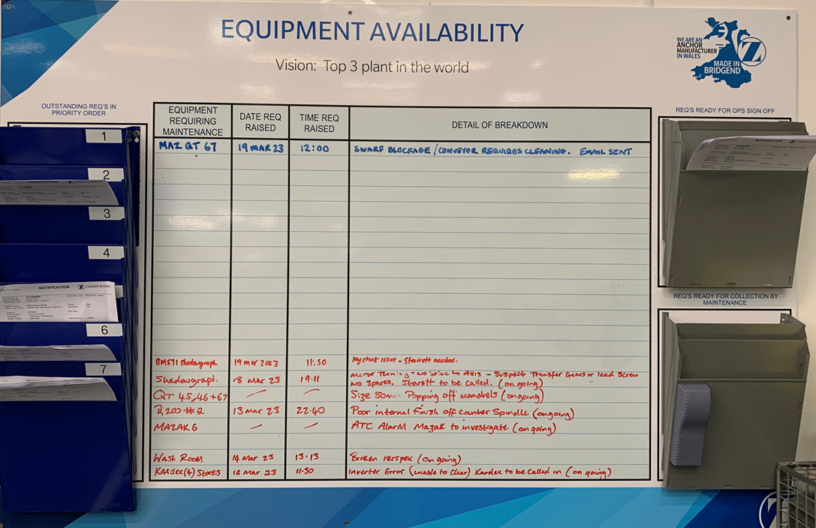
Figure 3 - Equipment Reliability Board

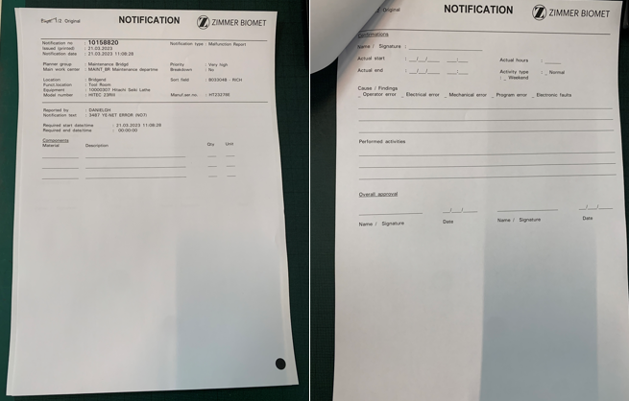
Figure 4 - Pages 1 and 2 of Job Notification

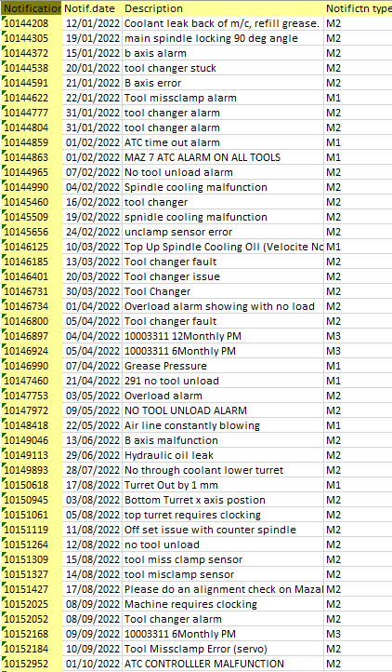
Figure 5 – SAP Data Example

3.2 Advantages of the Current Reactive Maintenance
The visual element offered by the Maintenance Breakdown board is one of the benefits of the present reactive maintenance procedure. Because everyone on the team can see the status of each breakdown, effective communication and teamwork are made possible. In addition, the job notification in Figure 6 requests the breakdown's root cause, which is essential for avoiding similar problems in the future. Real-time job creation by the SAP system also guarantees prompt resolution of maintenance-related difficulties. Historical data can be displayed via the SAP system, which is excellent for analysis.

3.3 Disadvantages of the Current Reactive Maintenance
The current reactive maintenance process is not without its drawbacks. Despite the stated requirement for identifying the root cause of equipment breakdowns in job notifications, this crucial information is not reviewed by the Maintenance Manager, nor is it entered into the SAP system for analysis, a root-cause tool would also be beneficial within the form, Figure 8 is an example of 5 why root cause. (Lab, 2023) As a result, the valuable data is rendered non-value adding. Additionally, the Maintenance Department is burdened with an excessive inventory of spare parts for the Mazaki100ST, taking up significant space and incurring high costs for the business, some of which may be obsolete or are not critical spares. Furthermore, the SAP data presented in Figure 4 lacks the necessary feature to require the person entering data to select a standard comment for a breakdown, making it exceedingly difficult to scrutinize the data or create Pareto charts of breakdowns. Whilst the data is so inconsistent, predicting mean time to failure will be extremely difficult. Figure 9 shows how the data would be presented, there’s simply too many different malfunction descriptions. It must be noted that all failures may not be a machine failure, it could be design or human error, for example, for this reason some simple tick boxes would also be beneficial to categorise the failure modes. (Thorn, 2023). It must be noted that human error is to be carefully managed and guidance can be found on how to manage human error effectively at HSE.gov.uk, a summary can be found in Figure 10. (HSE, 2023)

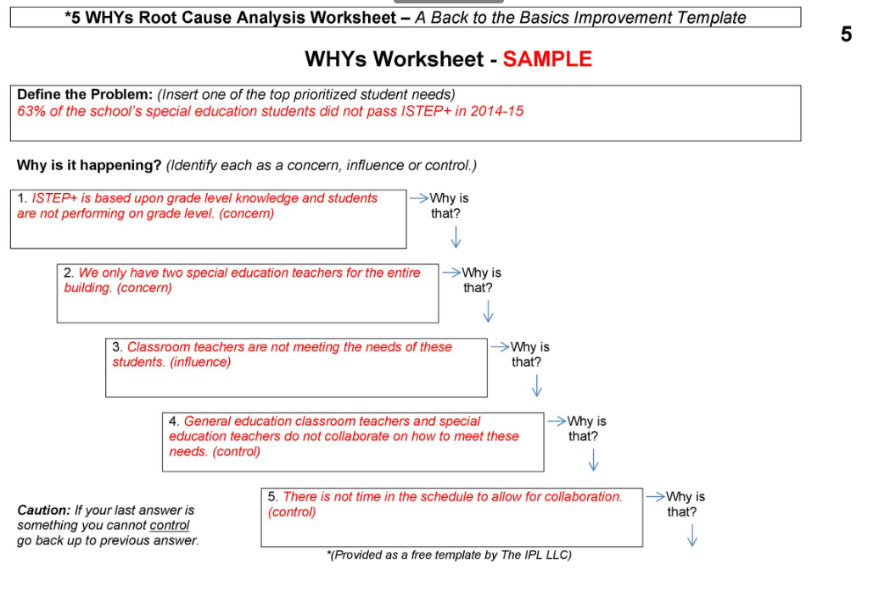
Figure 6 - 5 Why root cause example

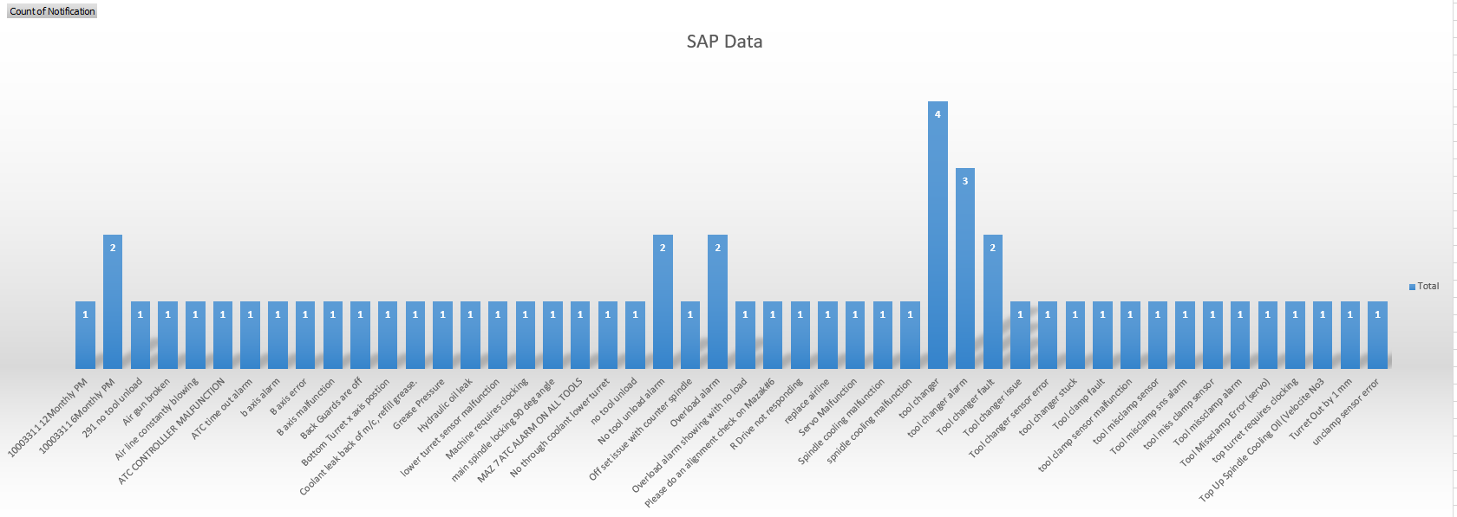
Figure 7 - SAP data represented in Graph Form

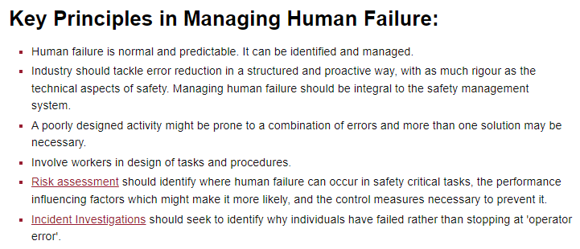
Figure 8 -Human error guidance (HSE)

3.4 Current Preventative Maintenance Practices.
In order to prevent breakdowns, extend equipment lifespan, and minimise unscheduled downtime, preventive maintenance (PM) involves periodic equipment inspections, repairs, and replacements. A lot of businesses, including manufacturing, use PM.. (Gross, 2002)
Preventive maintenance's major objective is to spot possible equipment breakdowns and fix them before they happen. This is accomplished by performing routine inspections, repairing damaged parts, lubricating moving parts, cleaning machinery, and carrying out other procedures to keep the machinery in good working order.
Preventive maintenance can minimise the need for expensive repairs and replacements, which contributes to lowering overall maintenance costs. Technicians can prevent major problems from developing that could lead to equipment failure and production disruption by completing routine maintenance tasks.. (Mobley, 2002)
The PMs at Zimmer Biomet Bridgend are run by SMEs, in this case Mazak. The planned maintenance tasks for the Mazak i100STs are divided into two categories: six-monthly and twelve-monthly.
Figure 8 presents an illustration of the six monthly tasks that Mazak advises to complete, the 12 Monthly Tasks are illustrated in Figure 9; these are also recommended by Mazak.
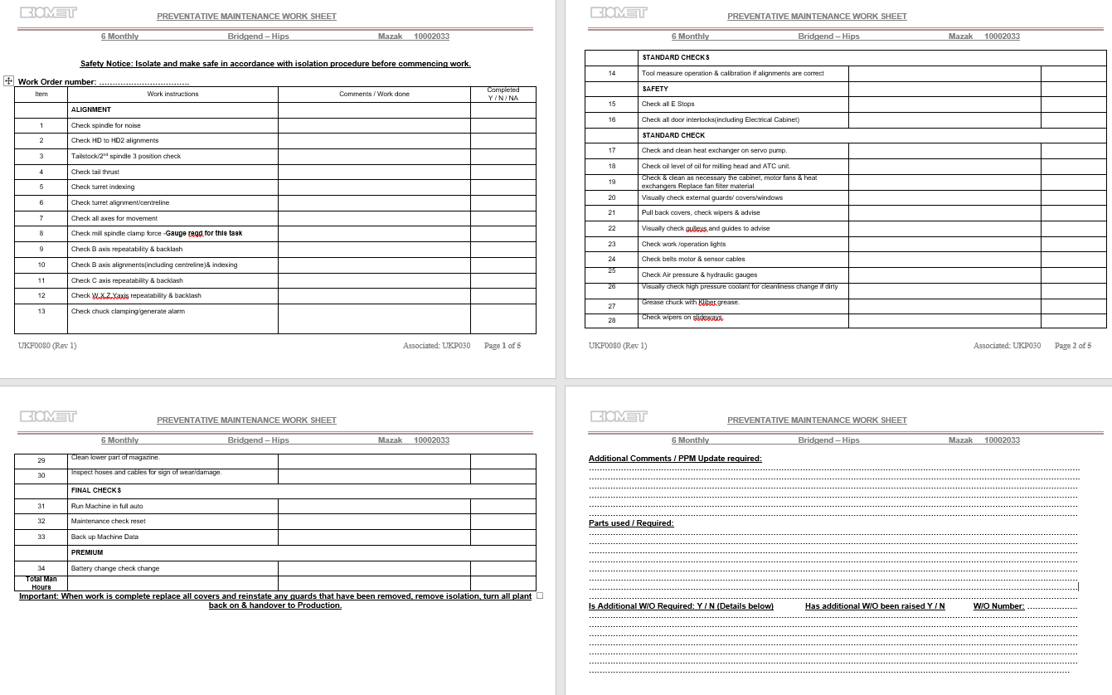
Figure 9 – 6 Monthly PM for Mazak

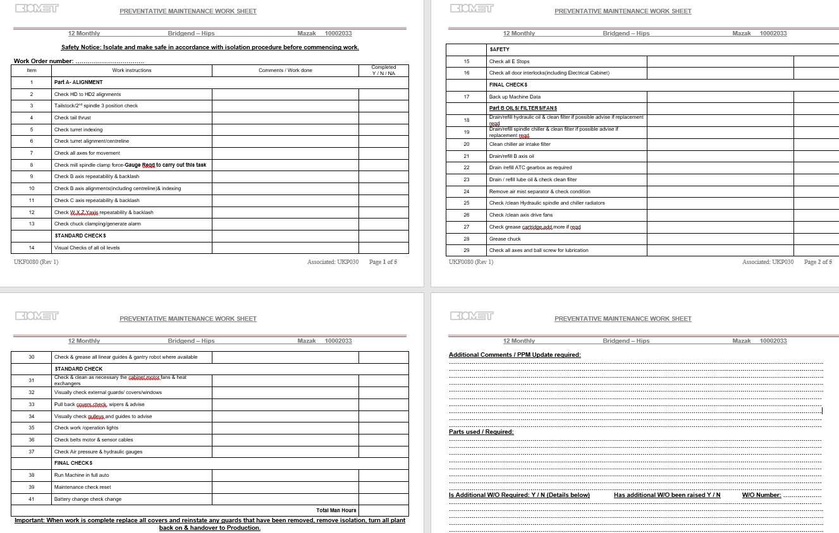
Figure 10 - 12 Monthly PM for Mazak
The 12 Monthly Task are more invasive than the previous 6 Monthly, this will look more in depth for ball screw failures, spindles failures as well as many other components.

3.5 Advantages of the Current Preventative Maintenance Practices.
The implementation of Planned Maintenance Tasks (PMTs) in the operation of Computer Numerical Control (CNC) machines is crucial for their optimal performance and longevity. In this regard, it is noteworthy that all the PMTs in place have been duly recommended and executed by the manufacturer of the CNC machine. Such adherence to the manufacturer's guidelines and recommendations reflects an acceptable level of planned maintenance in the context of CNC machines.
Additionally, the files produced by these PMTs are carefully maintained as evidence. By following the International Organization for Standardization (ISO) standards, this practise guarantees that the necessary paperwork is in place to verify the adherence to advised maintenance procedures.
The use of routine PMTs at predetermined intervals is also known to increase the equipment's lifespan while reducing the danger of failure. The CNC machine is more likely to run properly and with less downtime if these activities are completed promptly and consistently. As a result, using these PMTs has advantages that go beyond simply ensuring regulatory compliance and help the equipment work at its best.

3.6 Disadvantages of the Current Preventative Maintenance Practices.
The forms shown in Figures 8 and 9 show that they are appropriate for the task at hand. It is important to note that these forms do not contain any prompts or reminders asking Technicians to confirm whether any necessary work has been done prior to unforeseen downtime events. This oversight could potentially result in repeated work, which would cost the company more money. An example of this can be seen in Figure 12; a full coolant change is to be conducted on the 12 month PM, as a medical device manufacturer, coolant in any machine has set parameters, in Zimmer Biomet Bridgend it cannot be any higher than a concentration of 10. In this instance, the coolant could have been emptied and refilled only days before the PM, and then changed again during it. Not only would this be costly, but damaging for the environment, which Engineers have duty to protect. (Hersh, 2000)
Additionally, there are no daily Total Productive Maintenance (TPM) tasks allocated to the Technicians or machine operators for Mazak Computer Numerical Control (CNC) equipment. In order to keep the equipment in top working condition, it would be good to involve the machine operators in TPM activities given that they are present on the shop floor throughout working hours. They have a wealth of knowledge that could be wasted.

3.7 Current Predictive Maintenance Practices.
For CNC machines, predictive maintenance is becoming more and more crucial since it enables operators to foresee potential problems and treat them before they result in substantial downtime or equipment damage. For CNC machines, a good predictive maintenance approach can be implemented using various essential technologies, such as:
Condition monitoring sensors: These sensors can be mounted on CNC machines to track critical performance indicators including vibration, temperature, and oil pressure. Operators can prevent damage or downtime by proactively preventing early indicators of equipment breakdown by analysing this data in real-time.
Machine learning algorithms: On historical data from CNC machines, machine learning algorithms can be trained to find trends and forecast when equipment is likely to break down. These algorithms can be used to provide automated maintenance requests or alerts, assisting operators in anticipating possible issues.
Cloud-based monitoring platforms: Multiple CNC machines' real-time data can be collected and analysed using cloud-based monitoring solutions. Operators can develop a more thorough picture of the condition of their equipment and make better maintenance decisions by combining this data.
Zimmer Biomet Bridgend have not yet invested in such technology.

3.8 Current Reliability-Centred Maintenance Practices.
In order to maximise maintenance efforts and save maintenance costs, reliability-centred maintenance (RCM), an approach for maintaining equipment and systems. Identifying the functions and performance requirements of equipment and systems and prioritising maintenance tasks according to how they will affect safety, the environment, and output are some of the basic principles of RCM. According to John Moubray's book "Reliability-Centric Maintenance Second Edition," this is frequently accomplished through the use of decision trees and risk matrices. (Moubray, 1999) Besides, patterns of Failure are evaluated in RCM, they can be broken down in to three categories; Early Failures, Random cause failures and Wear out failures. (Thorn, 2023). Zimmer Biomet, Bridgend have not yet invested in Reliability-Centred Maintenance

4. Recommendations for Improvements.

Tables 3 - 5 provides a comprehensive breakdown of the recommendations in their entirety. They have been broken down in to short, medium and long term recommendations.
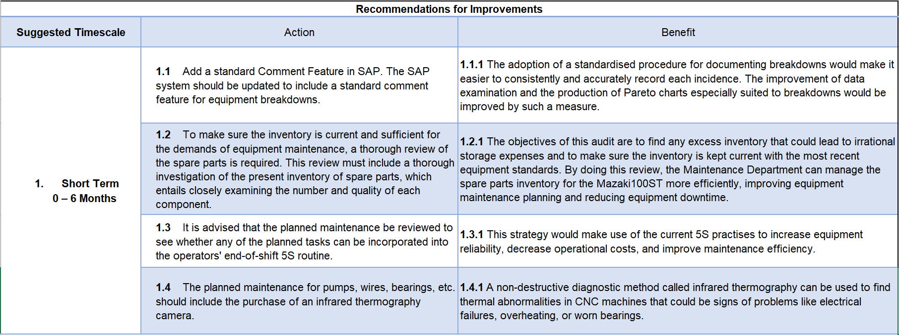
Table 3 - 0 - 6 Month Recommendations

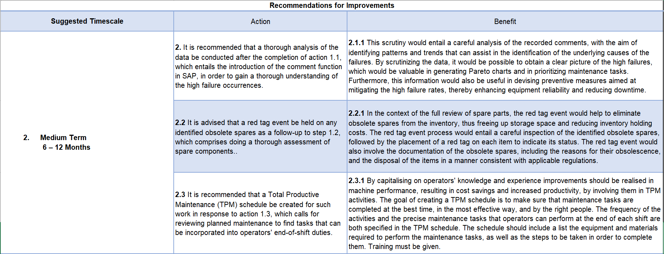
Table 4 - 6 - 12 Month Recommendations
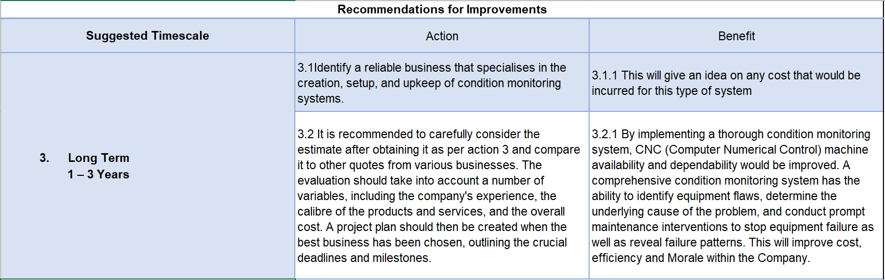
Table 5 - 1 - 3 Year Recommendations

5. Recommendations on managing change

Change in any company can lead to frustration and resentment between management and staff, therefore any implementation of change must be carefully thought out. The Lewin's Force Field Analysis is one approach to implementing change and could be an approach to consider.
Kurt Lewin was a highly respected psychologist who had a considerable impact on management during the 20th century. Despite having a background in psychology, Lewin's work on systems and group dynamics had a significant influence on modern management techniques. His force field analysis methodology is frequently used in management to spot resistance, get over it, and take use of motivating forces to accomplish objectives. Lewin's methodology for unfreezing and refreezing is still in use today. A change process, using the FFA, can be implemented by identifying change leaders, significant barriers, direction, and actions. Unfreezing, the actual change, and refreezing are the three stages of Lewin's three-phase method for implementing change. Finding the change's leader would be the first step towards unfreezing, after which the change may start. Resentment may start when the shift happens, but this transition can be facilitated by allocating enough resources, motivating the workforce, and delivering short-term rewards in the form of benefits. It is said that the change initiatives have been fully executed once the resistance to change has been overcome. At this point, the change agent may announce completion of the change and start the unfreezing procedure.
Even though this method may not be used, it is important to consider any change and how it may influence the workforce. Employee engagement will be crucial to the project's success.

References
Alsyouf, I., 2009. Maintenance practices in Swedish industries: Survey results. Int. J. Production Economics, 121(1), p. 222.
Bram de Jongea, P. A. S., 2020. A review on maintenance optimization. European Journal of Operational Research, 285(3), pp. 805-824.
Gross, J. M., 2002. Fundamentals of preventive maintenance. 1st ed. New York: McGraw-Hill.
Hersh, M., 2000. Environmental ethics for Engineers. Engineering Science and Education Journal, 9(1), pp. 13 - 16.
HSE, 2023. HSE.gov.uk. [Online]
Available at: https://www.hse.gov.uk/humanfactors/topics/humanfail.htm
[Accessed 25 March 2023].
ISO, 2016. ISO.org. [Online]
Available at: https://www.iso.org/obp/ui/#iso:std:iso:13485:ed-3:v1:en
[Accessed 27 Feb 2023].
John D. Campbell, J. V. R.-P., 2015. Uptime: Strategies for Excellence in Maintenance Management. 3rd ed. Beaverton: Ringgold Inc.
Kelly, A., 2006. Strategic Maintenance Planning. 1st ed. Burlington: Butterworth-Heinemann.
Lab, T., 2023. TemplateLab.com. [Online]
Available at: https://templatelab.com/root-cause-analysis/
[Accessed 25 March 2023].
Legistlation.Gov, 1974. Legistation.gov.uk. [Online]
Available at: https://www.legislation.gov.uk/ukpga/1974/37/contents
[Accessed 25 March 2023].
Mazak, 2022. Mazakeu.com. [Online]
Available at: https://www.mazakeu.com/integrex-ihseries/?_ga=2.262275791.2127263330.1679387541-484511397.1679387541&_gl=1*18urgpq*_ga*NDg0NTExMzk3LjE2NzkzODc1NDE.*_ga_ZF0DHYY48F*MTY3OTM4NzU0MS4xLjEuMTY3OTM4NzY4MC4wLjAuMA..
[Accessed 23 Feb 2023].
Mobley, R. K., 2002. An Introduction to Predictive Maintenance. Second ed. Knoxville: Butterworth-Heinemann.
Mobley, R. K., 2002. An Introduction to Predictive Maintenance. Second ed. Knoxville: Butterworth-Heinemann.
Moubray, J., 1999. Reliability-Centered Maintenance. 2nd ed. New York: Butterworth-Heinemann.
Thorn, A., 2023. Reliability-Centred Maintenance. Swansea: Andrew Thorn.
Wenbin, Z., 2017. Determination of the average maintenance time of CNC machine tools based on type II failure correlation. Eksploatacja i Niezawodnosc - Maintenance and Reliability, 19(15), pp. 604-614.
Yahya Mohammed Al-Naggara, N. J. M. F. H. a. A. R. Y., 2021. Condition monitoring based on IoT for predictive maintenance of CNC machines. Conference on Modeling of Machining Operations, 102(10), p. 316.

