
Problem Solving and Decision Making (BMSW4004_SWAN)
Component 2

March 25, 2022
Andrei selaru
2112461

Contents
1.0 Introduction 2
2.0 Main findings 3
2.1 SWOT analysis 3
2.2 PESTLE analysis 5
3.0 Conclusion 6
4.0 Recommendations 7
5.0 Monitoring, Reviewing and Communicating the Solution 8
6.0 Appendices 9
11
7.0 References 13

Introduction
This report aims to discuss one of the problems High Streets are facing right now naming the local identity crisis that communities are going through, who is affected by this problem and how are they affected. For this goal it will be carried a Nature, Scope, and Impact analysis to go into further details of the issue mentioned above. Also, a full SWOT and PESTLE analysis will be produced for a better overview of the issues High Streets are confronting. In this report will also be presented solutions to the issues once identified.
The nature of the crisis on High Streets is that local identity is fading due to accelerated trends caused by different factors such as Covid, retail parks, and online shopping. With more shops closing, local communities’ identity has been affected due to a lack of interaction and socializing Vidhya Alakeson (2020) mentioned that shops and restaurants are not the only features of high streets, they give a city, town, or neighbourhood its soul. Continuing by saying that we are fundamentally shaped by communities, which are the places where we meet and gather.
The scope of this problem High Streets are facing is affecting internal and external stakeholders. Stakeholders are parties that are interested in the affairs of a company and act on or are affected by them. An internal stakeholder is those with direct contact to High Street such as employees, employers, and owners while external stakeholders are considered to be anyone that has no direct affiliation with High Street but are affected by the decisions and actions within. In this category are included suppliers, investors, local economy, or property prices.
The impact of this issue discusses how are stakeholders affected by the identity crisis. Landlords are affected by being forced to sell their properties or rent them as offices rather than shops due to the low interest of small businesses to rent their properties. Communities are also affected by manifesting less interest in engaging in socializing in the town’s centre due to a lack of dignity and diversity in their urban environment. Andy Myring (2021) describes the town centre as very uncared, with streets looking so dull and scruffy. The identity crisis also affected individuals as they become more anxious being used to solitude and not valuing social interactions as much as they did before and that affects the local economy as people are not going out so often to spend money preferring house gathering.

Main findings

SWOT analysis
One of the main threats identified in the SWOT analysis that resulted in a local identity crisis among Highs Streets is with no doubt the growing trend of online shopping for customers. This trend become more popular in the last decade but suffered an important acceleration caused by Covid. Joe Ford (2020) remarks that the UK High Street is certainly struggling, but this is not news. As its footfall has steadily declined, and numerous brands went into administration, people have witnessed the decline of its business. Nevertheless, due to Covid, challenges for High Streets are becoming more pressing, and the impacts of digital are intensifying. He also mentioned that the rise of online retail has been very noticeable in recent years and almost all high street retailers have declined since today's consumers prefer digital over anything else. Why do consumers prefer online shopping? Because buyers are getting convenient options thanks to online marketplaces that build trust. Online shoppers became smarter. Before making a final purchase, they compare the products they are buying. There is also a mixture of online shoppers. While some buy frequently, others have the fear of buying products online too often (Prajapati, 2015). A few other reasons why people prefer online shopping are the benefits of crowd-free shopping, no purchase pressure, quick and discreet delivery, easy checkout, and clear information about the products.
Another threat of the identity crisis in local communities that is present in the SWOT analysis is the fast growth of the retail shopping parks. During the period 2017-2022, Global Data anticipated retail parks growth by 13.8%, outpacing the high street. With 90% of consumers saying they have shopped in a retail park within the last year, retail parks are increasingly favoured over high streets for their convenience and improving tenant mix. Global Data also found that 54.3% of surveyed customers visited retail parks at least once per month (Santamaria, 2017). The traditional focus of retail parks has been on household goods, DIY, and furniture stores. Over the past few years, however, 'softer' retailers like Boots and Next have moved in, as have banks like Metro Bank. At present, retail parks are not just a shopping area, people preferring retail parks because, with them, conveniences such as free parking can be obtained as well as leisure activities such as eating, watching a movie, or bowling. In addition to this variety of retailers, many of these shopping centres contain a supermarket on-site or within a close area (Holdens, 2013).
On a positive note, many experts say that high streets are not totally dead and in fact, the decline of high streets should be seen as an opportunity for local authorities to reinvent themselves and become even more prosperous than once ware. In an article by Forbes magazine, Grant Pawell (2022) mentioned that high streets are not dead and could be the birth of an independent sector that curates and cultivates new products, services, and goods. Continuing by saying that there is a great need for balance on the high street, with such a lot of chaos and change occurring around the world. Despite the fact that they look different, busy town centres can be revitalized with a well-planned mix of housing, modern office space, and varied hospitality and retail experiences. Shopping will no longer be the only purpose of the future high street. New spaces will be designed for communities that provide safety and social experiences through clear communication between communities, local authorities, and the private sector.
In Claire Hunt’s opinion (2021), the rebirth of the high street is in the hands of authorities and investors by allowing creative stakeholders to bring more diversity to the town’s centre as this is essential for communities’ well-being. She says that demolishing the buildings is not the solution and that the government is aware of this issue. In a positive way, the city shows an increasing awareness about how more green spaces in the public domain can reduce feelings of loneliness. The long-term benefits of investing in such spaces are sure to be significant.
To make high streets more appealing and resolve the identity crisis issue, a few conversion strategies has been produced as follows:
Engaging consumers in activities to combat retails parks - the high street needs to change to accommodate consumers who are now more interested in discovering experiences than things. Climbing centres and escape rooms are becoming increasingly popular and can foster a sense of community between people.
Advertise offline shopping - in order to get their products in front of customers, online-only stores can benefit from having a physical presence. "Showrooming", or the practice of interacting with goods before purchases before making a choice, has become more common as people look for peace of mind that anonymous reviews cannot provide.
Diversity in the workplace to prevent working from home - it is only logical that there are places designed for this. As the culture shifts to more flexible working, spaces are built to assist this. Smaller companies and solo operators can exchange ideas and feel at home in a shared office. Shared office spaces embrace a social, collaborative approach to employment making it more appealing (ABC Finance, 2019).
Green spaces to accommodate shopping - It cannot be overstated how beneficial green space can be to the retail experience. Including more green space in the traditional town center would enhance the shopping experience significantly.
A full SWOT analysis and conversions strategies can be found attached in the appendices.

2.2 PESTLE analysis
The main findings of the PESTLE analysis on high streets are as fallows bellow.
Political: British pound become weaker after UK leaving EU. Brexit is causing 53% of UK fashion retailers to cancel orders as a consequence of imports restrictions from the EU. As a result of Brexit, 98% of respondents report increased bureaucracy. With many retailers unable to fulfil their ‘’next day delivery’’ service (Nash, 2021).
Economic: Covid-19. In the past two years, high streets have been hit with a number of challenges, including forced temporary closures, travel restrictions, and social distancing guidelines caused by the pandemic. Many shops and restaurants in the high streets could not survive, closing permanently causing cities centres to look ghostly with deserted buildings.
Social: cultural differences. People believe that having diverse cultural spaces makes their local area a better place to live, according to a report by Arts Council England, A High Street Renaissance. When asked what their high street should have more of, culture was the second most popular answer after shops (Adams, 2021).
Technology: data breaches and cybercrimes. Retailers in the UK have embraced digitalization, following the global trend of improving customer experience and reducing costs by turning digitalization into consumer power but this came with the risk of cyber-attacks. Studies show that data breaches doubled in 2018 compared to the previous year (Consultancy.uk, 2019).
Legal: minimum wage increase. As a result of changes to the National Minimum Wage and National Living Wage, the Association of Convenience Stores has warned the government that it will put further pressure on high street businesses. The warning follows the announcement that the government had increased the National Living Wage by the "biggest increase ever" (Cambridge, 2020).
Environmental: ethical concerns among shoppers. The environmental aspect of high streets is an important factor to consider by shoppers with most of them appreciating more green spaces in their city’s centres. It is well known that an eco-environment helps mental and physical health.
Full PESTLE analysis can be found in the appendices.

3.0 Conclusion
As it can be seen in this report, there are many factors contributing to the identity problem that town centres are dealing with. Many communities have been affected by Brexit, Covid, inflation or the local decision of their authorities. Cert is that highs streets look different that it used to and while many consider it to be dead, others see this change as on opportunity to rebuild it and reinvent the traditional high street in a better version. The rebirth of high streets is a slow process but, as seen in the report, there are plenty of solutions to facilitate the recovery. Local authorities are already planning to make cities centres more appealing by creating more green spaces and outdoor activities. These efforts are supported by retails and restaurants by offering offline shopping discounts and in-store promotions, all of this in the hope of bringing people out to socialize and spend their money.

4.0 Recommendations
To aid high streets recover from decline and resolve the identity crisis created, a series of actions is needed, along with plans to be followed. As a first solutions, making streets greener is the most popular action to be taken according to the decision-making matrix. Creating more green spaces will help bringing shoppers in centres as these can be used as rest and socialising spaces.
Another solution is to make available more entertaining activities such as escape rooms and climbing walls as these are attractive and engaging for younger generation.
Shops can be offering discounts for in-store purchases. This will attract consumers to come to physical shops and spend money.
Bringing more cultural diversity to high streets is another solution as it creates a curiosity feeling and promotes non-racism.
The full decision-making matrix is attached in the appendices.

5.0 Monitoring, Reviewing, and Communicating the Solution

Decision implemented:

Creating more green spaces in high streets

Monitoring the decision:
Resources:
Local authorities and business owners will run a report every two weeks stating their income.
Shoppers will be invited for a survey every month to state their satisfaction rate

Key Indicators:
Numbers of consumers and businesses satisfactions
Share prices increasing

Targets:
Attract more people in cities centre by creating green spaces where they can rest and socialize using the SMART model.

Data Sources:
Data will be collected from stakeholders and will be available on an online private platform.

Reviewing the decision:
Does the solution have a clear vision?
Is the goal measurable?
Are there key indicators for each action that can be measured?
Has the plan been reviewed and approved by stakeholders?
How long it will take for the decision to be implemented?
Is the plan flexible in case of goals are not achieved?

Communicating the Decision:
Internal Stakeholders  Representatives such as managers will brief achievements and performances to their teams regularly as the plan is ongoing. | External Stakeholders  External stakeholders such as suppliers, creditors, or shareholders will be communicating updates and change through emails.

6.0 Appendices
SWOT ANALYSIS
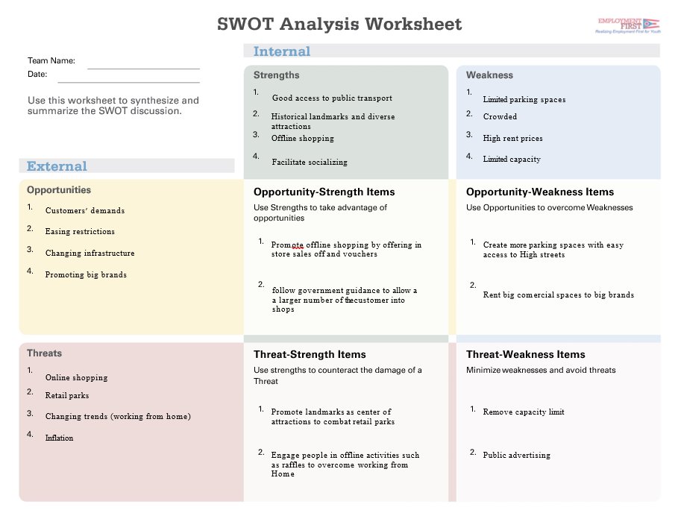

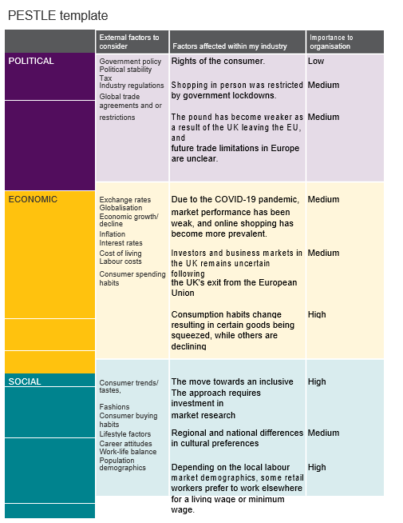
PESTLE ANALYSIS
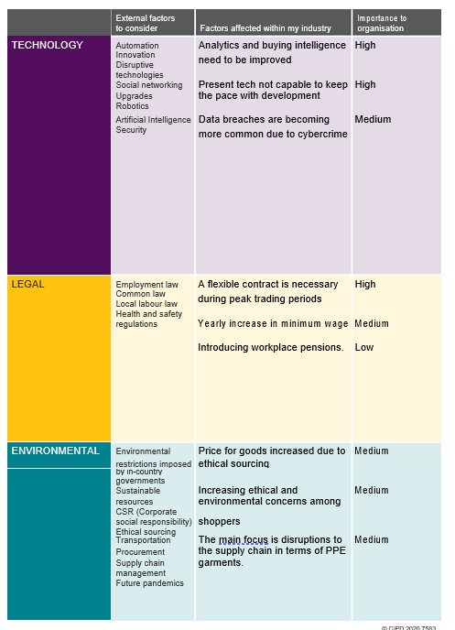

Decision-making matrix

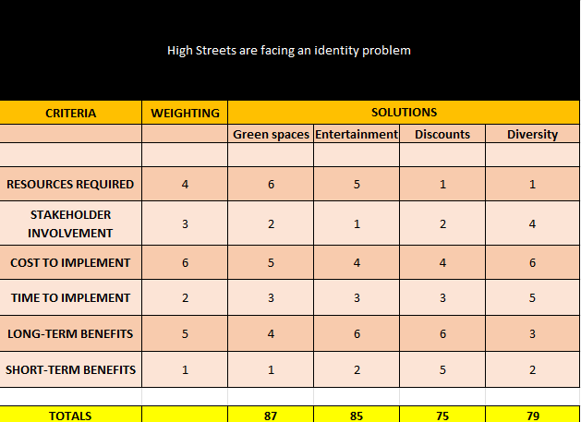

7.0 References
- ABC Finance (2019). ABC Finance Limited. [online] ABC Finance. Available at: https://abcfinance.co.uk/blog/the-future-of-uk-high-streets/ [Accessed 21 Mar. 2022
- Adams, G.K. (2021). Culture more in-demand than pubs on the high street. [online] Museums Association. Available at: https://www.museumsassociation.org/museums-journal/news/2021/08/culture-more-in-demand-than-pubs-on-the-high-street/# [Accessed 23 Mar. 2022]
- Cambridge, L. (2020). National minimum wage hikes will hit high street hard, warns the ACS. [online] The Grocer. Available at: https://www.thegrocer.co.uk/pay/national-minimum-wage-hikes-will-hit-high-street-hard-warns-the-acs/600642.article [Accessed 23 Mar. 2022]
- Consultancy.uk (2019). Cyber-security cost hits UK high street hard. [online] www.consultancy.uk. Available at: https://www.consultancy.uk/news/22044/cyber-security-cost-hits-uk-high-street-hard [Accessed 23 Mar. 2022]
- Ford, J. (2020). Decline and fall? The impact of digital on the UK high street. [online] New Digital Age. Available at: https://newdigitalage.co/retail/decline-and-fall-the-impact-of-digital-on-the-uk-high-street/ [Accessed 21 Mar. 2022].
- Holdens (2013). The High Street or Retail Park: Choosing the Best Retail Location. [online] Ratio Law. Available at: https://www.ratiolaw.co.uk/2013/07/the-high-street-or-retail-park-choosing-the-best-retail-location/#:~:text=Retail%20parks%20can%20offer%20convenience [Accessed 21 Mar. 2022].
- Myring, A. (2021). The role of community in mobilizing and reviving the high street. [online] The Drum. Available at: https://www.thedrum.com/opinion/2021/08/17/the-role-community-mobilizing-and-reviving-the-high-street [Accessed 18 March 2022]
- Nash, E.L. (2021). Was Brexit the Nail in the Coffin for the UK High Street? - RETHINK. [online] RETHINK Retail. Available at: https://www.rethink.industries/article/was-brexit-the-nail-in-the-coffin-for-the-uk-high-street/ [Accessed 23 Mar. 2022
- Powell, G. (2022). Reimagining The Future Of The High Street. [online] Forbes. Available at: https://www.forbes.com/sites/grantpowell/2021/02/26/reimagining-the-future-of-the-high-street/?sh=2a35b53274dc [Accessed 21 Mar. 2022].
- Prajapati, V. (2015). Why Do People Shop Online? - Top 7 Reasons. [online] TechPrevue. Available at: https://www.techprevue.com/reasons-prefer-online-shopping/ [Accessed 21 Mar. 2022]
- Santamaria, B. (2017). UK retail parks market set to outperform high streets over next five years. [online] Fashion Network. Available at: https://uk.fashionnetwork.com/news/Uk-retail-parks-market-set-to-outperform-high-streets-over-next-five-years,830466.html [Accessed 21 Mar. 2022]
- Vidhya Alakeson (2020). A community-led vision for our high streets - Power to Change. [online] power to change. Available at: https://www.powertochange.org.uk/news/community-led-vision-high-streets/ [Accessed 18 March 2022]

