Christopher B (2322626)

Abstract
Assignment covering the function of the given circuit and its replication, displaying hexadecimal characters, and a variety of programming task.
ACDA4004 – Micros, peripherals and interfaces

Contents
Table of figures 1
Introduction: 2
Section 1: 2
The given circuit: 2
The recreated circuit: 2
Section 2: 4
Conversion table: 5
Section 3: 7
Program 1: 7
Program 2: 11
Program 3: 13
Program 4: 16
Program 5: 20
Conclusion: 23
Bibliography 24

Table of figures
Figure 1: Original circuit to be reproduced. 2
Figure 2: Reproduced circuit in proteus 3
Figure 3: Shows which pins control each segment 4
Figure 4: This table shows the character values converted to binary and hex, with the buzzer being off. 7
Figure 5: flow chart for program 1 10
Figure 6: flow chart for program 2 13
Figure 7: flow chart for program 3 15
Figure 8: flow chart for program 4 19
Figure 9: flow chart for program 5 22

Introduction:
This report will cover 3 main sections. The first section will cover a given circuit, with a recreation of it and an explanation of each part of the circuit. The second section covers displaying 0-9, a-f on the seven segment display, using the pic microcontroller. It also covers converting from binary to hexadecimal. The third segment contains code for completing the given tasks, including a flow chart for each program.

Section 1:

The given circuit:
The figure(1) below shows the original circuit that was to be produced in proteus.
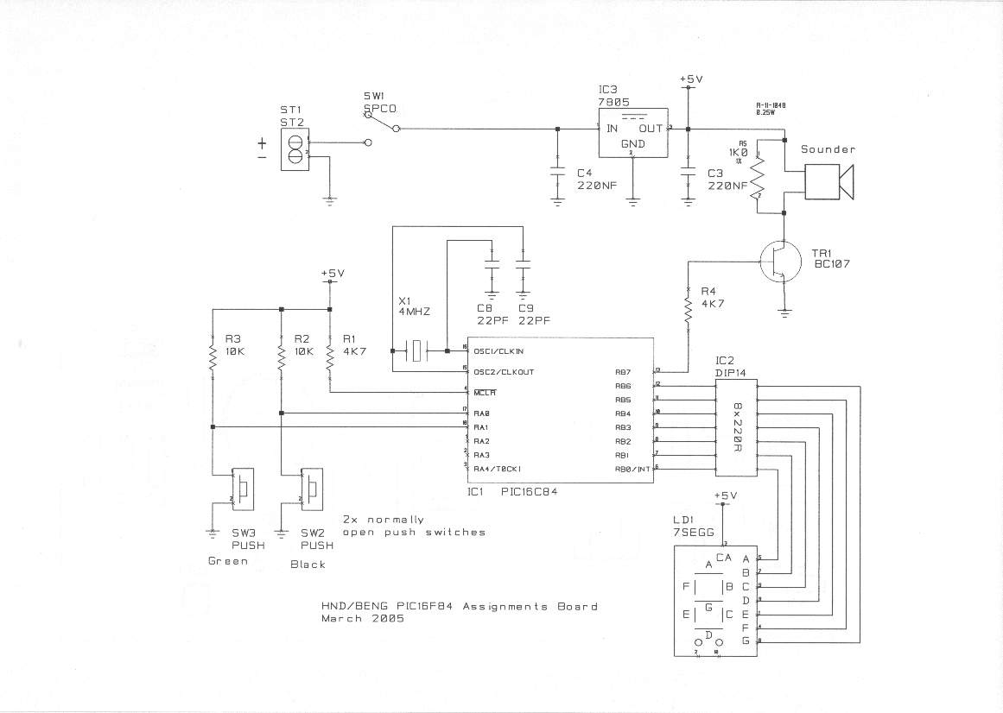
Figure 1: Original circuit to be reproduced.

The recreated circuit:

The circuit can be reproduced in proteus, and is shown in figure 2 below. All parts of the circuit have been reproduced , however, IC3, C3,C4, and SW1 are not used in the proteus simulation. The reason this was not needed was because it is part of a voltage regulation circuit, used to produce a clean 5V DC output. The IC3 7805 chip is used to regulate the supply voltage [1] to 5V, C3 is used to filter out ripples or instability in the input waveform, and C4 is used to filter out noise and ripples produced by the voltage regulator. The input capacitor is also used to protect the 7805 device from transient voltages [1]. This was not necessary to reproduce in proteus, as a 5V supply can be selected and used in proteus without any regulation.
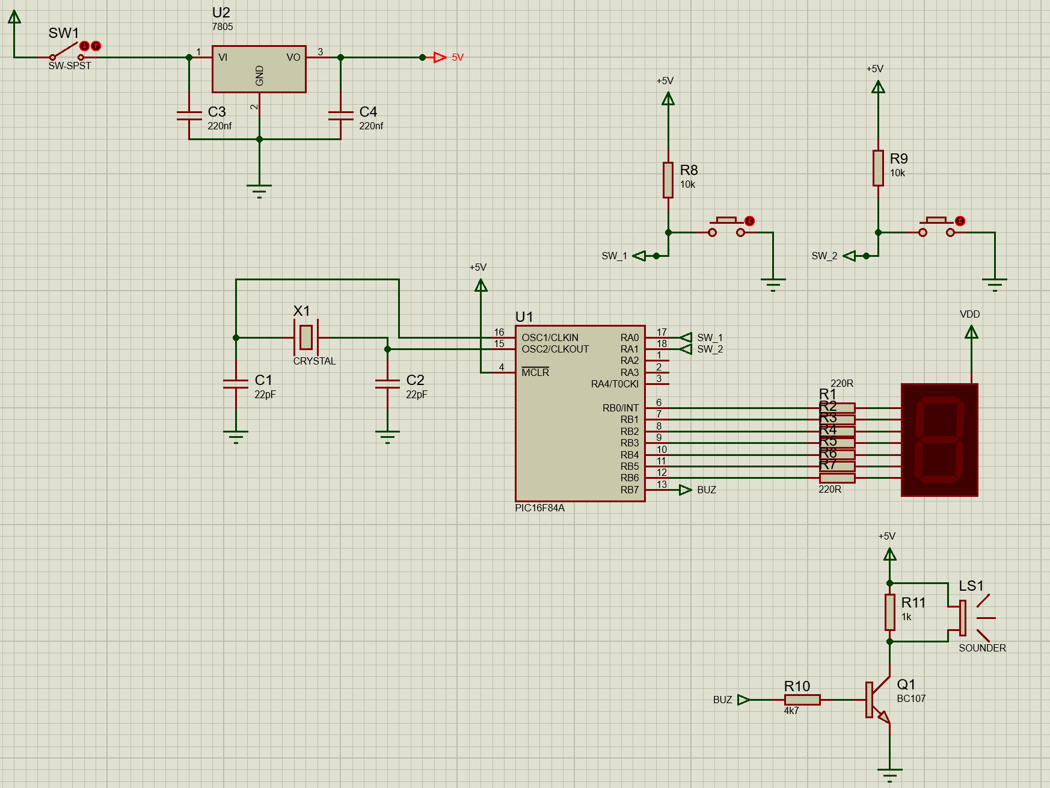
Figure 2: Reproduced circuit in proteus
The reproduced circuit has all the same sections and functions as the original one.
There are two buttons connecting to RA0, and RA1. When pressed, the pins are pulled low to ground, when not pressed, the pin is high. They are connected to the pic using ports, this is purely to make the circuit diagram easier to read.
The PIC microcontroller on proteus can have an internal oscillator, or external oscillator, and in the original it is external, so that has been recreated. The oscillator consist of 2 capacitors, and a crystal oscillator, at 4MHz. Crystal oscillators vibrate at a resonant frequency, depending on its cut. The capacitors are needed to start and sustain a stable oscillation, as well as filter out unwanted oscillations [2] [3]. The output pins are split from porta0-4, and portb0-7. PortA is a 5 bit bi-directional port set controlled by the register TRISA, the bits in this register can be set high or low to set the pin to input or output. PortB is similar, it is an 8 bit bi-directional port set, controlled by the TRISB register. The PIC16F8 It is programmed with assembly language, which can be done from inside of proteus.

The sounder circuit has been connected directly to a 5V supply, removing the need for the regulation circuit, as previously discussed. The sounder is operated by the PIC output pin connected to the base of a transistor, that, when in conduction and fully saturated, can provide a current path to ground, turning on the sounder. The resistor R11, is used to discharge the capacitance of the sounder, when the transistor is not in conduction.
The original circuit has a package called IC2 DIP14. This is a dual in line resistor package, giving seven resistors in a small, contained package. This has been replaced by single resistors, but would function exactly the same. The seven segment display is an array of led segments, and is active low. This means that when the pic outputs low, the led segment is on, and when the pic outputs high, it turns off. The pic outputs can be selected as such so that the led segment displays numbers and letters. The value of the resistors is calculated using R=V/I, with LED’s typically drawing 10-25mA, using 220Ohm resistors means that the leds draw 22.7mA (5/220 = 0.02272).

Section 2:
To display hexadecimal characters 0-F on the seven segment display, it must first be determined which outputs correspond to which segments on the display. The 8 RB0-6 outputs control the 7 segment display, with RB7 connected to the sounder. The seven segment display segments are active low, so to control them the pin must be off. To find which pin controls which segment, 8 bits can be sent to the RB0-7 pins, shifting 1 each time, for example, one time send 0000 0001, the next send 0000 0010, thus giving a mapping of each pin to each segment. To test this, the value must be moved into the working register (movlw), and then moved into f, location portb (movwf portb).
From testing this, the segments are controlled as follows:
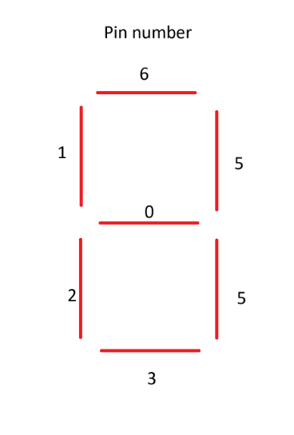
Figure 3: Shows which pins control each segment

The next step is to work out what segments make a number or letter, for example, for 0, all segments bar the middle must be on, so all pins bar the middle must be low. This means the 8 bit code for this would be 0000 0001
The rest can be seen in the table below

Conversion table:

Character | Binary | Hex | Output
0 | 0100 0000 | 40 | 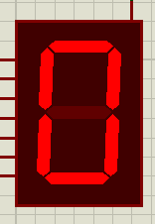
1 | 0111 1001 | 79 | 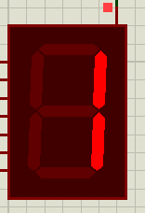
2 | 0010 0100 | 24 | 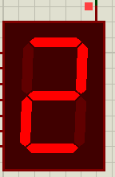
3 | 0011 0000 | 30 | 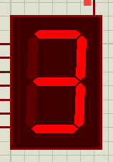
4 | 0001 1001 | 19 | 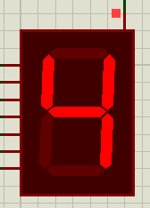
5 | 0001 0010 | 12 | 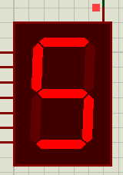
6 | 0000 0010 | 02 | 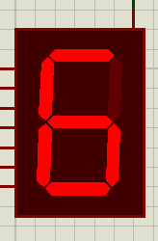
7 | 0111 1000 | 78 | 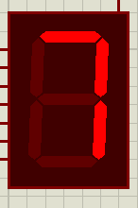
8 | 0000 0000 | 00 | 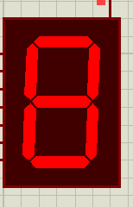
9 | 0011 1000 | 18 | 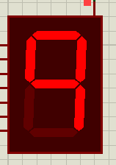
A | 0000 1000 | 08 | 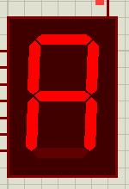
B | 0000 0011 | 03 | 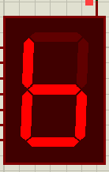
C | 0100 0110 | 46 | 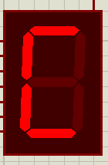
D | 0010 0001 | 21 | 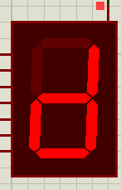
E | 0000 0110 | 06 | 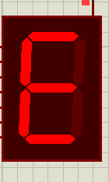
F | 0000 1110 | 0E | 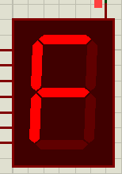
Figure 4: This table shows the character values converted to binary and hex, with the buzzer being off.
As is shown in the table above, the binary values have been converted to Hexadecimal to use in the assembly code. To convert the binary values to hexadecimal, each nibble was converted, as one nibble (4 bits) can represent 16 values (8+4+2+1, 0 to 15), and so can hexadecimal (0-9, and a-f for 10-15). This means that to convert the 8 bit binary values, it must be split into nibbles and converted. For example, F character is displayed with 0000 1110, the first nibble, 0000, is equal to 0, and the second nibble, 1110, is equal to 14, and the 14th value in hex is E, this means that 0000 1110 = 0E. This principle was used to calculate all the values in the table.

Section 3:
Before writing each section of code, it was first planned out in a flow chart.

Program 1:
“Modify “Count.asm” so that the seven segment display counts from 0 to F in hexadecimal numbers in 0.2 second increments”
; FILE: count.asm
; AUTHOR: Chris
; DESCRIPTION: Count to 255 at 1 second intervals and display on a seven
; segment display in binary.
; The pause subroutine takes apx. 0.2 sec.
; Pause is called 5 times

list p=16F84 ; select processor type
radix hex ; define radix as hexadecimal
; #include "p16f84.inc"
;----------------------------------------------------------------------
; cpu equates (memory map)
portB equ 0x06 ;port B address
trisb equ 0x06 ;trisB address in register bank 1
PCL equ 0x02

status equ 0x03 ;status register
RP0 equ 5 ;bit 5 of status register
RP1 equ 6 ;bit 6 of status register
z equ 2 ;bit 2 of status register

count equ 0x0c ; counter 0 to 255
nCount equ 0x0d ; pause routine inner loop counter
mCount equ 0x0e ; pause routine outer loop counter

;----------------------------------------------------------------------

org 0x000

start
bcf status,RP0 ; clear bank selection bits in the status reg
bcf status,RP1

bsf status,RP0 ; select bank 1
movlw 0x00 ; load w with 0x00
movwf trisb ; load it into trisb to make portb all outputs
bcf status,RP0 ; reselect bank 0

clrf portB ; clear all lines low
clrf count ; initialize counter to 0

get_count
movlw 0x00 ; load w with 0x00
addwf count, w ; move count to W
call seg_table ; call the look up table
movwf portB ; move W to port B to update the display
incf count, f ; increment the count f

movf count, w ; move count to register w
sublw 0x10 ; subtract 0x10(16) from w register
btfsc status, z ; if the last instruction yeilds 0, do not skip next
clrf count ; if not skipped, clear count to 0, reseting the lookup table position

call pause ;pause for 200ms

goto get_count ; repeat forever
;--------------------------------------------------------------------
;subroutine pause: lets waste some time....
;
;inputs: nothing
;outputs: nothing
;
;does: nothing but waste some time
;corrupts: register W
;
;description: two loops using "mCount" and "nCount" register files
; "mCount" is the outer loop counter (255 down to zero)
; "nCount" is the inner loop counter (255 down to zero)
;
;--------------------------------------------------------------------

seg_table
addwf PCL, f ;add value of pcl to f
retlw 0xc0 ;0 return to address in stack (return from subroutine) and load literal value into w register
retlw 0x79 ;1 ""
retlw 0x24 ;2 ""
retlw 0x30 ;3 ""
retlw 0x19 ;4 ""
retlw 0x12 ;5 ""
retlw 0x02 ;6 ""
retlw 0x78 ;7 ""
retlw 0x00 ;8 ""
retlw 0x18 ;9 ""
retlw 0x08 ;A ""
retlw 0x03 ;b ""
retlw 0x46 ;C ""
retlw 0x21 ;d ""
retlw 0x06 ;e ""
retlw 0x0e ;F ""

;--------------------------------------------------------------------

pause
movlw 0xff ; set w = 255 decimal
movwf mCount ; mCount = w: outer loop counter
loadN
movlw 0xff ; set w = 255 decimal
movwf nCount ; nCount = w: inner loop counter
decN
decfsz nCount, f ; nCount--
goto decN ; if nCount != 0 then repeat nCount--

decfsz mCount, f ; else decrement Count
goto loadN ; if mCount != 0 then
; reload nCount to 255 and decrement
return ; else exit subroutine

end

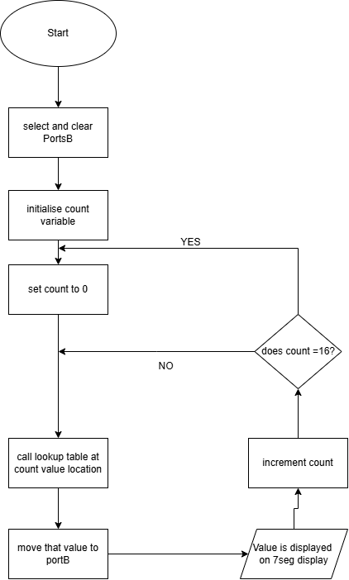
Figure 5: flow chart for program 1

Program 2:
“Write a program so that when you press one of the two buttons, it displays "L" on the 7 segment LED display, then when you press the other one, it displays "r".”
; FILE: count.asm
; AUTHOR: Chris

; DESCRIPTION: Display L when 1 button is pressed, r when the other is
;
;
;

list p=16F84 ; select processor type
radix hex ; define radix as hexadecimal
; #include "p16f84.inc"
;----------------------------------------------------------------------
; cpu equates (memory map)
portA equ 0x05
trisa equ 0x05
portB equ 0x06 ;port B address
trisb equ 0x06 ;trisB address in register bank 1

status equ 0x03 ;status register
RP0 equ 5 ;bit 5 of status register
RP1 equ 6 ;bit 6 of status register

count equ 0x0c ; counter 0 to 255
nCount equ 0x0d ; pause routine inner loop counter
mCount equ 0x0e ; pause routine outer loop counter

;----------------------------------------------------------------------

RST code 0x0 ;
goto start

PGM code
start
bcf status,RP0 ; clear bank selection bits in the status reg
bcf status,RP1

bsf status,RP0 ; select bank 1

movlw 0x00 ; load w with 0x00
movwf trisb ; load it into trisb to make portb all outputs

movlw 0x03 ; load w with 0x00
movwf trisa ; load it into trisba to make porta the two lsb inputs

bcf status,RP0 ; reselect bank 0

clrf portB ; clear all lines low
comf portB,1
clrf count ; initialize counter to 0

seg_l
btfsc portA,0 ; check if button on a0 is pressed
goto seg_r ; go to seg_r if button is not pressed
movf count,w ; move count to w
movlw 0x47 ; move 0x47, or L into the w reg
movwf portB ; move w register into portb, the output pins
movwf count ; move count into f reg
call pause ; wait 200ms
call pause
call pause
call pause
call pause
movf count,w
movlw 0x7f ;sets 7seg to 0 after 1 second
movwf portB ; move w into f and to portb
movwf count
call pause

seg_r
btfsc portA,1 ; check if button on a1 is pressed
goto seg_l ; go to seg_L if button is not pressed
movf count,w ; move count to w
movlw 0x2f ; move 0x2f, or L into the w reg
movwf portB ; move w register into portb, the output pins
movwf count ; move count into f reg
call pause ; wait 200ms
call pause
call pause
call pause
call pause
movf count,w
movlw 0x7f ; sets 7seg to 0 after 1 second
movwf portB ; move w into f and to portb
movwf count
call pause
goto seg_l ; go back to seg_l

;--------------------------------------------------------------------
;subroutine pause: lets waste some time....
;
;inputs: nothing
;outputs: nothing
;
;does: nothing but waste some time
;corrupts: register W
;
;description: two loops using "mCount" and "nCount" register files
; "mCount" is the outer loop counter (255 down to zero)
; "nCount" is the inner loop counter (255 down to zero)
;
;--------------------------------------------------------------------

pause
movlw 0xff ; set w = 255 decimal
movwf mCount ; mCount = w: outer loop counter
loadN
movlw 0xff ; set w = 255 decimal
movwf nCount ; nCount = w: inner loop counter
decN
decfsz nCount, f ; nCount--
goto decN ; if nCount != 0 then repeat nCount--

decfsz mCount, f ; else decrement Count
goto loadN ; if mCount != 0 then
; reload nCount to 255 and decrement
return ; else exit subroutine

end
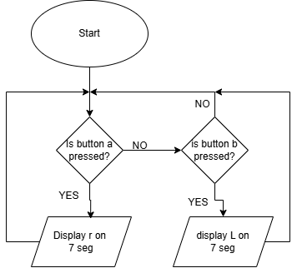
Figure 6: flow chart for program 2

Program 3:
“Write another program, so one button causes all of the LED segments to light, and the other switch turns them off. (the switch activations should be 'latching' i.e. you don't have to hold the button down for the on/off effect to remain)”

; FILE: count.asm
; AUTHOR: Chris
; DESCRIPTION: Latching buttons turning 7seg on or off
;
;
;

list p=16F84 ; select processor type
radix hex ; define radix as hexadecimal
; #include "p16f84.inc"
;----------------------------------------------------------------------
; cpu equates (memory map)
portA equ 0x05
trisa equ 0x05
portB equ 0x06 ;port B address
trisb equ 0x06 ;trisB address in register bank 1

status equ 0x03 ;status register
RP0 equ 5 ;bit 5 of status register
RP1 equ 6 ;bit 6 of status register

count equ 0x0c ; counter 0 to 255
nCount equ 0x0d ; pause routine inner loop counter
mCount equ 0x0e ; pause routine outer loop counter

;----------------------------------------------------------------------

RST code 0x0 ;
goto start

PGM code
start
bcf status,RP0 ; clear bank selection bits in the status reg
bcf status,RP1

bsf status,RP0 ; select bank 1

movlw 0x00 ; load w with 0x00
movwf trisb ; load it into trisb to make portb all outputs

movlw 0x03 ; load w with 0x00
movwf trisa ; load it into trisba to make porta the two lsb inputs

bcf status,RP0 ; reselect bank 0

clrf portB ; clear all lines low
comf portB,1
clrf count ; initialize counter to 0

seg_on
btfsc portA,0 ; check if button on a0 is pressed
goto seg_off ; go to seg_off if button is not pressed
movf count,w ; move count to f
movlw 0x00 ; move 0x00 to w reg
movwf portB ; move 0x00 to portB, turning on the leds
movwf count ; return count to f reg
call pause ; wait 200ms

seg_off
btfsc portA,1 ; check if button on a1 is pressed
goto seg_on ; go to seg_on if not pressed
movf count,w ; move count to f
movlw 0x7f ; move 0x7f to w
movwf portB ; move 0x7f to portb, tunring off the leds
movwf count ; return count to f reg
call pause ; wait 200ms
goto seg_on ; go back to seg_on

;--------------------------------------------------------------------
;subroutine pause: lets waste some time....
;
;inputs: nothing
;outputs: nothing
;
;does: nothing but waste some time
;corrupts: register W
;
;description: two loops using "mCount" and "nCount" register files
; "mCount" is the outer loop counter (255 down to zero)
; "nCount" is the inner loop counter (255 down to zero)
;
;--------------------------------------------------------------------

pause
movlw 0xff ; set w = 255 decimal
movwf mCount ; mCount = w: outer loop counter
loadN
movlw 0xff ; set w = 255 decimal
movwf nCount ; nCount = w: inner loop counter
decN
decfsz nCount, f ; nCount--
goto decN ; if nCount != 0 then repeat nCount--

decfsz mCount, f ; else decrement Count
goto loadN ; if mCount != 0 then
; reload nCount to 255 and decrement
return ; else exit subroutine

end

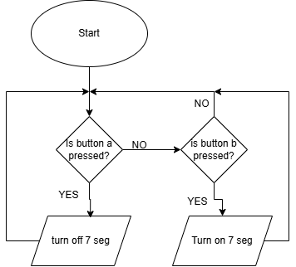
Figure 7: flow chart for program 3

Program 4:
“Then combine all of these techniques together, by writing a new program where you start by displaying '5' but you can count up (to a maximum of 9) if you press one button, and count down (to a minimum of 0) if you press the other.”

; FILE: count.asm
; AUTHOR: Chris
; DESCRIPTION: Starts by displaying 5, then count up to 9 with one button
; and down to 0 with the other
;
;

list p=16F84 ; select processor type
radix hex ; define radix as hexadecimal
; #include "p16f84.inc"
;----------------------------------------------------------------------
; cpu equates (memory map)
portA equ 0x05
trisa equ 0x05
portB equ 0x06 ;port B address
trisb equ 0x06 ;trisB address in register bank 1
PCL equ 0x02
z equ 2
status equ 0x03 ;status register
RP0 equ 5 ;bit 5 of status register
RP1 equ 6 ;bit 6 of status register

count equ 0x0c ; counter 0 to 255
nCount equ 0x0d ; pause routine inner loop counter
mCount equ 0x0e ; pause routine outer loop counter

;----------------------------------------------------------------------

RST code 0x0 ;
goto start

PGM code
start
bcf status,RP0 ; clear bank selection bits in the status reg
bcf status,RP1

bsf status,RP0 ; select bank 1

movlw 0x00 ; load w with 0x00
movwf trisb ; load it into trisb to make portb all outputs

movlw 0x03 ; load w with 0x03
movwf trisa ; load it into trisa to make porta the two lsb inputs

bcf status,RP0 ; reselect bank 0

clrf portB ; clear all lines low
movlw 0x05
movwf count

get_count

movf count,w ; move count to w
call seg_table ; go to seg_table
movwf portB ; move w to portb

call pause ; wait 200ms
btfsc portA,0 ; check if button on a0 is pressed
goto decrement ; if it is, go to decrement
call pause ; wait 200ms
goto increment ; then go to increment

increment

movf count,w ; move count to w
sublw 0x09 ; subtract 0x09 with w register
btfsc status,z ; test the status of the z bit
goto get_count ; go to get_count if z is 1
incf count,f ; increment count in f by 1
call pause ; wait 200ms
goto get_count ; go to get_count

decrement

btfsc portA,1 ; check if button on a1 is on
goto get_count ; if not go to get_count
call pause ; wait 200ms
movf count,w ; move count to w
btfsc status,z ; check z bit status
goto get_count ; if 1, go to get_count

decf count,f ; decrememnt count by 1
call pause ; wait 200ms
goto get_count ; go to get_count

;--------------------------------------------------------------------
;subroutine pause: lets waste some time....
;
;inputs: nothing
;outputs: nothing
;
;does: nothing but waste some time
;corrupts: register W
;
;description: two loops using "mCount" and "nCount" register files
; "mCount" is the outer loop counter (255 down to zero)
; "nCount" is the inner loop counter (255 down to zero)
;
;--------------------------------------------------------------------
seg_table
addwf PCL, f ;add value of pcl to f
retlw 0xc0 ;0 return to address in stack (return from subroutine) and load literal value into w register
retlw 0x79 ;1 ""
retlw 0x24 ;2 ""
retlw 0x30 ;3 ""
retlw 0x19 ;4 ""
retlw 0x12 ;5 ""
retlw 0x02 ;6 ""
retlw 0x78 ;7 ""
retlw 0x00 ;8 ""
retlw 0x18 ;9 ""

pause
movlw 0xff ; set w = 255 decimal
movwf mCount ; mCount = w: outer loop counter
loadN
movlw 0xff ; set w = 255 decimal
movwf nCount ; nCount = w: inner loop counter
decN
decfsz nCount, f ; nCount--
goto decN ; if nCount != 0 then repeat nCount--

decfsz mCount, f ; else decrement Count
goto loadN ; if mCount != 0 then
; reload nCount to 255 and decrement
return ; else exit subroutine

end

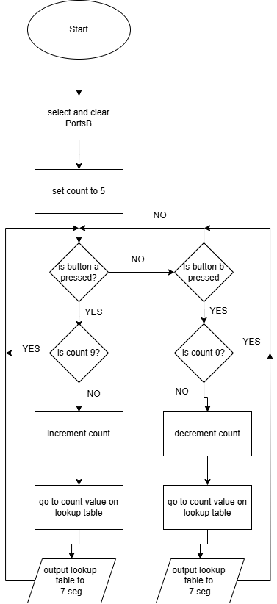Figure 8: flow chart for program 4

Program 5:
“Write a new program so that the piezo sounder produces a tone while one of the switches/buttons is pressed. As you are using a simulation program and not the actual hardware, see if you can get Proteus to output the virtual speaker/sounder to the actual PC speaker, but if this fails, attach a virtual oscilloscope to the speaker/sounder and monitor the waveform visually.”
; FILE: count.asm
; AUTHOR: Chris
; DESCRIPTION: Produce a tone when button is pressed
;
;
;

list p=16F84 ; select processor type
radix hex ; define radix as hexadecimal
; #include "p16f84.inc"
;----------------------------------------------------------------------
; cpu equates (memory map)
portA equ 0x05
trisa equ 0x05
portB equ 0x06 ;port B address
trisb equ 0x06 ;trisB address in register bank 1

status equ 0x03 ;status register
RP0 equ 5 ;bit 5 of status register
RP1 equ 6 ;bit 6 of status register

count equ 0x0c ; counter 0 to 255
nCount equ 0x0d ; pause routine inner loop counter
mCount equ 0x0e ; pause routine outer loop counter

;----------------------------------------------------------------------

RST code 0x0 ;
goto start

PGM code
start
bcf status,RP0 ; clear bank selection bits in the status reg
bcf status,RP1

bsf status,RP0 ; select bank 1

movlw 0x7f ; load w with 0x00
movwf trisb ; load it into trisb to make portb all outputs

bcf status,RP0 ; reselect bank 0

clrf portB ; clear all lines low

sound

btfsc portA,1 ; if button a1 is pressed
clrf portB ; clear portB
btfsc portA,1 ; if button a1 is pressed
goto sound ; go to sound

movlw 0xff ; move 0xff into w
movwf portB ; move w into portb
call pause ; wait
movlw 0x7f ; move 0x7f into w
movwf portB ; move w into port b
call pause ; wait
goto sound ; go to sound

;--------------------------------------------------------------------
;subroutine pause: lets waste some time....
;
;inputs: nothing
;outputs: nothing
;
;does: nothing but waste some time
;corrupts: register W
;
;description: two loops using "mCount" and "nCount" register files
; "mCount" is the outer loop counter (255 down to zero)
; "nCount" is the inner loop counter (255 down to zero)
;
;--------------------------------------------------------------------

pause
movlw 0x02 ; set w = 2 decimal
movwf mCount ; mCount = w: outer loop counter
loadN
movlw 0xbb ; set w = 187 decimal
movwf nCount ; nCount = w: inner loop counter
decN
decfsz nCount, f ; nCount--
goto decN ; if nCount != 0 then repeat nCount--

decfsz mCount, f ; else decrement Count
goto loadN ; if mCount != 0 then
; reload nCount to 255 and decrement
return ; else exit subroutine

end

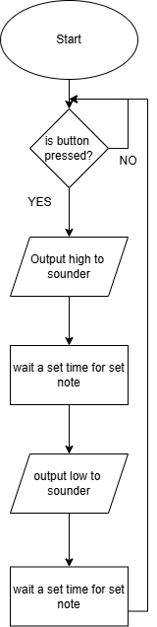
Figure 9: flow chart for program 5

Conclusion:
This report has covered the basic function of a given circuit, including component functions, and how this can be recreated in proteus. It has also covered the basics of addressing a 7 segment display from a pic micro controller, including converting from binary to hexadecimal. It also includes 5 coding tasks and a flow chart for each.

Bibliography

[1] | Texas Instruments, “ LM340, LM340A and LM7805 Family Wide VIN 1.5-A Fixed Voltage Regulators,” [Online]. Available: https://www.ti.com/lit/ds/symlink/lm7800.pdf. [Accessed 13 01 2025].
[2] | G. C. -. P. P. Engineer, “Creating Reliable Crystal Oscillators Circuits for Your MCU Design,” Renesas, 30 01 2023. [Online]. Available: https://www.renesas.com/en/blogs/creating-reliable-crystal-oscillators-circuits-your-mcu-design. [Accessed 11 01 2025].
[3] | Microchip Technology inc, “ Crystal Oscillator Basics and Crystal Selection for rfPIC and PICmicro Devices,” [Online]. Available: https://ww1.microchip.com/downloads/en/appnotes/00826a.pdf. [Accessed 11 01 2025].
[4] | Microchip technology, “18-pin Enhanced FLASH/EEPROM 8-Bit Microcontroller,” [Online]. Available: https://ww1.microchip.com/downloads/aemDocuments/documents/MCU08/ProductDocuments/DataSheets/35007C.pdf. [Accessed 13 01 2025].

